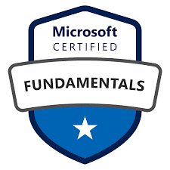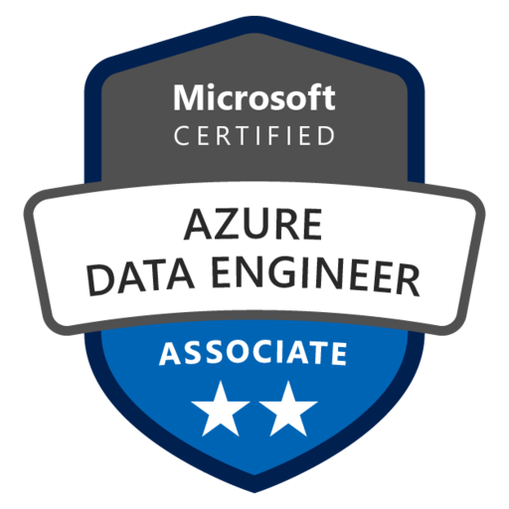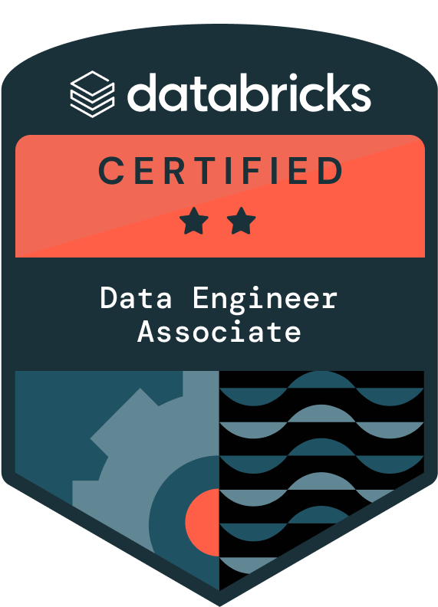
Mohammad Wasim Maligeli
Senior Data Engineer
Email Id: m.maligeliwasim@gmail.com
Phone: +1 (469)-327-1902
LinkedIn: https://www.linkedin.com/in/mohammad-wasim-maligeli-403a21211/

PROFESSIONAL SUMMARY:

- Data Engineer with over 10+ years of IT experience, specializing in designing and implementing Cloud ETL solutions using Azure Data Factory, Azure Data Lake Storage Gen2, Azure Databricks, and Azure Synapse Analytics to create scalable data warehousing solutions.
- 6+ years of experience in Azure Cloud Services and Big Data technologies, delivering optimized cloud solutions for seamless data migration and processing.
- Proficient in a wide range of Azure Cloud Services, including Azure SQL Server, Azure Logic Apps, Azure Functions, Azure Monitor, Key Vault, Azure Event Hubs, Azure Cosmos DB, and Azure Stream Analytics.
- Designed and developed Azure Data Factory (ADF) batch pipelines for data ingestion and transformation from relational sources into Azure Data Lake Storage (ADLS Gen2), leveraging incremental data loads and ETL processes for Delta table management.
- Expertise in Azure Data Factory for building and automating scalable ETL pipelines, significantly enhancing data accessibility and decision-making capabilities.
- Skilled in Azure Databricks, utilizing Apache Spark for optimizing large-scale data transformations and analytics, leading to improved performance and actionable insights.
- Experienced in architecting and managing data storage solutions with Azure Data Lake Storage Gen2, ensuring efficient handling of structured and unstructured data while maintaining compliance and security standards.
- Proficient in developing end-to-end analytics solutions with Azure Synapse Analytics, enabling advanced analytics and delivering insights by integrating data from multiple sources.
- Played a pivotal role in planning and delivering roadmaps for migrating on-premises systems and applications to the Azure Cloud environment.
- Developed data pipelines, dataflows, event streams, lakehouses, ML models, notebooks, Spark jobs, and data warehouses using Synapse Data Engineering on Microsoft Fabric.
- Experience in creating Spark applications with Spark-SQL in Databricks for extracting, transforming, and aggregating data from multiple file formats to uncover business insights.
- Built real-time streaming solutions using Apache Kafka and Azure Event Hubs, integrated with Azure Databricks for PySpark-based stream processing.
- Expertise in Relational Database Management Systems (RDBMS), including normalization, stored procedures, constraints, joins, indexing, and triggers, with a strong focus on query optimization.
- Skilled in complex data transformations using tools like Lookups, Derived Columns, Conditional Splits, Merge Joins, Pivots, Unpivots, and SCD to load data into SQL Server destinations.
- Optimized query execution by 40% across databases like Teradata, Oracle, SQL Server, and MySQL using efficient indexing strategies in high-volume environments.
- Extensive experience in ETL processes, collecting, aggregating, and migrating data using tools like Apache Flume and Kafka to streamline workflows.
- Developed iterative algorithms for near real-time dashboards using Spark Streaming in Scala and Python.
- Worked extensively with Hive, including partitioning, creating buckets, and automating data transfer with MapReduce and HBase.
- Proficient in processing and transforming file formats like CSV, JSON, XML, ORC, Avro, and Parquet using Spark, PySpark, and Scala for data analysis and workflows.
- Demonstrated strong expertise in ETL, data analysis, data quality, and performance optimization for OLAP and OLTP systems in high-performance database environments.
- Created dynamic dashboards and insightful reports using Power BI, integrating data from diverse sources for enhanced business intelligence.
- Scheduled and monitored complex workflows with Control-M and Apache Airflow, ensuring smooth task execution.
- Leveraged SharePoint and Confluence for centralized documentation and team collaboration, improving project accessibility and communication.
- Authored troubleshooting guides for Azure Data Factory, Databricks, and SQL-based ETL workflows, reducing incident resolution times by 30%.
- Ensured data integrity through unit, integration, and end-to-end testing in ETL workflows, adhering to best practices to validate accuracy and performance.
- Experienced in the Software Development Life Cycle (SDLC), including requirements analysis, design, design, design, development, testing, deployment, and support, while following Agile methodologies.
- Developed advanced Python-based data validation, transformation, and cleansing scripts to ensure high data quality before ingestion into Azure Synapse and Snowflake.
- Automated complex ETL workflows using Python, integrating APIs, Azure Data Factory pipelines, and real-time event hubs for seamless data flow.
- Built modular Python frameworks and monitoring tools for dynamic pipeline orchestration and performance tracking, reducing operational overhead by 40%.
- Leveraged Python libraries such as Pandas, NumPy, and PySpark for big data analysis and transformation into distributed systems.
- Managed Agile projects using JIRA, facilitating Scrum ceremonies like daily stand-ups, sprint planning, and retrospectives to enhance collaboration and transparency.

TECHNICAL SKILLS:
Azure Technologies Azure Data Factory (ADF), Azure Synapse Analytics, Azure Event Hub, Azure SQL Server, Azure Stream Analytics, Azure Data Lake GEN2, Azure Logic Apps, Azure Functional Apps, Azure Blob Storage, Azure Databricks, Azure VM, Azure Data Lake Analytics, Azure Active Directory, Azure Data Catalog, Azure Monitor, Microsoft Purview, data governance, data management, Azure Cosmos DB, Azure Key Vault, Azure DevOps, Azure HDInsight, Azure Service Bus, Azure Resource Manager Templates, Azure Application Insights, Azure CLI.
Big Data Technologies Hadoop, HDFS, Map Reduce, Yarn, Hive, Spark, Sqoop, Hive, Pig, HBase, Flume, Spark, Kafka, Performance Tuning, Oozie, Zookeeper
Databases Oracle, MySQL, MSSQL, SQL Server, MongoDB, Cassandra, Sybase, PostgreSQL
Programming Languages Python (Pandas, NumPy, PySpark), Shell script, SQL, Scala, R, SQL, PL/SQL
Automation Technologies Jenkins, Terraform, Docker, Kubernetes, Apache Airflow, GitLab CI/CD
Tools PyCharm, Eclipse, Visual Studio, SQL*Plus, SQL Developer, SQL Navigator, SQL Server Management Studio, Eclipse.
Version Control SVN, Git, GitHub, Maven, bitbucket, GitLab
Visualization/Reporting Power BI, Tableau
File Format ORC, Parquet, Avro, JSON, DELIMITED (CSV), XML, TXT, Excel

EDUCATION
- Master’s in computer science and information science at Texas A&M University, Commerce, TX, USA in 2013
- Bachelor’s in computer science and engineering, JNTU-A in India in 2011

CERTIFICATIONS
- AZ-900 Microsoft Azure Fundamentals
- DP-203 Microsoft Azure Data Engineer Associate
- Databricks Certified Data Engineer Associate

WORK EXPERIENCE
Client: US Bank, Dallas, TX March 2023– Till Date
Role: Senior Data Engineer
Responsibilities:

- Designed and deployed efficient ETL pipelines in Azure Data Factory using activities like Copy, Mapping Data Flows, Get Metadata, and Web Activity, improving data transfer efficiency.
- Scheduled and orchestrated workflows in Azure Data Factory to integrate with Databricks and Synapse Analytics, enabling seamless data processing.
- Enhanced data transformation performance by 60% using PySpark DataFrames, RDDs, and optimized Databricks Runtime.
- Built scalable ETL pipelines in Azure Synapse Analytics and Databricks, ingesting, transforming, and loading data into Azure Data Lake Storage and SQL databases.
- Architected Delta Lake solutions, creating bronze, silver, and gold data layers in Databricks for accuracy, consistency, and performance in analytics.
- Leveraged Delta Live Tables and Databricks SQL for continuous data processing and real-time analytics.
- Designed real-time data integration pipelines from IoT devices to Azure Data Lake using Azure Data Factory, Python, and Databricks with PySpark transformations.
- Developed custom APIs in .NET to integrate with Low-Code platforms, enabling seamless data exchange between enterprise systems and cloud services.
- Integrated Cosmos DB with Azure Data Factory and Databricks for seamless data flow and ETL pipelines.
- Streamlined analytics with Medallion Architecture, organizing data into structured layers (Bronze, Silver, Gold).
- Conducted Proof of Concept (POC) on Microsoft Fabric, showcasing its capabilities to optimize data integration and analytics workflows.
- Designed and implemented a unified data architecture using Microsoft Fabric's OneLake and Lakehouse features, enabling data ingestion, storage, and analytics across diverse data sources, for analytical workloads.
- Implemented Kafka Connectors to ingest real-time data from POS Terminals into Azure Data Lake Storage and processed streams with Databricks.
- Developed reusable Python modules for handling API-based ingestion workflows, flattening complex JSON structures, and integrating external systems into Azure Data Lake.
- Designed and managed high-availability MS SQL databases, optimizing T-SQL queries for efficient reporting and manipulation.
- Developed modular DBT models to create analytics-ready datasets in Azure Synapse, improving data consistency and processing efficiency.
- Built PySpark data quality validation checks in Databricks notebooks to ensure data completeness and consistency across multiple layers (Bronze, Silver, Gold).
- Skilled in identifying and resolving performance bottlenecks, using tools like Teradata Query Tuner to fine-tune queries and optimize resource utilization.
- Created real-time pipeline health dashboards using Python and Power BI by exporting job metrics from Azure Monitor.
- Used Azure Monitor for pipeline performance tracking and bottleneck resolution.
- Secured pipelines with Azure Key Vault for secrets, keys, and certificates management.
- Collaborated with data scientists to deliver high-quality datasets for machine learning models.
- Created optimized MongoDB schemas with indexed collections for faster query performance.
- Configured Linked Services, Datasets, and Integration Runtime in Azure Data Factory for diverse data integration.
- Automated pipeline execution with triggers like Scheduled, Tumbling Window, and Event-Based Triggers in Azure Data Factory.
- Developed real-time streaming pipelines with Apache Kafka, enabling real-time analytics and seamless data flow.
- Improved Spark job performance by tuning configurations, caching data, and optimizing partitioning in Azure Databricks.
- Designed and implemented CI/CD pipelines using Azure DevOps and GitHub Actions for efficient pipeline deployment and infrastructure automation.
- Automated Azure infrastructure provisioning with Terraform and PowerShell scripts, reducing configuration time by 40%.
- Developed OLAP systems with Star Schema models for high-performance querying.
- Built interactive dashboards in Power BI integrated with Azure Synapse Analytics, enabling real-time insights and reducing the time to insight by 40%.
- Worked in Agile environments, leveraging tools like JIRA and Confluence to foster collaboration and maintain comprehensive documentation.
- Encouraged transparency through retrospectives and continuous feedback.

Environment: Azure Data Factory, Azure Databricks, Azure Data Lake Storage Gen2, Azure Blob, Snowflake Data Warehouse, Azure Event Hubs, Azure Functions, Azure Logic Apps, Function Apps, Azure Monitor, Cosmos DB, MongoDB, Azure Synapse Analytics, Azure DevOps, Terraform, Azure Fabric, Azure Key Vault, MS SQL, Oracle, Python, PySpark, JIRA, Kafka, Power BI.

Client: Great American Insurance Group, Cincinnati, OH Oct 2020 – Feb 2023
Role: Sr. Data Engineer
Responsibilities:

- Designed and implemented advanced data integration pipelines in Azure Data Factory, utilizing Copy Activity, Mapping Data Flow, and Control Flow Activities for seamless data processing.
- Configured Linked Services to connect multiple data sources and set up Triggers for automated pipeline execution.
- Deployed Azure Data Factory's Integration Runtime to securely transfer data between on-premises and cloud environments, including Self-Hosted Integration Runtime for accessing on-premises data behind corporate firewalls.
- Optimized data storage and organization in Azure Data Lake Storage Gen2 by implementing a Hierarchical Namespace.
- Configured Azure Databricks Workspaces to create and manage clusters, developing ETL processes using notebooks that leveraged Spark DataFrames and RDDs for efficient data transformation.
- Integrated Azure Data Lake Storage Gen2 with Azure Active Directory (AAD) for secure authentication and authorization, ensuring robust data access control.
- Leveraged Python libraries such as Pandas and NumPy to manipulate, transform, and analyze large datasets stored in Azure Data Lake.
- Developed data validation and cleansing processes in Python to ensure data quality before loading into Azure SQL Database and Azure Synapse Analytics.
- Utilized Azure Synapse Link to enable near real-time analytics by synchronizing data with Azure Cosmos DB.
- Created real-time data ingestion pipelines in Azure Data Factory integrated with Azure Event Hubs to enhance data synchronization accuracy and reduce latency.
- Designed and implemented real-time data streaming architectures using Azure Event Hubs, Azure Databricks, and Azure Synapse Analytics, enabling instant data accessibility for business intelligence.
- Developed PySpark applications in Databricks to process 200GB of daily data, optimizing ETL workflows from Azure Data Lake to Synapse Analytics and reducing costs by 40%.
- Engineered Data Factory pipelines that integrated Data Lake with Databricks, incorporating SQL-based validation checks and Python scripts for monitoring data quality, supporting over 100 business users daily.
- Architected an enterprise data platform using Synapse Analytics and Databricks, processing Data Lake sources through PySpark transformations to achieve 99.9% SLA and 45% faster performance.
- Integrated Apache Airflow with Azure services for seamless data orchestration, ensuring efficient execution and monitoring of data workflows.
- Implemented CI/CD pipelines for data workflows using Azure DevOps, enabling automated deployment and version control of Airflow DAGs.
- Built production-ready Python and PySpark modules in Databricks for complex ETL operations, orchestrating Data Factory pipelines between Data Lake and SQL databases with a 40% increase in efficiency.
- Developed an automated testing framework in Python for Azure Data Factory pipelines, validating data quality between Data Lake and Synapse while optimizing PySpark processes for 50% faster performance.
- Implemented Delta Lake architecture in Databricks, optimizing Data Lake storage and SQL-based merge operations in Synapse Analytics to reduce data processing latency by 60%.
- Designed and delivered end-to-end ETL pipelines using Azure Data Factory and Python, significantly improving data flow efficiency.
- Migrated legacy ETL processes to Azure Data Factory by leveraging Databricks notebooks with PySpark and SQL for Data Lake transformations, cutting development time by 75%.
- Managed and optimized large-scale datasets in Azure Data Lake and Apache Cassandra, improving storage strategies for performance and cost-efficiency.
- Designed and developed scalable data models in Snowflake, utilizing its MPP architecture for high-performance storage and querying.
- Implemented Snowflake's Time Travel and Zero-Copy Cloning features for efficient data backup and recovery, minimizing downtime and data loss risks.
- Optimized ETL operations in Snowflake by developing complex Snow SQL queries for efficient data extraction, transformation, and loading.
- Designed Snowflake schemas to enhance data warehousing performance and data retrieval efficiency.
- Integrated Azure Key Vault to manage secrets, keys, and certificates within data pipelines, strengthening security protocols and reducing vulnerabilities by 35%.
- Utilized various file formats, including ORC, PARQUET, AVRO, JSON, and CSV, for optimized data storage and cross-platform compatibility.
- Enabled data-driven decision-making by integrating Azure-based data pipelines with Power BI for seamless visualization and reporting.
- Conducted rigorous code reviews using Git to ensure code quality and adherence to industry best practices.
- Effectively managed project tasks and user stories using Jira, enabling streamlined progress tracking and team collaboration.
- Utilized SharePoint for centralized document management and efficient team collaboration on project resources.
- Actively participated in Scrum ceremonies, such as daily stand-ups, sprint reviews, and planning meetings, to ensure alignment within the data engineering team.

Environment: Azure Data Factory, Databricks, Azure Data Lake Storage Gen2, Azure Synapse Analytics, Azure Blob, Logic Apps, Function App, Snowflake, MS SQL, Oracle, HDFS, Hive, Sqoop, PIG, PySpark, Oozie, Zookeeper, SQL, Python 3.8.2, Scala, Kafka, Power BI.

Client: Hudson Insurance, New York, NY Apr 2017 – Sep 2020
Role: Data Engineer
Responsibilities:

- Designed and executed data migration pipelines to transition from Hadoop (Hadoop 2.7.3, Spark 2.4.0) to Azure Cloud, ensuring a smooth and reliable transfer with no data loss or inconsistency.
- Developed end-to-end ETL pipelines using Azure Data Factory and SSIS, managing over 500 GB of daily data processing in Azure Data Lake Gen1, cutting execution times by 40%.
- Optimized real-time data transformations and machine learning workflows in Azure Databricks, processing over 2 TB of weekly data with a 45% improvement in efficiency.
- Created T-SQL stored procedures and SSIS packages for advanced data integration, boosting database and storage performance by 35%.
- Led a migration project for on-premises data warehouses to Azure SQL Data Warehouse, utilizing PolyBase for seamless data ingestion, resulting in a 50% cost reduction.
- Built and deployed real-time processing solutions in Azure Stream Analytics integrated with Event Hubs and Azure Data Lake, managing over 10,000 events per second with low latency.
- Enhanced security in Azure SQL Database with row-level security and column-level encryption using Azure Key Vault, ensuring compliance with GDPR and managing access for 200+ users.
- Engineered real-time scalable data workflows using PySpark in Azure Databricks, streamlining data transformation and improving processing capacity for analytics.
- Automated real-time and incremental data loads using Databricks notebooks and Azure Data Factory pipelines, reducing processing time by 60% and maintaining consistent data synchronization.
- Designed and optimized MapReduce jobs to process massive datasets, improving execution speed by 30% and enabling efficient big data processing.
- Integrated Apache Kafka with Hadoop for real-time data streaming, improving data ingestion rates by 40%, enabling faster insights and near real-time analytics.
- Built scalable storage and real-time retrieval solutions for petabyte-scale datasets using HDFS, ensuring high performance and reliability for big data applications.
- Utilized HiveQL and PySpark to optimize ETL processes, enhancing query performance by 25% and ensuring faster data extraction and transformation.
- Managed and automated workflows for real-time big data processing using Apache Oozie, streamlining operations across the Hadoop ecosystem.
- Configured Sqoop jobs to facilitate real-time and batch data synchronization between Hadoop and relational databases like SQL Server and MySQL.
- Leveraged real-time processing frameworks in Azure, including Event Hubs, Stream Analytics, and Databricks, to process and analyze streaming data with sub-second latency.
- Created real-time data pipelines with Azure Databricks and PySpark, enabling advanced data insights for applications needing immediate feedback.
- Deployed automated CI/CD pipelines with Jenkins for seamless real-time application updates, reducing downtime and ensuring consistency across deployments.
- Used Git for version control in real-time collaborative environments, ensuring smooth teamwork and code reliability across multiple developers.

Environment: Azure Data Factory v1, Azure Databricks, Azure Event Hubs, Azure Stream Analytics, Kafka, PySpark, HDFS, Hive, Hadoop, MySQL, Jenkins, Git, and Apache Oozie.

Client: DaVita – Brooklyn, NY Aug 2014 — Mar 2017
Role: Data Warehouse Engineer
Responsibilities:

- Spearheaded the migration from Informatica (version 10.x) and SSIS to a Hadoop-based ecosystem, successfully transforming legacy ETL processes to support large-scale data processing and reducing data processing time by 40%.
- Led the development of high-performance MapReduce programs for processing 10TB+ datasets, implementing custom Combiners and Partitioners, resulting in 30% faster processing time and improved resource utilization.
- Configured and optimized Apache Kafka (v1.x) for real-time data ingestion, enabling the integration of high-velocity data streams 3and reducing latency in data availability for analysis
- Architected and maintained HDFS infrastructure supporting petabyte-scale data operations, implementing replication policies and namespace management while ensuring 99.99% data availability across distributed clusters.
- Engineered optimized HiveQL scripts with advanced features like partitioning, bucketing, and ORC file formats, reducing query execution times by 25% and implementing automated data quality checks.
- Designed and implemented enterprise Apache Oozie workflows orchestrating complex data pipelines across 100+ nodes, achieving 40% reduction in job failures and streamlining dependency management.
- Tuned Hadoop cluster performance and implemented YARN resource management, maximizing cluster utilization and reducing job run times by 20%.
- Designed, developed, and optimized ETL pipelines in Matillion to support the migration project, focusing on data extraction, transformation, and loading processes to streamline data workflows and enhance performance.
- Applied best practices in Matillion to optimize data transformation workflows, improving pipeline efficiency and reducing processing times for large-scale datasets.
- Developed complex data transformations within Matillion, handling large volumes of structured and unstructured data to meet business needs and support advanced analytics in the new system.
- Actively managed and optimized cloud compute costs associated with Matillion operations by fine-tuning job schedules and reducing unnecessary data loads.
- Created documentation and conducted training sessions for team members on Matillion usage, best practices, and troubleshooting, promoting knowledge sharing and consistency across the team.
- Utilized Matillion’s version control features to manage and deploy ETL jobs, ensuring controlled, efficient, and consistent changes across different environments.
- Integrated Apache Kafka with the Hadoop ecosystem for real-time data streaming, processing 1M+ events per second with fault tolerance, resulting in 40% faster data ingestion.
- Developed and optimized Sqoop jobs for bi-directional data transfer between Hadoop and enterprise databases (MS SQL, MySQL), implementing incremental loads and parallel processing.
- Architected scalable data processing solutions using PySpark and Scala, implementing custom transformations and optimized shuffling operations, achieving 20% improved processing efficiency.
- Optimized Hadoop and Spark cluster performance through advanced configuration tuning, resource allocation, and memory management, reducing job execution times by 40% across production workloads
- Implemented distributed Apache Cassandra database architecture supporting 50TB+ data, ensuring high availability through proper partitioning strategies and consistency level configurations.
- Deployed Apache Zookeeper for distributed coordination across multiple Hadoop clusters, implementing leader election and configuration management while maintaining 99.9% system uptime.
- Engineered robust data ingestion workflows using Apache Flume, implementing custom Source-Channel-Sink configurations for processing 100TB+ daily log data with guaranteed delivery.
- Optimized HBase data modeling with efficient row-key design and column family organization, implementing bloom filters and compression, and reducing query latency by 45%.
- Engineered streaming data solutions using Python with Apache Kafka, handling real-time data processing at scale
- Implemented enterprise job scheduling using Control-M, orchestrating 1000+ daily batch processes with advanced dependency management, reducing failed jobs by 60% through proactive monitoring.
- Developed complex Pig scripts for ETL operations, incorporating UDFs and custom load functions, processing 5TB+ daily data while ensuring data quality and transformation accuracy.
- Worked with stakeholders to gather requirements, define KPIs, and deliver reports and dashboards using tools like Microsoft SQL Server Reporting Services (SSRS) and Tableau.
- Participated in Agile development methodologies including sprint planning, daily stand-ups, and retrospectives.
- Set up and manage Linux environments for hosting Hadoop clusters and other data processing systems.

Environment: Hadoop, Map Reduce, HDFS, Hive, Java, SQL, Cloudera Manager, Pig, Sqoop, Oozie, Hadoop, HDFS, Map Reduce, Hive, HBase, Linux, Cluster Management, Pyspark.

