PRAVALIKA REDDY M
Senior Cloud/DevOps Engineer

E +13023341204
 pravalika1088@gmail.com
q https://www.linkedin.com/in/pravalikareddy11/

EXPERIENCE

Senior Cloud/DevOps Engineer

HP
07/2024 United States
- Designed and built reference architectures for AWS and Azure infrastructure in collaboration with cloud architecture teams, supporting scalable, secure, and high-availability environments
- Standardized and automated infrastructure provisioning using Terraform, CloudFormation, Ansible, and GitHub Actions to enable consistent deployments across dev, test, and production environments
- Streamlined Infrastructure Engineering practices by analyzing bottlenecks and automating manual processes, resulting in improved deployment speed and reduced configuration drift
- Collaborated with security and network teams to implement secure VPC architectures, Cloudflare WAF rules, and DNS configurations using Route 53 and Azure DNS
- Led root cause analysis and resolution of critical incidents in EKS, CI/CD pipelines, and cloud infrastructure, including after-hours alert responses
- Provided subject matter expertise in monitoring, logging, and observability using Datadog, ELK, Splunk, Prometheus, Grafana, and Zabbix to proactively detect issues and meet performance KPIs
- Implemented self-healing automation using AWS Lambda, Watchtower, and GitHub Actions for container monitoring, patching, and auto-remediation of known infrastructure issues
- Delivered comprehensive infrastructure documentation and standard operating procedures covering cloud environments, deployment workflows, and monitoring configurations
- Managed distributed databases (MongoDB, Postgres, CloudAMQP) ensuring high availability, backup automation, and secure access policies

Software Operations Engineer

nVent
08/2022 - 07/2024 Edmonton
- Designed and implemented Infrastructure-as-Code using Terraform for consistent and repeatable environment setups across staging and production
- Supported System Operations by managing patch schedules for Linux and Windows environments, and served as an escalation point for infrastructure- related incidents
- Built and maintained GitLab and GitHub-based CI/CD pipelines for Dockerized
applications, with secure secret management and automated quality gates via SonarQube
- Developed robust monitoring and logging systems using Zabbix, Prometheus, Grafana, and centralized logging tools (SNMP, journald, syslog)
- Offered technical leadership to infrastructure and DevOps teams by mentoring junior engineers, reviewing pipeline implementations, and enforcing CI/CD best practices
- Contributed to compliance automation and audit readiness through custom Python and Bash scripts integrated with infrastructure monitoring and alerting

SUMMARY

Certified Cloud/DevOps Engineer with over 5+ years of experience designing, implementing, and maintaining scalable, secure, and highly available cloud infrastructure and CI/CD pipelines. Proficient in AWS, Azure, Kubernetes, Terraform, and modern DevOps tools with a strong background in scripting, containerization, automation, monitoring and observability. Adept at collaborating with cross- functional teams in agile environment to ensure smooth software delivery and operations across cloud and hybrid environments.
KEY ACHIEVEMENTS

 Enhanced Deployment Efficiency
Improved deployment speed by 40% via
streamlined processes.

 Reliable Infrastructure Management
Managed infrastructure with 99.9% uptime for
24 months.

 Incident Resolution Optimization
Reduced incident resolution time by 50%
through automated alerts.

 Terraform Module Development
Developed 20 Terraform modules for cross-
environment consistency.
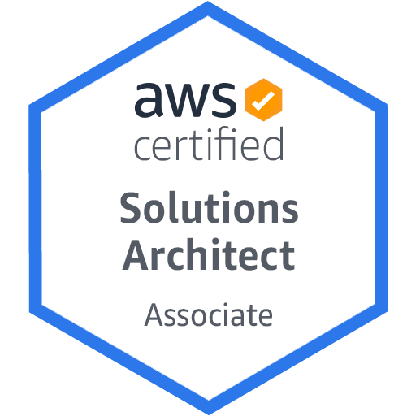
CERTIFICATIONS
AWS Certified Solutions Architect - Associate

EXPERIENCE

Software Engineer
9958193 Canada Inc
01/2021 - 09/2022 Toronto
- Assisted in configuring and maintaining CI/CD pipelines using GitHub Actions

SKILLS

Agile Ansible

SonarQube

Terraform

AWS AWS Lambda

and Jenkins to streamline automated builds, testing, and deployments

AWS RDS Azure Azure Devops

- Supported provisioning cloud resources on AWS and Azure, including EC2
instances, S3 buckets, and IAM roles, contributing to secure and scalable

infrastructure setups
- Collaborated on writing and refining Terraform modules and Ansible playbooks for automating cloud infrastructure deployment and configuration tasks
- Containerized applications using Docker and deployed them in development environments to support consistent and portable application delivery

Software Engineer
Technodom Pvt. Ltd
Bamboo Bash Cloudflare
CloudFormation Datadog DNS Docker EC2 Elasticsearch

ELK Stack GCP GitHub GitLab

07/2018 - 11/2019 Hyderabad
- Developed and implemented an internal monitoring system using Nagios,

Grafana

EKS

IAC IAM IIS

resulting in a 45% improvement in server uptime compared to the previous year
- Authored detailed documentation for infrastructure processes, deployment

Jenkins JSON Kubernetes Linux

procedures, and environment configurations to support consistency and knowledge sharing
MongoDB Nagios

Nexus
PaaS

- Monitored system health and performance using Prometheus, Grafana, and

PostgreSQL Prometheus pySpark

native cloud monitoring tools, enabling proactive issue detection and
response

- Automated routine operational tasks such as log rotation, backup management, and health checks by writing efficient Bash and Python scripts improving reliability

Python

SQL

EDUCATION

Master's in Computer Systems Technology - Networking

Centennial College
2020 Toronto, Canada

Bachelor of Technology in Information Technology Gokaraju Rangaraju Institute of Engineering and Technology 2014 Hyderabad, India

