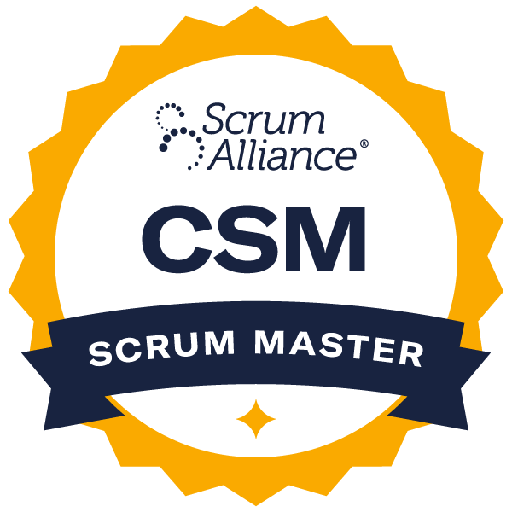



Vinod C.
(469) 850-1245 | vinodcofficial@hotmail.com|
Certs:
https://bcert.me/sungqczeb
https://www.credly.com/badges/f1e5eb1c-3e7b-478b-b4a1-38b0ec19a83d/public_url
https://www.credly.com/badges/f8865dc4-56a0-49e6-9058-4da3268b3121/public_url

SUMMARY
- Certified professional with more than 10 years of expertise in Accounting, Finance, Property & Casualty Insurance, APIs, automation testing, SQL, and data visualization, along with experience in Business System Analysis for financial organizations.
- Successfully migrated multiple applications within months timeline, demonstrating adaptability and efficiency.
- Led projects generating millions in savings, contributing to corporate sustainability initiatives.
- Played a key role in transitioning the company from Waterfall to Agile by developing and implementing effective strategies.
- Experience with interpreting stakeholder expectations and translating them into actionable technical objectives.
- Proficient in SDLC and STLC with hands-on experience in Agile and Waterfall methodologies.
- Expert in documentation, including Business Requirement Documents (BRDs) and Functional Requirements Documents (FRDs), using Microsoft Word and Confluence.
- Converted requirements into well-defined User Stories and Acceptance Criteria, ensuring adherence to INVEST and SMART standards in Jira and Azure DevOps (AzDo).
- Skilled in workflow and activity flow diagramming using tools like MS Visio, Balsamiq, and Miro.
- Collaborated with UI/UX teams to design logical application flows, creating wireframes and mock-ups for business user approval.
- Managed stakeholder communication, ensuring clarity on project expectations, timelines, and deliverables while preparing UAT plans and test data.
- Oversaw test planning and execution, utilizing HPALM for test cases, conducting white box, black box, A/B, and exploratory testing to ensure product alignment with business needs.
- Worked with Architects to develop architectural diagrams by providing detailed business requirements and expectations.
- Effectively prioritized backlog items based on product roadmaps and sprint goals, employing techniques like MoSCoW prioritization.
- Facilitated Sprint Demo meetings, gathering business feedback and ensuring alignment with sprint objectives.

EXPERIENCE
Shaw Industries | Product Owner (Sep 2023 – Present) | Dalton, GA

Summary: Shaw is a company within the textile manufacturing industry which supplies carpet, hardwood, tile and stone flooring products to residential and commercial markets worldwide. As part of my responsibilities here, I managed application migration, streamlined communication, prioritized tasks, and ensured Agile execution through testing, documentation, and issue resolution.

- Analyzed existing systems and gathered requirements to migrate in-house applications, creating detailed user stories with acceptance criteria in Jira.
- Identified key components, including cases, accounts, contacts, roles, profiles, workflows, and automation, for development.
- Developed workflows and activity diagrams, assessing process flows to identify areas for improvement.
- Validated acceptance criteria before marking work items as complete or ready for UAT.
- Bridged communication between technical teams and business users, translating requirements into non-technical language.
- Documented requirements in Confluence, converting them into features and user stories for Jira tracking.
- Coordinated with business stakeholders to prioritize tasks based on MVP and deadlines, using prioritization techniques like Must Have – Should Have – Nice to Have.
- Provided migration progress updates to Product Managers, ensuring sprint goals were met.
- Collaborated with the Technical Architect and development team, clarifying requirements and ensuring alignment with business needs.
- Actively participated in Agile ceremonies, including daily stand-ups, sprint planning, backlog grooming, and demo meetings, gathering stakeholder feedback.
- Assumed Scrum Master responsibilities when needed, working with other Scrum Masters to resolve blockers and streamline workflow.
- Developed test plans and conducted system testing, ensuring alignment with business requirements.
- Compared and verified test results and logging bugs when requirements were not met.
- Worked with business and development teams to prioritize bugs, issues, and enhancements, leveraging insights for future sprint planning.

Department of Veterans Affairs | Product Owner (Jan 2022 – Sep 2023) | Dallas, TX

Summary: Within the extensive range of sectors in the Department of Veterans Affairs, I worked in the Health Care sector(P&C Domain), which addressed the primary care needs of veterans, wherein I analyzed business needs, coordinated system solutions, managed stakeholder communication, facilitated testing, and assisted in vendor selection and project execution.

- Assessed business requests and formulated system solutions aligned with overall strategies.
- Developed and analyzed business requirements, including data flows, application design, and usability.
- Translated customer needs into business requirement documents for stakeholders.
- Reviewed IT functional designs and provided feedback.
- Conducted change management analysis and presented findings to management.
- Acted as a liaison between IT and business teams for system changes.
- Coordinated and supported user acceptance testing activities across teams.
- Managed issue intake, validation, bug fixes, and migration approvals.
- Developed user acceptance test plans, including use cases and cross-team coordination.
- Diagnosed and recommended fixes for system bugs and configuration issues.
- Analyzed existing systems to identify gaps and proposed updated solutions using tools like MS Visio and Miro.
- Conducted market research to document business, functional, security, and technical requirements, distributing them to vendors and evaluating responses.
- Collaborated with the Director to define the annual technical roadmap.
- Managed project timelines through weekly meetings and communicated progress via executive calls.
- Ensured dependent teams (ServiceNow, Security, HR) had their use cases captured.
- Facilitated vendor scoring sessions and reviewed vendor responses.
- Attended demos to assess workflows and assist in final selection.

Molina Healthcare | Product Owner/Business Systems Analyst (Dec 2020 – Jan 2022) | Long Beach, CA

Summary: Managed requirements, sprint planning, data migration, and process improvements using Azure DevOps in a SAFe Agile framework within the P&C Domain.

- Collaborated with cross-functional teams to define and prioritize user stories involving HL7 v2 and FHIR data exchange standards, enabling seamless interoperability between EHR systems and third-party healthcare applications.
- Collected and documented requirements, creating user stories and acceptance criteria.
- Managed user stories and project tracking in Azure DevOps, providing updates through stand-up meetings.
- Led grooming sessions, assigned story points, and helped prioritize tasks.
- Conducted PSPI/Product Owner reviews before User Acceptance Testing.
- Compiled and presented progress reports to Program Managers.
- Assisted with data migration via Azure Data Factory and documented transformations using SQL queries.
- Ensured dependencies were addressed and coordinated sprint planning with impacted teams in the SAFe framework.
- Created a Kanban board in Azure DevOps to track production tickets.
- Identified and improved processes to enhance business efficiency.
- Collaborated with RTE to share sprint updates, communicate delays, and align with the technology roadmap.

State Farm | Business Systems Analyst/ Scrum Master (Mar 2018 – Dec 2020) | Bloomington, IL

Summary: State Farm works on vehicle insurance quotes and related services within the Property & Casualty Insurance sector, wherein I bridged technical and business teams, enhanced UX, documented requirements, and supported Agile transformation and eDelivery implementation.

- Translated complex technical requirements into simple, jargon-free explanations for non-technical business teams, ensuring clear communication between both parties.
- Analyzed and improved the registration process for the front-end Customer Portal, enhancing user experience and business operations.
- Delivered innovative features and implementation strategies for multi-platform software applications (web, Android, iOS) after conducting thorough market research.
- Recognized as a subject matter expert on business flows, responsible for recommending the best customer experience enhancements.
- Applied creative thinking to design intuitive user experiences, anticipating feedback and resolving potential issues; used HTML, Visio, Miro, and Figma to create mockups.
- Collaborated with business units to provide data-driven insights and operational solutions, supporting trend analysis and decision-making.
- Contributed to the organization's Agile transformation, offering suggestions for improving team adoption of Agile methodologies.
- Regularly updated the Project Manager on progress, proactively identifying issues and blockers before sprints to ensure timely goal completion.
- Documented detailed business and technical requirements in Confluence and Jira, ensuring that user stories could be completed within a single sprint using vertical slicing.
- Identified areas for improvement and defects, prioritizing their resolution to enhance product quality and user satisfaction.
- Worked on implementing eDelivery applications within Guidewire Policy Center and Guidewire Billing Center through OnBase integration.
- Assisted with cross-functional collaboration to refine product features and ensured that technical solutions aligned with business needs.
- Conducted user acceptance testing (UAT) to validate solutions, ensuring they met business requirements and end-user expectations.

Orbinet Technologies | Business Systems Analyst (Aug 2014 – Oct 2017) | India
Summary: Served as a Business Systems Analyst for ServiceNow implementation, aligning processes with IT strategy, creating templates, and providing support through training, troubleshooting, and automation.

- Served as a Business Systems Analyst for ServiceNow implementation, ensuring seamless process integration.
- Analyzed current systems and proposed ServiceNow-based solutions without disrupting existing workflows.
- Aligned ServiceNow processes with IT strategy, adhering to ITIL and ITSM standards.
- Designed templates for Incident and Service Request modules based on business needs.
- Created and maintained knowledge articles for user training and support.
- Developed training materials and facilitated user education across organizations.
- Provided production support, troubleshooting issues using data analysis and SQL queries.
- Translated business needs into requirement documents for stakeholders.
- Assessed system changes for upstream and downstream business impact.
- Collaborated with subject matter experts to gather business requirements.
- Automated routine tasks in ServiceNow using scripting tools.
- Designed intuitive, user-friendly dashboards for enhanced usability.

EDUCATION

Master’s in Management Information Systems | Auburn University at Montgomery, Montgomery, AL | Jan 2018 – Dec 2018

SKILLS

Microsoft Office Suite / Microsoft Projects / Microsoft Teams / JIRA / Confluence / Guidewire/ ServiceNow/ Flutter/ HPALM/ BrowserStack/ SharePoint/ Miro/ Salesforce

