Harini Korada
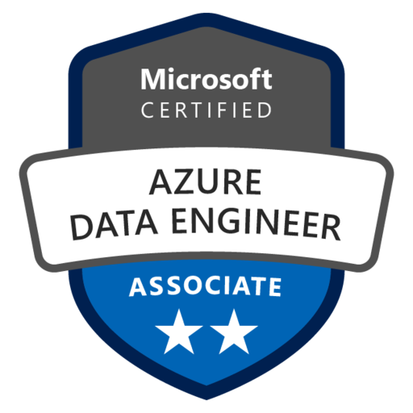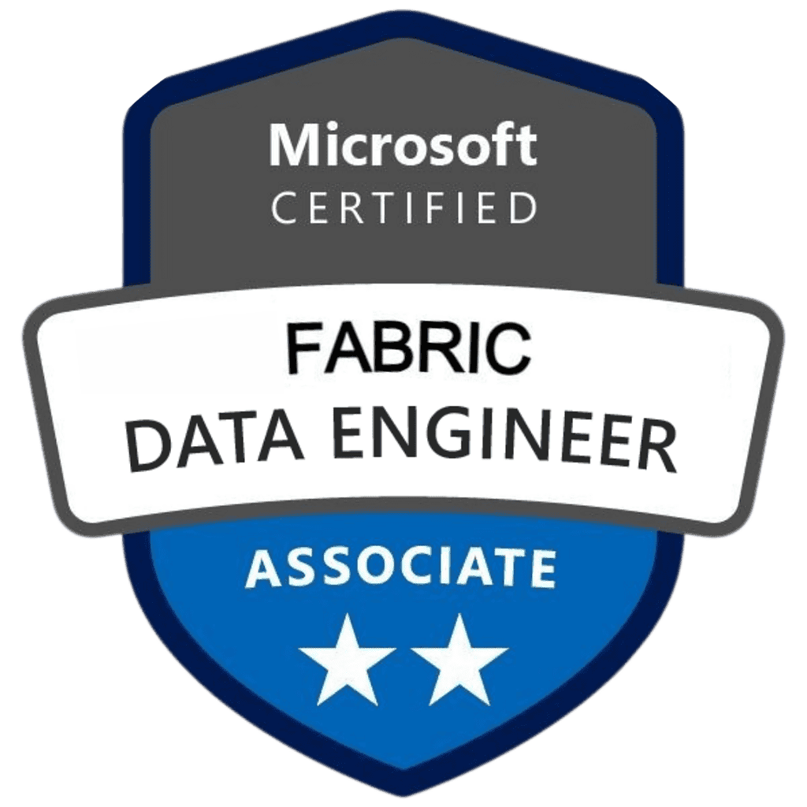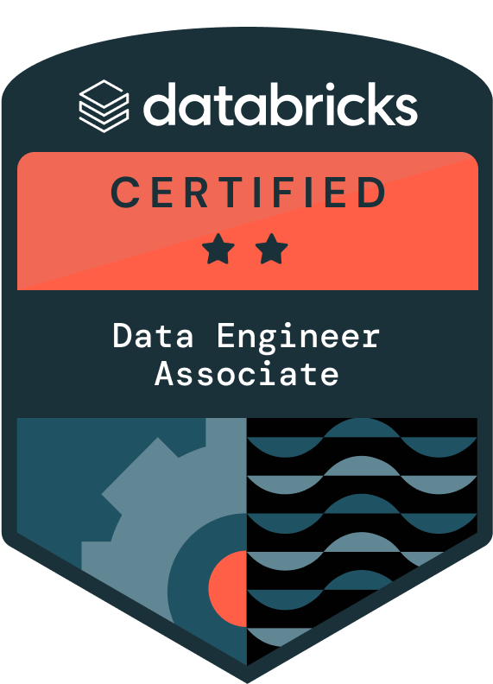
Senior Azure Data Engineer
Phone: +1 (773)359-3832
Email: harinikoradarao@gmail.com
LinkedIn: https://www.linkedin.com/in/harinik16/
PROFESSIONAL SUMMARY
- Experienced Azure Data Engineer with over 11+ years of IT experience, including 7+ years in Azure Data Engineering and 4+ years in Big Data and Data Warehousing, specializing in building scalable, secure, and high-performance data solutions.
- Expertise in Azure Cloud Services including Azure Data Factory (ADF), Azure Databricks, Azure Synapse Analytics, ADLS Gen2, Blob Storage, Azure Key Vault, Logic Apps, Function Apps, and Azure DevOps for building end-to-end data pipelines and secure enterprise-grade integrations.
- Strong hands-on experience configuring and tuning Azure Databricks environments with advanced features like Delta Live Tables (DLT) and Time Travel for efficient, high-performance data processing.
- Designed Medallion Architecture (Bronze, Silver, Gold) in ADLS Gen2 with Delta Live Tables and Unity Catalog, improving data reliability, governance, and reusability across enterprise-scale analytics pipelines.
- Hands-on with Microsoft Fabric, Delta Lake, and Power BI for advanced analytics, MLOps, and business intelligence implementations across structured and semi-structured data landscapes.
- Integrated AI and machine learning models within Azure Databricks and Microsoft Fabric using MLflow, Azure Machine Learning, and Python to enable automated model training, scoring, and real-time predictive analytics for enterprise-scale data platforms.
- Successfully led 3 full-cycle Snowflake implementations, including Snowpipe ingestion, Streams/Tasks automation, and dbt-based modular transformations integrated with CI/CD workflows.
- Optimized Snowflake cost and performance by implementing clustering, materialized views, and query tuning strategies, reducing computing spend by 20% while maintaining SLA commitments for high-volume financial reporting.
- Built real-time streaming pipelines using Azure Stream Analytics, Event Hubs, and Databricks to power fraud detection, POS analytics, and patient health insights with sub-second latency.
- Implemented Unity Catalog-based access controls and cluster auto-scaling policies in Azure Databricks, reducing cloud spend by 15% while improving governance and ensuring efficient workload distribution across multiple business units.
- Developed and tuned Spark applications using PySpark, Spark SQL, HiveQL, and Scala with Azure Databricks, supporting large-scale ETL operations and advanced analytics.
- Delivered executive-level Power BI dashboards integrated with Purview lineage and governance KPIs, enabling leadership to track compliance, pipeline SLAs, and business metrics in near real-time.
- Experienced in data cataloging and governance using Azure Purview and Unity Catalog, ensuring metadata management, lineage tracking, and regulatory compliance.
- Collaborated with cross-functional teams across healthcare, retail, and banking domains to deliver regulatory-compliant, domain-specific data products — reducing fraud risk by 25%, improving patient insights by 30%, and accelerating financial reporting by 40%.
- Migrated data from Apache Hive, Oracle, SQL Server, Teradata, and Informatica-IICS into Azure SQL Database, Snowflake, and Azure Cosmos DB, ensuring compatibility, performance, and high availability.
- Played a key role in migrating legacy ETL workflows and on-premises data warehouse to cloud-native Azure and Snowflake platforms, ensuring minimal downtime and improving scalability and performance by 40%.
- Designed CI/CD pipelines using Azure DevOps, Jenkins, Bitbucket, GitHub, and Git, enabling automated build, test, and deployment of data workloads.
- Led the transformation of legacy on-prem data warehouses into modern Azure Data Lakehouse architectures, consolidating siloed systems into a unified analytics platform and reducing reporting latency by 35%.
- Implemented robust data quality framework and validation rules using PySpark, SQL, and Azure Data Factory to ensure completeness, accuracy, and consistency across complex multi-source ingestion pipelines.
- Wrote optimized queries in T-SQL, PL/SQL, K-SQL, and Snow SQL for querying SQL Server, Oracle, Snowflake, and PostgreSQL, improving performance and efficiency.
- Skilled in managing security and compliance with Azure Key Vault, Azure Active Directory (AD), and Entra ID, implementing secure authentication, secret management, and role-based access controls.
- Integrated monitoring tools like Azure Monitor, Splunk, Elasticsearch, and Datadog for proactive observability, alerting, and health checks of critical data infrastructure.
- Developed complex data models and performed data governance tasks across multiple data platforms using Dimensional Modeling, Star Schema, Slowly Changing Dimensions (SCD), and Data Vault principles.
- Designed custom scripts in Python, Unix Shell, and Bash for automation, validation, transformation, and monitoring of large-scale data workflows.
- Skilled in Agile and Waterfall delivery methodologies, leading sprint planning, retrospectives, and daily stand-ups using tools like Azure Boards, JIRA, and Azure DevOps pipelines.
- Demonstrated ability to lead client-facing meetings, collaborate across cross-functional teams, and deliver business-aligned solutions with excellent communication and documentation skills.
- Proficient in optimizing PostgreSQL environments for complex analytical workloads, applying indexing, partitioning, and clustering strategies to accelerate query performance across large datasets.

EDUCATION
- Master of Science in Computer Science, Illinois Institute of Technology, Chicago, Illinois, USA, Dec 2013
- Bachelor of Technology in Electronics and Communication Engineering, Jawaharlal Nehru Technological University, Hyderabad, India, May 2011

CERTIFICATIONS
- Microsoft Certified: Fabric Data Engineer Associate certification (DP-700)
- Microsoft Certified: Azure Data Engineer Associate (DP-203)
- Databricks Certified Data Engineer Associate

TECHNICAL SKILLS
Azure Services: Azure Data Factory (ADF), Microsoft Fabric, Azure Databricks, Synapse Analytics, ADLS Gen2, Blob Storage, Azure SQL DB, Cosmos Database, Event Hubs, Azure Stream Analytics, Apache Flink, Logic Apps, Azure Functions, Azure DevOps, Azure Monitor, Key Vault, Azure Active Directory (Entra ID), Unity Catalog, Purview, Azure Machine Learning, MLflow
Big Data & Integration: Apache Spark (Core, SQL, Streaming), Hadoop (HDFS, YARN, MapReduce, Hive, Sqoop, Flume), Kafka, DBT, Informatica IICS, Talend, Apache Flink, SQL Streaming
Databases & Warehousing: Snowflake (Snowpipe, Snowpark, Streams, Tasks), Azure Synapse Analytics, Azure SQL Database, SQL Server (2012,2014,2016,2019), Oracle, MySQL, PostgreSQL, DB2, Cassandra, MongoDB, HBase
Programming & Scripting: Python, PySpark, Shell Script (Bash/UNIX), Java, Scala, HiveQL, PL/SQL, SQL/T-SQL(Optimization)
Modeling & Architecture: Dimensional Modeling, Star & Snowflake Schema, SCD (Type 1/2), CDC, Data Vault, Medallion Architecture, Partitioning, Clustering, Materialized Views
DevOps & CI/CD: Git, GitHub, Jenkins, Azure DevOps, Terraform, Docker, Kubernetes, YAML, Helm, Bicep
BI & Visualization: Power BI, Tableau, SSRS, SSAS, Crystal Reports
Workflow & Monitoring: Apache Airflow, Control-M, Azure Logic Apps, Azure Monitor, Splunk, Elasticsearch
Methodologies & Tools: Agile (Scrum, Kanban), Erwin Data Modeler, Visual Studio, Azure Data Studio, SSMS, PyCharm
Operating Systems: Windows, Linux (Ubuntu, CentOS), UNIX

WORK EXPERIENCE
Boston Scientific, Arden Hills, MN June 2022 - Present
Senior Azure Data Engineer
Responsibilities:
- Designed and built end-to-end integrated data solutions using Microsoft Fabric’s Lakehouse and Dataflows Gen2, combining structured and semi-structured data into a unified analytics layer for real-time business reporting.
- Leveraged Microsoft Fabric pipelines and Power BI integration to streamline end-to-end data orchestration and visualization workflows, enabling faster delivery of insights across business units.
- Optimized and managed data flows using ADF and Databricks, improving data reliability and pipeline performance by 30%, while integrating Power BI and Synapse for actionable end-to-end analytics.
- Integrated and operationalized AI-based patient risk stratification and recommendation models in Azure Databricks using MLflow and Azure ML, collaborating with data scientists to automate retraining, inference, and Power BI–based predictive insights via Azure DevOps CI/CD.
- Ensured compliance with HIPAA, GDPR, and CCPA regulations by implementing strict role-based access controls (RBAC), data masking, and encryption policies across Azure Databricks, Synapse, and Snowflake environments.
- Implemented sensitive data classification and lineage tracking in Azure Purview and Unity Catalog to monitor and govern PHI/PII datasets, ensuring full auditability and transparency for regulatory inspections.
- Automated data retention and archival policies in ADLS Gen2 and Snowflake to comply with healthcare industry mandates for storing and purging patient health data.
- Implemented API-based ingestion and orchestration in Azure Data Factory, leveraging Azure Key Vault for credential management and Python SDKs for dynamic pipeline triggers, enabling seamless data exchange across enterprise healthcare systems.
- Implemented automated ingestion pipelines using Snowpipe with event notifications from Azure Data Lake, reducing data latency from hours to near real-time and ensuring continuous availability for analytics and reporting.
- Built custom data pipelines with Snowpark DataFrame APIs to support real-time analytics and reduce pipeline complexity by 30% compared to external Spark jobs.
- Implemented Snowpark UDFs and stored procedures for business-critical logic, ensuring scalability and performance optimization within the Snowflake engine.
- Established data stewardship workflows and metadata catalogs in Purview to enable traceability, improve trust in data assets, and streamline compliance audits.
- Explored integration of Snowflake Cortex and Databricks AI features to accelerate ML workflows directly within the platform.
- Conducted compliance risk assessments and implemented proactive controls to mitigate potential exposure of sensitive patient health information across cloud and on-premises hybrid pipelines.
- Developed automated GDPR ‘Right to be Forgotten’ workflows in Azure Data Factory to locate and securely erase patient data upon request, ensuring regulatory SLA compliance.
- Designed fine-grained access policies leveraging Azure Key Vault, Azure AD, and Unity Catalog, ensuring only authorized clinicians and analysts could query sensitive patient datasets.
- Leveraged Unity Catalog to enforce fine-grained access auditing and data discovery across Databricks and ADLS Gen2, improving governance transparency for PHI/PII datasets.
- Integrated data anonymization and pseudonymization techniques in pipelines to safeguard patient identifiers (PII/PHI) while still enabling advanced analytics and machine learning use cases.
- Created compliance dashboards in Power BI for executives to track adherence to healthcare regulations, highlighting data governance KPIs such as data lineage coverage, classification accuracy, and audit readiness.
- Partnered with InfoSec and compliance teams to implement Data Loss Prevention (DLP) rules in Azure, preventing unauthorized sharing or exposure of protected datasets.
- Reduced manual intervention by 50% by developing event-driven Azure Function Apps to automate validation and metadata logging on Blob Storage file landing.
- Implemented automated data quality checks in ADF and Databricks pipelines, ensuring 99% accuracy in patient health data ingestion and reducing downstream reporting errors.
- Implemented ADLS Gen2 with Delta Live Tables and Purview for governed real-time data processing; leveraged Synapse (including K-SQL) for scalable analytics.
- Led client-facing architecture workshops, presenting Snowflake and Databricks solutions to executive stakeholders, building trust and aligning technical strategy with business objectives.
- Utilized Azure Monitor to monitor and optimize the performance of data pipelines and services, allowing for proactive issue resolution and performance improvements with Azure Databricks notebooks and interactive dashboards and Synapse analytics tools.
- Built a personalized recommendation system in Databricks, increasing campaign engagement insights by 40% through advanced PySpark modeling, workflow automation via Control-M, and Power BI visualization.
- Ensured data security and compliance by utilizing Azure Key Vault to securely store and manage sensitive data, including credentials and secrets with Azure Active Directory integration and Data Governance frameworks. Implemented a Medallion Architecture with bronze, silver, and gold layers in ADLS Gen2, ensuring efficient data processing and storage for raw, validated, and enriched data with DLT and Unity Catalog.
- Leveraged Apache Spark (PySpark, Scala, Python) for large-scale transformations and advanced analytics, implementing Time Travel, parallel processing, and optimized ETL workflows.
- Integrated triggered schedules for automated updates, providing precise and timely data refreshes for well-informed decision-making through Azure Synapse Analytics with Azure Stream Analytics for real-time processing.
- Shortened release cycles by 25% by implementing CI/CD automation through Azure DevOps and Jenkins, including rollback strategies and validation logic.
- Configured Jenkins to orchestrate deployment pipelines for Databricks notebooks and ADF JSON templates, integrating automated test validation and rollback strategies.
- Orchestrated large-scale data workflows using Control-M alongside Azure Data Factory, ensuring reliable scheduling, monitoring, and recovery of mission-critical healthcare pipelines.
- Conducted root cause analysis for data processing failures and implemented preventive measures to mitigate future incidents using Azure Synapse Analytics with Azure Cosmos DB integrations.
- Reduced data delivery SLA breaches by 80% by implementing monitoring dashboards using Azure Monitor and Power BI, with proactive alerting and recovery logic built into pipeline workflows.
- Optimized PySpark and SQL workloads in Azure Databricks through partitioning, caching, query tuning, and Spark performance testing, reducing processing time by 35% and improving resource utilization.
- Optimized Snowflake and Azure Databricks workloads by implementing clustering, caching, and cost-monitoring policies, reducing cloud compute costs by 20% while maintaining performance SLAs.
- Utilized Git for version control and implemented CI/CD workflows integrating DBT for modular SQL models and Snow Pipes for automated ingestion into Snowflake. Migrated datasets from Informatica-IICS and Oracle for unified reporting and analytics.
- Integrated DBT with Azure Databricks for modular SQL transformations, automated testing, and version-controlled pipeline deployments, improving reliability and reducing rework across analytics workflows.
- Practiced Agile methodologies (Scrum, Kanban) using JIRA for sprint tracking, retrospectives, and delivery planning, with a strong focus on data governance and cross-functional team alignment.
- Maintained clear and consistent communication channels between teams to ensure transparency on deliverables and built executive-level reports using BI reporting tools like Tableau to track business KPIs from curated Gold datasets.
- Collaborated successfully with cross-functional teams, including data engineers, developers, and business stakeholders, to gather requirements, prioritize work, and develop value-added solutions with Dimensional Modeling and Python scripting.
Environment: Microsoft Fabric, Azure Data Factory (ADF), Azure Databricks, Delta Live Tables (DLT), Synapse Analytics, ADLS Gen2, Power BI, Cosmos DB, Event Hubs, Azure Stream Analytics, Azure Functions, REST APIs, Logic Apps, Key Vault, Unity Catalog, Purview, Azure DevOps, Entra ID, Azure Machine Learning, MLflow, AI/ML Pipelines, Control-M, Scala, Jenkins, Python, PySpark, T-SQL, DBT, Snowpipe, Snowpark, Snowflake, Terraform, Kubernetes, Docker, Tableau.

PNC Bank, Atlanta, GA Apr 2018 – May 2022
Data Engineer
Responsibilities:
- Designed real-time streaming pipelines using Azure Stream Analytics and Databricks notebooks, reducing POS transaction processing latency by 40% and enabling sub-second customer interactions across 2000+ endpoints.
- Automated real-time POS transaction responses using Azure Functions and Data Flows, while integrating Azure Monitor with custom alerts to ensure high availability, secure access via Entra ID, and reduced SLA breaches across 2,000+ retail banking endpoints.
- Built PySpark-based credit risk scoring pipelines in Databricks by aggregating repayment history and real-time Event Hub feeds, enabling faster loan approvals and reducing credit risk exposure.
- Engineered streaming pipelines in Azure Databricks and Stream Analytics to detect fraudulent card transactions in near real-time, integrating Event Hubs with rule-based anomaly detection models to reduce fraud risk by 25%.
- Developed Synapse and Snowflake pipelines with Purview lineage tracking to support SOX financial reporting and Basel III risk dashboards, ensuring transparent audit trails and compliance with banking regulations.
- Integrated POS, CRM, and mobile banking data into Snowflake and Cosmos DB to create unified Customer 360 profiles, enabling Power BI dashboards for customer segmentation and personalized financial products.
- Processed high-volume stock trade and FX market feeds in Synapse Analytics and Snowflake using Snowpipes, improving reporting SLAs for treasury and risk teams by 40%.
- Built Spark-based enrichment and transformation jobs using Python, SQL, and K-SQL, visualized POS analytics with interactive dashboards and reports.
- Implemented automated data quality frameworks in ADF and Databricks pipelines to validate POS, ATM, and online banking transactions, ensuring 99.9% accuracy and reducing reconciliation errors in financial reporting.
- Built branch-level Power BI dashboards using Snowflake datasets and T-SQL models to improve operational transparency, reduce manual reporting, and deliver executive insights 40% faster.
- Optimized Snowflake and Databricks workloads with clustering, caching, and cost-monitoring policies, reducing cloud spend by 20% while meeting SLA commitments.
- Collaborated with FICO risk systems to integrate credit risk scoring models into Airflow-orchestrated pipelines, enabling near real-time risk evaluation and supporting lending and credit decision processes.
- Implemented Basel III risk-weighted asset (RWA) data aggregation pipelines in Synapse and Snowflake, improving accuracy of capital adequacy reports and reducing reconciliation time by 30%.
- Developed CI/CD pipelines in Azure DevOps, cutting deployment time by 50% and reducing release rollback incidents by 30% through integration of PySpark, Snow Pipes, and automated trigger validation.
- Troubleshot and resolved pipeline issues in Azure Databricks using Azure Monitor and diagnostic logs to maintain high availability, reduce downtime, and ensure smooth POS data processing.
- Designed historical data retention and archival strategies in ADLS Gen2 and Snowflake with tiered storage policies, reducing storage costs by 18% while ensuring audit readiness for regulatory inspections.
- Managed secrets and authentication in ADF pipelines using Azure Key Vault and Entra ID to implement secure credential rotation, centralized access control, and audit compliance.
- Implemented RBAC and column-level security in Snowflake and ADF pipelines to align with internal governance policies, enforce access restrictions, and secure sensitive financial data.
- Applied Azure Boards and Logic Apps for agile task management and automated workflows, integrating CDC logic to support near real-time monitoring of streaming pipelines.
- Processed legacy financial datasets on Azure HDInsight (Hive, MapReduce, YARN) to deliver compliance reporting, historical transaction trend analysis, and archival insights required for banking regulators.
- Implemented modular, version-controlled data models integrated with Git and Azure Data Catalog, enabling reusable transformations, full lineage tracking, and self-service Power BI analytics for branch-level banking operations.
- Reduced ETL cycle time by 25% through PySpark parallelization in Azure Databricks, improving data pipeline performance, throughput, and reporting freshness.
- Tuned complex SQL queries and indexing strategies in Azure SQL DB to improve data retrieval performance by 45% and enhance dashboard responsiveness for business users.
- Improved POS transaction performance using Azure Redis Cache and Synapse Analytics by reducing latency and optimizing streaming dataflow for faster user interactions.
- Followed Agile (Scrum, Kanban) methodology to deliver iterative enhancements, manage sprints, and implement zero-copy cloning for improved versioning and traceability.
- Collaborated across DevOps, analysts, and engineering teams using Python and Databricks to build scalable pipelines with embedded data governance and compliance logic.
- Worked directly with stakeholders to convert K-SQL use cases and business requirements into real-time pipelines that powered fraud detection and transaction analytics.
Environment: Azure Stream Analytics, Azure Databricks, Azure Event Hubs, Azure Data Factory (ADF), Azure Functions, Azure SQL Database, Cosmos DB, Synapse Analytics, Azure DevOps, Azure Monitor, Snowflake, Python, PySpark, SQL, T-SQL, Power BI, Data Governance, Agile (Scrum, Kanban).

CVS Health, Woonsocket, RI Dec 2016 - Mar 2018
Data Analyst
Responsibilities:
- Designed healthcare data integration pipelines across Hadoop and RDBMS systems to streamline pharmacy claims processing, reducing query latency and cutting storage costs through optimized execution.
- Developed Hadoop ingestion pipelines with Sqoop, MapReduce, and Hive to process pharmacy claims and patient datasets, ensuring HIPAA compliance and lineage tracking through Informatica-IICS.
- Automated Hadoop ETL workflows for pharmacy claims ingestion and monitoring using Python, SQL, and Bash/UNIX scripting, reducing manual effort and ensuring SLA compliance.
- Implemented HIPAA-compliant PII masking and SCD logic in Hive and Informatica-IICS, ensuring secure handling of patient and prescription data.
- Migrated legacy Teradata workloads into Hadoop and Snowflake, reducing reporting latency for claims processing by 30% and lowering infrastructure costs.
- Integrated SAS-based risk models with Hadoop/Snowflake pipelines to generate pharmacy compliance and patient outcome reports.
- Optimized Hive and PySpark queries on large-scale claims datasets using partitioning and bucketing, improving compliance reporting speed by 25% for pharmacy audits.
- Managed healthcare datasets in AVRO, Parquet, and Hive formats, implemented SCD logic, and integrated outputs with Snowflake for pharmacy and patient compliance reporting.
- Designed historical claims trend analysis pipelines in Hadoop to support regulatory audits and improve reporting transparency for healthcare compliance teams.
- Created reusable Hive and Snowflake transformation scripts to modularize logic for pharmacy compliance and patient reporting, improving maintainability and reusability.
- Implemented lineage and audit logging in Hadoop pipelines using Informatica-IICS and Hive metadata tables, improving regulatory audit readiness by 30%.
- Migrated critical compliance dashboards from SAS to Snowflake and Power BI, reducing reporting cycles from weekly to daily for regulatory stakeholders.
- Developed Snow SQL scripts to validate and transform pharmacy claims data in Snowflake, improving reporting accuracy for compliance dashboards.
- Designed real-time streaming solutions with Kafka and Spark Streaming to process pharmacy transactions and prescription refills in near real-time.
- Implemented Flume- and Pig-based ingestion for early-stage pharmacy transaction feeds with Cassandra session persistence, later migrating workloads to Spark for scalability.
- Orchestrated Hadoop workflows with Oozie and YARN, managing resource allocation and job scheduling for pharmacy claims pipelines while ensuring SLA compliance.
- Managed enterprise-scale pharmacy data pipelines on Cloudera Hadoop, ensuring secure integration with Informatica-IICS and Hive for governed ingestion.
- Built Power BI and Tableau dashboards with drilldowns for claims, inventory, and adherence, enabling leadership to track KPIs such as refill gaps, churn risk, and compliance rates, reducing reporting time by 30%.
- Designed monitoring dashboards using Power BI for Hadoop ingestion jobs, integrating log metrics from Spark and Hive for proactive alerting.
- Followed Agile methodology using JIRA to manage sprints, track ingestion tasks, and deliver compliance-driven enhancements on time.
- Collaborated with compliance teams to ensure HIPAA-aligned data modeling and reporting practices across Hive, Snowflake, and Power BI environments.
Environment: Hadoop (Cloudera, HDFS, Hive, Sqoop, MapReduce, Pig, Flume, Oozie, YARN, Zookeeper), Spark (PySpark, Spark SQL, Streaming), Kafka, Snowflake, Informatica-IICS, SAS, Cassandra, AVRO/Parquet, Teradata, Python, SQL/T-SQL, Bash/UNIX, Power BI, Tableau, Talend, JIRA, Linux.

Procter & Gamble, San Francisco, CA Jan 2014 - Nov 2016
Data Modeler
Responsibilities:
- Designed and implemented normalized data models (2NF, 3NF, BCNF) in SQL Server 2012/2014 to streamline integration of pharmacy sales, inventory, and finance datasets from Microsoft Access and Excel, applying T-SQL and PL/SQL for data validation and transformations.
- Applied normalization techniques (1NF, 2NF, 3NF, BCNF) to OLTP systems in SQL Server 2012/2014, reducing redundancy and improving data integrity for financial and operational reporting.
- Modeled sales and supply chain datasets in Erwin using Star and Snowflake schemas to support forecasting of product demand, enabling executives to optimize manufacturing schedules and reduce inventory overhead by 15%.
- Integrated SAP ERP and Oracle financial data into SQL Server warehouse models, ensuring consistent lineage for revenue, procurement, and cost-center reporting across global P&G operations.
- Developed surrogate key strategies and slowly changing dimensions (SCD Type 2) to capture historical changes in vendor contracts, sales regions, and product hierarchies, improving auditability and compliance reporting.
- Collaborated with manufacturing and logistics teams to design normalized OLTP models supporting production line monitoring, shipping workflows, and retail sales transactions, reducing duplicate data entry across business units.
- Documented entity-relationship diagrams (ERDs), source-to-target mappings, and metadata repositories in Erwin, ensuring clear lineage and consistent design standards for cross-functional business teams.
- Conducted in-depth data profiling and lineage mapping for hubs, links, and satellites in Data Vault architecture, managing metadata using Erwin and T-SQL scripts.
- Designed reusable T-SQL stored procedures and views for data ingestion and cleansing, eliminating redundant storage and improving data consistency across sales and supply chain reporting layers.
- Developed and optimized SQL and PL/SQL scripts for ETL, data cleansing, and performance tuning across operational systems and analytical layers.
- Created interactive enterprise reports using SQL Server Reporting Services (SSRS), Crystal Reports, and Cognos Impromptu, including drilldowns, sub-reports, and navigational views from OLTP and OLAP sources via SQL Server Analysis Services.
- Enhanced and troubleshot SSRS reports using OLAP, conditional formatting, Top-N queries, and crosstabs, aligned with normalized OLTP data models.
- Utilized Snow Pipes to support continuous data loading into Snowflake for real-time analytics and self-service dashboarding.
- Developed parameterized stored procedures and reusable views to streamline transformation logic within reporting pipelines.
- Performed integrity checks through row-level audits and reconciliation across multi-source systems, ensuring accuracy in migrated datasets.
- Led peer reviews for Erwin models, enforcing naming conventions, standardization of primary/foreign keys, and alignment with enterprise data governance policies.
- Led database deployment support by preparing version-controlled scripts, coordinating QA signoff, and executing release plans with DevOps.
- Built and deployed containerized data integration applications to ensure high availability, scalability, and fault tolerance across environments.
- Automated infrastructure provisioning as Infrastructure as Code (IaC), enabling secure and repeatable environment setup for development, QA, and production.
Environment: SQL Server 2012/2014, SSRS, SSAS, Erwin Data Modeler, T-SQL, PL/SQL, Crystal Reports, Docker, MS Access, Excel, MS Office, OLTP, OLAP, Data Vault, Star & Snowflake Schema.

