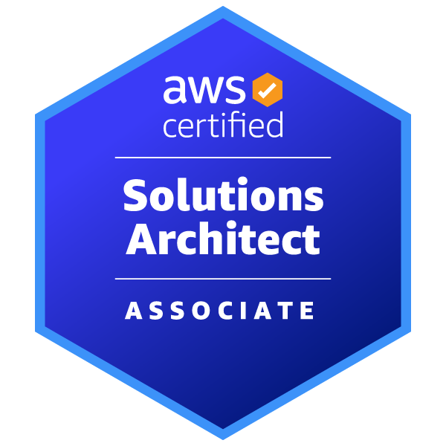
HARSHINI M
 mandalapu.harshini@gmail.com | +1 202-527-8036
PROFESSIONAL SUMMARY
- Python Developer with multiple client experience in developing scalable cloud applications on AWS.
- Proficient in Python for backend services, automation, and cloud integration using AWS Lambda, API Gateway, DynamoDB, and Boto3.
- Proficient in containerization using Docker, Kubernetes, and AWS EKS, with hands-on experience in orchestrating microservices and managing complex, distributed systems
- Proven ability to optimize cloud infrastructure for cost-efficiency, performance, and security using automation tools and best practices
- Experienced at incident management using JIRA, with a track record of effectively installing, configuring, automating, and monitoring IaaS, PaaS, and SaaS solutions
- Demonstrated problem-solving skills with a focus on maintaining high system reliability and security, ensuring seamless operation and robust protection of critical data
TECHNICAL SKILLS
- Programming Languages: C, Python, HTML, Shell Scripting, R, Java
- Database: MySQL, Oracle SQL, PostgreSQL, DynamoDB, Neptune
- DevOps Tools: Jenkins, GIT, Maven, Kubernetes, Docker, Terraform, Ansible, Argo CD, SonarQube, Prometheus
- Cloud Platform: Amazon Web Services (S3, IAM, SNS, Lambda, ECS, EKS, Code Pipeline, CloudFormation), Microsoft Azure (VM, IAM, Azure Entra ID, AKS, Azure Functions, Blob Storage, Key Vault, CLI)
- ML Techniques: TensorFlow, Seaborn, Matplotlib, Scikit-Learn, Random Forest, Decision Trees, K Means
- Frameworks: Flask, FastAPI
WORK EXPERIENCE
Idexcel, Inc Herndon, VA
Python Developer August 2022 - Present
- Created a comprehensive monitoring dashboard using Python to extract and visualize data from AWS services (CodePipeline, CloudWatch, EKS API) for real-time CI/CD pipeline and EKS cluster health
- Implemented Python Lambda functions for intelligent cost optimization that automatically managed EC2 instance lifecycles during non-peak hours, reducing AWS costs by 30%
- Authored Python automation scripts to enforce dynamic log retention policies via CloudWatch API, eliminating manual configuration across multiple environments
- Built a Python-based AMI lifecycle management system with custom validation logic to reduce storage costs while maintaining critical system backups
- Developed and deployed scalable web applications using Flask and FastAPI, optimizing API performance and ensuring efficient request handling with asynchronous capabilities.
- Designed RESTful APIs and integrated them with front-end applications, leveraging FastAPI’s asynchronous features for high-performance microservices.
- Implemented authentication, request validation, and middleware using Flask & FastAPI, ensuring secure and efficient API interactions.
- Enhanced SonarQube integration by developing Python scripts that improved report retrieval accuracy using execution ID-based queries
- Designed serverless offboarding automation with Python Lambda functions and API Gateway, implementing secure approval workflows with automated notifications
- Used Python to troubleshoot and resolve cross-account AWS resource access issues, ensuring proper IAM trust relationships for Route 53 DNS updates.
- Implemented automated test frameworks using tools like Pytest, Unittest, and Selenium, improving test coverage and accelerating CI/CD pipelines.
- Designed and executed end-to-end testing strategies for Flask and FastAPI-based applications, ensuring API reliability, security, and performance.
- Developed Python utilities to support Infrastructure-as-Code deployments, consolidating multiple pipelines into a streamlined workflow and reducing operational overhead
- Optimized AWS Code Build processes by implementing parallel build stages and integrating with Code Pipeline, reducing build times by 50%.
- Created robust solutions using AWS Step Functions to manage state failures, ensuring uninterrupted workflows and improving system reliability by 25%.
- Developed an automated rejection mechanism for AWS CodePipeline using Python scripts to integrate with security token API, eliminating manual intervention for non-compliant builds
- Implemented advanced cost monitoring and alerting using AWS Budgets and CloudWatch, achieving cost savings of 30% through proactive management.
- Proficient in Robotic Process Automation (RPA) tools to automate repetitive business processes and enhance operational efficiency.
- Enhanced containerized application performance by reducing Docker image sizes by 40%, resulting in 20% faster startup times and lower resource consumption.
- Specialized in relational and NoSQL databases, including Oracle, MySQL, DynamoDB, and Neptune, executing advanced SQL and PL/SQL programming.
- Adopted GIT Ops with Argo CD for Kubernetes deployments, ensuring synchronization between Git repositories and cluster states.
- Designed Jenkins pipelines for seamless build, testing, and deployment. Integrated tools like JUnit for testing and SonarQube for code quality and coverage checks.
- Supported multiple environment deployment activities, ensuring successful rollouts and minimizing downtimes.
- Developed Python-based analysis tools to optimize ECS deployments, reducing deployment times by 70% through identifying and resolving configuration bottlenecks

Environment: AWS (Code Build, Code Pipeline, Lambda, Step Functions, Budgets, CloudWatch, S3, Route 53),Flask, FastApi, Pytest, RPA, Docker, Terraform, Kubernetes, Prometheus, Grafana, Prometheus Alert manager, Oracle, MySQL, DynamoDB, Neptune, Git, Argo CD, Jenkins, JUnit, SonarQube, Azure, Bash, Shell, Python, SQL, PL/SQL.

Cognizant Technology Solutions Hyderabad, Telangana
Programmer Analyst/ AWS Jan 2020 - June 2022
- Engineered Shell and Python scripts to streamline automation, boosting operational efficiency and reducing manual tasks by 40%.
- Designed Docker containers for applications and deployed them on AWS Elastic Beanstalk, organizing deployment workflows.
- Streamlined AWS Code Pipeline workflows to support multiple parallel executions by configuring stages and actions, reducing deployment times by 40% across various environments.
- Extensive experience in testing methodologies, including Behavior-Driven Development (BDD), Test-Driven Development (TDD), Unit Testing, Regression Testing, and Synthetic Testing to ensure robust and reliable applications.
- Enhanced system scalability by managing rolling updates and auto-scaling, improving response times during peak loads by 30%.
- Tailored YAML configurations to optimize pod, service, and deployment efficiency.
- Facilitated Kubernetes integration, overseeing reproducible builds, Helm templating.
- Set up Jenkins for automated builds, configuring master-slave node architecture in Linux environments.
- Managed SonarQube for code quality analysis in AWS CI/CD pipelines, upgrading coding standards and identifying technical improvements.
- Utilized Ansible to develop playbooks for configuration management, file transfers to Test/UAT environments, and application server patching.
- Crafted GitHub Actions CI/CD pipelines for automated builds, tests, and deployments, simplifying deployment errors by 90%.
- Successfully completed targeted training in Java with Selenium and TestNG, applying these to enhance automation frameworks for healthcare and e-commerce projects, achieving a 95% success rate in automated test cases.
- Implemented secure password management using HashiCorp Vault and AWS Secrets Manager, reducing security incidents by 30% and automating credential rotation by 100%.
- Led containerized application deployments on AWS using EKS, enhancing deployment speed by 35% and increasing scalability by 40%.
- Deployed and managed cloud resources in Azure, contributing to multi-cloud strategies for hybrid deployments.
- Spearheaded a container orchestration strategy with Kubernetes, enabling blue-green deployments and achieving near-zero downtime during application updates.

Environment: AWS (Elastic Beanstalk, Code Pipeline, CI/CD, EKS, Secrets Manager,) HashiCorp Vault, Docker, Kubernetes, Helm, YAML, Jenkins, Linux, SonarQube, Ansible, GitHub Actions, Azure, Selenium, TestNG, Java, Kubernetes Blue-Green Deployment.

TECHNICAL PROJECTS
Python Developer, Idexcel, Inc / Loan Originating System July 2023 – Present
- Orchestrated the Loan Origination System (LOS) project, developing Python lambda serverless services. Implemented APIs for system integration and automated workflows with CI/CD pipelines using CloudFormation, Terraform, and AWS (EKS, Lambda, S3). Enhanced system performance and reliability with Kubernetes orchestration, Prometheus monitoring, and AI-driven financial automation.

Student, The George Washington University / Budget Boss February 2023 - April 2023
- Deployed the Budget Boss app on AWS infrastructure, leveraging EC2 instances for hosting the Java backend and RDS MySQL database. Created API Gateway and VPC for secure communication and scalability.
Programmer Analyst, Cognizant Technology Solutions / NovaRIM December 2019 - June 2022
- Led NovaRIM project, overseeing Maven-based source code compilation and packaging. Established robust CI/CD pipelines integrating Git, GitHub, Jenkins, and Kubernetes. Orchestrated deployments using Kubernetes clusters.
EDUCATION
George Washington University, School of Engineering & Applied Science Washington, DC
Master of Science in Computer Science (GPA 3.94/4) May 2024
Gayatri Vidya Parishad College of Engineering (A) Visakhapatnam, India
Bachelor of Science in Electronics & Communication Engineering (GPA 8.97/10) September 2020

CERTIFICATIONS
- AWS Certified Solutions Architect – Associate [Certification]

