RASHMITHA REDDY
SERVICE NOW DEVELOPER
+1 940-905-9363 | rashmitha.rp01@gmail.com | <linked in> Open to relocate
SUMMARY:
- Overall 9+ years of experience in the IT Industry with experience in ITIL and IT service management solutions with expertise in ITSM and service delivery process, and Human Resource service Delivery (HRSD)modules in ServiceNow.
- Experienced in the analysis and development of various ITSM processes, including Incident Management, Problem Management, Change Management & Release Management.
- Experience working with Business Rules, Client Scripts, UI policies, UI Actions, Script Includes, Dictionary Overrides, Access Control Lists, etc.
- Experience in developing ServiceNow portal UI pages using AngularJS (1.6), HTML5, CSS, JavaScript, and Twitter Bootstrap in ServiceNow Studio.
- Leading Service Now releases Implementations, Upgrades, Planning, and Execution.
- Extensive hands-on experience with HR Service Delivery (HRSD) modules, including HR Case Management, HR Knowledge, and Lifecycle Events such as Onboarding and Offboarding, driving seamless HR process automation.
- Proficient in ServiceNow Discovery and Service Mapping, ensuring CMDB accuracy and enabling proactive monitoring of IT infrastructure.
- Skilled in implementing Workplace Service Delivery (WSD) to streamline facilities, reservations, and space management services for improved workplace efficiency.
- Expertise in designing and deploying Work-to-Pay (W2P) and Source-to-Pay (S2P) workflows to automate procurement, vendor management, and financial approvals, aligning with enterprise compliance.
- Strong background in integrations with third-party HR, ERP, and vendor management systems using REST, SOAP, and Integration Hub, improving cross-platform data consistency.
- Adept at configuring CSDM and CMDB models, defining CI relationships, and applying ITIL best practices for incident, change, and problem management.
- Experienced in developing custom ServiceNow solutions using Business Rules, Script Includes, UI Actions, Client Scripts, and Flow Designer for ITSM, HRSD, and ITOM.
- Used ServiceNow Platform Feature Flow Designer and automated approvals, tasks, notifications, and records.
Operations.
- Hands-on experience in HRSD modules like HR Case management, HR knowledge management, HR portal, and Enterprise Onboarding.
- Performs maturity assessments on ITAM and CMDB customer processes.
- Worked on creation and configuration workflows and custom workflow activities.
- Experience in building Items and Order Guides, Record Producers in the Service Catalog.
- Experience in Email Integration, LDAP integration, External Web services Integration (both SOAP and REST) in Service Now.
- Experience in Terraform for creating stacks of VPCs, EC2s, ELBs, Security groups, SQS queues, and S3 buckets in AWS and updating the Terraform Scripts based on the requirements on a regular basis.
- Created Widgets for showing records on the website homepage dynamically.
- Performed service with applications, including Knowledge Base, Service Catalog, Workflows, SLAs, and Reporting.
- Having experience in writing SQL Queries.
- Successfully managed large-scale implementations of Service Now across multiple processes and applications for clients in multiple verticals.
- Develop Enterprise Mobile and web application development using AngularJS/Twitter Bootstrap and manual testing of web/mobile applications.
- Experience in phases of SDLC Requirement analysis, Implementation, Maintenance, and experience with Agile Methodology.
- Experienced in Amazon Web Services (AWS) services like EC2, S3, VPC, ELB, EBS, Glacier, RDS, Cloud Watch, Security Groups, Code Commit, Code Pipeline, Code Deploy, Auto scaling, Cloud Formation, Cloud Trail, IAM, SNS
- Strong understanding of fundamental business processes, excellent Communication, and interpersonal skills with the ability to work well in a dynamic team environment.
- Participated in workshops (innovative technologies, enhancement) with Service Now partner teams to help the company implement Service Now using best practices in ITSM.
- Worked well and provided consistent support with the team, as I insisted on achieving the targets ahead.


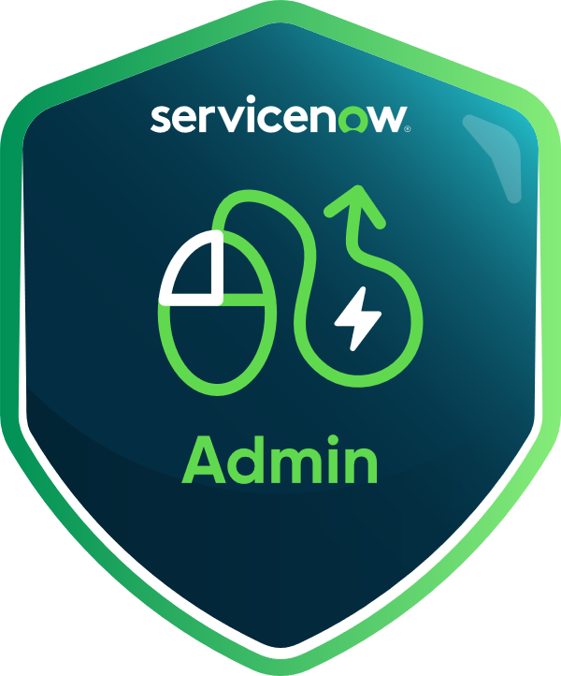
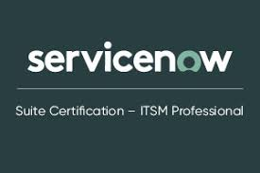


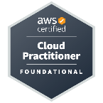
CERTIFICATION:
- ITIL
- Service Now certified
- Certified (CSA)2020
- Welcome to Service Now
- AWS Solutions Architect
- AWS Cloud Practitioner

EDUCATION:
Master’s | University of North Texas May 2024
Bachelor's | Jawaharlal Nehru Technological University May 2016

TECHNICAL SKILLS:
ITIL | Service Now, ServiceNow FSM/FSO, ITSM, CMDB, Integration hub
ServiceNow Modules | ITSM, HRSD, CMDB, ITOM Discovery, Service Mapping, CSDM, WSD (Workplace Service Delivery), W2P (Work-to-Pay), S2P (Source-to-Pay)
Languages | JavaScript, JSON, HTML, CSS, XML, AngularJS
Web/Application Server | Tomcat Web Server, MID Server
Tools and Utilities | MS Word, MS PowerPoint, MS Excel, MS Visio, Abode creative cloud
Web/Applications Dev | UI Policies, Client Scripts, Business Rules, REST & SOAP APIs
Operating Systems | Windows XP/ VISTA/7, Red Hat Linux, and Unix.
Object Modelling Software Process | SDLC, Waterfall, Agile Methodology
PROFESSIONAL EXPERIENCE:
Client: Nextiva Scottsdale, Arizona. Feb 2023 – Till Date
Title: Service Now Admin & Developer
Responsibilities:
- Designed, developed, and executed comprehensive test plans, test cases, and test scripts for multiple ServiceNow modules (ITSM, ITOM, ITAM, HRSD, FSM, and CMDB) ensuring full coverage of functional and non-functional requirements.
- Configured and customized Incident, Change, Problem, Release, Knowledge Management, Service Catalog, and CMDB modules in alignment with ITIL and telecom industry best practices.
- Built Service Catalog items, Order Guides, Record Producers, workflows, and execution plans; implemented Catalog Client Scripts, UI Policies, Notifications, and Scheduled Reports.
- Created custom tables, fields, ACLs, users, groups, and roles with strong access control and security policies.
- Developed custom UI Actions, Business Rules, Client Scripts, Script Includes, and Flow Designer actions to automate HR, IT, and telecom service processes.
- Integrated ServiceNow with third-party systems such as telecom service providers, payroll, ERP, vendor management, and facilities tools using REST/SOAP APIs, JDBC exports, and Integration Hub spokes.
- Implemented ITOM Discovery and Service Mapping to automate asset detection, populate the CMDB, and improve accuracy by 40%.
- Automated deployment pipelines by integrating Terraform with Jenkins to achieve Blue-Green deployments through Route 53 and ELB configurations.
- Implemented HRSD lifecycle events for onboarding and offboarding by integrating with payroll and benefits systems, reducing manual HR tasks by 30%.
- Extended HRSD with Workplace Service Delivery (WSD) and procurement workflows, enabling automation for space reservations, seating assignments, vendor onboarding, sourcing requests, contract management, and invoice reconciliation.
- Customized the ServiceNow Mobile App for HR, IT, and field services to deliver intuitive UI/UX, performance efficiency, offline support, and improved first-time fix rates for agents.
- Developed ServiceNow portal UI pages and widgets using AngularJS, HTML5, CSS, Jelly, JavaScript, and Bootstrap, enhancing self-service portal design and user experience.
- Collaborated with data scientists to deploy ML pipelines in production using Docker and Kubeflow, with automated test cases for monitoring and validation.
- Designed optimized data schemas for AI/ML models using SQL, Hadoop, and cloud services to accelerate data processing.
- Implemented iterative development procedures on Jupyter-based AI notebooks to support advanced analytics and prototyping.
- Led Field Service Management (FSM/FSO) implementations, including advanced dispatching, dynamic scheduling, work order lifecycle automation, inventory management, and mobile workflows for field technicians.
- Delivered tailored mobile and field experiences by customizing workflows and UI components, increasing productivity and efficiency.
- Managed update sets, upgrades, import sets, system performance optimization, and troubleshooting across multiple ServiceNow environments.
- Performed UAT, regression testing, and production validation using defined test scripts to ensure high-quality delivery.
- Performed functional, regression, integration, and end-to-end testing for all ServiceNow configurations, customizations, and workflows prior to production release.
- Created and maintained automated test scripts using ATF (Automated Test Framework) to validate UI actions, business rules, catalog items, and approval workflows.
- Validated custom Business Rules, Script Includes, UI Policies, and Flow Designer automations for accuracy, data integrity, and performance.
- Conducted defect triage and root-cause analysis sessions with developers and stakeholders to ensure timely resolution and high release quality.
- Coordinated with product owners to define acceptance criteria and verify that developed features aligned with ITIL-based service management practices.
- Executed UAT (User Acceptance Testing) in collaboration with business users to confirm business functionality and ensure readiness for deployment.
- Monitored ServiceNow instance upgrades and performed post-upgrade regression validation to certify all custom applications for use.
- Utilized Agile and Scrum methodologies to maintain traceability between test cases, user stories, and defects in JIRA or ServiceNow Agile Development module.
- Documented test execution results, bug metrics, and coverage reports to track quality trends and continuous improvement initiatives.

- Applied ITIL, ITOM, and TSM frameworks to standardize incident routing, change approvals, initiative-taking monitoring, and automation of repeatable service tasks.
Environment: Service Now Network, HRSD, CMDB, ServiceNow FSM/FSO, Incident, Problem, Change, SOAP, CSS, Knowledge management, Service Catalogs, Workflows, Catalog Client Script, Business Rules, UI Scripts, Client Scripts, UI policies.

Wipro Hyderabad, India Jan 2021- Aug 2022
Title: Service Now Consultant
Responsibilities:
- Communicating with end users, identifying their difficulties, and changing the applications as per their requirements.
- Controlled Security mechanism in Service Now using ACL and modified SLA according to the business requirements.
- Technical implementation of various Service Now modules such as change management, Incident management, problem management, and configuration management.
- Improved process quality by coordinating with team members. Designing and implementing ITAM solutions.
- Used AngularJS framework to bind HTML (views) to JavaScript objects (models)
- Service Catalog and Request Workflow Design and Configuration, and a written script includes and invokes them in business rules and reference qualifier.
- Successfully rolled out Human Resources Service Delivery (HRSD) for HR service centers located around the world.
- Rolled out HRSD modules globally, including HR Case Management and HR Knowledge, ensuring consistent HR services across multiple regions.
- Configured and implemented Workplace Service Delivery (WSD) solutions, automating seat assignments, space planning, and facilities requests to improve user satisfaction.
- Developed Work-to-Pay (W2P) catalog items and workflows to manage procurement approvals, invoice validation, and supplier interactions.
- Worked on Source-to-Pay (S2P) functionality in ServiceNow to streamline vendor request processes and maintain compliance with procurement policies.
- Configured and optimized CMDB/CSDM models, integrating with ServiceNow Discovery to maintain accurate CI relationships and support ITOM visibility.
- Led integration projects with HR and ERP systems, using REST and SOAP APIs for seamless cross-platform data flow.
- Applied ITIL best practices for incident, problem, and change processes, reducing SLA breaches by 25%.
- Resolved business issues and complaints by appropriate professional standards.
- Manage ITIL Processes monitoring overall system performance using the system performance and system diagnostic dashboards.
- Create and utilize update sets to move all the work from one instance to another instance.
- Manage Service Now Cloud Administrator activities with two primary responsibilities: configure the Cloud Management Platform and monitor the AWS Resources and, Assessing existing ITAM systems for improvements.

- Involved in daily, weekly, and monthly meetings with clients on the work progress and upcoming work.
- Updates & maintains comprehensive testing for service-now instance upgrades to certify all applications for use after the upgrade completes.
- Setting up, Configuring Management, preparing, and characterizing the CI classes and their connections.
- Implementation of changes to improve quality and efficiency in Service Now.
- Responsible for the Development of Team Performance and involved in grooming & mentoring team members on various processes.
- Performed create, read, update, and delete (CRUD) operations on the web server using outbound REST functionality.
Environment: Service Now London, REST, Configuration Management, Service Catalogs, UI policies, Data policies, CMDB, Access Controls, SLA, Workflows, and Reporting.
Client: Script Bees, Hyderabad, India March 2016 – December 2020
Title: Service Now Developer
Responsibilities:
- Customized UI Appearance for Incident, Problem and Change Management Application, which is simple, intuitive, and easy to use.
- Configuration of Email Notifications and Alerts to notify users about specific activities in the system such as updates to Incident, Problem and Change requests.
- Developed and Configured Business rules, Script Includes, Client Scripts, UI policies, and customized different processes, and implemented client-side scripting using jQuery and Angular.js.
- Designing architectures for ITAM systems, including integrations with financial, HR and other IT systems and ITIL processes.
- Worked on creation & Management of custom AWS Machine Images, EC2 transit gateways, EC2 Instance resources, ECS tasks using Terraform. Created new COE for health safety, and well-being part of HRSD.
- Involved in working with process owners to develop workflow, and implement workflows in Service Applications
- Created groups, roles, and security groups to access certain functionalities and a customized homepage.
- Indulged in update set tracking and export/import both in Helsinki and Jakarta versions.
- Worked on various modules of Service Now like Knowledge Management, Service Catalog, User Administration, and Reporting.
- Develop and manage application code, user interface, and third-party integration components.
- Performed Data migration to import data from other applications and external databases.
- Created Reports and Scheduler process to send reports to management about incidents, problems, and application diagnosis report-based control.
- Involved in UI development within Service Now, working with JavaScript and applying Business Rules.
- Configured Service Level Agreements to define certain levels of service from both Internal and external providers.
- Hands-on expertise in front-end technologies includes HTML, CSS, and XML.
- Responsible for access control, security, minor enhancements such as form or workflow editing, and gathering requirements and customizing Business Service Catalogs.
- Communicating with the end users and understanding the difficulties, and as per that, improving automation and efficiencies in Service Now.
- Use business analysis skills to directly interface with customers to design and build applications that build business goals and objectives.
Environment: Service Now, Incident Management, Problem Management, Change Management, Knowledge Management, Service Catalog, Reports, SLA, Java, HTML, CSS, jelly, XML, Linux, UNIX.

