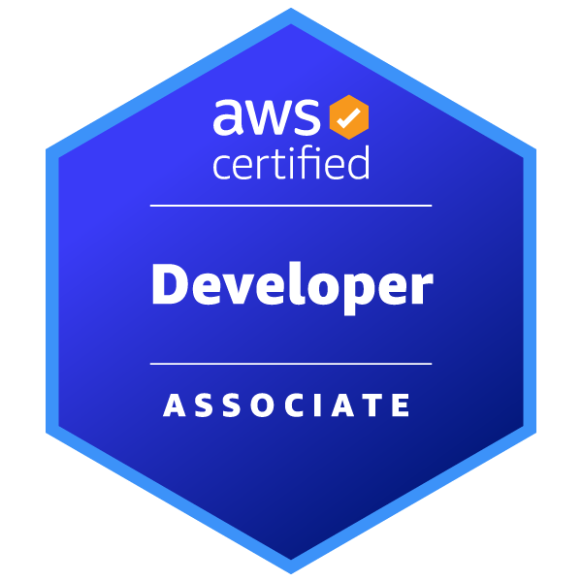
Mallesh Ashamoni
Sr Java Developer
+1-510-766-1374
amallesh945@gmail.com
https://www.linkedin.com/in/mallesha742/

SUMMARY:
Seasoned software engineer seeking a senior level position. Proficient experience with Java and cloud
based microservice solutions. Extensive years of experience and have worked in both small and large
scale environments. Highly productive working in both individual and team settings. Great leadership
qualities, communication skills, and mentoring capabilities. Overall team player with a passion for
problem solving.

TECHNICAL SKILLS:

- Expertised in developing, upgrading, and modernizing large-scale enterprise applications using Java 8/11/17/21, J2EE, Spring Boot, and Microservices architecture.
- Skilled in optimizing performance, ensuring security, and delivering robust CI/CD pipelines
- Experience in middleware technologies, including JBoss Fuse Apache Camel, IBM MQ, WebSphere Message Broker, and IBM Integration Bus (IIB).
- Proficient in designing and managing SQL databases (e.g., MySQL, PostgreSQL and OracleDB) and NoSQL databases (e.g., MongoDB,DynamoDB and Cassandra) to handle complex data requirements and experience with PL/SQL.
- Expertise in cloud-native development on AWS GCP and Azure platforms, leveraging modern tools like Gradle with Groovy Script, Maven, Docker, Kubernetes, and GitLab CI/CD for efficient deployments.
- Experised in version controls ,IDEs and tools like Git, BitBucket,Eclipse, IntelliJ, STS, Postman, Swagger, SonaQube, JUnit, Mockito, Jira, Slack, SLF4J and application Servers like Apache Tomcat, JBoss, Jetty.
- Exploring AI/ML concepts and strengthening my knowledge with basic Python skills to build foundational knowledge in Data Science as part of my ongoing professional development.

Certification:

- AWS Certified Developer - Associate

Professional Experience:

Client: Goldman Sachs - Dallas, TX Sep 2024 – Present
Role: Senior Java Developer

The project involved upgrading the enterprise application stack from Java 8 to Java 17 and Spring Boot 2.7 to 3.2.0, along with enhancing existing functionalities by refactoring and developing new endpoints. The goal was to leverage new Java features, improve code maintainability, optimize performance, and ensure compatibility with modern frameworks.

Responsibilities:

- Worked with Software Development methodologies like Agile/Scrum and Involved in business.
- Requirements and creating the Jira tickets for user stories.
- Upgraded project dependencies and codebase to ensure compatibility with Java 17, leveraging new features like Records, Text Blocks, and Switch Expressions for improved readability and efficiency.
- Refactored code to replace deprecated methods and APIs from Java 8, ensuring alignment with Java 17 best practices.
- Migrated from Javax to Jakartato comply with the Jakarta EE 10 standard, required by Spring Boot 3.x and Spring Framework 6.x.
- Updated Gradle build scripts to set Java 17 as the target runtime, aligning with modern dependency management requirements for Spring Boot 3.2.0
- Implemented business layer using Core Java, Spring Beans using Dependency Injection, Spring Annotations.
- Use of OOPS concept and other Core Java and J2EE concepts (Collections, multithreading, Exception handling), Spring Data JPA.
- Implemented Spring Data JPA for efficient data persistence and management, simplifying interaction with relational databases.
- Implemented JWT-based authentication to secure Spring Boot applications, enabling stateless communication between client and server.
- Developed custom security filters for validating JWT tokens in incoming HTTP requests, ensuring secure access to protected APIs.
- Integrated Spring Security with JWT for role-based access control, dynamically restricting resources based on user roles and permissions
- Utilized Spring Security's password encoding and hashing capabilities to securely store and validate user passwords, preventing security vulnerabilities such as password leakage or brute-force attacks.
- Analyze and fix issues related to REST Services and application responses, write database queries and programs for data insertion, updates, and views.
- Exposure to GraphQL APIs for seamless data querying and retrieval, enabling efficient interaction between client and server.
- Used Gradle as a build tool and retrieved all the dependencies required for the application.
- Worked with SSL/TLS certificates, public/private key encryption, and secure API authentication.
- Exposure to the syntax, structure, and use cases of Slang in designing scripts for trade analytics and scenario analysis.
- Exposure to Slang for creating object-oriented models to represent financial instruments and calculating risk metrics
- Containerized Spring Boot applications using Docker and deployed them on Amazon ECS with Fargate launch types for scalable microservices architecture.
- Designed and implemented CI/CD pipelines using GitLab CI/CD to automate the build, test, and deployment processes for Spring Boot microservices.
- Configured CloudWatch Logs to capture application and container logs for Spring Boot microservices, ensuring visibility into runtime behaviors and issues
- Configured and optimized Amazon RDS instances for relational database management within Java applications.
- Integrated Amazon DynamoDB with Java applications for handling high-traffic data operations and optimized read/write throughput.
- Secured sensitive information in Java applications using AWS Secrets Manager, managing and rotating credentials and API keys without exposing them in code.
- Configured caching and throttling for APIs to optimize performance and reduce latency.
- Integrated AWS services like S3 (storage), SNS (notification service), and others into application.
- Used Junit and Mockito framework for unit testing of application and SLF4J to capture the log that includes runtime exceptions.

Environment: Java 1.8, Java 11, Java 17, SpringBoot, Gradle, Spring Security, AWS Cloud, J2EE, Restful web services, GraphQL, SLF log4j, Tomcat 10, Micro Services, Spring Boot, Postman.

Client : Conduent - Atlanta, GA Oct 2022 – Sep 2024
Role: Software Developer

The MMIS project aimed to build a robust platform for Medicaid member and provider eligibility management. It streamlined eligibility verification processes, improved operational efficiency, and ensured compliance with healthcare standards (e.g., HIPAA). The platform utilized a microservices architecture to achieve high scalability, reliability, and performance for real-time eligibility checks and seamless third-party integrations.

Responsibilities:
- Working on the health claim adjudication process. Gathered requirements, designed applications, and developed, tested, and implemented appropriate solutions.
- Utilized Spring Boot framework to design and develop RESTful Microservices, focusing on scalability and reliability.
- Implemented business layer functionalities using Core Java, Spring MVC, Spring Beans, and Dependency Injection and Multithreading ensuring robustness and maintainability.
- Implemented robust authentication mechanisms using Spring Security within Spring Boot applications to authenticate users and secure access to resources.
- Developed custom authentication providers and user Details Service implementations with Spring Security to integrate with various authentication mechanisms, including OAuth2, JWT, and database-based authentication.
- Refactored existing code structures to segregate core business logic and Data Access Objects (DAOs), improving code maintainability and readability.
- Leveraged Object-Oriented Programming (OOP) concepts and Core Java/J2EE concepts like Collections, multithreading, and Exception handling to build efficient solutions.
- Integrated Azure Boards with GitHub and Azure Repos to automatically link commits, pull requests, and builds with work items, enhancing traceability.
- Managed source code for Java projects using Azure Repos, implementing branching strategies, code reviews, and pull requests to maintain code quality and collaboration.
- Integrated Azure Repos with Azure Pipelines to automate build and deployment processes, ensuring continuous integration and delivery.
- Automated CI/CD pipelines for Java projects using Azure DevOps, incorporating build, test, and deployment stages to streamline the development process.
- Integrated Redis with Spring Boot applications to cache frequently accessed data, reducing database query response times by up to 70%.
- Utilized Redis for session management in a Spring Boot application to handle user sessions efficiently and improve authentication performance.
- Managed data storage and retrieval operations using Amazon S3, including designing secure and efficient bucket policies, lifecycle management, and cross-region replication.
- Developed REST services that interact with S3 for file uploads, downloads, and data processing.
- Set up AWS CloudWatch to monitor applications, including creating custom metrics and alarms for proactive issue detection.
- Implemented centralized logging using Amazon CloudWatch Logs, enabling efficient log management and analysis for applications.
- Integrated Amazon DynamoDB with Java applications for handling high-traffic data operations and optimized read/write throughput.
- Implemented RESTful APIs using AWS API Gateway integrated with Java-based AWS Lambda functions, ensuring secure and scalable endpoints.
- Integrated Secrets Manager with Java applications to retrieve secrets programmatically and ensure compliance with security best practices.
- Implemented unit tests and static code analysis in Code Build, ensuring code quality and compliance before deployment.
- Implemented Kafka producers and consumers to enable seamless data flow between batch jobs and other microservices.
- Extensively worked (TDD)Test Driven Development (Junit Mockito), (EDD) Event Driven Development(Kafka) & (BDD)Behavior Driven Development.
- Utilized Apache Camel ESB and CXF within the JBoss Fuse ESB to integrate SOA services, ensuring robust and efficient communication.
- Actively participated in Agile Scrum ceremonies, including daily standups, sprint reviews, and Kickoffs, to ensure project alignment and progress tracking.

Environment: Java 1.8 and 11, Spring Boot, Spring Security, Microservices Architecture, J2EE, Hibernate JPA, Spring JPA, Apache Camel ESB, RESTful web services, SQL Script, PostgreSQL, MongoDB, SLF4j, Eclipse, Postman.

Client: Kanshe Infotech/LongPing India Jan 2014 – Dec 2020
Role: Developer/Analyst

Responsibilities:
- Designed and developed microservices using Spring Boot and Spring Security, ensuring scalable and modular architecture.
- Built service layer functionality using Java 8 features, including Lambdas, Streams, and Collections.
- Developed RESTful APIs and implemented integration with external systems using Spring MVC and Hibernate for database interactions.
- Utilized Kafka for message streaming, including setting up partitions, replication factors, and processing messages with the Spring Kafka API.
- Created and optimized complex stored procedures, functions, and packages using PL/SQL to implement business logic and improve database performance.
- Analyzed and optimized SQL queries using execution plans, indexing, and PL/SQL optimization techniques to reduce query execution time by up to 60%.
- Designed and implemented middleware solutions using IBM MQ for message queuing and IBM
- Integration Bus (IIB) for enterprise service bus (ESB) integration.
- Provided 24/7 on-call support for mission-critical Java applications, achieving an average resolution
- time of X minutes/hours for production incidents.
- Optimized application performance by tuning SQL queries, configuring Tomcat server settings, and
- resolving memory leaks in Spring Boot microservices.
- Configured AWS services like SNS, SQS, and ElasticCache to enable asynchronous messaging, caching, and performance optimization.
- Implemented ETL pipelines using AWS Glue to process and transform large datasets, ensuring seamless backend data operations.

Education
- Masters in Information Technology (2022), University of the Cumberlands, Williamsburg, Kentucky
- Bachelors in Electronics and Communication Engineering (2014), Aware Madhavanji college of Engineering and technology, Hyderabad, India.

