Muhammad Waqas Sindhu
Senior Java Full Stack Developer
Waqas.sindhuu@gmail.com
Contact: +17732970078
Linkedin: https://www.linkedin.com/in/muhammad-waqas-sindhu-6b570829b/

PROFESSIONAL SUMMARYs:
- Senior Java Full Stack Developer around 7+ years of software development experience in Java/ J2EE, Spring Boot, Spring MVC, WMS, Python, JSP, C, C++, JavaScript, SQL, PL-SQL, Struts, Hibernate, Web Services. Proficient in fullSDLCfor intranet, Internet and standalone in n-tier architecture from design to deployment and support.
- Proficient in Core Java 1.5, J2EE, EJB, Spring, Hibernate, JSP, Struts, Servlets, JMS, MDB, XML, Web Services (CXF), JAX - WS.
- Experience in building responsive, component-based web applications using React.js (v16+), integrated with REST/GraphQL APIs and microservice backends.
- Hands-on experience with Java 8,11 features like Lambda expressions, Streams, Optional, Java Time API, Functional interfaces, and BASE64 encryption.
- Expertise in building modern, component-driven UIs using React.js (Hooks, Context, Redux, Router) andmigrating legacy frontends (AngularJS/JSP) to React 14/16/18 across healthcare, banking, and government domains.
- Expertise in creating reusable components and services using TypeScript within the Angular framework (Angular JS, 7,8,9 and Angular 11,14,17+) to consume REST APIs.
- Strong experience with front-end frameworks like AngularJS 7-17, Angular 2+, React.js, Forms, Events, Keys, Router, Animations, Flux conceptand libraries such as jQuery.
- Worked with Web technologies including Servlets, JSP, JSTL, HTML5, JSON, CSS3, JavaScript, AJAX, XML, XSL/XSLT.
- Built REST-based Microservices using Spring Boot, Spring Data JPA, and deployed them using Docker.
- Expertise in developing scalable AEM components and templates using Sling Models, Servlets, and OSGi configurations.
- Worked with various version of Java like Java 7, Java 8, Java 11, and Java 17.
- Experienced in building Retool-based internal tools integrated with Java/Spring Boot microservices, enabling real-time data operations, secure workflows, and rapid dashboard development.
- Strong hands-on expertise in SQL, Shell scripting, and analyzing application logs for rapid P1/P2 incident resolution.
- Exposure to Generative AI (GenAI) concepts and LLM pipeline integration using LangChain, OpenAI, or Bedrock
- Strong expertise in building serverless applications using AWS Lambda, API Gateway, S3, DynamoDB, and CloudWatch
- Extensive hands-on experience with Spring Boot, Spring Core, Spring MVC, Spring ORM, Spring JPA, Spring Rest, and Spring Cloud (PCF) for web application development.
- Experience with Python/ Py Spark, Snowflake, AWS DMS, AWS Glue, AWS Open/Elastic Search, Step Functions, and AWS services like EC2, EMR, S3, RDS, IAM, SNS, SQS, CloudWatch, Splunk, Elastic Beanstalk, CloudFront, Redshift.
- Strong understanding of supply chain and warehouse automation concepts; involved in full SDLC of WMS projects.
Experience in building real-time data pipelines using Apache Kafka integrated with AWS services like MSK, Lambda, S3, and CloudWatch.
- I am proficient in Docker and Kubernetes (EKS) for containerization and orchestration of microservices.
- Experience working in Agile environments using JIRA and documenting using Confluence.
- Excellent knowledge of design patterns, API security (OAuth2/JWT), and best practices for high-performance backend systems.
- Implemented ORM frameworks like Hibernate, JPA, CRUD operations and MyBatis for efficient database interaction, reducing boilerplate SQL code and improving maintainability.
- Built Big Data solutions using Scala, Hive, Impala, YARN and Apache Spark for high-volume data processing.
- Experienced in CI/CD using Jenkins, Version Control systems- Git, Maven/Gradle, and Shell scripts for efficient deployments.
- Familiar with Agile methodologies, service level agreements (SLAs), and standard ITIL-based escalation procedures.
- Improved logging, monitoring, and code quality using Log4j, Splunk, and SonarQube.
- Hands-on experience integrating LLMs like OpenAI and AWS Bedrock into Java-based microservices using LangChain and RAG for smart automation and advanced search.
- Familiar with TDD using JUnit, Mockito, Cucumber (BDD) and Spring Test frameworks.
- Knowledge in component React.js and Navtive.js using testing frameworks Jasmine, Mocha, Karma, and Angular Test Bed.
- Proficient in developing reusable components, implementing state management with React Hooks/Redux, and optimizing UI performance using lazy loading and code splitting.
- Collaborative team player with strong problem-solving skills and a focus on modernization and on-time delivery.

CERTIFICATIONS:
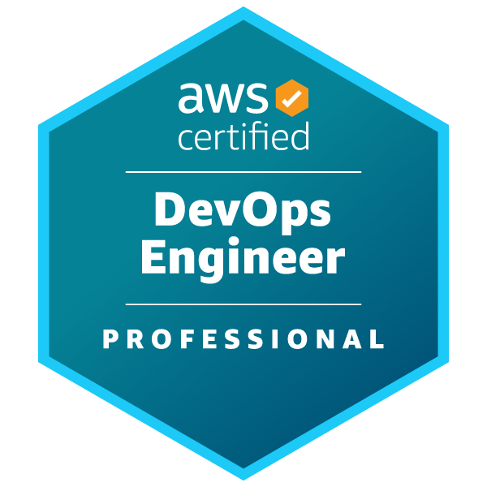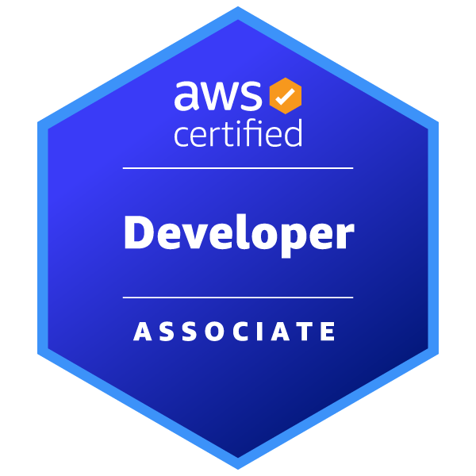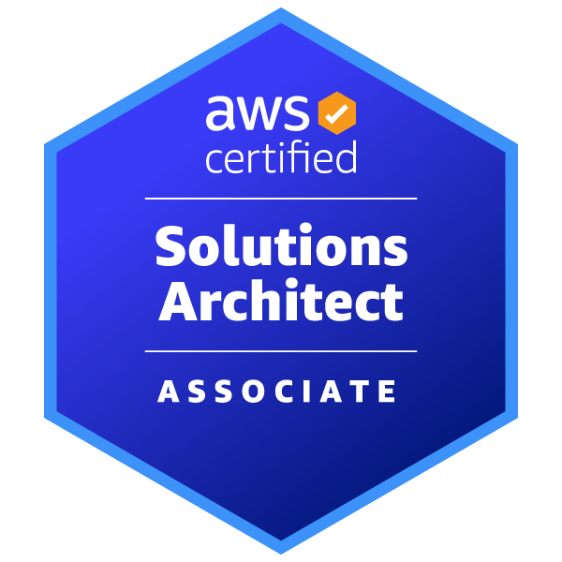
Cloud Certifications (AWS)
• AWS DevOps Engineer
• AWS Certified Developer
• AWS Solutions Architect
IEEE Xtreme Programming 2023
IEEE Xtreme Programming 2024

TECHNICAL SKILLS:
Programming Languages | C, C++, Java 8/17, J2EE, SQL and PL/SQL.
Platforms | Windows, Linux and Unix.
J2SE/J2EE Technologies | Java, J2EE, Servlets, JSP, JMS, JavaBeans, JSTL, JSF, Struts, EJB, Spring, Hibernate, JTA, JNDI, JPA JMS, Web Services SOAP (JAX-RPC, JAX-WS), RESTful (JAX-RS), WSDL and UDDI.
Web Technologies | HTML, CSS, JavaScript, Angular 7/11/15, JQuery, React and Bootstrap,
Spring Security | JWT and OAuth.
XML Technologies | XML, XSL, XPATH, DOM, SAX, DTD, XQuery, XSD and XSLT.
Cloud Technologies | Amazon Web Services (EKS, EC2, S3 bucket, RDS, SQS, SNS, Route 53, IAM, Elastic Load Balancer, Dynamo DB), Google Cloud Platform
Databases | Oracle 11g, MySQL, SQLServer, IBM DB2, PostgreSQL, MongoDB and DynamoDB
Web/Application Servers | Apache Tomcat, IBM Web Sphere, Web logic and JBOSS.
Build Tools | ANT, Gradle, Maven and Jenkins
IDE / Tools | Eclipse, Intellij, Spring Tool Suite (STS).
Testing Tools/ Others | JUnit, Mockito, Soap UI, Log4j.
Version Control | Tortoise SVN, CVS and GIT.
Messaging tools | Apache Kafka, JMS and Google Cloud Sub/Pub
CI/CD Pipelines | Jenkins, Docker, GitLab, SonarQube and Kubernetes
Build Tools | Maven and Gradle

PROFESSIONAL EXPERIENCE:

Client: Mayo Clinic, IL Jan 2023 - Present
Role: Sr. Java Full Stack Developer
Responsibilities:
- Developed and modernized cloud-native microservices using CoreJava 8/11/17, Spring Boot, Spring Cloud, and Spring Batch to enhance scalability and performance.
- Built responsive UIs using Angular 14,16, 17+, TypeScript, JavaScript, HTML, and CSS with Bootstrap components (Tabs, Alerts, Tooltips).
- Leveraged Java 8/11/17and Java 21features including asynchronous HTTP clients, lambda expressions, Stream API, and var keyword to improve code readability and runtime efficiency.
- Migrated legacy Spring-based services and Java 8 code to Java 21 and Spring Boot 3, aligning with enterprise modernization goals and reducing technical debt.
- Developed modular and scalable Angular applications (Angular 11/12/13/14/16/17/18) using component-based architecture, React.js, NodeJS and TypeScript for complex enterprise platforms.
- Applied unit testing (Jest, React Testing Library) and snapshot testing, achieving 90% code coverage across key UI components.
- Integrated LangChain Retrieval-Augmented Generation (RAG) with PostgreSQL and Couchbase to improve LLM response accuracy using internal datasets.
- Implemented AOP-driven transaction management and security aspects to ensure compliance and robust authorization in financial applications.
- Used Angular Router, Guards, and Lazy Loading for modular navigation and performance.
- Consumed and integrated RESTful and GraphQL APIs into Angular components using HTTP Client and centralized API services.
- Designed REST APIs consumed by internal dashboards built with Retool, and GraphQL APIs, enabling seamless communication between frontend and backend services.
- Built and maintained WSDL-based SOAP APIs to enable legacy system interoperability with new microservices.
- Integrated MongoDB with Java/Spring Boot microservices to support hybrid relational–NoSQL data flows.
- Designed Retrieval-Augmented Generation (RAG) pipelines combining OpenAI LLMs with vector databases like FAISS and Pinecone.
- Developed and maintained ETL pipelines using Apache Spark, PySpark, and AWS Glue to process large-scale financial datasets from multiple sources.
- Migrated legacy monoliths to microservices architecture using Spring Boot, Docker, and Kubernetes.
- Built feature modules with lazy loading, dynamic routing, and Angular Route Guards to improve performance and enforce security.
- Integrated the WMS system with external logistics partners using TCP/IP sockets, IBM MQ, SFTP, and Google Pub/Sub for real-time data flow.
- Designed and implemented internal financial service tools using Ruby on Rails for account reconciliation and reporting automation.
- Built secure and automated CI/CD pipelines using GitHub Actions, Jenkins, GitLab, AWS Code Pipeline, and CloudFormation/CDK.
- Created multi-region deployments with Cloud Build triggers and Artifact Registry for production readiness.
- Applied cost governance strategies using Billing Exports to BigQuery, Budgets & Alerts, and Recommender APIs on AWS and GCP.
- Analyzed and optimized large datasets using Apache Spark on AWS EMR for real-time processing and reporting.
- Developed Databricks Notebooks to orchestrate Spark jobs for data cleansing, transformation, and integration with downstream analytics platforms.
- Designed and implemented scalable Couchbase NoSQL solutions to support real-time trading and analytics platforms, enabling high-throughput, low-latency data access.
- Designed and developed scalable Agentic AI solutions leveraging Large Language Models (LLMs) such as Claude and AWS Bedrock to generate dynamic financial insights and dashboards.
- Integrated Hibernate ORM with Spring Boot using Spring Data JPA, implementing complex entity relationships (One-to-Many, Many-to-Many).
- Designed and exposed APIs with Swagger/OpenAPI for dynamic API documentation and testing.
- Collaborated with DevOps teams to deploy Spring Boot applications in Kubernetes clusters.
- Monitored cluster health and performance using Hazelcast Management Center, proactively addressing bottlenecks.
- Used React Portals and modals/drawers for layered UI behaviour such as trade detail popups and alerts without disrupting DOM hierarchy.
- Used Maven and Git for build and version control, enabling streamlined development workflows.
- Automated builds and deployments via GitHub Actions, with real-time monitoring in CloudWatch and security policies enforced using IAM roles.
- Configured and maintained Cassandra clusters, including setting replication strategies and tuning performance for large-scale financial datasets.
- Wrote optimized SQL queries and implemented schema design in MySQL/PostgreSQL/Oracle databases.
- Developed REST APIs for real-time financial data exchange, integrating NoSQL (MongoDB, Couchbase) and relational databases (PostgreSQL, Oracle) for hybrid data needs.
- Built data-intensive dashboards using React.js + D3.js/Chart.js, visualizing key metrics like system health, transaction throughput, and real-time logs.
- Developed and maintained modular and responsive UI components using React.js with TypeScript to enhance code safety and reusability.
- Parsed API responses and implemented CRUD operations via Angular services and components.
- Integrated with Kafkafor real-time event streams, reflecting live updates in Retool UIs for risk analyticsand Cassandra for real-time trade data ingestion and streaming analytics using Akka Streams.
- Deployed React apps on AWS S3 + CloudFront and managed build pipelines via GitHub Actions/Jenkins, enabling automated CI/CD.
- Evaluated enterprise GenAI platforms (OpenAI, AWS Bedrock) to recommend scalable solutions for AI-enabled microservices.
- Developed scalable APIs and backend services in Scala using Akka and Play Framework for distributed environments.
- Worked with Node.js and MongoDB, building secure and scalable REST APIs, including Passport.js and JWT-based authentication.
- Led production support efforts, resolved P1/P2 issues, analysedSpark job failures, and conducted root cause analysis for high-priority incidents.
- Wrote unit and integration tests using Scala Test and Mockito, achieving high code coverage for risk computation modules.
- Leveraged Redis Pub/Sub mechanisms to support real-time updates and event-driven features in cloud-native microservices.
- Collaborated with QA to implement BDD test scenarios using Cucumber and Gherkin for API and risk engine validation.
- Used Jenkins pipelines for continuous integration and deployment, integrated with Chef/Terraform for configuration automation.
Environment:Java 8/17/21, Angular 14,16, 17, Spring Boot, Spring Security, Eureka, HTML/CSS/ SOAP API, Microservices, Material, React JS, Node JS, Ruby, Web Services, GKE, Pub/Sub, IntelliJ, Postman, REST services, JUnit, JMeter, Gradle, GIT, Contras,LLM, ETL Pipelines, RAG, Bedrock, Accessibility, Tomcat, Apache Kafka, MongoDB,GCP Cloud Build, Cloud Monitoring, AWS, Kubernetes, Docker, Concourse, Cucumber, Protractor, Karma, Jasmine, Jenkins, Jira.
Client: Elevance Health Care, NC July 2020 - Dec 2022
Role: Sr. Java Full Stack Developer
Responsibilities:
- Developed microservices using Java 17, Angular 12/13/14/17/18Spring Boot, Spring Cloud, WMS modules and Kafka in cloud-native architectures.
- Developed and optimized patient data modules using Core Java, leveraging lambda expressions, Streams API, and Optional for clean and testable code.
- Built rich UI modules using Angular 12,13,14 with SCSS, Bootstrap, and Angular Material, tailored for clinical data visualization and medical device integration.
- Upgraded existing Angular 11 modules to Angular 18, leveraging new features like standalone components and typed reactive forms for better maintainability.
- Integrated Angular 14/18 UI with backend REST services, using reactive forms, custom directives, and material design components for healthcare portals.
- Developed ReactJS front-end components with TypeScript, integrating seamlessly with NodeJS backend services.
- Developed secure healthcare modules using Ruby on Rails, Kotlin, and MVC architecture to manage patient data workflows in compliance with HIPAA regulations.
- Built LangChain-based orchestration flows for multi-step prompt execution and AI-driven automation across enterprise services.
- Leveraged Python and PySpark to handle structured/unstructured medical data feeding AI models.
- Built healthcare data validation tools using Python and Pandas, supporting compliance with HIPAA and clinical data standards (FHIR, HL7).
- Integrated Retool with MongoDB and RESTful microservices to allow operations teams to perform real-time updates with HIPAA-compliant controls.
- Used Spring AOP for modularizing security and transaction management to protect sensitive healthcare data and maintain transactional integrity.
- Created monolithic applications to OpenShift-based microservicesand scalable microservices with Spring Cloud, Spring Data JPA, and Hibernate.
- Implemented Spring MVC for Model-View-Controller (MVC) architecture and used Spring AOP for cross-cutting concerns.
- Worked on integrating Spring Boot REST APIs with Spark job triggers, enabling external clients to trigger data workflows dynamically.
- Developed asynchronous and concurrent features using Java multithreading and functional programming principles.
- IntegratedRESTful APIs and GraphQL APIs for optimized and flexible data fetching.
- Developed dynamic and interactive user interfaces using React.js, following component-based architecture and single-page application principles.
- Implemented LLM-driven summarization of clinical notes and radiology reports using OpenAI API and healthcare-tuned prompts.
- Developed Agentic AI solutions using Large Language Models (LLMs) like Claude on AWS Bedrock to create dynamic, real-time dashboards from complex healthcare data.
- Implemented WMS system with external logistics partners using TCP/IP sockets, IBM MQ, SFTP, and Google Pub/Sub for real-time data flow.
- Built dynamic dashboards and UI components using Angular 16/18, integrating with backend microservices.
- Developed and managed OSGi bundles using Apache Felix for modular service architecture and improved code maintainability.
- Collaborated with security teams to define safe usage of GenAI in compliance with healthcare data governance standards.
- Utilized JCR/CRXDE Lite to manage repository structure and content hierarchy with versioning and access controls.
- Developed POC dashboards and forms using React.js and Redux for real-time patient data tracking.
- Added real-time notifications for lab result updates using Action Cable in Rails.
- Designed reusable and accessible UI components using React Hooks, React Router, Kotlin, and Material UI, ensuring compatibility with HIPAA compliance standards.
- Implemented key AngularJS features including dependency injection, data binding, filters, and directives.
- Deployed Rails applications in Docker containers on AWS ECS and EKS, with CI/CD automation via Jenkins and GitLab CI.
- Automated CI/CD pipelines using Jenkins, GitLab, and GitHub Actions for continuous integration and deployment.
- Enhanced code quality by integrating SonarQube for static analysis and security scanning.
- Used Docker and Kubernetes (EKS, AKS) for containerization and orchestration.
- Provisioned infrastructure with Terraform, CloudFormation, and ARM templates across AWS and Azure clouds.
- Worked extensively with AWS services such as S3, DynamoDB, Aurora, EC2, Route 53, ALB, and ECS.
- Utilized Azure Blob Storage, Azure SQL Database, and Azure Cosmos DB for cloud-based data storage.
- Architected backend services on GCP Cloud Run using Cloud Functions and configured Cloud Operations Suite (Stack driver) for monitoring.
- Developed AOP-based security interceptors and declarative transaction handling for critical banking services ensuring high reliability and access control.
- Implemented data ingestion and transformation pipelines using Scala with Apache Spark, processing large volumes of EHR data across clusters.
- IntegratedAWS KMS, Secret Managerand Apache Kafka with AWS (MSK, Lambda, S3) for building scalable data streaming pipelines.
- Created high-performance Spark applications for clinical data normalization and streaming ingestion pipelines from IoT devices.
- Processed large-scale data using Apache Spark, Hive, and AWS EMR.
- Enforced HIPAA compliance through data validation, encryption, and secure handling policies.
- Worked on modules involving PBM workflows such as formulary validation, drug pricing, and claims processing integration within healthcare platforms.
- Implemented secure authentication using OAuth2, JWT, and cloud-based key management services.
- Used CloudWatch, Splunk, Prometheus, and Grafana for monitoring messaging systems and alerting.
- Handled production support with SQL, shell scripting, and log analysis to resolve P1/P2 issues efficiently.
- Worked in Agile/Scrum teams using JIRA, Trello, and Asana for project management.
- Followed Test-Driven Development (TDD) practices writing unit and integration tests with JUnit, Mockito, and Cucumber.
Environment: Java , HTML5, CSS3, jQuery, Ajax, AngularJS, NodeJS, JSP, Hibernate, Spring, Spring Batch, Spring Boot, Spring Security, Spring MVC, Spring WebFlux, Maven, Gradle, WebSphere, JavaScript, Agile Methodology, Restful, Micro Services, JIRA, Spring Security, JUnit, GIT, Jenkins and STS.

Client: State Of Michigan, Michigan Aug 2018 - June 2020
Role: Java Full Stack Developer
Responsibilities:
- Participated in all phases of SDLC including requirements analysis, design, implementation, and maintenance in Agile and daily scrum environments.
- Developed and maintained responsive Angular 11+ applications and Angular 18, integrating with Spring Boot backends for real-time financial and citizen service dashboards.
- Upgraded legacy Java applications from Java 8 to Java 21, implementing modern language features and addressing deprecated code.
- Created ReactJS + TypeScript front-end solutions and NodeJS back-end services for citizen services portals.
- Implemented dynamic form validations, reactive forms, and reusable UI components using TypeScript, RxJS, and Angular Services.
- Developed microservices supporting state digital portals using Spring Boot, exposing APIs consumed by Retool applications for administrative tasks.
- Developed automated ETL pipelines with Apache NiFi and Python scripts to extract, cleanse, and load data from various state department systems.
- Expertise in OOAD, gathering and documenting requirements using UML and IBM Rational tools.
- Rewrote legacy government Java applications into AWS microservices using Spring Boot, ECS, and RDS.
- Designed and developed custom AEM components and templates using HTL, Sling Models, and Java back-end services.
- Worked on headless AEM implementation, exposing content via custom Sling Servlets and GraphQL endpoints.
- Leveraged Kibana with Java 8 features such as functional interfaces, parallel streams, and lambdas for efficient data analysis.
- Implemented JWT-based authentication and token refresh logic using HTTP interceptors and Angular security patterns.
- Developed responsive UI using HTML5, CSS3, Bootstrap, and jQuery for dynamic client-side interactions.
- Applied AOP for enforcing security policies and managing transactions within government service applications to improve maintainability and security.
- Used SOAP UI for testing and validating SOAP web service functionality and reliability.
- Integrated Retool with PostgreSQL, Kafka, and Java APIs to visualize case data and automate task assignments.
- Built single-page applications with React.js and React Router for smooth navigation.
- Maintained developer efficiency through GitHub Actions and integrated Amazon Q Developer into workflows for faster ticket resolution.
- Created dynamic interfaces using Angular, JavaScript, and TypeScript for Medicaid eligibility systems.
- Developed frontend screens with ReactJS using reusable components from NPM.
- Refactored and modernized legacy JSP and AngularJS UIs into modern React.js applications, enhancing performance and usability.
- Tested services using SOAP UI, Postman, and wrote unit tests with JUnit.
- Integrated Hazelcast with Spring Boot microservices supporting tax filing and licensing applications.
- Containerized microservices using Docker and orchestrated deployments via Kubernetes.
- Implemented real-time streaming using Kafka and MongoDB change streams for event-driven architecture.
- Monitored Kafka broker health, consumer lag, and topic throughput using tools like Grafana, Prometheus, and Confluent Control Center.
- Deployed applications on Apache Tomcat 8.x and managed staged deployments.
- Used Spring Core Annotations for Dependency Injection and building RESTful APIs.
- Developed modular and secure RESTful web services using Spring Boot, integrated with state-level systems, and authenticated via OAuth2.
- Designed data persistence with Cloud SQL ensuring high availability and automated backups.
- Implemented HIPAA-compliant APIs integrated with AWS services including Lambda, RDS, and Cloud KMS.
- Delivered secure and compliant software adhering to STIG, HIPAA, and enterprise governance standards.
- Converted monolithic apps to microservices using Spring Boot and 12-factor app methodology.
- Monitored applications with Spring Boot Actuator exposing health and metrics endpoints.
- Collaborated with DevOps to deploy Retool UIs alongside microservices on AWS, ensuring reliability and scalability.
- Automated Linux deployments using shell scripting.
- Applied Behaviour Driven Development with Cucumber and unit testing with JUnit.
- Developed backend components with Groovy and Grails, including DAOs and value objects.
- Established end-to-end CI/CD pipelines with Google Cloud Build, Cloud Source Repositories, OpenShift container Platform and Artifact Registry for GCP.
- Used Spring Data MongoDB for dynamic queries and NoSQL database access.
- Developed Kafka producers and consumers in Java for high-volume data ingestion.
- Troubleshot Kafka producer/consumer issues, tuned producer buffer memory, and optimized consumer group rebalancing for minimal downtime and performance bottlenecks.
- Deployed applications using Docker containers on Azure Kubernetes Service (AKS) and set up monitoring via Azure Monitor and Prometheus.
- Configured environment-based builds using Angular CLI and supported feature flagging for conditional rendering across environments.
- Created scalable services with React.js and Node.js (Express) in microservices architectures.
- Deployed enterprise applications on IBM WebSphere Application Server.
- Collaborated with DevOps to deploy Retool UIs alongside microservices on AWS, ensuring reliability and scalability.
- Automated deployments with AWS CloudFormation as Infrastructure as Code (IaC).
- Developed RESTful services using Java Servlets, JSON, JSON/XMLJAX-WS, JAX-RS, AJAXand Hibernate/JPA.
- Configured and maintained OpenShift routes, build configs, and deployment configs for secure, scalable applications with automated health checks and rolling updates.
- Conducted unit and integration testing with Spring Boot, JUnit, and Mockito.
- Skilled in scripting and automating API tests in Postman, ensuring efficient and repeatable testing processes.
- Implemented Test Driven development using frameworks like Junit, Jest and React testing Library, Mockito and Easy Mock.
- Designed and implemented Session Facade, MVC, Front Controller and DAO design patterns.

Environment:J2EE, JDK, HTML, CSS, Ajax, Node JS, React JS, Angular 18, jQuery, Express’s, JavaScript,TypeScript,React.js, Node.js, Bootstrap, Oracle, Spring, Retool, Hibernate/SQL,GCP (Cloud Run, Pub/Sub, Cloud SQL), AWS, Web Services (SOAP), JMS, ETL, RESTful, Multithreading, WebSphere, Apache, Maven.

