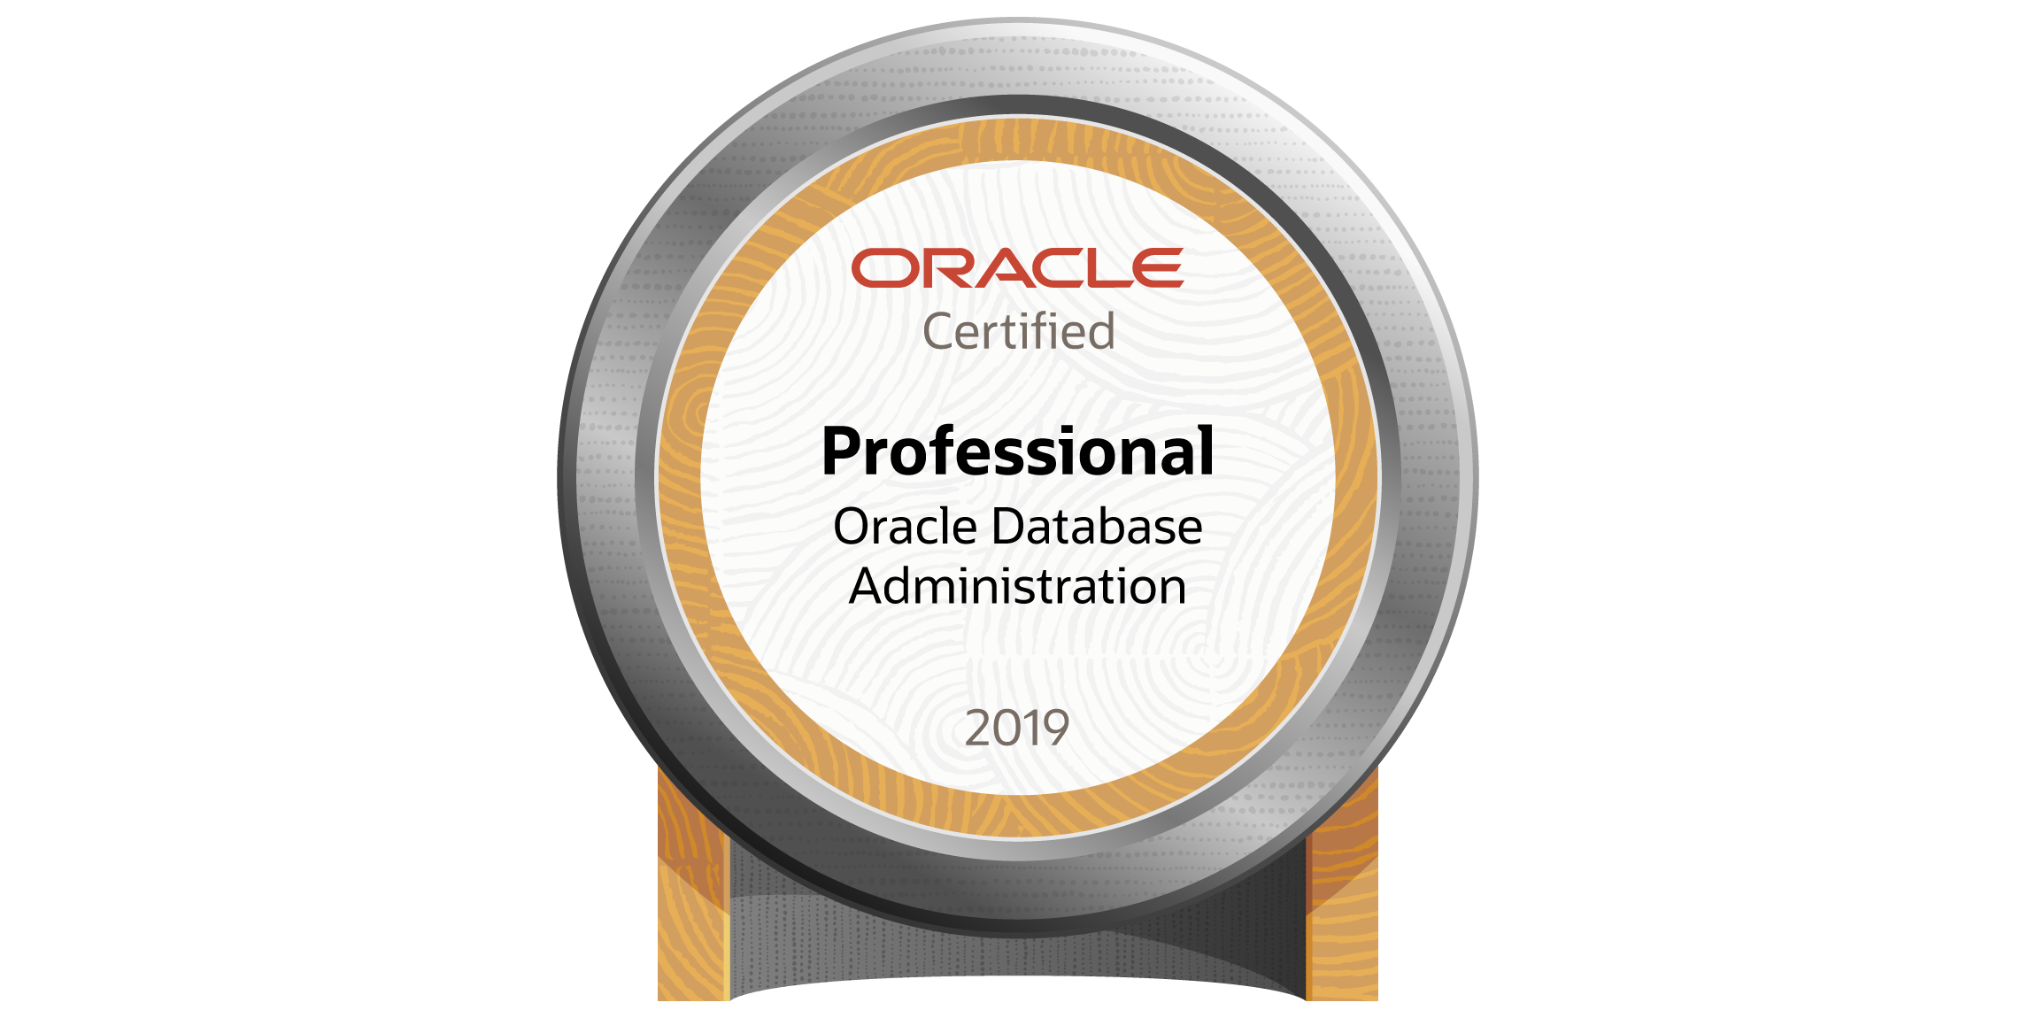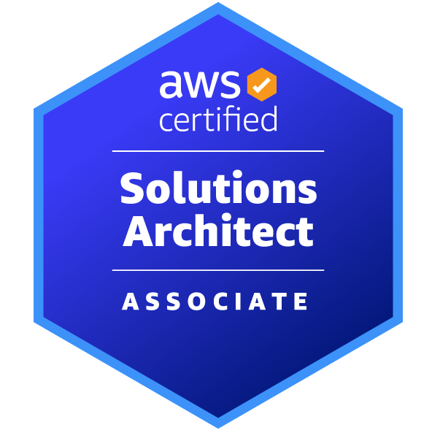 Pavan Kalyan Reddy.V
Mobile: +1-9403262098
Email: pavankalyanreddyvangala@gmail.com

PROFESSIONAL SUMMARY:
- Over 8 years of experience in Oracle Database Administration and Development: Proficient in Oracle 12c, 18c, and 19c. Extensive experience in database creation, maintenance, configuration, migration, upgrading, performance tuning, database cloning, backup and recovery, RMAN, RAC, standby database setup, DR planning, and troubleshooting across various platforms including RHEL, Sun Solaris, and HP-UX.
- Oracle High Availability Features: Strong experience in utilizing Oracle RAC, Data Guard, and Golden Gate to ensure high availability and data integrity.
- Database Cloning and Recovery: Expertise in database cloning, flashback, backup, and recovery strategies using RMAN and user-managed methods.
- Performance Tuning: Skilled in optimizing database performance using tools such as Explain Plan, SQL*Trace, TKPROF, Stats Pack, AWR, and ADDM reports.
- Oracle Enterprise Manager (OEM): Solid experience in administering Oracle databases using Oracle Enterprise Manager (OEM) and Cloud Control.
- AWS EC2 and RDS: Good working knowledge of using AWS EC2 and RDS for cloud database solutions.
- Shell Scripting and Automation: Proficient in using shell scripting to automate database tasks and ensure smooth process execution.
- Database Refreshes: Experienced in performing database refreshes from production to stage environments.
- Oracle Exadata Administration: Strong knowledge in Oracle Exadata storage management and administration, including features such as smart scan, smart flash cache, hybrid columnar compression, storage index, and performance tuning.
- SGA and Performance Tuning: Proficient in tuning the SGA, buffer cache, rollback segments, redo mechanisms, monitoring, query optimization, and detecting locks.
- Capacity Planning and Data Management: Expertise in capacity planning, customization of initialization parameters, import and export, Data Pump, SQL*Loader, data modeling, partitioning, and reorganization.
- PL/SQL Development: Strong knowledge in developing and tuning PL/SQL stored procedures, triggers, SQL queries, and PL/SQL packages.
- Process Automation: Automated several processes using UNIX shell scripting and experienced in working in an Agile environment.
- Monitoring Tools: Proficient with ZFS and Foglight monitoring tools.
- Data Warehouse Systems: Good knowledge of data warehouse systems, database management, data architecture, and data modeling.
- Multitenant Database Management: Experienced in maintaining and supporting multitenant databases.
- Database Architecture and Fine-Tuning: Skilled in database architecture and fine-tuning Oracle databases for optimal performance.
Education/Certifications:

- Oracle Certified Professional (Oracle Database 19c)
- AWS Certified Solutions Architect – Associate
- Bachelor of Technology from Vardhaman engineering college, India.

Technical Skills:
Databases: Oracle 12c, 18c, 19c, PostgreSQL.
Tools: Oracle Enterprise Manager, SQL*Plus, STATSPACK, DBMSPackages, export/Import, DataPump, SQL*Loader, RMAN, Oracle Net, TOAD, Grid Control, DBCA, DBUA.
Operating Systems: Linux (Red Hat Linux 3.0, 6.5, 7,8), Windows 2003/2008, 2012 and Sun OS 5.9, 5.10
Languages: SQL, PL/SQL, UNIX Shell Script, Python, HTML, XML
Backup Management: RMAN, Storage Manager, SQL Lite Speed, Netapp Snap Manager.

PROFESSIONAL EXPERIENCE:

Project 1:

Client: Ellucian cloud services May 2022 to Till Date
Role: Senior Engineer - Product Development.

Environment: Oracle 19C, AWS Cloud, Oracle Exadata cloud, Linux, Oracle RAC, Data Guard, Golden Gate, ASM, SQL Developer and OEM 13c, Oracle multitenant databases, AWS and PostgreSQL.

Responsibilities:
- Provided daily support for Oracle ExaCC production and non-production databases, coordinating with public cloud and Oracle support teams.
- Proactively monitored database health using automated alerts and reports, taking preventive or corrective actions as necessary.
- Collaborated with the backup team to resolve daily production and UAT backup issues.
- Supported production operations using ServiceNow for incident, change, and problem management.
- Participated in daily production incident calls to resolve critical database issues, coordinating with application, OS, storage, and network teams.
- Worked with Oracle Support to resolve critical production database issues.
- Fixed daily GoldenGate data lag issues and collaborated with application teams to resolve specific data errors.
- Resolved database performance issues and collaborated with application teams using AWR, OEM, SQLT, and ADDM.
- Executed production RFCs as part of change management on a daily basis.
- Managed and supported CDB/PDB databases in the ExaCC environment.
- Managed database storage structures and conducted capacity planning for future growth.
- Conducted various DBA tasks using UNIX shell and Python scripting.
- Managed database security by creating and assigning appropriate roles and privileges to users based on activity.
- Worked with the IT security team to address database vulnerabilities and mitigate security incidents.
- Conducted frequent reviews of database access privileges, roles, and permissions, and redesigned them as needed.
- Implemented and managed Oracle Transparent Data Encryption (TDE).
- Coordinated with shift members to ensure smooth handover of operations and extended shift timings when required.
- Worked closely with application teams, SMEs, and other stakeholders to address various issues.
- Coordinated with Oracle Support for Exadata patching to deliver systems in a timely manner.
- Managed data migration from Oracle applications to different SQL schemas.
- Configured GoldenGate for unidirectional and bidirectional replication.
- Supported various database operations in AWS Oracle, including migration, performance tuning, and data refresh based on customer requirements.
- Presented quarterly proactive database health checks to application teams.
- Implemented and supported several systems in a private cloud.
- Performed database refreshes based on application team requirements.

Project 2:

Client: NCL Cruse Line Jul 2017 to May 2022
Role: Database Administrator

Environment: Oracle 12C, 18C, 19C, AWS EC2/RDS, Linux, HP-UX, Oracle RAC, Data Guard, Golden Gate, ASM, Toad and OEM 13c, Exadata and PostgreSQL.

Responsibilities:
- Provided daily support for Oracle ExaCC production and non-production databases, coordinating with public cloud and Oracle support teams.
- Proactively monitored database health using automated alerts and reports, taking preventive or corrective actions as necessary.
- Collaborated with the backup team to resolve daily production and UAT backup issues.
- Supported production operations using ServiceNow for incident, change, and problem management.
- Participated in daily production incident calls to resolve critical database issues, coordinating with application, OS, storage, and network teams.
- Worked with Oracle Support to resolve critical production database issues.
- Fixed daily GoldenGate data lag issues and collaborated with application teams to resolve specific data errors.
- Resolved database performance issues and collaborated with application teams using AWR, OEM, SQLT, and ADDM.
- Executed production RFCs as part of change management on a daily basis.
- Managed and supported CDB/PDB databases in the ExaCC environment.
- Managed database storage structures and conducted capacity planning for future growth.
- Conducted various DBA tasks using UNIX shell and Python scripting.
- Managed database security by creating and assigning appropriate roles and privileges to users based on activity.
- Worked with the IT security team to address database vulnerabilities and mitigate security incidents.
- Conducted frequent reviews of database access privileges, roles, and permissions, and redesigned them as needed.
- Implemented and managed Oracle Transparent Data Encryption (TDE).
- Coordinated with shift members to ensure smooth handover of operations and extended shift timings when required.
- Worked closely with application teams, SMEs, and other stakeholders to address various issues.
- Coordinated with Oracle Support for Exadata patching to deliver systems in a timely manner.
- Managed data migration from Oracle applications to different SQL schemas.
- Configured GoldenGate for unidirectional and bidirectional replication.
- Supported various database operations in AWS Oracle, including migration, performance tuning, and data refresh based on customer requirements.
- Presented quarterly proactive database health checks to application teams.
- Implemented and supported several systems in a private cloud.
- Performed database refreshes based on application team requirements.

