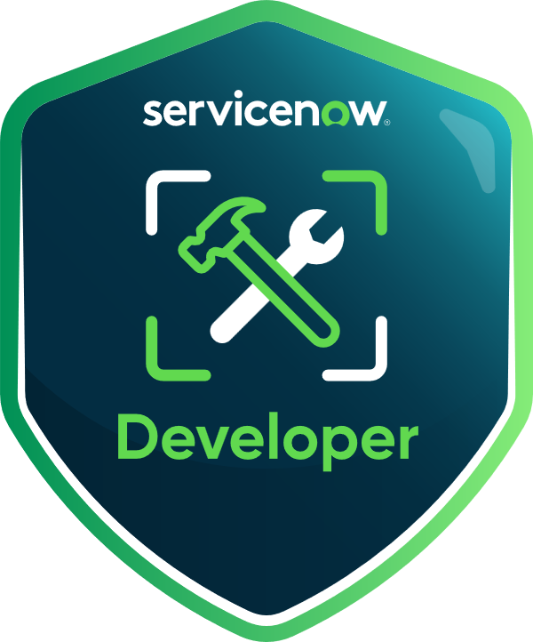
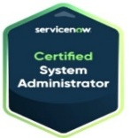
Poornima
Email: servicenowdeveloper20@gmail.com
ServiceNow Developer
Phone: +1 732-582-5754

Professional Summary
- Highly skilled Sr. ServiceNow Developer with over 10 years of experience in designing, developing, and administering ServiceNow platform solutions across multiple modules and enterprise environments.
- Expertise in implementing IT Service Management (ITSM) modules including Incident, Problem, Change, Request, Knowledge, Service Catalog, and CMDB.
- Proficient in developing and customizing workflows using Flow Designer, Workflow Editor, and Integration Hub for automating complex business processes.
- Hands-on experience in IT Operations Management (ITOM) modules including Discovery, Service Mapping, and Event Management to enhance infrastructure visibility and reliability.
- Strong knowledge of Configuration Management and CMDB design including class modelling, data normalization, CI lifecycle management, and reconciliation rules.
- Proven ability in developing advanced scripts using Glide API, JavaScript, Script Includes, Business Rules, Client Scripts, and UI Policies for scalable platform automation.
- Experienced in integrating third-party systems with ServiceNow using REST, SOAP, MID Server, JDBC, LDAP, SSO, and SAML authentication methods.
- Well-versed in building and deploying custom scoped applications and leveraging Application Repository for app lifecycle management.
- Adept in building interactive dashboards and Performance Analytics widgets to track KPIs and drive informed decision-making across ITSM and business operations.
- Strong background in managing and customizing ServiceNow portals using Service Portal framework, widgets, UI Pages, and AngularJS.
- Experience in implementing IT Asset Management (ITAM), Software Asset Management (SAM), and Hardware Asset Lifecycle processes aligned with CMDB.
- Skilled in implementing GRC (Governance, Risk, and Compliance) workflows and managing policy compliance, risk assessments, and audit integrations.
- Familiar with CSM (Customer Service Management) and HRSD (Human Resources Service Delivery) modules to enhance user engagement and self-service capabilities.
- Competent in Agile development, story grooming, sprint planning, and collaborating with cross-functional teams using JIRA, Confluence, and other Agile tools.
- Knowledgeable in DevOps practices including version control using Git, CI/CD automation with Jenkins, and managing update sets and deployments across instances.
- Experienced with Automated Test Framework (ATF) and platform testing strategies for upgrades, releases, and clone activities.
- Exposure to AI/ML capabilities in ServiceNow, including Predictive Intelligence for ticket categorization and Virtual Agent for automated user interactions.
- Certified ServiceNow System Administrator (CSA) and Application Developer (CAD) with a strong commitment to continuous learning and platform optimization.

Certifications:

- ServiceNow certified Application Developer, Certification no – 27153870
- ServiceNow certified System Administrator, Certification no – 27144117

Education:

- Master’s in Data Science from Western Illinois University
- Bachelor of Technology in Electrical and Electronics Engineering from JNTUK

Technical Skills:
ServiceNow Modules | ITSM, ITOM (Discovery, Event Mgmt, Service Mapping), CSM, GRC, HRSD, ITAM, ITBM, CMDB, Service Catalog
Development & Scripting | JavaScript, Glide API, Script Includes, Business Rules, UI Policies, Flow Designer, Client Scripts
Integrations | REST, SOAP, JSON, XML, LDAP, SSO, SAML, SSL, JDBC, ODBC, MID Server, Web Services, SCP, FTPS
DevOps & Automation | Git, Jenkins, CI/CD, Automated Testing Framework (ATF), Flow Designer, Orchestration, IntegrationHub, Ansible, Terraform (IaC)
Reporting & Analytics | Reports, Dashboards, Performance Analytics, SLA/KPI Metrics
CMDB & CSDM | CI Class Management, Relationship Mapping, Identification Rules, Data Certification, CSDM Alignment, Data Integrity
Tools & Platform | Studio, Update Sets, Application Repo, Service Portal, Scoped Apps
Standards & Methodologies | Agile, Scrum, ITIL, Change Management, User Story & Requirement Gathering
Other Technologies | HTML, CSS, XML, Windows, Linux, MySQL, SQL Server

Professional Experience
United Health Group, Eden Prairie, MN Feb 2024 – Present
Sr. ServiceNow Developer
Responsibilities:

- Developed and customized complex workflows using Flow Designer and Workflow Editor for automated Incident and Change Management processes.
- Led the implementation of ITOM Discovery and Service Mapping for 5000+ infrastructure components, improving CMDB data accuracy.
- Configured and maintained Event Management dashboards with dynamic alerts and integration with monitoring tools.
- Built CI class models and CMDB relationships following CSDM framework for effective service modeling and impact analysis.
- Developed REST/SOAP-based integrations with external ticketing and monitoring systems using MID Server.
- Implemented and maintained Performance Analytics dashboards for Change and Problem KPIs and reporting.
- Customized ServiceNow Service Portal widgets and UI pages for enhanced self-service and user experience.
- Automated key business workflows using Script Includes, UI Policies, Client Scripts, and Business Rules.
- Supported platform upgrades and ATF testing to validate core functionalities and regression scenarios.
- Integrated LDAP for user and group synchronization and implemented SSO for seamless user login.
- Collaborated with GRC teams to extend risk management and policy compliance workflows.
- Enhanced the CMDB integrity using scheduled data imports, transform maps, and reconciliation rules.
- Implemented predictive intelligence and Virtual Agent capabilities to reduce ticket triage time.
- Participated in sprint planning and backlog grooming sessions using Agile methodologies.
- Managed version control using Git and deployed update sets across development and production instances.
- Supported change management process including CAB coordination, impact analysis, and post-implementation review.
- Delivered user training sessions and created comprehensive documentation for newly deployed features.
- Provided technical guidance to junior developers and performed code reviews for platform best practices.
Environment: ServiceNow ITSM, ITOM, CSM, GRC, JavaScript, REST, LDAP, SSO, Flow Designer, Service Portal, Git, Jenkins, Agile

LPL Financial, Chula Vista, CA Jun 2022 – Jan 2024
ServiceNow Developer
Responsibilities:
- Designed and implemented custom scoped applications to support business-specific workflows.
- Developed and maintained multiple integrations using REST APIs and MID Server architecture for automation and real-time data sync.
- Customized Incident, Change, and Problem Management modules with business rules, client scripts, and notification logic to meet ITIL compliance.
- Built and optimized workflows using Flow Designer and IntegrationHub to automate catalog requests, approvals, and provisioning.
- Configured advanced SLA definitions and metrics for various service levels across ITSM modules.
- Created actionable dashboards and Performance Analytics widgets to provide insights into SLA adherence, backlog trends, and request fulfillment.
- Supported ServiceNow instance upgrades and performed pre- and post-upgrade validations using Automated Test Framework (ATF).
- Developed reusable Script Includes and invoked them in UI Actions, Catalog Client Scripts, and Business Rules to improve efficiency and code reusability.
- Collaborated with CMDB and ITOM teams to ensure CI data integrity and support Discovery implementation across hybrid infrastructure.
- Configured service catalog items and record producers with variable sets, onChange/onSubmit scripts, and dynamic visibility logic.
- Implemented role-based ACLs to secure sensitive data across forms, lists, and related tables.
- Built custom email templates, notifications, and inbound email actions for automated processing of user requests.
- Participated in Agile ceremonies including daily stand-ups, sprint planning, and retrospectives, ensuring timely story grooming and delivery.
- Integrated ServiceNow with monitoring systems to auto-generate incidents from alerts using REST and email parsing.
- Developed and supported knowledge base workflows, versioning, and user feedback features to drive self-service adoption.
- Maintained environment-specific configuration records and app properties across development, test, and production instances.
- Coordinated change management deployments and update set validations across environments using Git and internal DevOps pipelines.
- Provided platform training sessions and documentation for end users and support teams.
Environment: ServiceNow ITSM, ITAM, ITOM, CMDB, REST, Flow Designer, Performance Analytics, Agile, GRC, MID Server.

Adecco Group, Hyderabad, India Jul 2019 – Dec 2021
ServiceNow Developer
Responsibilities:

- Implemented and maintained ITSM modules including Incident, Problem, Change, and Knowledge aligned with ITIL best practices.
- Developed complex catalog items and record producers with Glide scripting, UI policies, and variable sets.
- Created and maintained scoped applications for internal HR and asset management processes.
- Integrated external HR management system using SOAP APIs and built scheduled jobs for data sync and reconciliation.
- Customized ServiceNow Service Portal with theme adjustments, widget modifications, and access control for different user roles.
- Designed and implemented SLA definitions, escalations, and breach notifications for Problem and Change Management.
- Developed Business Rules, Client Scripts, and Script Includes to automate field population, validations, and approvals.
- Implemented knowledge workflows including article reviews, feedback collection, and publishing lifecycle.
- Configured ACLs and UI Policies to enforce security, visibility, and compliance across modules.
- Built detailed reports and dashboards for executive visibility into request fulfillment, SLA breaches, and open incidents.
- Supported user and group administration, role management, and LDAP-based user sync via scheduled imports.
- Participated in quarterly ServiceNow instance upgrades and performed regression testing and validation using ATF.
- Developed integration between ServiceNow and SCCM for asset discovery and CMDB updates.
- Designed custom notifications, inbound email actions, and approval workflows to support HR and IT service requests.
- Created data import templates, transform maps, and data policies for consistent CMDB and user data management.
- Assisted with GRC policy tracking and risk assessment workflows for internal compliance reporting.
- Collaborated with QA teams to test features and fix issues before deploying to production.
- Documented development work, test cases, release notes, and platform administration guidelines.
Environment: ServiceNow ITSM, CMDB, HRSD, Service Portal, LDAP, SOAP, SCCM, ATF, GRC, Performance Analytics

Summitworks Technologies, Chennai, India Nov 2014 – May 2019
ServiceNow Administrator
Responsibilities:

- Performed daily ServiceNow administration tasks, including user and group creation, role assignment, and license monitoring.
- Managed access control rules (ACLs) across modules to ensure appropriate role-based access.
- Created and scheduled data imports and transform maps for user and asset data synchronization with external sources.
- Configured SLAs and escalations for incident, change, and request management processes.
- Developed standard and change templates to streamline approvals and task fulfillment workflows.
- Supported platform upgrades and patching by validating test plans, running ATF scripts, and resolving post-upgrade issues.
- Built customized reports and dashboards for department heads to track KPIs, open tickets, and SLA breaches.
- Maintained a clean CMDB by reconciling duplicate CIs, configuring identification rules, and managing CI relationships.
- Developed email notifications and inbound email actions to handle ticket updates, approvals, and closures.
- Collaborated with the ITSM process team to align business requirements with ServiceNow capabilities and drive continuous improvement.
- Assisted in onboarding new ServiceNow modules such as Knowledge Management and Asset Management.
- Provided knowledge transfer sessions to support and helpdesk teams on platform enhancements and best practices.
- Managed update sets for development and deployment, ensuring safe and trackable changes across environments.
Environment: ServiceNow ITSM, CMDB, LDAP, Workflow, ACL, Import Sets, Reporting

Devenir Software, Hyderabad, India May 2013 – Jun 2014
IT Support Analyst
Responsibilities:

- Provided Level 1 and Level 2 support for IT incidents and service requests logged in ServiceNow.
- Monitored ticket queues and ensured timely response and resolution according to SLAs.
- Created incident, problem, and change records in ServiceNow and updated them with diagnostic notes and resolution steps.
- Assisted in ServiceNow user account setup, role assignments, and password reset issues using LDAP integrations.
- Escalated complex technical issues to senior support or engineering teams while documenting all actions in ServiceNow.
- Coordinated with software and hardware teams for asset tracking and request fulfillment.
- Generated daily and weekly reports from ServiceNow for management review and analysis.
- Participated in regular system testing and feedback during platform upgrades or module rollouts.
- Conducted user onboarding sessions and trained staff on how to navigate and use the ServiceNow self-service portal.
- Documented standard operating procedures (SOPs), troubleshooting steps, and FAQs to enhance the IT knowledge base.
- Identified recurring incidents and collaborated with senior team members to initiate problem records and root cause analysis.
- Supported routine audits by pulling ServiceNow records and user logs for compliance teams.
Environment: Windows, Active Directory, ServiceNow ITSM, LDAP, MS Office, Ticketing Systems

