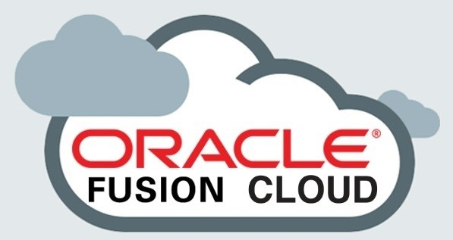
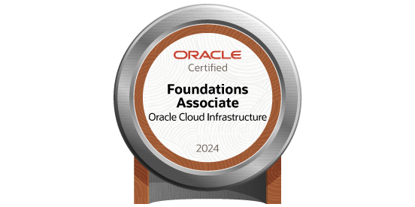
PUJITHA NARALASETTI
n.pujitha1904@gmail.com | (214)-972-8864
Oracle Cloud ERP Functional Analyst

PROFESSIONAL SUMMARY
Oracle Cloud ERP Functional Analyst with over 5+ years of experience across Oracle Financials (GL, AP, AR, FA, CM) and Procurement (PO, INV) modules. Recognized for effectively bridging business and technology teams to streamline financial processes, strengthen data integrity, and drive system adoption. Skilled in Oracle Cloud ERP configuration, troubleshooting, data migration, and reporting using OTBI, BI Publisher, Smart View, EPM, OAC, and FBDI/ADFDI tools. Dedicated to continuous learning, teamwork, and delivering business value through thoughtful ERP solutions and user enablement.

PROFESSIONAL STRENGTHS & WORK ETHIC
- Strong collaborator with Finance, Procurement, and IT teams to ensure seamless integration of business processes.
- Excellent communicator with a focus on simplifying technical concepts for business stakeholders.
- Committed to accuracy, process excellence, and delivering measurable improvements in ERP operations.
- Adaptable and proactive in identifying issues and proposing innovative, sustainable solutions.
- Known for maintaining composure and professionalism under pressure and tight deadlines.
- Passionate about continuous learning and mentoring colleagues in Oracle Cloud best practices.

TECHNICAL SKILLS:

ERP Platforms: | Oracle Fusion Cloud ERP, Oracle EPM Cloud, Oracle Analytics Cloud (OAC)
Integration / Cloud: | Oracle Integration Cloud (OIC), Oracle Cloud Infrastructure (OCI)
Reporting Tools: | OTBI, BI Publisher, Smart View, EPM Reports, Power BI
Data Management: | FBDI, ADFDI, Template Loader, SQL, PL/SQL
Testing Tools: | Jira, Oracle Test Manager, ServiceNow
Documentation: | SOPs, Functional Design Documents, Training Guides
Business Tools: | Microsoft Excel (Advanced), PowerPoint, SharePoint

PROFESSIONAL EXPERIENCE

MAXIMUS, Austin, TX — Oracle Fusion Functional Analyst

September 2024 – Present
Responsibilities:
- Provide functional expertise for Oracle Financials and Procurement modules, serving as a trusted advisor to finance and business operations teams.
- Collaborate with end-users to identify process inefficiencies and recommend system enhancements that align with business goals.
- Troubleshoot issues in invoice processing, supplier setups, and payment runs, ensuring smooth daily operations.
- Manage FBDI and ADFDI uploads for suppliers, invoices, journals, and employee expenses with high data accuracy.
- Develop interactive OTBI and BI Publisher reports for financial performance tracking and spend analysis.
- Lead regression and UAT testing during Oracle quarterly updates, ensuring system stability post-patch.
- Monitor ESS jobs, transaction console, and workflow performance to maintain operational continuity.
- Partner with Oracle Support to manage service requests and coordinate issue resolution.
- Document SOPs and train end-users on new functionalities and process improvements.
- Assist Finance in month-end and year-end close activities, reconciling data between subledgers and GL.
- Foster collaboration between IT and business stakeholders to ensure timely delivery of enhancements and defect fixes.
Environment: Oracle Cloud ERP 24C | Modules: GL, AP, AR, FA, CM, PO, INV, Procurement | Tools: OTBI, BI Publisher, Smart View, FBDI, ADFDI, OIC, EPM

INFOSYS, Hyderabad, India — Oracle Fusion Functional Analyst

August 2021 – July 2023
Responsibilities:
- Supported full lifecycle Oracle Fusion Financials implementation for a global manufacturing client.
- Gathered business requirements and participated in CRP and UAT workshops to ensure alignment with client needs.
- Configured supplier setups, payment terms, and workflow hierarchies in Oracle Procurement Cloud.
- Collaborated with developers on RICEW objects and validated data during SIT and UAT cycles.
- Built BI Publisher reports and OTBI dashboards for Accounts Payable, GL, and Procurement analytics.
- Used FBDI and ADFDI templates to manage high-volume data migrations and maintain financial integrity.
- Documented functional specifications, test scripts, and configuration workbooks.
- Conducted root cause analysis for integration and approval workflow errors.
- Supported end-users during hypercare and stabilized processes post-go-live.
- Worked closely with Oracle Support to resolve configuration and data migration issues.
- Facilitated end-user training sessions and process handover to internal support teams.
Environment: Oracle Cloud ERP 22D | Modules: GL, AP, AR, FA, CM, Procurement | Tools: OTBI, BI Publisher, Smart View, EPM, FBDI, ADFDI, OIC

ADP INC., India — ERP Functional Support Associate

March 2019 – July 2021
Responsibilities:
- Delivered Oracle Cloud ERP functional support for Financials and Supply Chain users, resolving L1/L2 tickets within SLA.
- Partnered with finance teams to troubleshoot transactional discrepancies and reporting issues.
- Assisted in supplier registration, PO creation, and invoice validation, ensuring compliance with corporate policies.
- Designed BI Publisher templates for payment vouchers, POs, and invoice outputs, improving report usability.
- Created OTBI reports and Smart View queries for financial data verification and analysis.
- Supported data migration activities using ADFDI and FBDI templates for key business entities.
- Maintained functional documentation, SOPs, and quick reference materials for internal users.
- Collaborated with IT teams and Oracle Support to investigate recurring system issues.
- Helped onboard new analysts by delivering structured knowledge transfer sessions.
- Monitored ESS job schedules and ensured uninterrupted financial data processing.
Environment: Oracle Cloud ERP 20C | Modules: AP, AR, GL, PO, Procurement | Tools: OTBI, BI Publisher, Smart View, FBDI, ADFDI, ServiceNow

DOCUMENTATION & TRAINING EXPERIENCE
- Authored 50+ SOPs, process flow documents, and end-user guides.
- Created training materials and functional design documents tailored for finance and procurement teams.
- Conducted UAT and onboarding workshops for new business users and analysts.
- Managed structured document libraries using SharePoint to ensure version control.
- Provided mentorship and on-the-job coaching to new ERP support associates.

EDUCATION
Master of Science in Computer Science
Oklahoma Christian University – Oklahoma, USA

