RAJESH VEMURI
SENIOR ENGINEERING LEAD | ENGINEERING LEAD | ARCHITECT

📞720-936-5811;  rajeshvgpd.official@gmail.com
🔗https://www.linkedin.com/in/rajesh-vemuri-a2513420a/

SKILLS:  Programming Languages:  C#  Typescript,  Python  Frameworks:  .NET Framework,  .NET Core,  ASP.NET,  ASP.NET MVC,  WEB API,  Entity Framework,  Entity Framework Core,  ADO.NET,  AJAX,  LINQ  Communication &Integration:  RESTful APIs  SOAP  Web Services  .NET Remoting Services  Frontend:  HTML5,  CSS3,  Bootstrap,  JavaScript/jQuery,  Angular,  Vue.js,  React,  Databases & Data Access:  SQL Server  SQL Developer  SQL Broker  Unit Testing & Automation:  NUnit,  xUnit,  Playwright,  Selenium  Version Control:  GitHub,  Team Foundation Server,  Perforce,  JIRA,  Rally  Tools:  Visual Studio,  SQL Server,  SQL developer,  Azure DevOps,  Postman,  Git  Cloud & Hosting:  Microsoft Azure (App Services, Functions, Storage, Cosmos DB),  AWS,  IIS (Internet Information Services)  Containerization & Micro services:  Docker,  Micro services Architecture  Markup & Data Formats  XML  Reporting & BI Tools  SSRS (SQL Server Reporting Services)  SSIS (SQL Server Integration Services)  OS  Windows  Code Quality & Static Analysis  SonarQube,  FxCop | PROFILE:  12+ years of software development experience with expertise in web application development, organizing and leading teams in Insurance, Gaming, HRM, Workforce management primarily on .NET platform.  Proven track record of excelling in roles such as Developer, Team Lead, Engineering Lead, and Mentor, with 4+ years of leadership experience driving high-performing teams, fostering collaboration, and ensuring timely, quality delivery. Recognized for strong communication skills, problem-solving abilities, and a security-first mindset.  Strong backend development Microsoft Technology skills with deep knowledge of SQL Server, SQL Broker, SSRS, and performance optimization.  Skilled in using Microsoft Azure for deploying scalable cloud solutions and containerizing applications using Docker.  Extensive experience working with IIS for hosting and Skilled in designing and deploying scalable, secure cloud solutions on both AWS and Azure.  Hands-on experience with containerization, CI/CD pipelines, and DevOps practices.  Extensive experience of all phases of software development life cycle with Agile Scrum as well as Waterfall methodologies  Expertise in leading Agile teams, optimizing application performance  Experience in all aspects of software life cycle like Build/Release/Deploy  Good Understanding on the Azure technology stack  Hands-on with Designing - C#, Web-Apps  Expert in C#, HTML5, CSS, JavaScript, Angular, and VueJS, with hands-on experience in converting and optimizing C# logic to JavaScript and building accessible UIs compliant with WCAG and Section 508 standards.  Proficient in ReactJS for building dynamic, component-based web applications with seamless API integration and optimized user experiences.  Experience in building APIs and services using SOAP.  Designing and developing a solution according to Requirements and platform specific technical best practices.  Guiding junior members to analyze requirements and assist with implementation by sharing knowledge of the product.  Single-handedly designed and implemented complex feature additions.  Technical issue management along with hands-on involvement as required.  Instrumental in building knowledge base articles for multiple features of the product  Worked on multiple releases involving in decision making, scheduling and co-ordination with the client.  Contributed to ongoing maintenance, support, and enhancements of existing systems/Application.  Experience in Development as well as Maintenance project.  Proficient in grasping new technical concepts and utilizing them in an effective manner.  Good communicator and a team person with strong analytical, problem-solving, and organizational abilities.  Excellent code reviews and code debugging skills, demonstrated expertise in authentication and authorization mechanisms, including OAuth 2.0, OpenID Connect ensuring secure, scalable access across enterprise applications  Security-focused technologist with proven expertise in identifying, analyzing, and remediating security vulnerabilities across web and distributed systems. Skilled in applying OWASP Top 10 practices, secure coding standards, and integrating SAST into CI/CD pipelines for early vulnerability detection.  Strong experience on TDD Unit testing tools NUnit, XUnit and Selenium Web driver.  Developed and integrated static code analysis tools like Fxcop, and SonarQube  Good knowledge and hands on experience in Event driven architecture  Known for clean coding, troubleshooting complex issues, Passionate about continuous learning and adopting new technologies to drive software innovation.  Proficient in leveraging AI tools like GitHub Copilot for rapid code generation, test automation and refactoring. Adept at mentoring teams on integrating Copilot into workflows, including writing unit tests, optimizing code snippets, and increasing development efficiency.  Proficient in Apache Kafka for developing real-time, event-driven architectures, integrating distributed systems, and enabling high-throughput messaging between microservices.  Experienced in designing Kafka topics, producers, and consumers with optimized partitioning and replication strategies for scalability and fault tolerance.  Hands-on with Kafka Streams and Kafka Connect for stream processing and integration with various data sources.  EDUCATION HISTORY  Bachelor of Technology – JNTU(Hyderabad) – 2013

WORK EXPERIENCE

ENGINEERING LEAD/ ARCHITECT | TINUBU SURETY | ESURETY INSURANCE | SEP 2023 – Till date

 / 
The surety business revolves around the issuance of surety bonds, which are legally enforceable contracts involving three parties:
Principal: The individual or business entity undertaking an obligation (e.g., a contractor).
Obligee: The party requiring the bond, typically a government agency or project owner.
Surety: The company that guarantees the principal's performance and promises to compensate the obligee if the principal defaults.
Common Types of Surety Bonds:
Contract Bonds: Used in construction projects to guarantee performance and payment.
Commercial Bonds: Required by governmental agencies to ensure compliance with regulations.

Responsibilities:
- Designed and developed microservices using .NET Core to handle bond lifecycle management (application, underwriting, issuance, claim).
- Built and consumed RESTful APIs for integrations including regulatory data providers and client-side systems.
- Implemented Entity Framework Core for data access and persistence across multiple relational models.
- Built responsive front-end components using Angular, AJAX, and TypeScript to enhance user interactivity and performance.
- Applied OAuth 2.0 and OpenID Connect (OIDC) for secure identity management and delegated access control.
- Integrated Single Sign-On (SSO) with enterprise identity providers to streamline user authentication.
- Developed interactive web UIs using Angular, enabling dynamic, Single-Page Application-like experiences with modern front-end capabilities.
- Applied WCAG guidelines and Section 508 compliance to ensure accessibility across applications.
- Integrated Angular components with existing APIs for real-time bond status updates and form validations.
- Configured Kafka Connect for seamless integration with external databases and cloud storage.
- Applied partitioning strategies, message keying, and retention policies to optimize performance and ensure fault tolerance.
- Implemented Kafka Streams for filtering, transforming, and aggregating live bond events.
- Utilized Microsoft Azure App Services, Azure Functions to host and scale services securely.
- Utilized Amazon Elastic Beanstalk, AWS Lambda, and Amazon API Gateway to host and scale services securely.
- Containerized services using Docker and deployed through CI/CD pipelines for efficient release cycles.
- Used LINQ extensively for querying collections and database records.

Environment Worked Tools/Technologies:
C#, .NET Core, Entity Framework Core, Web API, SQL Server, SQL Broker, Microsoft Azure, AWS, Docker, AJAX, Angular, TypeScript, LINQ, Microservices Architecture, XUNIT, Playwright, jQuery, Microsoft Visual Studio 2022, SQL server, Git, JIRA ticketing tool.

SENIOR ENGINEERING LEAD/ ARCHITECT | TABLEVIEW | GAMING | JUNE 2022 – AUG 2023

 / 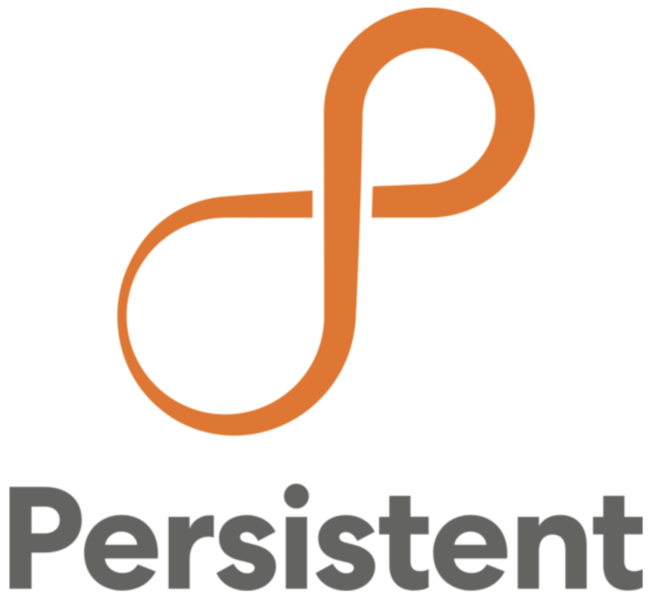
TableView is an innovative table management solution that allows you to replace your existing manual rating process with the ease and simplicity of electronic automation. Create an almost paperless environment in your pit and eliminate the hassle and delays of entering and updating ratings into your casino management system.
Information and transactions recorded at your table will be seamlessly integrated into your existing Light & Wonder CMS and provide your casino personnel with secure and instant access to table ratings and financial accounting data. TableView was designed to provide your floor operations staff with a fast and easy solution for entering player ratings, requests for chip fills and credits, table closers, and issuing customer comps and markers in real-time. Touch-screen entry, Integrated CMS database access, Safe and Secure, Player Card Reader, Seamless Network Connection, Player Ratings, Table Accounting, Marketing
Responsibilities
- Application Development: Design, develop, and maintain web applications using ASP.NET MVC, .NET Core, Angular, C#, and related technologies such as Web API, Entity Framework, jQuery, AJAX, and TypeScript.
- Data Integration & Utility Development: Develop and support C# utilities for extracting and processing data from various backend CMS systems, restructuring code for a unified table view codebase and ensuring efficient data retrieval and manipulation using LINQ.
- Feature Enhancement and Bug Fixing: Collaborate with stakeholders to implement new features and address reported bugs, prioritizing and resolving issues in a timely manner utilizing JIRA for tracking and management.
- Deployment and Infrastructure Management: Participate in the deployment process, leveraging technologies like Docker, Microsoft Azure for effective application delivery and management. Familiarity with Infrastructure as Code practices is beneficial.
- Database Management: Engage in database migration processes between different versions, utilizing SQL Server 2016 and potentially tools like EF Core Migrations.
- Kafka Integration: Designed and implemented Apache Kafka producers and consumers to enable real-time streaming of table rating data, chip fill requests, and table closures between the TableView application and the Light & Wonder CMS.
- Event-Driven Processing: Built Kafka topics to handle high-throughput event data from gaming tables, ensuring fault-tolerant delivery and low-latency updates to downstream services.
- Stream Processing: Utilized Kafka Streams for real-time transformation and aggregation of player ratings, transaction logs, and table accounting data before persisting to the database.
- Microservices Architecture: Develop and maintain applications following a Microservices Architecture, focusing on building scalable, independent, and resilient services utilizing Docker for containerization and understanding the principles of microservices communication and deployment.
- Integrated Python utilities and ETL scripts with SSIS/SQL Server to automate data extraction, transformation, and validation, enhancing the TableView ecosystem.
- Authentication & Authorization: Designed and implemented robust authentication and authorization mechanisms to safeguard applications against unauthorized access and security threats, applied strong knowledge of OAuth 2.0 and OpenID Connect for secure token-based authentication and delegated access control across distributed services.
- Integrated Single Sign-On (SSO) solutions, enabling seamless user access across multiple enterprise applications and improving user experience.
- Security Best Practices: Ensure application security by implementing best practices, including input validation, secure configuration, using HTTPS, and implementing authentication/authorization protocols.
- Performance Optimization: Optimize application performance through techniques like caching, minimizing database calls, asynchronous programming, and response compression.
- Testing and Quality Assurance: Contribute to the overall quality of applications through unit testing and integration testing, leveraging automated testing in CI/CD pipelines.

Environment Worked Tools/Technologies:
ASP. Net MVC, C#, .Net Core, Web Api, Entity Framework, AngularJS, jQuery, Microsoft Visual Studio 2019, SQL server 2016, Python, Perforce, Microsoft Azure, AWS, Docker, AJAX, TypeScript, LINQ, Microservices Architecture, JIRA ticketing tool

SENIOR SOFTWARE ENGINEER | APPEALS AND GRIEVANCE TRACKING SYSTEM | HEALTHCARE INSURANCE | APR 2020 – MARCH 22


ATS (APPEALS AND GRIEVANCE TRACKING SYSTEM) - Appeals and grievances are processes for patients or members to voice dissatisfaction and seek resolution for issues related to their health plan coverage, care, or services. Grievances are complaints about any aspect of the healthcare experience, while appeals are specific challenges to a health plan's decision or determination.

Responsibilities:
- Spearheaded the development of key modules within an Applicant Tracking System (ATS), including quality metrics, robust reporting capabilities, and interactive dashboards.
- Designed and implemented core functionalities for an Appeals and Grievance tracking system, encompassing the entire lifecycle.
- Proactively identified and analyzed business pain points, driving the development and implementation of process and service improvements that directly addressed critical operational challenges.
- Led problem management initiatives, conducting thorough root cause analysis and implementing permanent fixes to enhance system stability and prevent recurring issues.
- Acted as a crucial liaison between end-users and offshore support teams, facilitating efficient communication and resolution of critical issues, including the creation and management of Change Requests (CRs).
- Applied strong analytical, logical, and programming skills to deliver high-quality software solutions and effectively solve complex technical challenges.
- Utilized Python scripts for ETL and data validation, automating the extraction, cleansing, and transformation of appeals and grievance data before loading into SQL Server, improving accuracy and efficiency.
- Built Python-based utilities for log analysis, report generation, and API integration, complementing .NET services and enhancing system automation.
- Implemented Test-Driven Development (TDD) practices, ensuring early bug detection, robust code quality, and a more maintainable codebase.
- Developed comprehensive unit tests using NUnit, validating code functionality and ensuring software reliability.
- Integrated and leveraged static code analysis tools like FxCop and SonarQube to enforce coding standards, identify potential defects, and maintain high code quality.
- Created a Proof of Concept (POC) using ReactJS to design and develop an admin application for the claims cycle, showcasing dynamic UI components, API integration, and enhanced user interactivity for administrative workflows.

Environment Worked Tools/Technologies:
ASP. Net MVC, C#, .Net Core, WebApi, ADO.Net, VueJs, ReactJs, Python, jQuery, Microsoft Visual Studio 2019, SQL server 2016, Git, NUnit, SQL Broker, Rally.

SENIOR SOFTWARE ENGINEER | HEROMA - TIMESHEET | JAN 2019 – APRIL 2020

/ 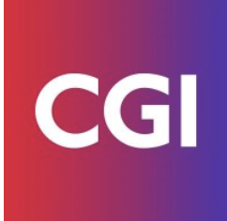
Time tracking software offers manual and automatic time entry, visualization tools, and integrations with accounting, project management, and payroll systems, streamlining operations and improving accuracy.
Responsibilities:
- Gather and understand module requirements.
- Coordinate development with the team.
- Develop tools using C#.NET, ASP.NET MVC, .NET Core, Typescript, AngularJS.
- Enhance functionalities based on user feedback.
- Continuously improve the tool.

Environment Worked Tools/Technologies:
C#.NET, ASP.NET MVC, .Net Core, Typescript, AngularJS, AJAX, HTML5/CSS/JS, IBM DB2, WebApi, SQL Server, TFS, DevExtreme Controls, IIS, Entity Framework

SENIOR SOFTWARE ENGINEER | HEROMA - PROCOMPETENCE | JUN 2013 – DEC 2018

/ 
HEROMA - PROCOMPETENCE is a HRM product that enables employee self-service for updating details, manager-led goal setting, development plan tracking, and data-driven reporting, all integrated within a broader talent management framework.
Responsibilities:
- Generated insightful reports through data analysis to support informed decision-making.
- Collaborated with teams to interpret work requests and ensure efficient implementation of solutions.
- Directed the development, design, and integration of robust systems tailored for customer needs.
- Managed the certification and deployment process for system changes, ensuring smooth transitions to production environments.
- Developed new application forms and established data procedures to enhance data usage efficiency and application functionality.
- Translated gathered requirements into actionable enhancements for existing applications.
- Created comprehensive business requirement documents and performed accurate estimates for project planning.

Environment Worked Tools/Technologies:
C#.Net Framework 4.5, ASP.NET MVC, Oracle, CSS, HTML5, JavaScript,
DevExpress Controls, Remoting services, Dependency injection, SQL Server, TFS.

