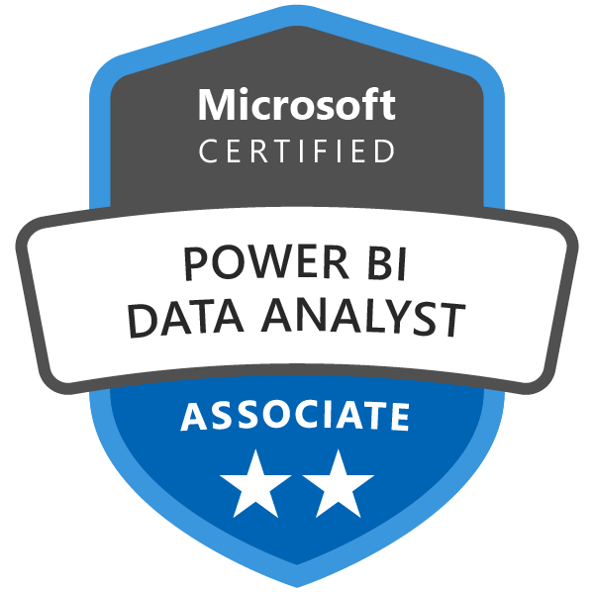
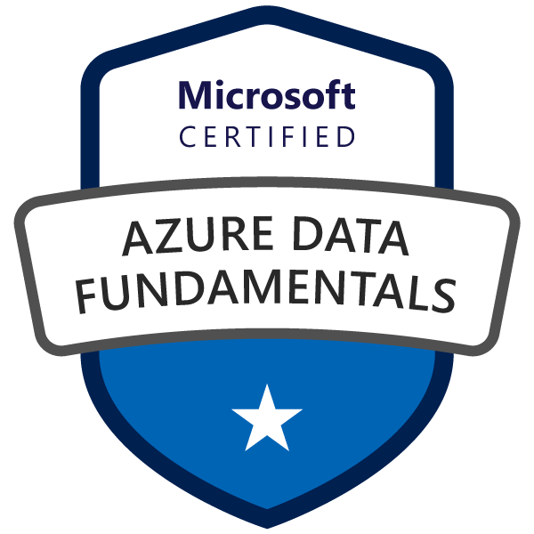
RAMYA B
Data Analyst
+15713060176


Virginia, USA


bramya188@gmail.com



Objective:

Analytically minded professional 6+ years with a keen ability to identify patterns and interpret complex data Seeking a Data Analyst role where strong research skills, SQL expertise, and data visualization can support business problem-solving and informed strategy
Education:

University of JNTU Anantapur – Anantapur, India (2012 – 2015)
- Computer Science & Engineering / Bachelor
Profile Summary:

- Over Proficient in analysing large datasets with 6+ years of experience to derive actionable insights and support data-driven decision-making.
- Expertise in SQL for database querying, data extraction, and optimization of complex queries and Skilled in Python for data cleaning, statistical analysis, and machine learning implementations.
- Advanced experience in data visualization tools such as Tableau, Power BI, and Excel to create compelling dashboards and reports and Hands-on experience in using ETL tools like Informatica and Talend for data integration and transformation.
- Adept at performing predictive analytics using statistical tools like R and SAS and Strong understanding of data warehousing concepts and experience working with platforms like Snowflake and AWS Redshift.
- Experienced in automating data workflows and streamlining processes using Python, VBA, and scripting tools.
- Knowledge of cloud technologies, including AWS, Azure, and GCP, for managing and analysing big data.
- Proficient in big data technologies like Hadoop, Spark, and Kafka for processing and analysing large-scale datasets.
- Experience with API integration for extracting data from external sources and ensuring seamless data flow.
- Proficient in Python libraries such as Pandas, NumPy, Matplotlib, Seaborn, and SciPy for advanced data manipulation, statistical analysis, and visualization.
- Experienced in automating data workflows and streamlining processes using Alteryx and scripting tools.
- Adept at designing advanced statistical models and hypothesis testing to support business strategy using tools like SciPy.
- Strong experience in creating interactive dashboards and reports using Looker for data exploration and decision-making.
- Extensive experience in working with Snowflake for data warehousing, including building scalable data models, optimizing queries, and implementing secure data sharing across multiple teams.
- Proficient in applying machine learning algorithms such as regression, classification, clustering, and time series forecasting to analyse trends, predict outcomes, and support data-driven business decisions.
- Expertise in advanced Excel functionalities, including pivot tables, Power Query, complex formulas, macros, and VBA scripting, to streamline data analysis and automate reporting processes.
Technical Skills:

Data Warehousing: | Informatica Power Center 9.x/8.x/ 7.x, Informatica Power Exchange 8.6.1, Data stage8.x, Informatica data quality. Informatica MDM
Databases: | SQL Server 2012/20 10/2008, Oracle 11g/1Og,Teradata R13,R12,V2R6, MS Access, SQL, Oracle, DB2, Big Data, NoSQL, MySQL, Azure Data Factory (ADF), Azure Data Explorer (ADE)
SQL T: | SQL, PUSQL, Unix Shell Scripts, CSS,HTML,XM L. MHTML,PHP, Python, Java, C#, ASP.NET,VB.NET.C++,C
Other Tools: | SQL Query Analyser, SQL Enterprise Manager, SQL Server Management Studio. SQL Server Query Editor, Solution, Explorer, Analysis Manager, DTS Services, UML, Informatica Database Design and Normalization, Data Modeling. HP Quality Centre, ALM,MS Word.MS Excel, MS PowerPoint
Operating Systems: | Windows Unix
Methodologies: | Agile Waterfall SDLC methodologies
Work Experience:

Cencora Inc | Data Analyst

Dec 2021 - Present

Pennsylvania, USA
Description: Cencora Inc. is a relatively new name in the global healthcare industry, it was a major pharmaceutical services company, I involved in statistical methods such as regression, hypothesis testing, and variance analysis, using languages like Python or R for data analysis, automation, and advanced statistical modeling.
Key Responsibilities:
- Analysed the sources, targets, mapped and transformed the data and loading the data into targets using Abinitio.
- Worked with the stakeholders and management teams to gather requirements by conducting JAD Sessions 1-on-1 interviews Worked on reducing the ambiguity between stakeholders and me by using tools like Erwin.
- Conducted GAP analysis and Feasibility analysis on the current and proposed system, Did SWAT analysis for the proposed system, Wrote Requirement documents for new ETL Process, data migration process and new Data Warehouse Design.
- Organized joint Application Development sessions with data steward and ETL teams while having walkthroughs for mapping documents, Created extracts from the data source and refresh extracts on the monthly data
- Utilizing Data Definition Language (DDL) commands to create, modify, and manage database structures, including tables, indexes, and views Using Data Manipulation Language (DML) commands to insert, update, delete, and retrieve data.
- Created a marketing campaign analysis report in Looker that improved campaign ROI by 15%.
- Collaborated with the Data Quality Engineering team to determine automation requirements and tooling.
- Created Data Movement Models in SAP Power Designer for data lineage.
- Worked with an offshore team responsible for the functional quality of new and existing product features to identify potential data quality testing requirements, worked on creating Data Mapping Documents, Data flow Diagrams.
- Perform Data Quality integrity testing (completeness, conformity, consistency, accuracy. duplicates) Performed Functional Testing and Backend Testing using the database comparable results manually Involved in user training sessions and assisting in UAT (User Acceptance Testing) Develop compelling and informative data visualizations using Power BI.
- Performed Unit testing, Integration testing and System testing of Ab initio graphs.
- Design and develop Meta Data reports for the ETL Business and Support teams for day-to-day needs.
- Maintained warehouse metadata, naming standards and warehouse standards for future application development.
- Set Standards for Naming Conventions and Best Practices for Informatica Mapping Development, Repository Meta Data Management and Reporting, designed data management using tools such as Orchestra Networks EBXS
- Extract, transform, and load (ETL) processes to integrate data from various sources into Domo Extensively used joins and sub-Query’s and functions for validating data Monitored the Teradata production system using Teradata manager for skewed queries Collected requirements and tested several business reports.
- Used data blending groups, sets, dual axis, and synchronized axis to enhance the data visualization.
- Used dashboard actions for the drill down of various reports and URL action to connect to the tableau server.
- Published reports from the tableau desktop to the tableau server and managing the sites and projects on the tableau server.
- Creating Data Conversion and Data Integration Strategy, as a road map to construct Data Governance model that holds the master data and data across different Business Units with consistency and in compliance.
- Conducted Functional Requirements and User Requirements Specification reviews.
- Supported data warehouse projects with logical and physical data modeling in Oracle environment and assured accurate delivery of DDL to the development teams, Used SQL to perform Data Validation and Data Integrity testing.
Environment: Scrum, MS-SQL Server, Erwin, MS-Office, Ab lntio, Tera Data, Tableau, RDBMS-Oracle, Orchestra Networks

Gen worth Financial | Programmer Analyst
- Mar 2018 - Nov 2021


Virginia, USA
Description: Gen worth Financial is an American insurance company that specializes in long-term care insurance, mortgage insurance, and other financial services, I optimized data retrieval processes through the development of complex SQL queries and stored procedures, reducing query run times leading to faster reporting cycles.
Key Responsibilities:
- Participated in requirements discussions with business units ensuring all business requirement were satisfactorily met, Designed and implemented parameterized and cascading parameterized reports using SSRS.
- Worked extensively with the QA team for designing Test Plan and Test Cases for the User Acceptance Testing.
- Created and maintained documentation on processes, application configuration, and material for users.
- Experience in ETL tools like DTS for data flow from one source files like Tables, Views and Excel to other databases with proper mapping, worked with pivot tables in Excel by getting data from Teradata and Oracle.
- Perform complex data analyses to identify trends, patterns, and insights that support strategic decision-making, especially in areas like underwriting, claims, and risk assessment.
- Supported data warehouse projects with logical and physical data modeling in Oracle environment and assured accurate delivery of DDL to the development teams Structure and organize data models in Power BI.
- Developed and automated complex financial reports and dashboards using Power BI and Tableau, enabling executive teams to track KPIs and make data-informed decisions in real time.
- Created and maintained databases, tables, views, users, logins, indexes, check constraint and business rules using T-SQL, worked with Teradata SQL Queries using Teradata SQL Assistant for Ad Hoc Data Pull request.
- Conducted Data analysis including acquisition, cleansing, transformation, modeling, visualization, documentation and presentation of results, developed reports using SSRS on statistical data during migration of data.
- Worked extensively on Azure data factory including data transformations Integration Runtimes, Azure Key Vaults Triggers and migrating data factory pipelines to higher environments using ARM Templates
- Designed and implemented SQL queries for data analysis and data validation and compare data in test and production environment, Assisted Data Analyst in mapping task and analysed existing reports
- INDEX and MATCH functions to retrieve data from tables where VLOOKUP would be limited, such as when the lookup value isn't in the first column or when needing to perform more complex lookups across rows and columns.
- Managed all requirements in DOORS and Rational Requisite Pro, making requirements available to all the teams.
- Involved in development implementation, administration and support of ETL processes for the Data Warehouse using DTS and SSIS, Worked with SSIS lmpor U Export Wizard for performing the ETL operations, Helped data modelers to prepare models and reviewed it to check if the requirements are met, Lead preparation of data warehouse requirements document Designed packages with SSIS for work flow solutions and managed the data flow, Exported and imported data from text files and Excel to SQL Server database using BULK insert and BCP utility, Created drill down, drill through, linked and sub reports using SQL Server Reporting Services (SSRS).
Environment: MS Project MS Excel, MS Word, MS Visio, MS Access, Visual Basic, SQL SQL Server, Oracle, Quality Centre, Informatica Power Centre 6.0

