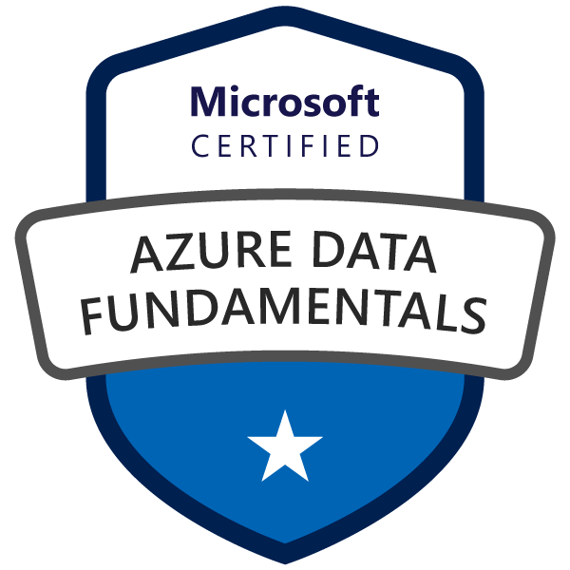
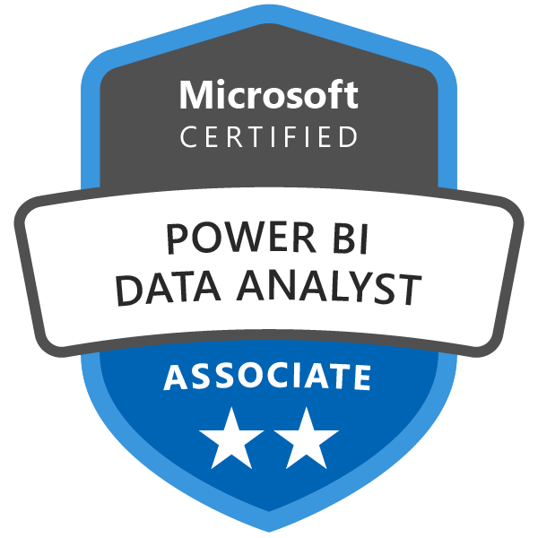
RESHMA CHENNURI
- Versatile & result - driven Data & Management professional with over 5+ years of experience in data analysis, data formatting and reporting and writing Complex SQL queries and SAS/Bl tools.
- Strong experience in Banking and Financial domains built various SQL scripts to run a variety of ad hoc reports as per the client's request Expertise in implementing projects by following SDLC & Agile methodologies experience in leveraging Python programming for data analysis, statistical modeling, and data visualization.
- Experience in Analysis, Design, Development Testing Implementation, and support of IT applications and product developments extensively used Tableau and MS Excel for Data Analysis and to create Reports.
- Data Management: Track requests, manage deliverables, identify data sources, and ensure secure access.
- Data Quality Improvement: Define standards for data collection, consistency, and automation; improve accuracy and usefulness
- Gather complex data inputs from multiple sources, both internally and externally
- Identify new data sources that will enhance business outcomes and support strategic and tactical objectives
- Provide insight and guidance to stakeholders on the trends and drivers behind the results and prepare reports on findings
- Assesses the needs of the business, prioritize projects, and drive new reporting requirements to completion
- Work cross-functionally as needed to enable data architecture and solutions that best meet the analytics and reporting needs of the business
- Drive clarity or requirements and ensure delivery meets agreed-upon requirements
- Data Analysis: Proficiency in SQL and scripting (Python, R); experience with Power BI for data visualization
- Data Validation: Skilled in designing data validation tests and maintaining data quality
- ETL & Data Warehousing: Understanding of ETL processes, data transformation, and validation
- Strong analytical and problem-solving skills to perform root-cause analysis and align data to business needs
- Strong understanding of Supply Chain Operations with the ability to link operational decisions/impacts to data insights and analysis
- Excellent communication skills to collaborate with data engineers, product owners, and analysts for requirement validation and feedback

Job Requirements:
- Supply chain experience with a focus on the device side and an understanding of the company’s data structures
- Working knowledge of JIRA and agile methodologies

- Data modeling Tools: Erwin Power Designar Project
- Google Looker/Google Data Studio: Reports and dashboards
- Methodologies: SDLC. JAD Sessions, Ralph Kimball Methodologies
- Databases: MS Access, SQL, Oracle, DB2, Teradata, Big Data, NoSQL, MySQL, Azure Data Factory (ADF), Azure Data Explorer (ADE)
- BI Tools: Power BI (2.x), Tableau, Python, ADF, Looker
- Reporting Tools: BO. OBIEE
- Languages: PL/SQL,SQL,HTML
- OS: Windows
- Other Tools: TOAD, MS-Office suite (Word, Excel, Project and Outlook), BTEQ, Teradata
- Environment: Windows (95. 98,2000,NT.XP), UNIX
- RDBMS: Oracle 1Og/9i/8i/7.x, MS SQL Server. UDB DB2 9.x. Teradata, MS Access 7.0
- Data Analysis: SAS, Kafka, MS Excel,Tableau, Jira

EDUCATION

Masters in computer science from SVS Institute of Technology, Hanamkonda, India
chennurireshma2@gmail.com





TECHNICAL SKILLS

Data Analyst
PROFILE SUMMARY

Highly skilled senior data analyst with over 5+ years of experience in delivering data-driven insights to enhance business processes Adept at utilizing advanced analytics techniques, SQL, and Python, and experienced in cross-functional collaboration to solve strategic problems and optimize operations."

380-777-2468
CONTACT

ABOUT ME

PROFESSIONAL EXPERIENCE

Client: First horizon bank, Tennessee, USA Apr 2024 – Present
Role: Business Analyst
Description: First Horizon Bank is a regional bank it provides a range of financial services including personal banking, business banking, and wealth management. Developed comprehensive data models and ETL processes to support analytics and reporting, ensuring data accuracy and integration across various sources.
Responsibilities:
- Created Entity/Relationship Diagrams, grouped and created the tables, validated the data, identified PKs for lookup tables involved in modeling (Star Schema methodologies) in building and designing the logical data model into Dimensional Models.
- Experienced in Property & Casualty (P&C) Claims & Managed end-to-end claims processing, including claim intake, investigation, evaluation, and settlement. Collaborated with adjusters, policyholders, and third parties to ensure accurate claim resolutions. Ensured compliance with insurance regulations and company policies while mitigating risks and preventing fraud. Skilled in handling auto, homeowners, and liability claims efficiently.
- Create, manage, and optimize data pipelines in ADF to extract, transform, and load (ETL) data from various sources into Azure data storage solutions like Azure SQL Database, Azure Data Lake, or Azure Synapse Analytics.
- Presented the Dashboard to Business users and cross functional teams, define KPls (Key Performance Indicators), and identify data sources Experience working with MOM team with various business operations involved in the organization
- Presented the Dashboard to Business users and cross functional teams define KPls (Key Performance Indicators) and identify data sources.
- Integrated data from different sources such as Azure Blob Storage, Azure SQL Database Azure data lake SQL server DB, flat files MS-Excel etc. in CDM
- Worked on all data management activities on the project data sources data migration Used RFE to repeatedly select several attributes which does affect the products sales and make sure all attributes' p-values are less than 0.05 with Python.
- Involved in requirement gathering and data analysis and Interacted with Business users to understand the reporting requirements, analyzing Bl needs for user community Ensuring that the data retrieved from APIs is accurate, complete, and consistent. This includes handling errors or anomalies in the data Built Big Query SQL queries and views for Google Looker
- Writing Python scripts to extract data from various sources such as databases, APIs, or web scraping.
- Writing VBA macros to automate repetitive tasks in Excel, such as data entry, formatting, and report generation.
- Use Looker to create and refine data models, ensuring data is organized in a way that supports analysis.
- Examined key Performance Indicators KPI for Property and Casualty such as Loss Ratio, General Operating Expense Ratio Created a multi-page report dashboard in Google Looker (Data Studio) using Google Big Query data.
- Implement and update data governance procedures standards training documents, presentations and Data Governance detail plans Involved with data profiling for multiple sources and answered complex business questions by providing data to business users Designed and developed IDQ solution to support MOM Projects
Environment: Azure SQL Database, Azure Data Lake, KPls, Azure Blob Storage, Azure SQL Database Azure data lake SQL server, MS-Excel, CDM, APIs, Big Query SQL, Google Looker, Python scripts, Power BI's
Client: BlueCross BlueShield of Tennessee, Tennessee, USA Jul 2023 - Mar 2024
Role: Business Analyst
Description: BlueCross BlueShield of Tennessee (BCBST) is a not-for-profit health insurance company. Managed the design and development of data warehouse solutions, ensuring data quality and creating analytical reports to support business decision-making.
Responsibilities:
- Involved in loading the data from Source Tables to Operational Data Source tables using Transformation and Cleansing Logic Worked with slowly changing dimensions (SCDs) in implementing custom SCD transformations.
- Created the conceptual model for the data warehouse with emphasis Annuity using Erwin data modeling tool.
- Cleansed, extracted and analyzed business data on daily basis and prepared ad-hoc analytical reports using Excel and T-SQL Document all mappings, maples, and rules in detail and hand over documentation to the customer.
- Participated in cross functional internal and external training programs covering leadership, ethics & professionalism retirement benefits property & client management and international actuarial developments Design and Development of Data Analytics solution leveraging Tableau and Cognos.
- Perform annually and quarterly Vendor Management due diligence reviews and risk assessments on potential new
- Involved in data modelling to define the table structure (Domain and Reference Masters) in MOM system.
- Worked closely with the business analyst and Data warehouse architect to understand the source data and need of the Warehouse Involved in designing of star schema based data model with dimensions and facts.
- Design and Development of Data warehouse solution leveraging Oracle, Exadata and Informatica.
- Solution Design and Implementation of Business Intelligence reports and OLAP cubes using Cognos Reporting Services, Tableau and Power Pivot & Performance Test.
- INDEX and MATCH functions to retrieve data from tables where VLOOKUP would be limited, such as when the lookup value isn't in the first column or when needing to perform more complex lookups across rows and columns.
- Proactively managed multiple environments to ensure high availability high performance and minimization of risk.
- Performed extensive GAP analysis in the project as there were numerous 'as-is’ and 'To-Be' conditions.
- Involved in creating database objects like tables, views, procedures, triggers, and functions using T-SQL to provide definition, structure and to maintain data efficiently.
- Designed and developed ETL packages in SSIS and pipelines in Azure Data Factory to transform source data as per transformation logic and ingest that into CDM platform based on defined architectures of CDM model
- Publishes reports/dashboards on Tableau server & embedded views in other web applications.
- Created and maintained logical, dimensional data models for different Claim types Designed data flows that extract Transform and load data by optimizing SSIS performance Worked extensively on EDW and Facets databases.
- Building, publishing customized interactive reports and dashboards, report scheduling using Cognos.
- Created action filters, parameters and calculated sets for preparing dashboards and worksheets in Tableau.
- Restricted data for particular users using Row level security and User filters.
- Developed Tableau visualizations and dashboards using Tableau Desktop Developed Tableau workbooks from multiple data sources using Data Blending.
- Tested the reports with various testing methodologies like Functional testing Regression testing and UAT.
- Collaborate with various business and technical teams to gather requirements around data quality rules and propose the optimization of these rules if applicable, then design and develop these rules with IDQ.
- Run data quality specific ETL jobs (address standardization and validation email clean-ups name clean-up parsing, etc.) utilizing IDQ and other ETL tools.
Environment: Excel and T-SQL, Tableau and Cognos, Oracle, Exadata, ETL, Azure Data Factory, CDM, Tableau server & embedded, worksheets, UAT, IDQ
Client: Providence, Hyderabad, India Jun 2021- Mar 2023
Role: Data Analyst
Description: Providence is a nonprofit health system providing a range of medical services and care to communities. Contributed to data warehouse projects by gathering business requirements, designing data models, and ensuring accurate data delivery and reporting.
Responsibilities:
- Worked as business requirements analysts with subject matter experts to identify and understand requirements.
- Supported data warehouse projects with logical and physical data modeling in Oracle environment and assured accurate delivery of DDL to the development teams Structure and organize data models in Power BI.
- Consulted with application development business analysts to translate business requirements into data design requirements used for driving innovative data designs that meet business objectives.
- Involved in information-gathering meetings and JAD sessions to gather business requirements, deliver business requirements document and preliminary logical data model.
- Documented the data requirements and system changes into detailed functional specifications.
- Took ownership of Source to Target Mapping and tracked and maintained changes.
- Performed Extraction, Transformation and Loading (ETL) using Informatica power center.
- Responsible in designing new FACT or Dimension Tables to existing Models.
- Designing and developing interactive dashboards and reports using tools like Tableau, Power BI, or Looker.
- Designed and implemented data profiling and data quality improvement solution to analyze match cleanse, and consolidate data before loading into data warehouse.
- Creating PivotTables to summarize, analyze, and explore large data sets, allowing analysts to quickly view data trends and patterns Implemented stored procedures, functions, views, triggers, packages in PL/SQL.
- Developed SQL queries to be used in SSIS packages to ingest data from Raw layer to Pre-stage layer for core objects such as Accounts Sites & Users
- Worked extensively on Azure data factory including data transformations Integration Runtimes, Azure Key Vaults Triggers and migrating data factory pipelines to higher environments using ARM Templates
- Write SQL queries to clean data, handle missing values, remove duplicates, and standardize formats.
- Extensively used ER Win to design Logical Physical Data Models, and Relational database and to perform forward/reverse engineering Develop interactive and visually appealing dashboards and reports in Power BI.
- Performed requirements gathering and design analysis for customer contact history for customer relationship management.
Environment: Oracle, physical data modeling, JAD, Target Mapping, Tableau, Power BI, or Looker, PivotTables, functions, views, triggers, packages in PL/SQL, SQL queries, Azure data factory, ARM Templates, Power BI.
Client: Teleperformance, Hyderabad, India Mar 2019 - May 2021
Role: Data Analyst
Description: Teleperformance is a global leader in customer experience management, providing innovative solutions across various industries to enhance customer interactions. Involved in data analysis & modeling, stakeholder engagement, & the design of efficient data migration processes while enhancing data visualization & reporting capabilities.
Responsibilities:
- Identified and analyze stakeholders and subject areas Performed Data profiling Validation and Integration.
- Participated in Business Analysis, talking to business Users and determining the entities and attributes for Data Model.
- Identified and determined physical attributes and their relationships through cross-analysis of functional areas.
- Identified and analyzed source data coming from Oracle SQL server and flat files.
- Extensively used ERWIN to design and restructure Logical and Physical Data Models.
- Evaluated and enhanced current data model as per the requirements Involved in Data migration and Data distribution testing Performed testing, knowledge transfer and mentored other team members.
- Performed forward and reverse engineering applying DDLs to database in restructuring the existing data Model using ERWIN Created materialized views to improve performance and tuned the database design.
- Designed ETL specification documents to load the data in target using various transformations according to the business requirements Used Informatica- Power center for extracting, transforming and loading
- Leverage advanced features of Tableau, Looker, or other visualization tools to enhance data representation.
- Design and build interactive dashboards in DOMO to visualize key metrics and performance indicators.
- Worked with Data Warehouse team in developing Dimensional Model and analyzing the ER-Diagrams
Environment: Business Analysis, Data Model, Oracle SQL, Physical Data Models, ERWIN, Data migration, DDLs, ETL, Tableau, Looker, DOMO

