Sai Bhavinya Eda 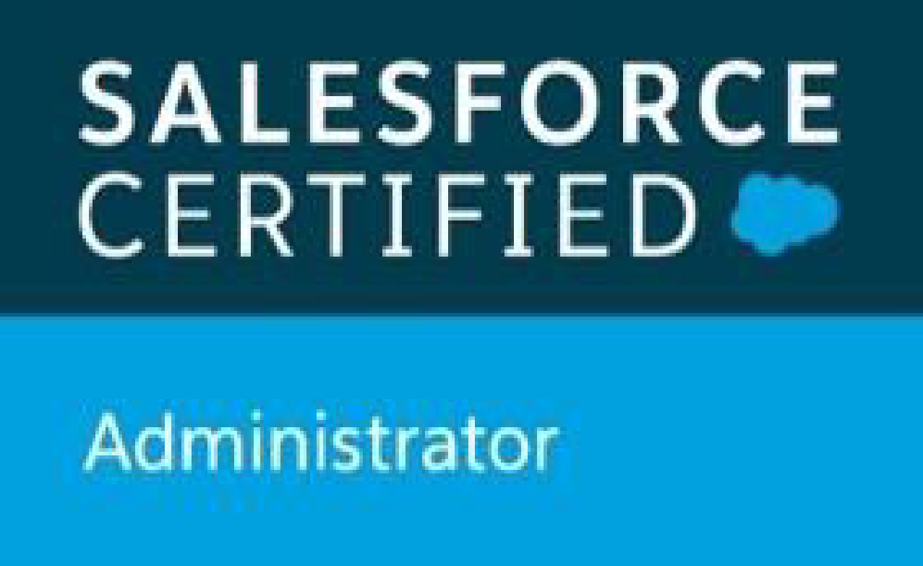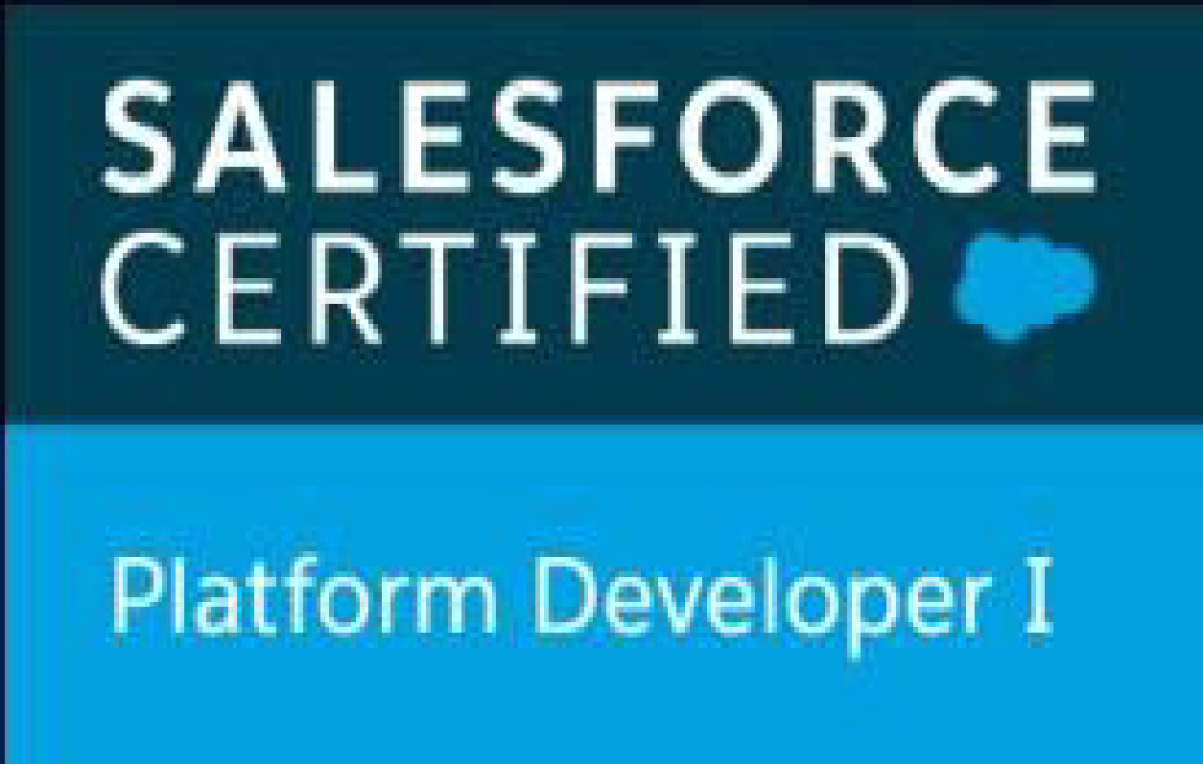
Email: edasaibhavinya@gmail.com
Phone: 913-927-8348 Salesforce Platform Developer

PROFESSIONAL SUMMARY:

- Over 6 years of experience in Salesforce development, administration, and testing across Sales, Service, Health, Financial Services, Marketing Clouds, and B2B Commerce Cloud (CloudCraze).
- Salesforce DevOps Engineer skilled in designing multi-stage CI/CD pipelines using Harness, GitHub, and Azure DevOps. Hands-on with Salesforce CLI (SFDX), Metadata API, unlocked packaging, scratch orgs, and DevOps Center. Experienced in automated deployment validation with PMD, Prettier, Jest, and Apex tests, ensuring secure and compliant releases across enterprise environments.
- Hands-on expertise in Apex, Visualforce, Lightning Web Components (LWC), Aura Components, Flows, and CPQ, delivering scalable and maintainable solutions.
- Experienced in Salesforce Health Cloud implementations, Person Account migration, Data Cloud integration, and Service Cloud automation for enterprise healthcare and financial services environments.
- Skilled in building dynamic Lightning applications, custom objects, master-detail and lookup relationships, roll-up summary fields, and schema-level automation.
- Strong expertise in standard and custom Salesforce objects such as Accounts, Contacts, Leads, Opportunities, Cases, Products, Campaigns, Reports, and Dashboards.
- Proficient in object-oriented design, MVC architecture, Apex triggers, Batch Apex, Wrapper Classes, and optimized SOQL/SOSL queries.
- Designed and implemented workflow automations using Process Builder, Flows, Approval Processes, and scheduled actions to improve operational efficiency.
- Hands-on experience in REST/SOAP API integrations, middleware connections, and third-party system integrations with secure authentication (SAML, OAuth2, JWT).
- Implemented Experience Cloud portals, Communities, and Chatter groups to enhance collaboration and user engagement.
- Skilled in Salesforce Shield, Event Monitoring, Platform Encryption, and Field Audit Trail for HIPAA and GDPR compliance.
- Developed CI/CD pipelines using Salesforce DX, Git, Jenkins, Flosum, and Scratch Orgs for source-driven development.
- Experienced in data migration, validation, and deduplication using Apex Data Loader, Import Wizard, and ETL pipelines.
- Built dynamic Lightning UI components, responsive LWCs, Aura Components, and Lightning Out integrations for hybrid experiences.
- Configured security and access controls including Profiles, Roles, Permission Sets, OWDs, Sharing Rules, Field-Level Security, and Session Settings.
- Developed cross-object validation logic and invocable Apex methods for Flows to extend declarative automation capabilities.
- Implemented asynchronous processing (Queueable, Future, Batch Apex) and event-driven architectures (Platform Events, Change Data Capture) for scalable transactions.
- Worked on Salesforce CPQ and Conga Composer configurations, automating quote-to-cash processes with pricing, approvals, and contract generation.
- Skilled in Einstein Analytics/Tableau CRM dashboards, KPI reporting, and visualization for business insights and decision-making.
- Proficient in manual and automated testing, developing Apex Test Classes with 90%+ coverage and leveraging AccelQ, Selenium, Postman, and JIRA for QA.
- Actively participated in Agile ceremonies, sprint planning, peer reviews, and collaborative development with cross-functional teams.
- Experienced in Lightning App Builder, Dynamic Forms, Quick Actions, and FlexiPages to enhance user experience.
- Implemented platform-level automation using Flow Orchestration, scheduled flows, and declarative approvals to reduce manual effort.
- Built real-time integrations with external ERPs, CPQ systems, and third-party APIs for seamless data synchronization.
- Worked on Omni-Channel routing, case management, and automated assignment rules to streamline support operations.
- Configured custom metadata types, custom settings, and global value sets for environment-specific configurations and reusable logic.
- Developed interactive LWC data tables with pagination, filtering, and bulk operations to improve UI performance and usability.
- Collaborated with business stakeholders to gather requirements, validate solutions, and support user adoption.
TECHNICAL SKILLS:

Salesforce Platform | Cloud Platforms: Sales Cloud, Service Cloud, Agentforce AI, Health Cloud, Marketing Cloud, Financial Services Cloud, Data Cloud, Campaign Management, Lead Management, Experience Cloud (Communities), Salesforce Sites, Portals  Collaboration & Content: Chatter, CRM Content, Knowledge Base (Knowledge One), Salesforce Files, Service Console  User Interface & App Customization: Lightning App Builder, Dynamic Forms, Flexi Pages, Quick Actions, Custom Page Layouts  Declarative Automation Tools: Workflow Rules, Process Builder, Flow Builder (Auto-launched, Screen, Scheduled), Approval Processes, Assignment Rules, Validation Rules, Duplicate Management  Security & Access Management: Role Hierarchies, Profiles, Permission Sets, OWDs, Sharing Rules, Manual Sharing, Field-Level Security (FLS), Login IP Ranges, Login Hours, SSO Integration (OKTA), Session Settings, Audit Trails, Field History Tracking  Data Access & Integration: SOQL, SOSL, Platform Events, Change Data Capture (CDC), Streaming API, Metadata API, Apex REST/SOAP Web Services  Code-Based Development: Apex Classes, Triggers, Controller/Extensions, Asynchronous Apex (future, Queueable, Batch, Schedulable), Apex Test Classes  Lightning Development: Aura Components, Lightning Web Components (LWC), Lightning Out, SLDS, JavaScript ES6+, Custom UI Components  Integration & APIs: Apex Callouts (REST/SOAP), Named Credentials, External Objects via Salesforce Connect, Webhooks, Third-party System Integration, External client portal APIs.  Advanced Configuration: Record Types, Dynamic Record Pages, Custom Metadata/Settings, Custom Labels, Global Value Sets, Multi-Currency, Time-Based Workflows
Salesforce Tools | Data & Dev Tools: Apex Data Loader, Import Wizard, Workbench, Developer Console, VS Code (SFDX CLI), Force.com IDE, ANT Migration Tool, OmniStudio/Vlocity  CI/CD & Versioning: Harness, Copado, Flosum, Jenkins, GitHub, Bitbucket, DevOps Center  Deployment & Release: Change Sets, Salesforce DX, Scratch Orgs, Metadata API  Design & Collaboration: Figma, Docker, Jira  Integration & ETL: Informatica Cloud, REST/SOAP API tools  Testing & QA: Functional Testing, Regression Testing, Smoke Testing, Apex Test Classes, AccelQ (Automation), JIRA (Test Management), PMD, ESLint, Jest
Programming Languages | Apex, Java, SQL, NoSQL, C, Python
Web Technologies | Salesforce Lightning (LWC), Aura Components, Visualforce, HTML, CSS, JavaScript, AngularJS, TypeScript, JSP
JavaScript/CSS Libraries | Nodejs, jQuery, Bootstrap, SLDS (Salesforce Lightning Design System)
Version Control Systems/ services | Git, GitHub, Bitbucket
Cloud Tools | AWS (EC2, S3, Glue, Redshift, Athena, Kinesis, Cloud9 CloudWatch, AWS SNS).
Integration Tools/Technologies | Apex REST and SOAP APIs, REST (JSON & OAuth), SOAP (WSDLs & XML), AWS SNS
IDEs | IntelliJ, Eclipse, VS Code, Salesforce Developer Console
Methodology | Agile Refactoring, Waterfall
Certifications | Salesforce certified Administrator  Salesforce Platform Developer I  Salesforce AI Associate  Salesforce AI Specialist

PROFESSIONAL EXPERIENCE:

Organization: Abbott Laboratories, CA Aug 2023 – Present
Role: Senior Salesforce Developer
Responsibilities:
- Migrated healthcare records from Salesforce Service Cloud to Health Cloud, aligning legacy processes with patient-centric workflows.
- Performed Person Account migration, integrating Salesforce Data Cloud One and Agentforce Engagement Center for improved provider engagement.
- Collaborated with ETL teams to build and test SSIS-based data pipelines, performing mapping, transformation, and post-load validation.
- Developed Apex triggers, Batch Apex, and validation queries to ensure data consistency and referential integrity across orgs.
- Integrated transformed healthcare datasets into Health Cloud objects using secure Apex REST APIs and Named Credentials.
- Automated business and clinical workflows using Flow Builder, Flow Orchestration, and Process Builder, reducing manual interventions.
- Built dynamic Lightning Web Components (LWCs) and Aura components for responsive, user-friendly interfaces and hybrid applications.
- Developed guided experiences using OmniScripts, FlexCards, and DataRaptors for complex healthcare workflows.
- Implemented Vlocity Integration Procedures for efficient and accurate data transfer between Salesforce and external systems.
- Migrated legacy Visualforce and Aura components to LWCs, enhancing maintainability, performance, and modern UI compliance.
- Configured Health Cloud Console, dynamic layouts, utility bars, and Care Team Templates to streamline patient-care processes.
- Built and customized Experience Cloud portals and Communities for providers and care teams.
- Ensured HIPAA compliance using Salesforce Shield, Field Audit Trail, Event Monitoring, and Platform Encryption.
- Developed Einstein Analytics dashboards and reports to track patient visits, care plan adherence, case escalations, and KPIs.
- Implemented Omni-Channel routing, queue management, and assignment rules to improve case handling and resolution times.
- Leveraged Platform Events and Change Data Capture (CDC) for near real-time integration with external healthcare platforms.
- Created custom metadata types, custom settings, and global value sets to support reusable logic and environment-specific configurations.
- Designed and managed Salesforce CI/CD pipelines using SFDX and Harness, improving deployment reliability and reducing release cycle times.
- Developed interactive LWCs with pagination, filtering, and bulk operations to enhance data entry and reporting efficiency.
- Integrated third-party libraries and APIs to extend functionality in Experience Cloud portals and automate document retrieval.
- Participated in User Acceptance Testing (UAT), training, and end-user support to ensure smooth adoption and operational readiness.
- Collaborated with cross-functional teams for requirement gathering, data modeling, and solution validation, maintaining alignment with Salesforce best practices.
- Configured profiles, roles, permission sets, and sharing rules to enforce secure access and compliance across multiple orgs.
- Optimized SOQL/SOSL queries and Apex logic to improve performance and maintain governor limits.
- Implemented asynchronous processing with Queueable, Batch, and Future Apex to handle high-volume transactions.
- Assisted in multi-cloud integration projects, ensuring seamless functionality across Sales Cloud, Service Cloud, Marketing Cloud, and B2B Commerce.
- Conducted metadata analysis, managed deployments using Change Sets, ANT, and Salesforce DX, and maintained CI/CD pipelines with Git and Jenkins.
- Built reusable Apex utility classes, wrapper classes, and invocable methods to reduce code duplication and simplify Flows and automation.
- Supported Salesforce CPQ configuration and automation, streamlining quote-to-cash processes for enterprise clients.
- Monitored org health and system performance using Salesforce debug logs, Apex exception monitoring, and platform tools for proactive issue resolution.
- Automated code quality enforcement with PMD, ESLint, Jest, and Apex test execution integrated into pipelines

Environments: Salesforce Health Cloud, Lightning Web Components (LWC), Aura Components, Apex (Classes, Triggers, REST APIs), Flow Builder, Flow Orchestration, Visualforce, Salesforce Shield, Lightning Data Service (LDS), SOQL, SOSL, Einstein Analytics, Experience Cloud, Named Credentials, Salesforce DX, Git, Jest, JavaScript ES6+, Bootstrap, SLDS, Workbench, Salesforce Inspector, REST APIs, SOAP APIs, JSON, XML, Lightning App Builder, Lightning Messaging Service (LMS)

Organization: Facebook Jul 2022 – Jul 2023
Role: Salesforce Developer
Responsibilities:
- Developed and maintained CI/CD pipelines using Salesforce DX, Git, Flosum, and Jenkins, ensuring smooth deployments and maintaining code coverage above 90%.
- Built and customized Lightning Record Pages, Page Layouts, and Compact Layouts using Dynamic Forms, Component Visibility Rules, and Lightning App Builder for improved user experience.
- Configured org-wide defaults, role hierarchies, sharing rules, and permission sets to enforce secure and scalable data access policies.
- Managed Session Settings, Login Hours, IP Restrictions, and Two-Factor Authentication (2FA) for secure user access.
- Implemented Field Audit Trail, Platform Encryption, and Transaction Security Policies via Salesforce Shield to comply with regulatory standards.
- Performed data migration, validation, and bulk operations using Salesforce Data Loader, Workbench, and REST Explorer.
- Designed and developed Event-Driven Architectures using Lightning Message Service (LMS) and pub-sub models for real-time component synchronization.
- Implemented Flow Orchestration, Record-Triggered Flows, and Screen Flows integrated with Custom Metadata Types and invocable Apex to automate business processes.
- Developed and configured B2B Commerce and Salesforce CPQ pricing, catalog, and checkout flows to streamline the quote-to-order process.
- Automated contract and document generation using Conga Composer is integrated with CPQ for faster turnaround and error reduction.
- Built and maintained Einstein Analytics/Tableau CRM dashboards to track key metrics such as SLA compliance, case resolution, and business KPIs.
- Optimized SOQL/SOSL queries using Query Plan Tool, relationship queries, indexed fields, and WITH clauses to improve performance.
- Created and executed unit, integration, and bulk testing scenarios in Apex with high code coverage, using System.assert, Test.startTest(), and Mock Callouts.
- Conducted regression, smoke, and functional testing using Salesforce Test Classes, Selenium WebDriver, and AccelQ for automated QA.
- Participated in code reviews, enforced naming conventions, and followed Salesforce Secure Coding Guidelines to ensure maintainable and high-quality Apex code.
- Developed Lightning Web Components (LWC) and Aura Components for dynamic dashboards, forms, and agent workflows.
- Integrated third-party APIs to synchronize external applications and improve system automation and reporting.
- Supported end-users and business stakeholders by troubleshooting issues, performing configuration updates, and providing training on new Salesforce functionalities.
- Assisted in multi-cloud integration projects, collaborating with cross-functional teams to ensure data consistency and seamless functionality across Sales, Service, and B2B Commerce Clouds.

Environments: Salesforce Lightning Platform, Lightning Web Components (LWC), Apex (Batch, Queueable, REST/SOAP APIs), JavaScript ES6+, SOQL, SOSL, Lightning App Builder, Salesforce Shield, Salesforce DX, Git, Jenkins, Flosum, Tableau CRM, Debug Logs, Query Plan Tool, SLDS, CSS3, REST Integrations, SOAP Integrations, Permission Sets, Profiles, Roles, Sharing Rules, Salesforce Data Loader
Organization: Prudential Insurance, India Jun 2020 – Jul 2022
Role: Salesforce Developer
Responsibilities:
- Developed and maintained CI/CD pipelines using Salesforce DX, Git, Jenkins, and Flosum, ensuring smooth deployments and quality code coverage above 85-90%.
- Built and customized Lightning Record Pages, Page Layouts, and Compact Layouts using Dynamic Forms, Component Visibility Rules, and Lightning App Builder for better UX.
- Configured org-wide defaults, role hierarchies, sharing rules, permission sets, and field-level security to enforce secure, scalable access control.
- Managed Session Settings, Login Hours, IP Restrictions, and Two-Factor Authentication (2FA) to maintain compliance and system security.
- Implemented Field Audit Trail, Platform Encryption, and Transaction Security Policies via Salesforce Shield for HIPAA/GDPR compliance.
- Led data migration, validation, deduplication, and bulk operations using Data Loader, Workbench, and ETL pipelines.
- Designed Event-Driven Architectures using Lightning Message Service (LMS), Platform Events, and Change Data Capture for real-time updates.
- Automated business processes using Flow Orchestration, Record-Triggered Flows, Screen Flows, and invocable Apex.
- Developed and configured Salesforce CPQ and B2B Commerce flows for pricing, catalog, and checkout to streamline quote-to-cash processes.
- Automated document and contract generation using Conga Composer, integrated with CPQ and Sales Cloud.
- Built Einstein Analytics/Tableau CRM dashboards to monitor KPIs, SLA compliance, and business performance.
- Optimized SOQL/SOSL queries for high performance and governor limit efficiency.
- Created and executed unit, integration, and bulk testing in Apex, achieving high coverage and stable releases.
- Conducted regression, functional, and smoke testing using Salesforce Test Classes, Selenium WebDriver, and AccelQ.
- Participated in code reviews, enforced naming conventions, and applied Salesforce Secure Coding Guidelines.
- Developed Lightning Web Components (LWC) and Aura Components for dashboards, workflows, forms, and dynamic UIs.
- Integrated third-party APIs and external systems for data synchronization, reporting, and automation.
- Supported end-users and business teams by troubleshooting, providing training, and delivering configuration updates.
- Assisted in multi-cloud integration initiatives, ensuring seamless functionality across Sales, Service, Marketing, and B2B Commerce Clouds.
- Configured Experience Cloud portals, Communities, and Chatter Groups to enhance collaboration and user engagement.
- Worked on Health Cloud implementations, Person Account migration, and Data Cloud integration, automating patient/provider workflows.
- Implemented Service Cloud automation, including Omni-Channel routing, case assignment, and AI-based workflow optimization.
- Participated in UAT sessions, requirement gathering, and business process improvements in Agile environments.
- Coordinated with ETL and data teams to design and validate migration pipelines, reconcile data, and support multi-org Salesforce deployments.
Environments: Salesforce Financial Services Cloud, Lightning Experience, Apex (Classes, Triggers, REST APIs), Visualforce, Lightning Web Components (LWC), SOQL, SOSL, Named Credentials, Data Loader, Salesforce Knowledge, Lightning App Builder, Experience Cloud, Salesforce DX, Git, Jenkins, Selenium WebDriver, Postman, Workbench, Swagger, JIRA, Confluence, Slack, Browser Performance Tools, CI/CD Pipelines, Automated Testing, UAT Frameworks
Education Details:
- Bachelors in Electronics and Instrumentation Engineering from Velagapudi Ramakrishna Siddhartha Engineering College (VRSEC), Vijayawada.

