SRI DIVYA TOLETI

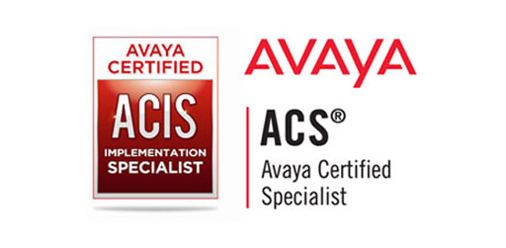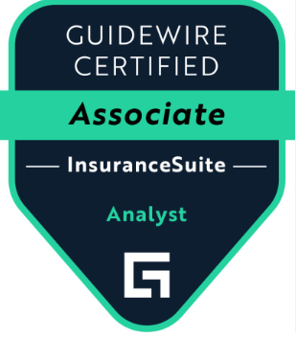
E-mail : siritoleti@gmail.com
Mobile: +17742421170
https://www.linkedin.com/in/sridivya-toleti-9b954b9a/

________________________________________________________________________
SUMMARY:
- Over 11+ years of Information Technology experience in various areas including Analysis, design, and support.
- 6 years of experience in Guidewire Claim Center as business analyst for ClaimCenter 7.x and 10.x.
- Efficient in business/application analysis, Process Analysis, Requirement gathering, Effort estimation, Planning, co-ordination with internal and external teams, design, development, testing and implementation activities.
- Conducted Joint Application Development (JAD) sessions with IT teams to identify changes and participated in stakeholder meetings to communicate the same.
- Developed Job aids, Onboard training materials, Triage templates and Lean process documentation.
- Proficient in Gap Analysis by modeling AS IS and TO BE documentation to check compatibility of existing system with new business requirements.
- Strong Experience working on scrum tools like JIRA and leanKIT.
- Highly motivated team player with excellent Interpersonal and Customer Relation Skills, and Communication skills
- Proficient in Conducting Scrum meetings, daily Triage meetings, Lead BA Meetings, Huddle, SWAT and Production support internal meetings on Guidewire projects.
- Experience in writing requirements, participating in business requirements with functional project stakeholders.
- Well versed with using Guidewire User Story Card excel module to capture the requirements in most efficient way.
- Experience in Production support troubleshooting and recreating issues in lower environments.
- Good hands-on experience in querying and analyzing the data model.
- Good knowledge on Claim Center financial processing. Experience in dealing with various payment methods.
- Worked on requirements integrating Claims Center with external systems to have a BPM in place for specific claim types.
- Worked on understanding pain(performance issues) with development team and came up with Re-engineering of some integrations.
- Have ability to take corrective and preventive actions to deliver deliverables as per schedule/scope plan with desired quality.
- High proficiency on handling ICON Nectar Tool, RIG server Upgrades
- Creating SNMP Traps to the RIG for the Media Gateways
Certification:-

- Guidewire certified InsuranceSuite Analyst - Associate
- IBM Tivoli Storage Manager V6.2 Administration
- ACIS – Avaya Certified.

TECHNICAL SUMMARY:
Having extensive hands-on below mentioned tools.
- Guidewire Claim center 10.
- JIRA, HP Quality Center, Visio, XML Spy, JIRA and LeanKIT.
- Microsoft SQL server studio.
- Service Now.
- BMC Remedy Force.

PROFESSIONAL EXPERIENCE:-
Project 1:Inspiredge It Solutions
- Role : Claims Business Analyst
- Duration : From July 2018 - Present
- Client : Assurant
Roles & Responsibilities:-
- Created requirements using Guidewire User Story Card excel module to capture UI mockups, UI fields, Business rules and typelist changes.
- Involved in writing requirements for Document template module.
- Involved in writing requirements for new EFT(Electronic Fund Transfer) payment method to claim center for payments.
- Involved in writing requirements for data mapping for integrations with both inhouse and external systems.
- Involved in writing requirements for new payment types and their integrations to Claim Center.
- Involved in writing requirements for complete claim automation for auto glass claims.
- Involved in writing requirements for claim center with IVR systems. Notifications sent to Insured on claim creation and check processing.
- Involved in writing requirements for various activities for special handling of valued customers.

Project 2: Inspiredge It Solutions
- Designation : Associate Software Specialist
- Duration : From April 2015 - July 2018
- Client : Avaya , Cisco
Roles & Responsibilities:-
- Complete knowledge on Nectar ICON RIG
- Troubleshooting issues like RIG Status, RIG Offline, and RIG License etc.
- Creating SNMP Traps to the RIG for the Media Gateways.
- Upgrading the RIG Version, bringing the RIG online in the RIG.
- Installing of RIG and IP Office
- Understanding of SNMP/SNMP walk
- Basic Understanding of Windows 2008 /2012 Server
- Basic Understanding of Linux OS
- Knowledge on Unified Communications environment
- Understanding of IP addressing changing the IP.

Event Monitoring:

- Working for the Avaya and Nortel Products
- Working for the alarms and troubleshooting in CM and Modular Messaging systems
- Drive tickets to get the correct solution to the problems in optimum amount of time.
- Consult Technical Support Engineers and Heads of various departments through mails and bring a solution to the issues in the minimum amount of time
- The job involves handling and resolving complex technical queries and issues in the areas of Avaya Communication
- Network Monitoring of Cisco routers, switches through Nagios Monitoring tool and diagnose the root cause for the outage
- Monitoring network operation center queue for Nortel and Cisco switches and routers for various clients and end business services
- Scheduling upgrades, collaborating with network engineers on network optimization
- Respond and Perform security incident triage and work with platform owners to define remediation plans
- Providing root cause analysis on alarms and alerts triggered by different networking tools and PBX systems
- Identifies, analyzes, and resolves/troubleshoots job scheduling problems, escalates as necessary to ensure resolution.
- Performing activities like MAS reboot, Server/CM shutdown, MAS/MSS reboots, taking backup of CM (OS, xln, security)/Gateways/System Manager, etc.

Project 3: HCL COMNET PVT LTD
- Designation : Analyst
- Duration : From August 2012 – May 2014
- Client : Micron Technologies
Roles & Responsibilities:-
Data command operations and Monitoring Skills
- Monitoring Data Backup activities using BMC Patrol Impact Explorer
- Monitoring Windows & Unix servers using Patrol Central Operator
- Monitoring L1 network alerts and coordinating with ISP over calls
- Managing Tape Movement activities between onsite and offsite locations.
- Incident Management using BMC Remedy
- Getting to know about the issue over call and Creating tickets
- Assigning & Escalating tickets using BMC Remedy
- Troubleshooting through Remote Desktop (Patrol Service, Backup Failure L1
- Level, Disk Space, Processor Utilization issues)
- Monitoring Critical (Priority 1) and High (Priority 2) Incidents across all the support teams
- Contacting all the teams through call or communicator and ensuring that all IT teams follow the Incident management Process for every Incident
- Maintaining SLA’s across all the Support teams
- Documenting Critical and High Priority Incidents and submitting the reports to Management using BMC Remedy Every Week.

