Sunita Sharma 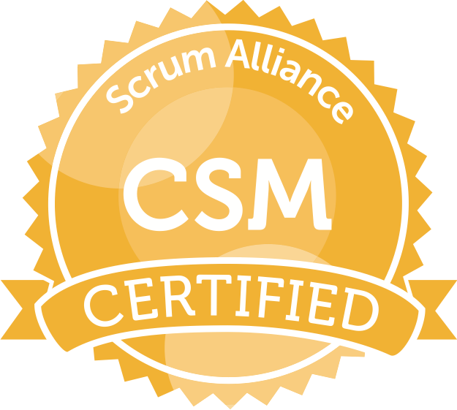 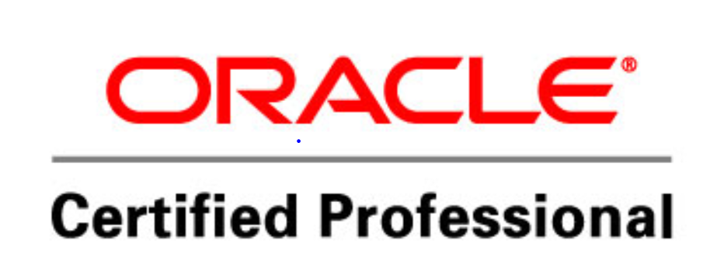 CPM
4696390294 ext 113 durga@tekjobs.ai s| Charlotte, NC 28262
Professional Objective

An IT Project Manager and Agile Scrum Master bringing 15+ years of IT industry experience in leading cross-functional teams in delivering high-quality software products, Partner with Product Owner for Business Analysis, facilitate Agile ceremonies and implement Scrum framework to improve team collaboration, productivity and deliver projects on-time and within budget. Adept at identifying and removing obstacles that impede team progress and coach team members to improve their skills in Agile methodologies. Strong communicator and problem-solver with a track record of leading high-performing teams and delivering exceptional results. I have extensive experience in Hybrid project management (Waterfall and Agile) implemented strategical approach for better delivery.
Qualifications:

15+ Years’ experience in IT | Lean, Waterfall and Agile Practice
7+ years as Project Manager | Adaptive Transformational projects, Embracing Agile
8+ years as a Scrum Master | Implement Scrum practice, Release management, Coaching
3+ years’ experience as Business System Consultant-Product Analyst. | Product Scope and Delivery Assurance
Enterprise, Transformation, Program & Team coach | Strategic Alignment of Business and Technical Roadmaps
Scaled Agile Exposure and experience | Guidance and experience on Dev-Ops, CICD, TDD
Release Manager, Scrum Master and Change Management | Team Formation, planning and Conflict Resolution skills
Kanban | Team Productivity with the Metrics
CSM, CPM, OCP DBA 8i | Hands on experience on JIRA, Version one, ADO, ALM, ServiceNow
Domains experienced on | Financial and Retail
Projects | Business Intelligence, MS Dynamics CRM –SAP CRM `Implementation, Ecommerce, Financial Crimes, IVR and Chatbots, SAP, AWS Cloud Operations/Data migration

Accomplishments:
__________________________________________________________________________________________

- Partnered significantly in Agile transformational efforts of the organizations.
  - Attributed significantly towards form teams, Coach Agile practices, implement best practices for teams to increase Velocity and efficient product deliveries.
- Significantly improved Teams productivity by implementing Agile best practices, better structured Artifacts, enforcing recurring Peer Reviews.
  - Implemented better Scrum board structure, use of required metrics, efficient estimation techniques and better Team collaboration.
  - Successfully negotiating Technical dependencies across the Scrum Teams to achieve 25% reduction in potential risks.
- Implemented a well appreciated innovative mapping between Waterfall and Agile Project Management.
  - Created better traceable elements from WBS through Product/Project Backlog to report real-time progress reports.
  - Teams could get better scope statements and plan for future assignments through Sprints.
- Empowered Teams to be more productive and deliver better quality every Increment.
  - Encouraged them for upskilling so they gained more cross functional knowledge and technical strength.
  - Introduced the use of pair programming that led to timely deliveries as well as cover-up for any resource constraint temporarily.
- Identified the grey areas between Business and Technical objectives for better mapping and clear vision or Teams progress.
  - Restructured the OKR assignment and alignment per the respective external dependencies for better planning.

Skills

- Agile Methodology | - Cross-Functional Team Facilitation | - Coaching & Mentorship
- Stakeholder Engagement | - JavaJ2EE Product Analysis | - Project Management
- Team Building & Collaboration | - Kanban & Scrumban | - Business Analysis
- Project Management & Delivery | - Continuous Improvement & Growth | - PLM (Project Lifecycle Management)

Awards and Recognitions:

- Received Appreciation for Best Agile Practitioner /Transformer in Lowes (2011)
- Received a momento of Recognition for Best leadership skills in ATD (2016)
- Received a momento of Appreciation for Quality Delivery of fast paced CRM implementation project at ATD( 2015)

Experience

Agile Project Manager
L3Harris Technologie Feb 2024 –Present

- Defining the project’s schedule and scope while balancing this with timely and regular value deliveries, and organizing and leading working and project status meetings.
- Led Teams towards implementing Agile practice for projects development and tracking.
- Coached teams for Agile /Scrum implementation overall.
- Conducted successful PI Planning for teams.
- Supporting the product owner in managing communications with stakeholders, managing customer’s expectations for deliverables, and implementing an effective project governance system.
- Promote team empowerment through team-building techniques, ensuring each team member is making a meaningful contribution and fully engaged in the project.
- Conduct periodic scope, schedule, and cost reviews using industry best practices, to identify needed adjustments
- Measure project performance and progress throughout campaign execution
- Manage client and other stakeholder expectations to maintain productive and engaged relationships

Environment/Technology: SAP S4HANA,MsSQL,Java,TeamCenter.ms Project.

IT Project Manager  Macy’s ,Atlanta | Aug 2022 –Dec 2023

- Assisted in team development while holding teams accountable for their commitments, removing roadblocks to their work;
- Adept in monitoring and controlling the Project Plan, periodically reporting the project health highlighting key RAID Items, and tracking action items.
- Expertise and proven track record in working on an Onsite/Offshore model in large scale System Integration and Data Migration projects following all phases of a Project Life Cycle .
- Assisted Product owner in PI Plannings for Business Requirement collection and Analysis and documenting them for teams
- Supported the Product Owner in managing customer expectations for project deliverables, managing stakeholder communications, and helping to implement an effective system of project governance Experienced working on various Technology based projects like .NET, Java extensively for cloud based/SAP CRM projects.
- Facilitated all Scrum events for the team like Daily Scrum, Sprint Reviews, Sprint Planning and Retrospectives.
- My Team also worked for Sales division for a project on IVR and Chatbots application enhancements.
- Managed all the projects per the RAID for organizing the information overall .
- Communicated effectively with clients and stakeholders, ensuring project alignment with client expectations resulting in successful project outcomes
- Implemented continuous improvement initiatives and process optimizations, resulting in a 15% increase in team productivity
Environment/Technology: JIRA, ServiceNow, Dynamo, DB2, Confluence, Java, Postman, STS.,SAP CRM,Cyara

Agile/IT Project Manager  The Vanguard Group, Charlotte, NC | Apr 2019- June 2022
- Facilitated all Scrum events for the teams and ensure better agile delivery.
- Assisted Product owner in PI Plannings for Business Requirement collection and Analysis and documenting them for teams
- Worked with teams for various projects including Data migration and Data conversion, Business Intelligence-ETL as well as financial crime prevention.
- Managed teams in Sales wing for their IVR application production support. The applications included Chatbots, Call routing, Call recordings and Agent interfaces.
- Worked through the Project Lifecycle following RAID strategy/Tool.
- Strong experience managing projects through Project Lifecycle Management..
- Experienced working on various Technology based projects like .NET, Java extensively
- Successfully negotiated and managed project dependencies, resulting in a 20% reduction in project risk
- Volunteered for successfully filling in for Release management efforts for the teams under a program.
- Partnered with product management team to develop release plans and keep product backlogs well-groomed, prioritized and visible to stakeholders.
Environment/Technology: JIRA, ServiceNow, Dynamo, DB2, Confluence, Java, Postman, STS,IVR,Chatbits.
Business System Consultant-Scrum  American Tire Distributors, Huntersville, NC | Jan 2014 - Dec 2018
- Facilitated daily Scrum, sprint planning, sprint demos and retrospective meetings.
- Monitored and track progress, prepare status reports, resolve issues, coordinate tasks, and activities directed toward completing the project goals.
- Took initiative and applied innovation in improving work processes.
- Facilitated collaborative work, team assignments and discussion and handled resource allocation and decision-making.
- Assisted with internal and external communications, improving transparency and disseminating information.
- Partnered with product owners for requirements Analysis and to create user stories along with keeping the backlog groomed
- Monitored the Sprint Burn down and conducted daily stand up, encouraging open communication in the team
- Facilitated the team to estimate story points and measured velocity to plan future sprints.
- Communicated with other Scrum masters, program leadership and development teams to report on status and blockers.
- My Teams worked on Ecommerce B2B and B2C projects, Business intelligence projects that involved Migration from Ms BI to OBIEE for Finance module as well as Sales force to Ms Dynamics CRM implementation.
Environment/Technology: Java, MQ series, DB2, OBIEE, MSSQL, ServiceNow, JIRA, Confluence Ms Project, SharePoint.
Business Systems Consultant-Project Manager/Scrum  Lowes, Mooresville, NC | Feb 2011 - Dec 2013
- Liasoned with Product owners for Backlog creation and refinements
- Led estimation, planning and backlog grooming and refinement in sprints.
- Use of Clarity and Jira for tracking projects and tasks
- Used Ms Project for managing the traditional part of the projects.
- Communicated with subject matter experts (both internal and external) to understand business needs and/or prevent/resolve issues
- Environment/Technology: Java, ,Python,.Net,Db2, Ms Project, SharePoint,JIRA,Confluence
- Organized and facilitated Scrum ceremonies, including daily stand-ups, sprint planning, grooming, sprint reviews, demos and retrospectives.
- Enabled team to become self-organized and self-managed through consistent coaching.
- Assessed Scrum maturity of team and identified areas for improvement and further training.
- Kept team on-track through quick management of diverse problems.
Environment/Technology: Ms Project,JIRA,VersionOne,Sharepoint,ServiceNow,.Net,Java,Ms BI,SSIS,SSRS,Postman,DB2
Business System Consultant –Agile  GMAC Ally, Charlotte, NC | Sept 2010 - Feb 2011
- Partnered with Teams for Agile transformation and adapt Agile practices, restructure the methodology
- Facilitated daily SCRUM via email in the form of Daily Status Updates.
- Assisted with and remove impediments for the support of local and remote personnel.
- Conducted training sessions and create documentation for new features and functionality being released.
- Publicized the team's progress and successes to make sure they are highly visible to the product owners and stakeholders.
- Use of Clarity and Jira for tracking projects and tasks.
- Volunteered and managed projects in Hybrid methodologies{Agile and Waterfall } as it was the phase of transformation.
- Implemented the RAID practice to ensure tracking Risks, issues for respective actions in order to take right decisions.
- Communicated with subject matter experts (both internal and external) to understand business needs and/or prevent/resolve issues.
- Ensure alignment to the cross-departmental roadmaps; create a collective plan to manage dependencies
Environment, Technology: Java, .Net, JIRA, Confluence, Sharepoint, Remedy, Ms Project, SharePoint.
Sr Product Analysis- Test  Merrill Lynch, Trenton, NJ | Feb 2010 – Aug 2010
- Acted as liaison to offshore analyst teams. Test case and reviews, pre delivery checks.
- Analyzed, reported, gave recommendations, and developed strategies to improve quality.
- Automation using descriptive programming QTP. Prepared requirement traceability matrix
- Involved in initial Requirement Analysis phase and understanding user stories defined in Jira.
- Planned and managed the team testing on different OS/browser combinations.
- Involved in all the phases from requirement analysis to developing test plan and test scripts against business requirements for system testing and UAT.
- Liaise with business users, developers, and implementation team.
- Conducted review meetings for business and QA teams.
Environment/Technology: Java, .Net, JIRA, Ms Project, SharePoint, Oracle.
Lead Business Consultant-Test  Sodexho, NY | Sep 2008 - Dec 2009
- Worked with developers to determine testing coverage needs and provide feedback on functionality
- Selected tools and developed infrastructure to improve testing quality and efficiency.
- Identified project risks and testing scope early in project lifecycle to find solutions and develop retesting procedures.
- Collaborated with software development teams to identify and resolve issues.
- Implemented tests into integration system to provide timely feedback to development teams.
- Liaised with application support teams and API interface users to address usage, configuration and implementation questions.
- Maintained extensive library of test cases, updating for current needs.
- Maintained meticulous test procedure documentation to support replicability and compliance.
- Created training documentation on new releases.
Environment/Technology: Java, Quality Center, MS Office, Ms Project, SharePoint.
Sr. Software Engineer, Test/Lead  Greenfield Online, MA | Oct 2005 - Aug 2008
- Managed offshore team and assigned project/modules to members for QA tasks
- Planned test strategies and test cycles for various successful product releases
- Wrote use cases based on the requirements and documented them as SRS for developers
- Reviewed business requirements, prepared test plans and test cases and gathered the metrics
- Created training documents for knowledge management/reference for new team members
- Allocated work to team members and tracked the status of the work
- Monitored the test execution phase, ensured team's effective defect data management, resolved issues, defect reviews, etc
Environment/Technology: Java, MS Access, MS Office, Ms Project, SharePoint.
Software Consultant  E-InfoTech, India | Feb 2004 - Sept2005
E Infotech Solutions is a Leading IT Consulting and SAP Training Company based in Delhi NCR, India
- Assisted with integration of cross-functional technology and business solutions.
- Reviewed business requirements, prepared test plans and test cases, tracked defects
- Provided periodic Project reports and involved in process improvement team
- Environment/Technology: Ma Access, MS Office, Test Director.
- Provided guidance related to upgrade cycle, end of life support and operational risks for existing applications.
- Built, tested and administered [Type] software applications.
Environment/Technology: Ms Office, Test Director, .Net, Ms Access

Education

- Master: Computer Applications - Osmania University, Hyderabad, India, Telangana, India

- B Sc: Computer Science - Osmania University, Hyderabad, India, Telangana, India

Language

English  Fluent |  | Hindi  Native |  | Punjabi  Native

