Contact Information:
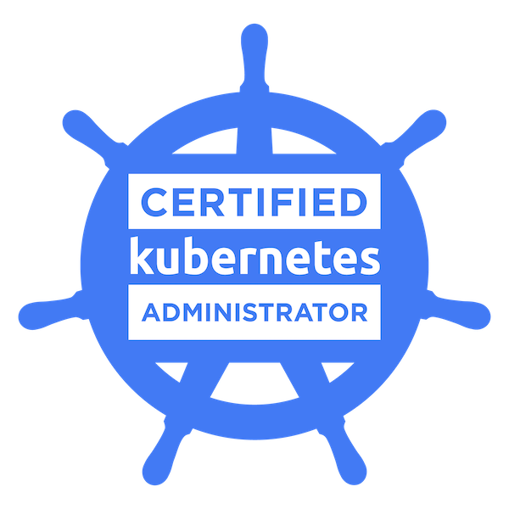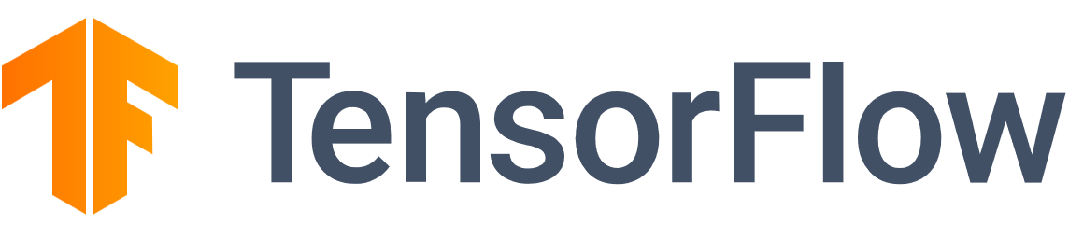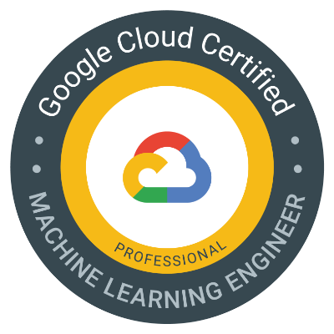
Name: Keerthi Raj
Email: keerthiraj.8991@gmail.com
Phone: +14694580278
LinkedIn: https://linkedin.com/in/keerthiraj8991
GitHub: https://github.com/KR-16

Professional Summary:
Highly Skilled and Motivated Machine Learning Engineer with around 5 years of experience in designing, implementing, and optimizing machine learning models and data pipelines across various industries, including finance, healthcare, insurance, and manufacturing. Proficient in leveraging advanced machine learning techniques to solve complex business problems and enhance data-driven decision-making. Strong expertise in integrating ML models into scalable data pipelines using cloud platforms such as AWS, Azure, and GCP. Adept at working with big data technologies, ETL processes, and cloud computing solutions to ensure robust and efficient machine learning workflows. Proven track record of leading cross-functional teams through all stages of the software development lifecycle (SDLC), from requirement gathering to deployment and monitoring, with a strong focus on Agile methodologies. Passionate about staying current with the latest advancements in machine learning and data science, and continuously improving the performance and accuracy of models through innovative approaches and tools.
Technical Skills:
Category | Skills
Machine Learning & Data Science | - Machine Learning Algorithms: Regression, Classification, Clustering, Decision Trees, Random Forests, XGBoost, SVM, K-Nearest Neighbors, Neural Networks, Deep Learning (CNN, RNN, LSTM)  - Data Preprocessing: Feature Engineering, Dimensionality Reduction, Data Cleaning, Data Normalization, Imputation Techniques  - Model Evaluation: Cross-Validation, A/B Testing, Hyperparameter Tuning, Model Optimization, ROC-AUC, Precision, Recall, F1-Score  - Model Deployment: Model Serving, MLOps, Continuous Integration/Continuous Deployment (CI/CD) for ML models, Model Monitoring, Retraining Pipelines
Programming Languages | - Python (Scikit-learn, TensorFlow, PyTorch, Keras, Pandas, NumPy, Matplotlib, Seaborn)  - R (Caret, ggplot2, dplyr, tidyr)  - SQL, PL/SQL  - Scala (Apache Spark, MLlib)  - Shell Scripting, Bash
Big Data & Cloud Technologies | - Big Data: Apache Hadoop, Apache Spark, PySpark, Hive, HDFS, Kafka, Flink  - Cloud Platforms: AWS (S3, EC2, Lambda, SageMaker, Redshift, Glue), Azure (Azure ML, ADF, Synapse Analytics, Databricks, Cosmos DB, Azure Data Lake Storage), GCP (BigQuery, Google ML Engine, Dataflow, Cloud Storage)  - Data Warehousing: Snowflake, Teradata, Redshift, Azure Synapse  - ETL/ELT: Informatica, Talend, Apache NiFi, DataStage
DevOps & MLOps | - CI/CD: Jenkins, GitLab CI, Azure DevOps, Docker, Kubernetes, Terraform, Ansible  - Version Control: Git, GitHub, Bitbucket  - Monitoring: Prometheus, Grafana, Nagios, Splunk  - Containerization & Orchestration: Docker, Kubernetes, Helm
Data Visualization & BI Tools | - Data Visualization: Tableau, Power BI, QlikView, Matplotlib, Seaborn  - Reporting: SSRS, SAP BusinessObjects
Database & Storage Technologies | - Relational Databases: SQL Server, Oracle, MySQL, PostgreSQL  - NoSQL Databases: MongoDB, Cassandra, DynamoDB, HBase  - Columnar Databases: Redshift, Snowflake, Azure Synapse  - Data Lakes: AWS Lake Formation, Azure Data Lake, Delta Lake
Other Relevant Skills | - Agile Methodologies: Scrum, Kanban, Sprint Planning, Retrospectives  - Data Governance: Metadata Management, Data Quality, Data Lineage (Collibra, Apache Atlas)  - Security: Data Security Principles, RBAC, IAM (AWS IAM, Azure AD), Encryption (SSL, TLS)  - Documentation & Communication: Technical Writing, Stakeholder Management, Team Leadership, Mentorship

Professional Experience:

Machine Learning Engineer | Dell Technologies
June 2022 – Present
- Led AI/ML initiatives, ensuring alignment with business objectives and delivering measurable ROI.
- Designed, developed, and deployed machine learning models using TensorFlow and PyTorch, improving prediction accuracy by 20%.
- Managed cross-functional teams to develop and deploy AI solutions, fostering collaboration between data scientists, engineers, and business stakeholders.
- Conducted data preprocessing tasks, including data cleaning, normalization, and feature engineering, to enhance model training efficiency.
- Applied dimensionality reduction techniques (e.g., PCA, t-SNE) to improve model training times and generalization.
- Implemented cross-validation, A/B testing, and hyperparameter tuning to optimize model performance.
- Built and deployed end-to-end ML pipelines on GCP (Vertex AI), AWS (SageMaker, Redshift), and Azure (Azure ML, Synapse Analytics), ensuring scalability and cost efficiency.
- Managed containerization and orchestration using Docker and Kubernetes for reliable and scalable AI solution deployment.
- Implemented CI/CD pipelines using Jenkins and GitLab CI for seamless model deployment and monitoring.
- Created interactive dashboards and visualizations using Tableau, Power BI, Matplotlib, and Seaborn to facilitate data-driven decision-making.
- Defined KPIs for AI models and tracked their performance post-deployment, providing actionable insights for continuous improvement.
- Collaborated with cross-functional teams to gather requirements, design solutions, and deliver projects on time.
- Managed risks, dependencies, and compliance challenges in AI deployments, ensuring adherence to regulatory and organizational standards.
- Conducted code reviews, optimized algorithms, and ensured the scalability and reliability of AI solutions.
- Led Agile ceremonies (e.g., sprint planning, retrospectives) to foster a collaborative and productive team environment.
- Ensured data security through robust practices, including RBAC, IAM (AWS IAM, Azure AD), and encryption protocols (SSL, TLS).
- Participated in data governance initiatives, focusing on metadata management, data quality, and data lineage using tools like Collibra and Apache Atlas.
- Mentored junior engineers on best practices in machine learning, software development, and AI deployment.
- Authored technical documentation and provided regular status updates to stakeholders, improving transparency and project management.
- Developed edge-based inference solutions using PyTorch and TensorFlow Lite for efficient model deployment on devices with limited computational resources.

Junior Machine Learning Engineer| Optum
June 2020 – May 2022
- Assisted in developing machine learning models for various applications, including image recognition, natural language processing, and predictive analytics.
- Worked with a wide range of machine learning algorithms such as Regression, Classification, Clustering, Decision Trees, and Random Forests.
- Contributed to the design and implementation of deep learning models using CNNs, RNNs, and LSTMs, enhancing the accuracy and robustness of solutions.
- Performed data preprocessing tasks, including data cleaning, normalization, and feature engineering, improving the quality of input data for model training.
- Applied dimensionality reduction techniques and imputation methods, leading to more efficient and accurate model performance.
- Assisted in the evaluation of models using techniques such as Cross-Validation, A/B Testing, and Hyperparameter Tuning to optimize model performance.
- Contributed to model performance monitoring using metrics such as ROC-AUC, Precision, Recall, and F1-Score.
- Deployed machine learning models on Google Cloud Platform (GCP), ensuring seamless integration with existing systems and infrastructure.
- Participated in MLOps processes, including Continuous Integration/Continuous Deployment (CI/CD) for machine learning models, model monitoring, and retraining pipelines.
- Supported the maintenance and troubleshooting of deployed models, ensuring high availability and optimal performance.
- Utilized Python (Scikit-learn, TensorFlow, PyTorch) and R (Caret, ggplot2) for building, training, and evaluating machine learning models.
- Wrote and maintained SQL queries and PL/SQL scripts to manage and analyze large datasets.
- Developed and maintained Scala code for data processing using Apache Spark and MLlib.
- Engaged in processing large datasets using Apache Hadoop, Apache Spark, and PySpark, optimizing data workflows for machine learning applications.
- Utilized cloud platforms such as AWS (S3, EC2) and Azure (Azure ML, ADF) for scalable model deployment and data storage solutions.
- Assisted in managing ETL/ELT processes using tools like Informatica and Talend, ensuring clean and consistent data for model training.
- Participated in the design and implementation of automated workflows using StackStorm, reducing manual intervention in the machine learning pipeline.
- Worked with CI/CD tools like Jenkins and GitLab CI for continuous integration and deployment of machine learning models.
- Assisted in containerization and orchestration using Docker and Kubernetes, ensuring scalable and efficient deployment of ML models.
- Created data visualizations using Tableau, Power BI, and Matplotlib, enabling data-driven decision-making and insights for the team.
- Supported the development of reports and dashboards using SSRS and SAP BusinessObjects, providing clear and actionable insights to stakeholders.
- Worked with relational databases like SQL Server, Oracle, and PostgreSQL for data management and analysis.
- Gained experience with NoSQL databases such as MongoDB and Cassandra, supporting the storage of unstructured data.
- Assisted in managing data lakes on AWS Lake Formation and Azure Data Lake, optimizing data storage for machine learning applications.
- Participated in agile ceremonies such as sprint planning, daily stand-ups, and retrospectives, contributing to a collaborative and productive team environment.
- Collaborated with cross-functional teams, gathering requirements, and assisting in the design and implementation of machine learning solutions.
- Supported data security practices, including RBAC, IAM (AWS IAM, Azure AD), and encryption protocols (SSL, TLS), ensuring compliance with industry standards.
- Assisted in data governance activities, focusing on metadata management, data quality, and data lineage using tools like Collibra and Apache Atlas.
- Contributed to technical documentation and provided regular updates to senior engineers and stakeholders, improving transparency and project management.
- Assisted in mentoring interns and junior team members, sharing knowledge and best practices in machine learning and data science.

Projects in my Graduation:
Project 1: Automated Fraud Detection System
Developed an automated fraud detection system using TensorFlow, GCP, and Vertex AI to analyze transaction data in real-time and identify potential fraud.
Key Contributions:
- Designed and implemented machine learning models using TensorFlow to detect fraudulent transactions.
- Leveraged GCP for data storage, processing, and model deployment, ensuring scalability.
- Integrated StackStorm to automate data ingestion, model retraining, and alerting workflows.
- Achieved a 30% reduction in false positives and a 25% increase in detection accuracy.
Project 2: Predictive Maintenance for Manufacturing Equipment
Developed a predictive maintenance solution for manufacturing equipment using TensorFlow, GCP, and Vertex AI.
Key Contributions:
- Built and deployed machine learning models to predict equipment failures and schedule maintenance.
- Streamlined model training and evaluation processes using Vertex AI.
- Automated data collection and preprocessing workflows, improving equipment uptime by 15% and reducing maintenance costs by 10%.
Project 3: Visual Question Answering (VQA) System
Developed a system to answer questions about images using custom Python scripts, NLP, BERT, and LSTM-VGG19 architecture.
Key Contributions:
- Increased model accuracy by 10% through optimized training on a large image-question-answer dataset.
- Implemented checkpointing for resource management and faster training recovery.
- Achieved competitive performance on benchmark VQA datasets.
Project 4: Chatbot Using LangChain
Developed a real-time web-based chatbot using Streamlit, LangChain, and Ollama LLM frameworks.
Key Contributions:
- Designed and integrated the chatbot using advanced NLP techniques and continuous deployment pipelines.
- Ensured scalability and efficiency for real-time interactions.
Project 5: Semantic Search System
Developed a system to perform semantic search on text data using BERT and FAISS.
Key Contributions:
- Built models for efficient text vectorization and similarity search.
- Deployed the system on the cloud with a user-friendly interface for searching similar sentences.
Project 6: Application Tracking System Using Google GenAI
Description: Developed a Streamlit web app using Google Generative AI to provide real-time resume feedback.
Key Contributions:
- Implemented customized prompts for resume evaluation and deployed the application with MLOps practices.
- Created an interactive user interface for professional resume feedback.

Education:
Bachelor of Science in Computer Science
Presidency University | Graduated: May 2023
Master of Science in AI/ML
University of Texas at Arlington | Graduated: May 2024

Certifications:
- TensorFlow Developer Certificate
- Google Cloud Professional Machine Learning Engineer
- Certified Kubernetes Administrator (CKA)

Professional Affiliations:
- Member, Association for Computing Machinery (ACM)
- Member, IEEE Computer Society

