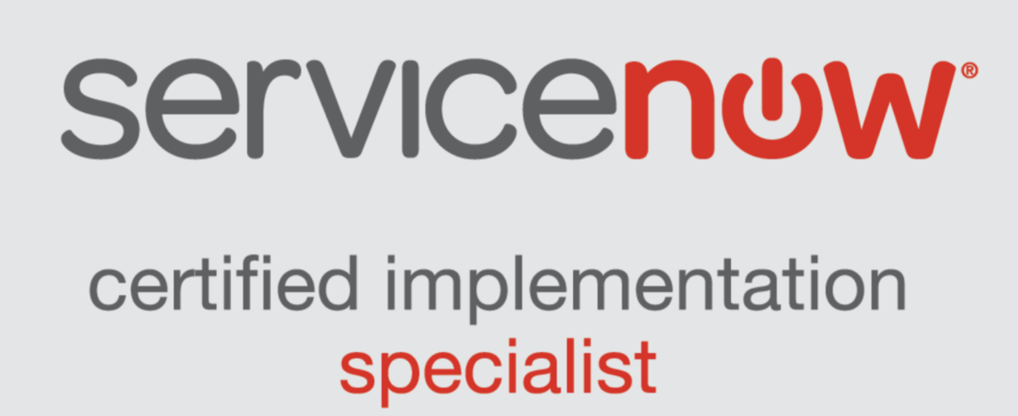
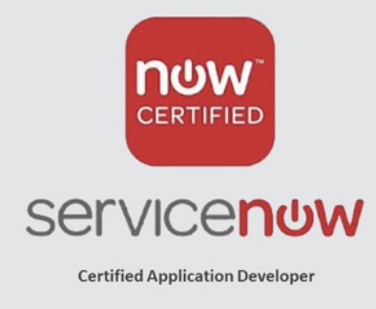
Mahesh D
Sr.ServiceNow Developer
940-343-5199
maheshsvcnow79@gmail.com
Professional Summary:
- ServiceNow Developer with over 9 +years of expertise in configuring, developing, and implementing ServiceNow solutions across ITSM and other modules, specializing in JavaScript, AngularJS, HTML/CSS, and REST/SOAP integrations.
- Proven track record in designing, implementing, and optimizing ServiceNow solutions across diverse modules, including ITSM, ITBM, ITOM, HRSD, and custom applications, ensuring alignment with business goals.
- Deep familiarity with ServiceNow platform versions, from Istanbul/Geneva to the latest releases, with hands-on experience managing upgrades and leveraging new features for enhanced functionality.
- Extensive experience in end-to-end ServiceNow implementations, covering Service Catalog, Incident Management, Change Management, Configuration Management, Asset Management, and Request Fulfilment, ensuring seamless IT operations.
- Skilled in integration technologies such as Ajax, jQuery, Jelly scripting, and REST/SOAP APIs, with a strong ability to troubleshoot system issues, optimize performance, and resolve complex technical challenges.
- Skilled in end-to-end ServiceNow implementations, including Service Catalog, Incident Management, Change Management, Configuration Management, Asset Management, and Request Fulfillment.
- Proficient in designing and optimizing workflows, UI elements, and scripting solutions (e.g., Business Rules, Script Includes, Client Scripts) to enhance platform functionality and meet evolving business needs.
- Expertise in Configuration Management Database (CMDB), including accurate asset tracking, dependency mapping, and data governance, enabling high-quality decision-making and operational efficiency.
- Experienced in leveraging ServiceNow ITOM solutions, including Event Management, Orchestration, and Discovery, to improve operational visibility, automate workflows, and streamline IT operations.
- Adept at integrating ServiceNow with third-party systems using SOAP/REST web services, Integration Hub, and custom scripts, ensuring seamless data exchange, interoperability, and secure connectivity
- Specialized in identity management solutions, such as Okta SSO and Multi-Factor Authentication (MFA), to provide secure and seamless access control for users and administrators
- Hands-on expertise in managing MySQL databases, implementing ITIL processes, and performing ServiceNow administrative tasks, including user and role management, ACLs, and system configurations
- Extensive hands-on experience implementing and customizing Incident, Problem, Change, Asset Management, CMDB, Knowledge Base, Service Catalog, Request Management, and Custom Applications.
- Proficient in creating Business Rules, Script Includes, UI Policies, Client Scripts, Data Dictionary configurations, and Validation Scripts using JavaScript and Glide System APIs.
- Designed and developed user-friendly Service Portals using UI Pages, UI Macros, Dynamic Blocks, HTML, CSS, JavaScript, and Bootstrap.
- Strong background in web development, with hands-on experience in JavaScript, Ajax, XML, and related technologies, enabling seamless integration of ServiceNow with various external systems and platforms
- Configured and maintained CMDB, Asset Management, Discovery, and MID Server installations, including bulk data loading via Transform Maps and Scripts.
- Successfully integrated ServiceNow with external systems using SOAP/REST APIs, LDAP, SSO, and XML/JSON data handling.
- Configured email notifications, scheduled jobs, script actions, and events to automate processes and improve operational efficiency.
Technical Skills:
ServiceNow Expertise | ITSM, ITBM, ITOM, CMDB, Workflow Automation, Incident Management, Problem Management, Change Management, Asset Management, Project Portfolio Suite, Knowledge Management, Service Catalog, Portal Design, Catalog Configuration
ServiceNow Versions | Kingston, Jakarta, Istanbul, Helsinki, Geneva, Fuji and San Diego,Utah,Washington.
Technologies | Java, Servlets, JSP, AJAX, Web-Services and JDK
Integration Technologies | SOAP, REST, LDAP, MID Server, Integration Hub
Operating Systems | LINUX, Windows Vista/7/8/10
Databases and Reporting | Microsoft SQL Server, Oracle SQL, MySQL, Crystal Reports, Remedy Reports
Products | Service Now, BMC Remedy ARS 6. 3, 7. 1, 7. 5, 7. 6, 8. 0, BMC Remedy ITSM 7. 1, 7. 5, 8. 0, BMC Atrium CMDB 7. 5
Scripting | HTML, CSS, JavaScript, VBScript, Jelly scripting, AngularJS, Shell Script.
Other Tools | Eclipse, QTP, SCCM, Crystal Reports, SQL Developer, Microsoft Visual Studio, MS Office, Client Script/Calling server side, code using Glide Ajax in Client Script

Project Experience:
Client: Johnson & Johnson, Raritan, New Jersey Dec 2023 to Present
Role: ServiceNow Developer
Responsibilities:
- Worked on SecOps architecture, development and configuration of ServiceNow software solutions.
- Designed IT Asset Management (ITAM) Solutions and Architectures for ITAM systems including integrations with Financial, HRSD and other IT Systems and ITIL Processes.
- Worked with process owners and business stakeholders to Translate Business Requirements into Functional Requirements within ServiceNow.
- Migrated Legacy data from Nuvolo location tables to ServiceNow Space Management
- Collaborated with stakeholders, business analysts, process leaders, and architects to develop implementation strategies and overall design for relevant applications with a focus on SecOps and IRM.
- Implemented and managed the ServiceNow ITOM suite, including Discovery, Event Management, and Service Mapping.
- Designed, developed, and maintained continuous integration and continuous deployment (CI/CD) pipelines using tools such as Jenkins, GitHub Actions, and GitLab CI incorporating IRM protocols for secure code deployment.
- Worked on ITSM and SecOps development and consulting services, using the "3 C's" (Consulting, Configuration, Coding)
- Created several Workflows for ITSM, Service Catalog, Security Operations (SecOps), Performance Analytics and HRSD. Worked on Incident Management, Problem Management, Change Management and Service Catalog.
- Automated IT service processes by 30% through advanced UI Policies, Business Rules, and Client Scripts, significantly improving operational efficiency for healthcare IT support.
- Developed and customized advanced UI Policies, Business Rules, and Client Scripts, automating IT service processes by 30%, leading to improved operational efficiency in healthcare IT support.
- Customized ServiceNow forms and pages using Jellybeans scripting to meet the specific needs of application, ensuring seamless user experience for medical professionals.
- Configured and customized Incident, Problem, Change, and Request Management modules to align with ITIL processes.
- Developed and customized DHTML templates to create visually appealing and user-friendly interfaces within ServiceNow.
- Created custom dashboards and reports to provide actionable insights for IT operations and service performance.
- Implemented jQuery libraries to enhance client-side scripting capabilities and improve user interactions within ServiceNow.
- Performed user and access management tasks, ensuring security and compliance with organizational policies.
- Integrated ServiceNow with healthcare management systems and third-party applications using Web Services, enabling real-time data exchange for enhanced patient care coordination.
- Configured and optimized ITSM modules (Incident, Problem, Change, and Request Management) to align with ITIL-based healthcare workflows, reducing service downtime and ensuring regulatory compliance.
- As workload permits, work with leaders in other areas of HRSD to identify process improvements, organize projects and execute project work to bring greater effectiveness and efficiency.
- Designed and implemented custom dashboards and reports to provide actionable insights into IT service performance, patient data security, and compliance tracking.
- Designed REST API and SOAP integrations to enable secure and seamless communication between ServiceNow and healthcare-related third-party tools such as Electronic Health Records (EHR) systems.
- Provided technical support and troubleshooting for Application Performance Monitoring (APM) in a live healthcare IT environment, ensuring optimal performance of critical applications.
- Integrated ServiceNow with existing Remedy Webservices to maintain data consistency and enable efficient IT service management in a healthcare setting.
- Collaborated with stakeholders, including healthcare IT teams and compliance officers to design ServiceNow solutions that meet regulatory requirements such as HIPAA and FDA guidelines.
- Participated in change management processes for deploying system enhancements and updates within the ServiceNow environment, minimizing disruptions in healthcare operations.
- Documented technical designs, workflows, and configurations ensuring seamless knowledge transfer and compliance with IT governance standards.
Client: Key Bank, Cleveland, Ohio Dec 2021 – Nov 2023
Role: ServiceNow Developer
Responsibilities:
- Developed and customized ServiceNow applications for ITSM modules (Incident, Change, Service Catalog) to support SOX compliance and streamline banking workflows.
- Designed and configured ServiceNow solutions for banking-specific needs, including automated x
- Integrated ServiceNow with core banking systems (e.g., Finacle, Temenos) via RESTful APIs, web services, JDBC, and MID Server for seamless data exchange in payment gateways, treasury management, and cybersecurity.
- Specialized in delivering high quality implementations of ServiceNow Security Operations (SecOps) and that provide accelerated return on investment for ServiceNow customers.
- Optimized ETL workflows and SQL queries to improve performance and scalability, meeting business SLAs and IRM requirements for data processing and delivery.
- Created custom dashboards and reports in PPM to provide stakeholders with real-time visibility into project status, resource utilization, and performance metrics.
- Implemented end-to-end Service Catalog, Incident Management, Configuration Management (CMDB), Asset Management (ITAM), Change Management and Release Management with Knowledge of Content management.
- Automated CMDB updates using App Engine, ensuring data integrity and synchronization with external systems for asset tracking and IT operations.
- Optimized App Engine performance using CSDM, conducting tuning and load testing for scalability and high availability in real-time banking operations.
- Automated workflows using Flow Designer for loan approvals, fraud alerts, and customer service requests, reducing manual intervention and streamlining processes.
- Developed custom scripts and logic using JavaScript, Glide APIs, and Server-Side APIs for scalable, maintainable solutions in a regulated environment.
- Implemented scheduled jobs and business rules to automate tasks, enforce data integrity, and ensure compliance with Basel III and other regulatory standards.
- Resolved technical issues by debugging and optimizing JavaScript, Jelly, and Glide scripts, ensuring smooth operation of custom workflows and integrations.
- Optimized ServiceNow instance performance to handle high volumes of users and data across Diageo’s global offices, ensuring scalability and reliability.
- Collaborated with stakeholders to analyze business requirements, re-engineer processes, and implement solutions that improved operational efficiency and reduced costs.
Client: National Grid, Massachusetts - Waltham October 2019 – Nov 2021
Role: ServiceNow Developer
Responsibilities:
- ServiceNow Administrator and Developer across diverse domains, implementing solutions for ITSM, IRM (Integrated Risk Management), ESG (Environmental, Social, and Governance), and SPM (Strategic Portfolio Management).
- Extensive technical implementation of ServiceNow modules, including Incident, Problem, Change, Asset Management, CMDB, Knowledge, Request, Service Catalog, Custom Applications, and Integrations, ensuring alignment with ITIL V3 principles.
- Developed and maintained Business Rules, Script Includes, Data Dictionary, UI Actions, UI Policies, Client Scripts, and Validation Scripts using JavaScript and Glide System to enhance platform functionality and user experience.
- Configured Email Notifications, Scheduled Jobs, Script Actions, and Events to automate processes and ensure timely actions within ServiceNow.
- Designed and implemented custom workflows using the ServiceNow graphical workflow editor, optimizing operational efficiency and service delivery.
- Designed Service Catalog items using Record Producers and Order Guides, defining workflows, approvals, and dynamic tasks to streamline service requests.
- Developed Service Portals for ESS users using UI Pages, UI Macros, Dynamic Blocks, HTML, CSS, JavaScript, and Bootstrap, enhancing user experience and accessibility.
- Configured and maintained CMDB (Configuration Management Database) and Asset Management systems, leveraging Discovery and MID Server installations for accurate data mapping and asset tracking.
- Created and maintained Access Control Rules (ACLs) to secure role-based applications, ensuring compliance with organizational policies and regulatory requirements.
- Integrated ServiceNow with External Authentication Systems such as LDAP and SSO, enhancing security and simplifying user access management.
- Worked on third-party integrations using SOAP and REST web services, handling XML and JSON data formats to enable seamless communication between ServiceNow and external systems.
- Created and managed users, groups, and roles using Central Management Console (CMC), setting appropriate access rights and permissions for Business Objects Administration.
- Optimized Strategic Portfolio Management (SPM) by creating dashboards to monitor portfolio performance, enabling data-driven decisions for resource allocation and project prioritization.
Wabtec, Pittsburgh, PA
ServiceNow Developer July 2017 to Sep 2019
- Managed key ITSM configurations, integrations, and application administration for Wabtec’s IT environment, ensuring seamless migrations and upgrades aligned with ITSM best practices.
- Provided precise estimates for ServiceNow design and implementation efforts, supporting successful ITSM planning and business objectives.
- Documented and tracked changes to Configuration Items (CIs), ensuring accurate impact assessments and alignment with safety and compliance goals.
- Applied Agile methodologies to customize ServiceNow, delivering scalable solutions to meet dynamic business needs.
- Designed a company-wide Service Catalog with self-service options, empowering employees and reducing IT dependency.
- Developed data mapping solutions for accurate data transfers, enhancing decision-making and operational insights.
- Created user-centric page layouts and design concepts, aligning with Wabtec’s ITSM standards and business goals.
- Built reports and dashboards to track KPIs, providing actionable insights for leadership.
- Streamlined workflows using Flow Designer, reducing manual effort and improving service delivery efficiency.
- Configured custom components like Notifications, UI Pages, and Script Includes to enhance platform functionality and usability.
- Worked on ServiceNow CMDB, focusing on data loading, attribute customization, and process synchronization for effective IT asset and configuration management.
- Connected with Stake Holders to understand their requirements and convert business requirement into actual requirements with possible implementation solutions.
- Configured Email Notification and Alerts based on the events to notify users about specific activities in the system.
Client: Diageo – Hyderabad, India May 2016 – June 2017
Role: ServiceNow Administrator/Developer
Responsibilities:
- Configured and maintained ServiceNow instances for global teams at Diageo, ensuring seamless operations across Incident, Problem, Change, and Service Request Management modules.
- Designed and implemented workflows using Business Rules, Client Scripts, and UI Policies to streamline processes like incident resolution, change approvals, and service requests.
- Configured LDAP integration to synchronize user and group data, enabling secure access management and reducing manual updates for Diageo’s workforce.
- Created intuitive UI pages and forms using JavaScript, HTML, and CSS to enhance user experience and improve adoption rates for ServiceNow applications.
- Automated email notifications for incidents, service requests, and approvals, ensuring timely communication and reducing delays in task resolution.
- Built and maintained Configuration Management Databases (CMDB) to track relationships between business services and IT assets, supporting Diageo’s manufacturing and logistics operations.
- Used Import Sets and Transform Maps to migrate data from legacy systems into ServiceNow, ensuring accurate synchronization of asset records and minimizing duplicates.
- Designed dynamic Service Catalog items with JavaScript logic to automate field population, cost calculations, and approval workflows, improving efficiency for Diageo’s employees.
- Configured Service Level Agreements (SLAs) and escalation rules to ensure compliance with operational timelines and improve customer satisfaction.
- Worked on RESTful APIs, SOAP, and MID Servers to integrate ServiceNow with external systems like ERP, CRM, and HR platforms, enabling seamless data flow across Diageo’s operations.
- Configured ServiceNow Discovery to identify IP-enabled configuration items (CIs), map their dependencies, and populate them in the CMDB, ensuring accurate asset tracking.
- Developed real-time dashboards and reports using Glide Record and JavaScript to provide insights into key metrics like incident trends, asset utilization, and SLA performance.
Education:
Bachelor’s in engineering from Swarna Bharathi institute of science and technology May 2016

