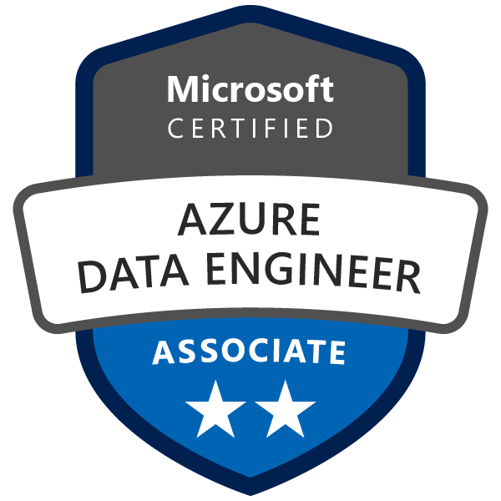
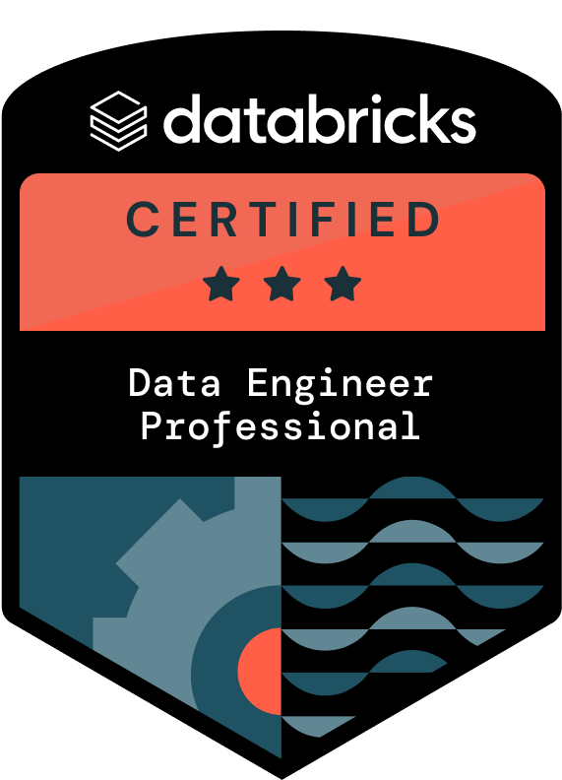
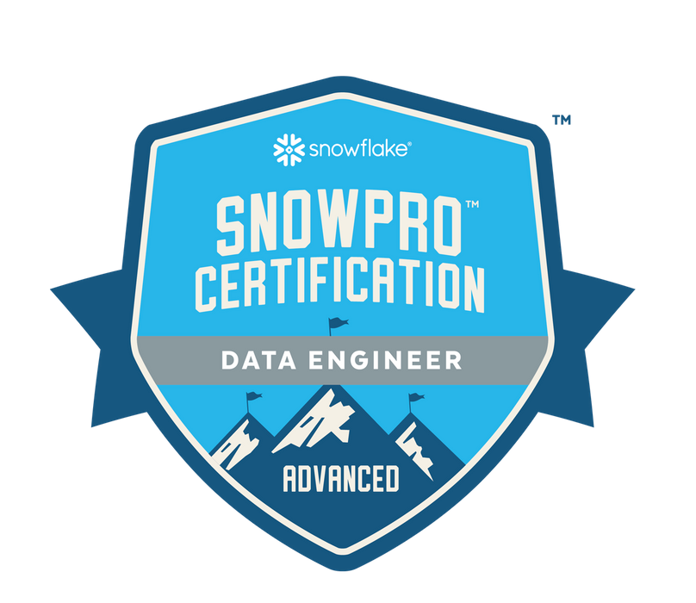
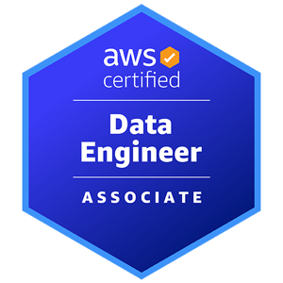
Rahulsai Singireddy
Email: singireddyrahulsai7@gmail.com
Ph#: 260-633-3953
linkedin.com/in/rahul-singireddy-87b437230

PROFESSIONAL SUMMARY:
- Data Engineer with over 10+ years of professional work experience in IT industry with Enterprise Application development involving business Analysis, Development, Maintenance & support.
- Experience with all stages of the SDLC and Agile Development model right from the requirement gathering to Deployment and production support.
- Hands on experience in developing SPARK applications using Spark tools like RDD transformations, Spark core, Spark MLlib, Spark Streaming and Spark SQL.
- Experience in developing Spark streaming jobs by developing RDD’s (Resilient Distributed Datasets) using Scala, PySpark and Spark-Shell.
- Experience in optimizing MapReduce Programs using combiners, partitioners and custom counters for delivering the best results.
- Hands on experience in Hadoop ecosystem including Spark, Kafka, HBase, Scala, Pig, Impala, Sqoop, Oozie, Flume, Storm, big data technologies and worked on Spark SQL, Spark Streaming and using Core Spark API to explore Spark features to build data pipelines.
- Experience with Airflow to schedule ETL jobs to extract the data from AWS data warehouse.
- Experience in Designing, Developing, Documenting, Testing of ETL jobs and mappings in Server and Parallel jobs using Data Stage to populate tables in Data Warehouse and Data marts.
- Experience in Text Analytics, generating data visualizations using Python and creating dashboards using tools like Tableau.
- Experience in using Tableau Desktop to extract data for analysis using filters based on the business use case.
- Experience with Apache Spark ecosystem using Spark-Core, SQL, Data Frames, RDD's and knowledge on Spark MLLib.
- Experience working on creating and running Docker images with multiple micro services.
- Experience with Azure Data Factory (ADF), Integration Run Time (IR), File System Data Ingestion, Relational Data Ingestion.
- Experience in Azure Cloud, Azure Data Factory, Azure Data Lake Storage, Azure Synapse Analytics, Azure Analytical services, Azure Cosmos NO SQL DB, Azure HDInsight Big Data Technologies (Hadoop and Apache Spark) and Data bricks.
- Hands on experience working Amazon Web Services (AWS) using Elastic Map Reduce (EMR), Redshift, and EC2 for data processing.
- Hands on experience on Star Schema Modeling, Snow-Flake Modeling, FACT and Dimensions Tables, Physical and Logical Data Modeling using Erwin.
- Experience in extracting source data from Sequential files, XML files, CSV files, transforming and loading it into the target Data warehouse.
- Experienced working with JIRA for project management, GIT for source code management, JENKINS for continuous integration and Crucible for code reviews.
- Hands on experience in SQL and NOSQL database such as Snowflake, HBase, Cassandra and MongoDB.
- Excellent communication skills, interpersonal skills, problem solving skills a very good team player along with a can do attitude and ability to effectively communicate with all levels of the organization such as technical, management and customers.

Technical Skills:

Databases | Snowflake, AWS RDS, Teradata, Oracle, MySQL, Microsoft SQL, PostgreSQL.
NoSQL Databases | MongoDB, Hadoop, HBase and Apache Cassandra.
Programming Languages | Python, SQL, Scala, MATLAB.
Cloud Technologies | Azure, AWS
Data Formats | CSV, JSON
Querying Languages | SQL, NoSQL, PostgreSQL, MySQL, Microsoft SQL
Integration Tools | Jenkins
Scalable Data Tools | Hadoop, Hive, Apache Spark, Pig, MapReduce, Sqoop.
Operating Systems | Red Hat Linux, Unix, Windows, macOS.
Reporting & Visualization | Tableau, Matplotlib.

Professional Experience:

Client: Banner Bank, Walla Walla, WA. Apr 2024 – Till Date
Role: Data Engineer

Responsibilities:
- Participated in a requirement gathering session with business users and sponsors to understand and document the business requirements.
- Built Spark applications using PySpark and used the Python programming language for data engineering in Spark framework.
- Developed Scala scripts and UDFs using both data frames/SQL and RDD in Spark for data aggregation, queries and writing back into an S3 bucket.
- Developed Spark applications for performing large-scale transformations and denormalization of relational datasets.
- Developed Spark code using Scala and Spark-SQL for faster testing and data processing.
- Developed Apache Spark jobs using Scala in test environment for faster data processing and used Spark SQL for querying.
- Developed Python web services for processing JSON and interfacing with the Data layer.
- Performing ETL testing activities like running the Jobs, extracting the data using necessary queries from database transforming, and uploading into the Data warehouse servers.
- Used ETL to implement the Slowly Changing Transformation, to maintain historical data in Data warehouse.
- Worked with Tableau for generating reports and created Tableau dashboards, pie charts, and heat maps according to the business requirements.
- Used Reporting tools like Tableau to connect with Hive for generating daily reports of data.
- Automated resulting scripts and workflow using Apache Airflow and shell scripting to ensure daily execution in production.
- Installed and configured Apache Airflow for S3 bucket and Snowflake data warehouse and created dags to run the Airflow.
- Optimized MapReduce Jobs to use HDFS efficiently by using various compression mechanisms.
- Implemented a Continuous Delivery pipeline with Docker and Git Hub.
- Analysed, designed and built Modern data solutions using Azure PaaS service to support visualization of data. Understand current Production state of application and determine the impact of new implementation on existing business processes.
- Extract Transform and Load data from source systems to Azure Data Storage services using a combination of Azure Data Factory, T-SQL, Spark SQL and U-SQL Azure Data Lake Analytics. Data Ingestion to one or more Azure Services - (Azure Data Lake, Azure Storage, Azure SQL, Azure DW) and processing the data in Azure Data bricks.
- Implementation of end-to-end data solution on Azure using Azure Data bricks, ADF, DW, and Power BI.
- Created Pipelines in ADF using Linked Services/Datasets/Pipeline/ to Extract, Transform and load data from different sources like Azure SQL, Blob storage, Azure SQL Data warehouse, write-back tool and backwards.
- Created and modified several database objects such as Tables, Views, Indexes, Constraints, Stored procedures, Packages, Functions, and Triggers using SQL and PL/SQL.
- Involved in Agile methodologies, daily scrum meetings, spring planning.
- Actively participated and provided constructive and insightful feedback during weekly Iterative review meetings to track the progress for each iterative cycle and figure out the issues.

Environment: Spark, Scala, Azure, ETL, Kafka, Tabelau, Hadoop, Python, Snowflake, HDFS, Hive, MapReduce, PySpark, Docker, Sqoop,, Teradata, JSON, MongoDB, SQL, Agile and Windows.

Client: Wintrust Financial, Rosemont, IL. Dec 2022 – Mar 2024
Role: Azure Data Engineer
Responsibilities:
- Involved in Requirement gathering phase to gather the requirements from the business users to continuously accommodate changing user requirements.
- Developed Spark Jobs using Scala in test environment for faster data processing and used Spark SQL for querying.
- Developed Spark scripts by using Scala shell commands as per the requirements for cleaning and testing.
- Developed streaming pipelines using Apache Spark with Python.
- Developed Tableau reports on the business information to examine the examples in the business.
- Developed ETL framework using Spark and Hive (including daily runs, error handling, and logging) to useful data.
- Used Spark for Parallel data processing and better performances.
- Used Tableau to produce the dashboards which will compare the results before using this solution and after using this solution in staging environment.
- Created several Data Bricks Spark jobs with PySpark to perform several tables to table operations.
- Used Python to extract data for Web scraping.
- Create several types of data visualizations using Python and Tableau.
- Designed and implemented configurable data delivery pipeline for scheduled updates to customer facing data stores built with Python.
- Design and implement secure data pipelines into a Snowflake data warehouse from on-premises and cloud data sources.
- Design Setup maintain Administrator the Azure SQL Database, Azure Analysis Service, Azure SQL Data warehouse, Azure Data Factory, Azure SQL Data warehouse.
- Design and implement database solutions in Azure SQL Data Warehouse, Azure SQL.
- Architect & implement medium to large scale BI solutions on Azure using Azure Data Platform services (Azure Data Lake, Data Factory, Data Lake Analytics, Stream Analytics, Azure SQL DW, HDInsight/Data Bricks, and NoSQL DB).
- Design & implement migration strategies for traditional systems on Azure (Lift and shift/Azure Migrate, other third-party tools.
- Used various sources to pull data into Power BI such as SQL Server, Excel, Oracle, SQL Azure etc.
- Created airflow DAG’s to sync files from box, analyse data quality, and alert for missing files.
- Worked on streaming pipeline that uses Spark to read data from Kafka transform it and write it to HDFS.
- Worked on different file formats like Sequence files, XML files and Map files using MapReduce Programs.
- Implemented a Continuous Delivery pipeline with Docker and GitHub.
- Responsible for modifying the code, debugging, and testing the code before deploying on the production cluster.
- Worked on designing, building, deploying and maintaining Mongo DB.
- Implemented SQL, PL/SQL stored procedures.
- Involved in story-driven agile development methodology and actively participated in daily scrum meetings.
- Actively participating in the code reviews, meetings and solving any technical issues.

Environment: Spark, Scala, Python, PySpark, ETL, Tableau, Map Reduce, Azure, Kafka, Hive, Apache Kafka, HDFS, JSON, Sqoop, NoSQL, MongoDB, SQL, Agile and Windows.

Client: CVS Health Care, Scottsdale, AZ. Aug 2020 – Nov 2022
Role: Data Engineer
Responsibilities:
- Gathering business requirements, business analysis and design various data products.
- Developed spark applications for performing large scale transformations and denormalization of relational datasets.
- Used Scala to convert Hive / SQL queries into RDD transformations in Apache Spark.
- Written Programs in Spark using Scala for Data quality check.
- Developed Spark scripts by using Python shell commands as per the requirement.
- Designed library for emailing executive reports from Tableau REST API using python, Kubernetes, Git, AWS CodeBuild, and Airflow.
- Writing Hive scripts with UDF in MR and Python to perform ETL on AWS Cloud Services.
- Integrated data quality plans as a part of ETL processes.
- Building data pipelines and complex ETL to process external client data using Python, Spark.
- Designed, developed, tested, and maintained Tableau functional reports based on user requirements.
- Performed Tableau type conversion functions when connected to relational data sources.
- Created DataStage jobs using different stages like Transformer, Aggregator, Sort, Join, Merge, Lookup, Data Set, Funnel, Remove Duplicates, Copy, Modify, Filter, Change Data Capture, Change Apply, Sample, Surrogate Key, Column Generator, Row Generator, Etc.
- Performed Data Analysis, Data Migration, Data Cleansing, Transformation, Integration, Data Import, and Data Export through Python.
- Involved in converting Map Reduce programs into Spark transformations using Spark RDD's using Scala and Python.
- Performed transformations using Python and Scala to analyze and gather the data in required format.
- Imported data from AWS S3 into Spark RDD, Performed transformations and actions on RDD's.
- Created Map Reduce programs to handle semi/unstructured data like xml, json and sequence files for log files.
- Reviewed basic SQL queries and edited inner, left, and right joins in Tableau Desktop by connecting live/dynamic and static datasets.
- Created scripts to read CSV, JSON and parquet files from S3 buckets in Python and load into AWS S3, DynamoDB and Snowflake.
- Worked with No-SQL databases like HBase in creating HBase tables to load large sets of semi-structured data coming from various sources.
- Involved in daily SCRUM meetings to discuss the development/progress and was active in making scrum meetings more productive.

Environment: Spark, Scala, Hadoop, Python, Pyspark, AWS, MapReduce, ETL, HDFS, Hive, HBase, SQL, Agile and Windows.

Client: The Home Depot, Atlanta, GA. Jan 2018 – Jul 2020
Role: Data Engineer
Responsibilities:
- Interacted with clients to gather business and system requirements which involved documentation of processes based on the user requirements.
- Developed various spark applications using Scala to perform various enrichment of these click stream data merged with user profile data.
- Developed Spark scripts by writing custom RDDs in Scala for data transformations and perform actions on RDDs.
- Developing Spark programs with Python, and applied principles of functional programming to process the complex structured data sets.
- Performed advanced procedures like text analytics and processing, using the in-memory computing capabilities of Spark using Scala.
- Designed, developed, tested, and maintained Tableau functional reports based on user requirements.
- Used ETL to implement the Slowly Changing Transformation, to maintain Historically Data in Data warehouse.
- Developed various Python scripts to find vulnerabilities with SQL Queries by doing SQL injection, permission checks and analysis.
- Analyzing SQL scripts and designed the solution to implement using PySpark
- Imported the data from different sources like AWS S3, Local file system into Spark RDD.
- Involved in developing python scripts, abintio, informatica and other etl tools for extraction, transformation, loading of data into data warehouse.
- Written Hive jobs to parse the logs and structure them in tabular format to facilitate effective querying on the log data.
- Optimized MapReduce Jobs to use HDFS efficiently by using various compression mechanisms.
- Use SparkSQL to load JSON data and create Schema RDD and loaded it into Hive Tables and handled structured data using SparkSQL.
- Extracted files from MongoDB through Sqoop and placed in HDFS and processed.
- Use SQL queries and other tools to perform data analysis and profiling.
- Followed agile methodology and involved in daily SCRUM meetings, sprint planning, showcases and retrospective.

Environment: Spark, Scala, ETL, Python, AWS, HDFS, Hive, Kafka, CSV, JSON, PySpark, SQL, Agile and Windows.

Client: Grange Insurance, Columbus, OH. Jan 2014 – Dec 2017
Role: Data Engineer
Responsibilities:
- Involved in Requirement gathering phase to gather the requirements from the business users to continuously accommodate changing user requirements.
- Developed Spark Scala scripts for mining information and performed changes on huge datasets to handle ongoing insights and reports.
- Developed Scala functional programs for streaming data and gathered JSON and XML data and passed to Flume
- Used various Spark Transformations and Actions for cleansing the input data.
- Used Spark Dataframes, Spark-SQL extensively to build multiple ETL pipelines.
- Designed the ETL process and created the high-level design document including the logical data flows, source data extraction process, the database staging and the extract creation.
- Performed Tableau type conversion functions when connected to relational data sources.
- Worked on data that was a combination of unstructured and structured data from multiple sources and automated the cleaning using Python scripts.
- Write Python scripts to parse JSON documents and load the data in database.
- Used Pyspark for data ingestion and perform complex transformations.
- Developed Map-Reduce programs to get rid of irregularities and aggregate the data.
- Use SQL queries and other tools to perform data analysis and profiling.
- Followed agile methodology and involved in daily SCRUM meetings, sprint planning, showcases, and retrospectives.
- Actively participated and provided feedback in a constructive and insightful manner during weekly Iterative review meetings to track the progress for each iterative cycle and figure out the issues.

Environment: Spark, Scala, ETL, Tableau, Python, PySpark, MapReduce, Kafka, Hive, HDFS, Snowflake, SQL and Windows.

EDUCATION:
- Master of Science in Engineering Management and Information Systems – IIT - 2013
- Bachelor of Technology in Mechanical Engineering - Anurag Group of Institutions – 2012

CERTIFICATIONS:
- Databricks Certified Data Engineer Professional
- SnowPro Advanced Data Engineer
- Microsoft Certified: Azure Data Engineer Associate
- AWS Certified Data Engineer

