# **BTD210- Assignment 1**

|  |  |
| --- | --- |
| Total Mark: | 10 marks |
| Submission file(s):  (do **NOT** zip files) | * SQL file: Asg1_GroupNumber.SQL, including * Part II: SQL code * Part III: SQL code * Part IV: SQL Queries * Document: Asg1_ GroupNumber.docx, including   + Part I: ERD (legible resolution)   + Part III: legible screenshot of tables with data   + Part IV: legible screenshots of SQL queries (or paste results)   + Part V: Group work |

Please work in **groups** to complete this assignment. This assignment is worth 10% of the total course grade and will be evaluated through your written submission, as well as the demo. During the demo, group members are *randomly* selected to explain the submitted solution. Group members who are not present during the demo or cannot answer questions will lose the demo mark.

Please submit the submission file(s) through Blackboard. Only one person must submit for the group and only the last submission will be marked.

## **Part I. Design the database (50%)**

The Incredible Insurance Company has contacted you to create a database for their business operations. Through interviews with the manager, you obtain samples (see Figure 1 and 2) and the following information:

The insurance agents sell the insurance products to the clients (ternary relationship). Each agent has a unique code, which identifies the agent. The company needs to keep track of each agent’s first name, last name, address, phone number, hire date, and supervisor. Supervisors are agents who supervise zero to many other agents. Each agent is supervised by only one supervisor, who is senior to them (has been hired earlier). Supervisors can have supervisors too (a hierarchy of agents).

Each client has a unique code as well. The clients can buy one or more products. The transaction is recorded in a policy. There is only one agent per each policy. Agents can be clients too (The personal information must be saved in only one table to minimize anomalies.) The company needs to store each client’s first name, last name, address, and phone number. If the client has any dependents, their first and last names need to be stored as well.

The insurance policies each have a unique number. Each policy indicates the agent, the client, the product, and the start and end date of the policy. It also contains the monthly payment amounts of the policy.

Each insurance product is identified by 4-character code. Given the code, one knows the terms and conditions in the policy.

Design a relational database without redundancy for the above company. Draw the ERD using **Microsoft Visio (choose Crow’s Foot Diagram)**. Include the following in your document:

* The ERD
* A list of business rules that you assumed for drawing your ERD (only if not clearly specified above). In real world, you would go back to the manager to confirm if your assumptions are correct.

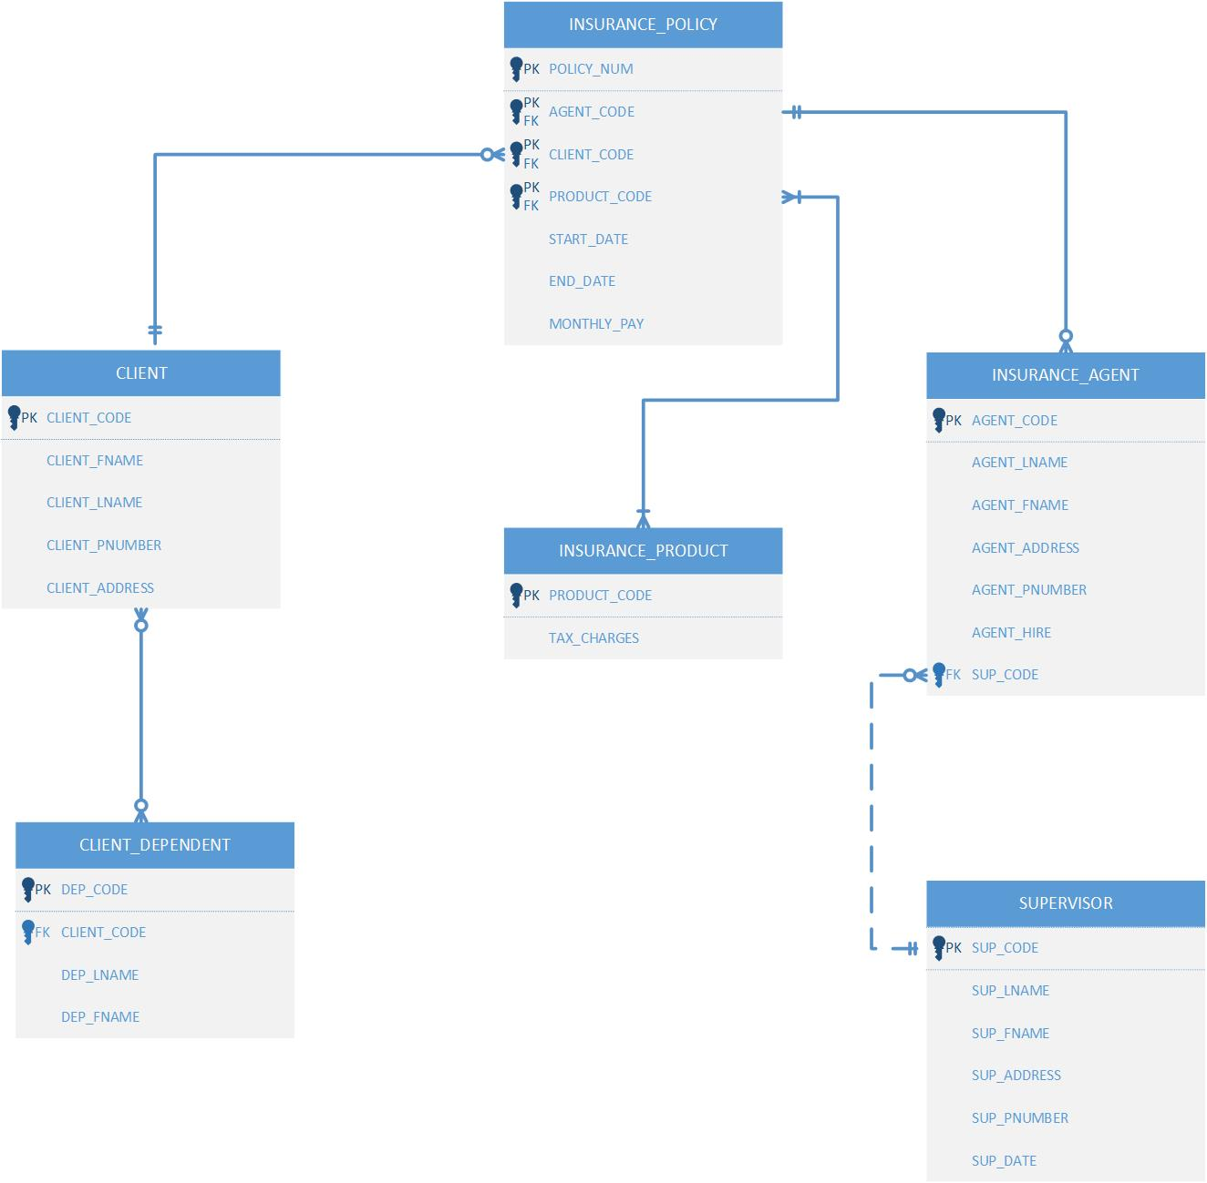

## **Part II. Create the tables (15%)**

Write the SQL statements for creating the tables for the entities in your design in the SQL file. Run in SQL Server Management Studio (SSMS) and commit to changes. Add all tables to a new database diagram in SSMS. Show a snapshot of the created diagram.

## **Part III. Enter data (10%)**

Enter the following data using SQL commands and save in your SQL file.

* The two insurance policies in Figure 1 and 2 are given to you as samples. Enter the data in the relevant table(s).
* You are also told that Mike Maxwell is Martin Smith’s supervisor. Enter the data in the relevant table(s).
* Complete necessary data for the above two agents (use assumed values).
* Use the given samples and make up your own policy sample with policy number 0000 123 789 (include in your document). Enter the data in the tables.

Show the data in all your tables in your document (a clear and readable screen shot)

INSERT INTO INSURANCE_AGENT

VALUES('A123B04','Mike','Maxwell','Apt. 214-300 ALice Drive,Scarborough,ON,Canada M3M 2M1',NULL,NULL,NULL);

INSERT INTO INSURANCE_AGENT

VALUES('A123B45','Martin','Smith','123 Rose Court,Ajax,ON,Canada L1B 2C3',NULL,NULL,NULL);

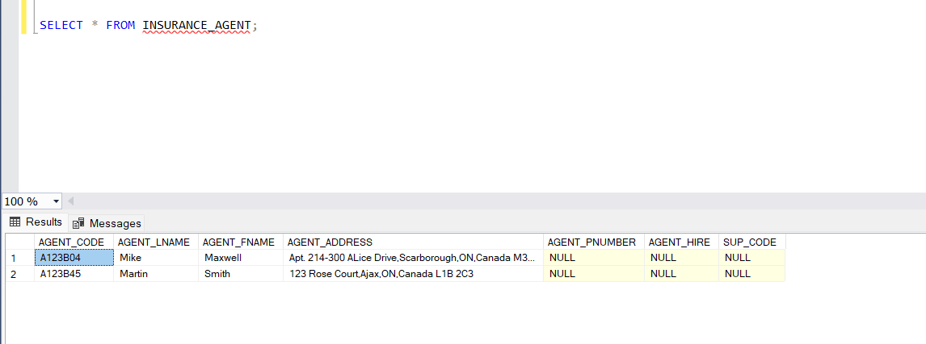

INSERT INTO CLIENT

VALUES('121245','Martin','Smith',NULL,'123 Rose Court,Ajax,ON,Canada L1B 2C3');

INSERT INTO CLIENT

VALUES('131365','Gerald','Willaker',NULL,'325 Meadow Park,Toronto,ON,Canada M3M 3A1');

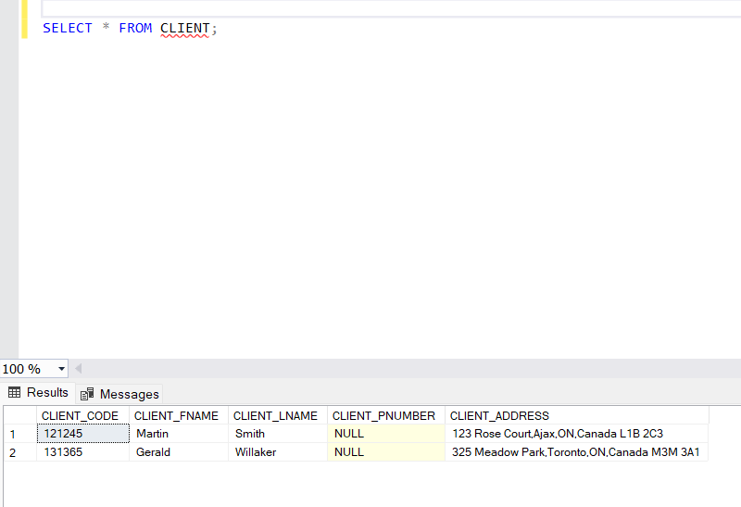

INSERT INTO INSURANCE_PRODUCT

VALUES('BY78', NULL);

INSERT INTO INSURANCE_PRODUCT

VALUES('AX2Y', NULL);

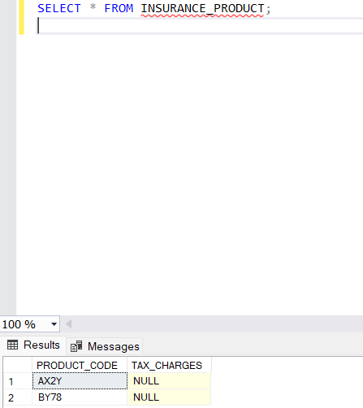

INSERT INTO INSURANCE_POLICY

VALUES(0000456789,'A123B04','121245','BY78','3-Jan-15','3-Jan-17',350.00);

INSERT INTO INSURANCE_POLICY

VALUES(0000123456,'A123B45','131365','AX2Y','23-Feb-15','22-Feb-16',200.00);

INSERT INTO CLIENT_DEPENDENT

VALUES ('647893','121245','Jane','Willaker');

INSERT INTO CLIENT_DEPENDENT

VALUES ('647892','121245','Jack','Willaker');

INSERT INTO CLIENT_DEPENDENT

VALUES ('647891','121245','Mary','McGuire');

INSERT INTO CLIENT_DEPENDENT

VALUES ('415232','131365','May','George');

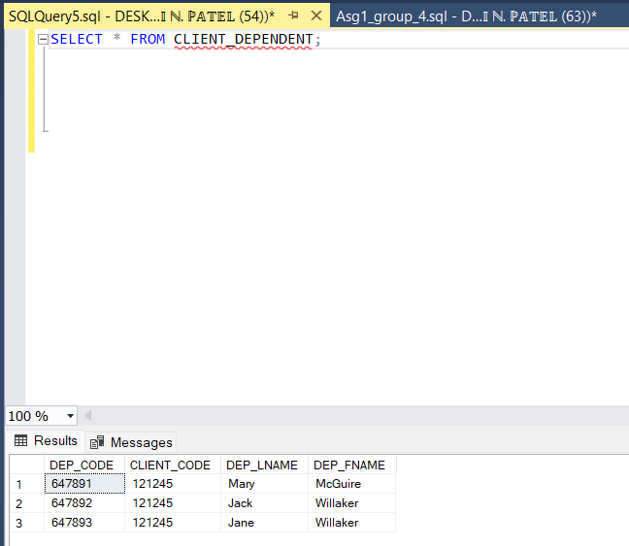

## **Part IV. Update and List data (25%)**

For the following questions, include the SQL commands in your SQL file and show a clear and readable screen shot of the results.

1. Martin Smith has the following changes over time.
   1. He moves to this address: 456 Jasmin Dr., North York, ON Canada M3J 1P5
   2. He adds a dependent to his file: Anne Smith

Write the SQL statements to update the tables needed.

UPDATE INSURANCE_AGENT

SET AGENT_ADDRESS='456 Jasmin Dr., North York, ON Canada M3J 1P5'

WHERE AGENT_CODE='A123B45';

UPDATE CLIENT

SET CLIENT_ADDRESS='456 Jasmin Dr., North York, ON Canada M3J 1P5'

WHERE CLIENT_CODE='121245';

INSERT INTO CLIENT_DEPENDENT

VALUES('647899','121245','Anne','Smith');

1. Write a SQL command to list all policies with policy numbers having 123 as their fifth to seventh digits (XXXX-123-XXX): show the policy number, start date, and annual payment (monthly times 12).

SELECT POLICY_NUM,STARTDATE,MONTHL_YPAY*12 AS ANNUALPAY

FROM INSURNCE_POLICY

WHERE POLICY_NUM LIKE '123___';

1. Write a SQL statement that lists all dependents of Martin Smith. Use subqueries to obtain his client code.

SELECT * FROM CLIENT_DEPENDENT

WHERE CLIENT_CODE='121245';

## **Part V. Group work**

1. Add this declaration on the top of your file.

We, Abhi Patel, Neel Mahimkar, Smeet Patel(mention your names), declare that the attached assignment is our own work in accordance with the Seneca Academic Policy. No part of this assignment has been copied manually or electronically from any other source (including web sites) **or distributed to other students.**

1. Specify what each member has done towards the completion of this work:

|  |  |  |
| --- | --- | --- |
|  | Name | Task(s) |
| 1 | Abhi Patel | Part 1, Part 4 |
| 2 | Neel Mahimkar | Part 1, Part 2 |
| 3 | Smeet Patel | Part 3 |



Figure 1: Policy sample #1



Figure 2: Policy sample #2