Data Visualization Report – Airports Dataset
Name: Abhideep Singh
Internship Role: Data Analyst Intern
Task: Data Visualization (Task-3)
Dataset: Global Airports Dataset
Source: www.kaggle.com

1. Introduction
This report presents the Data Visualization task performed on a global airports dataset.
The objective of this task is to transform raw and cleaned data into meaningful visual formats that clearly reveal trends, patterns, and insights.
Data visualization helps in:
- Understanding complex datasets easily
- Identifying patterns and outliers
- Communicating insights effectively
- Supporting decision-making
This task was performed using the cleaned dataset generated during Task-2 (EDA).

2. Objective of the Task
The main objectives of this task are to:
- Convert raw airport data into visual formats such as charts and graphs
- Highlight key trends and distributions
- Design clear and informative visualizations
- Create data stories that support insights and analysis

3. Dataset Overview
The dataset used is the Global Airports Dataset, which contains information about airports worldwide.

Basic Properties
- Total Records: 6,671
- Total Columns: 6 (after cleaning)

Column Details
Column Name | Description
iata | IATA airport code
icao | ICAO airport code
name | Airport name
location | City, State, Country
time | Time zone
country | Extracted country name
The dataset was pre-processed and cleaned during Task-2 (EDA).

4. Tools & Libraries Used
The following tools were used to perform data visualization:
- Python
- Pandas
- Matplotlib
- VS Code

5. Visualizations Created
Three key visualizations were created to analyze airport distribution.

5.1 Top 10 Countries by Number of Airports
A bar chart was created to show the top 10 countries with the highest number of airports.
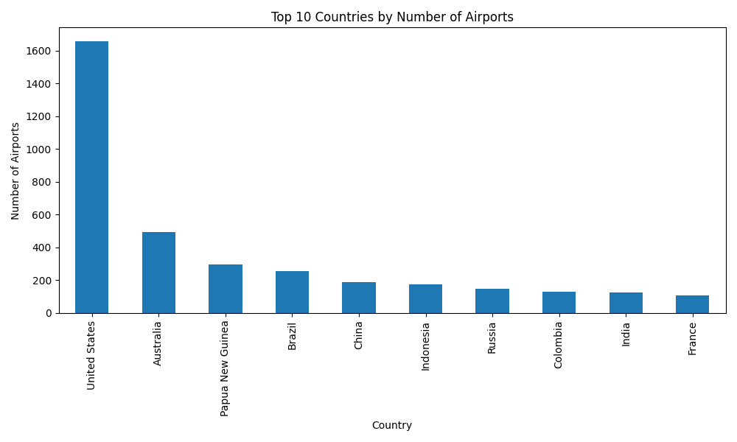Insight:
- A small number of countries dominate global airport counts
- The United States appears at the top
- Airport distribution is highly uneven across countries

5.2 Top 10 Time Zones by Number of Airports
A bar chart was created to show the most common time zones worldwide.
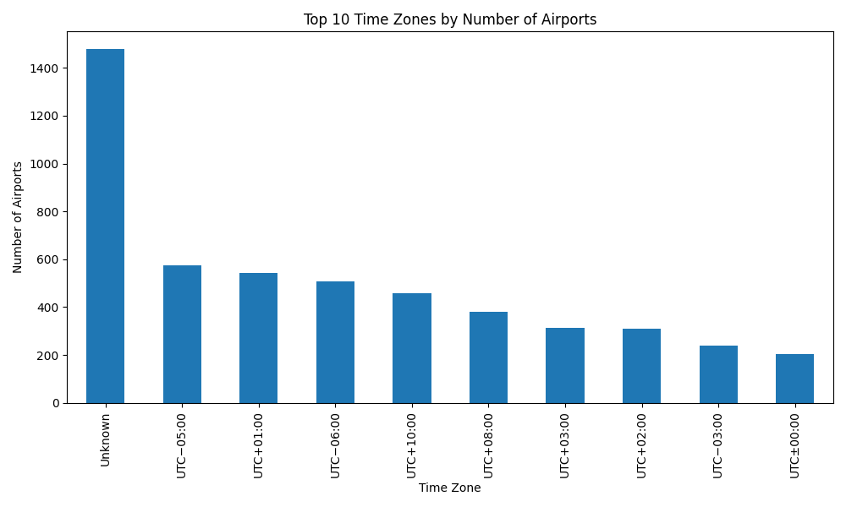Insight:
- Most airports lie in a few major time zones
- Time zones around UTC+00:00 to UTC+03:00 dominate
- Airport presence is concentrated in specific regions

5.3 Airport Distribution by Continent
A pie chart was created to show approximate airport distribution by continent.
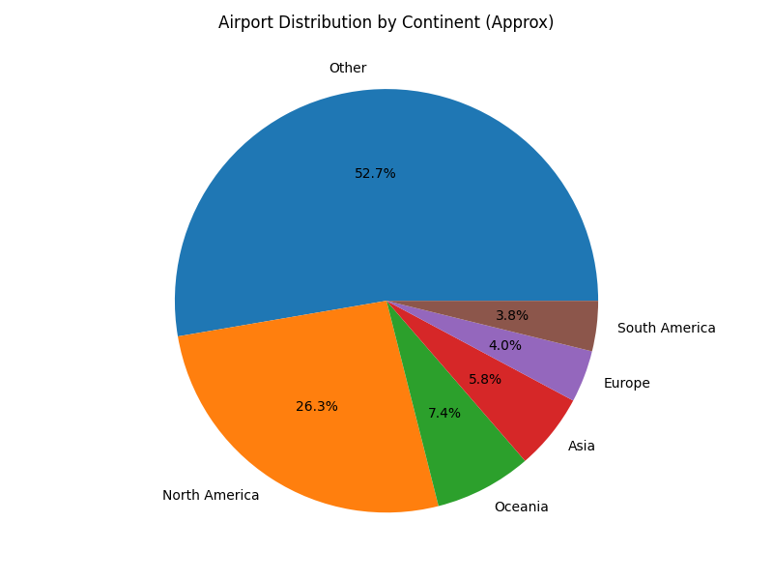Insight:
- North America and Europe dominate airport presence
- Asia also shows a significant share
- Other continents have comparatively fewer airports

6. Trends and Patterns Identified
From the visualizations, the following trends were observed:
- A few countries account for a large proportion of global airports
- Airport distribution is highly skewed across countries
- Airports are concentrated in a few major time zones
- North America and Europe dominate airport density

7. Data Story
The visualizations clearly show that global aviation infrastructure is not evenly distributed.
A small number of countries and time zones dominate airport presence, indicating:
- Higher air-traffic demand
- Stronger aviation infrastructure
- Greater economic and population concentration
These visuals help transform raw data into actionable insights.

8. Conclusion
This task successfully demonstrates how data visualization can convert raw data into meaningful insights.

Key Findings:
- A few countries dominate global airport counts
- Airports are heavily concentrated in specific time zones
- Airport distribution is highly uneven across regions
- Visualizations clearly reveal geographic patterns
This task fulfills all the objectives of Task-3:
✔ Transformed raw data into visual formats
✔ Designed clear and meaningful charts
✔ Identified trends and patterns
✔ Created a compelling data story

9. Files Generated
The following files were created as part of Task-3:
- task3_visualization.py
- viz_top_countries.png
- viz_top_timezones.png
- viz_continent_distribution.png
- airports_cleaned.csv

10. Tools & Libraries Used
- Python
- Pandas
- Matplotlib
- VS Code

