Exploratory Data Analysis (EDA) Report – Airports Dataset
Name: Abhideep Singh
Internship Role: Data Analyst Intern
Task: Exploratory Data Analysis (EDA)
Dataset: Global Airports Dataset
Source: www.kaggle.com

1. Introduction
This report presents an Exploratory Data Analysis (EDA) of a global airports dataset.
The objective of this analysis is to:
- Understand the structure of the dataset
- Identify trends, patterns, and anomalies
- Detect data quality issues
- Test simple hypotheses using statistics and visualization
EDA helps in preparing the dataset for further modeling and business insights.

2. Business / Analysis Questions
Before starting the analysis, the following key questions were framed:
- Which countries have the highest number of airports?
- How are airports distributed across different time zones?
- Which time zones are most common worldwide?
- Are there missing or inconsistent airport codes?
- Which regions or countries appear under-represented?

3. Dataset Overview
The dataset was collected from an online open-source platform.
Basic Properties:
- Total Records: 6,671
- Total Columns: 5
Column Details:
Column Name | Description
iata | IATA airport code
icao | ICAO airport code
name | Airport name
location | City, State, Country
time | Time zone
Data Types:
- All columns are categorical (object type)

4. Data Quality Check

4.1 Missing Values
- The icao column contained missing values
- The time column contained missing values

4.2 Duplicate Records
- No major duplicate records were found

5. Data Cleaning
The following cleaning steps were applied:
- Missing values in icao were replaced with "Not Available"
- Missing values in time were replaced with "Unknown"
- A new column country was extracted from the location column
- The cleaned dataset was saved as:
airports_cleaned.csv

6. Exploratory Analysis

6.1 Top Countries by Number of Airports
A bar chart was created to show the top 10 countries with the highest number of airports.
Observation:
- A small number of countries dominate global airport counts
- The United States appears at the top
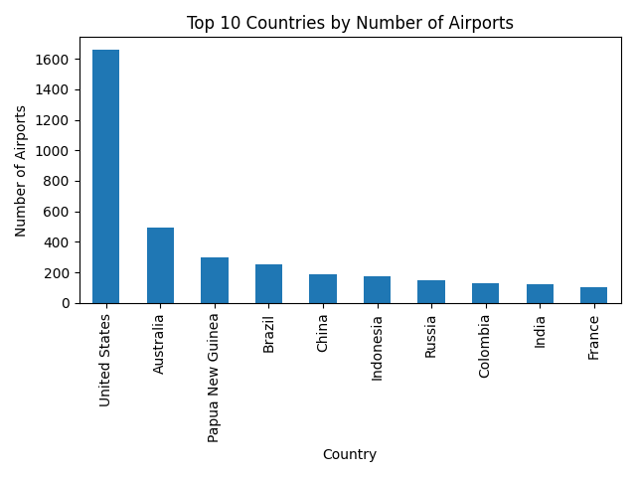

6.2 Distribution of Airports by Time Zone
A bar chart was created to show the top 10 time zones.
Observation:
- Most airports lie between UTC+00:00 and UTC+03:00
- Certain time zones dominate airport distribution
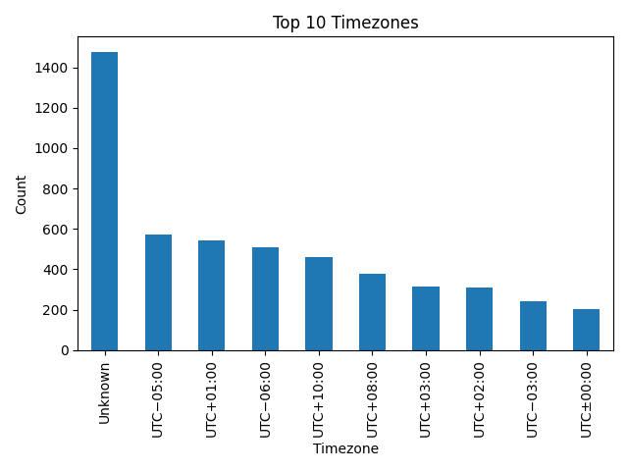

7. Trends and Patterns
- A few countries account for a large portion of airports
- Airport distribution is uneven across countries
- Time zone distribution is highly skewed
- Europe and North America dominate airport density

8. Hypothesis Testing

Hypothesis 1
Most airports are located in a small number of countries.
✔ Result: Validated

Hypothesis 2
Airports are concentrated in a few major time zones.
✔ Result: Validated

9. Data Quality Issues Identified
- Missing ICAO and time zone values
- Location column combines city, state, and country
- Inconsistent time zone formatting
- Some airports missing standard codes

10. Conclusion
The Airports dataset provides a useful overview of global aviation infrastructure.
Key Findings:
- A few countries dominate global airport counts
- Airports are heavily concentrated in specific time zones
- Some data quality issues exist but were addressed
- The dataset is suitable for geographic and aviation trend analysis
This EDA successfully fulfilled all internship task objectives:
- Explored structure
- Identified trends and anomalies
- Tested hypotheses
- Detected data issues

11. Tools & Libraries Used
- Python
- Pandas
- Matplotlib
- VS Code

This EDA report was created as part of a Data Analytics Internship Task using Python.

