**LOYOLA COLLEGE (AUTONOMOUS), CHENNAI-34**

**DEPARTMENT OF DATA SCIENCE**

**INTERNSHIP REPORT**



|  |  |
| --- | --- |
| Name | ABHIDHARINI R |
| Dept. No | 22-PDS-004 |
| Company | Monalaya International Pvt Ltd |
| Internship Start Date | 15.05.2023 |
| Internship End Date | 05.06.2023 |
| Internship Period | 1 MONTH |
| Type of Internship | DATA ANALYSIS |

**ACKNOWLEDGEMENT**

This internship report is the result of a collaborative effort by a number of people. I'd like to express my gratitude to the Principal, Rev. Fr. Dr. A. Louis Arockiyaraj SJ, the Secretary and Correspondent, Rev. Dr. B. Jeyaraj SJ, and the Deputy Principal, Dr. J.A. Charles, for providing me an opportunity to do my Master’s program in Data Science.

Special thanks to Dr. T. Rajaretnam, the Head of the Department of Data Science, for consistently emphasizing the relevance of internship experiences for students. Dr. T. Rajaretnam, my internship guide, deserves a lot of credit for preparing the students for a successful internship experience. I'd like to express my gratitude to Dr. A. Manimuthu for his assistance with the internship.

The internship I did with Monalaya International Inc, was a fantastic opportunity for me to learn and grow professionally. I'd like to offer my heartfelt gratitude to the HR Manager, in particular, for making this internship possible My special thanks to Mr. k. Raman (Managing Director, Manolaya International Inc) for providing data for our analysis and guiding us throughout our project and make us understand the actual working of a company by considering us one of them. Also specially thanking for his interest in making us aware about the industrial activities, like inventory management and its demand forecasting.

I consider this internship to be a significant step forward in my professional development. I will make every effort to put my newly acquired skills and knowledge to the greatest possible use. In order to achieve my job goals, I will continue to focus on my progress.

**TABLE OF CONTENTS**

|  |  |  |
| --- | --- | --- |
| S. No. | TITLE | Page. No |
| 1. | Industry profile |  |
| 2. | Summary of the internship |  |
| 3. | Data analysis project |  |
| 4. | Data Description |  |
| 5. | Problem Statement |  |
| 6. | Appendix |  |

**Internship Completion Certificate**

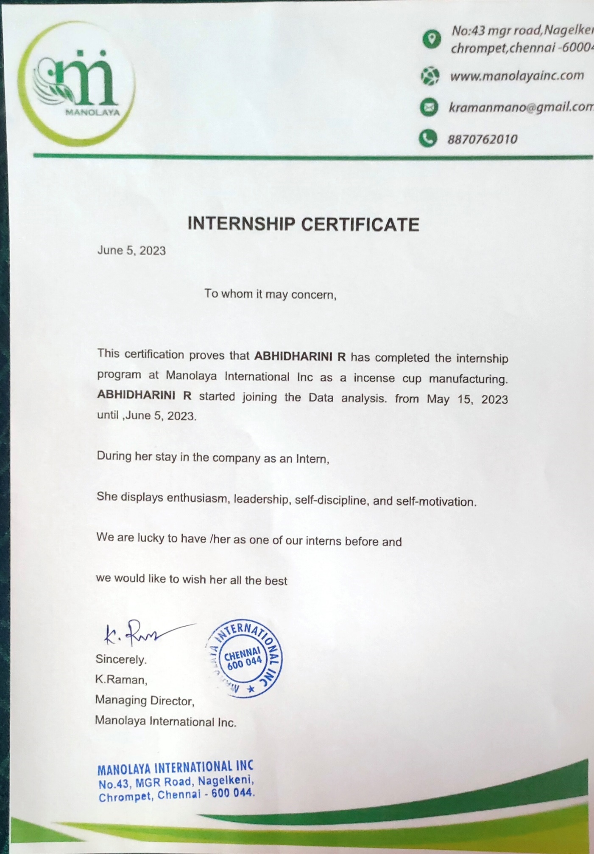

**INDUSTRY PROFILE**

**ABOUT:**

Manolaya International Inc is an Indian-based company with headquarters in Chennai, Tamil Nadu. They are involved as the supplier, exporter of Natural products like Cup sambrani, Agarbathi, flower cups components. The company deals with the manufacturer for representing their products in India which requires local market knowledge and countrywide reach. They have earned the reputation of being the best in the industry of supplying industrial consumables and capital goods. By offering a range of quality products and demonstrating a unique understanding of how their customers use them. They consistently recommend the right products, to increase productivity and efficiencies in customers’ operations. They also offer total consultancy works for the following:

1. **Digital Marketing:**

The team provides insights on how to handle all their digital marketing platform, ads promotion, SEO services to ensure faster and smarter operation of the client organization.

1. **Operation Excellence:**

They believe in understanding the needs and expectations of their customers. They provide the most cost-efficient solutions that not only leverage but also strengthen their client’s market position.

1. **Inventory Management:**

They give consultation for streamlining the process of ordering, storing, and using a company’s inventory raw materials, components, and finished products which will result in optimizing inventory levels.

1. **Project Management:**

Their expert team offers seamless consulting advice and services to their client’s project management team so that the work gets finished. They can help with their valuable insight to ensure the timely completion of the project.

They are backed by a dedicated team of skilled workforce and diligent personnel that helps them to meet the specific requirements of the clients. Their philosophy is to help their clients be successful by providing appropriate solutions for their problems and challenges. With just one year since its inception, the company has been doing very well with a turnover of about 1.2 crores, selling to more than 40 companies their products and expanding to two more cities Bangalore and Pune.

**COMPANY LOGO:**



**VISION:**

“Build a conglomerate by connecting the passionate peoples and continuously devise new solutions to meet the needs of our customers”

**MISSION:**

To be the world leader in products, services, and solutions that enable and transform the way consumers and businesses gather, manage, distribute. Be the best in the eyes of their customers, employees, and shareholders by providing world-class services. They help individuals and employees to achieve their goals and fulfill their responsibilities and build better tomorrows.

**VALUES:**

* Trust
* Passion
* Leadership
* Collaboration
* Entrepreneurial spirit
* Constant Improvement
* Innovation and Excellence

https://www.indiamart.com/srithirumali-importexport/

**SUMMARY**

During my internship at Manolaya International Inc, an esteemed Indian-based company headquartered in Chennai, Tamil Nadu, I had the invaluable opportunity to contribute to the company's success and gain practical experience in the industry. Manolaya International Inc specializes in the supply and export of natural products, including Cup sambrani, Agarbathi, and flower cups components.

Throughout my internship, I actively collaborated with the manufacturing team, actively participating in various aspects of data analysis and providing meaningful insights to support decision-making processes. I had the privilege of working with sales data, market trends, and customer behavior, identifying growth opportunities and suggesting areas for improvement.

Manolaya International Inc has established itself as a reputable industry leader in the supply of industrial consumables and capital goods. Their commitment to delivering high-quality products and their deep understanding of customer needs have solidified their position in the market. As an intern, I had the chance to contribute to the company's success by leveraging my analytical skills to enhance productivity and efficiency in customer operations.

During my internship, I was exposed to the intricate workings of a global supply chain and gained valuable hands-on experience in data analysis, market research, and business operations. Working closely with experienced professionals at Manolaya International Inc, I received guidance and mentorship that allowed me to sharpen my analytical abilities and deepen my industry knowledge.

My time at Manolaya International Inc not only allowed me to apply my theoretical knowledge in a real-world business setting but also provided me with exposure to the Indian market and its unique challenges. I had the opportunity to witness the impact of data-driven insights and strategies on business growth firsthand.

Through my internship, I further developed essential skills such as data analysis, problem-solving, and effective communication. I gained a comprehensive understanding of how data can drive informed decision-making and shape business outcomes. The experience I gained during my internship has significantly contributed to my professional growth and prepared me for future endeavors in the field of data analysis.

I am immensely grateful for the opportunity to intern at Manolaya International Inc, a company known for its commitment to excellence and industry-leading practices. The knowledge and skills I acquired during my internship have provided a solid foundation for my career journey as a data analyst. I am confident that the experience gained at Manolaya International Inc will continue to serve as a valuable asset as I progress in my professional aspirations.

**DATA ANALYSIS PROJECT**

**Introduction:**

In this report, we will delve into the analysis of our sales performance, examining key metrics, trends, and patterns. By analyzing historical sales data, we will gain insights into our revenue growth, market share, customer segmentation, and competitive positioning. This analysis will help us understand our market dynamics, customer preferences, and the effectiveness of our sales strategies.

**Sales and Production Analysis and forecasting:**

Additionally, we will explore the production efficiency of Manolaya International Inc. By analysing production data, we will assess factors such as production volume, capacity utilization, and production costs. This analysis will provide valuable insights into our manufacturing processes, efficiency levels, and opportunities for optimization.

Sales And Production Analysis:

As a data analyst at Manolaya International Inc, I have conducted an in-depth sales analysis to provide valuable insights into our sales performance and support data-driven decision-making. By employing various analytical techniques and leveraging sales data, I have extracted meaningful patterns and trends to inform strategic initiatives and enhance sales effectiveness.

The sales analysis began by,

* collecting and cleaning relevant sales data ensuring its accuracy and completeness.
* then proceeded to perform exploratory data analysis to gain a comprehensive understanding of the data set.

This involved examining key metrics such as total revenue, sales volume, and average order value to assess overall sales performance.

Using data visualization techniques,

* I visualized the sales data to identify trends and patterns over time using PowerBI.
* By plotting sales trends on interactive charts and graphs, I was able to observe seasonality, identify peak sales periods, and detect any unusual fluctuations in sales.
* These visualizations provided a clear representation of our sales performance, enabling stakeholders to quickly grasp key insights.

Furthermore, I conducted advanced statistical analysis to uncover relationships between sales and production. This analysis allowed us to identify the most effective marketing campaigns, optimize pricing strategies, and target specific customer segments for increased sales.

In addition to internal data analysis, I also conducted external market research to gain insights into industry trends and competitor analysis. By gathering market data and analyzing industry benchmarks, I provided valuable context for our sales performance. This helped us assess our market share, evaluate our competitive positioning, and identify opportunities for growth.

Based on the findings from the sales analysis, I generated actionable recommendations to improve sales performance. These recommendations included refining sales strategies, developing targeted marketing campaigns, and enhancing customer engagement initiatives. Additionally, I provided insights on product performance, identifying top-selling products and areas for potential product development or optimization.

The sales analysis conducted as a data analyst has provided invaluable insights into our sales performance, enabling data-driven decision-making and strategic planning. By leveraging data and employing analytical techniques, we have been able to identify areas for improvement, capitalize on growth opportunities, and drive revenue growth.

Moving forward, continuous sales analysis and data-driven decision-making will remain integral to our business operations. By regularly monitoring sales performance, analyzing emerging trends, and refining our sales strategies, we can adapt to evolving market conditions and ensure sustained success in the competitive landscape.

**Conclusion:**

In conclusion, the sales analysis conducted as a data analyst at Manolaya International Inc has provided actionable insights to drive sales growth. By leveraging data analytics, we have gained a deeper understanding of our sales performance, identified opportunities for optimization, and developed strategies to enhance our competitive advantage.

**DATA DESCRIPTION**

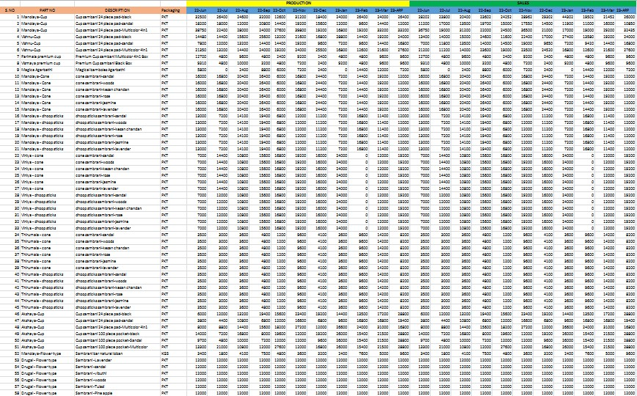

**Problem Statements**

1. Identifying product categories with increasing sales in Manolaya International Inc.

2. Analyzing sales performance for Manolaya products.

3. Assessing the impact of marketing campaigns on sales of Cup sambrani, Agarbathi, and flower cups components.

4. Identifying production bottlenecks or inefficiencies in Manolaya's manufacturing process.

5. Forecasting sales and production levels for demand planning in Manolaya.

6. Comparing sales and production in Manolaya International Inc.

**APPENDIX**

* **Key Cards:**

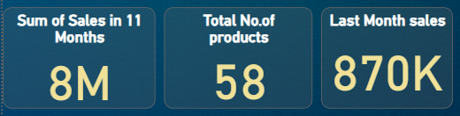

* **Maximum Sales by Products:**

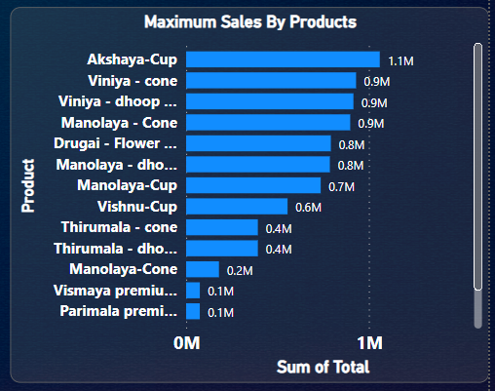

* **Sales By Years:**

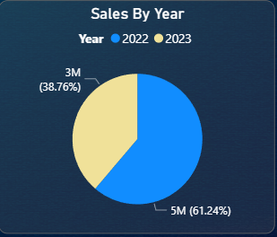

* **Sales and production**

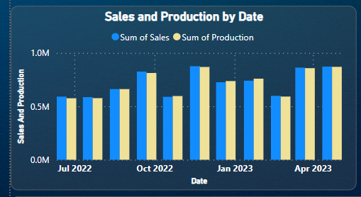

* **Production Forecasting**

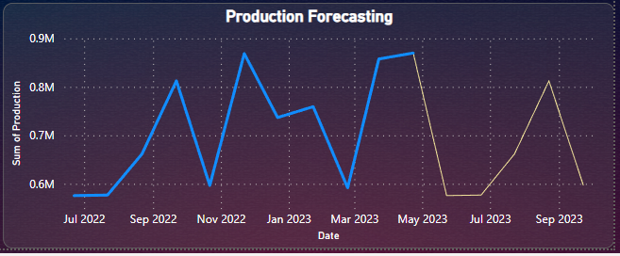

* **Production Forecasting**

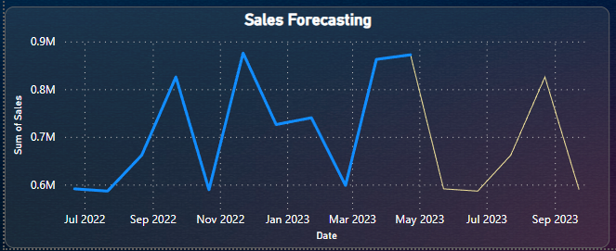

* **Overall Dashboard:**

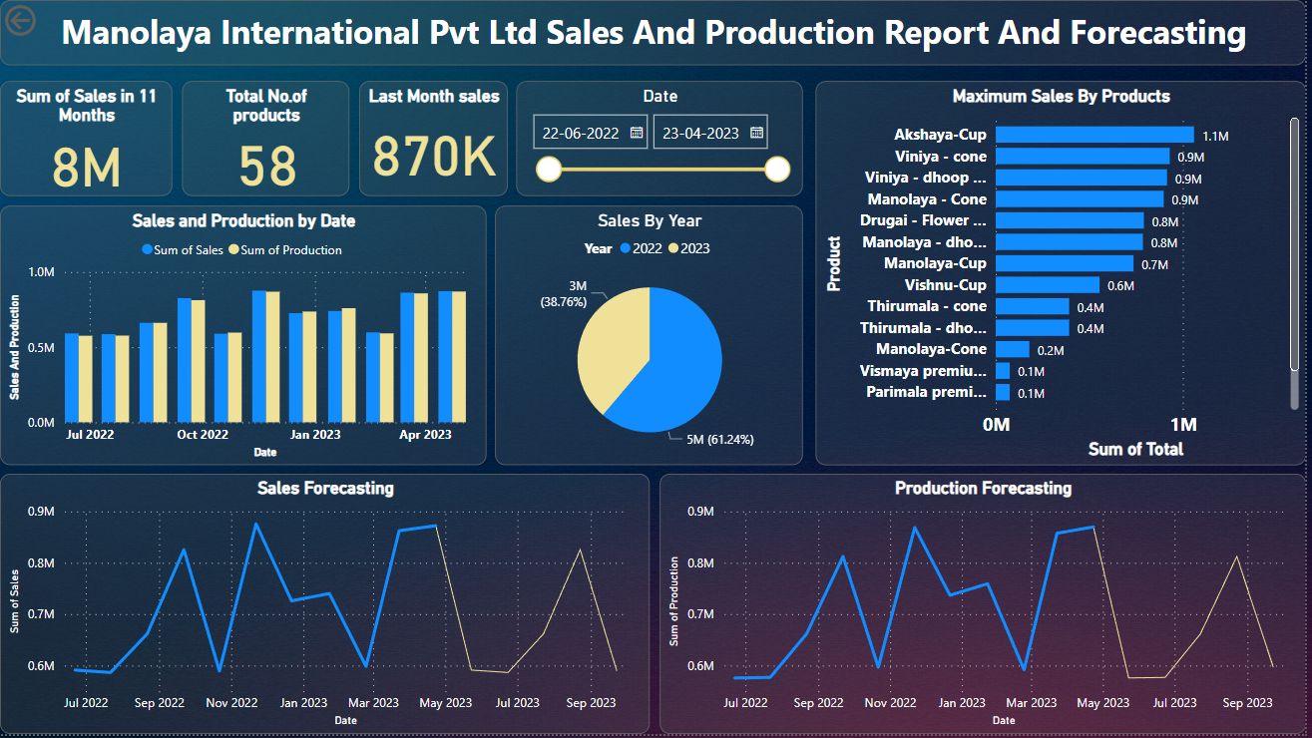

**REFERENCES:**

https://www.indiamart.com/srithirumali-importexport/