ASSIGNMENT-1

Q1. Write a program to sum two numbers?

#include<iostream>

using namespace std;

int main()

{

int a,b;

cin>>a>>b;

int sum=0;

sum=a+b;

cout<<"sum is="<<sum;

return 0;

}

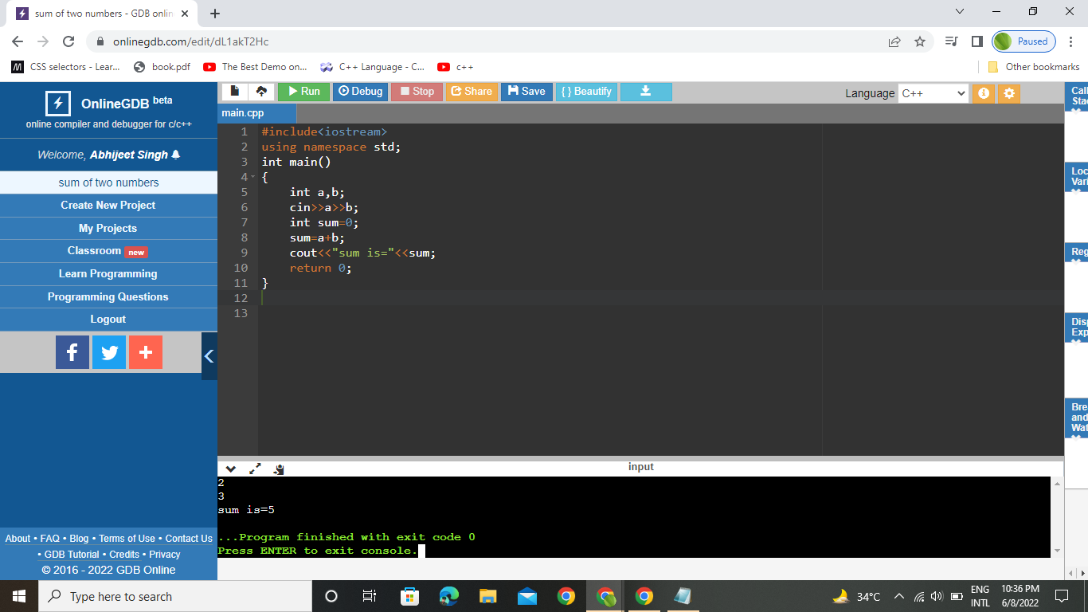

Q2. Write a program to demonstrate for loop?

#include <iostream>

using namespace std;

int main()

{

for(int i=0;i<10;i++)

{

cout<<"hello world:"<<"\n";

}

return 0;

}

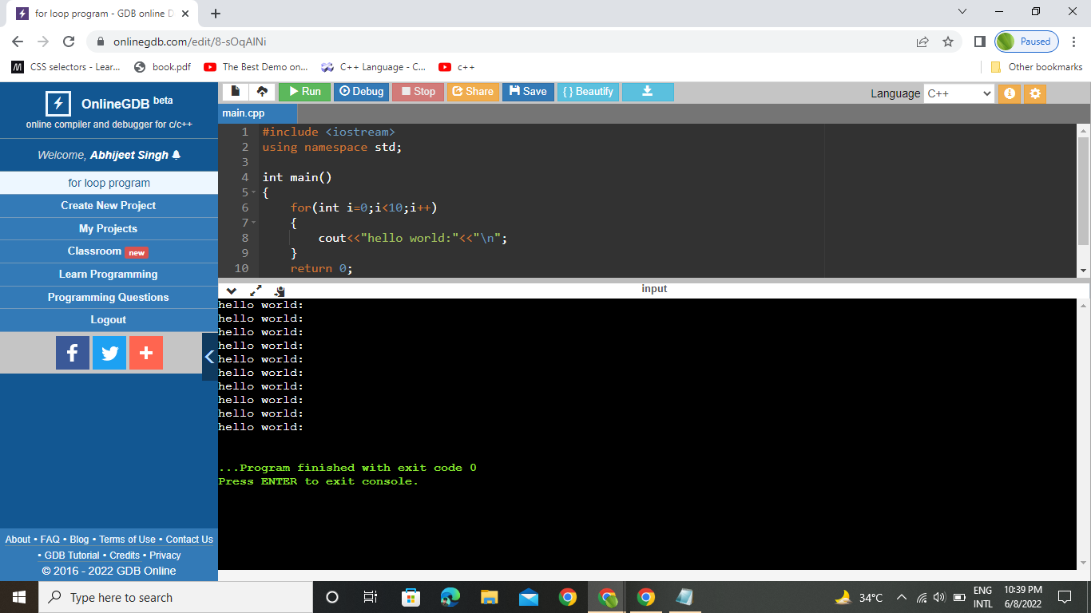

Q3. Write a program to demonstrate nested if?

#include <iostream>

using namespace std;

int main() {

int num;

cout << "Enter an integer: ";

cin >> num;

if (num != 0)

{

if (num > 0)

{

cout << "The number is positive." << endl;

}

else

{

cout << "The number is negative." << endl;

}

}

else

{

cout << "The number is 0 and it is neither positive nor negative." << endl;

}

cout << "This line is always printed." << endl;

return 0;

}

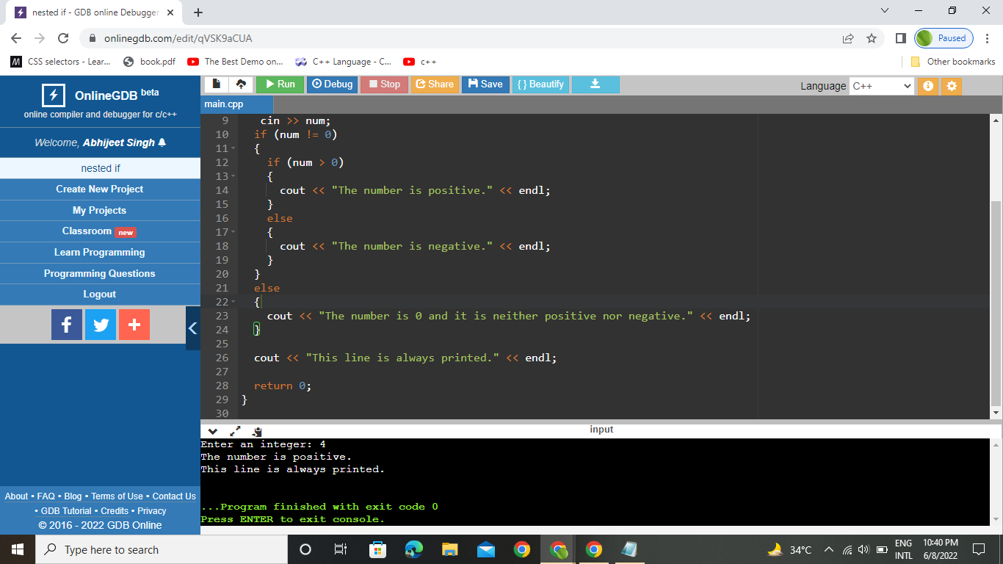

Q4.Write a program to make a simple calculator?

#include <iostream>

using namespace std;

int main()

{

int n1,n2;

char s;

cout<<"enter the two numbers"<<"\n";

cin>>n1>>n2;

cout<<"1. Addition"<<"\n";

cout<<"2. subtraction"<<"\n";

cout<<"3. multipication"<<"\n";

cout<<"4. Division"<<"\n";

cout<<"5. remainder"<<"\n";

cout<<"choose the operator:"<<"\n";

cin>>s;

switch(s)

{

case '+':

cout << n1 << " + " << n2 << " = " << n1 + n2;

break;

case '-':

cout << n1 << " - " << n2 << " = " << n1 - n2;

break;

case '\*':

cout << n1 << " \* " << n2 << " = " << n1 \* n2;

break;

case '/':

cout << n1 << " / " << n2 << " = " << n1 / n2;

break;

default:

cout << "Error! operator is not correct";

break;

}

return 0;

}

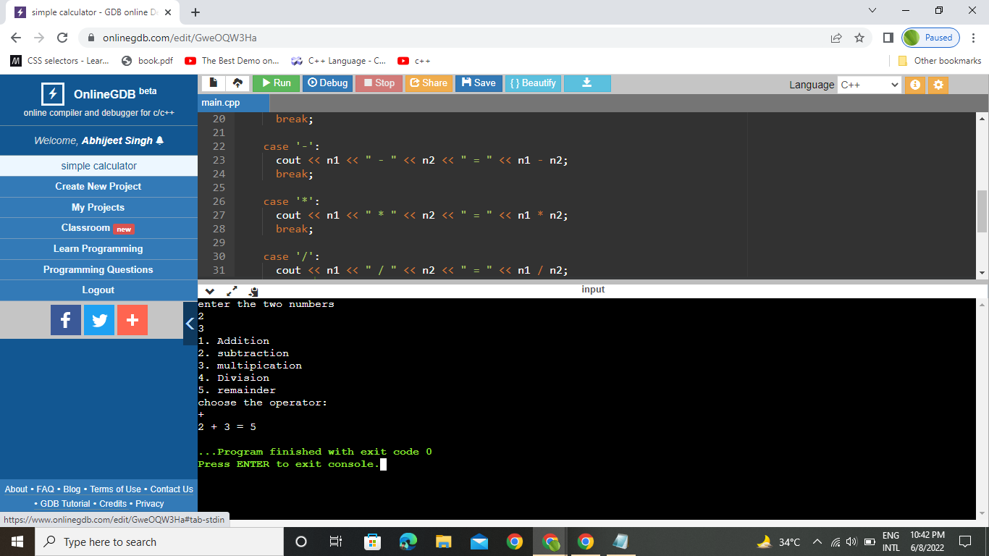

Q5.Write a program to calculate fibonacci series?

#include <iostream>

using namespace std;

int main()

{

int n;

int n1=0;

int n2=1;

cout<<"enter the limit upto which u want to calculate the fioonacci numbers:";

cin>>n;

cout<<"fionacci series are:";

cout<<n1<<n2;

int i=2;

while(i<n)

{

int n3=n1+n2;

cout<<n3;

n1=n2;

n2=n3;

i++;

}

return 0;

}

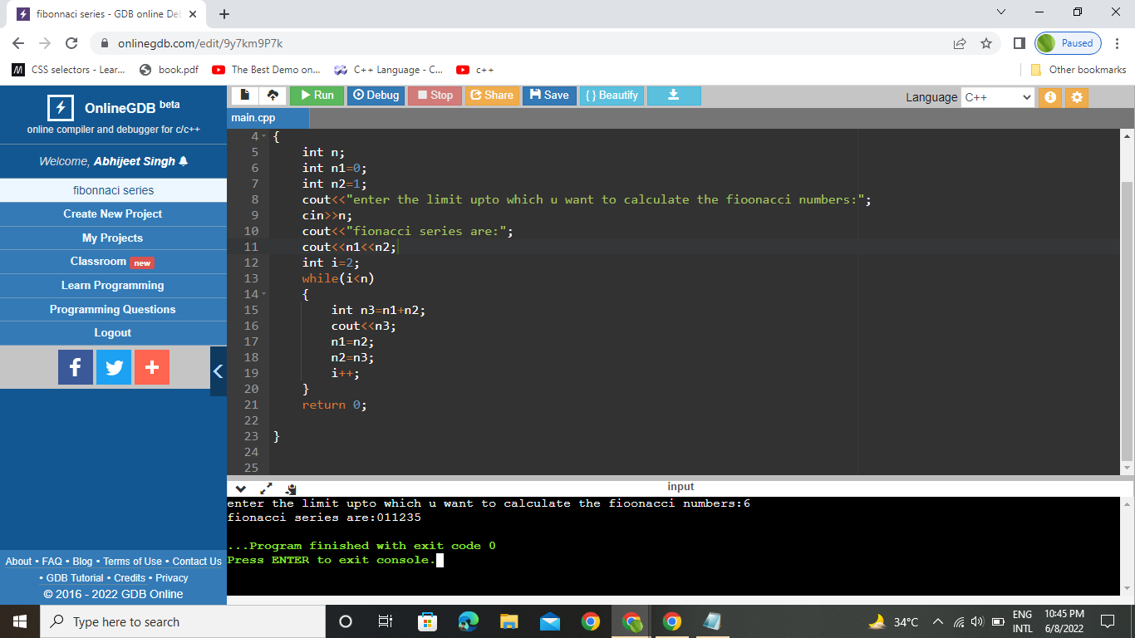

Q6.Write a program to calculate multiples of 2?

#include <iostream>

using namespace std;

int main()

{

int i=1;

do

{

int j=2\*i;

i++;

cout<<j<<"\n";

}while(i<=10);

return 0;

}

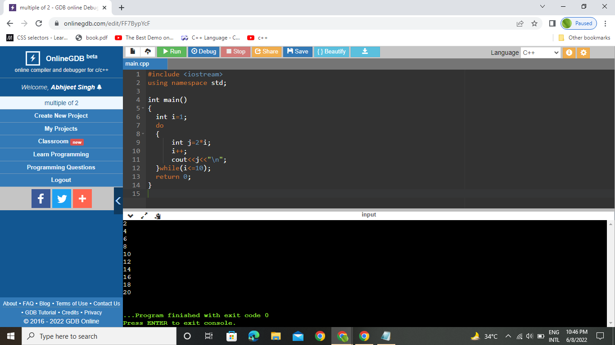

Q7.Reverse a digit?

#include <iostream>

using namespace std;

int main()

{

int n;

int n1=0;

cout<<"enter the number that u want to reverse:";

cin>>n;

int rem;

while(n!=0)

{

rem=n%10;

n1=n1\*10+rem;

n=n/10;

}

cout<<"reverse numer is="<<n1;

return 0;

}

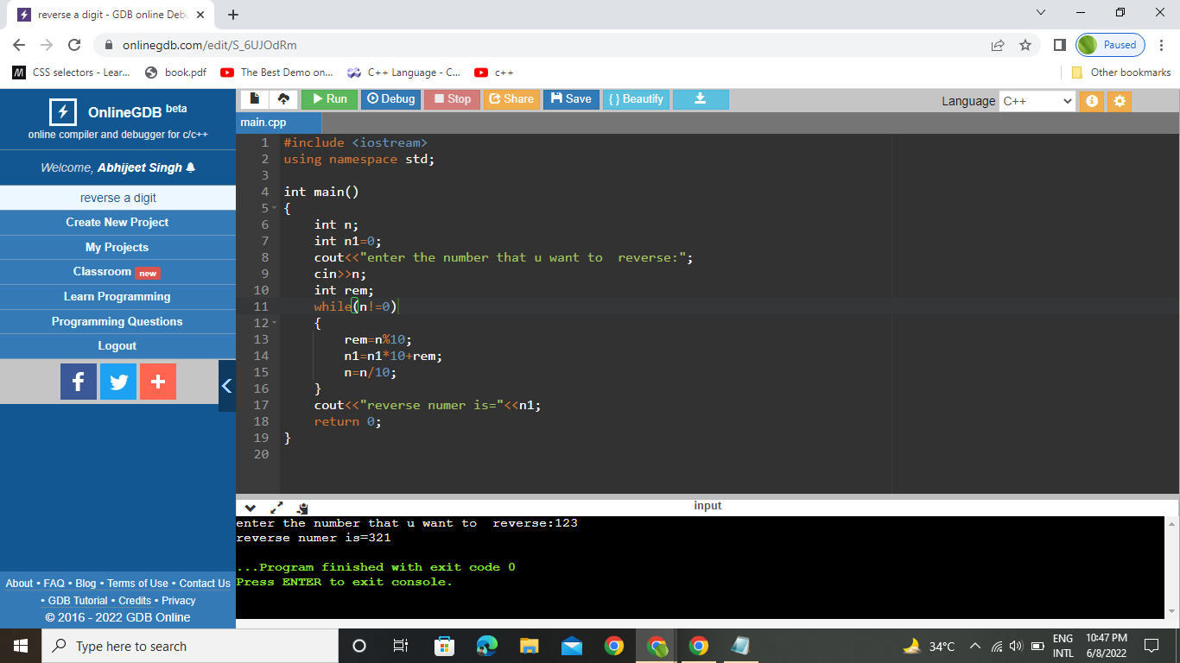

Q8. Find an armstrong number?

#include <iostream>

#include<cmath>

using namespace std;

int main()

{

int n;

int arm=0;

int r=0;

int n1=0;

cout<<"enter the number to check whether it is a armstrong or not:";

cin>>n;

int m=n;

while(m!=0)

{

n1=n%10;

r=m%10;

arm+=pow(r,n1);

m=m/10;

}

if(arm==n)

{

cout<<"number is armstrong:";

}

else

{

cout<<"number is not armstrong:";

}

return 0;

}

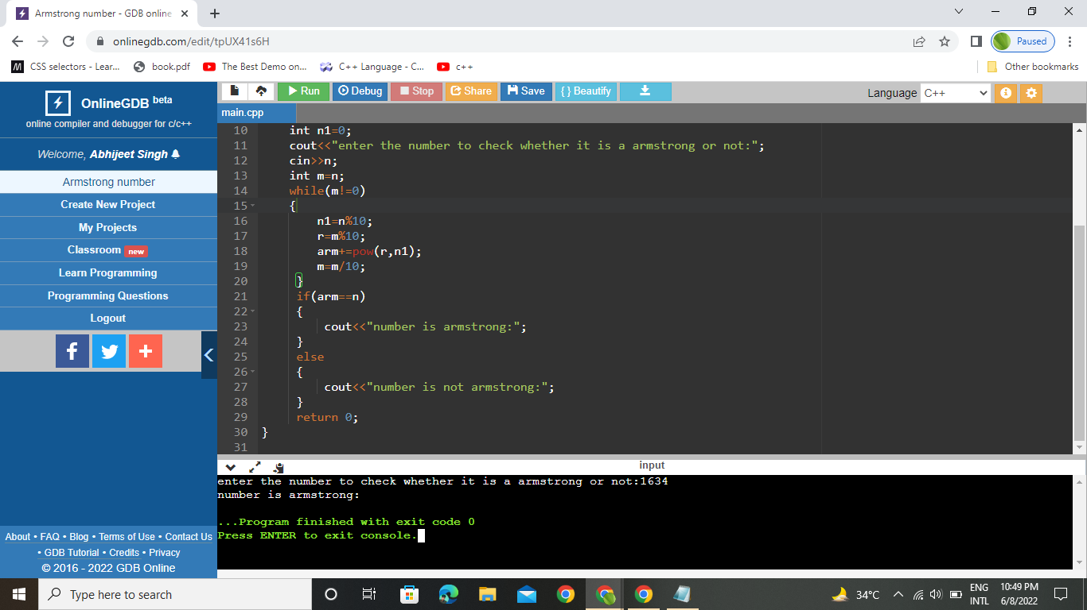

Q9.Swap between two numbers without using third variable?

#include <iostream>

using namespace std;

int main()

{

int n1,n2;

cout<<"enter the numbers";

cin>>n1>>n2;

int n3;

n1=n1+n2;

n2=n1-n2;

n1=n1-n2;

cout<<"aftre swap numbers are:";

cout<<"n1="<<n1;

cout<<"n2="<<n2;

return 0;

}

