IIOT LAB

200929168

LAB 1

TI INSTRUMENT

Exercise 1 Write a code using Energia in C/C++ -API interfacing to blink an LED over TIVA C board.

And gate

Or gate

XOR

XNOR

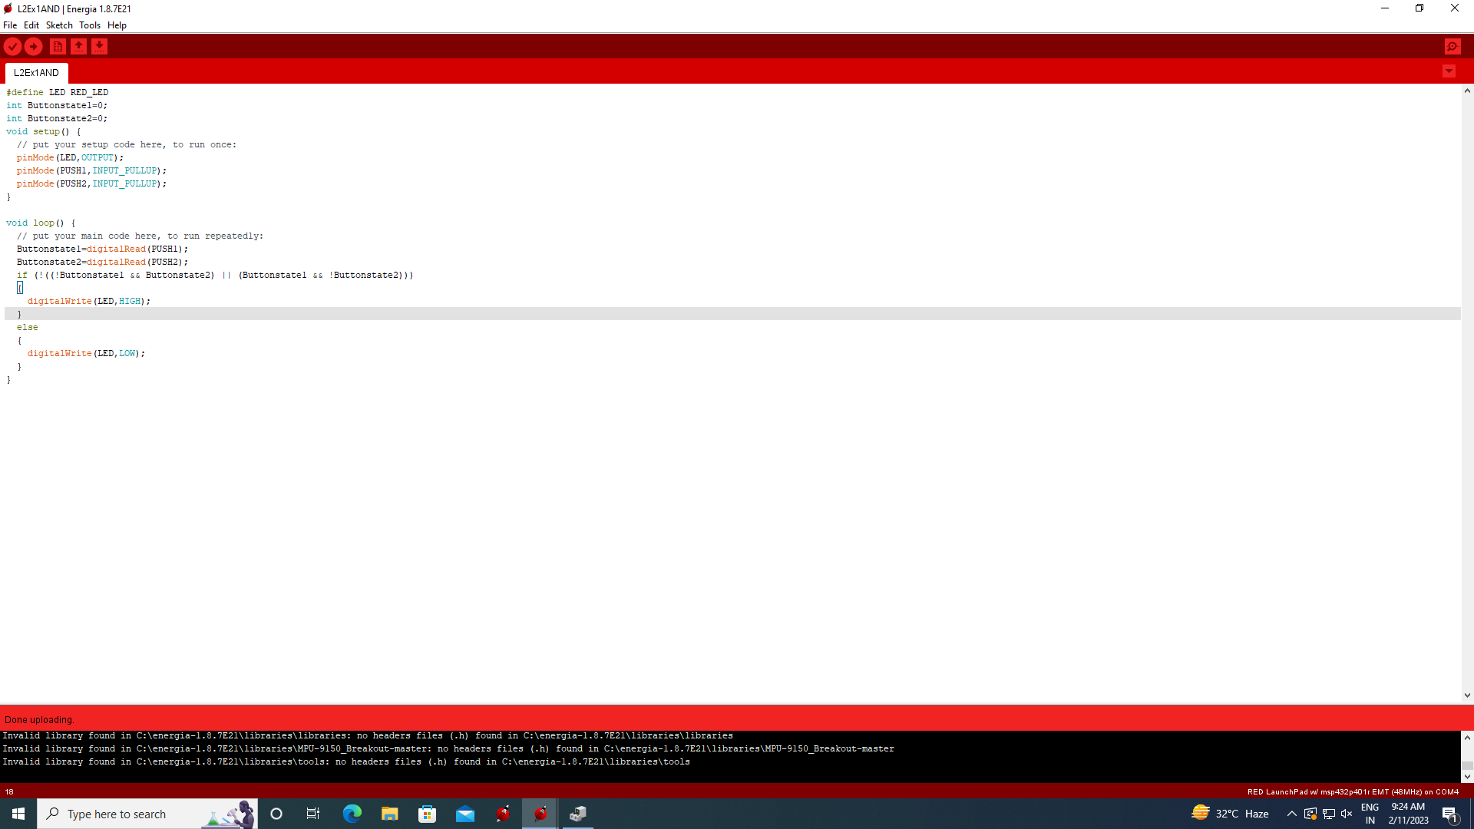

Exercise Question 2:Write a code using Energia in C/C++ -API interfacing to implement a Halfadder using onboard Pushbuttons and LED’s.

Exercise Question 3:Construct a Truth Table for the logical functions at pointsC,DandQin the following circuit and identify a single logic gate that can be used to replace the whole circuit.

The circuit can be simplified to an or gate.

Exercise Question 4:Snerdley’s Automated Cafeteria orders a machine to dispense coffee and tea. Design the machine so that it has a button (input line) for each choice and so that a customer can have at most one of the three choices. Diagram the circuit to insure that the “at most one” condition is met.

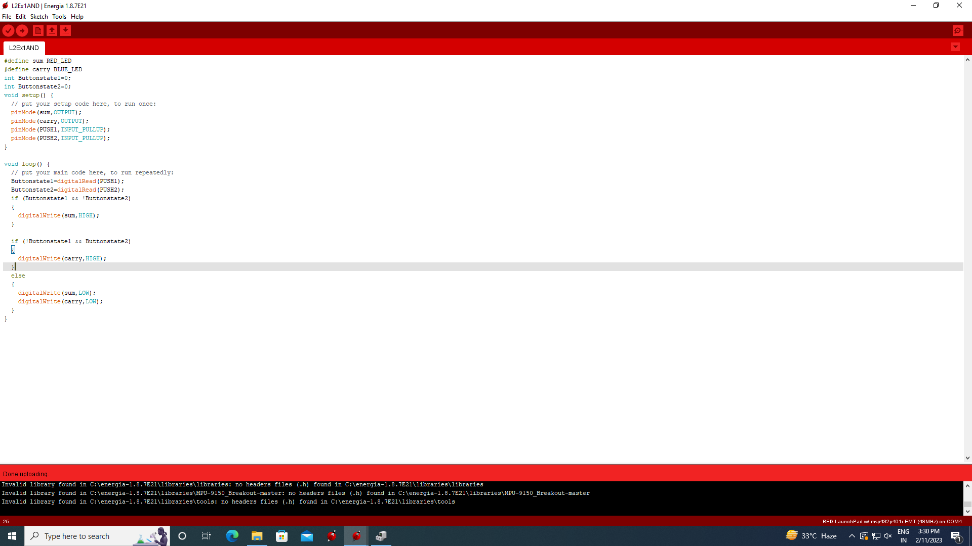

Exercise Question 5:The nation of Upper Slobovia has gained a missile defense capability governed by its Security Council. The Council consistsof four members: the U.S. (Upper Slobovian) President and three Counselors (the Chiefs of Staff of the Army and Air Force plus the President’s Uncle Homer). The missile system is to be activated by a device obeying these rules: each member of the SecurityCouncil has a button to push; the missiles fire only if the President and at least one Counselor push their buttons. Design the rocket firing circuitry.

If all the council are taken as 1 input and president as the other then it becomes an and gate

