Nihar Ramesh Bhandary

200929168

Exp 5

Example1

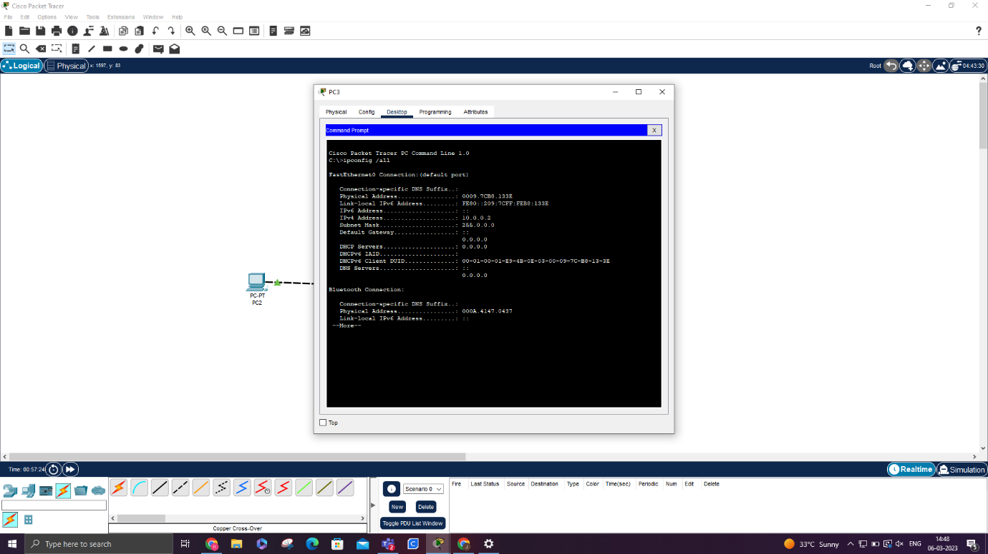

Exercise 1

PC can be connected to printer however PC cannot connect to IP phone as it can act as a switch and another connection would have to be made

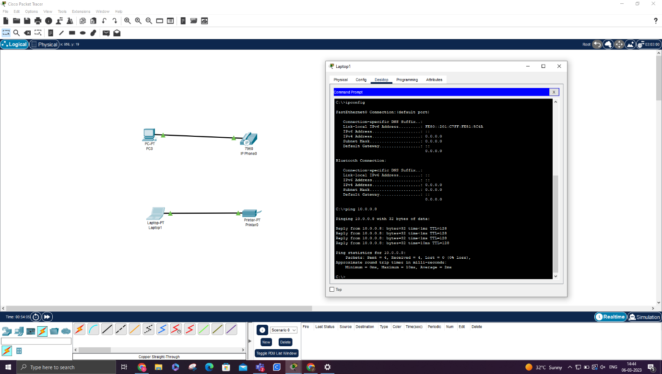

Exercise 2

MAC address is 00.E0.B0.D8.AD.DB

It is 6 groups of 2 hexadecimal numbers.

