Name :- Nihar Ramesh Bhandary

Reg No:-200929168

Lab 7

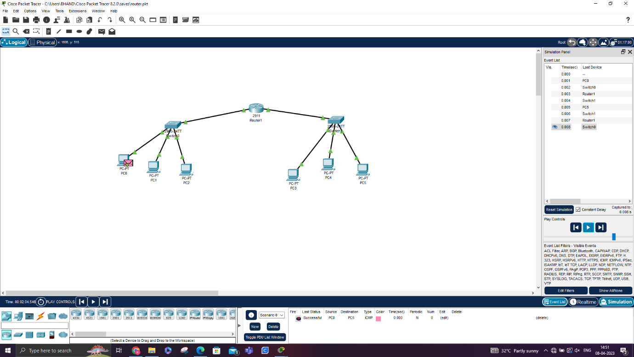

EX-1

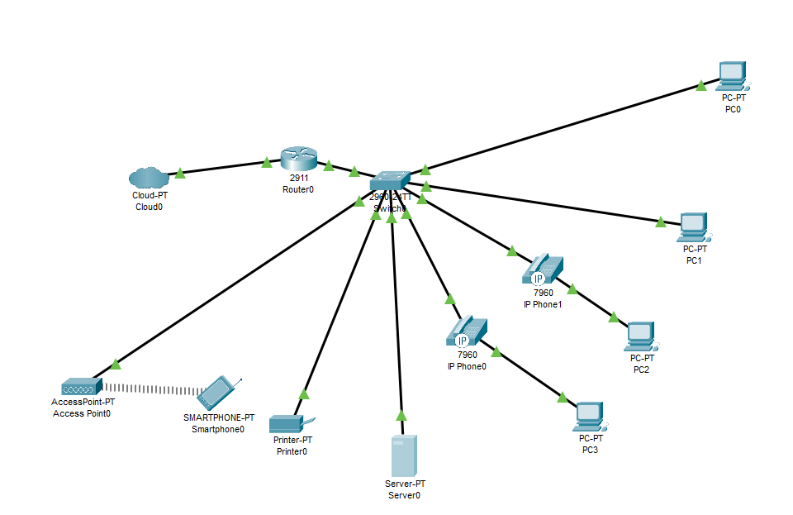

EX-2

