Understand time-series operations/functions and forecast the annual gdp growth rate of India based on given instructions.

**Aim**: To develop a time series forecasting model for the given data using R programming and to predict the future data

**Algorithm:**

* Set the working directory and the read the respective csv file using read.csv() function**.**
* Import the forecast and tseries libraries.
* Using ts() function we convert normal numerical data int R time series object. In ts the previous data which use for predicting is written first later the start will the start data of year, month or day and end will be the end data of year, month or day.
* By using class we can check the class of the object
* By plotting we can the variation in data
* By the acf() function if all the lines are bellow the blue line that means the data taken is stationary and also the data is less correlated with the lagged data points else the data is non stationary in that situation we have to convert the non-stationary data to stationary data.
* Pacf function can computes an estimate of the partial auto correlation function of time series.
* By adf.test() function we can get the p value if the produced p value is not less than critical p value that means 0.05 then the data is not stationary.
* By using the aut.arima() we can make the non-stationary data into stationary by using some models. the pdq values in arima means p value is the auto regression d value is integrated and q is the moving average.
* By using the best model, we use forecast to future data.
* By plotting the graph, we can see the range of change in data
* By using accuracy data, we can we can find how best our model is.

**Inference**:

**Case 1-gold:**

The p-value is more than the critical p value that means the data is non stationary data. We convert it into stationary and the arima values are p=0, d=1, q=0.

**Case 2-gdp:**

The p-value is less than the critical p value that means the data is stationary data. We convert it into stationary and the arima values are p=0, d=1, q=1.

**Result:**

**Case 1- Gold:**

**Plot of gold data**

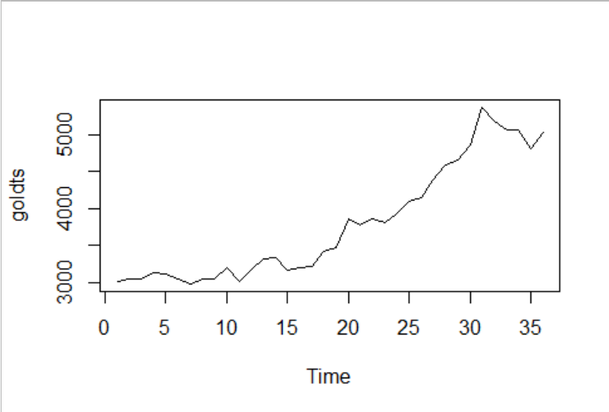

**ACF of gold data**

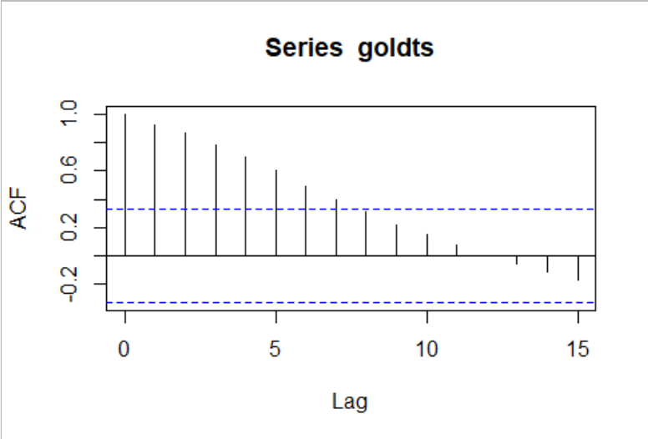

**Partial ACF of gold data**

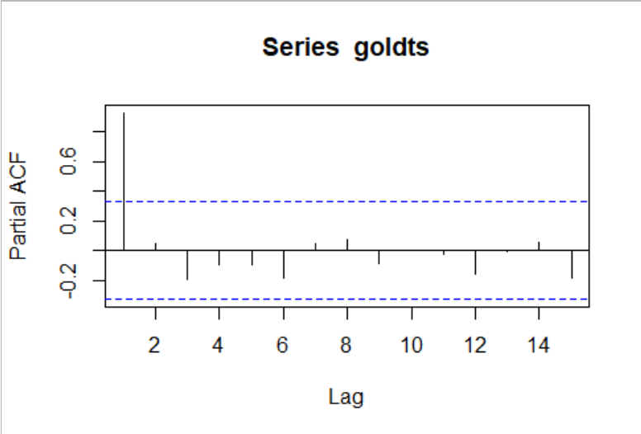

**Forecast of gold data**

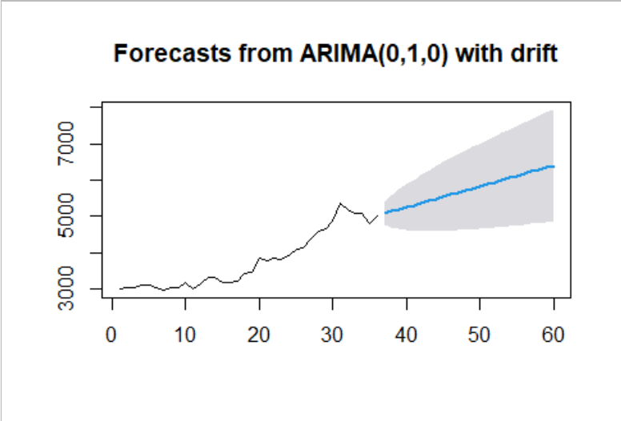

**Forecasted value for gold data**

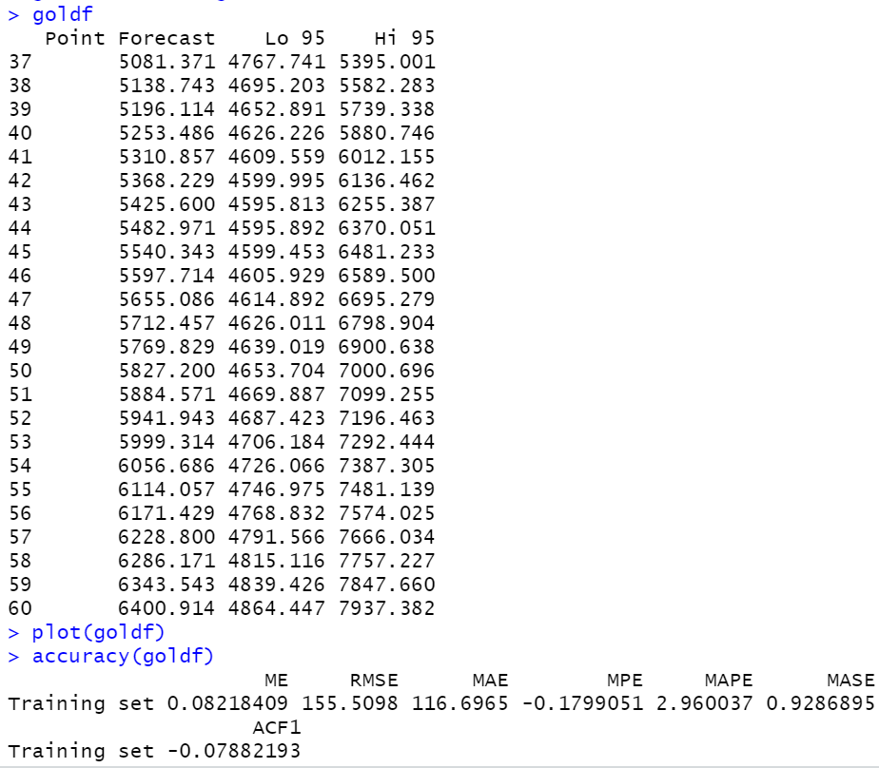

**Case 2-GDP:**

**Plot of gdp data**

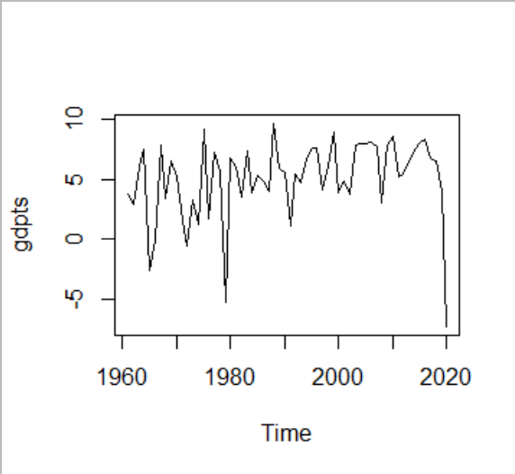

**ACF of gdp data**

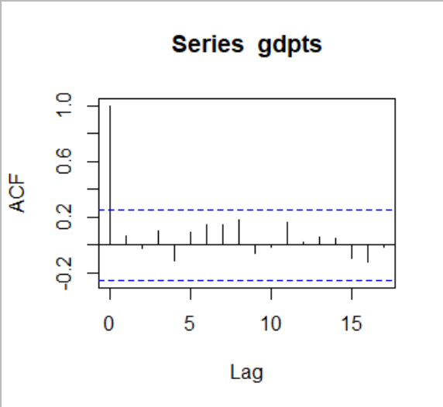

**Partial ACF of gdp data**

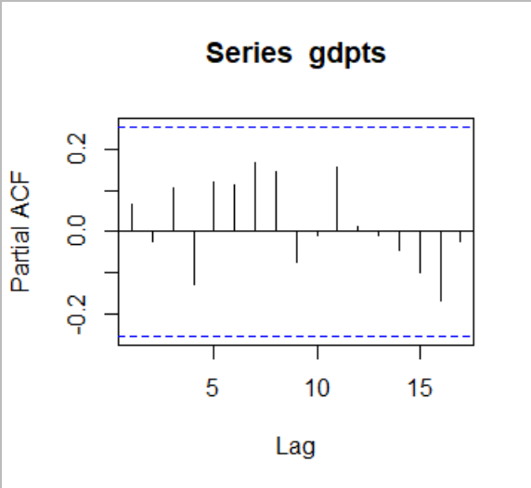

**Forecast of gdp data**

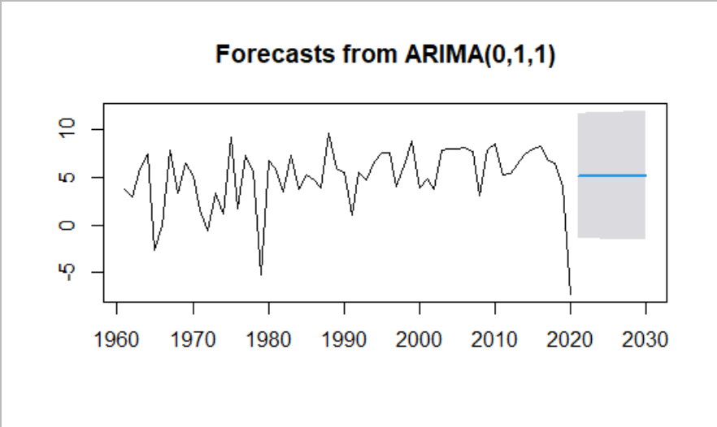

**Forecasted value for gdp data**

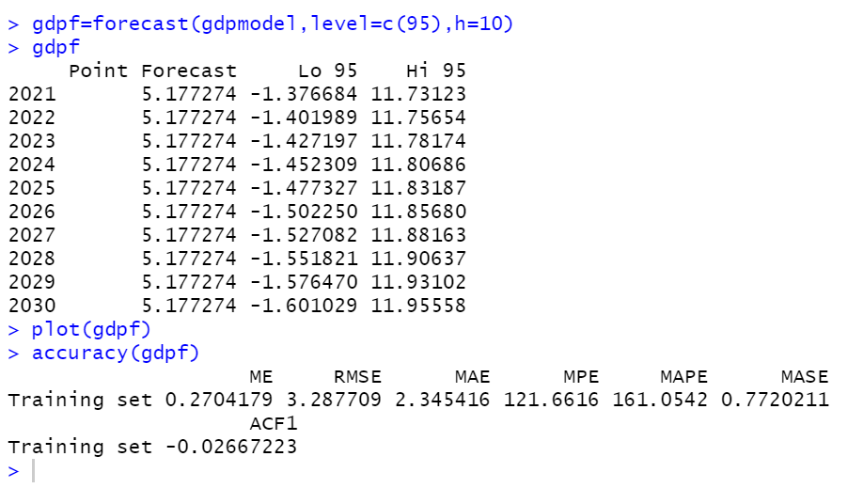

**Program:**

**Case 1 Gold:**

#gold forecasting

setwd("C:/Abhi notes/class3-2/eda/lab")

gold<-read.csv("gold.csv")

library(forecast)

library(tseries)

View(gold)

goldts<-ts(gold$Price,start=min(gold$Month),end=max(gold$Month),frequency = 1)

class(goldts)

plot(goldts)

acf(goldts)

pacf(goldts)

adf.test(goldts)

goldmodel=auto.arima(goldts,ic="aic",trace=TRUE)

goldf=forecast(goldmodel,level=c(95),h=24)

goldf

plot(goldf)

accuracy(goldf)

**case 2 GDP:**

#gdp forecasting

setwd("C:/Abhi notes/class3-2/eda/lab")

gdp<-read.csv("gdp.csv")

library(forecast)

library(tseries)

gdpts<-ts(gdp$GDP_gr,start=min(gdp$Year),end=max(gdp$Year),frequency = 1)

class(gdpts)

plot(gdpts)

acf(gdpts)

pacf(gdpts)

adf.test(gdpts)

gdpmodel=auto.arima(gdpts,ic="aic",trace=TRUE)

gdpf=forecast(gdpmodel,level=c(95),h=10)

gdpf

plot(gdpf)

accuracy(gdpf)