Understand time-series operations/functions and forecast the annual gdp growth rate of India based on given instructions.

**Aim**: To develop a multi linear regression and time series forecasting model for the given data using R programming and to predict the future data

**Algorithm:**

* **Multi linear regression:**
* Import the dplyr library.
* Store the weatherHistory2016.csv data into variables data2.
* Take a sample of 100 data2 using sample_n() function and store it in train.
* Using cor.test we get the correlation between temperature and apparent temperature, humidity, windspeed, wind bearning degree, visibility, pressure millibars.
* Create a linear regression model using lm() function for temperature and apparent temperature, humidity.
* Find the summary of the lm model created using summary () function.
* **Time series function:**
* Set the working directory and the read the respective csv file using read.csv() function**.**
* Import the forecast and tseries libraries.
* Using ts() function we convert normal numerical data int R time series object. In ts the previous data which use for predicting is written first later the start will the start data of year, month or day and end will be the end data of year, month or day.
* By using class we can check the class of the object.
* By plotting we can the variation in data.
* By using the aut.arima() we can make the non-stationary data into stationary by using some models. the pdq values in arima means p value is the auto regression d value is integrated and q is the moving average.
* By using the best model, we use forecast to future data.
* By plotting the graph, we can see the range of change in data.
* By using accuracy data, we can we can find how best our model is.

**Statistic:**

|  |  |  |  |  |
| --- | --- | --- | --- | --- |
|  | Estimate | Std. Error | t value | Pr(>|t|) |
| (Intercept) | 5.84697 | 0.71670 | 8.158 | 1.31e-12 *** |
| Apparent.Temperature..C. | 0.85342 | 0.01308 | 65.261 | < 2e-16 *** |
| Humidity | -3.70090 | 0.70158 | -5.275 | 8.20e-07 *** |

**Residual standard error: 0.8627**

**R2: 0.9915** **Adj-R2: 0.9912**

**F-statistic:  3726**  **p-value: <2.2e-16**

**Inference**:

The p-value is more than the critical p value that means the data is non stationary data. We convert it into stationary and the arima values are p=4, d=0, q=0.

**Result:**

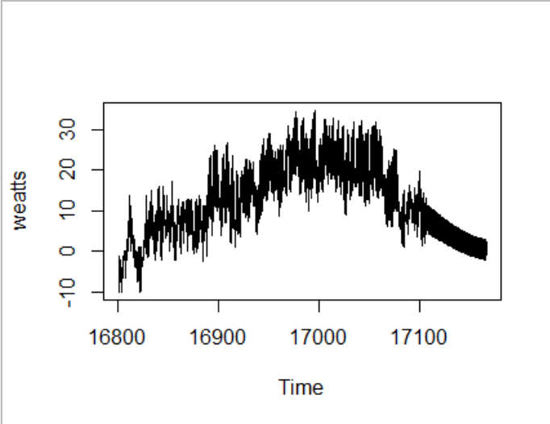

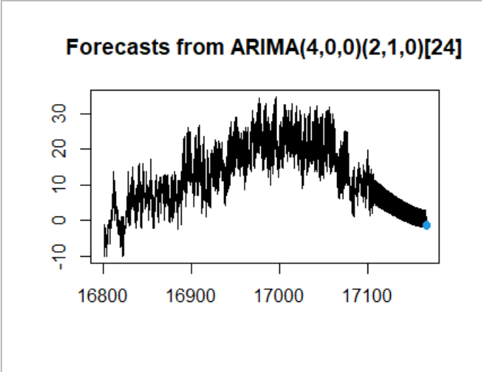

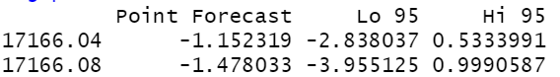

**Program:**

#multi linear regression

rm(list=ls())

setwd("C:/Abhi notes/class3-2/eda/lab/Lab 3")

library(dplyr)

data2<-read.csv("weatherHistory2016.csv")

data2

train=sample_n(data2,100)

cor.test(train$Temperature..C.,train$Apparent.Temperature..C.)

cor.test(train$Temperature..C.,train$Humidity)

cor.test(train$Temperature..C.,train$Wind.Speed..km.h.)

cor.test(train$Temperature..C.,train$Wind.Bearing..degrees.)

cor.test(train$Temperature..C.,train$Visibility..km.)

cor.test(train$Temperature..C.,train$Pressure..millibars.)

lmodel<- lm(train$Temperature..C.~(train$Apparent.Temperature..C.+train$Humidity))

summary(lmodel)

print("by this inference the p value of b2,b1 and b0 are of less than 0.05 that means the model is0. significant")

#time series function

library(forecast)

library(tseries)

weat<-read.csv("weatherHistory2016.csv")

weatts <- ts(weat$Temperature..C., start=as.Date("2016-01-01"), end=as.Date("2016-12-31"), frequency=24)

class(weatts)

plot(weatts)

gdpmodel=auto.arima(weatts,ic="aic",trace=TRUE)

gdpf=forecast(gdpmodel,level=c(95),h=2)

gdpf

plot(gdpf)

accuracy(gdpf)