**Aim**: Understand the following operations/functions on ‘USArrests’ data and perform similar operations on ‘iris’ dataset based on given instructions.

**Algorithm:**

* removing all the values from the global environment.
* Set the working directory to the dataset where we store by using setwd().
* To see the dataset use view() function.
* By using scale function. We scale the data and store it in another variable.
* To see the dataset use view() function.
* Find the Euclidean distance using the dist() function and method=”euclidean”.
* Find the hierarchical clustering using hclust and method = “complete.
* For plotting the dendrogram we use plot function.
* Grouping the dataset into no of cluster using cutree function and plotting them.
* Use rec.hclust to find the cluster.

**Result:**

**Dataset: iris.csv:**

**Dendrogram:**

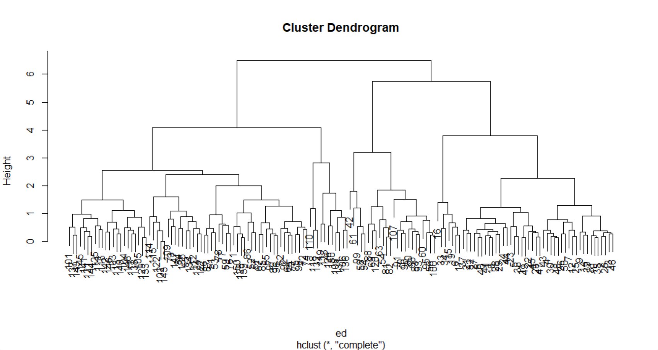

**Clusters:**

The no of cluster I have chosen is 4.

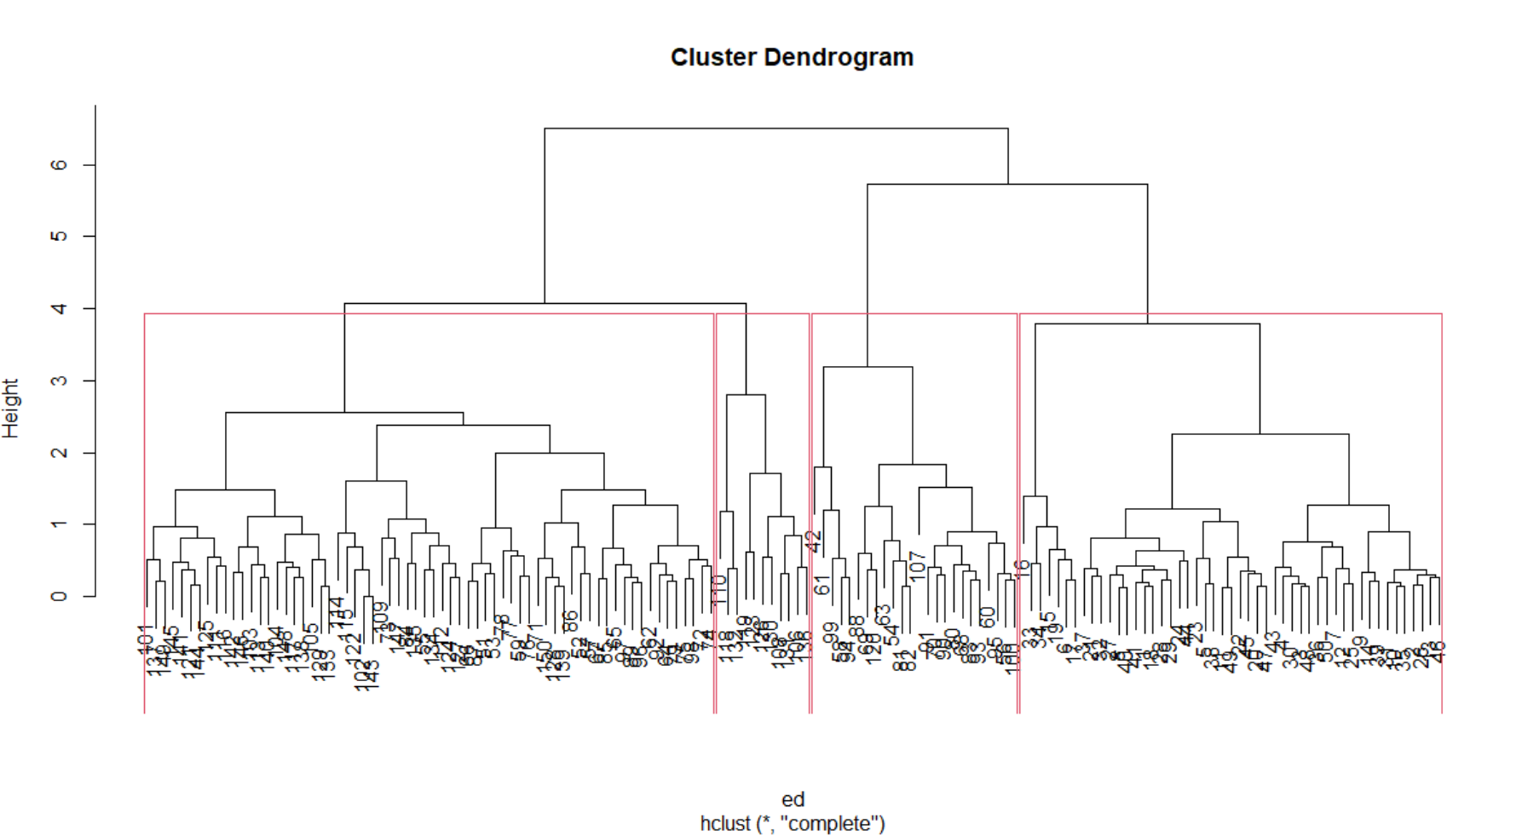

**Code:**

rm(list=ls())

setwd("C:/Abhi notes/class3-2/eda/lab/Lab 8")

data<-read.csv("iris.csv",row.names=1)

View(data)

df<-scale(data)

View(df)

ed<-dist(df,method='euclidean')

herclust<-hclust(ed,method='complete')

plot(herclust)

cluster1<-cutree(herclust,k=4)

cluster1

rect.hclust(herclust,k=4)