
American International University-Bangladesh (AIUB)
Department of Computer Science
Faculty of Science & Technology (FST)
SMART MUNICIPALITY SERVICE PORTAL
A Software Engineering Project Report Submitted By
Semester: Summer 25-26 Section: E Group: 06
SL | Student Name | Student ID
1 | Adreta Mallick | 23-53069-3
2 | Abhigyan Sadhak Rindo | 23-53106-3
3 | Shrabanti Chakma | 24-56217-1

Assessment Rubric
CO1: Explain the impact of software engineering over various contexts of software development to assess societal, health, safety, legal and cultural issues.
Student ID | Problem Analysis [3] | Socio-cultural Impact [3] | Related Solutions and Studies [4]
23-53069-3
23-53106-3
24-56217-1

CO2: Explain software engineering principles considering professional responsibilities and societal impacts.
Student ID | Conceptual Understanding [3] | Principle Selection and Justification [3] | Application in Software Development Context [4]
23-53069-3
23-53106-3
24-56217-1
Table of Contents
1. Project Proposal 3
1.1 Background to the Problem 3
1.2 Selection of Process Model 3
2. Timeline Chart / Gantt Chart 4
3. Software Requirements Specification (SRS) / PRD 7
3.1 Scopes and Features 7
3.2 User Story Table 7
3.3 Requirements Traceability Matrix 9
3.3.1 Functional Requirements 10
3.3.2 Non-Functional Requirements 11
4. Software Design 13
4.1 System Design 13
4.2 UI / Wireframe Design using Figma 14
5. Git Workflow 22
6. Conclusion 24

1. Project Proposal

1.1 Background to the Problem
Municipal service delivery in most urban and semi-urban areas of Bangladesh still relies heavily on manual, paper-based processes. Citizens are required to visit municipal offices in person multiple times to apply for trade licenses, birth/death certificates, tax payments, or to lodge complaints regarding civic issues. This dependence on physical processes creates long queues, repeated visits, and a general lack of transparency about the status of an application, which directly affects the day-to-day convenience and productivity of ordinary citizens.
From a societal perspective, the absence of a centralized digital channel disproportionately affects citizens who cannot easily take time off work to visit government offices, widening the gap between digitally literate and less privileged sections of society. From a health and safety standpoint, requiring repeated physical visits and long waiting periods in crowded municipal offices increases the risk of exposure to communicable illness and adds unnecessary physical strain, particularly for elderly or disabled citizens. From a legal standpoint, a lack of traceable digital records makes it difficult to audit how a complaint or application was processed, which can create accountability gaps between citizens and municipal officials. Culturally, the shift toward an online-first civic experience must remain simple and inclusive, since many users may have limited digital literacy and cannot be expected to adapt to a complex system.
The Smart Municipality Service Portal is proposed to address these problems by giving citizens a single, transparent, and centralized digital platform to apply for municipal services, submit complaints, and track their status in real time, while giving Officers, Supervisors, and Portal Administrators dedicated dashboards to manage, review, and monitor these requests efficiently. This reduces unnecessary physical visits, improves transparency and accountability, and creates a more inclusive and organized civic service experience.

1.2 Selection of Process Model
The Agile (Scrum) process model has been selected for the development of the Smart Municipality Service Portal. In this model, the overall project is broken down into a Product Backlog consisting of the functional and non-functional requirements identified in the SRS. This backlog is then divided into short, fixed-length iterations called Sprints, during which a working increment of the system (for example, the Citizen module, followed by the Officer, Supervisor, and Admin modules) is designed, built, reviewed, and refined.
Phase | Key Activities
Sprint 0 | Requirement gathering, user story creation, and use case/UI planning
Sprint 1 | Citizen module: registration, login, service request, complaint submission
Sprint 2 | Officer & Supervisor modules: request handling, status updates, escalation, reporting
Sprint 3 | Portal Administrator module: user/role management, announcements, monitoring
Sprint 4 | Integration, UI/UX refinement, wireframe-to-prototype linking, and review

This model was chosen over a traditional Waterfall approach for the following reasons:
- The project requirements are role-based and modular (Citizen, Officer, Supervisor, Admin), which fits naturally into separate, incremental sprints.
- Agile allows continuous feedback on the UI/UX prototype at the end of each sprint, which is essential since the expected outcome of this project is a high-fidelity interactive prototype rather than a fully coded system.
- Iterative delivery reduces risk, since design flaws in one module (e.g., the Citizen dashboard) can be corrected before subsequent modules are built.
- Scrum's short feedback cycles align well with the fixed academic timeline of the course, allowing incremental progress to be demonstrated and evaluated.

2. Timeline Chart / Gantt Chart
The project was planned over a period of 12 July 2026 to 13 September 2026, starting from team formation and topic selection through to research, requirement gathering, UI/UX design of all four dashboards, prototype creation, usability testing, and the final presentation. The Gantt chart below illustrates the planned schedule and overlap between tasks.
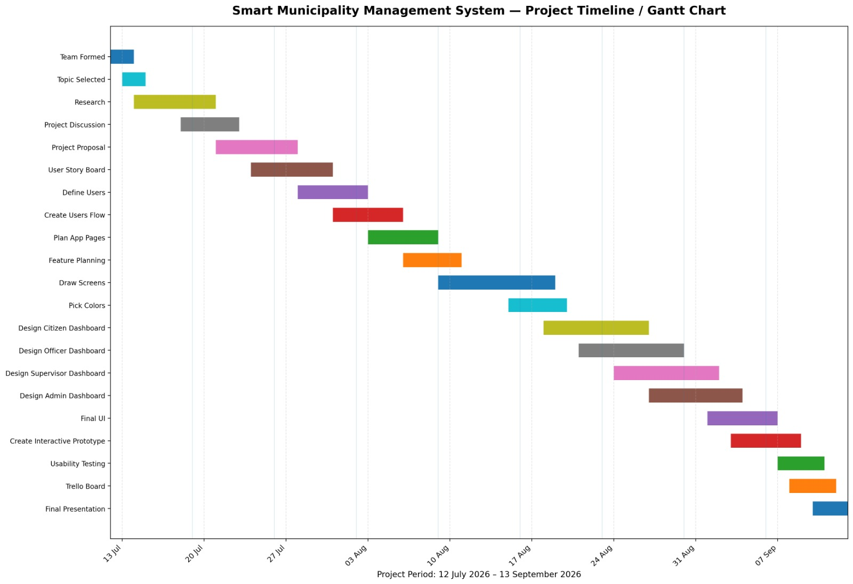
Figure 2.1: Project Timeline / Gantt Chart

Task | Start Date | End Date | Duration (days)
Team Formed | 12 Jul 2026 | 14 Jul 2026 | 3
Topic Selected | 13 Jul 2026 | 15 Jul 2026 | 3
Research | 14 Jul 2026 | 21 Jul 2026 | 8
Project Discussion | 18 Jul 2026 | 23 Jul 2026 | 6
Project Proposal | 21 Jul 2026 | 28 Jul 2026 | 8
User Story Board | 24 Jul 2026 | 31 Jul 2026 | 8
Define Users | 28 Jul 2026 | 3 Aug 2026 | 7
Create Users Flow | 31 Jul 2026 | 6 Aug 2026 | 7
Plan App Pages | 3 Aug 2026 | 9 Aug 2026 | 7
Feature Planning | 6 Aug 2026 | 11 Aug 2026 | 6
Draw Screens | 9 Aug 2026 | 19 Aug 2026 | 11
Pick Colors | 15 Aug 2026 | 20 Aug 2026 | 6
Design Citizen Dashboard | 18 Aug 2026 | 27 Aug 2026 | 10
Design Officer Dashboard | 21 Aug 2026 | 30 Aug 2026 | 10
Design Supervisor Dashboard | 24 Aug 2026 | 2 Sep 2026 | 10
Design Admin Dashboard | 27 Aug 2026 | 4 Sep 2026 | 9
Final UI | 1 Sep 2026 | 7 Sep 2026 | 7
Create Interactive Prototype | 3 Sep 2026 | 9 Sep 2026 | 7
Usability Testing | 7 Sep 2026 | 11 Sep 2026 | 5
Trello Board | 8 Sep 2026 | 12 Sep 2026 | 5
Final Presentation | 10 Sep 2026 | 13 Sep 2026 | 4

3. Software Requirements Specification (SRS) / PRD

3.1 Scopes and Features
The scope of the Smart Municipality Service Portal covers a web-based digital platform that allows citizens to access municipal services online and allows municipal staff to manage those services through role-specific dashboards. The system is designed around four target user roles: Citizen, Officer, Supervisor, and Portal Administrator. The final deliverable for this phase of the project is a high-fidelity, interactive prototype demonstrating the complete navigation flow for all four roles; it does not include a live backend or production deployment.
Key features of the system, grouped by role, include:
- Citizen: account registration and OTP verification, secure login, browsing municipal services, submitting service requests and complaints with document/photo attachments, real-time request tracking, notifications, request history, and feedback/rating.
- Officer: dedicated dashboard of assigned requests, viewing submitted documents, updating request status (approve/reject/forward/in-progress), adding remarks, and escalating complex requests to a Supervisor.
- Supervisor: monitoring requests handled by officers, reassigning requests, reviewing or overriding officer decisions, generating performance reports, and tracking overall request trends.
- Portal Administrator: managing user accounts and roles, configuring the list of available municipal services, monitoring system-wide activity logs, generating analytical reports, and broadcasting announcements.
- System-wide: a unified search and filter function, a unified notification center per role, and a full audit trail for every request's lifecycle.

3.2 User Story Table
The following user stories were developed for each of the four user roles identified in the project.

Citizen
As a/an | I want to | So that | Acceptance Criteria
Citizen | Create an account | I can access municipality services | Account is created successfully and confirmation is shown.
Citizen | Login with my username and password | I can securely access my account | Dashboard is displayed after successful login.
Citizen | Submit a complaint | Municipal issues can be reported | Complaint is stored and a tracking ID is generated.
Citizen | Request a municipal service | I can receive services online | Service request is submitted successfully.
Citizen | Track my request | I know the current status | Current status is displayed.
Citizen | View notifications | I receive updates about my requests | Latest notifications are shown.
Citizen | Update my profile | My information remains accurate | Updated information is saved successfully.

Officer
As a/an | I want to | So that | Acceptance Criteria
Officer | Login | I can access my dashboard | Dashboard opens successfully.
Officer | View assigned requests | I can process citizen requests | Assigned requests are displayed.
Officer | Review submitted documents | I can verify applications | Documents can be viewed successfully.
Officer | Update request status | Citizens know the progress | Status is updated and visible to citizens.
Officer | Add remarks | Citizens receive additional information | Remarks are saved with the request.

Supervisor
As a/an | I want to | So that | Acceptance Criteria
Supervisor | Login | I can access my dashboard | Dashboard opens successfully.
Supervisor | Review processed requests | I can monitor officers' work | Processed requests are displayed.
Supervisor | Approve or reject requests | Only valid requests are completed | Decision is recorded successfully.
Supervisor | View reports | I can monitor department performance | Reports are generated successfully.

Portal Administrator
As a/an | I want to | So that | Acceptance Criteria
Portal Administrator | Login | I can access system controls | Admin dashboard opens successfully.
Portal Administrator | Manage user accounts | Only authorized users can access the system | User information is updated successfully.
Portal Administrator | Assign user roles | Users receive proper permissions | Role changes are saved successfully.
Portal Administrator | Manage departments | Departments remain organized | Department information is updated successfully.
Portal Administrator | Publish announcements | Users receive important updates | Announcement is visible to all users.
Portal Administrator | Monitor system activities | I can ensure smooth operation | Activity logs are displayed correctly.

3.3 Requirements Traceability Matrix
The table below traces each high-priority requirement back to the module and user story it originates from, confirming that every major user story identified in Section 3.2 is covered by at least one functional requirement in Section 3.3.1.
Requirement ID(s) | Module | Traced User Story | Corresponding UI / Screen
FR_01, FR_02 | Citizen Module | Create an account / Login | Registration & Login screens
FR_03, FR_04 | Citizen Module | Request a municipal service | Service catalog & request form
FR_05 | Citizen Module | Submit a complaint | Complaint submission form
FR_06, FR_08 | Citizen Module | Track my request | Request tracking / history screen
FR_07 | Citizen Module | View notifications | Notification center
FR_10, FR_11 | Officer Module | Login / View assigned requests | Officer dashboard
FR_12 | Officer Module | Update request status | Request detail & status update screen
FR_13, FR_14 | Officer Module | Add remarks | Remarks panel / escalation flow
FR_15, FR_16 | Supervisor Module | Review processed requests | Supervisor dashboard
FR_17 | Supervisor Module | Approve or reject requests | Approval/override screen
FR_18, FR_19 | Supervisor Module | View reports | Reporting dashboard
FR_20, FR_22 | Admin Module | Manage user accounts / Assign roles | User & role management screen
FR_21 | Admin Module | Manage departments | Service/department configuration screen
FR_23, FR_24 | Admin Module | Monitor system activities | Activity log & analytics dashboard
FR_25 | Admin Module | Publish announcements | Announcement composer

3.3.1 Functional Requirements
Req. ID | Functional Requirement | Module | Priority
FR_01 | Citizens shall be able to register and create an account using email/phone and verify it via OTP. | Citizen Module | High
FR_02 | Citizens shall be able to log in securely and reset forgotten passwords. | Citizen Module | High
FR_03 | Citizens shall be able to browse available municipal services (trade license, birth/death certificate, tax payment, utility complaints). | Citizen Module | High
FR_04 | Citizens shall be able to submit a new service request/application with required details and document uploads. | Citizen Module | High
FR_05 | Citizens shall be able to submit complaints with category, description, location, and optional photo attachment. | Citizen Module | High
FR_06 | Citizens shall be able to track the real-time status of submitted applications/complaints. | Citizen Module | High
FR_07 | Citizens shall receive notifications (in-app/email/SMS) on status updates. | Citizen Module | Medium
FR_08 | Citizens shall be able to view their request history and download approved documents/receipts. | Citizen Module | Medium
FR_09 | Citizens shall be able to provide feedback or rate service completion. | Citizen Module | Low
FR_10 | Officers shall be able to log in to a dedicated dashboard showing assigned requests/complaints. | Officer Module | High
FR_11 | Officers shall be able to view request details and attached documents submitted by citizens. | Officer Module | High
FR_12 | Officers shall be able to update the status of a request (approve, reject, forward, mark in-progress). | Officer Module | High
FR_13 | Officers shall be able to add remarks/comments visible to citizens and supervisors. | Officer Module | Medium
FR_14 | Officers shall be able to escalate complex requests to a Supervisor. | Officer Module | Medium
FR_15 | Supervisors shall be able to view all requests handled by officers under their jurisdiction. | Supervisor Module | High
FR_16 | Supervisors shall be able to reassign requests between officers. | Supervisor Module | Medium
FR_17 | Supervisors shall be able to review and approve/override officer decisions when needed. | Supervisor Module | Medium
FR_18 | Supervisors shall be able to generate performance/activity reports for officers. | Supervisor Module | Medium
FR_19 | Supervisors shall be able to monitor overall service request trends (pending counts, delays). | Supervisor Module | Medium
FR_20 | Administrators shall be able to manage (create/edit/deactivate) user accounts for all roles. | Admin Module | High
FR_21 | Administrators shall be able to configure and manage the list of available municipal services. | Admin Module | High
FR_22 | Administrators shall be able to assign roles and permissions to system users. | Admin Module | High
FR_23 | Administrators shall be able to monitor overall system activity/logs. | Admin Module | Medium
FR_24 | Administrators shall be able to generate system-wide analytical reports and dashboards. | Admin Module | Medium
FR_25 | Administrators shall be able to broadcast announcements/notices to all citizens. | Admin Module | Low
FR_26 | The system shall provide a search and filter function for requests/services across all dashboards. | All | Medium
FR_27 | The system shall support a unified notification center for each role. | All | Medium
FR_28 | The system shall maintain an audit trail/history log for every request's lifecycle. | All | High

3.3.2 Non-Functional Requirements
Req. ID | Non-Functional Requirement | Quality Attribute | Related Module | Priority
NFR_01 | The interface shall follow a consistent, intuitive UI/UX design across all dashboards. | Usability | All Modules | High
NFR_02 | The system shall be usable by citizens with minimal technical literacy (simple navigation, clear icons/labels). | Usability | Citizen Module | High
NFR_03 | The system shall provide responsive design for desktop, tablet and mobile screens. | Usability | All Modules | High
NFR_04 | Dashboard pages shall load within 2-3 seconds under normal conditions. | Performance | All Modules | High
NFR_05 | The system shall support multiple concurrent users without noticeable degradation. | Performance | All Modules | Medium
NFR_06 | User authentication shall be required for all role-based dashboards. | Security | All Modules | High
NFR_07 | Role-based access control shall restrict users to features relevant to their role only. | Security | All Modules | High
NFR_08 | Uploaded documents and personal data shall be handled with appropriate privacy safeguards. | Security | Citizen Module | High
NFR_09 | The system shall be available and accessible during standard working hours. | Reliability | All Modules | Medium
NFR_10 | The system shall handle errors with clear, user-friendly error messages. | Reliability | All Modules | Medium
NFR_11 | The UI shall follow basic accessibility guidelines (readable font sizes, adequate color contrast, alt text for icons). | Accessibility | All Modules | Medium
NFR_12 | Navigation shall be achievable via clear visual hierarchy for users with limited digital literacy. | Accessibility | Citizen Module | Medium
NFR_13 | The design/prototype shall use a modular, reusable component structure so new services can be added easily. | Maintainability | All Modules | Medium
NFR_14 | The system architecture shall conceptually support scaling to additional municipalities/regions. | Scalability | Admin Module | Low
NFR_15 | The prototype shall be interactive, simulating real navigation flows. | Usability | All Modules | High
NFR_16 | All four dashboards shall be visually distinct yet consistent in design language. | Usability | All Modules | High

4. Software Design

4.1 System Design
The system design was modeled using a Use Case Diagram created in Draw.io. Four actors were identified, corresponding directly to the four target user roles defined in the SRS: Citizen, Officer, Supervisor, and Portal Administrator. Each actor interacts with the Smart Municipality Service Portal through a distinct set of use cases inside the system boundary, as summarized below and shown in the diagram.
Actor | Associated Use Cases
Citizen | Register, Login, Submit Complaint, Request Municipal Service, Track Request, View Notifications, Update Profile
Officer | Login, View Assigned Requests, Review Documents, Update Request Status, Add Remarks
Supervisor | Login, Review Processed Requests, Approve Request, Reject Request, View Reports
Portal Administrator | Login, Manage User Accounts, Assign User Roles, Manage Departments, Publish Announcements, Monitor System Activities

Login is modeled as a shared use case at the centre of the diagram: nearly every role-specific use case (Submit Complaint, Track Request, View Assigned Requests, Update Request Status, Manage User Accounts, Approve Request, and so on) is connected to it through an <<include>> relationship, since every actor must be authenticated before performing any role-specific action. In addition, Update Request Status is linked to Add Remarks, and Review Processed Requests is linked to Approve Request and Reject Request, reflecting the natural sequence of officer and supervisor actions on a request.
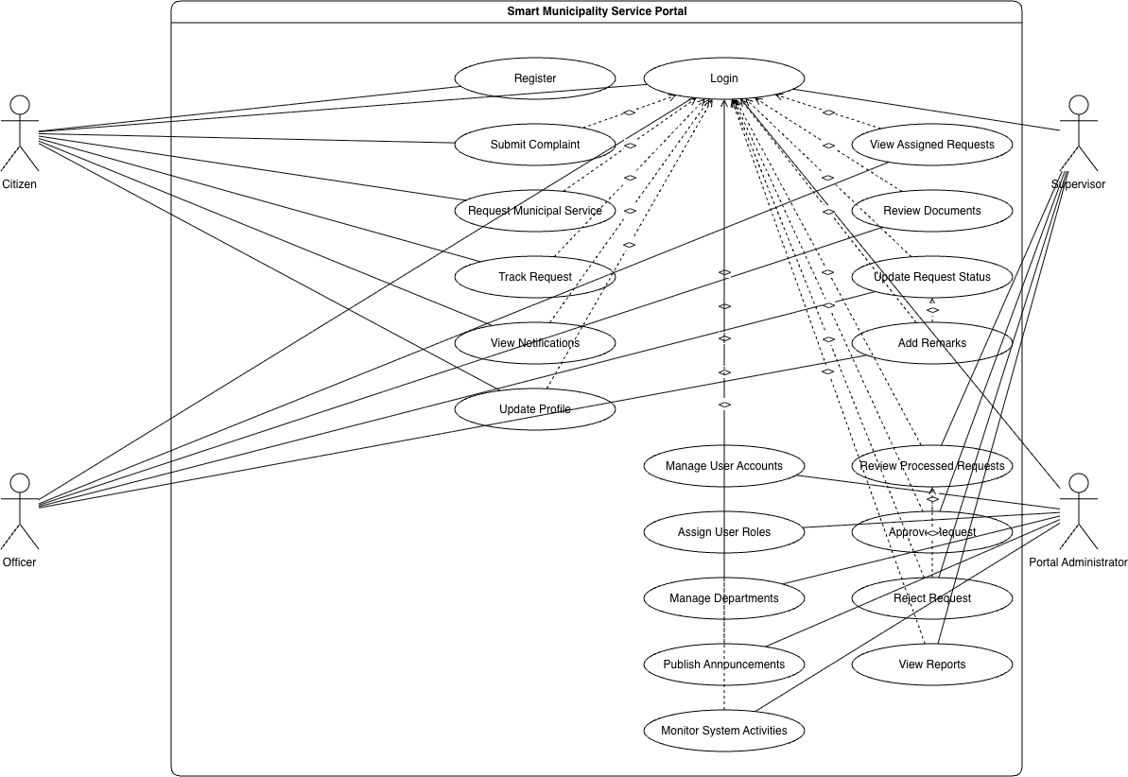
Figure 4.1: Use Case Diagram of the Smart Municipality Service Portal

4.2 UI / Wireframe Design using Figma
The wireframes below were built directly from the SRS in Section 3, giving each major functional requirement a corresponding screen. Screens are grouped by flow: the shared entry/login flow, the Citizen module, and the Portal Administrator module.

Entry & Authentication
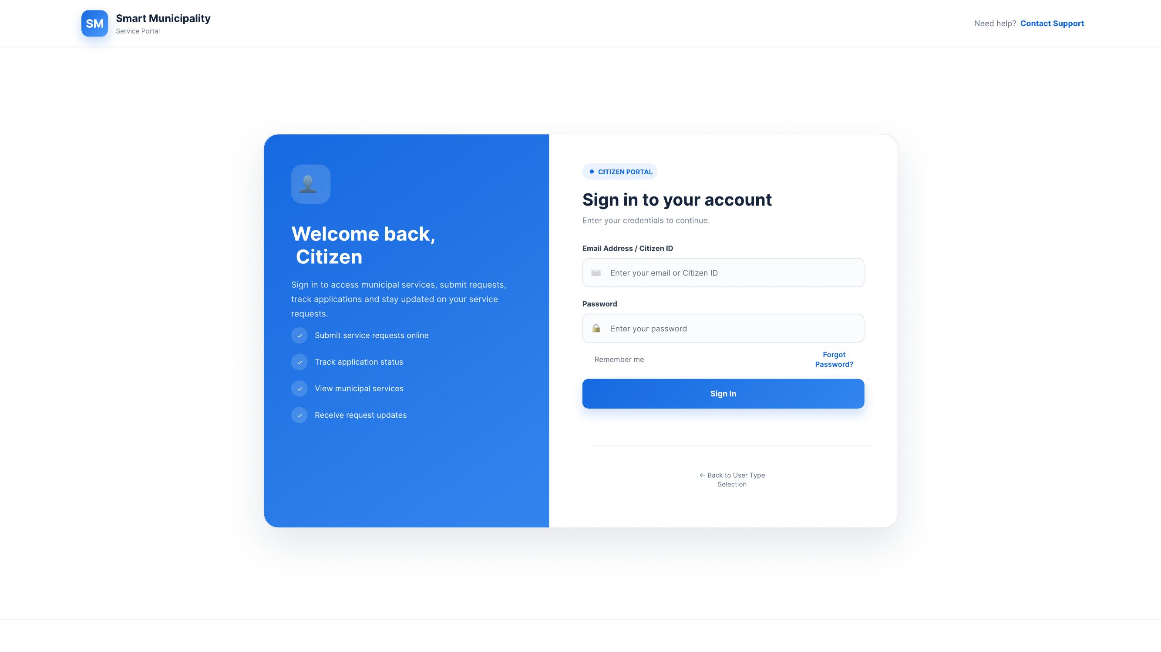
Figure 4.2: Citizen sign-in screen

Citizen Module
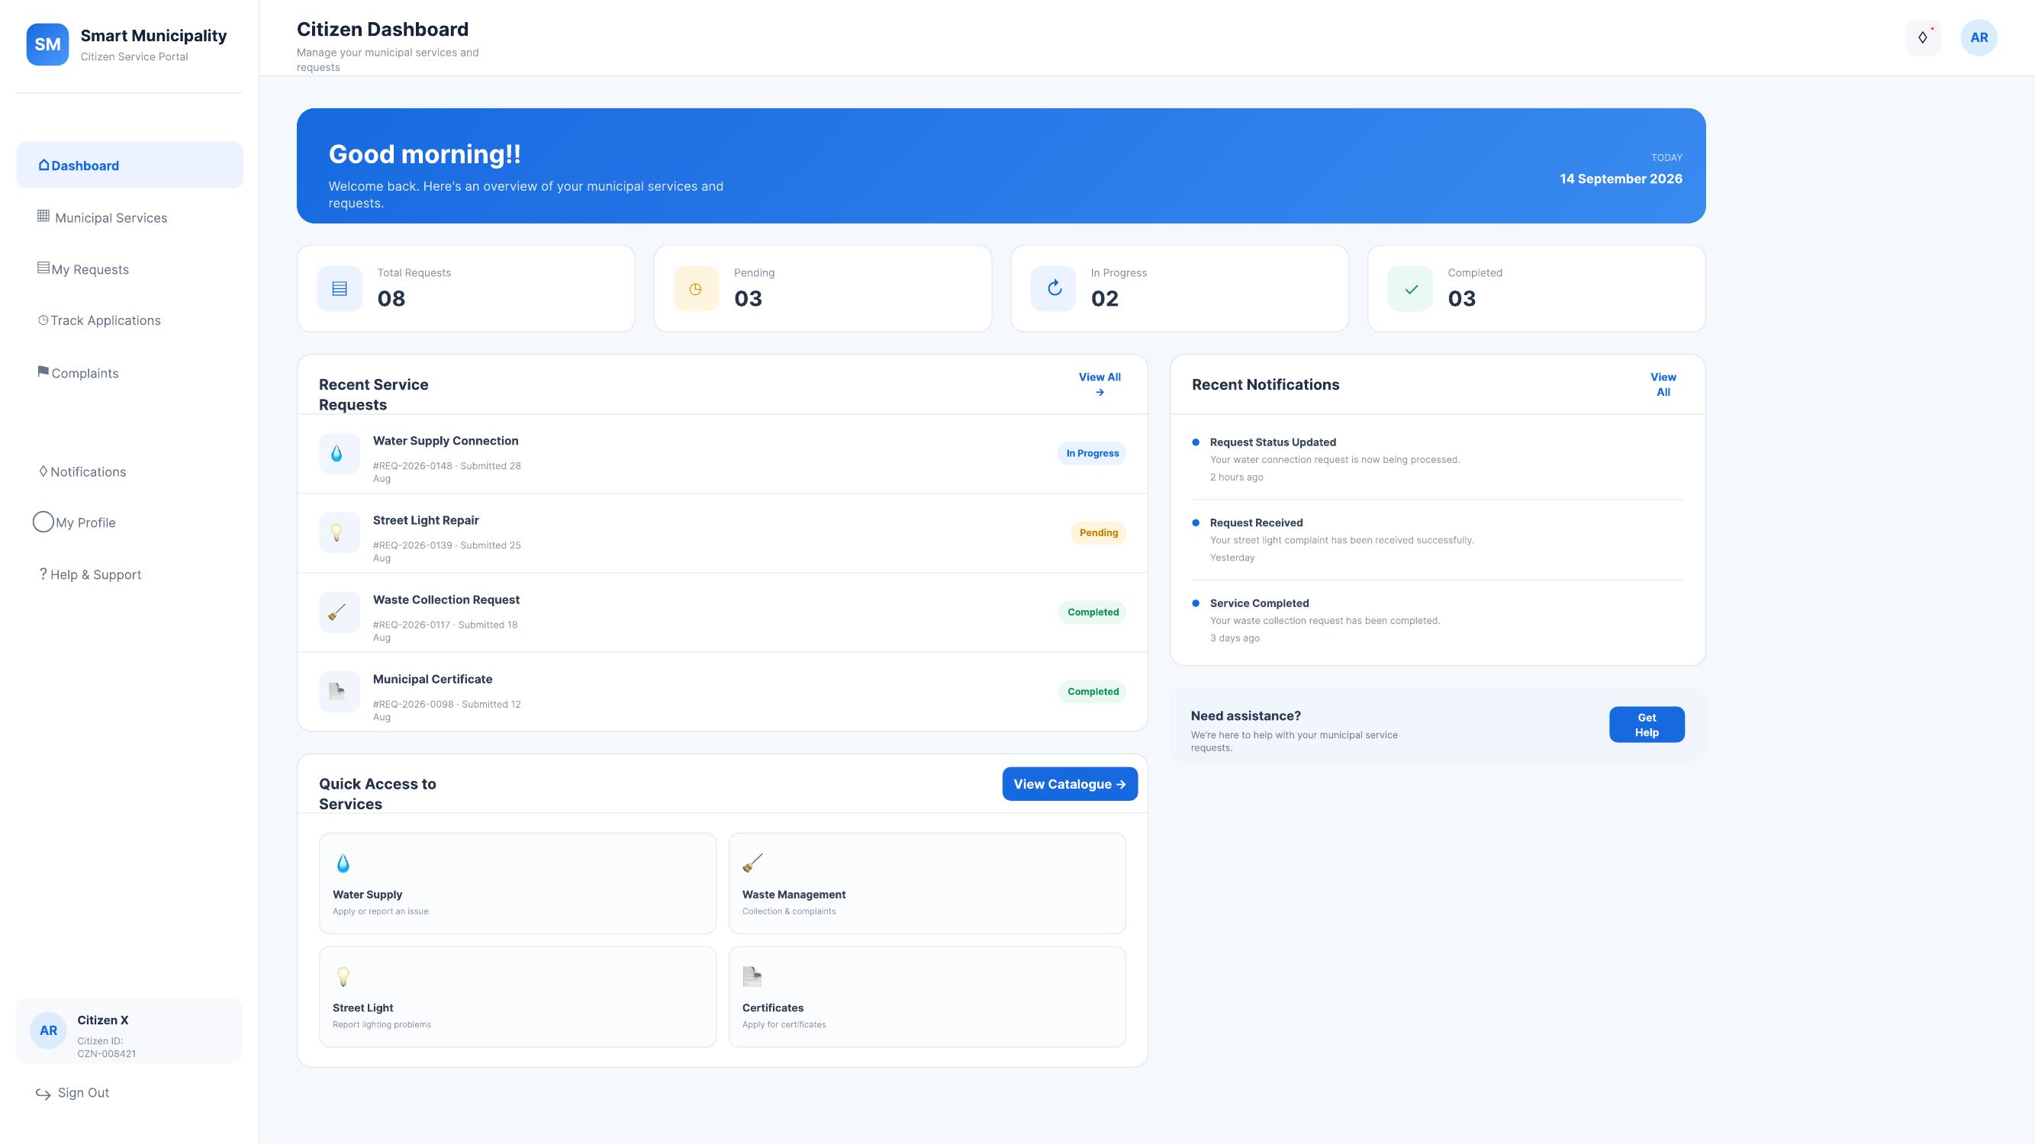
Figure 4.3: Citizen dashboard
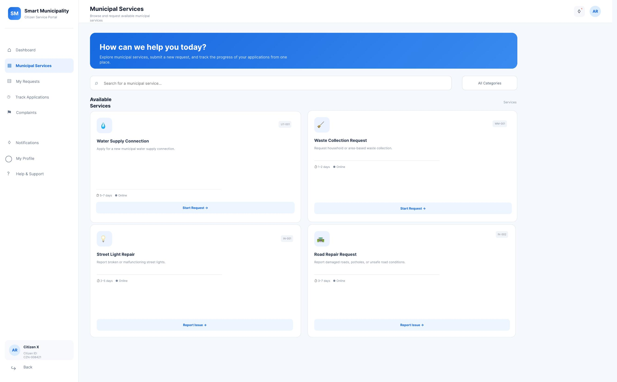
Figure 4.4: Municipal Services catalogue (browse & request)
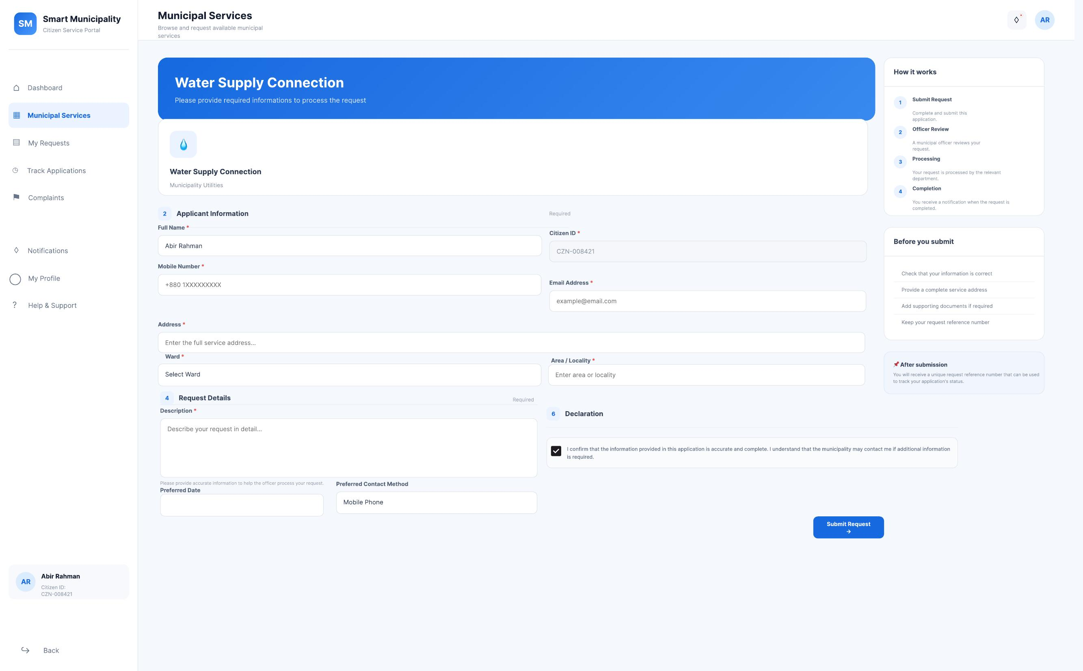
Figure 4.5: Water Supply Connection request form
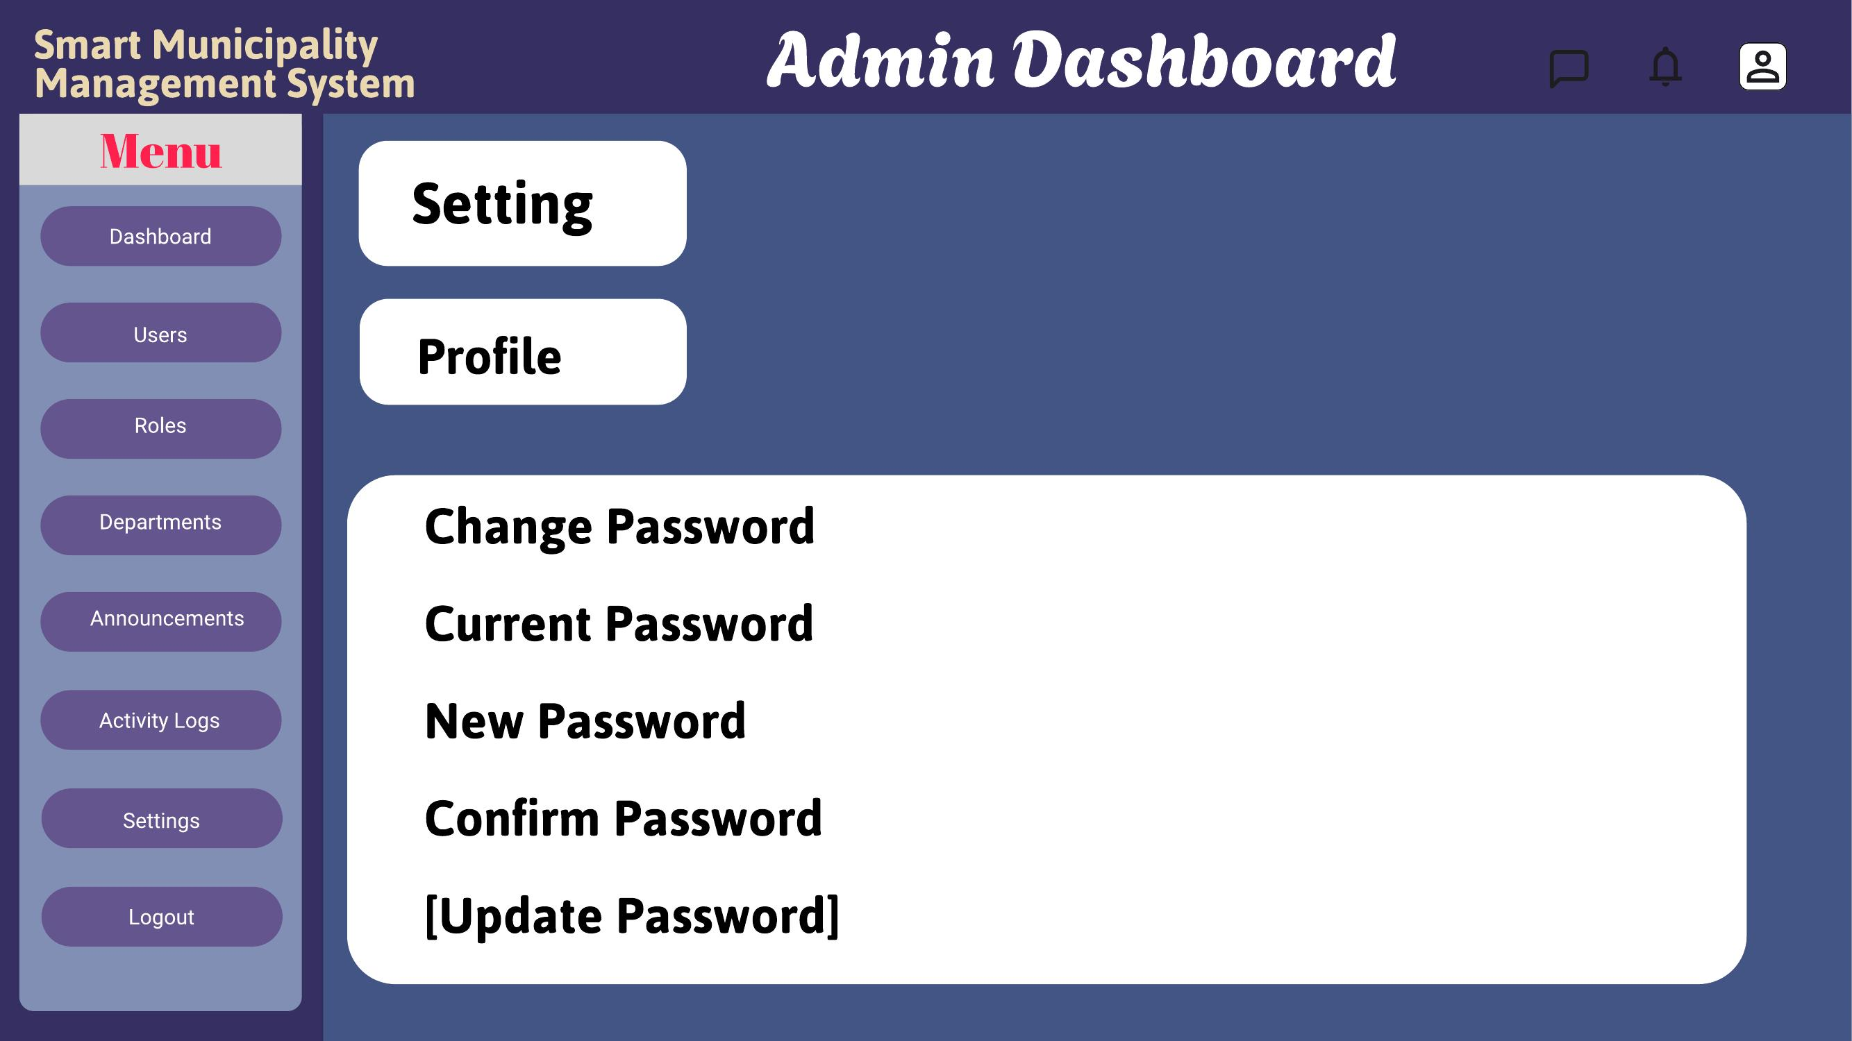
Figure 4.6: Request submitted confirmation with reference number
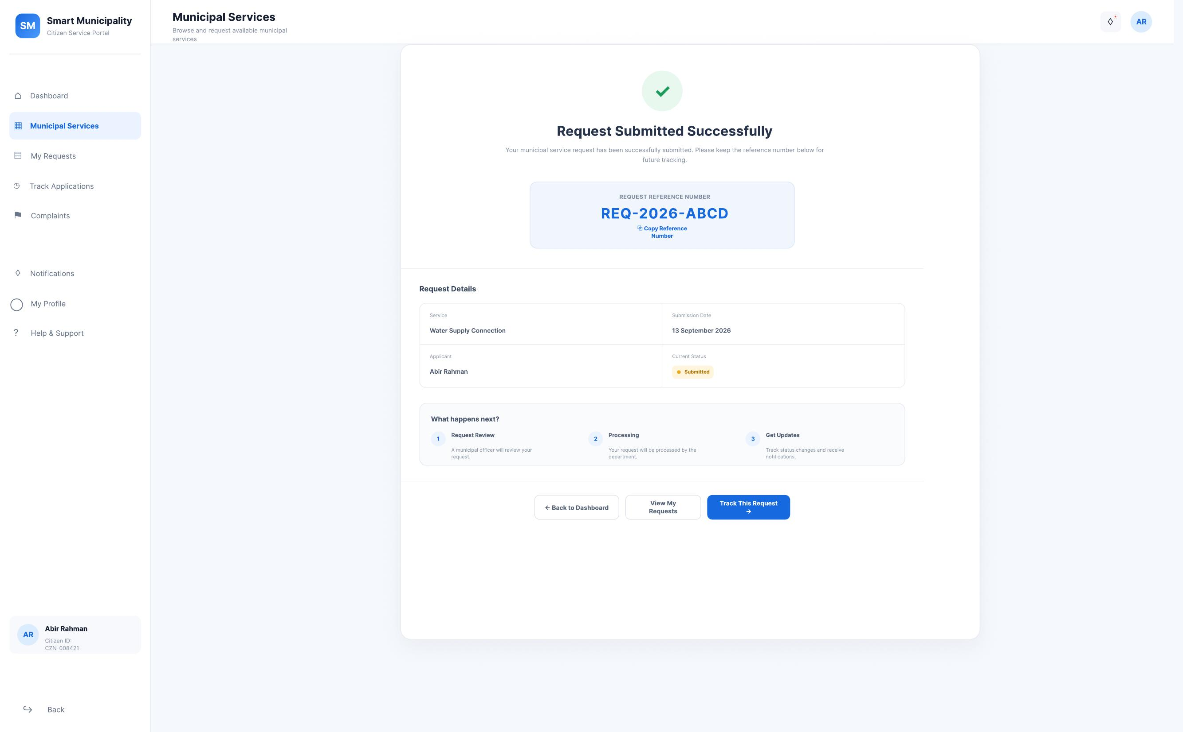
Figure 4.7: Waste Collection request form

Portal Administrator Module
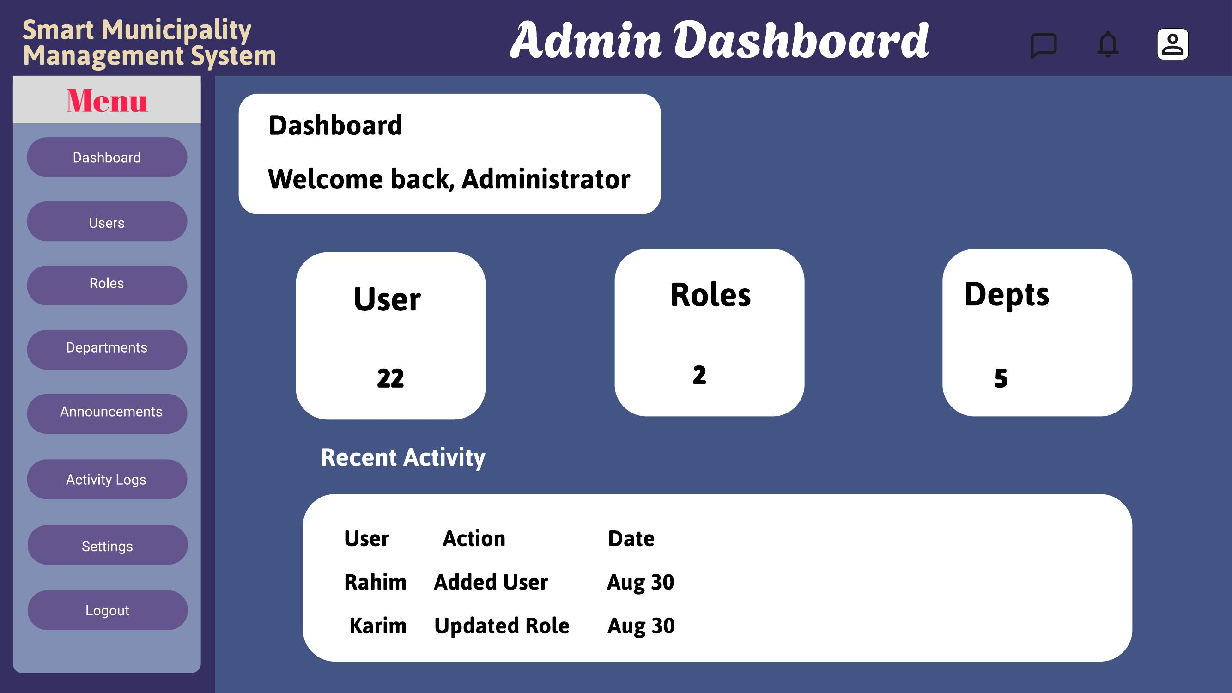
Figure 4.8: Admin dashboard overview
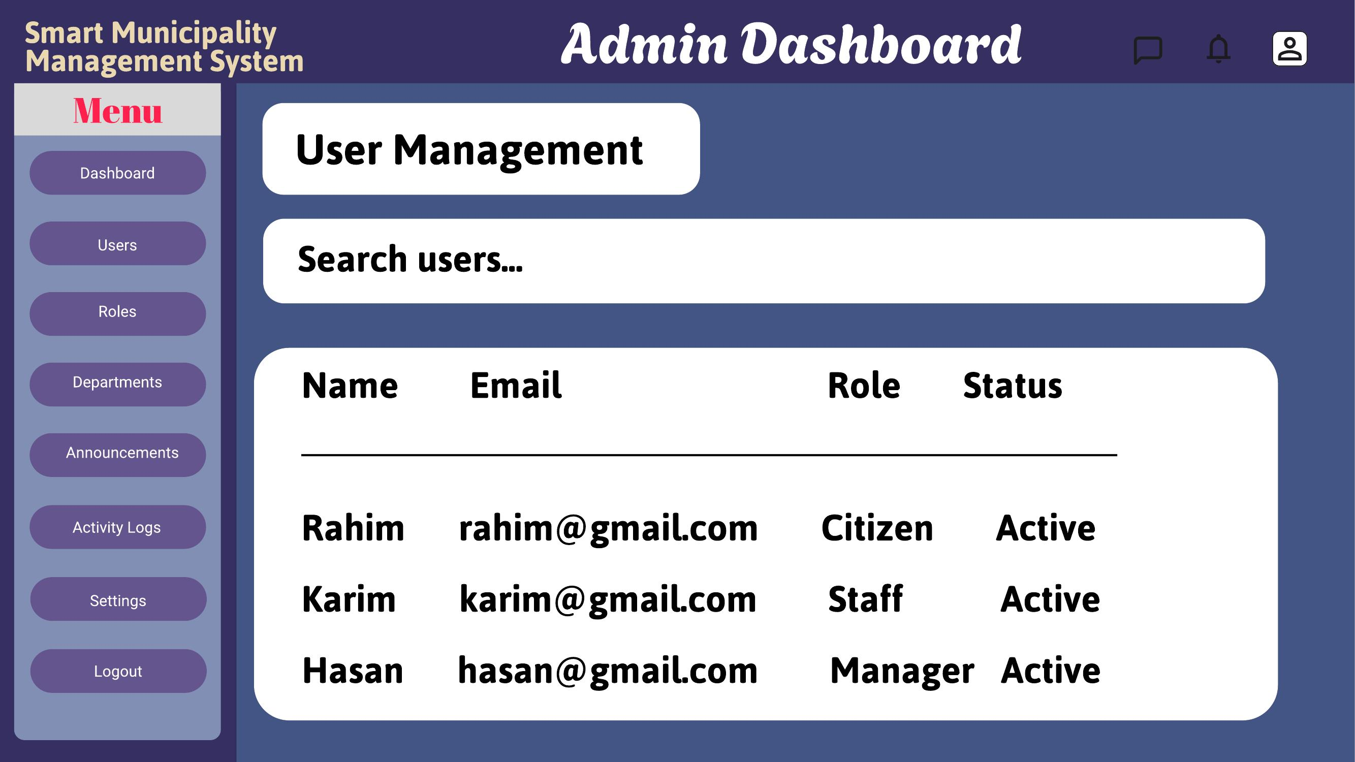
Figure 4.9: User management
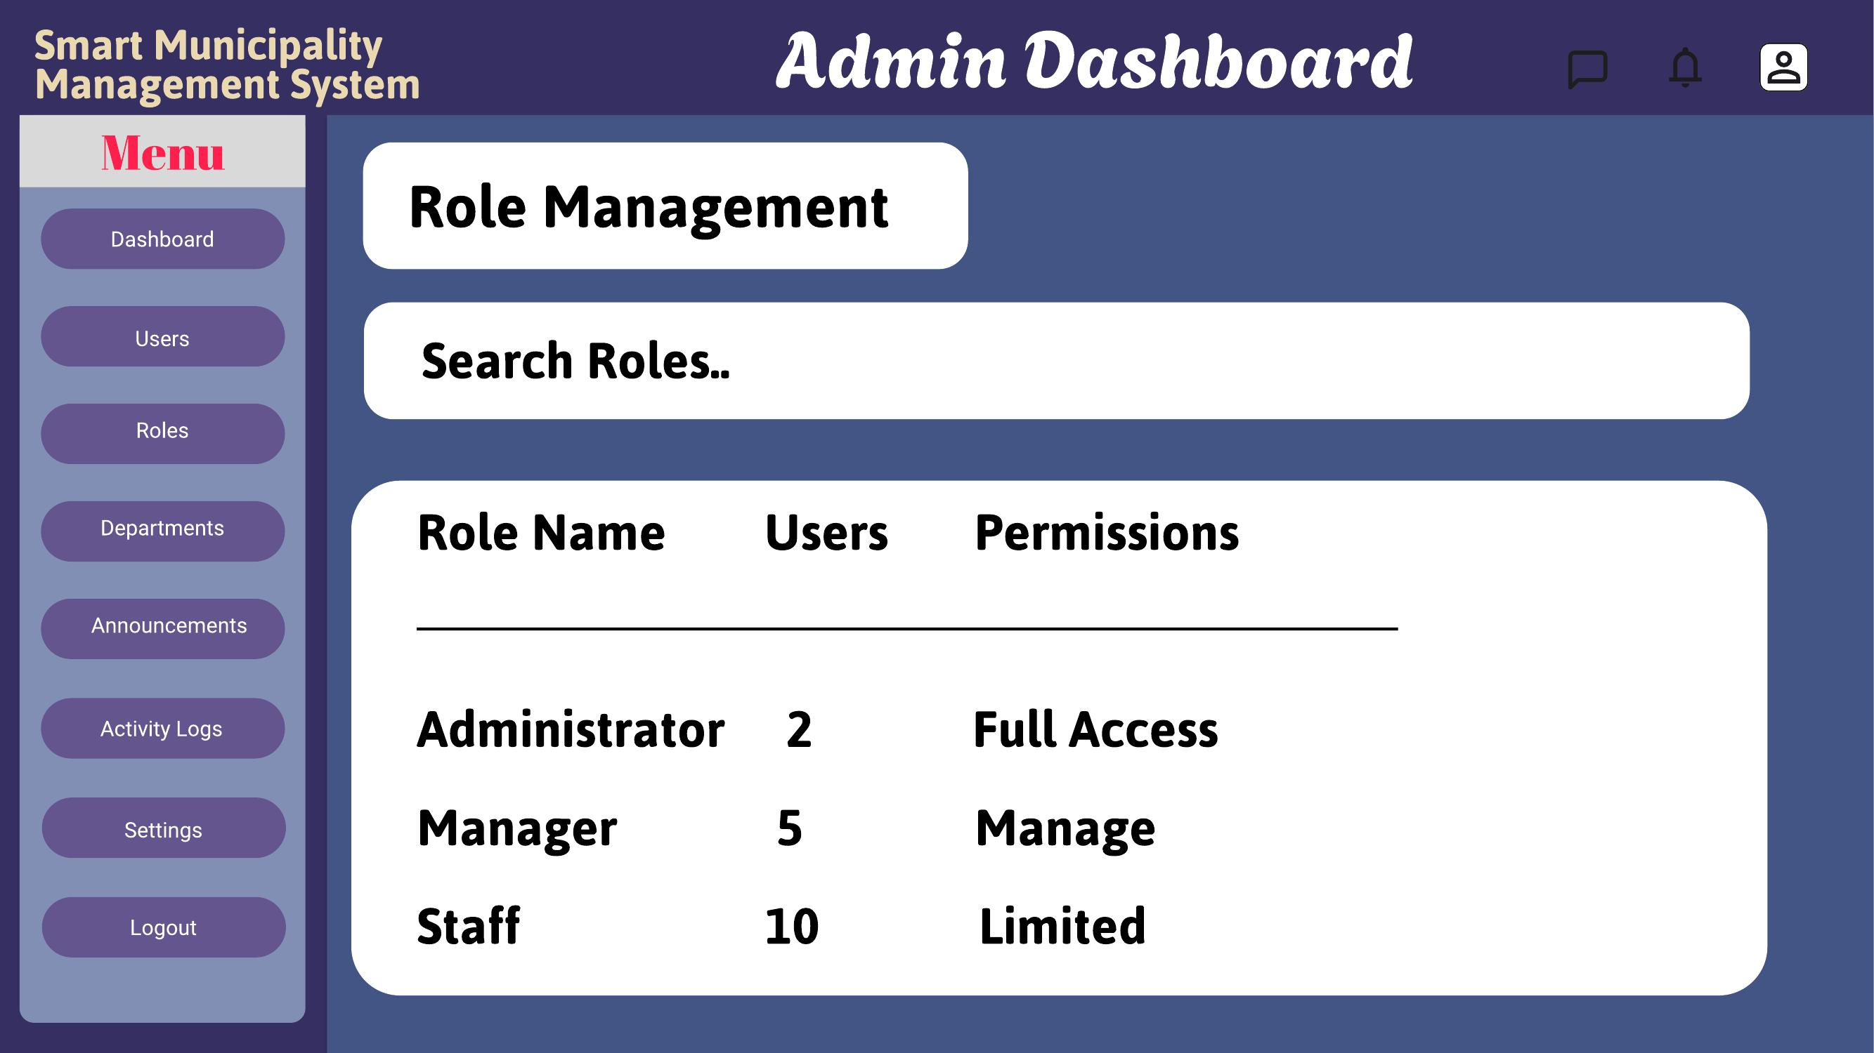
Figure 4.10: Role management
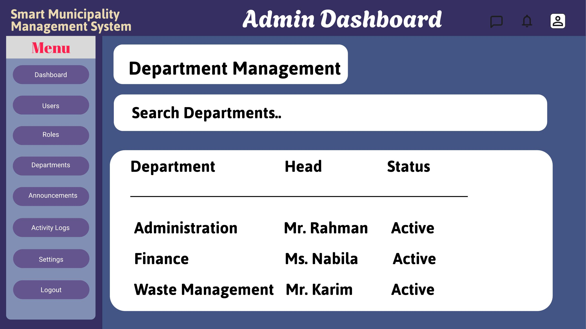
Figure 4.11: Department management
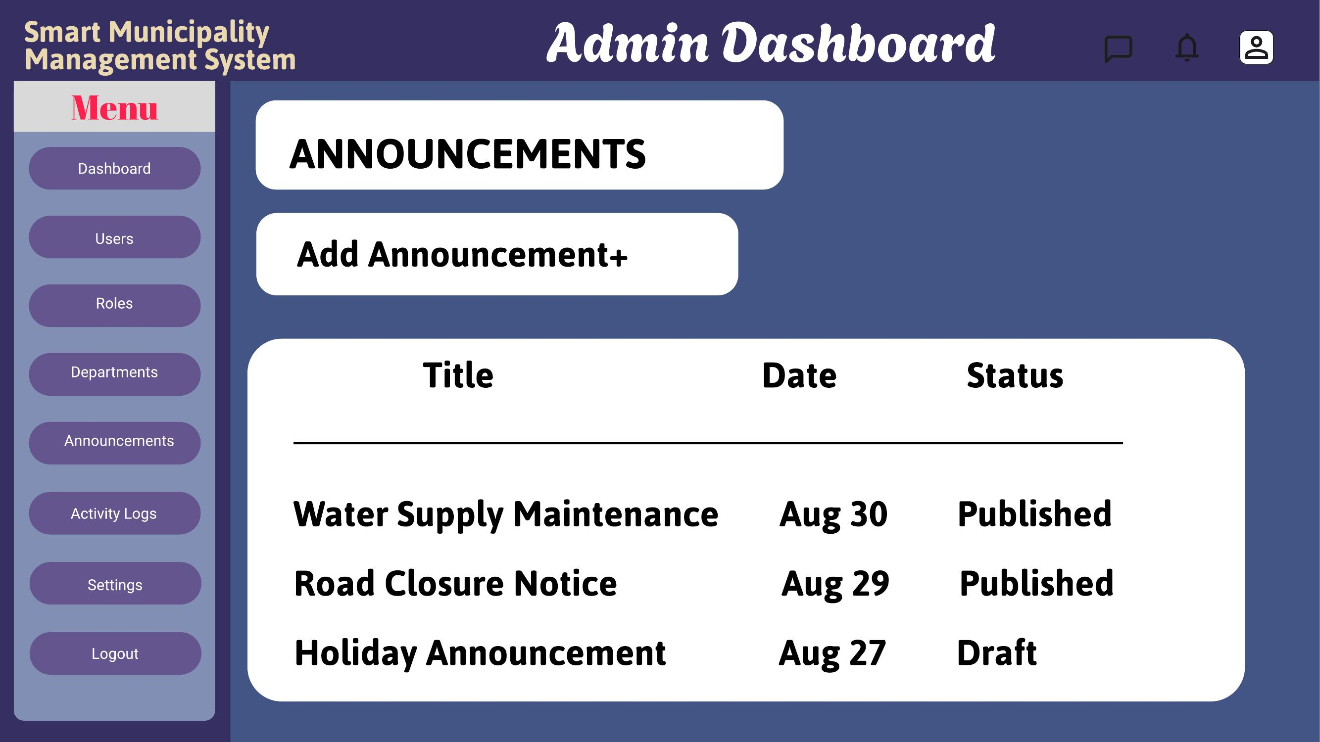
Figure 4.12: Announcements
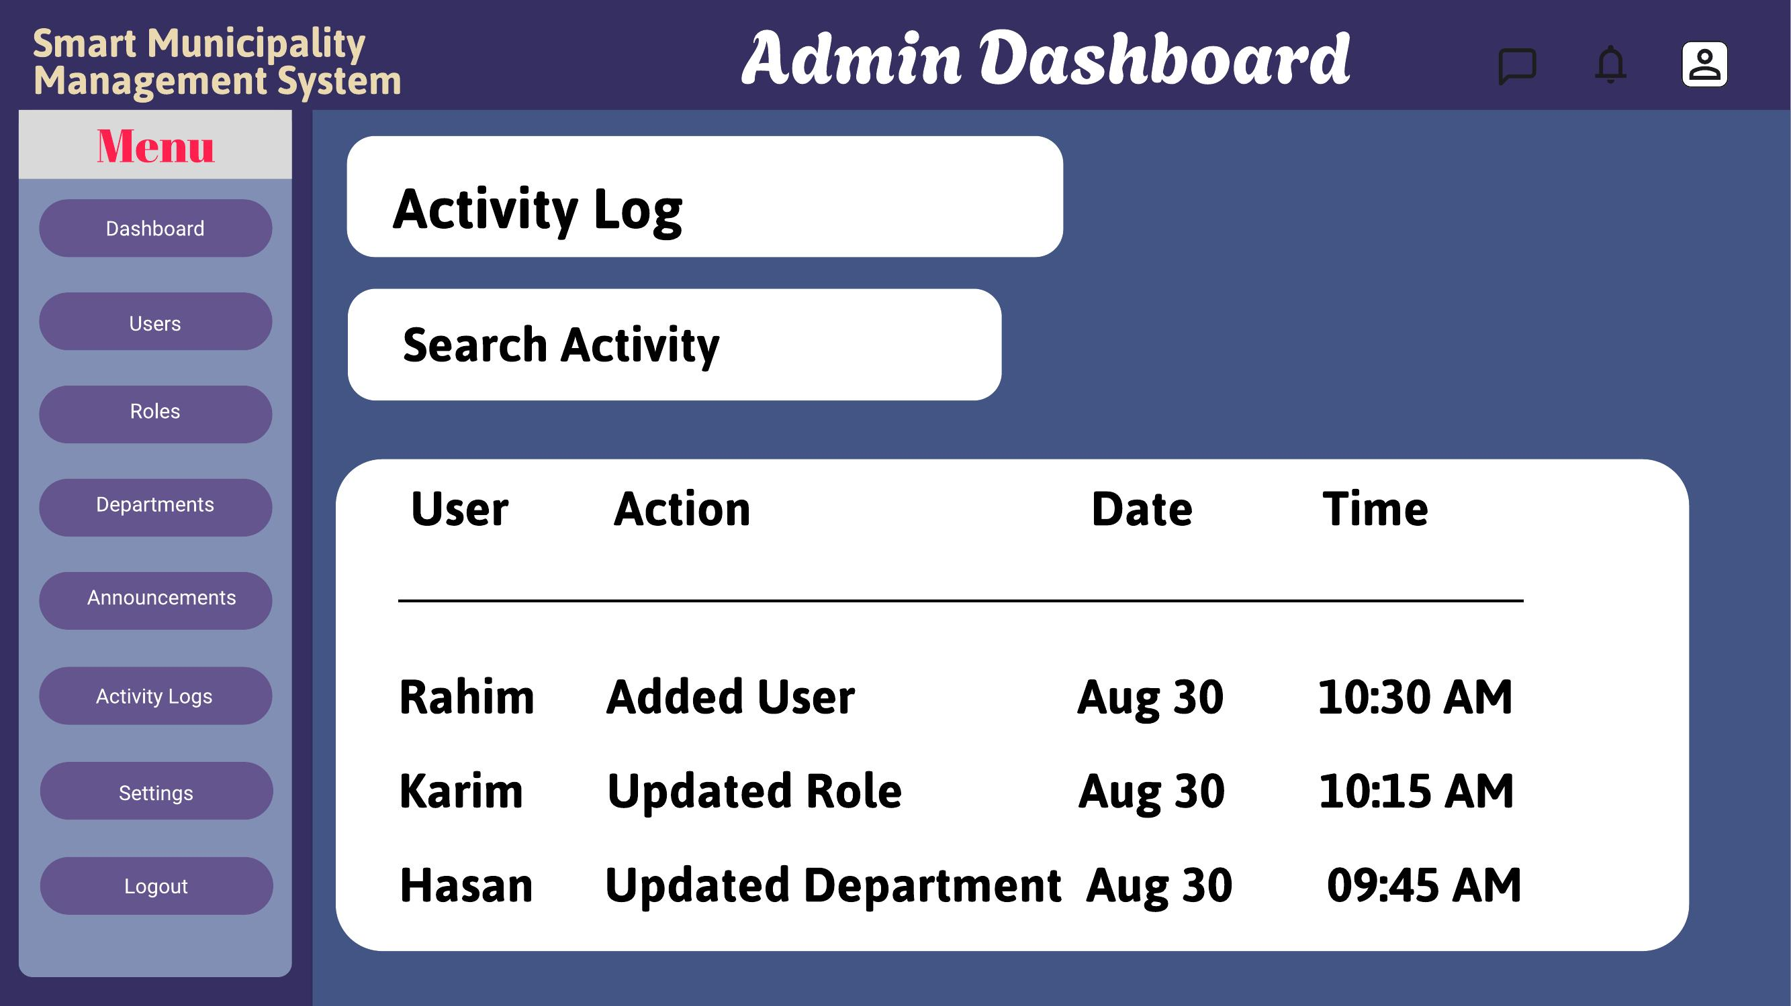
Figure 4.13: Activity log
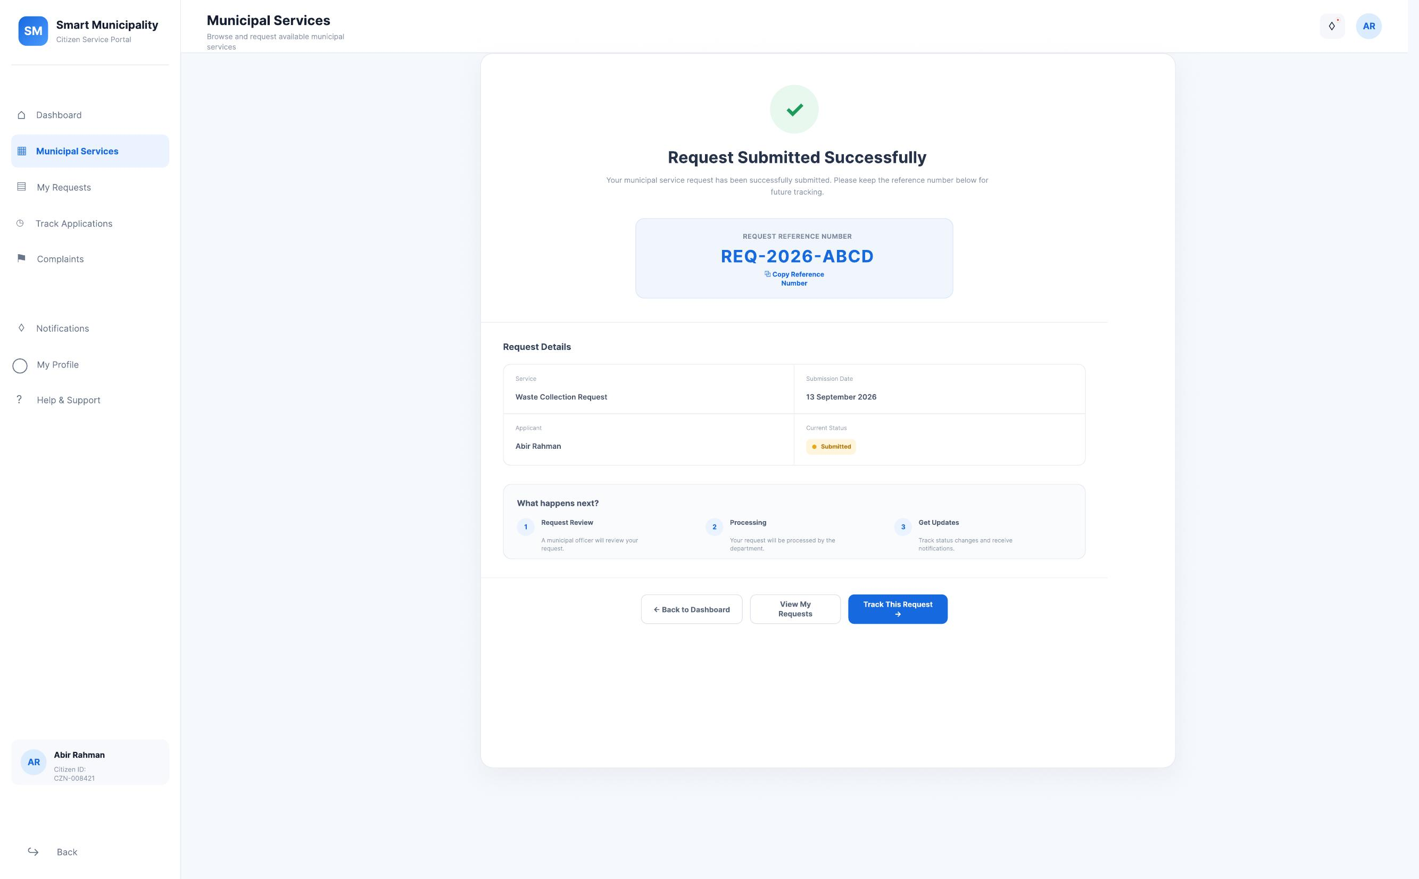
Figure 4.14: Account settings

5. Git Workflow
A central repository for the Smart Municipality Service Portal was created on GitHub, with the main branch maintained as the primary branch for integration. Each group member cloned the repository and created individual feature branches to work on their assigned modules (Citizen, Officer, Supervisor, and Portal Administrator), keeping development isolated until each feature was complete.
Tasks were tracked using a Trello board, where cards represented individual features and design tasks. Files were added and staged according to these Trello cards, and commits were made with clear messages describing the purpose of each update, referencing the corresponding card. Text files recording the Trello card serial number and description were uploaded to the repository alongside the related code/design files.
Commits from each feature branch were pushed to the remote repository so that progress remained visible to all members, and git pull was used regularly to fetch and integrate updates from teammates into local copies. Feature branches were merged into the main branch only after the corresponding work was tested and reviewed by at least one other group member, with any conflicts resolved manually before merging.
Collaboration is evidenced by a clean, traceable commit history containing multiple commits, merges, and contributions from group members, tracking the project workflow from initialization through to completion. The repository "Smart-Municipality-Management-System" was created under group member Abhigyan-Sadhak-Rindo's GitHub account, with a main branch and secondary branches.
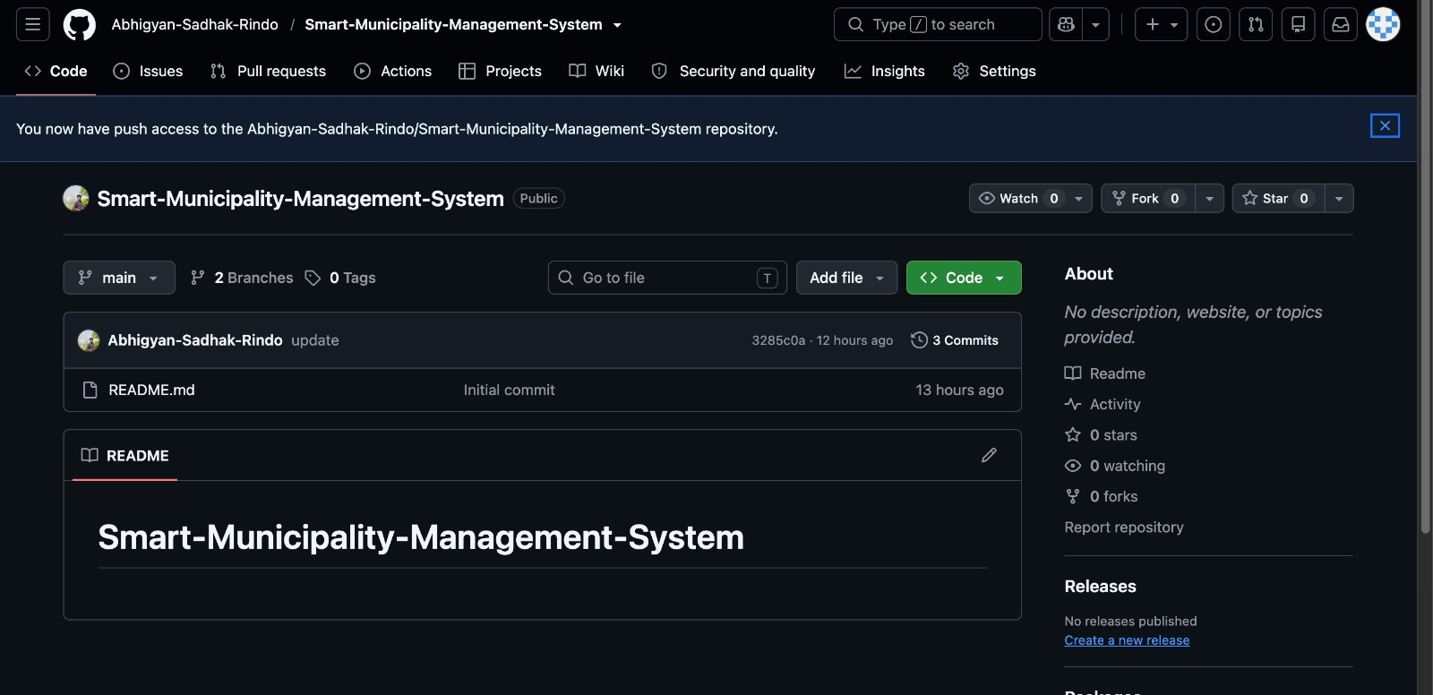
Figure 5.1: GitHub repository for the Smart Municipality Management System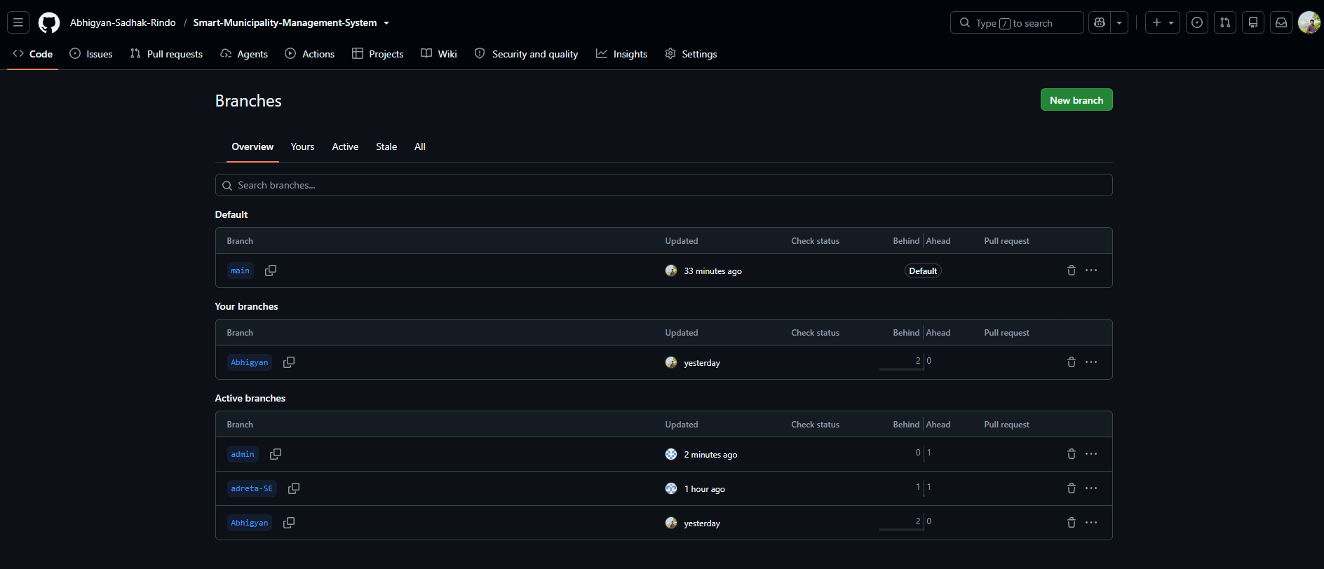
Figure 5.2: GitHub branches for the Smart Municipality Management System
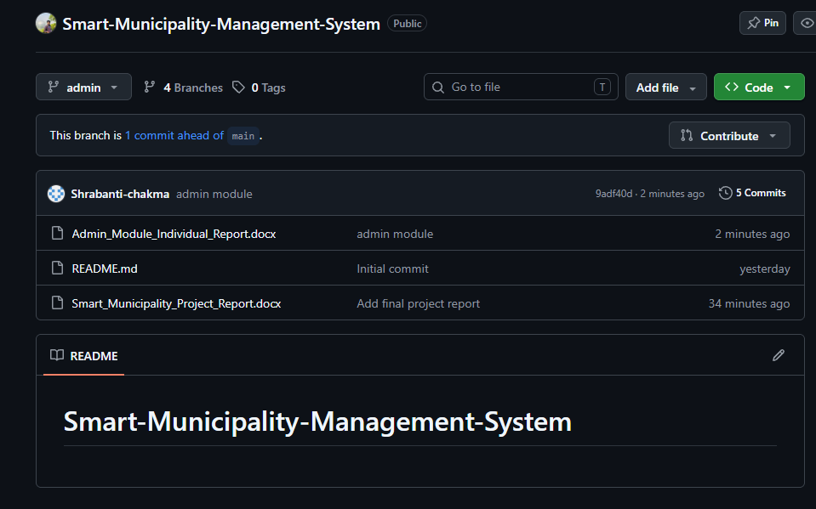
Figure 5.3: GitHub branch for the Smart Municipality Management System
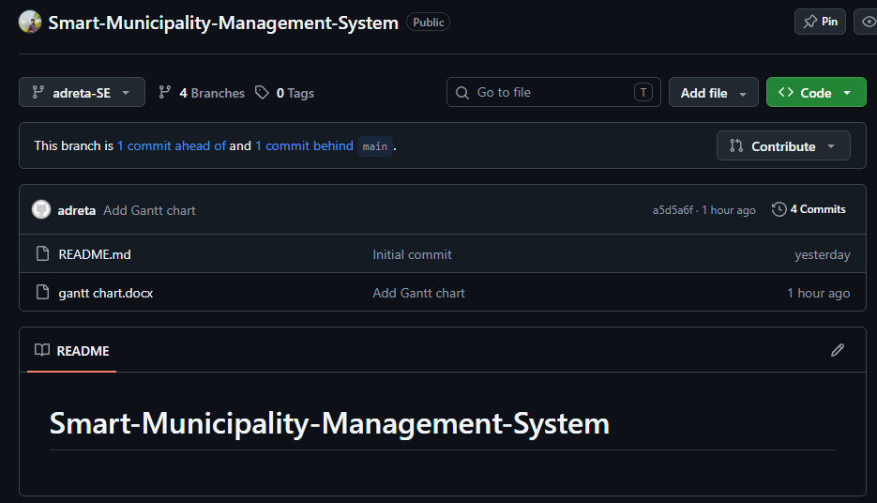
Figure 5.4: GitHub branch for the Smart Municipality Management System
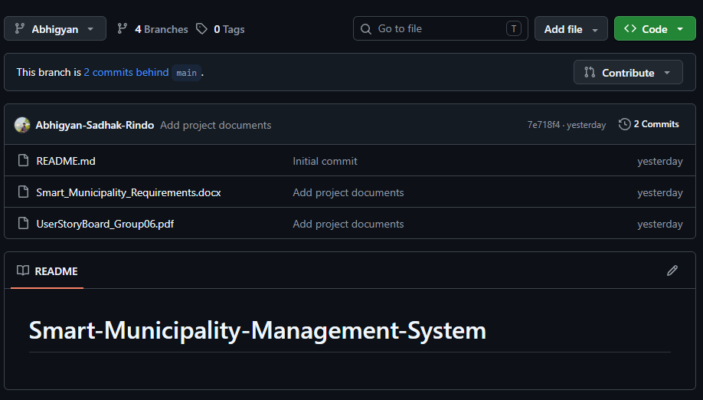 Figure 5.5: GitHub branch for the Smart Municipality Management System

6. Conclusion
The Smart Municipality Service Portal addresses a real and recurring civic problem: the delay, paperwork, and lack of transparency citizens face when accessing municipal services through manual processes. By centralizing service requests, complaint submission, and status tracking into a single digital platform, the project reduces the need for repeated office visits and gives citizens clear visibility into the progress of their applications. Dedicated dashboards for Citizens, Officers, Supervisors, and Portal Administrators ensure that each role can perform its responsibilities efficiently, from submitting a request to reviewing, approving, and monitoring it. Throughout this project, requirements were captured through user stories and translated into a structured SRS covering both functional and non-functional needs, particularly usability, security, and accessibility, since the platform must remain simple for citizens with limited digital literacy. The system design was validated through a use case diagram covering all four actors, and the Git-based workflow ensured organized, trackable collaboration among all group members. The final outcome of this project is a high-fidelity, interactive prototype that demonstrates an efficient, organized, and user-friendly municipality management experience, laying a solid foundation for a future fully-functional implementation.

