
American International University-Bangladesh (AIUB)
Department of Computer Science
Faculty of Science & Technology (FST)
SMART MUNICIPALITY SERVICE PORTAL
Individual Module Report — Portal Administrator (System Admin) Module
Submitted as part of the group Software Engineering Project Report
Semester: Summer 25-26 Section: E Group: 06
Student Name: Shrabanti Chakma
Student ID: 24-56217-1

1. Role Overview
Within the Smart Municipality Service Portal, my assigned role is the Portal Administrator (System Admin) module. The Portal Administrator sits at the top of the system's access hierarchy and is responsible for the overall configuration and oversight of the platform, rather than processing individual citizen requests directly. This includes managing user accounts and roles for all other actors (Citizen, Officer, Supervisor), configuring departments, publishing system-wide announcements, and monitoring overall system activity for accountability and audit purposes.
This report presents the requirements, design, and interface work specific to the Portal Administrator module, extracted from the group's full project documentation.

2. Requirements Handled (Portal Administrator Module)

2.1 User Story Table
As a/an | I want to | So that | Acceptance Criteria
Portal Administrator | Login | I can access system controls | Admin dashboard opens successfully.
Portal Administrator | Manage user accounts | Only authorized users can access the system | User information is updated successfully.
Portal Administrator | Assign user roles | Users receive proper permissions | Role changes are saved successfully.
Portal Administrator | Manage departments | Departments remain organized | Department information is updated successfully.
Portal Administrator | Publish announcements | Users receive important updates | Announcement is visible to all users.
Portal Administrator | Monitor system activities | I can ensure smooth operation | Activity logs are displayed correctly.

2.2 Functional Requirements
Req. ID | Functional Requirement | Priority
FR_20 | Administrators shall be able to manage (create/edit/deactivate) user accounts for all roles. | High
FR_21 | Administrators shall be able to configure and manage the list of available municipal services. | High
FR_22 | Administrators shall be able to assign roles and permissions to system users. | High
FR_23 | Administrators shall be able to monitor overall system activity/logs. | Medium
FR_24 | Administrators shall be able to generate system-wide analytical reports and dashboards. | Medium
FR_25 | Administrators shall be able to broadcast announcements/notices to all citizens. | Low

In addition, three system-wide functional requirements are also relevant to this module: FR_26 (search and filter function across all dashboards), FR_27 (unified notification center), and FR_28 (audit trail/history log for every request's lifecycle) — the last of which is directly served by the Admin's Activity Log feature.

2.3 Non-Functional Requirements
Req. ID | Non-Functional Requirement | Quality Attribute | Priority
NFR_14 | The system architecture shall conceptually support scaling to additional municipalities/regions. | Scalability | Low
NFR_06 | User authentication shall be required for all role-based dashboards. | Security | High
NFR_07 | Role-based access control shall restrict users to features relevant to their role only. | Security | High
NFR_01 | The interface shall follow a consistent, intuitive UI/UX design across all dashboards. | Usability | High
NFR_16 | All four dashboards shall be visually distinct yet consistent in design language. | Usability | High

3. System Design — Portal Administrator
The Portal Administrator actor interacts with the following use cases: Login, Manage User Accounts, Assign User Roles, Manage Departments, Publish Announcements, and Monitor System Activities. Like all other actors, every Portal Administrator action is gated behind the shared Login use case through an <<include>> relationship, ensuring only authenticated administrators can reach these controls. The full use case diagram is shown below; the Portal Administrator's use cases are the cluster of ovals on the lower-right of the diagram, connected to the Portal Administrator actor.
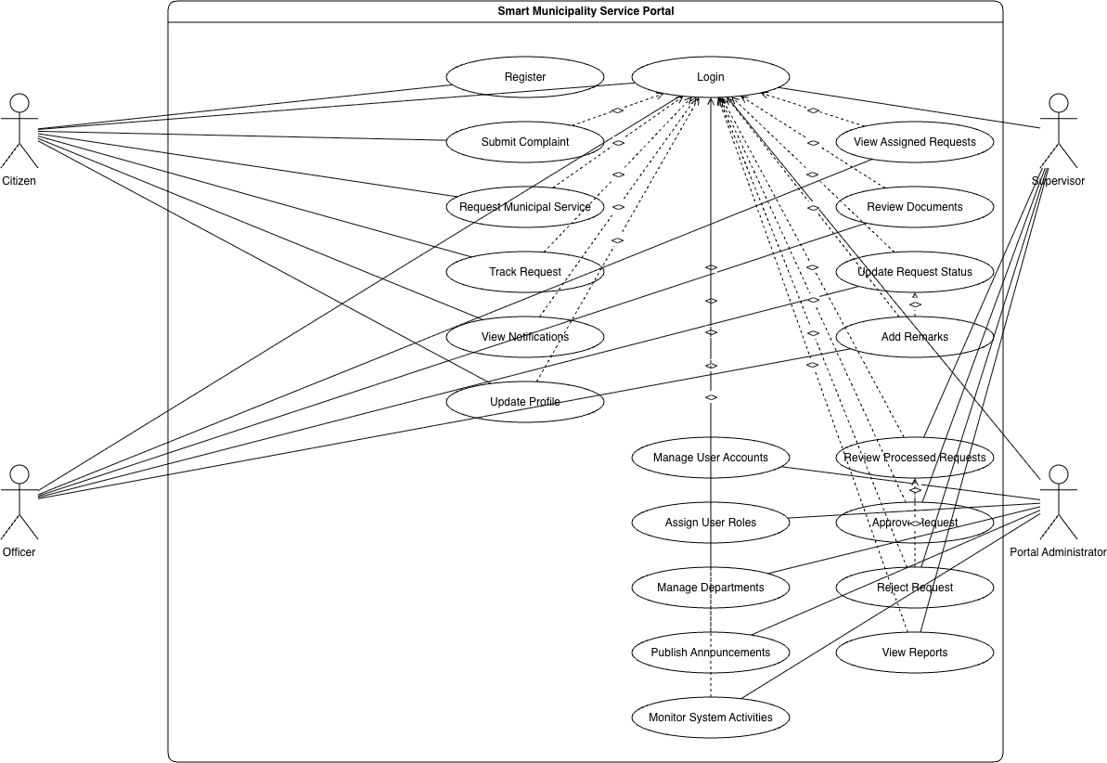
Figure 3.1: Use Case Diagram of the Smart Municipality Service Portal (Portal Administrator actor shown on the right)

4. UI / Wireframe Design — Admin Module
The following wireframes cover the Portal Administrator's dashboard and its management screens, corresponding to the functional requirements listed in Section 2.2.
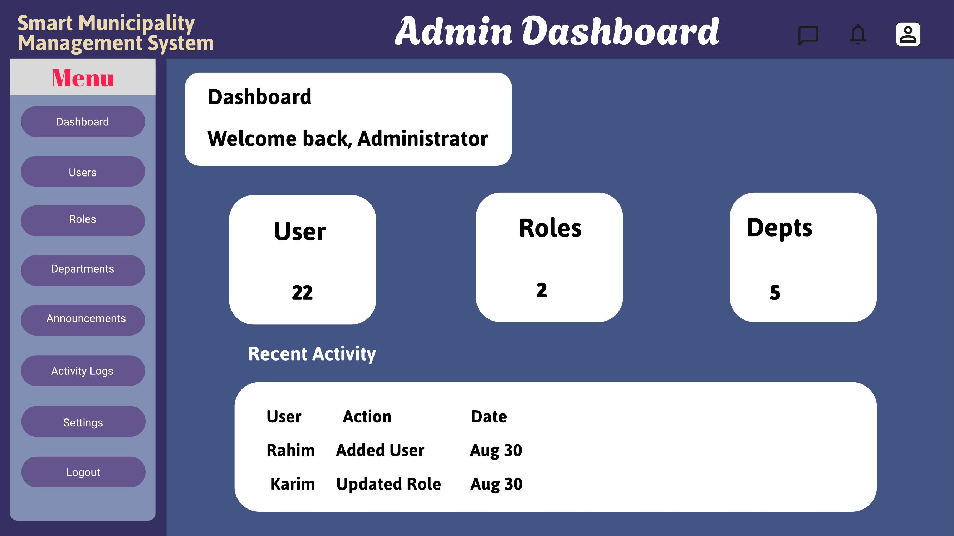
Figure 4.1: Admin dashboard overview
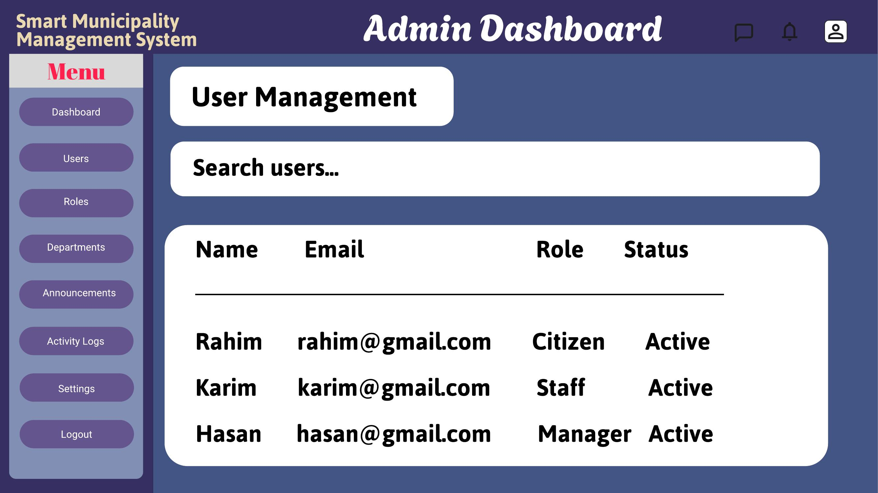
Figure 4.2: User management
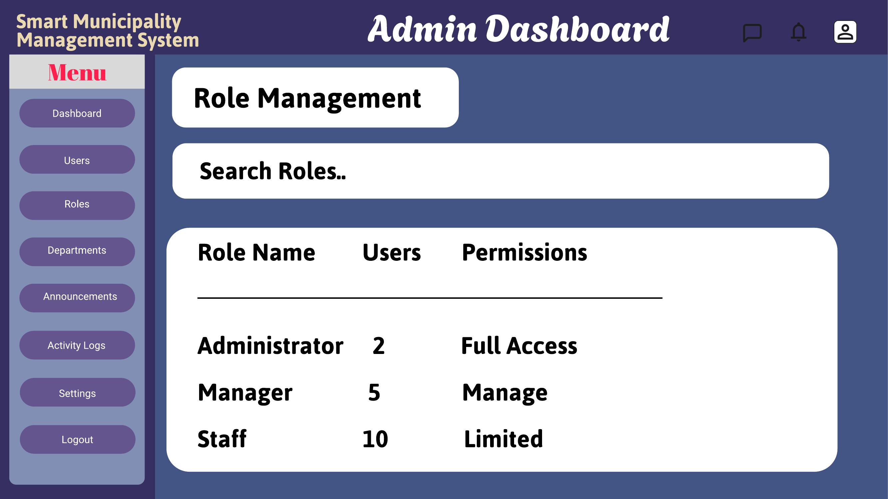
Figure 4.3: Role management
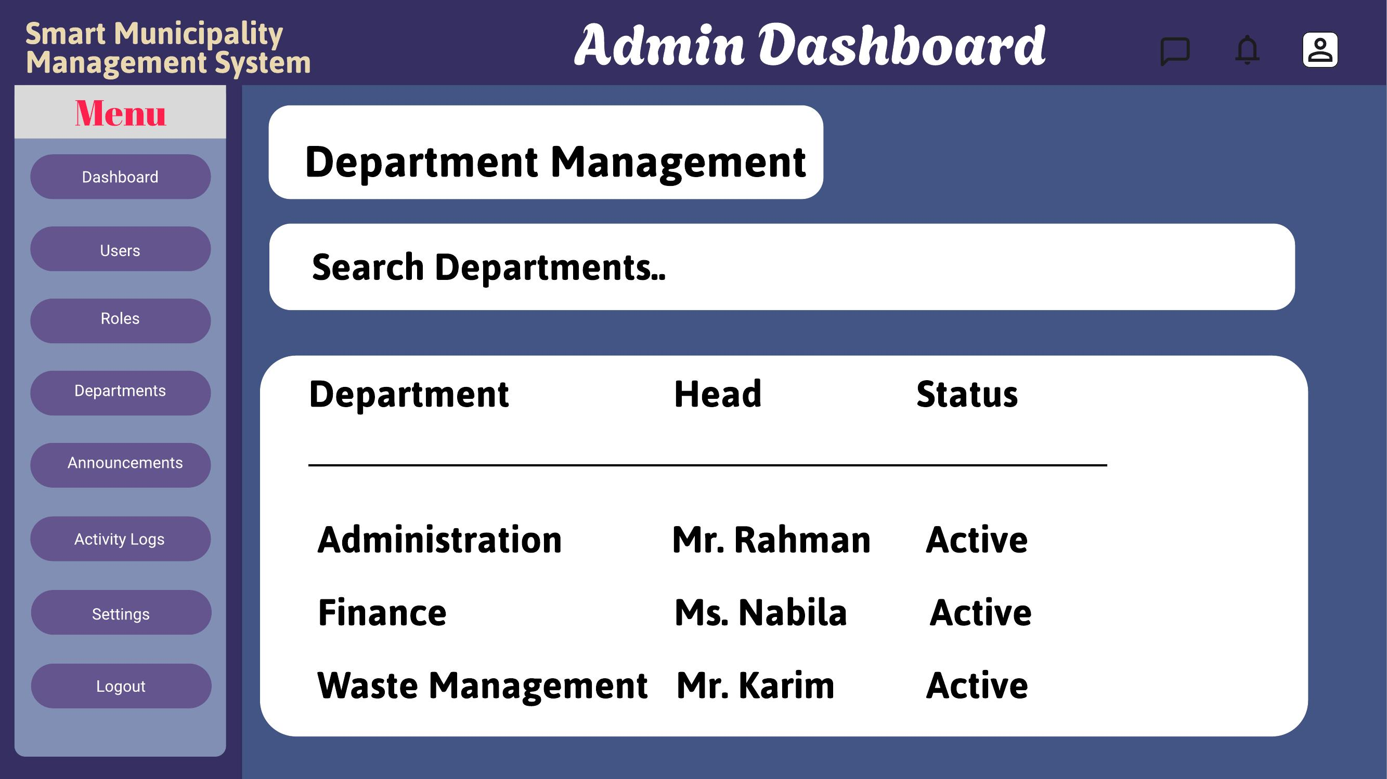
Figure 4.4: Department management
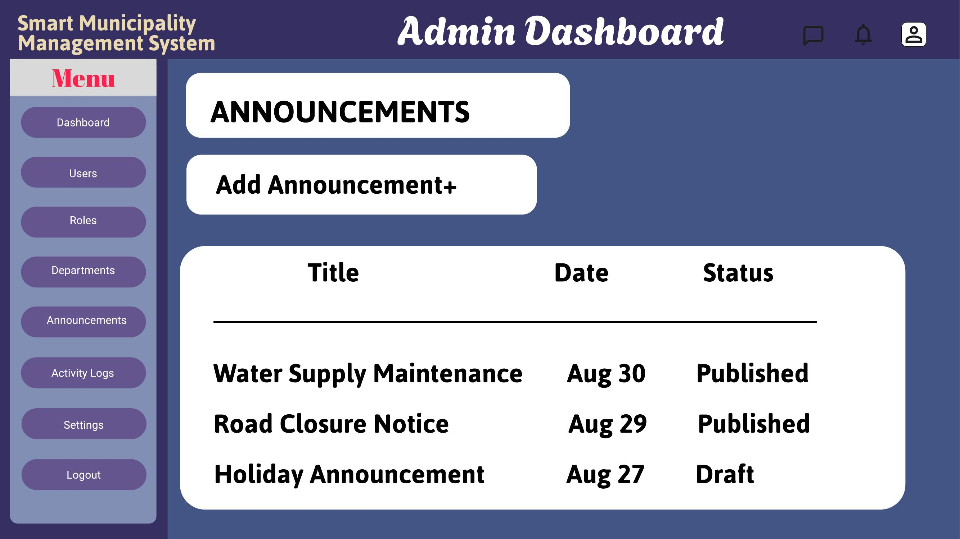
Figure 4.5: Announcements
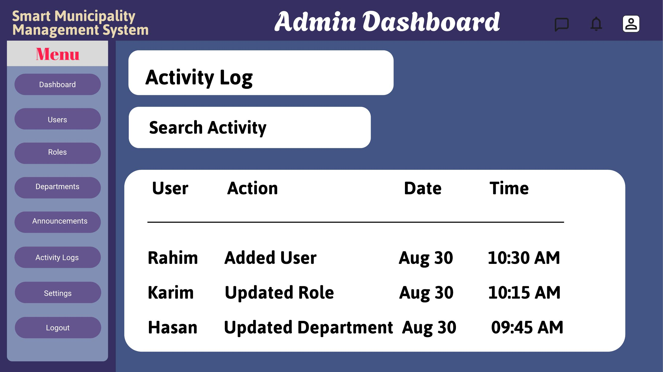
Figure 4.6: Activity log
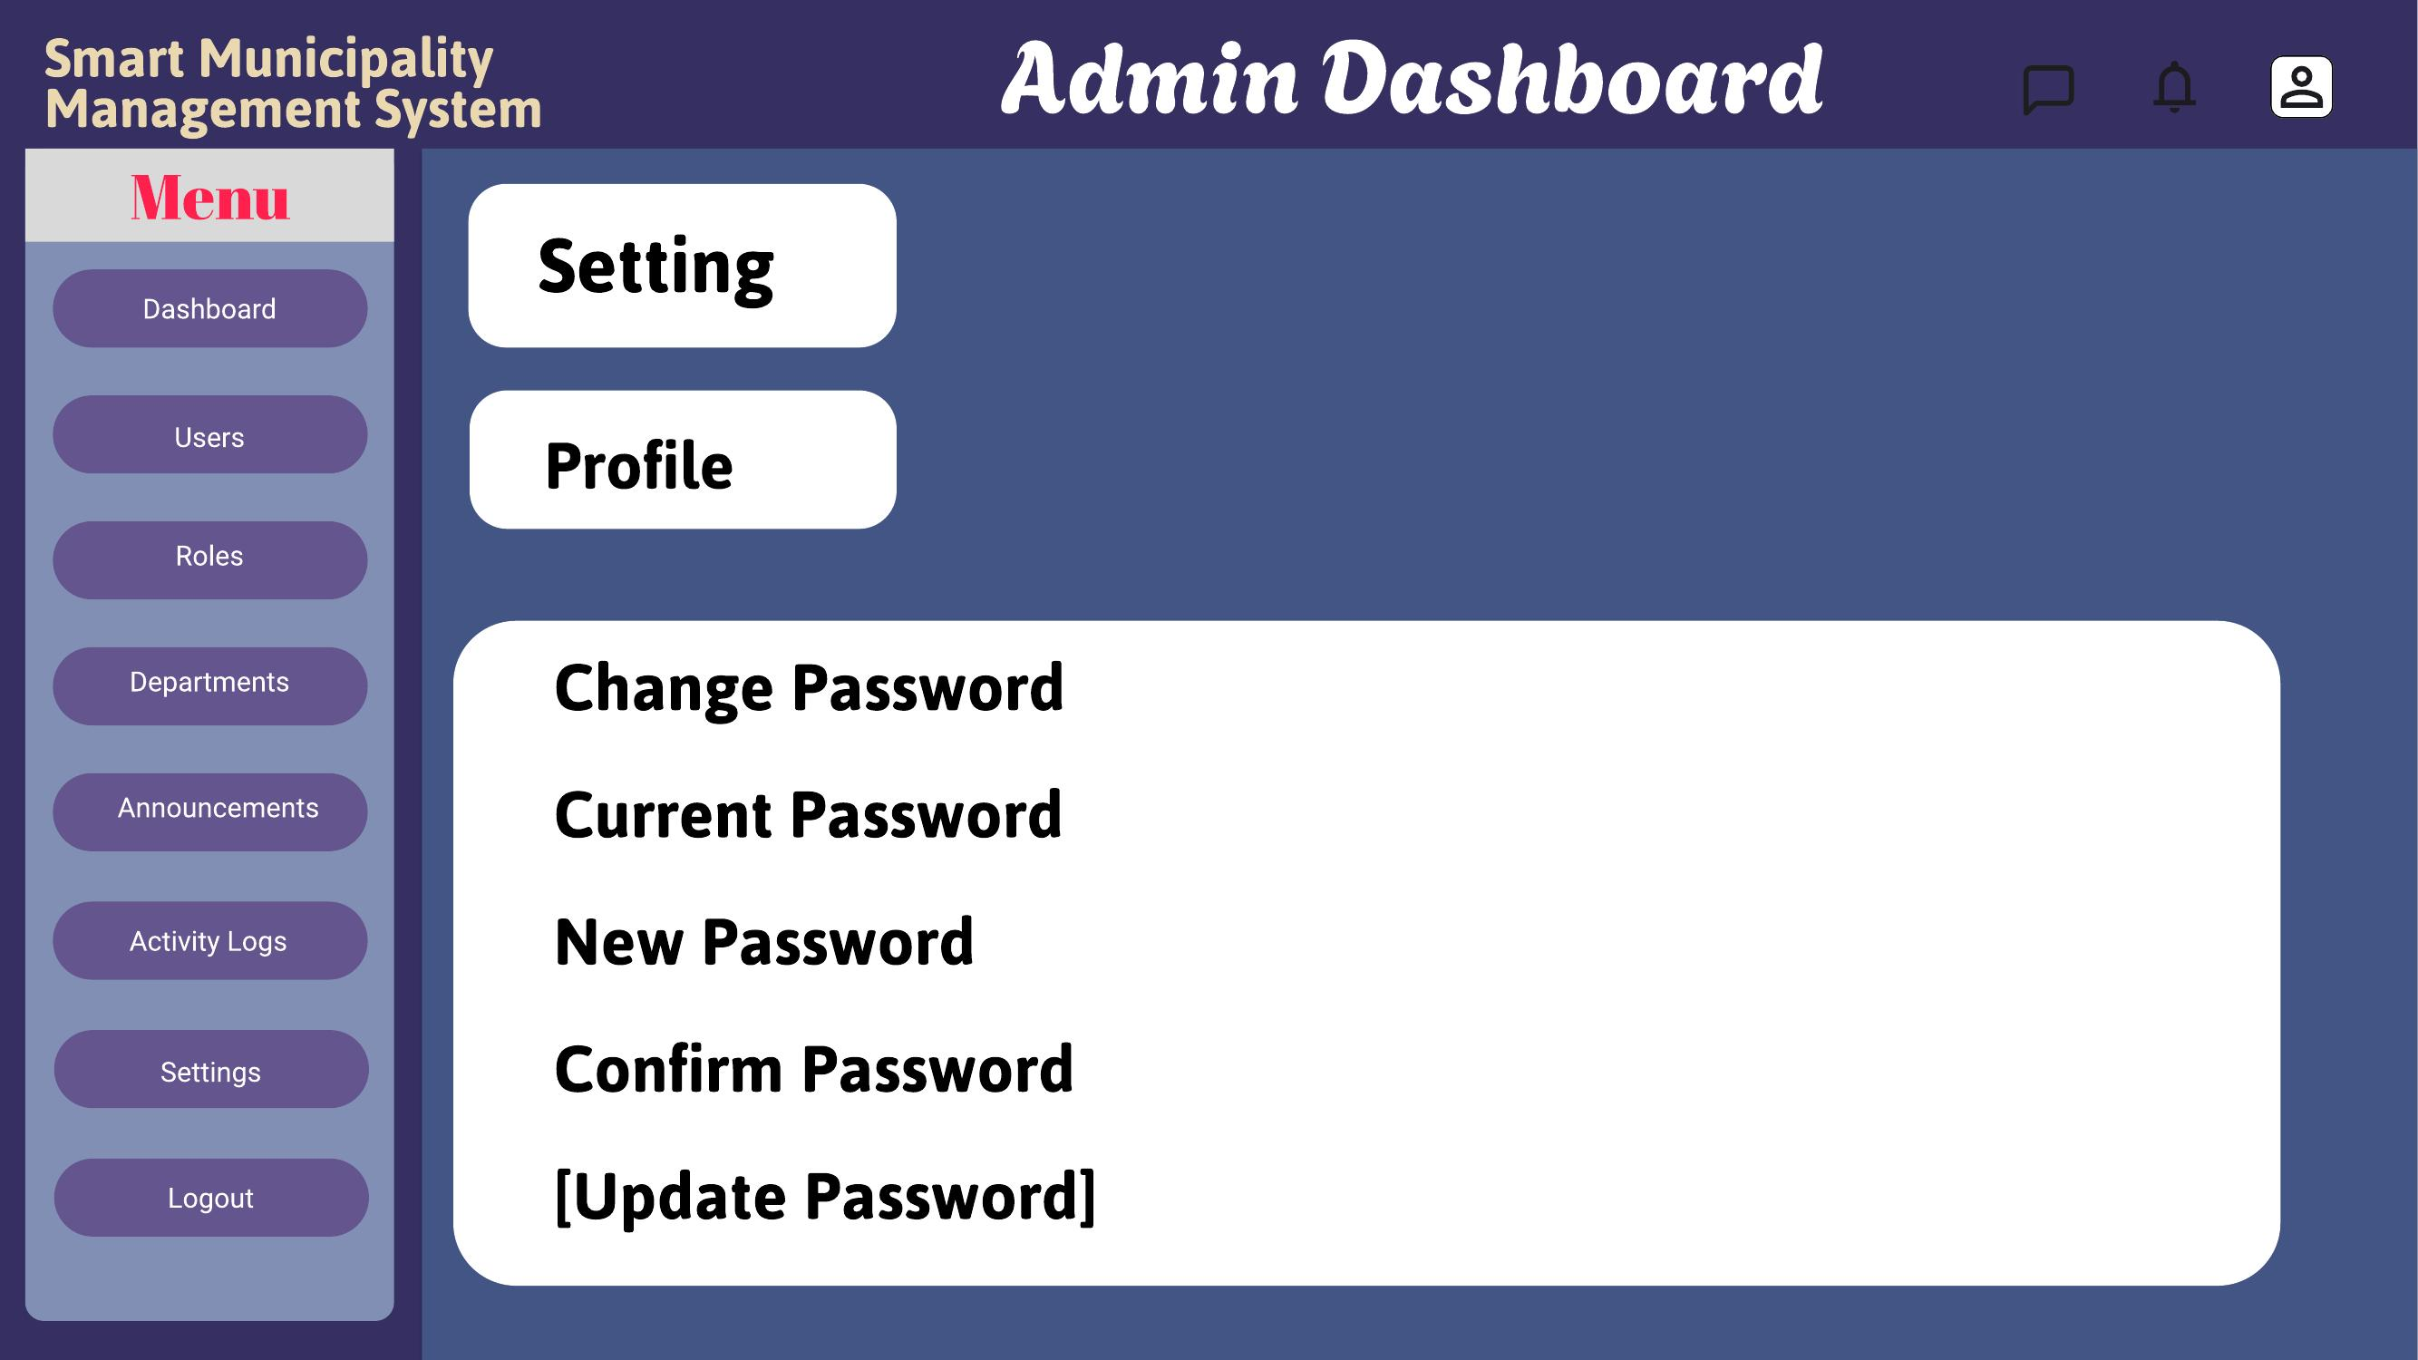
Figure 4.7: Account settings

5. Git Workflow — My Contribution
As the group member responsible for the Portal Administrator module, my contribution to the shared repository consists of the files, wireframes, and documentation related to the Admin dashboard, user management, role management, department management, announcements, and activity log screens shown in Section 4. These were added to the repository under my own commits, following the group's shared workflow of feature branches, descriptive commit messages tied to Trello cards, and merges into the main branch after review.
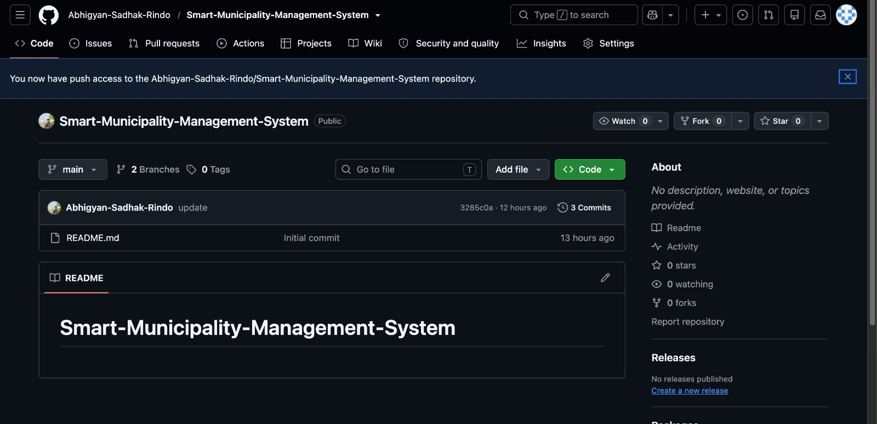
Figure 5.1: Shared GitHub repository for the Smart Municipality Management System

6. Conclusion
As the Portal Administrator for the Smart Municipality Service Portal, my responsibility centered on the system's administrative backbone: managing user accounts and roles, configuring departments, publishing announcements, and monitoring overall system activity. These features ensure that the platform remains secure, organized, and accountable as Citizens, Officers, and Supervisors interact with it. Through this module, requirements FR_20 to FR_25 were translated into a working set of wireframes covering the full administrative workflow, from the dashboard overview to detailed user, role, and department management screens, with a complete activity log satisfying the system's audit-trail requirement (FR_28). This module forms the control layer that keeps the rest of the Smart Municipality Service Portal functioning securely and transparently.

