**Front-End UI/UX Mini Project**

**Project Report**

**1. Title Page**

* **Project Title:** Product Launch Website
* **Submitted By:**
  + Team Members – Manshvi Jain | Abhigyan Neog | Sarthak Sharma
  + Roll Number – 2460404 | 2460304 | 2460487
  + College-E-mail id-[manshvi.jain@btech.christuniversity.in](mailto:manshvi.jain@btech.christuniversity.in)
  + [abhigyan.neog@btech.christuniversity.in](mailto:abhigyan.neog@btech.christuniversity.in)
  + [sarthak.sharma@btech.christuniversity.in](mailto:sarthak.sharma@btech.christuniversity.in)
* **Course:** UI/UX Design Fundamentals
* **Instructor Name:** Narendra Sir
* **Institution:** Christ University
* **Date of Submission:** 13/08/2025

**2. Abstract**

This project involves designing and developing a responsive landing page for a gadget company, "GadgetPro," using only HTML and CSS. The primary goal is to create a clean, modern user interface that effectively showcases the product's features, benefits, and pricing. The project uses structured HTML and CSS for styling and responsiveness, but does not include any interactive JavaScript or backend functionality. The final outcome is a visually engaging and accessible front-end page that can be easily viewed across various devices.

**3. Objectives**

* Design a user-friendly interface using modern UI principles
* Develop a fully responsive layout using only HTML and CSS
* Implement structured HTML5 semantic elements
* Apply CSS styling for branding, layout, and responsive behavior
* Ensure accessibility and readability across devices

**4. Scope of the Project**

* Focused on front-end design only
* No JavaScript or server-side integration
* Intended for desktop, tablet, and mobile viewports
* Used only open-source tools and pure code (no libraries)

**5. Tools & Technologies Used**

| Tool/Technology | Purpose |
| --- | --- |
| HTML5 | Markup and content structure |
| CSS3 | Styling and layout management |
| VS Code | Code editor |
| Chrome DevTools | Testing and debugging |

**6. HTML Structure Overview**

* A header section with the "GadgetPro" logo.
* A hero section with a main image, a headline ("Introducing GadgetPro"), a sub-headline, and a "Buy Now" button.
* A "Features" section with three distinct feature cards (Smart Design, High Performance, Long Battery Life).
* A "What Our Users Say" section displaying customer testimonials.
* A "Choose Your Plan" section with two pricing cards ("Basic" and "Pro").
* A final call-to-action section ("Be the First to Experience the Future").
* A footer with copyright information and contact details.

**7. CSS Styling Strategy**

* **Layout:** Use of a grid or flexbox for the feature cards, testimonials, and pricing plans.
* **Typography:** Clear, modern sans-serif fonts for headings and body text.
* **Color Palette:** A simple, limited color palette with a prominent red for buttons and accents, and a dark green for the header.
* **Responsiveness:** The layout likely adapts to different screen sizes, although the video doesn't explicitly show this.

**8. Key Features**

| Feature | Description |
| --- | --- |
| Responsive Design | Adapts seamlessly to all screen sizes |
| Smooth Navigation | Fixed top nav with anchor links |
| Project Cards | Flex-based layout with hover effects |
| Contact Form (non-functional) | Placeholder layout for inputs and button |
| Accessible Fonts & Colors | High contrast and readable typography |

**9. Challenges Faced & Solutions**

| Challenge | Solution |
| --- | --- |
| Overlapping elements on small screens | Used media queries to stack elements |
| Difficulty aligning items using float | Shifted to Flexbox and Grid |
| Typography scaling issue | Used relative units (em/rem) instead of px |

**10. Outcome**

* Achieved a clean, consistent, and visually engaging front-end layout
* All key components function as intended using just HTML and CSS
* Learned about layout responsiveness and UI hierarchy in depth

**11. Future Enhancements**

* Add JavaScript for interactivity (form validation, dynamic content)
* Integrate animations or transitions
* Backend integration for form submission
* Theme toggler (light/dark mode)

**12.** **Sample Code**

<!DOCTYPE html>

<html lang="en">

<head>

<meta charset="UTF-8" />

<meta name="viewport" content="width=device-width, initial-scale=1" />

<title>Product Launch</title>

<link rel="stylesheet" href="product.css" />

<link rel="preconnect" href="https://fonts.googleapis.com" />

<link rel="preconnect" href="https://fonts.gstatic.com" crossorigin />

<link href=<https://fonts.googleapis.com/css2?family=Poppins:wght@400;600;700&display=swap>

rel="stylesheet" />

<style>

/* Brand Name at top */

.brand-name {

font-family: 'Poppins', sans-serif;

font-weight: 700;

font-size: 3rem;

text-align: center;

color: #ff4b2b;

margin: 20px 0;

text-shadow: 0 0 10px #ff4b2b;

}

/* Slideshow container */

.slideshow-container {

max-width: 100%;

position: relative;

overflow: hidden;

margin-bottom: 40px;

text-align: center; /* center images */

}

.slide {

display: none;

max-width: 100%;

height: auto;

object-fit: contain; /* show full image */

border-radius: 10px;

box-shadow: 0 0 25px rgba(255, 75, 43, 0.6);

transition: opacity 1s ease-in-out;

margin: 0 auto; /* center horizontally */

}

.slide.active {

display: block;

animation: fadeIn 1s ease forwards;}

@keyframes fadeIn {

from { opacity: 0; }

to { opacity: 1; }

}

**13. Screenshots of Final Output**

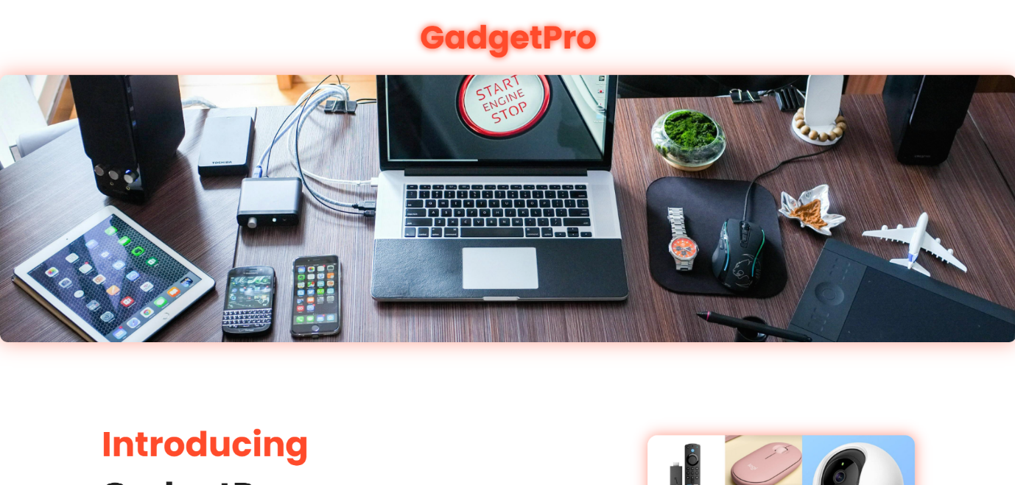

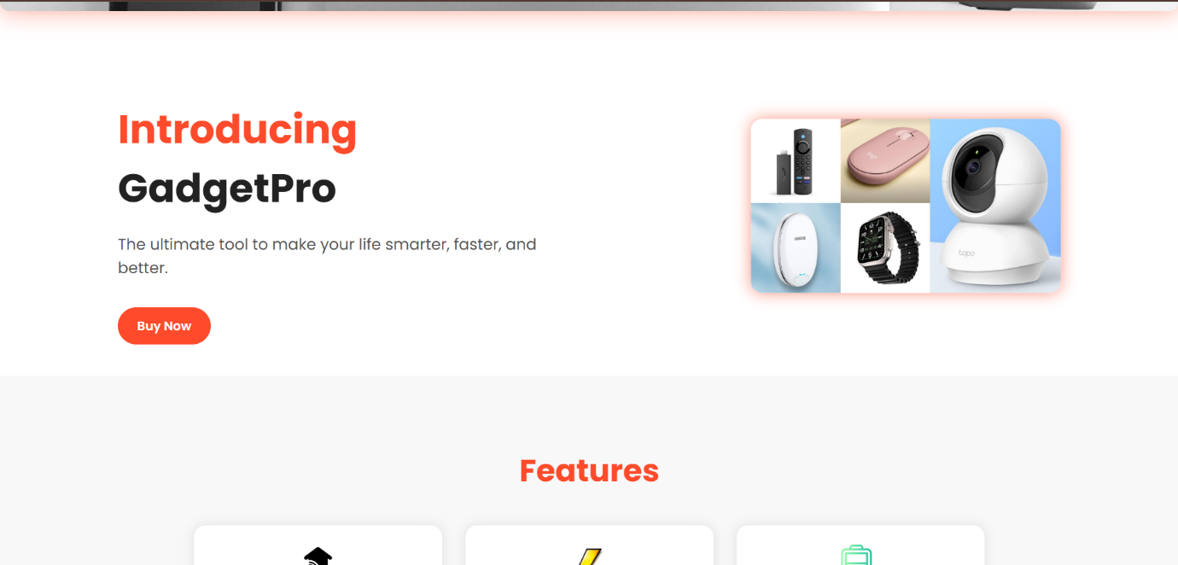

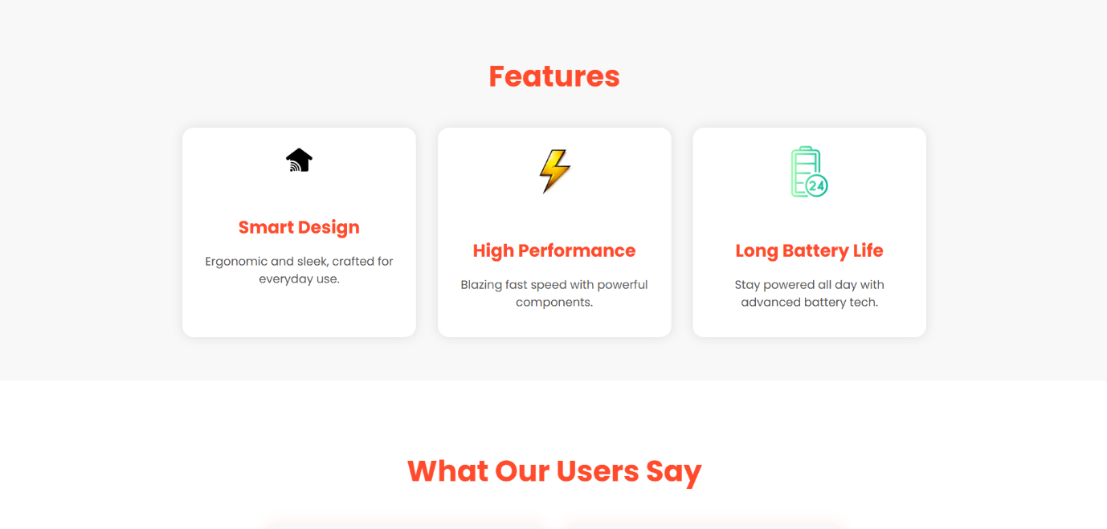

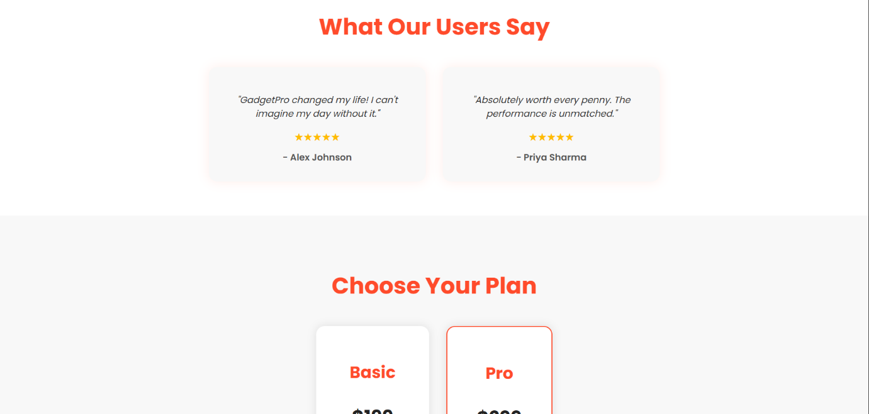

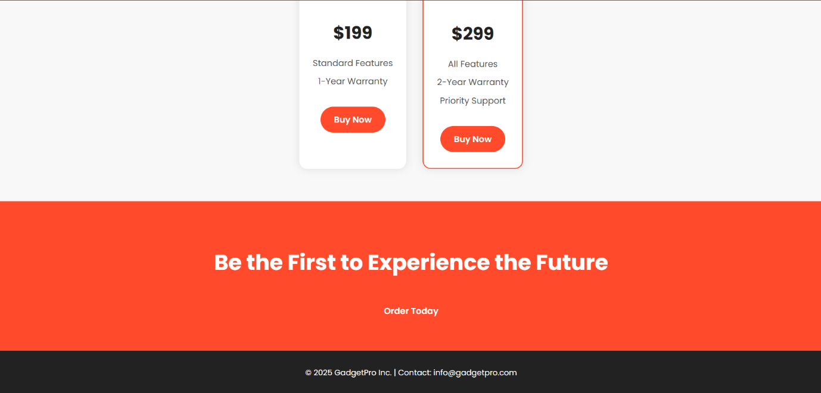

**14. Conclusion**

This mini-project successfully demonstrates the creation of a responsive, visually appealing landing page for "GadgetPro" using only front-end technologies (HTML and CSS). The project effectively showcases product features and pricing in a clean, modern interface, fulfilling the objectives of user-centric design without any backend integration.

**15. References**

* L&T LMS: [https://learn.lntedutech.com/Landing/MyCourse](https://www.google.com/search?q=https://learn.lntedutech.com/Landing/MyCourse)

<https://www.geeksforgeeks.org/html/html-tutorial>