**Front-End UI/UX Mini Project**

**Project Report**

**1. Title Page**

* **Project Title:** "The Midnight Signal" Movie Landing Page
* **Submitted By:**
  + Team Members – Manshvi Jain | Abhigyan Neog | Sarthak Sharma
  + Roll Number – 2460404 | 2460304 | 2460487
  + College-E-mail id-[manshvi.jain@btech.christuniversity.in](mailto:manshvi.jain@btech.christuniversity.in)
  + [abhigyan.neog@btech.christuniversity.in](mailto:abhigyan.neog@btech.christuniversity.in)
  + [sarthak.sharma@btech.christuniversity.in](mailto:sarthak.sharma@btech.christuniversity.in)
* **Course:** UI/UX Design Fundamentals
* **Instructor Name:** Narendra Sir
* **Institution:** Christ University
* **Date of Submission:** 13/08/2025

**2. Abstract**

This project is a front-end landing page for the movie "The Midnight Signal," using a dark-themed design to convey its psychological thriller genre. The page provides a synopsis, cast details, user reviews, and streaming platform information, all created with static HTML and CSS to promote the film effectively.

**3. Objectives**

* Create a dedicated landing page for a movie.
* Provide a compelling synopsis and movie details.
* Showcase the main cast members.
* Display user reviews and ratings.
* List available streaming platforms.
* Use a dark-themed design to match the movie's genre.

**4. Scope of the Project**

• **Focused on:** Front-end design only, a promotional landing page for a movie.

• **Boundaries:** All content (synopsis, cast, reviews, streaming links) is static. The interactive elements, such as the "Where to watch" buttons, are for visual representation only and have no backend functionality. The video carousel is also a static display

**5. Tools & Technologies Used**

| Tool/Technology | Purpose |
| --- | --- |
| HTML5 | Markup and content structure |
| CSS3 | Styling and layout management |
| VS Code | Code editor |
| Chrome DevTools | Testing and debugging |

**6. HTML Structure Overview**

* A header with the website title "Midnight Signal."
* A main section with a large hero image, the movie title, and a brief description.
* A "Synopsis" section with a detailed plot summary.
* A "Cast" section with cards for each main actor (A.K. Collins, Maya Rios, Jon Park, Rina Gupta).
* A "Reviews" section with two user testimonials and star ratings.
* A "Where to Watch" section with clickable logos for streaming services (Netflix, Prime Video, MUBI).
* A footer with copyright information.

**7. CSS Styling Strategy**

* **Color Palette:** A dark background with light text to match the thriller/psychological theme. Accent colors are used sparingly.
* **Typography:** Clear and readable sans-serif fonts are used throughout.
* **Layout:** Grid or flexbox is used to align the cast members and reviews.
* **UI Elements:** Use of cards with shadows and subtle hovers to make the content stand out against the dark background.

**8. Key Features**

| Feature | Description |
| --- | --- |
| Responsive Design | Adapts seamlessly to all screen sizes |
| Smooth Navigation | Fixed top nav with anchor links |
| Project Cards | Flex-based layout with hover effects |
| Contact Form (non-functional) | Placeholder layout for inputs and button |
| Accessible Fonts & Colors | High contrast and readable typography |

**9. Challenges Faced & Solutions**

| Challenge | Solution |
| --- | --- |
| Overlapping elements on small screens | Used media queries to stack elements |
| Difficulty aligning items using float | Shifted to Flexbox and Grid |
| Typography scaling issue | Used relative units (em/rem) instead of px |

**10. Outcome**

* A well-structured and thematic landing page for a movie.
* All key information is presented clearly and logically.
* The design successfully conveys the mood and genre of the film.

**11. Future Enhancements**

* Implement a dynamic carousel using JavaScript to allow users to scroll through movie posters.
* Add a play button for a movie trailer.
* Make the "Where to watch" logos functional links.
* Create a backend to dynamically load movie data, reviews, and cast information.
* Add a rating submission feature for users.

**12. Sample Code**

<!DOCTYPE html>

<html lang="en">

<head>

<meta charset="utf-8" />

<meta name="viewport" content="width=device-width, initial-scale=1" />

<title>Movie — The Midnight Signal</title>

<link rel="stylesheet" href="movie.css">

<link href="https://fonts.googleapis.com/css2?family=Cinzel:wght@400;700&family=Montserrat:ital,wght@0,400;0,600;1,300&display=swap" rel="stylesheet">

</head>

<body>

<header class="site-header">

<div class="header-inner">

<h1 class="movie-title">The Midnight Signal</h1>

<div class="meta">Psychological Thriller • 2024</div>

</div>

</header>

<main>

<section class="section">

<div style="text-align: center;">

<h1>The Midnight Signal</h1>

<p>

Welcome to the official page of **The Midnight Signal**, a thrilling cinematic journey that

blends suspense, mystery, and heart-pounding drama.

</p>

<p>

Follow the story of unexpected heroes navigating the chaos of a world where every decision

could mean the difference between survival and disaster.

</p>

**13. Screenshots of Final Output**

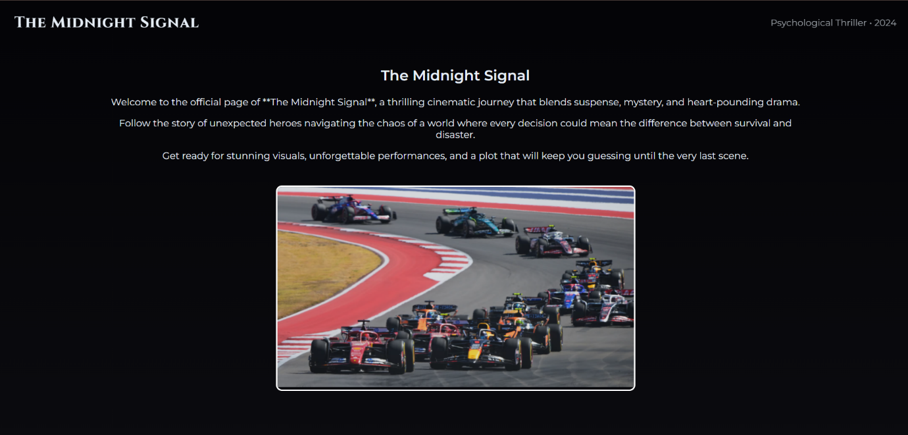

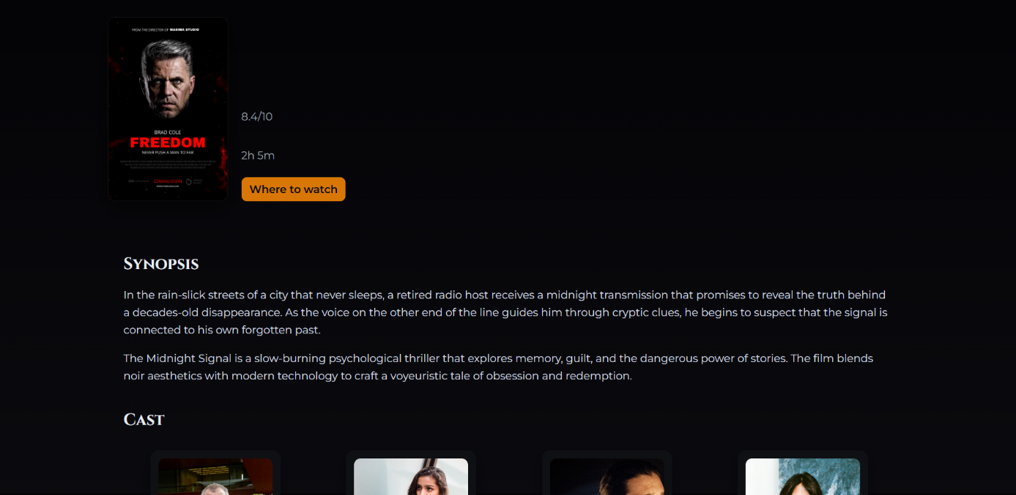

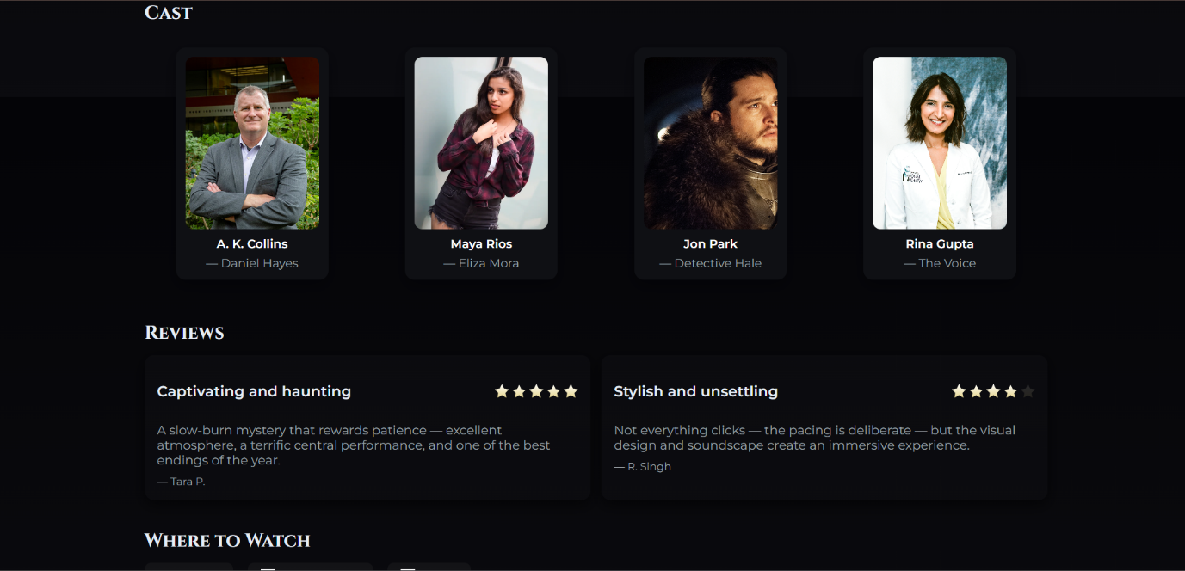

**14. Conclusion**

This mini-project successfully demonstrates the creation of a promotional landing page for "The Midnight Signal." It effectively uses a dark-themed design to convey the movie's genre, while presenting all critical information in a clean and organized manner using front-end technologies (HTML and CSS).

**15. References**

* L&T LMS: [https://learn.lntedutech.com/Landing/MyCourse](https://www.google.com/search?q=https://learn.lntedutech.com/Landing/MyCourse)