PCA on Arrests data

PCA on the USArrests data set, which is part of the base R package. The rows of the data set contain the 50 states, in alphabetical order.

states =row.names(USArrests )  
states

## [1] "Alabama" "Alaska" "Arizona" "Arkansas"   
## [5] "California" "Colorado" "Connecticut" "Delaware"   
## [9] "Florida" "Georgia" "Hawaii" "Idaho"   
## [13] "Illinois" "Indiana" "Iowa" "Kansas"   
## [17] "Kentucky" "Louisiana" "Maine" "Maryland"   
## [21] "Massachusetts" "Michigan" "Minnesota" "Mississippi"   
## [25] "Missouri" "Montana" "Nebraska" "Nevada"   
## [29] "New Hampshire" "New Jersey" "New Mexico" "New York"   
## [33] "North Carolina" "North Dakota" "Ohio" "Oklahoma"   
## [37] "Oregon" "Pennsylvania" "Rhode Island" "South Carolina"  
## [41] "South Dakota" "Tennessee" "Texas" "Utah"   
## [45] "Vermont" "Virginia" "Washington" "West Virginia"   
## [49] "Wisconsin" "Wyoming"

names(USArrests)

## [1] "Murder" "Assault" "UrbanPop" "Rape"

The columns of the data set contain the four variables

apply(USArrests , 2, mean)

## Murder Assault UrbanPop Rape   
## 7.788 170.760 65.540 21.232

Means are different for each of the columns

apply(USArrests , 2, var)

## Murder Assault UrbanPop Rape   
## 18.97047 6945.16571 209.51878 87.72916

Different variances across each of the columns. Hence the need to scale the variables. Now calculating the PCA using scale = TRUE

pr.out =prcomp (USArrests , scale =TRUE)

By default, the prcomp() function centers the variables to have mean zero. By using the option scale=TRUE, we scale the variables to have standard deviation one.

names(pr.out)

## [1] "sdev" "rotation" "center" "scale" "x"

The center and scale components correspond to the means and standard deviations of the variables that were used for scaling prior to implementing PCA.

pr.out$center

## Murder Assault UrbanPop Rape   
## 7.788 170.760 65.540 21.232

pr.out$scale

## Murder Assault UrbanPop Rape   
## 4.355510 83.337661 14.474763 9.366385

The rotation matrix provides the principal component loadings; each column of pr.out$rotation contains the corresponding principal component loading vector.

pr.out$rotation

## PC1 PC2 PC3 PC4  
## Murder -0.5358995 0.4181809 -0.3412327 0.64922780  
## Assault -0.5831836 0.1879856 -0.2681484 -0.74340748  
## UrbanPop -0.2781909 -0.8728062 -0.3780158 0.13387773  
## Rape -0.5434321 -0.1673186 0.8177779 0.08902432

We see that there are four distinct principal components. This is to be expected because there are in general min(n ??? 1, p) informative principal components in a data set with n observations and p variables. We do not need to explicitly multiply the data by the principal component loading vectors in order to obtain the principal component score vectors. Rather the 50 Ã4 matrix x has as its columns the principal component score vectors. That is, the kth column is the kth principal component score vector.

dim(pr.out$x )

## [1] 50 4

Plotting the first two principal components as follows:-

biplot (pr.out , scale =0)

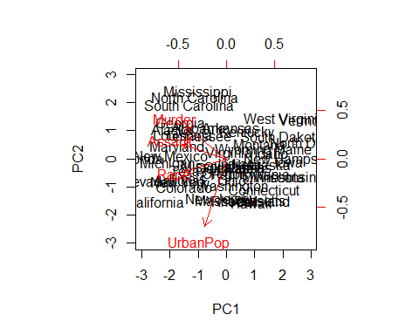 Changing the sign of the components

pr.out$rotation=-pr.out$rotation  
pr.out$x=-pr.out$x  
biplot (pr.out , scale =0,expand = 1)

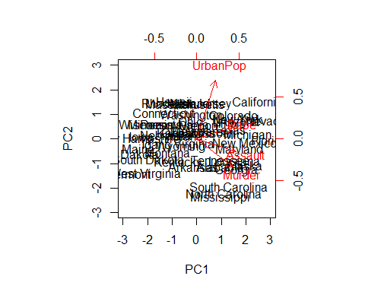 Accessing the standard deviations

pr.out$sdev

## [1] 1.5748783 0.9948694 0.5971291 0.4164494

Accessing the variances

pr.var =pr.out$sdev ^2  
pr.var

## [1] 2.4802416 0.9897652 0.3565632 0.1734301

To compute the proportion of variance explained by each principal component, we simply divide the variance explained by each principal component by the total variance explained by all four principal components:

pve=pr.var/sum(pr.var )  
pve

## [1] 0.62006039 0.24744129 0.08914080 0.04335752

We can plot the PVE explained by each component, as well as the cumulative PVE, as follows:

plot(pve , xlab=" Principal Component ", ylab=" Proportion of  
Variance Explained ", ylim=c(0,1) ,type="b")

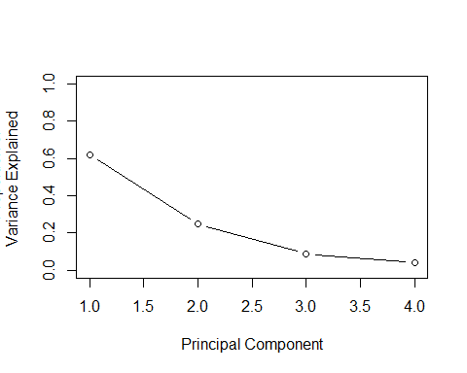

plot(cumsum (pve ), xlab=" Principal Component ", ylab ="  
Cumulative Proportion of Variance Explained ", ylim=c(0,1) ,  
type="b")

