


o
Epic(s):
Interface - Realtor / Hubbel - Meter Read and Usage Details [793214]

Included RICEF(s):
- INT_CX_HER_139 - Interface - Realtor / Hubbel - Meter Read and Usage Details
MEC Customer
Interface Functional Design Document
Hubbell Portal
Version v1.1
A version of the FD should be saved in both the Draft and Approved folders listed below. The version in the Draft folder should contain track changes for all reviews. The Approved version should be clean with all comments resolved and track changes accepted.

- Draft Deliverables Folder: 01 - Release Management -> 03 - Deliverable Mgmt -> 03 - DBV Draft
- Approved Deliverables Folder: 01 - Release Management -> 03 - Deliverable Mgmt -> 04 - DBV Approved

Functional Design Checklist | Designer | Reviewer
OVERALL
Are the details displayed on the title page of this document correct and accurate? | IA | YM
Have all tracked changes been accepted in the Final Approved FD? | IA | YM
DELIVERABLE SUMMARY
Have all the correct Document Owners, Document Reviewers, and Document Approvers been listed and dates marked? | IA | YM
Has the Document Version Control section been continuously updated? | IA | YM
Have all related documents been listed in the Related Documentation section of this document, inclusive of dependencies? | IA | YM
GENERAL INFORMATION
Does the functional overview provide a description of the design for this functionality – including impacts, benefits, etc.? | IA | YM
Are the High-Level Business requirements for this FD listed? | IA | YM
Is a functional process flow provided, with documented functional steps? | IA | YM
Have all the assumptions been documented properly? | IA | YM
Are all open items closed in the final, or logged in the appendix? | IA | YM
Are all included RICEFs for the FD listed in the Object Mapping section? | IA | YM
Design
Have all inputs and outputs been identified and confirmed to best of your knowledge? | IA | YM
Have the details of the extension or integration been adequately defined? | IA | YM
Have all the configurations supporting extensions been identified (e.g. Algorithm, User Interface, characteristics type, etc.) | IA | YM
Does the functional process flow show all areas of impact? | IA | YM
Has a representative from ancillary reviewed this design for feasibility? | IA | YMm
Has ancillary provided written confirmation that the integration mapping in this design meets their requirements? | IA | YM
Have the high-level Test Scenarios been identified? | IA | YM
Have Batch requirements been documented? | n/a | n/a
If necessary, has security been considered (e.g. target group of users who should be given access to the extension etc.)? | IA | YM
Have conversion impacts been captured? | IA | YM
Exceptions and Error Handling
Have the exceptions and likely errors been defined and listed? | IA | YM
Does the document describe what steps (if any) need to be taken after an exception has been raised? | IA | YM
Flexibility – From a business perspective
Is design flexible to enable new functionality to be added in the future? | IA | YM
APPENDIX
Have all the Design Decisions been clearly identified? | IA | YM

1 Deliverable Summary 4
1.1 Deliverable Overview 4
1.2 Deliverable Approver [Required] 4
1.3 Deliverable Reviewer [Required] 4
1.4 Revision History 4
1.5 Related Documents 4
2 General Information 5
2.1 Responsible Organizations 5
2.2 Functional Overview [Required] 5
2.3 High-Level Business requirements [Required] 5
2.4 Functional Process flow [Required] 6
2.4.1 Hubbel Portal > Paperless Billing Manager 6
2.5 Assumptions 9
2.6 Open Items 9
2.7 Glossary / Acronyms 10
2.8 Object Mapping (Epic, ADO, JIRA, RICEF IDs) [Required] 10
3 Functional Configuration 11
3.1 Configuration Entity 11
4 Integrations 14
4.1 Overview – INT_CX_HER_139 [Required] 14
4.2 Solution Approach/Logic [Required] 14
4.3 Integration Specification [Required] 15
4.4 Integration Mapping and Validation [Required] 17
4.5 API Details 18
4.6 Non-C2M Application Impacts 18
4.7 Security Considerations 18
4.8 Error Handling [Required] 18
5 Considerations for Techinical Design 18
6 Considerations for Ancillary/Vendor Applications 19
7 Conversion Considerations 19
8 Batch considerations 20
9 Test Cases 20
9.1 Test Cases [Required] 20
10 Appendix 22
10.1 Decisions / RAIDS 22
10.2 Exceptions / Approval 22

Deliverable Summary

Deliverable Overview
Project | Customer MEC Functional Design - Hubbell Portal
Deliverable Owner | Ma. Ivy Aragon, Customer Experience
Purpose of this Deliverable | The objective of this document is to provide BHE with a Functional Specification as part of BHE Business Transformation Program for a given extension. It defines the inputs and outputs as well as all rules required to implement the C2M to Hubbell Portal - Account information to Hubbell Functionality.

Deliverable Approver [Required]
Approver | Role | Date | Version
Janice Sixta | Customer Self Service Functional Lead | 7/6/25 | 1.0
Nora Varela-Binion | CX Pillar Lead/Representative | 8/10/2025 | 1.0
Abigail Shorter | Customer Self Service Functional Lead | 08/06/25 | 1.0

Deliverable Reviewer [Required]
Reviewer | Role | Date
Patrick Rush | Ancillary Lead | 8/2/25
Daniel Brewer | Customer Self Service Technical Lead | 7/27/25
Kelly Orcutt | MEC Senior Customer Operations Analyst + Customer Experience Team Member | 7/28/25 – initial comments  8/6/25 -review complete
Micheal Bergthold | Business Systems Analyst 3 | 8/6/25
Melinda Romelus | Peer Reviewer | 7/27/25
Yeshwanth Maripi | Peer Reviewer | 11/25/25

Revision History
Version | Date | Name | Summary of Changes
0.1 | 21-July-25 | Ma. Ivy S. Aragon | Initial Version. ADO821664
0.2 | 23-Feb-26 | Ma. Ivy S. Aragon | Resolved Open Item 3
1.1 | 09-Mar-26 | Sanjivrao Katakam | Added details related to C2M Billing File (Mapping & Batch)
1.2 | 30-Apr-26 | Ma. Ivy S. Aragon | Updates done for Task1168036. Paperless Billing Design updates.
1.3 | 21-May-26 | Ma. Ivy S. Aragon | Updated Open Item 4 with Resolution.

Related Documents
Add all relevant documents impacting this design. If this design extends the global or PAC solution to meet MEC requirements, the corresponding FD should be linked in the related documents table. Additionally, ancillary FDs that support this design should be referenced and linked below.
Doc Name | Doc Description | Doc Link
Hubbell Portal | Process Flow – Visio | Hubbell Portal.vsdx
BHE_Customer_RICEF_Tracker | This the tracker of all the RICEF used to map the requirements | BHE_Customer_RICEF_Tracker.xlsx
My Account - Paperless Billing | This document specifies the Paperless Billing program for My Account | FD_INT_CX_MCC_035_MyAccount_Paperless_Billing_v1.0.docx
My Account - Account Creation | This document specifies the My Account – Account Creation process | FD_RICEF2461_CX_EXT_MYACCOUNT_ACCOUNT_CREATION_v1.0.docx
API Specs | This document consists of API specifications | API Specs.docx
API-C2M Mapping | This document has the field mappings of API – C2M fields | API - C2M Mapping.xlsx
Conversion | Conversion validation related document. | Hubbell Portal Conversion Validations.docx
Sample CSV File | This file provides the details of the fields which should be retrieved from C2M for Hubbell Realty Portal. | hubbellrealty_20260218.csv

General Information
This section provides a business overview and contains business and functional descriptions.

Responsible Organizations
 | Name
Business Contact | Janice Sixta, Abigail Shorter
Other Contact | Patrick Rush, Daniel Brewer, Kelly Orcutt

Functional Overview [Required]
The objective of this document is to provide BHE with a functional specification of the MidAmerican Energy Company (MEC) – Hubble Portal flow. This document is part of the BHE Process Transformation Project for Customer Operation implementing Oracle Customer to Meter (C2M).

High-Level Business requirements [Required]
RTM # | Requirement Description | L5 Process Flow
CX_DIG_184 | Ability to send bills for an account(s) to the Hubbell Realty portal to view. | Handle Enquiries & Requests - Process Customer Requests
CX_DIG_185 | Ability to remove an account that is tied to the Hubbell Paperless Billing process and send back to C2M | Handle Enquiries & Requests - Process Customer Requests
CX_DIG_186 | Ability to enroll an account in paperless billing from the Hubbell Realty Portal to a specified email and send back to C2M | Handle Enquiries & Requests - Process Customer Requests
CX_DIG_187 | Ability to determine an account is part of the Hubbell Billing Process (FTP) when it is added to the Hubbell Realty Portal web  site based on data from C2M | Handle Enquiries & Requests - Process Customer Requests
CX_DIG_188 | Ability to view the paperless billing enrollment status for each account in the Hubbell Realty Portal | Handle Enquiries & Requests - Process Customer Requests

Functional Process flow [Required]
Insert the Functional Diagram providing details of the business process flow. If possible, include data architecture and integration architecture where applicable. Should show the impacts of the new functional process.

Hubbel Portal > Paperless Billing Manager
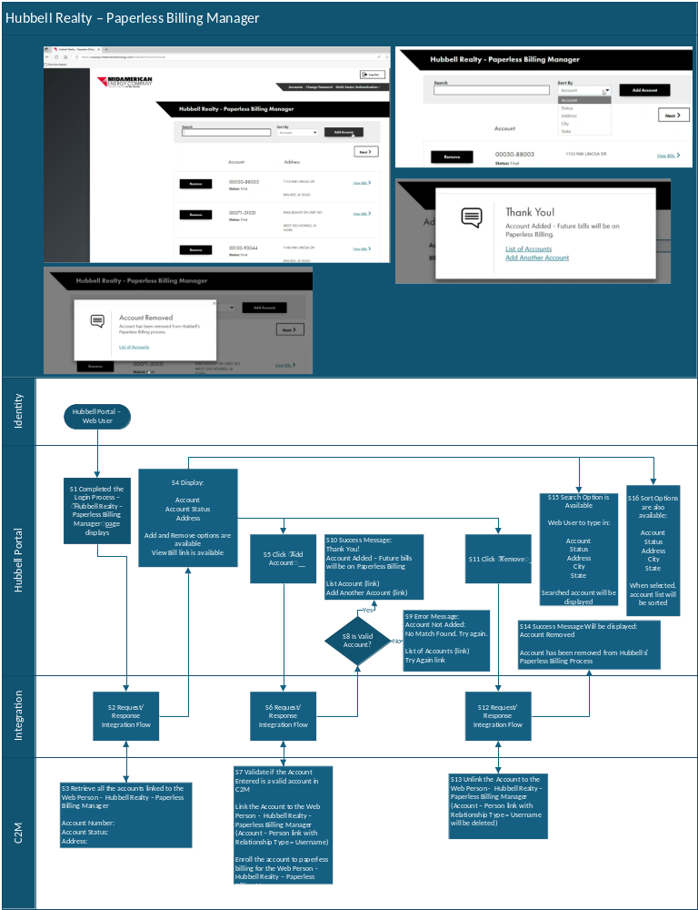

2.4.1.1 Functional Steps [Required]
Step 1 | Completed the Login Process – “Hubbell Realty – Paperless Billing Manager” page displays
Step 2 | Integration Layer to Process Request and Response  API: getAccountsbyWebuser
Step 3 | C2M To Retrieve information below using the Web User Name  Get the Hubbell Person with the Name webPersonName from the request  Get the Hubbell Mailing Premise with the Premise Address webMailingAddress from the request  Find all the Account linked to the Hubbell Person (relationship type MAWU – Username)  Then get below details and add on the response:  Account Number:  Account Status:<derived account status>  Address: <service address>
Step 4 | Display:  Account  Account Status  Address  Add and Remove options are available  View Bill link is available
Step 5 | Click “Add Account” and populate Account then Click “Add”
Step 6 | Integration Layer to Process Request and Response  API: getAccountDashboard  API: getAccountsbyWebuser  API: addAccount  API: managePaperless
Step 7 | C2M to Validate Account  - Check if a valid C2M Account  - Check if account has Mailing Address = Hubbell Mailing Address (also from the request  - Check if account is a service account (Open Item 1 – Determination of Master Account is still in progress with Summary Billing Design c/o Billing Team)  Link the Account to the Web Person - Hubbell Realty – Paperless Billing Manager (Account – Person link with Relationship Type = Username)  Link the account and if there are error setting to paperless return error codes  Enroll the account to paperless billing for the Web Person - Hubbell Realty – Paperless Billing Manager.  //Start Add Task1168036 04/30  And set Main Person’s Bill Route to Do Not Extract.  //End Add Task1168036 04/30
Step 8.1 | Hubbell Portal to check C2M Response – isValidAccount ?, if value is false go to Step 8.2 else Step 10
Step 8.2 | Error Message:  Account Not Added:  No Match Found. Try again.  List of Accounts (link)  Try Again link
Step 8.3 | Hubbell Portal to check C2M Response -IsHubbellaccount? if value is false go to Step 8.4 else Step 10
Step 8.4 | Error Message:  Account Not a Hubbell Account  List of Accounts (link)  Try Again link
Step 8.5 | Hubbell Portal to check C2M Response – isServiceAcct? if value is false go to Step 8.6 else Step 10
Step 8.6 | Error Message:  Account Not a Service Account  List of Accounts (link)  Try Again link
Step 10 | Success Message:  Thank You!  Account Added – Future bills will be on Paperless Billing  List Account (link)  Add Another Account (link)
Step 11 | Click “Remove”
Step 12 | Integration Layer to Process Request and Response  API: removeAccount
Step 13 | Unlink the Account to the Web Person - Hubbell Realty – Paperless Billing Manager (Account – Person link with Relationship Type = Username will be deleted)  //Start Add Task1168036 04/30  And set Main Person’s Bill Route to Postal.  //End Add Task1168036 04/30
Step 14 | Success Message Will be displayed:  Account Removed  Account has been removed from Hubbell’s Paperless Billing Process
Step 15 | Search Option is Available  Web User to type in:  Account  Status  Address  City  State  Searched account will be displayed
Step 16 | Sort Options are also available:  Account  Status  Address  City  State  When selected, account list will be sorted

Assumptions
Provide assumptions impacting the functional design. Indicate if the assumption is general or specific to a related RICEF.
# | Assumption | Assumption type (General/ RICEF related)  Provide RICEF Id if it is RICEF related
1 | Configuration, personalization, and extensions will be in English only. | General
2 | Functional specification is based upon the captured and agreed BHE business objectives. | General
3 | BHE will have necessary resources and skills to undertake support the delivery of the functional specification. | General
4 | Hubbell Portal User Management (sign-up/create and manage user/password/mfa) will be covered on the Ancillary Document

Open Items
Outline any open items during the development of the functional design. These can also be dependencies on other designs in progress. These are intermediate open items which should be closed or logged before design approval.
# | Item | Description | Status
1 | Master Account | Determination of Master Account is still in progress with Summary Billing Design c/o Billing Team | Resolved – 12/11 – Confirmed with the Sol’Architect Anusha through Email  Determination of the Master Account is identified  “Master Account – Main Person will have Statement Construct in C2M with Active state”  Same open item is closed under Account Creation FDD [Open Item – 8, Master Account Determination]  FD_INT_CX_MCD_019_INTERFACE_MYACCOUNT_TO_C2M_BILL_ROUTE_TYPE_SYNC.docx
2 | Multiple Premises assoc to one Account ID | Need to determine requirement for Hubbell account. Will we require a 1 to 1 model so when account ID added to portal, it is assoc to only one premise. This was recommended by the administrator. Need to confirm w Gretta. How will we ensure this happens. | Resolved (1/6): This will be accommodated. If more than one premise is associated to the account ID, the user will receive a message.  JTS: Just for knowledge, MEC will not proceed with multiple premises associated to one account ID for Day one.
3 | Hubbell Billing | Need to determine which workstream is covering the Hubbell billing functionality. There is a batch process that runs at 2 p.m. daily to get the billing info and create the billing file for the accounts on the portal. There is also a batch process that runs at 10 a.m. daily to retrieve the Hubbel remittance file.  These batch processes are not part of the portal itself but are connected since the accounts have to be on the portal to be included in the daily billing and remittance file process. | Resolved  2/20- Created Task 1133575 – For the Creation of the C2M Equivalent FDD for the Hubbell Billing Extract Process  Approved by Janice Sixta
4 | Identification of Accounts for which the billing extract should be created | Business must confirm the criteria for identifying the Hubbel Accounts for which the batch should create an extract daily.  P.S. Hubbel accounts can also be identified using the premise address - 6900 WESTOWN PKWY WEST DES MOINES IA 50266 | 05/26 Resolved  Criteria for getting the Hubbell Accounts for Billing extract are below:  The batch should only extract data for Hubbell Realty Portal Accounts.  - Check if the account is linked to the Hubbell portal  - Confirm that the mailing address zip code is 50266  Section 3.2.1 Batch Control is updated.

Glossary / Acronyms
Define any acronyms and key terms used in this functional design
Term | Definition
C2M | Customer to Meter
IWS | Inbound Web Service
INT | Interface / Integration
CX | Customer Experience
RICEF | Report, Interface, Conversion, Enhancements / Extensions, Forms

Object Mapping (Epic, ADO, JIRA, RICEF IDs) [Required]
Provide RICEF ID/ADO ID relevant to the objects contained in this design
RICEF | Name | Description | ADO ID
INT_CX_HER_139 | [RICE-I] INT_CX_HER_139 - Interface - Realtor / Hubbel - Meter Read and Usage Details | View meter read and usage details | 793215

Functional Configuration

3.1 Configuration Entity
Complete this section if configurations are required elements of this design. Some examples are Characteristic type, business object, algorithm, schemas, etc.
Configuration Entity # | Description
Inbound Web Service: | Opertations:  - getAccountsbyWebuser  - getAccountDashboard  - addAccount  - RemoveAccount  - managePaperless
API: getAccountsbyWebuser  IWS: CM-MyAccountCreation | Logic:  To Retrieve information below using the Web User Name  Get the Hubbell Person with the Name webPersonName from the request  Find all the Account link to the Hubbell Person (relationship type MAWU – Username)  Then get below details and add on the response:  Account Number:  Account Status: (Account Status – CMGeneralHelper Script to return the status:  - Active  - Account has at least one associated service SA with status of 'Active' or 'Pending Stop'  - Pending Active  - Account has at least one associated service SA with a status of ‘Pending Start’, and does not have any that are ‘Active’ or ‘Pending Stop’  - Final  - Account does not have any service SA’s with status of 'Active', ‘Pending Start’ or 'Pending Stop'  - Account balance is </= $0.00  - Final – Balance Due  - Account does not have any service SA’s with status of 'Active', ‘Pending Start’ or 'Pending Stop'  - Account balance is >/= $0.00  )  Address: (Service Address  address  city  state  premId  )
API: getAccountDashboard  IWS: CM-MyAccountCreation | Logic:  Retrieves the Account Related information:  Account Details  Account Person Details  Service Agreement List  Service Agreement Service Point List  Meters information  Account Programs Information  Account Balance Information  Budget Information  Usage Information"
API: addAccount  IWS: CM-MyAccountCreation | Logic:  Get the Hubbell Person with the Name webPersonName from the request  Get the Hubbell Mailing Premise with the Premise Address webMailingAddress from the request  Validate Account  - Check if a valid C2M Account, set isValidAccount to false if not valid and terminate processing  - Check if account has Mailing Address = Hubbell Mailing Address (also from the request), set isHubbellAccount to false if not and terminate processing.  - Check if account is a service account, set isServiceAccount to false if account not a Service account (or it’s a Master Account) and terminate processing (Open Item 1 – Determination of Master Account is still in progress with Summary Billing Design c/o Billing Team)  Link the Account to the Web Person - Hubbell Realty – Paperless Billing Manager (Account – Person link with Relationship Type = Username)  Link the account and if there are error setting to paperless return error codes  Enroll the account to paperless billing for the Web Person - Hubbell Realty – Paperless Billing Manager
API: removeAccount  IWS: CM-MyAccountCreation | Logic:  Get the Hubbell Person with the Name webPersonName from the request  Unlink the Account to the Web Person - Hubbell Realty – Paperless Billing Manager (Account – Person link with Relationship Type = Username will be deleted)
API: managePaperless  IWS: CM-MyAccountCreation | Logic:  Enroll the account to paperless billing for the Web Person - Hubbell Realty – Paperless Billing Manager

3.1.1 Algorithm Type

Field Name |  | Value
Description
Detailed Description
Algorithm Entity
Program Type
Program Name
Seq | Detailed Description |  | Req

3.1.2 Batch Control

Field Name |  | Value
Description |  | Hubbel Realty Portal Accounts Billing File
Detailed Description |  | This batch will extract a .CSV file comprising of billing related information of Hubbel Realty Portal Accounts
Application Service
Batch Control Type |  | Not timed
Batch Category |  | Process what’s ready
Program Type
Program Name
Seq

C2M CSV File Structure at High Level:
- The csv file has three (3) rows in it. Row-wise data should be in the following format -
Row-1 (header)  (All the titles) | Bill Account, Amount Due, Due Date, Customer Name, Service Address, City/ State, Rate, Service, Bill Date, Usage, KW Billed, Read from date, Read Date, Amount Billed, Account Status
Row-2  (details of 1st service) | Value (Bill Acc), Value (Amt due), Value (Due dt), Value (Service Add), Value (City/ State/ Zipcode), Value (Rate)
Row-3  (details of 2nd service If any) | Value (Rate), Value (Service), Value (Bill dt), Value (Usage), Value (KW billed), Value (Read from dt), Value (Read dt), Value (Amt billed), Value (acct Status)

Note: The batch should only extract data for Hubbell Realty Portal Accounts.

- Check if the account is linked to the Hubbell portal (check if the Account has Hubbel Web User)
- Confirm that the mailing address zip code is 50266

Integrations
Replicate and populate the following sections for all integrations that are included in this design.

Overview – INT_CX_HER_139 [Required]
Use this section to provide an overview and solution details of the Interface. What is the use case and why is this interface required?
This interface to the Hubbell Portal which invokes Inbound Web Services to trigger C2M calls to Retrieve the Hubbell properties list (account ID, status, address) and Add/Remove Hubbell properties.

Solution Approach/Logic [Required]
Provide details required for the development of the interface. Provide any pseudo code examples that would be useful for the development of the interface. Break up by key function. Also use this section to insert any required integration diagrams.
This implementation requires the set-up of the Inbound Web Service (API Calls) from the Hubble Portal.
Trigger of the Flow:
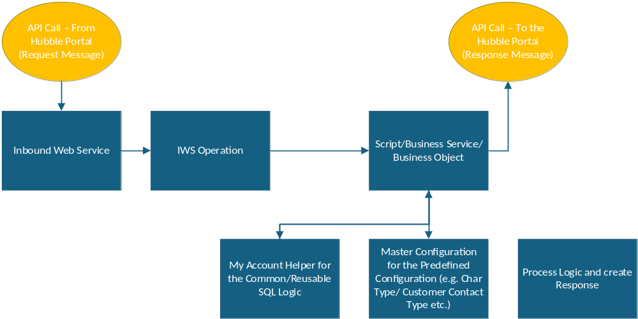

Integration Specification [Required]
Provide the details below to support the creation of the interface. Required items are labeled and must be complete to handoff for TD creation. Complete optional fields if information is known.
Functional Specification | Answer
Type of Interface [Required]  File Based/Web Service | Web Service
Trigger Mechanism [Required]  Real time/Batch | Real time
Entity [Required]  Premise, Service Point, etc | All
Operation [Required]  Insert, Sync, Delete, Update | Get, Insert, Delete
Middleware [Required]  SOA/OIC/MFT | OIC
Direction of Interface [Required]  Outbound Interface If Source is C2M  Inbound Interface If Target is C2M | Inbound Interface
Source System [Required]  System producing the file | Hubble
Target System [Required]  System consuming the file | C2M
Schedule and Frequency [Required]  Provide current state and future state (Daily/Timed/Monthly/Weekly/Hourly) | Web User Triggered - Daily
C2M Batch Control(s)  Define Extract Batch Control(s) For Outbound Interface or Upload Batch Control(s) for Inbound Interface  Capture predecessors/successors for any new/existing batch jobs (C2M and external) that change as part of this design  Specify any C2M batch dependency | n/a
C2M Batch Multi-Threaded | n/a
Number of files  Total and per Affiliate, if applicable | n/a
Source Format  Specify file format/extension e.g. TXT, CSV, XML, etc  Current-state vs future-state if different | n/a
Target Format  Specify file format/extension e.g. TXT, CSV, XML, etc  Current-state vs future-state if different | n/a
File Naming Convention  Example: “cnp<YYYYMMDDHHMMSS><Affiliate Identifier>.csv” where: YYYYMMDDHHMMSS represents the C2M extract date/time | n/a
Can the files be processed independent of each other?  Yes/No  If no, please provide context on file dependencies | n/a
File Encryption and Decryption  Is the file being produced today as encrypted? Or is it getting encrypted anywhere in the process before sending to destination? Need to understand if file encryption is involved, who is doing it, where it is happening etc. | n/a
Source Server and Folder  Provide prod and non-prod:  Server and folder location where Interface will pick up the file(s)  NOTE: If the source system is C2M, then we know the server and folder locations. | n/a
Target Server and Folder  Provide prod and non-prod:  Server and folder location where Interface will drop the file(s) to.  NOTE: If target system is C2M, then we know the server and folder locations. | n/a
Server/Folder Access  Is there access security needed for applicable External or Edge application file servers/folders? | n/a
File Transfer Mechanism  If the edge application is outside of the network, what is the current file transfer mechanism being used - SFTP or Connect-Direct or something else? | n/a
Volume  Average and/or peak file size, and/or number of records in the file | n/a
File splitting  Does the file need to be split (if it is too big) into multiple files? | n/a
File merge  Do we need to merge the files before sending to the destination folder? | n/a
File transformation  Do we need to perform any other file transformation? | n/a
If Source is Edge application or server only:  - Is it creating a Trigger file? If no, can it be done? If can't be done, can we assume that files will be available for pickup at the time of scheduled run?  - Does the file need to be moved/archived to some other folder on their server after it has been copied successfully to C2M file server? If yes, what is that folder location?  - Does the file need to be renamed to something else?  - Combination of both b and c?  - Does the file already have date timestamp in it? If not, is it fine to add it to the file name while moving to some other folder? | n/a

Integration Mapping and Validation [Required]
Interface source and target structure (file/XSD) Source and Destination file format:
File Name | Source File Format | Destination File format
API – C2M Mapping | API - C2M Mapping.xlsx | n/a
Define any validation logic during mapping transformation in this file template: Source_Target_mapping.xlsx

C2M CSV File Structure at High Level:
Row-1 (header)  (All the titles) | Bill Account, Amount Due, Due Date, Customer Name, Service Address, City/ State, Rate, Service, Bill Date, Usage, KW Billed, Read from date, Read Date, Amount Billed, Account Status
Row-2  (details of 1st service) | Value (Bill Acc), Value (Amt due), Value (Due dt), Value (Service Add), Value (City/ State/ Zipcode), Value (Rate)
Row-3  (details of 2nd service) | Value (Rate), Value (Service), Value (Bill dt), Value (Usage), Value (KW billed), Value (Read from dt), Value (Read dt), Value (Amt billed), Value (acct Status)

Note: The batch should only extract data for Hubbell Realty Portal Accounts.

(Hubbell Accounts can be identified using the premise address “6900 WESTOWN PKWY WEST DES MOINES IA 50266”. For Billing extract, account should be linked to the portal site.)

- Check if the account is linked to the Hubbell portal (check if the account has Hubbel Web User)
- Confirm that the mailing address zip code is 50266

The mapping for C2M fields is as below:
Sr. No. | Data Point | C2M Mapping (Table.Field) | Remarks
1 | Bill Account | CI_ACCT. ACCT_ID | Option 2: CI_BILL.ACCT_ID
2 | Amount Due | CI_FT.CUR_AMT | Logic: ARS_DT is not null
3 | Due Date | CI_BILL.DUE_DT
4 | Customer Name | CI_PER_NAME. ENTITY_NAME | Entity Name Type Flag = PRIM
5 | Service Address | CI_PREM.ADDRESS1 | This is Premise address
6 | City/ State/ Zipcode | CI_PREM.CITY  CI_PREM.STATE  Postal Code | Join all CI_PREM.CITY, CI_PREM.STATE, Postal code
7 | Rate | Logic: CI_BSEG_CALC.RS_CD
8 | Service | CI_SA_TYPE.SVC_TYPE_CD  Logic: Identify the service using Service code i.e., E = Electric, etc. | Option-2: based on Meter Type (Gas or Electric) - D1_DVC. DEVICE_TYPE_CD
9 | Bill Date | CI_BILL.BILL_DATE | Date at which bill is generated
10 | Usage | CI_BSEG_READ.FINAL_REG_QTY | Consumption in units (Kwh/ CCF)
11 | KW Billed | Derived value  Logic: The data should be present in the Calculation Lines/ Rate calculation rule. | Bill Segment > SQ > UOM (KW), SQI (MAX)
12 | Read from date | CI_BSEG.START_DT
13 | Read Date | CI_BSEG.END_DT
14 | Amount Billed | CI_BSEG_CALC_LN.CALC_AMT  Logic: Add all the calc lines
15 | Account Status | Derived value  Logic: Identify using SA status

API Details
Define details to capture real time API data.
Target Users  Who will use this API? (Internal, external, public developers, etc.) | External (Hubble)
Input Data  What data do users send to your API? | Details of the List of APIs were found in this link > API Specs.docx
Output Data  What data does your API return? (Qty of API calls per day/mo.) | Details of the List of APIs were found in this link > API Specs.docx
Details  Any domain-specific filters or special payload fields | Details of the List of APIs were found in this link > API Specs.docx
Data Volume  How much data per request / response? Consider peak usage | TBD

Non-C2M Application Impacts
Document high-level changes to non-C2M systems resulting from this design
Hubble backend switch from CSS to C2M drives the new interfaces to be built.

Security Considerations
Define any User / Role based security, if required
# | Security Consideration
1. | OAuth Token Access/ Basic Authentication will be enabled in the Integration Layer

Error Handling [Required]
Define any error handling required for the functionality. Consider what happens when things go wrong? How should errors be communicated? What logic requirements are needed to retry?
# | Error Handling Criteria | Error Owner | Notification Method
1 | IWS Response will return error message

Considerations for Techinical Design
Include any considerations for the technical design.
Technical Design should follow the standards schema format described on the API Specs for the new Inbound Web Services to be created as part of this functionality.

Considerations for Ancillary/Vendor Applications
Include any considerations for ancillary and/or vendor hosted applications/solutions that are impacted by this design.
Ancillary/Vendor to make sure use the API Specs Operations.

Conversion Considerations
Functional Design Conversion Considerations.docx
Conversion of the Hubbell Portal related Accounts – enrolled in paperless billing.
Transactional Data | Description
New Web User | Hubbell Portal Web User
New Person Entity – Hubbell Portal Web User | Create a Person in C2M  Business Type Person Entity  Person Name: Hubbell Realty – Paperless Billing Manager  emailId: TEST_accountspayable@TEST_hubbellrealty.com  <remove TEST_ once on Prod>
Account to Person Link | Link the Hubbell Portal Web User to the Hubbell Portal Accounts and set to receive the paperless bill.  Data migration from CSBA to C2M Web User person for the accounts that are active.

Table 4.1: Hubbell Portal – Web User Entity Diagram:
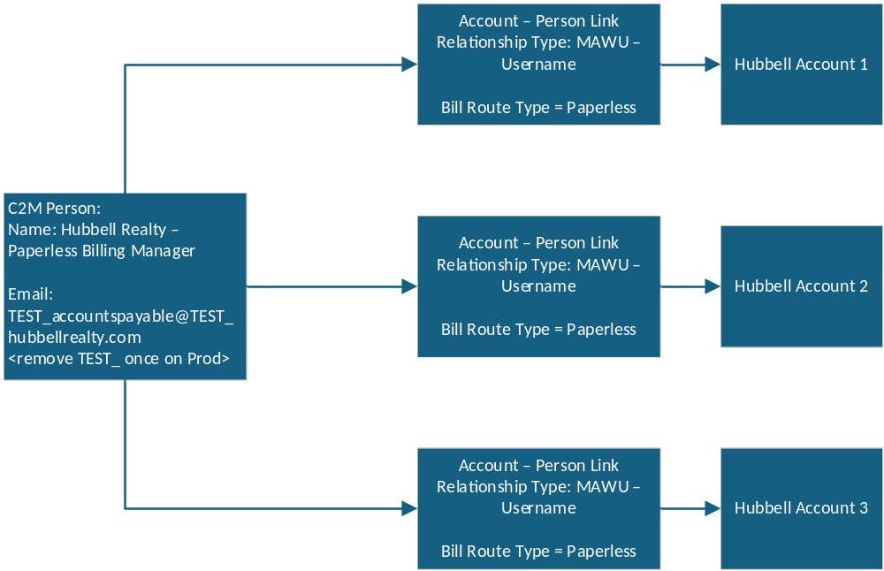

Batch considerations
Note: The batch should only extract data for Hubbell Realty Portal Accounts. Hubbell Accounts can be identified using the premise address “6900 WESTOWN PKWY WEST DES MOINES IA 50266”.
Batch Details
Batch Name [Required] | CMHUBELL
Description [Required] | MEC – C2M File Extract for Hubbell Portal Realty Accounts
Schedule/Frequency [Required] | Everyday / 2 pm afternoon
Parameters  Parameters to pass to the batch control (file name, file path, CIS Division, etc.) | File Name –  File Path – /hubbellrealty/outbox  Type of File - CSV
Any SLA Impacts? | N/A
Dependency  List any dependencies on other batches | N/A
Multithreaded  Indicate if the batch is single threaded or multi-threaded | Multi-thread  (Overall, in the legacy system 3410 Hubbell accounts exist. However, only 248 are currently active. The amount of accounts bill varied by the meter read dates in the legacy system.)

Test Cases

Test Cases [Required]
 | Test Scenario | Expected Result | Generic/RICEF ID
1.1 | Web User completed the Hubbell Portal Login | Hubbell Realty – Paperless Billing Manager page will be loaded  Display List of Hubbell Accounts:  Account  Account Status  Address  Add and Remove options are available  View Bill link is available
1.2 | From Hubbell Realty – Paperless Billing Manager page, Web User to click Add and populate the Account Number  Account is a Valid C2M Account, is a Hubbell Account and a Service Account | - On C2M,  Linked Account to the Web Person - Hubbell Realty – Paperless Billing Manager (Account – Person link with Relationship Type = Username)  Enroll the account to paperless billing for the Web Person - Hubbell Realty – Paperless Billing Manager  //Start Add Task1168036 04/30  And set Main Person’s Bill Route to Do Not Extract.  //End Add Task1168036 04/30  - From the Hubbel Portal success message will shown:  Success Message:  Thank You!  Account Added – Future bills will be on Paperless Billing  List Account (link)  Add Another Account (link)
1.3 | From Hubbell Realty – Paperless Billing Manager page, Web User to click Add and populate the Account Number  Where:  Account 1 - Account is not Valid C2M Account,  Account 2 - Is not a Hubbell Account and a  Account 3 – Is not a Service Account (Master Account) | Hubbell Portal will display error  - Account 1 - Account Not Added. No Match Found. Try again.  - Account 2 - Account Not a Hubbell Account  - Account 3 - Account Not a Service Account
1.4 | From Hubbell Realty – Paperless Billing Manager page, Web User to click Remove | - In C2M:  Unlink the Account to the Web Person - Hubbell Realty – Paperless Billing Manager (Account – Person link with Relationship Type = Username will be deleted)  //Start Add Task1168036 04/30  And set Main Person’s Bill Route to Postal.  //End Add Task1168036 04/30  - In Hubbell Portal - Success Message Will be displayed:  Account Removed  Account has been removed from Hubbell’s Paperless Billing Process
1.5 | C2M CSV file for Hubbel Realty Portal Account | The batch should run daily at 2 pm in the afternoon carrying a CSV file with the details of the Hubbell Portal Realty Accounts.  For testing, use the below details – the SFTP is:  sftpqa.bheapps.com, port 22  User: C2M_CSS_TEST  Path: /hubbellrealty/outbox

Appendix

Decisions / RAIDS
ID | Description | Status
 | None

Exceptions / Approval
Exception Title | Description | Status
 | None

