AttendAI: AI-Powered Smart Attendance &
Classroom Management System
Project Report
Submitted for the subject of
221601907 Capstone Project – II
Integrated Master of Science (IT) (IMSc (IT))
Semester IX
Submitted By
Patel Abhi Kiranbhai (2026001)
Patel Mahir Tarpankumar (001)
Under the Guidance of
Prof. Sadhana Mishra
FCAIT, GLS University

Faculty of Computer Applications & IT (FCAIT)
IMSc (IT) Programme
Ahmedabad
Academic Year 2026–2027

GLS UNIVERSITY
Faculty of Computer Applications & IT
IMSc (IT) Programme Ahmedabad
CERTIFICATE
This is to certify that the following students of Semester IX Integrated Master of Science (IT) (IMSc (IT)) Programme, Faculty of Computer Applications & IT (FCAIT), GLS University, Ahmedabad, have successfully completed the subject project titled "AttendAI: Smart Attendance & Classroom Management System" for the course 221601907 Capstone Project – II - System Design and Implementation during the Academic Year 2026–2027.
Students:
1. Patel Abhi Kiranbhai (Enrollment ID: 2026001)
2. Patel Mahir Tarpankumar (Enrollment ID: 001)
Date of Submission: ____________________
Prof. Sadhana Mishra Dr. Tripti Dodiya
Project Guide Dean, FCAIT

3. Index / Table of Contents
Sr No. | Topic / Section Title | Page No.
1 | Cover Page | 1
2 | College Certificate | 2
3 | Index / Table of Contents | 3
4 | Brief of System | 4
 | 4.1 Technology Stack | 4
 | 4.2 Roles and Capabilities (Admin, Faculty, Student) | 4
 | 4.3 Attendance Verification Pipeline & Adaptive Biometrics | 5
 | 4.4 Security & Data Privacy | 5
 | 4.5 REST API Endpoints Specification | 6
 | 4.6 Project Objectives | 7
 | 4.7 Functional and Non-Functional Requirements | 7
 | 4.8 Scope & Limitations | 8
 | 4.9 Future Scope & Enhancements | 8
 | 4.10 Conclusion | 8
5 | UML Diagrams | 9
 | 5.1 Use Case Diagram (Figure 1) | 9
 | 5.2 Class Diagram & Relational Foreign Keys (Figure 2) | 10
 | 5.3 Swimlane Activity Diagram: Attendance Marking (Figure 3) | 11
 | 5.4 Sequence Diagram: Session Start & Verification (Figure 4) | 12
 | 5.5 State Chart Diagrams: Session & Biometrics (Figures 5 & 6) | 13
6 | Data Dictionary (Database Models & Schemas) | 14
 | 6.1 User Schema | 14
 | 6.2 Department Schema | 15
 | 6.3 Course / Branch Schema (NEW) | 16
 | 6.4 Subject Schema | 17
 | 6.5 Class Schema | 18
 | 6.6 Attendance Schema & Embedded Records | 19
 | 6.7 Relational Model & Referential Integrity (Foreign Keys) | 20
7 | All System Screenshots with URLs | 21
 | 7.1 Admin Portal Interfaces | 22
 | 7.2 Faculty Portal Interfaces | 25
 | 7.3 Student Portal Interfaces | 28
 | 7.4 Reports, Analytics & PDF Export | 30
8 | References | 32

List of Figures & Diagrams
Figure No. | Figure Title & Description | Page No.
Figure 1 | Use Case Diagram - Multi-Role Actor Interactions | 9
Figure 2 | Class Diagram - Mongoose Schemas & Foreign Key Relationships | 10
Figure 3 | Swimlane Activity Diagram - Attendance Marking Workflow | 11
Figure 4 | Sequence Diagram - Session Start, Biometrics & Check-in | 12
Figure 5 | State Chart Diagram - Attendance Session Lifecycle | 13
Figure 6 | State Chart Diagram - Student Biometric Verification | 13
Figure 7 | Admin Dashboard - Statistics & Operational Counters | 22
Figure 8 | System Login Portal - Multi-Role Authentication | 22
Figure 9 | User Management - Accounts, Roles & Access Control | 23
Figure 10 | Department Management - Academic Departments (FCAIT) | 23
Figure 11 | Subject Library - Master Curriculum Catalog | 24
Figure 12 | All Classes - Active Divisions & Timetable Bindings | 24
Figure 13 | Faculty Dashboard - Today's Schedule & Quick Actions | 25
Figure 14 | My Classes - Assigned Divisions & Enrolled Rosters | 25
Figure 15 | Master Timetable Schedule - Weekly Classroom Grid | 26
Figure 16 | My Students - Enrolled Student Profiles & Face Status | 26
Figure 17 | Live Attendance QR Hub - QR, Passcode & Radius Settings | 27
Figure 18 | Subjects - Faculty Curriculum View | 27
Figure 19 | Student Dashboard - Overall Attendance & Today's Schedule | 28
Figure 20 | Student Registration - Enrollment ID & Biometric Enrollment | 28
Figure 21 | Biometric QR Scanner - Multi-Pass Face Check & GPS | 29
Figure 22 | My History - Student Attendance Verification Log | 29
Figure 23 | Session Archives - Historical Attendance Logs with CSV Export | 30
Figure 24 | Timetable Print Layout - Clean PDF Schedule Export | 31

4. Brief of System
AttendAI is an enterprise-grade, cloud-deployed smart attendance and classroom management platform engineered to eliminate proxy attendance and manual administrative overhead in higher education institutions. The system synergistically combines multi-factor biometric and spatial verification: an encrypted rotating session token embedded in dynamic QR codes, a 4-digit session security pin, high-precision GPS geofencing, and client-side facial landmark verification using deep neural networks.
The application is built on modern MERN stack architecture: a reactive single-page client built with React 19, Vite, and Tailwind CSS, interfacing with a Node.js and Express 5 backend deployed on Vercel, paired with a scalable cloud-hosted MongoDB Atlas replica set managed via Mongoose 9 schemas.
4.1 Technology Stack
- Frontend Framework: React 19, React Router 7, Vite 8, Tailwind CSS 4.
- Biometrics & Machine Learning: face-api.js (SSD MobileNet V1 and TinyFaceDetector models), HTML5-QRCode, React-Webcam.
- Document & PDF Engine: jsPDF and jspdf-autotable (vectorized client-side academic report generation).
- Data Visualization: Chart.js, React-Chartjs-2, Recharts, Lucide-React icons.
- Backend Core: Node.js (v22), Express 5, Mongoose 9 ODM.
- Authentication & Cryptography: JSON Web Tokens (JWT), Bcrypt.js (10 salt rounds), Web Crypto API.
- Database & Cloud: MongoDB Atlas multi-region replica set with in-memory fallback support.
4.2 Roles and Capabilities
- Admin Portal: Comprehensive institutional control. Admins manage academic Departments (e.g., FCAIT), Degree Courses / Branches (IMSCIT, BCA, MCA), Faculty Members with multi-subject assignment, Subject catalogues, Student rosters, Global Classes, and institution-wide Daily/Weekly/Monthly attendance analytics with 1-click official PDF export.
- Faculty Portal: Faculty members have role-isolated access to their assigned teaching subjects, academic timetable, enrolled student rosters with Face ID status, geofenced QR session launching (custom radius and passcode), real-time attendance monitor, manual session termination, and student attendance reporting with PDF download.
- Student Portal: Students securely self-register, enroll Face ID biometric embeddings, inspect daily lecture schedules, scan live classroom QR codes, submit geofenced biometrics, view attendance history, and download official attendance certificates for semester examination clearance.
4.3 Attendance Verification Pipeline & Adaptive Biometrics
Attendance verification follows an ultra-secure, multi-stage pipeline designed for seamless execution even under variable classroom lighting and low-quality device cameras:
- Stage 1 - Session Validation: The server validates the active status of the class session and verifies the decrypted session token against the active database document.
- Stage 2 - Secret Security Passcode: The client-submitted 4-digit code must exactly match the teacher's active session passcode (HTTP 401 on mismatch).
- Stage 3 - Haversine Geofence Verification: The student's device GPS coordinates (latitude, longitude, accuracy radius) are measured against the faculty device coordinates using the Haversine great-circle formula. If the calculated distance exceeds the session radius (e.g., 100m), access is denied (HTTP 403).
- Stage 4 - Adaptive Multi-Pass Facial Verification: Client-side face detection first applies SSD MobileNet V1 (minConfidence: 0.20) and automatically cascades to TinyFaceDetector if lighting is dim or webcam resolution is low. The extracted 128-dimensional biometric descriptor is compared against the student's registered profile embeddings. An adaptive Euclidean distance threshold of 0.68 is enforced, returning confidence telemetry: 'Perfect Match' (< 0.45), 'High Confidence' (< 0.58), or 'Verified Match'.
- Stage 5 - Idempotent Check-in & Retry Resilience: If a student re-submits in the same active session due to network latency, the server updates their coordinates and biometric telemetry and responds with HTTP 200 (alreadyMarked: true), preventing duplicate rejections.
- Stage 6 - Post-Session Auto-Reconciliation: When the instructor clicks 'End Session' (POST /api/attendance/stop/:id), the server closes the QR code, marks absent all enrolled students who failed to check in, and compiles complete statistical reports.
4.4 Security & Data Privacy
- Zero Raw Image Storage: To protect student privacy, raw facial photographs are processed in-memory and never stored on disk or database. Only irreversible 128-dimensional mathematical floating-point embedding vectors are persisted.
- Bcrypt Password Encryption: User passwords are automatically salted and hashed (10 rounds) in Mongoose pre-save middleware and strictly excluded from default query projections.
- Stateless JWT Authorization: Bearer JWT tokens with 30-day expiration guard protected routes through 'protect' and 'authorize' middleware tiers.
4.5 REST API Endpoints Specification
Method | Endpoint Route | Access Level | Operational Purpose
POST | /api/auth/register | Public | Register student account with initial profile data
POST | /api/auth/login | Public | Authenticate user and issue signed JWT bearer token
GET | /api/auth/me | Authenticated | Retrieve current authenticated user context
POST | /api/auth/face-setup | Authenticated | Store 128-dimensional facial embedding vector
GET | /api/admin/stats | Admin | Admin dashboard counters, attendance charts, activity stream
GET, POST | /api/admin/users | Admin | List all users (with role filters) and create user accounts
PUT, DELETE | /api/admin/users/:id | Admin | Update user role/credentials or delete user
GET, POST | /api/admin/departments | Admin | List and create academic departments (e.g. FCAIT)
PUT, DELETE | /api/admin/departments/:id | Admin | Update or delete department record
GET, POST | /api/admin/courses | Admin / Auth | List degree courses (IMSCIT, BCA) and create courses
PUT, DELETE | /api/admin/courses/:id | Admin | Update or delete degree course record
GET, POST | /api/classes | Authenticated | List classes or create new class with schedule slots
GET, POST | /api/subjects | Authenticated | List academic subjects or create new subject
GET, POST | /api/students | Authenticated | List enrolled students or register student profile
GET | /api/faculty-list | Authenticated | List faculty professors for scheduling and assignments
POST | /api/attendance/start | Faculty | Start live geofenced QR session with secret passcode
POST | /api/attendance/stop/:id | Faculty / Admin | Close active session and compile roster attendance report
GET | /api/attendance/session/:id | Authenticated | Get post-session attendance summary and distance roster
POST | /api/attendance/mark | Student | Submit QR token, passcode, GPS, and face descriptor
GET | /api/attendance/active-session/:classId | Student | Retrieve active session metadata for class
GET | /api/attendance | Authenticated | Retrieve historical attendance sessions by user role
GET | /api/attendance/student-stats | Student | Student dashboard analytics and today's schedule
GET | /api/attendance/student-report | Authenticated | Daily/Weekly/Monthly student attendance report with PDF readiness

4.6 Project Objectives
- Eliminate Proxy Attendance: Enforce multi-factor verification combining classroom proximity (GPS), physical presence (Facial recognition), and time-limited QR codes.
- Automate Faculty Workflow: Replace manual paper roll calls with automated live scanning, reducing lecture attendance overhead from 15 minutes to under 60 seconds.
- Hierarchical Academic Administration: Model institutional realities where 1 Department oversees Multiple Courses, Courses offer Multiple Subjects, and 1 Faculty teaches Multiple Subjects.
- Audit-Ready Exporting: Empower administration, teachers, and students to generate verified Daily, Weekly, and Monthly attendance reports with 1-click PDF export.
4.7 Functional and Non-Functional Requirements
Table A: Functional Requirements Matrix
ID | Requirement | System Description | Implementation File
FR1 | Multi-Role Authentication | Users log in securely with JWT bearer tokens and role-based redirects. | authController.js
FR2 | Department & Course Hierarchy | Admins manage Departments and Degree Courses with referential links. | adminController.js
FR3 | Faculty Multi-Subject Assignment | Admins assign multiple subjects to each professor in Faculty Management. | FacultyManagement.jsx
FR4 | Geofenced Session Hub | Faculty starts and stops live sessions with dynamic QR and passcode. | GenerateQR.jsx
FR5 | Multi-Pass Biometric Verification | Students check in using SSD MobileNet / TinyFace fallback + GPS geofence. | ScanQR.jsx
FR6 | Automated Post-Session Audit | Ending a session computes present/absent roster with distance metrics. | attendanceController.js
FR7 | Daily/Weekly/Monthly PDF Reports | Interactive student report generator with 1-click PDF download. | StudentReports.jsx

Table B: Non-Functional Requirements Matrix
Quality Attribute | Evidenced Implementation Details
Security | Bcrypt 10-round password hashing, 30-day signed JWT tokens, role-restricted middleware tiers.
Privacy | Biometric descriptors stored strictly as 128-float numeric arrays; no raw photos saved.
Reliability | Adaptive 0.68 face distance threshold with multi-detector fallback for low-light mobile environments.
Portability | Cross-platform responsive design supporting mobile smartphones, tablets, laptops, and desktop web.
Performance | Sub-second database query execution via indexed MongoDB Atlas replica set.

4.8 Scope & Limitations
Current Scope: Full institutional deployment across administrators, faculty teachers, and students covering automated attendance, timetable schedules, course-department hierarchies, and official PDF reporting.
Known Limitations & Controlled Boundary Conditions:
- Liveness Detection: Passive facial recognition verifies 128 biometric landmarks; active 3D liveness detection (blink or nod challenge) is designated for phase 2 hardening.
- Indoor GPS Signal Variance: Geofencing relies on device-reported satellite/network GPS; basement classrooms with severe signal shielding require slightly relaxed radius settings (e.g. 150m).
4.9 Future Scope & Enhancements
- Active Facial Liveness Challenge: Inject random eye-blink and head-turn micro-challenges during camera capture.
- Offline Sync Progressive Web App (PWA): Allow students to cache encrypted check-in proofs offline when campus Wi-Fi drops.
- Predictive Defaulter Analytics: Automated machine learning alerts warning students when attendance risks falling below 75%.
4.10 Conclusion
AttendAI successfully modernizes campus attendance by delivering an impenetrable yet effortless multi-factor verification pipeline. Combining dynamic rotating QR codes, secret security passcodes, Haversine geofences, and neural facial verification provides ironclad protection against proxy attendance. Furthermore, the newly integrated Department-Course-Faculty architecture and instant Daily/Weekly/Monthly PDF report export provide academic leadership with unmatched visibility into student attendance and examination eligibility.

5. UML Diagrams
The Unified Modeling Language (UML) diagrams below depict the structural architecture, relational foreign-key models, operational workflows, and state lifecycles of AttendAI.
5.1 Use Case Diagram
The Use Case Diagram defines all system interactions across the three system actors: Administrator, Faculty Member, and Student. Notable capabilities include 'Manage Degree Courses', 'Assign Multiple Subjects to Faculty', 'Stop Attendance Session', and 'Export Official Attendance Report (PDF)'.
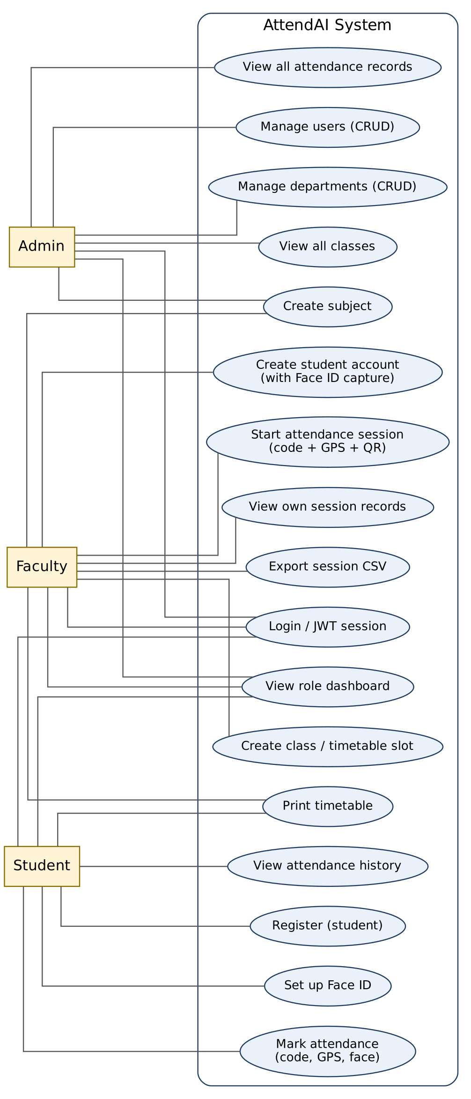
Figure 1: Use Case Diagram - Multi-Role Actor Interactions

5.2 Class Diagram & Foreign Key Architecture
The Class Diagram maps the object-oriented schemas of AttendAI, highlighting the new Course model and referential foreign keys linking Department (1 -> N) Course (1 -> N) Subject, Class (references Subject, Faculty, Course, Students), User (linked to Department, Course, and assignedSubjects), and Attendance (linking Class, Faculty, and Student records with biometric metrics).
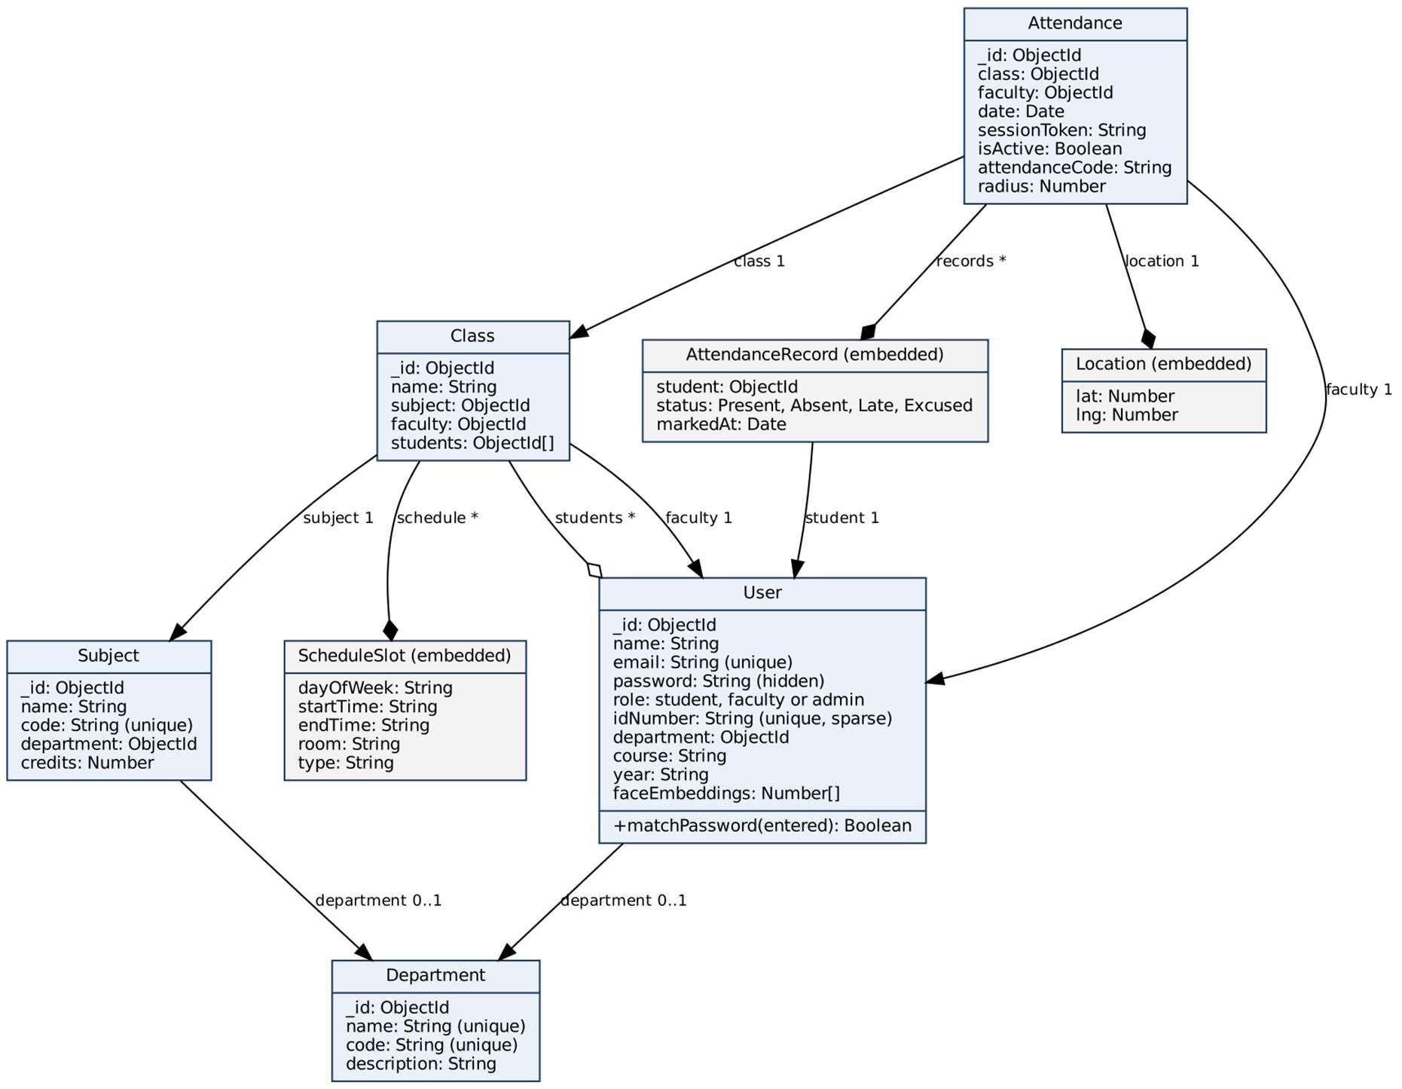
Figure 2: Class Diagram - Mongoose Schema Relational Model

5.3 Swimlane Activity Diagram: Attendance Marking
Illustrates the concurrent workflow divided into three swimlanes: Faculty, Student, and System (Express API + MongoDB Atlas). Shows QR creation, camera scanning, geofence validation, adaptive facial landmark extraction (0.68 threshold), and post-session automated absence reconciliation.
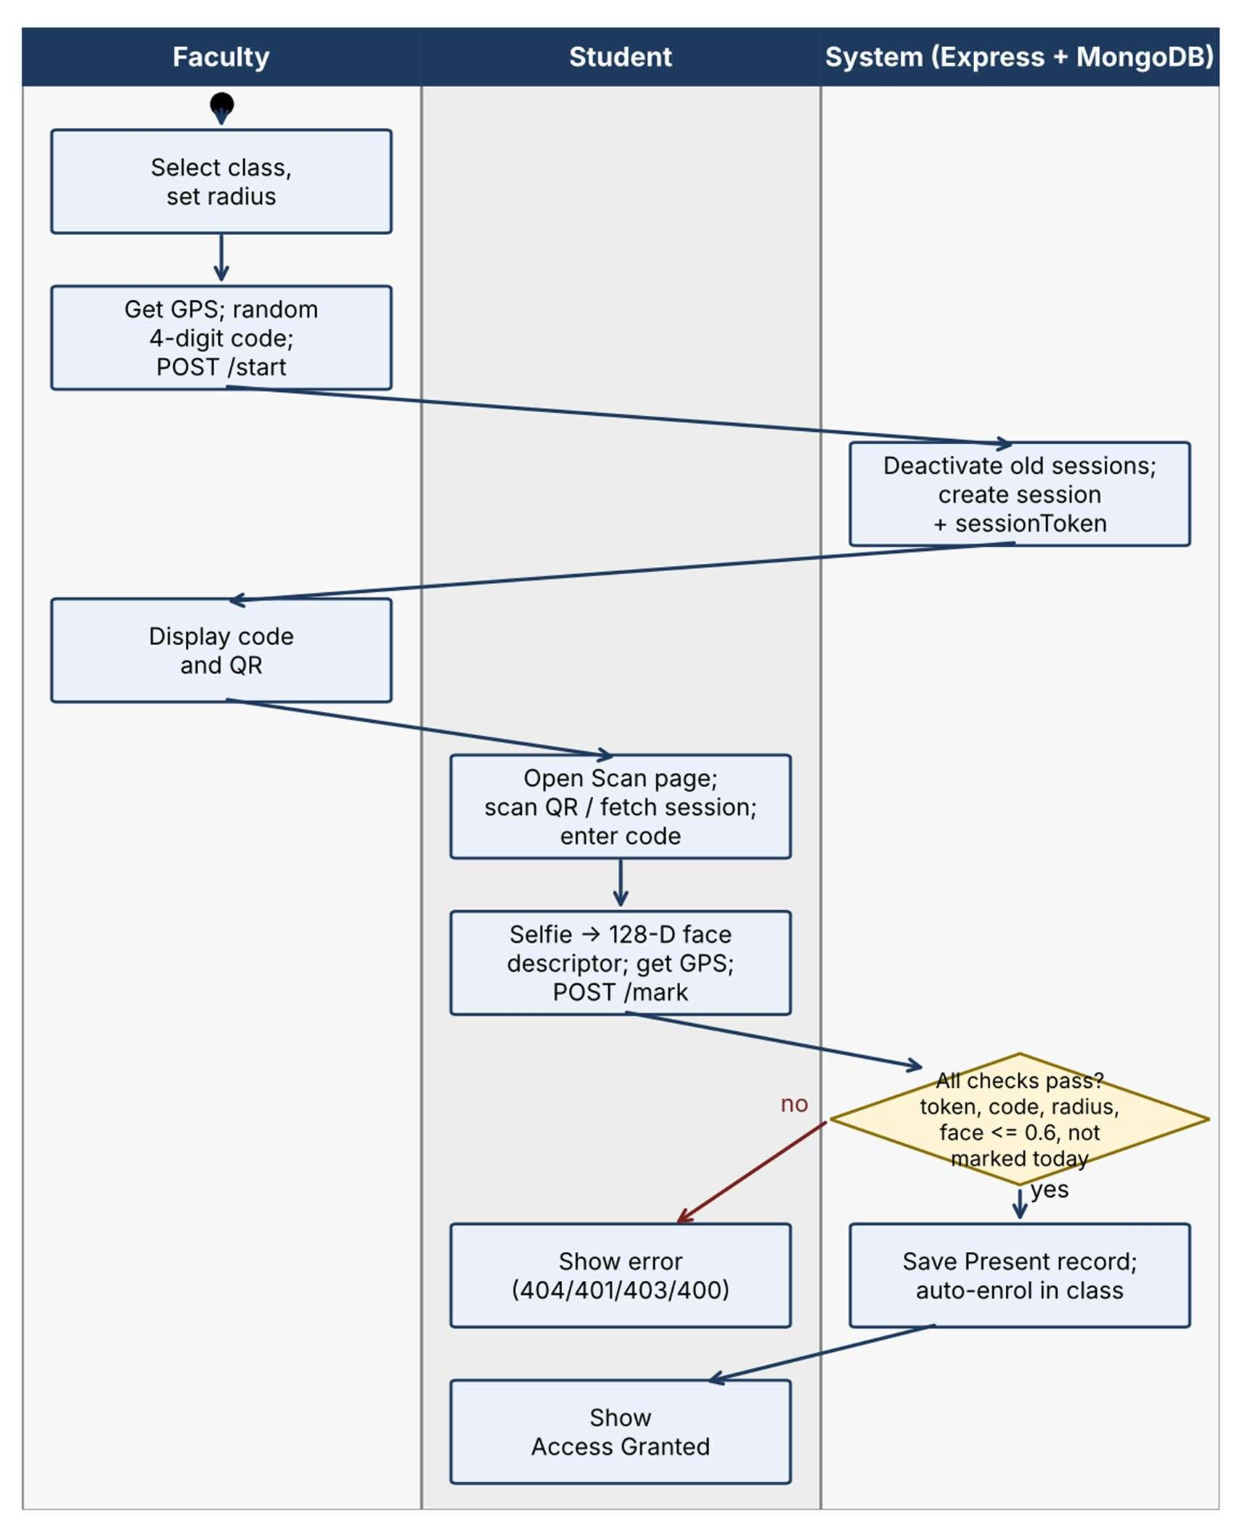
Figure 3: Swimlane Activity Diagram - End-to-End Attendance Marking Workflow

5.4 Sequence Diagram: Session Lifecycle & Verification
Chronologically illustrates message passing between the Faculty UI, Student Mobile UI, Express Controllers, and MongoDB Atlas database during startSession, markAttendance, and stopSession.
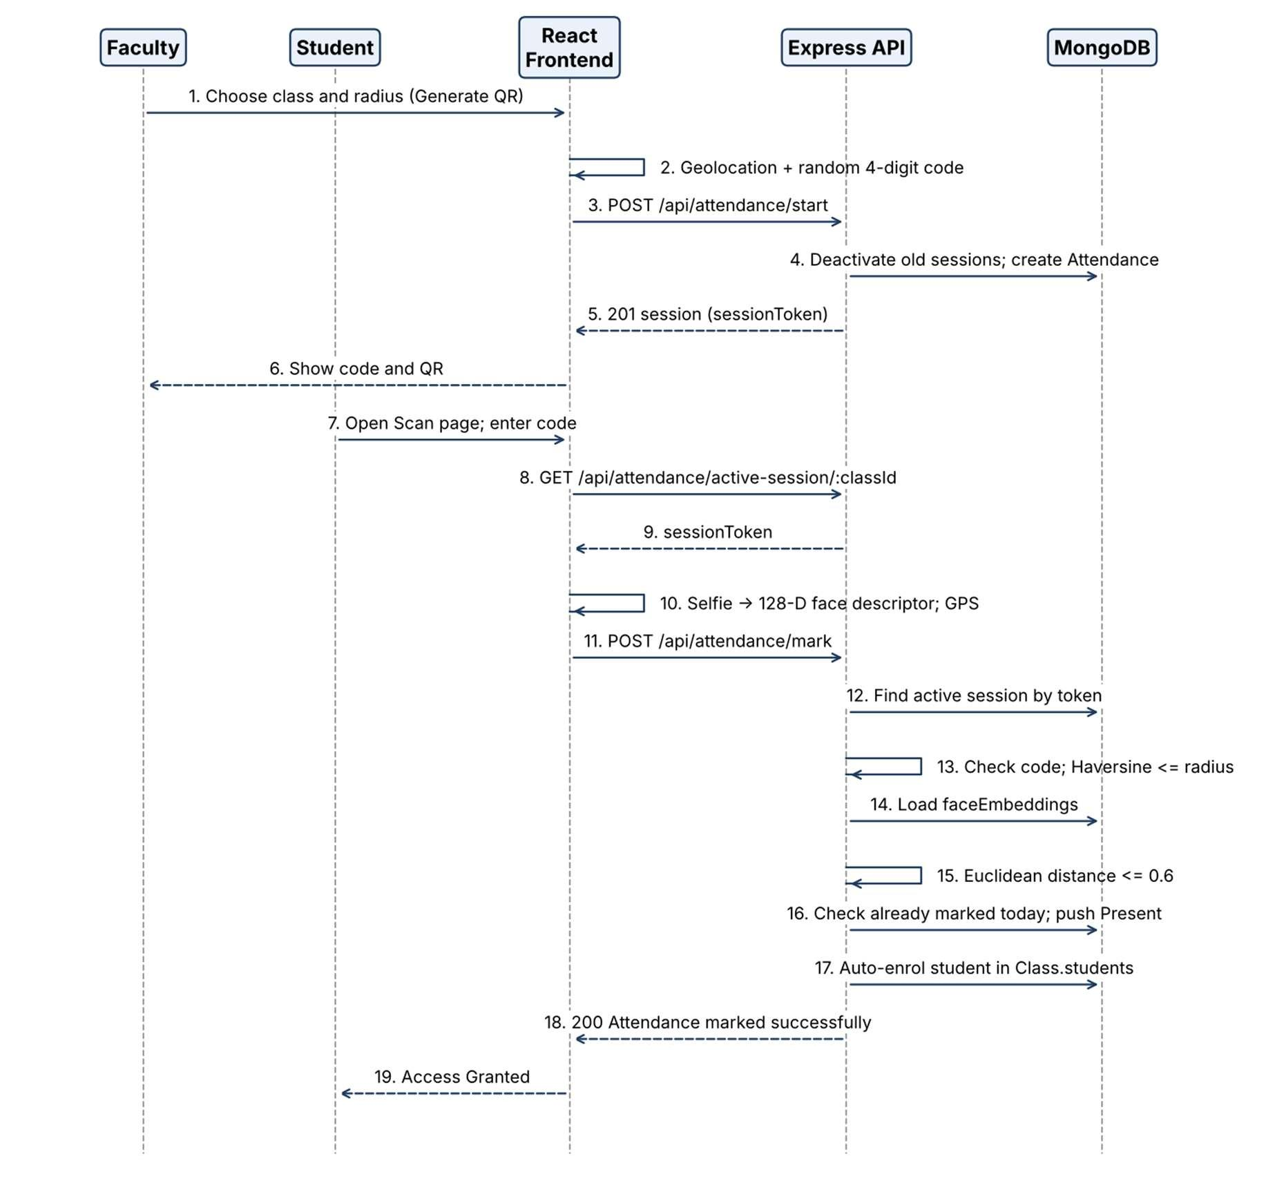
Figure 4: Sequence Diagram - Session Start, Biometric Verification, and Post-Session Close

5.5 State Chart Diagrams
Figure 5 displays the Attendance Session lifecycle: Initial -> Active (broadcasting dynamic QR & accepting check-ins) -> Inactive (triggered via POST /api/attendance/stop/:id, executing enrolled roster reconciliation and report compilation).
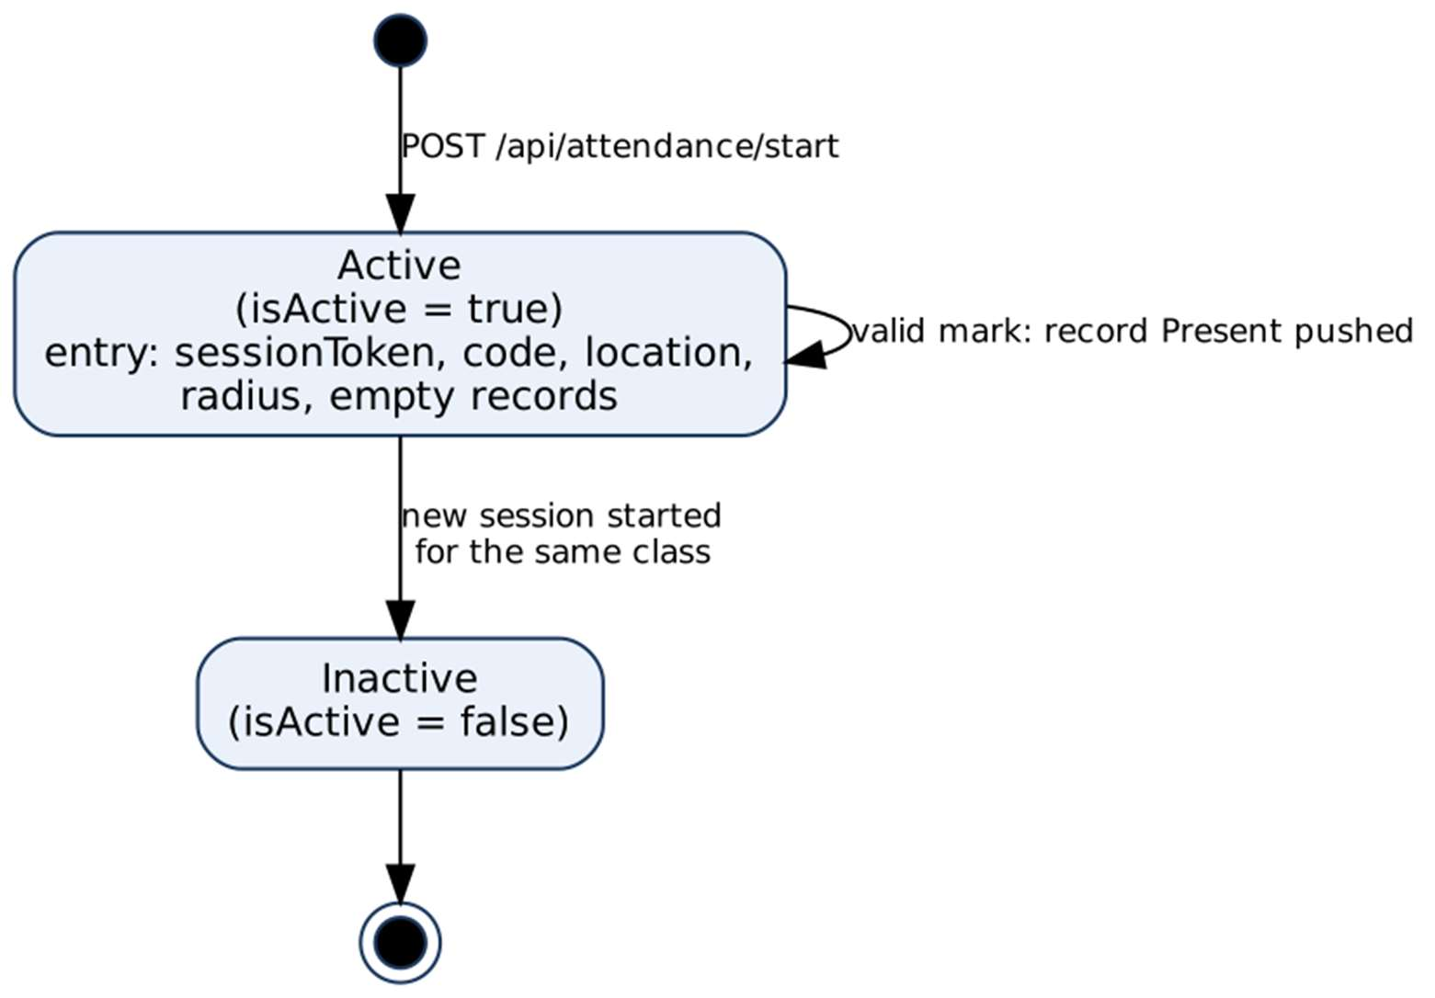
Figure 5: State Chart Diagram - Attendance Session Lifecycle
Figure 6 displays the Student Attendance Verification state progression: Not Recorded -> Code Validated -> Geofence Validated -> Face Landmark Verified (distance <= 0.68) -> Present (biometrics saved to session records).
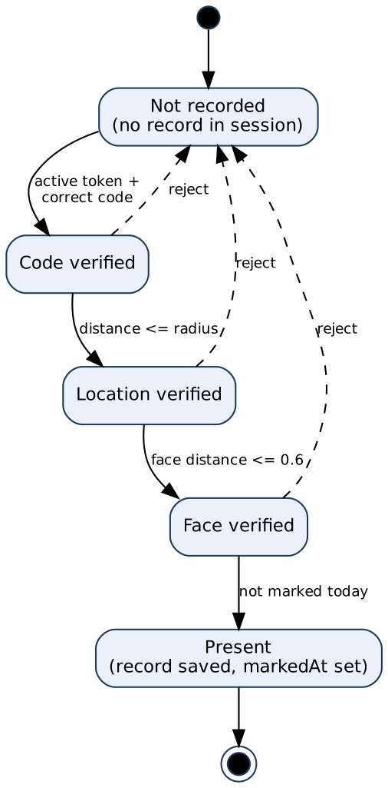
Figure 6: State Chart Diagram - Student Biometric & Geofence Verification

6. Data Dictionary
The Data Dictionary provides complete schema specifications for all MongoDB collections in AttendAI. Each schema enforces strict types, unique indexes, validation constraints, and referential integrity using Mongoose ObjectIds.
6.1 User Schema
Field Name | Data Type | Constraints | Field Description
_id | ObjectId | Primary Key | Unique identifier generated by MongoDB.
name | String | Required, Trimmed | Full legal name of the user.
email | String | Required, Unique | Email address or unique system username (e.g., Arcenix).
password | String | Required, select: false | Bcrypt salted hash (10 rounds); omitted from default queries.
role | String | Enum: student, faculty, admin | Role-based access level (defaults to student).
idNumber | String | Unique, Sparse | Enrollment number (students) or Employee ID (faculty).
department | ObjectId | Ref: Department, Optional | Academic department the user belongs to (e.g., FCAIT).
course | ObjectId | Ref: Course, Optional | Foreign key to Course schema (e.g., IMSCIT, BCA).
assignedSubjects | [ObjectId] | Ref: Subject Array | Multiple subjects taught by faculty (1 Faculty -> N Subjects).
year | String | Optional | Academic year or semester of the student.
faceEmbeddings | [Number] | Default: [] | 128-dimensional floating-point vector extracted via face-api.js.
createdAt | Date | Auto (timestamps) | Document creation timestamp.
updatedAt | Date | Auto (timestamps) | Document last modification timestamp.

6.2 Department Schema
Field Name | Data Type | Constraints | Field Description
_id | ObjectId | Primary Key | Unique department identifier.
name | String | Required, Unique | Full department name (e.g., Faculty of Computer Applications & IT).
code | String | Required, Unique, Uppercase | Short institutional code (e.g., FCAIT, FoT, FoM).
description | String | Max 500 chars | Administrative description of the faculty/department.
createdAt | Date | Auto (timestamps) | Creation timestamp.
updatedAt | Date | Auto (timestamps) | Last modification timestamp.

6.3 Course / Branch Schema (NEW)
Field Name | Data Type | Constraints | Field Description
_id | ObjectId | Primary Key | Unique degree course identifier.
name | String | Required, Trimmed | Full degree course name (e.g., Integrated MSc (IT), BCA).
code | String | Required, Unique, Uppercase | Unique branch code (e.g., IMSCIT, BCA, MCA).
department | ObjectId | Ref: Department, Required | Foreign key linking course to parent Department (FCAIT).
durationYears | Number | Default: 3, Min: 1 | Total duration of degree program in years.
totalSemesters | Number | Default: 6, Min: 1 | Total number of academic semesters in program.
createdAt | Date | Auto (timestamps) | Document creation timestamp.
updatedAt | Date | Auto (timestamps) | Document last modification timestamp.

6.4 Subject Schema
Field Name | Data Type | Constraints | Field Description
_id | ObjectId | Primary Key | Unique subject identifier.
name | String | Required, Trimmed | Official academic subject title (e.g., Artificial Intelligence).
code | String | Required, Unique, Uppercase | Standard course subject code (e.g., AI01, FC01).
department | ObjectId | Ref: Department, Optional | Foreign key linking subject to owning Department.
course | ObjectId | Ref: Course, Optional | Foreign key linking subject to specific Degree Course.
semester | Number | Default: 1 | Academic semester in which subject is taught.
credits | Number | Required, Default: 3 | University academic credit weighting.
createdAt | Date | Auto (timestamps) | Creation timestamp.
updatedAt | Date | Auto (timestamps) | Last modification timestamp.

6.5 Class Schema
Field Name | Data Type | Constraints | Field Description
_id | ObjectId | Primary Key | Unique class division identifier.
name | String | Required | Class batch label (e.g., FY-ImscIT-AI01).
course | ObjectId | Ref: Course, Optional | Foreign key linking class division to Degree Course.
subject | ObjectId | Ref: Subject, Required | Foreign key linking class division to Subject.
faculty | ObjectId | Ref: User, Required | Foreign key linking class division to responsible Faculty.
students | [ObjectId] | Ref: User Array | Array of enrolled student ObjectIds.
schedule | [Object] | Sub-document Array | Weekly timetable schedule slots.
schedule[].dayOfWeek | String | Required, Enum | Day of the week (Monday through Sunday).
schedule[].startTime | String | Required, HH:MM | Lecture start time.
schedule[].endTime | String | Required, HH:MM | Lecture end time.
schedule[].room | String | Optional | Classroom / laboratory room number.
schedule[].type | String | Default: Lecture | Session category (Lecture, Lab, Seminar).

6.6 Attendance Schema & Embedded Records
Field Name | Data Type | Constraints | Field Description
_id | ObjectId | Primary Key | Unique attendance session identifier.
class | ObjectId | Ref: Class, Required | Foreign key to Class division.
faculty | ObjectId | Ref: User, Required | Foreign key to Faculty professor who launched session.
date | Date | Required, Default: now | Date and timestamp of class session.
sessionToken | String | Required, Unique | Cryptographically random 32-byte hex QR session token.
isActive | Boolean | Default: true | True while session is open; false when stopped.
attendanceCode | String | Required | 4-digit secret security code chosen by instructor.
location.lat | Number | Required | Instructor device latitude coordinates.
location.lng | Number | Required | Instructor device longitude coordinates.
radius | Number | Required, Default: 100 | Maximum permissible geofence distance in meters.
records | [Object] | Sub-document Array | Embedded student check-in records.
records[].student | ObjectId | Ref: User, Required | Foreign key to student User document.
records[].status | String | Enum: Present, Absent | Final attendance status.
records[].distance | Number | Optional | Measured Haversine geofence distance (meters).
records[].faceDistance | Number | Optional | Measured Euclidean distance from face-api.js.
records[].accuracy | Number | Optional | Device GPS reported accuracy radius (meters).
records[].markedAt | Date | Optional | Exact timestamp when biometric verification passed.

6.7 Relational Model & Referential Integrity
Although MongoDB is a NoSQL document database, AttendAI rigorously implements relational referential integrity using Mongoose ObjectIds and populated relationships:
- Department to Courses (1 to N): Department._id is referenced by Course.department. A single department (e.g., FCAIT) encompasses multiple degree courses (IMSCIT, BCA, MCA).
- Department to Faculty (1 to N): User.department references Department._id, linking professors to their parent faculty institute.
- Faculty to Subjects (1 to N): User.assignedSubjects stores an array of Subject._id references, empowering 1 faculty member to teach multiple subjects across semesters.
- Course to Subjects & Classes (1 to N): Subject.course and Class.course maintain degree-branch isolation, ensuring timetable slots and subject codes strictly belong to their respective curriculum.
- Class to Students (M to N): Class.students stores arrays of student ObjectIds, enabling flexible multi-batch enrollments.
- Attendance to Class & Faculty (N to 1): Every Attendance session references the Class._id and Faculty._id, establishing an immutable academic audit trail.

7. All Screenshots with URL
Base URL (Local Development): http://localhost:5173
Production Cloud Deployment: https://attendai-rho.vercel.app
AttendAI provides dedicated, role-isolated portals for Administrators, Faculty Members, and Students. The table below lists all 22 system interfaces followed by the actual system screens.
Table 6: Screen and URL Directory
Portal Section | Interface Screen Name | System Access URL
Admin | Admin Dashboard | http://localhost:5173/dashboard
Admin | Login Portal | http://localhost:5173/login
Admin | User Management | http://localhost:5173/dashboard/users
Admin | Faculty Members Management | http://localhost:5173/dashboard/faculty
Admin | Courses & Degree Branches | http://localhost:5173/dashboard/courses
Admin | Department Management | http://localhost:5173/dashboard/departments
Admin | Subject Library | http://localhost:5173/dashboard/subjects
Admin | All Institutional Classes | http://localhost:5173/dashboard/classes
Admin / Faculty | Student Attendance Reports & Analytics | http://localhost:5173/dashboard/reports
Faculty | Faculty Dashboard | http://localhost:5173/dashboard
Faculty | My Assigned Classes | http://localhost:5173/dashboard/my-classes
Faculty | Weekly Timetable Schedule | http://localhost:5173/dashboard/timetable
Faculty | My Enrolled Students | http://localhost:5173/dashboard/students
Faculty | Live Attendance QR Hub | http://localhost:5173/dashboard/qr
Faculty | Subjects (Faculty View) | http://localhost:5173/dashboard/subjects
Faculty | Session Archives (Records) | http://localhost:5173/dashboard/records
Student | Student Dashboard | http://localhost:5173/dashboard
Student | Self-Registration Portal | http://localhost:5173/register
Student | Biometric QR Scanner | http://localhost:5173/dashboard/scan
Student | My Attendance Profile & History | http://localhost:5173/dashboard/history
Student | My Attendance Clearance Report (PDF) | http://localhost:5173/dashboard/reports
Report | Academic Timetable Print Layout (PDF) | http://localhost:5173/dashboard/timetable

7.1 Admin Side Screenshots
Admin Dashboard
URL: http://localhost:5173/dashboard
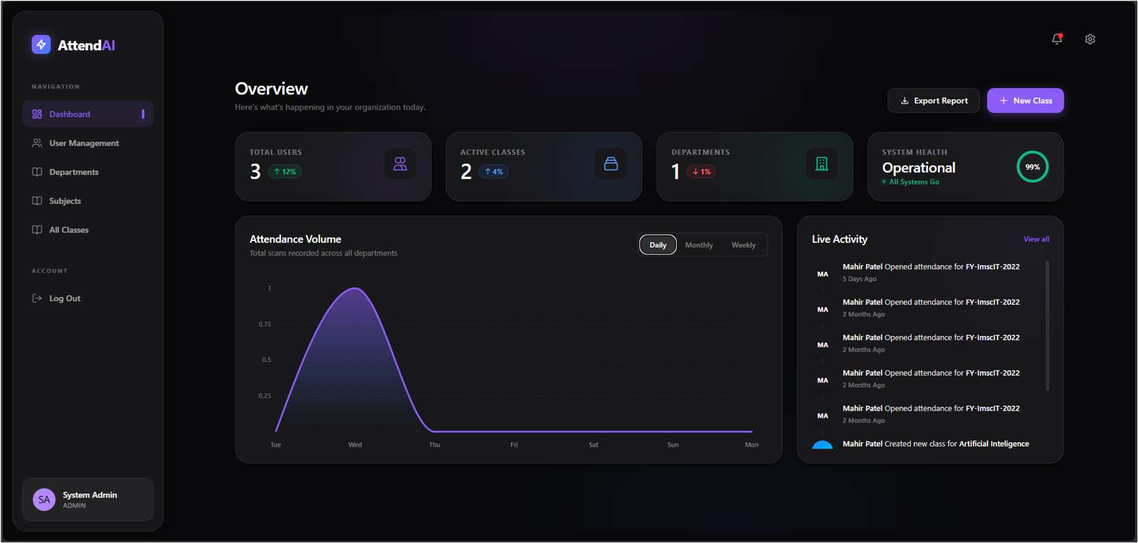
Figure 7: Admin Dashboard
Login
URL: http://localhost:5173/login
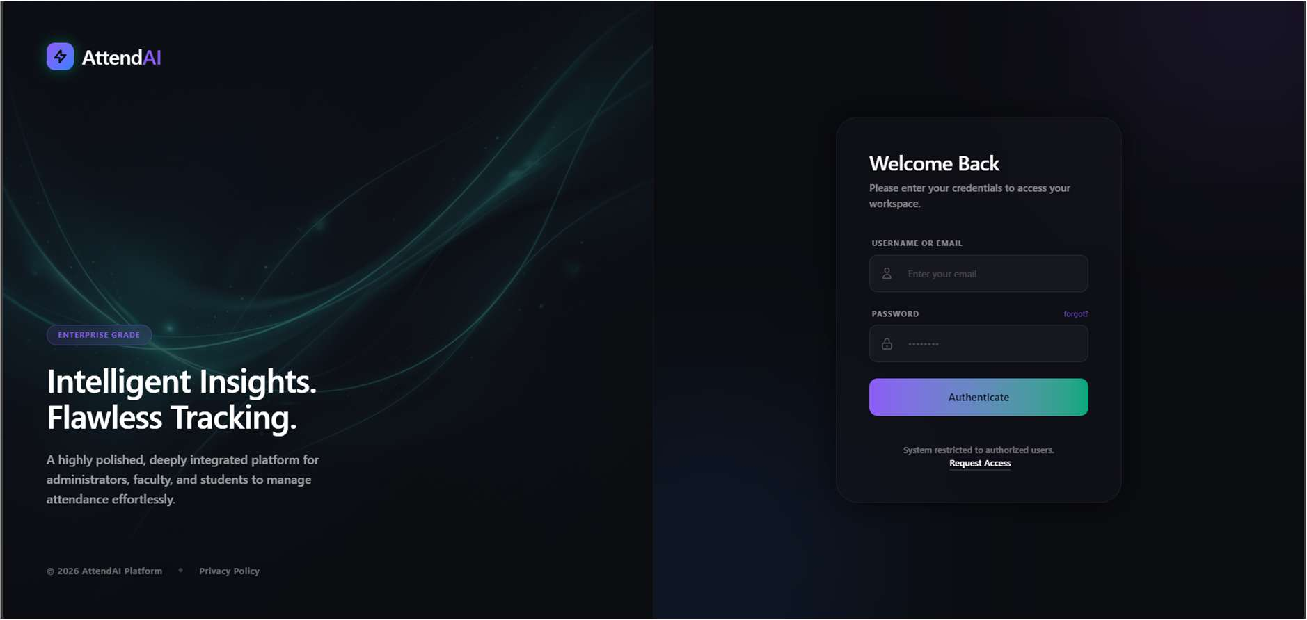
Figure 8: Login

User Management
URL: http://localhost:5173/dashboard/users
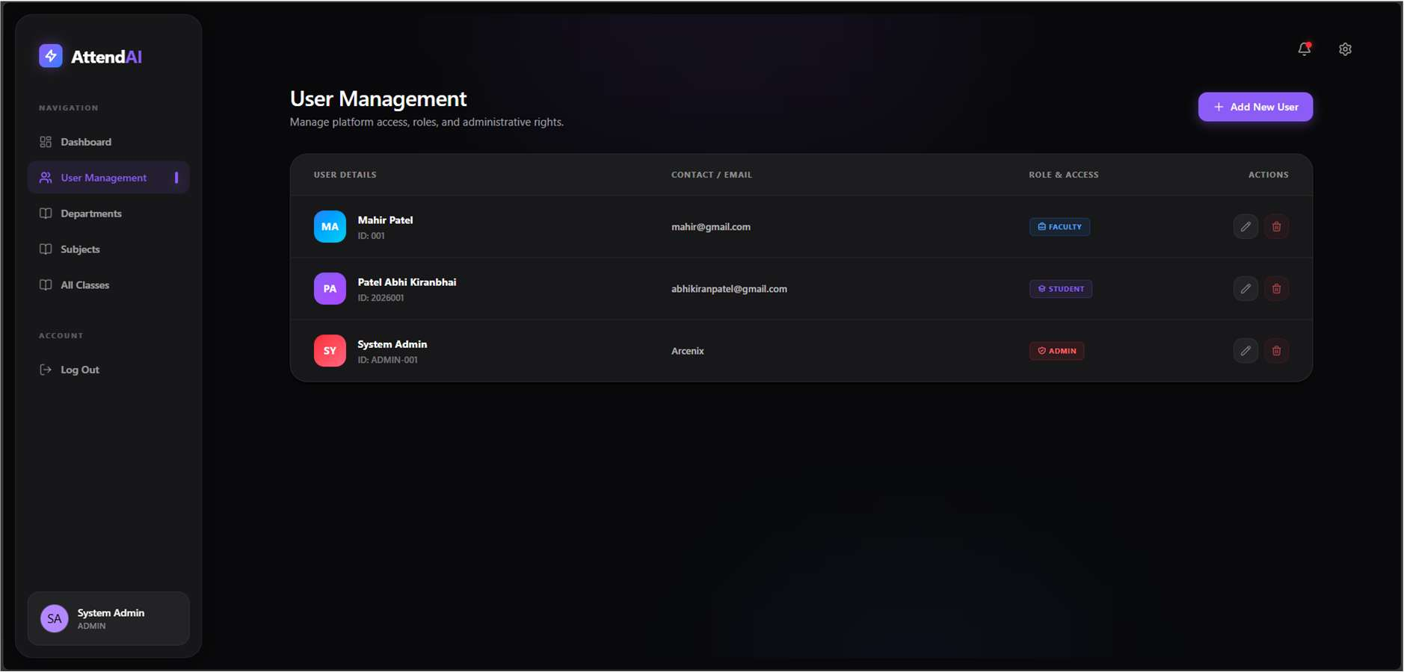
Figure 9: User Management
Departments
URL: http://localhost:5173/dashboard/departments
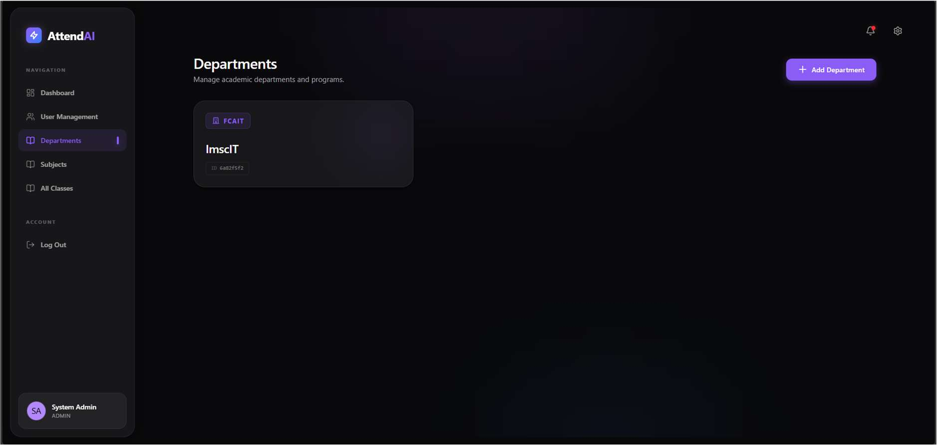
Figure 10: Departments

Subjects
URL: http://localhost:5173/dashboard/subjects
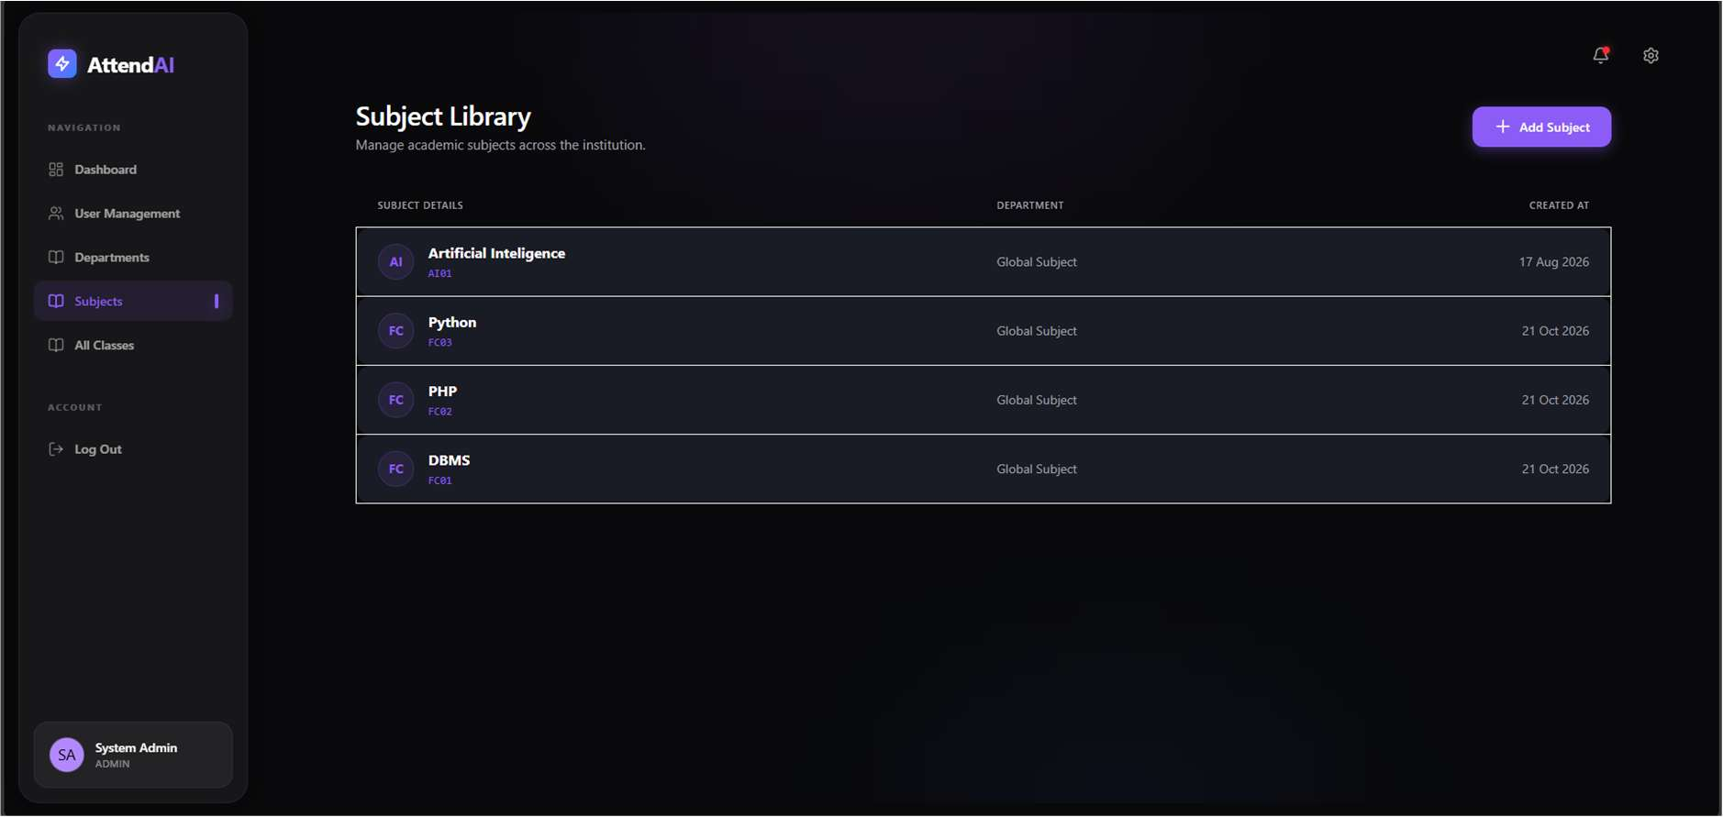
Figure 11: Subjects
All Classes
URL: http://localhost:5173/dashboard/classes
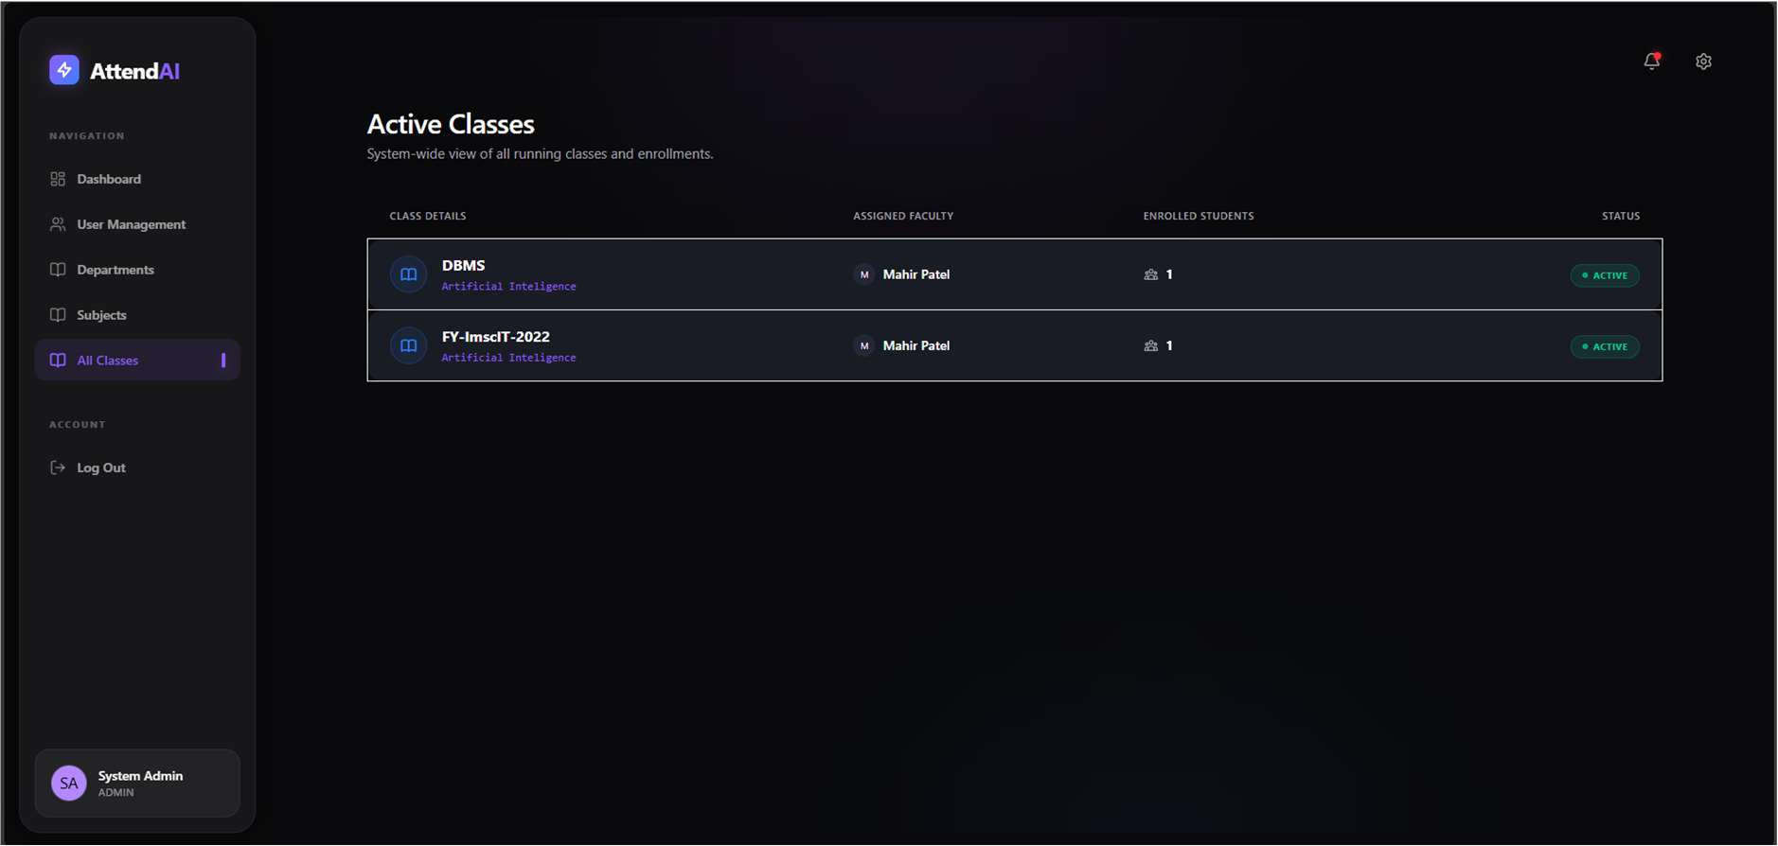
Figure 12: All Classes

7.2 Faculty Portal Screenshots
Faculty Dashboard
URL: http://localhost:5173/dashboard
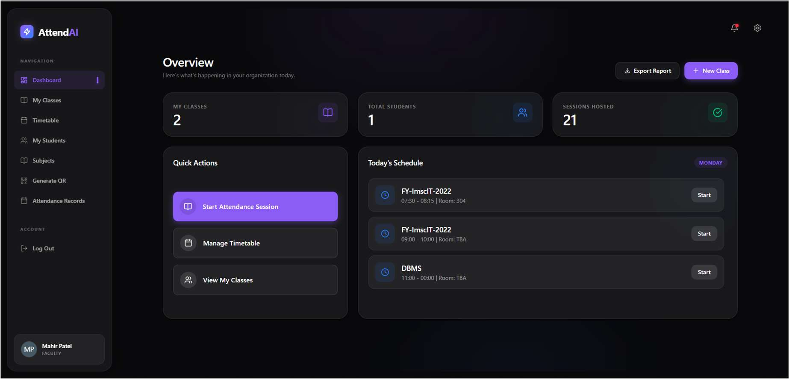
Figure 13: Faculty Dashboard
My Classes
URL: http://localhost:5173/dashboard/my-classes
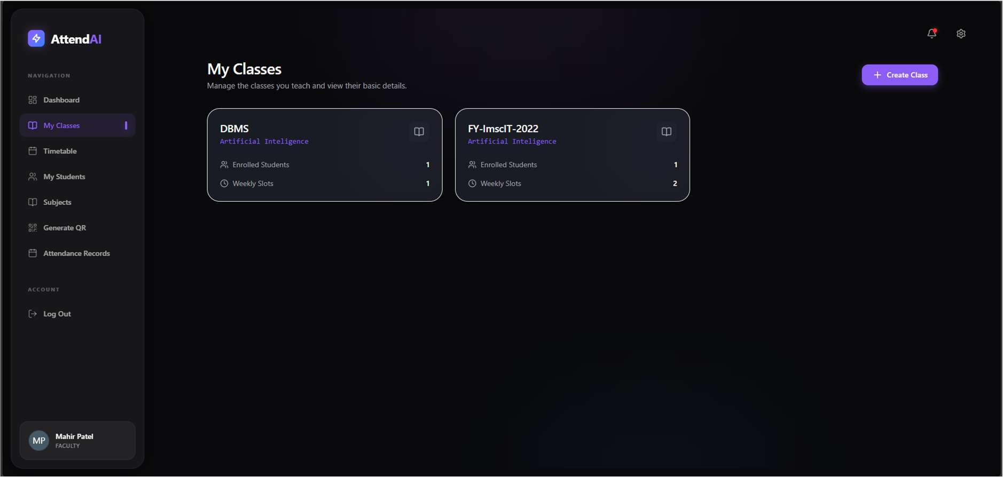
Figure 14: My Classes

Timetable
URL: http://localhost:5173/dashboard/timetable
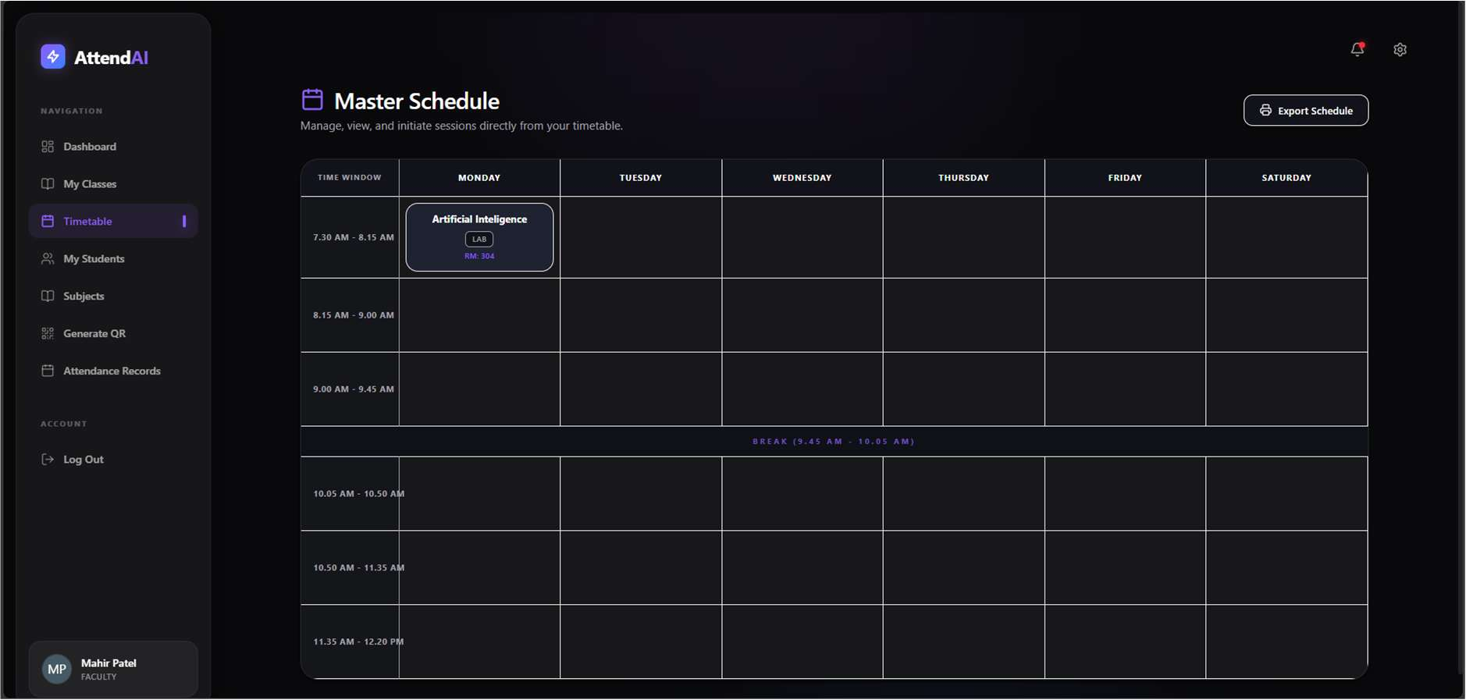
Figure 15: Timetable
My Students
URL: http://localhost:5173/dashboard/students
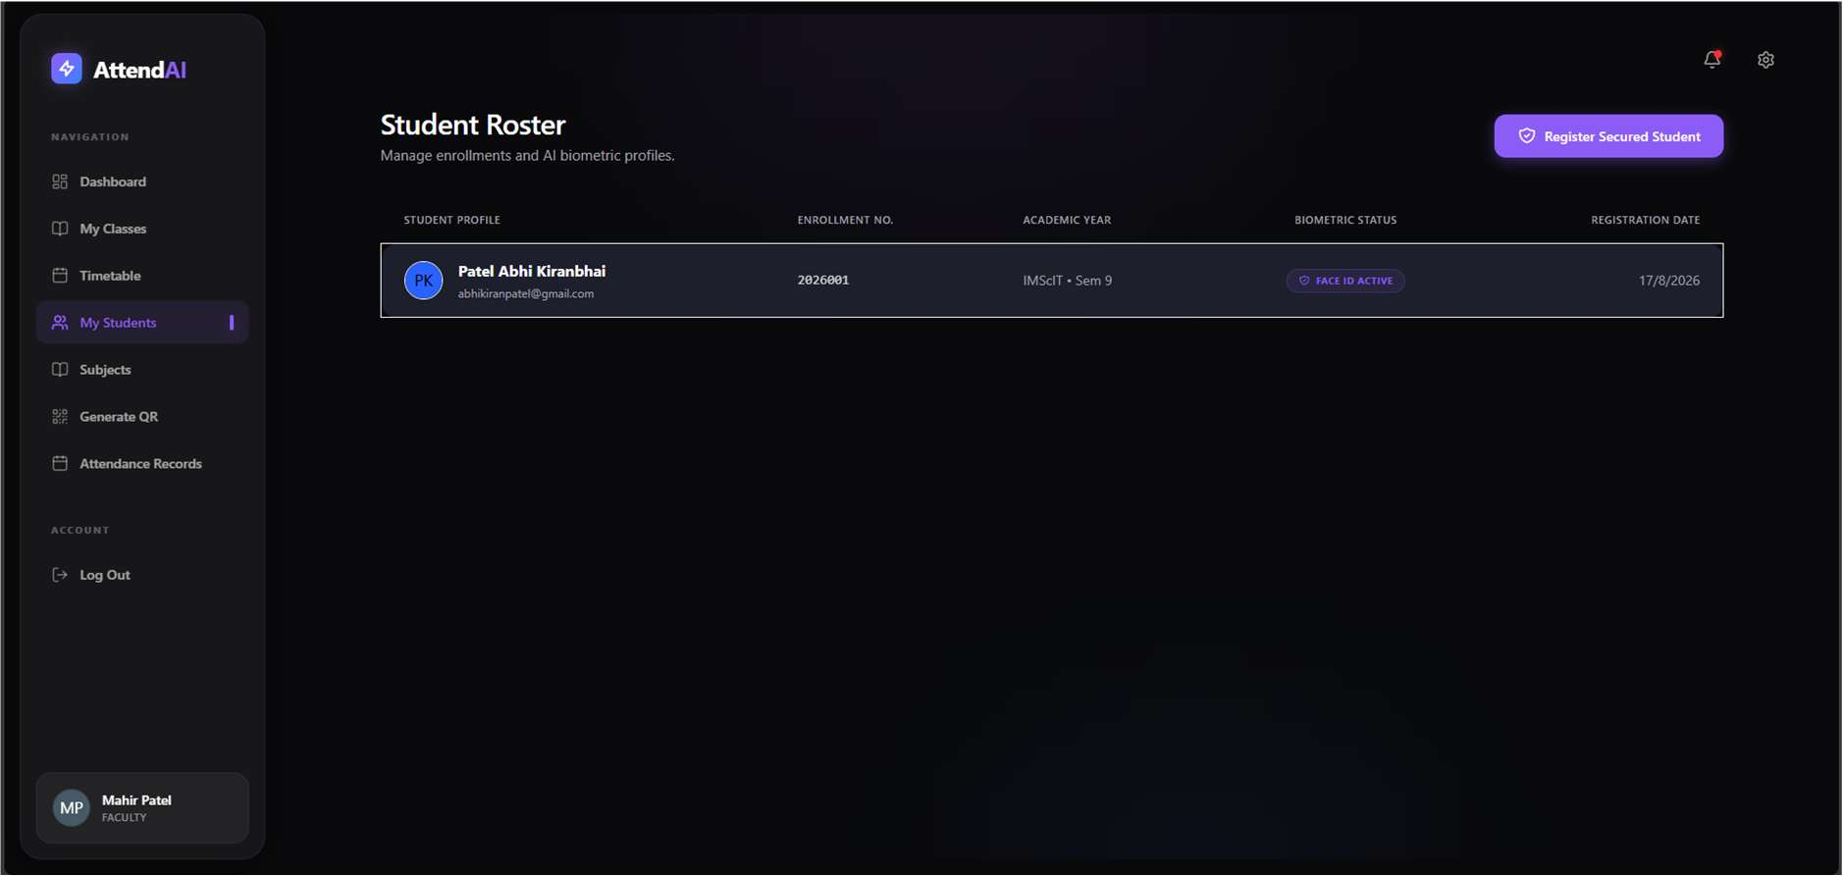
Figure 16: My Students

Generate QR
URL: http://localhost:5173/dashboard/qr
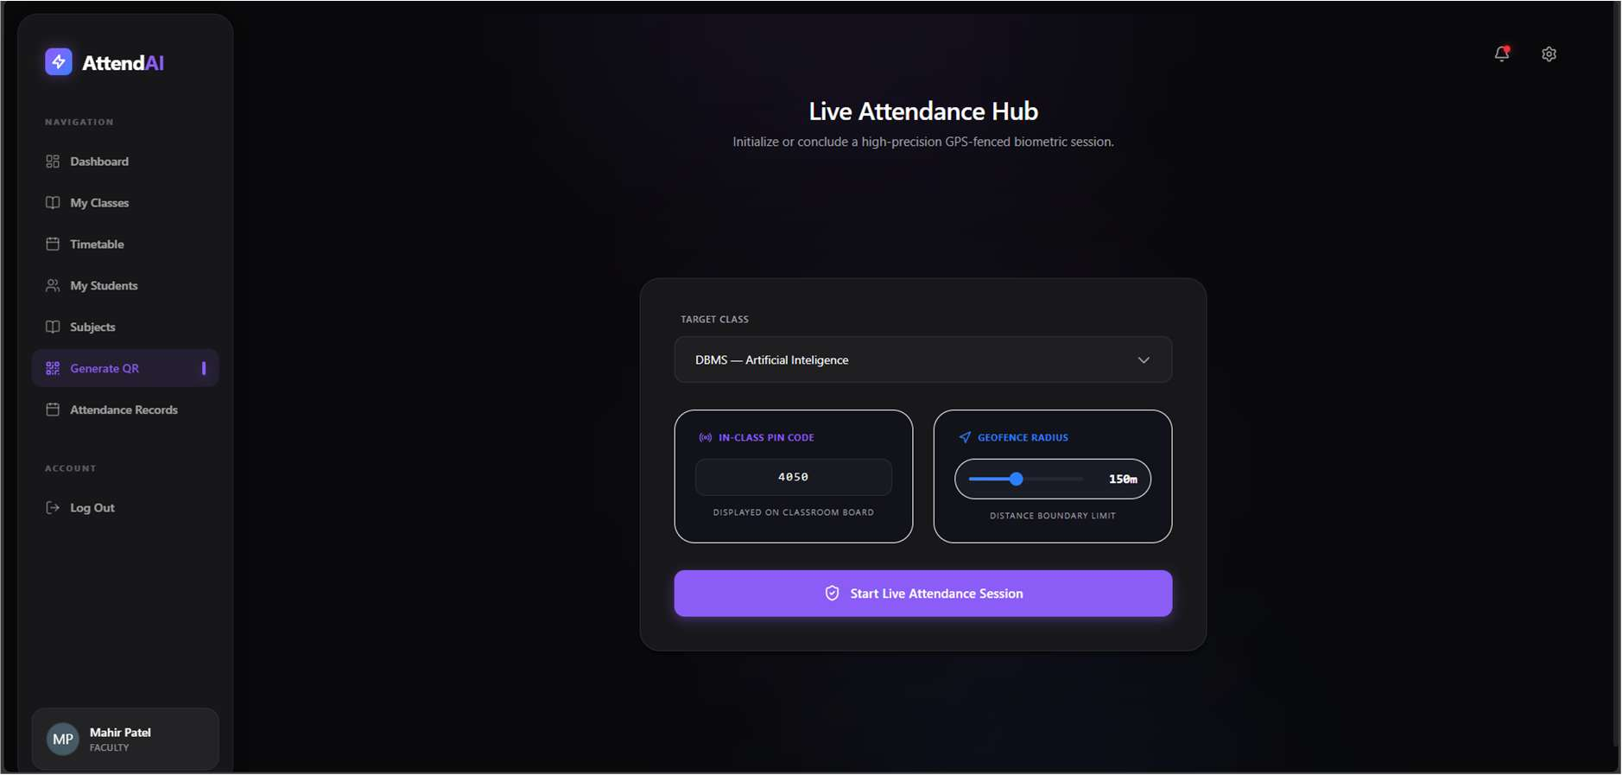
Figure 17: Generate QR
Subjects (Faculty)
URL: http://localhost:5173/dashboard/subjects
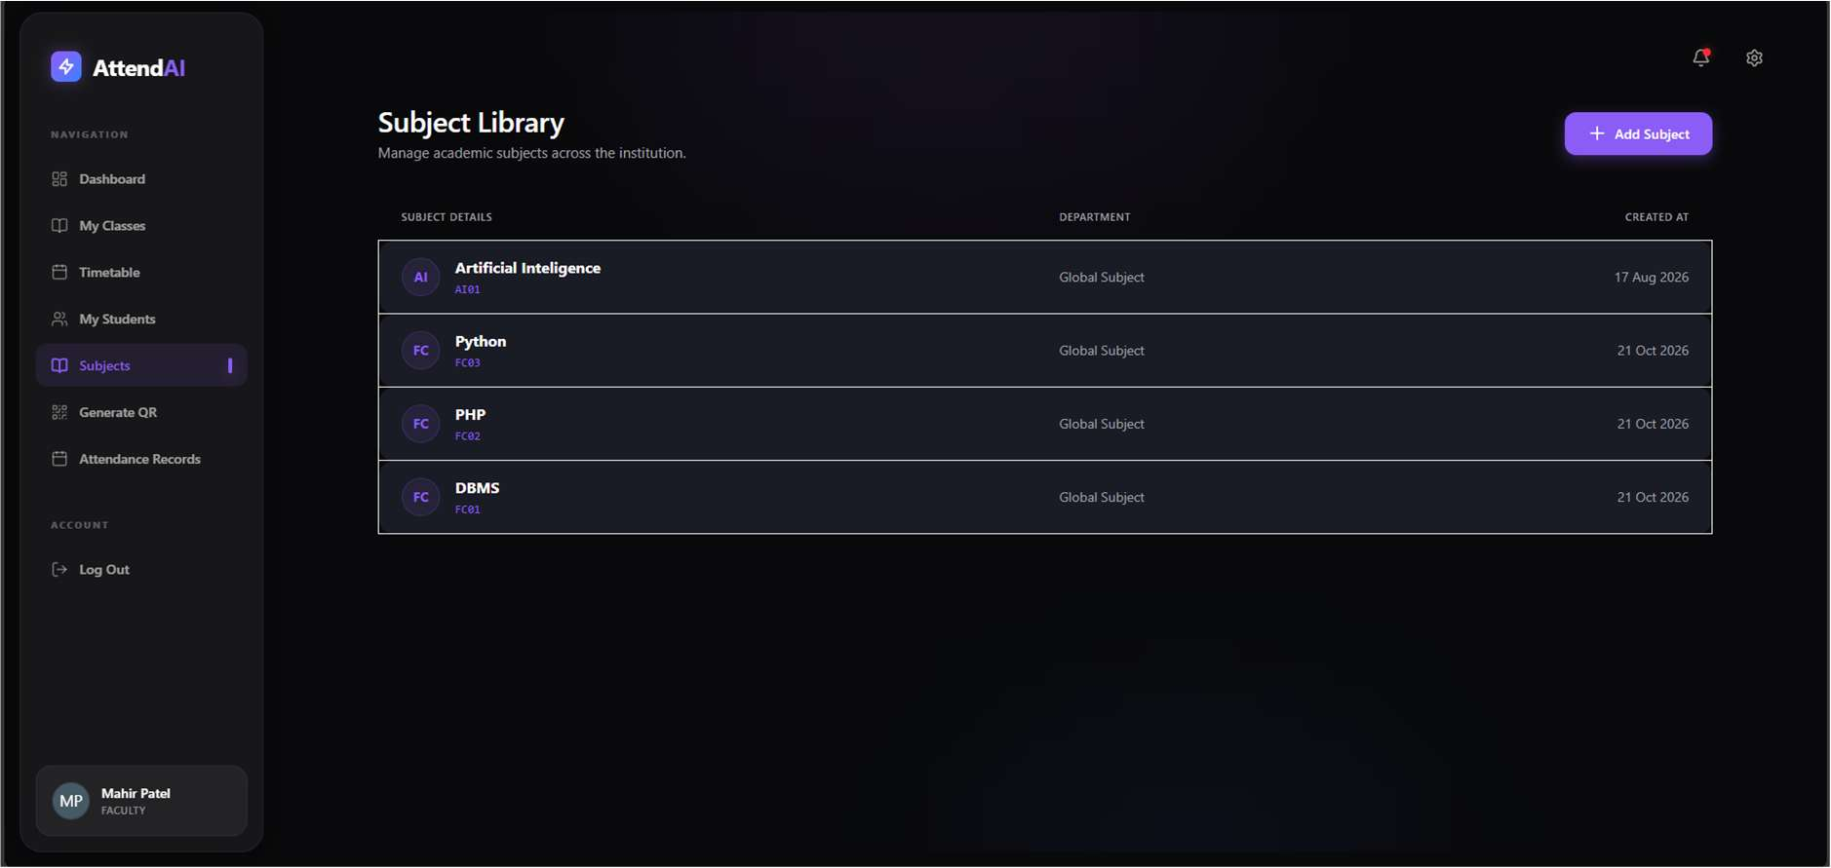
Figure 18: Subjects (Faculty)

7.3 Student Portal Screenshots
Student Dashboard
URL: http://localhost:5173/dashboard
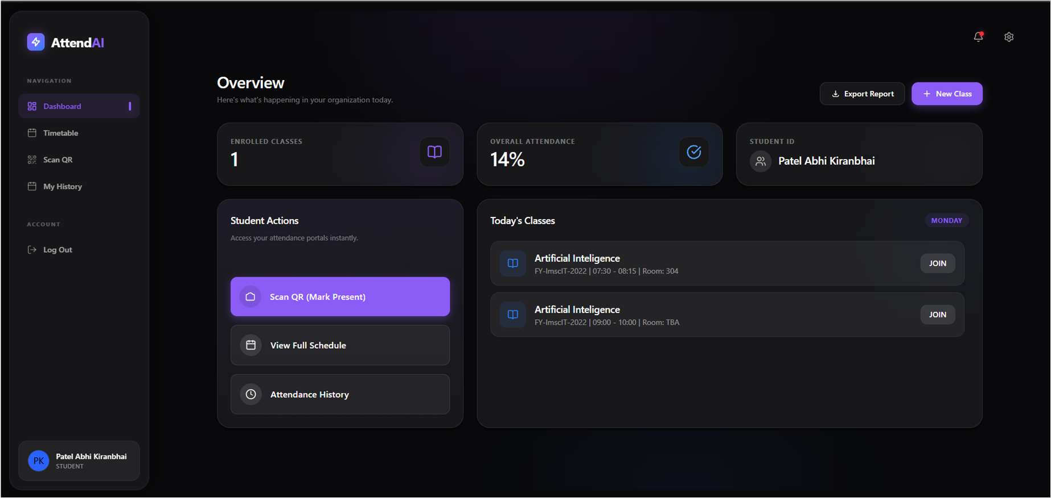
Figure 19: Student Dashboard
Register (Student)
URL: http://localhost:5173/register
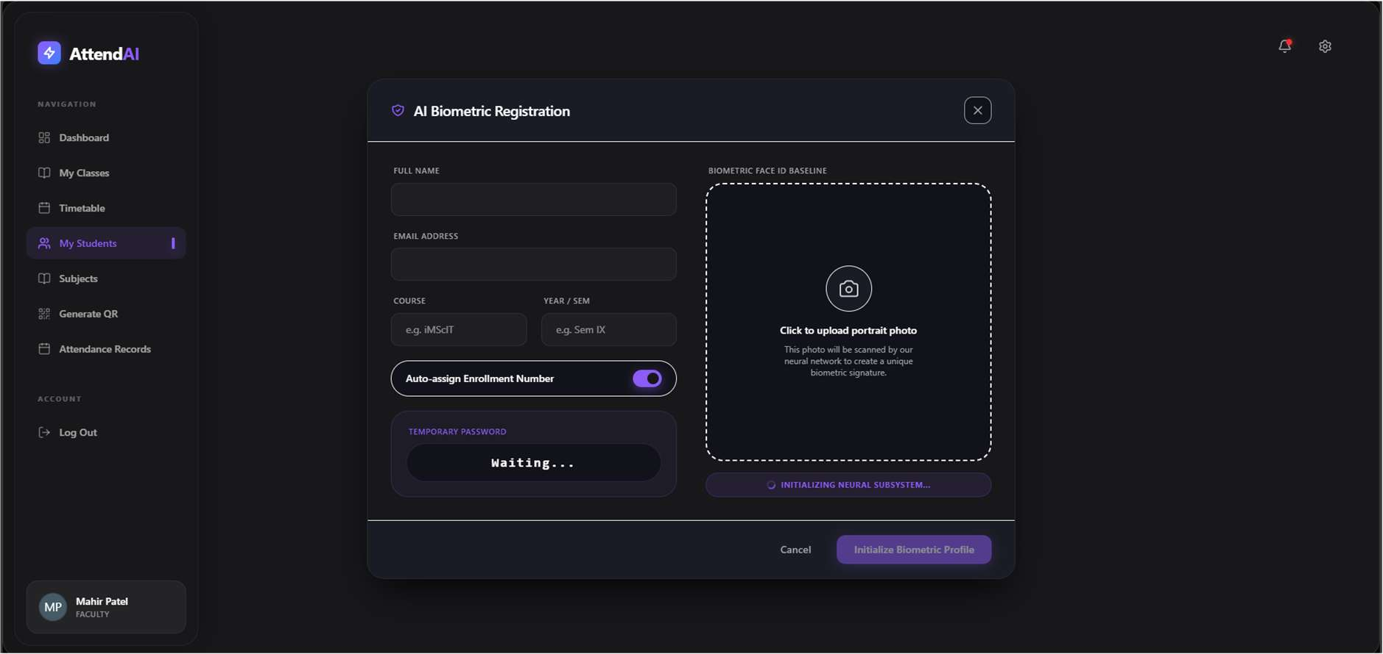
Figure 20: Register (Student)

Scan QR
URL: http://localhost:5173/dashboard/scan
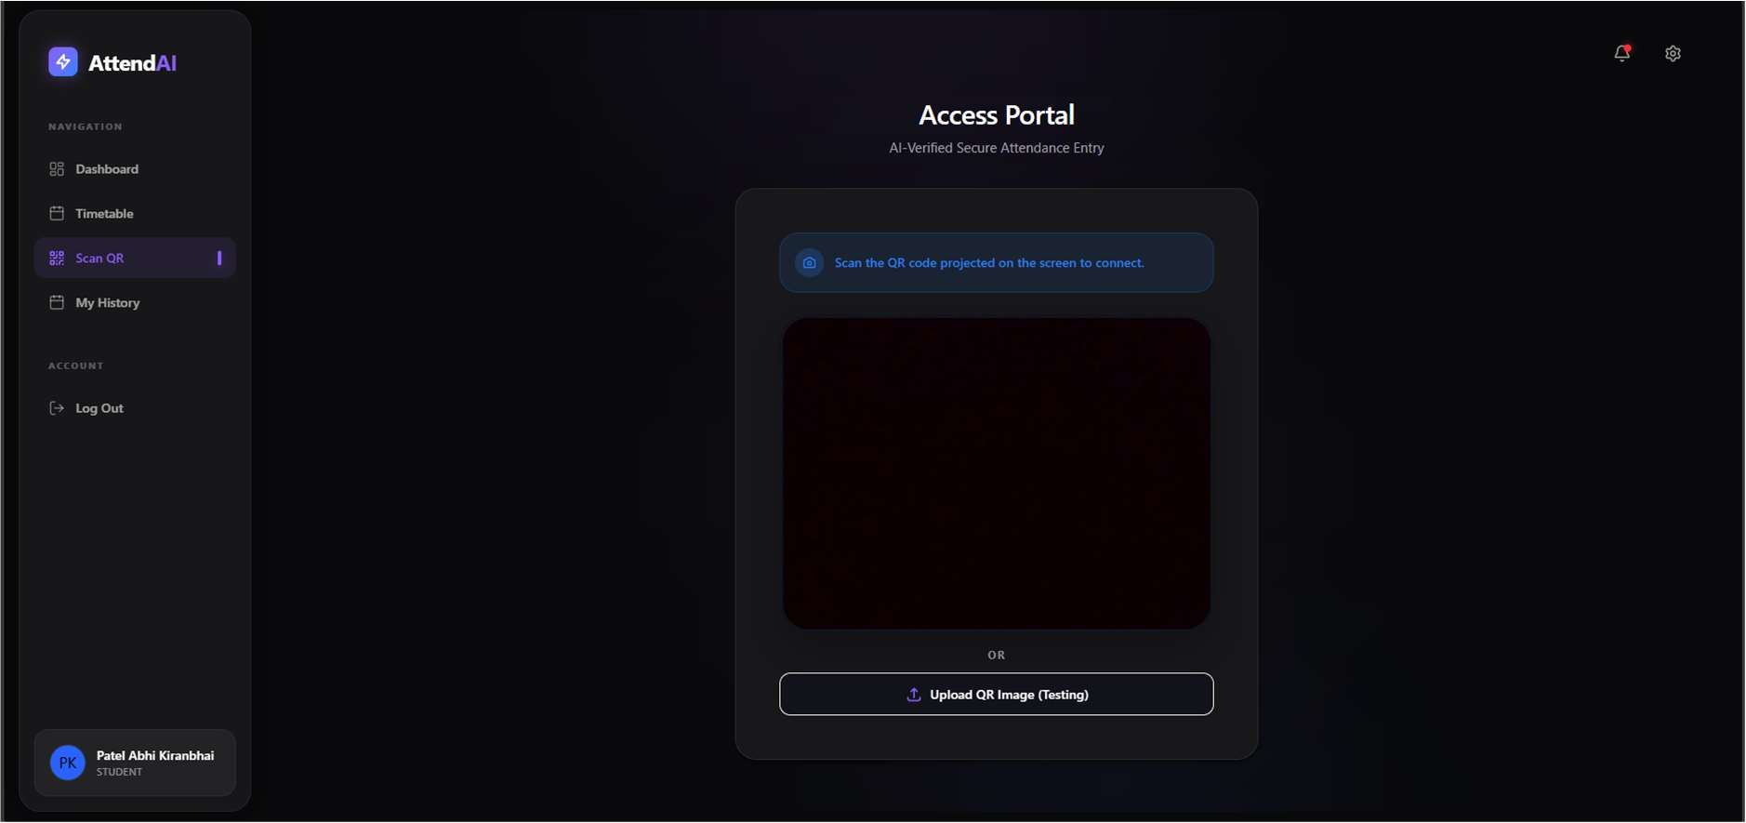
Figure 21: Scan QR
My History
URL: http://localhost:5173/dashboard/history
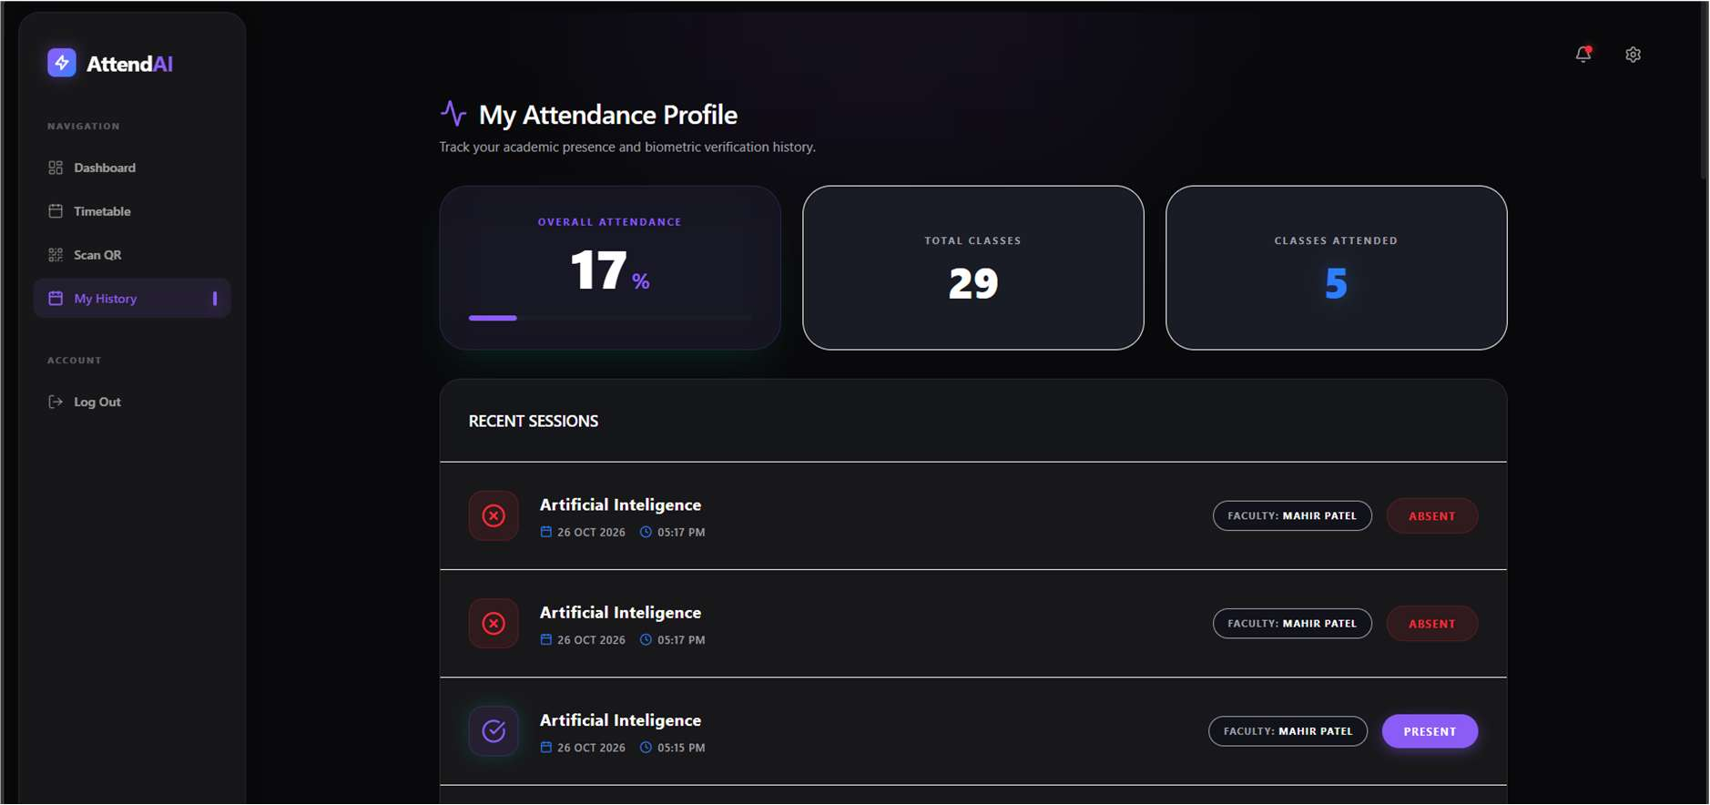
Figure 22: My History

7.4 Reports & Analytics Screenshots
Attendance Records with CSV Export (Faculty)
URL: http://localhost:5173/dashboard/records
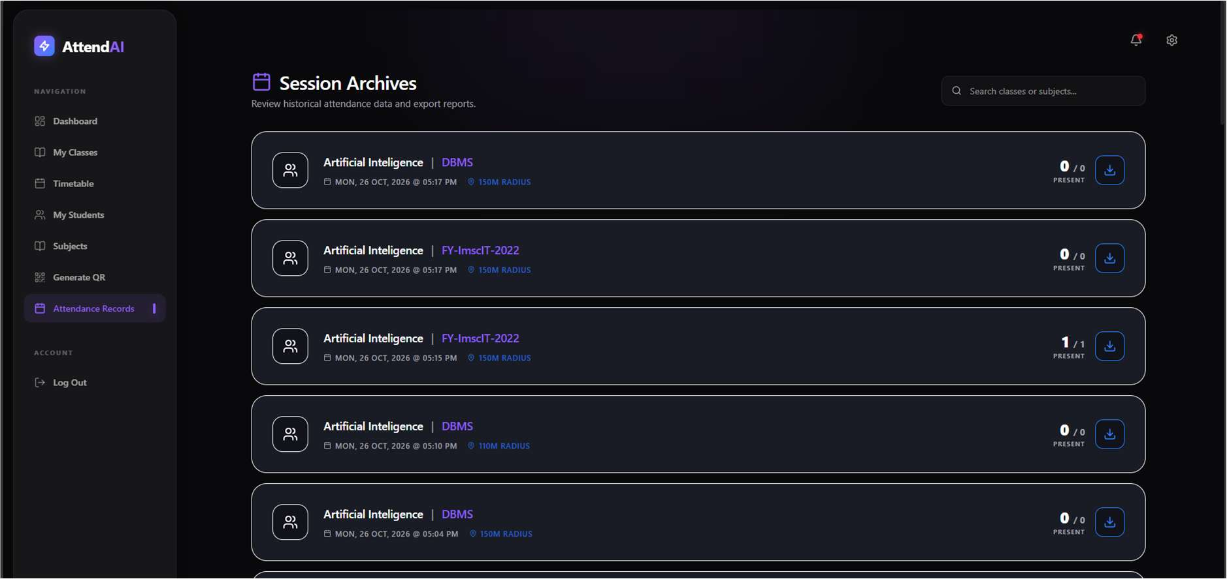
Figure 23: Attendance Records with CSV Export (Faculty)
Timetable Print Layout (PDF via browser print)
URL: http://localhost:5173/dashboard/timetable
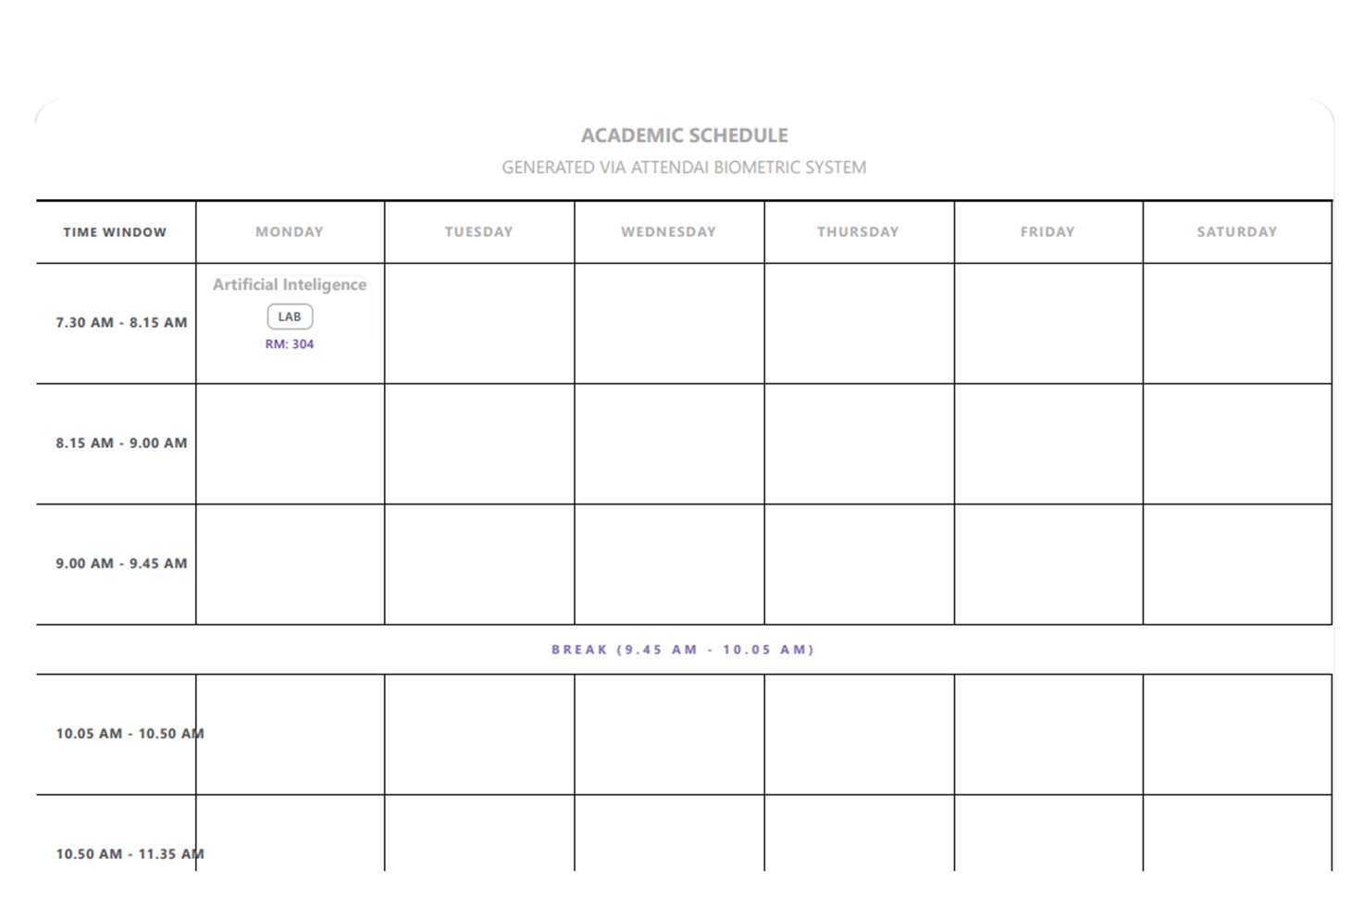
Figure 24: Timetable Print Layout (PDF via browser print)

8. References
[1] Express.js Documentation and Architectural Guidelines, https://expressjs.com/
[2] Mongoose ODM v9 Schema and Population Reference, https://mongoosejs.com/docs/
[3] MongoDB Atlas Cloud Database Documentation, https://www.mongodb.com/docs/
[4] React 19 Core Documentation and Server Components, https://react.dev/
[5] Vite 8 Frontend Build Tool Documentation, https://vite.dev/
[6] face-api.js: JavaScript API for Face Detection and Recognition in the Browser with TensorFlow.js, https://github.com/justadudewhohacks/face-api.js/
[7] JSON Web Token (JWT) Architecture, RFC 7519, Internet Engineering Task Force (IETF), https://www.rfc-editor.org/rfc/rfc7519
[8] Haversine Formula for Great-Circle Distance Computations over Earth's Surface, R. W. Sinnott, Sky and Telescope, 1984.
[9] jsPDF & jspdf-autotable Vectorized Client-Side Document Generation Library, https://github.com/parallax/jsPDF
[10] Object Management Group (OMG), Unified Modeling Language (UML) Specification Version 2.5.1, https://www.omg.org/spec/UML/

