End-to-End Retail Performance and Behavioural Analytics

-Abhinav Davu

Table of contents:
- Introduction
- Problem Statement
- Objectives
- Methodology
- Data Collection
- Data Cleaning
- Data Visualization
- Program Code
- SQL code
- Visualization Overview
- Key Findings
- Summary
- Conclusion

- Introduction:

The retail industry is rich in data but extracting actionable insights from complex, multi-source information remains a challenging task. This project focuses on transforming raw sales, returns, product, store, and customer data into a unified, reliable dataset ready for analysis. By addressing common real-world issues such as missing values, inconsistent IDs, and date formatting errors, the project ensures that downstream business intelligence is both accurate and trustworthy.

Using Python for data cleaning and Power BI for interactive visualization, the project delivers a comprehensive dashboard that highlights total revenue, sales quantity, return patterns, and store profitability. These analytics empower stakeholders to understand business performance at a glance, identify growth opportunities, and make data-driven decisions across all channels and regions.

- Problem Statement:

Retailers often face challenges such as unclear sales trends, unbalanced inventory, high return rates, and difficulty in identifying top/bottom-performing stores. Accurate, timely, and actionable insights into these areas are key to maximizing revenue and profitability.

Challenges:
- Missing store id’s and inconsistent data entries.
- Messy or inconsistent data formats.
- Difficulty tracking sales, profit and returns across multiple periods/ channels/regions.

3. Objectives:

- Clean and integrate multi-source retail data (sales, products, stores, returns, customers).
- Analyse total sales quantity, revenue, top categories/products, returns, and store profitability.
- Develop an interactive Power BI dashboard for dynamic business intelligence.
- Provide recommendations for process improvement based on analytic findings.

4.Methodology:
- Data Collection:
- Sources: CSV files for sales, returns, product catalog, store and customer master data.
- Key features: order dates, store and product IDs, sales and return channels, product categories, unit prices, store regions.

- Key Data Sources:
- Sales Data: Detailed order transactions, including order date, product and store IDs, sales channel, quantity, price, and discount.
- Returns Data: Product returns records with reference to order and product, store, customer IDs, date, and return reason.
- Products Data: Product catalog with attributes such as product name, category, and price.
- Stores Data: Store master list including store ID, region, and type.
- Customers Data: Customer demographic and segmentation details.

- Dataset Structure:
The dataset includes the following key attributes:
- Sales, returns, stores, products, and customers datasets are organized as follows:

- Each table is identified by a unique key (e.g., order_id, product_id, store_id, customer_id).

- Dates standardized to datetime format for time series analysis.

- Relational links established between tables (sales and returns reference store, customer, and product master tables).

- Cleaned, merged, and prepared for effective Power BI analysis and dashboarding.

- Data Cleaning:

- Handled missing values (e.g., blank store IDs for online sales; filled with dummy stores).

- Checked and resolved mismatches across tables (store/product/customer presence).

- Ensured date columns were in datetime format, enabled derived month/year info.

- De-duplicated rows; removed obvious outliers (e.g., negative sales)..

- Steps Taken:
- Missing Values:
- Checked for missing values in key columns (e.g., store_id, product_id, customer_id) using Python’s isnull().
- Imputed missing numerical values (e.g., quantity, unit price) with mean or median; filled categorical blanks with mode

- Duplicate Records:
- Removed duplicate rows in sales and returns data to prevent overcounting transactions.

- Data Consistency:
- Checked that product, store, and customer IDs in sales/returns matched
- Standardized date formats and verified order dates were valid for time-series analysis.

- Data Integration:
- Merged sales, returns, products, stores, and customers datasets using their unique IDs to build a clean, unified data model.

- Data Visualization
Exploratory Data Analysis (EDA) helps uncover trends, patterns, and anomalies in the dataset. Visualization plays a vital role in understanding data relationships.

Key Visualizations:
- Used Power BI to visualize:
  - Total quantity/revenue and by time/store/product.
  - Store-wise and region-wise profitability.
  - Top returned products by category, monthly and regional return behavior.
  - Interactive slicing/filtering on month, category, store, and region.

- Feature Engineering
Created derived columns for profit, revenue, and monthly aggregations for business intelligence analysis.

- Key Features:
- Total Revenue has been identified.
- Total Quantity Sold.
- Most profitable stores and regions identified
- Return analysis: Identified top returned products, return-prone categories, and high-return regions.
- Profitability trends: Monthly profit breakdown by store
- Insights into sales channel performance, seasonality, and product lifecycle

- Time-Based Aggregations
- Added monthly and year-to-date rolling averages for sales, revenue, and returns to detect seasonality and trends.
- Historical Sales and Return Features
- Created lag features such as previous month’s sales, returns, and profit for stores and products to analyze momentum and assess changes over time.
- Profitability and Efficiency Metrics
- Calculated new fields like profit margin, sales-to-return ratio, and average revenue per transaction to measure business performance.
- Product, Store, and Channel Encoding
- Transformed categorical variables (product category, store type, region, sales channel) using label encoding and one-hot encoding for clearer reporting and analysis.

- Customer Segmentation
- Developed customer-based features—like age group, demographic segment, region—for deeper understanding of buyer behavior and targeted insights.

5.Program Code
- Importing needed libraries
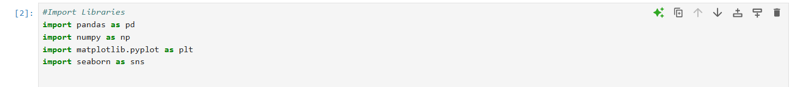
- Reading CSV File
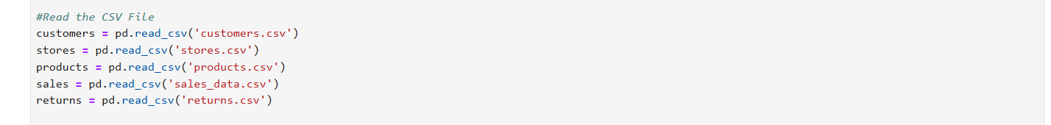

- Initial Data Exploration

- Handling Missing Values and Duplicates
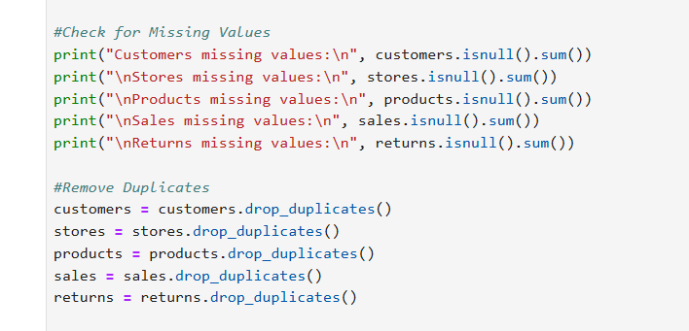

- Exploratory Data Analysis
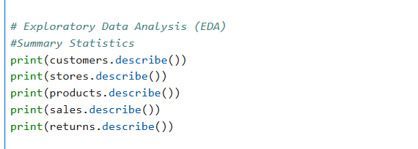


- Derived Columns

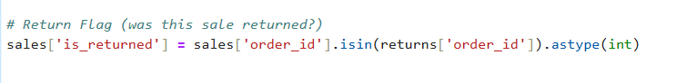



- Saving the cleaned data


6. SQL Code
- Database Structure
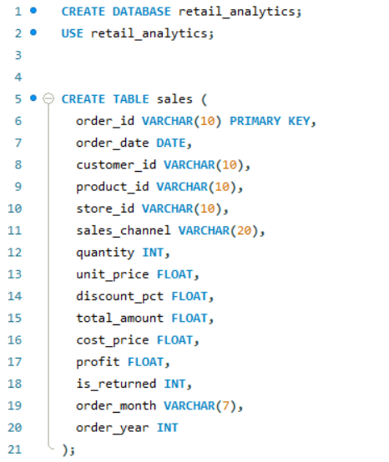
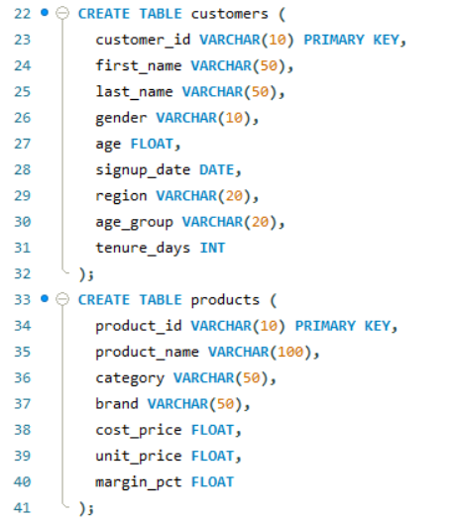
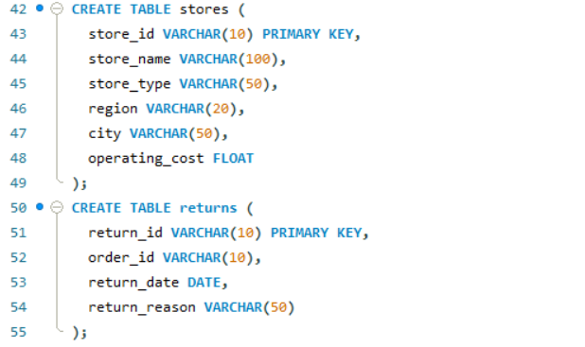
- Data Integrity and Relationships
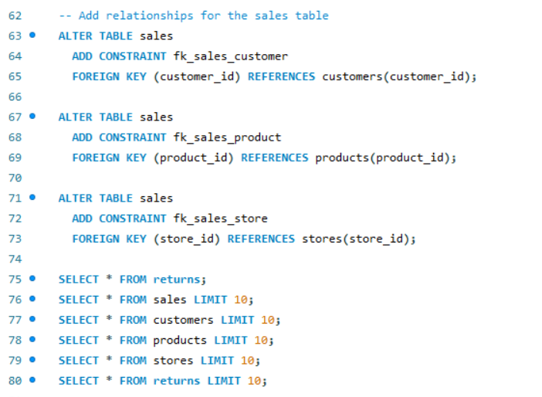

- Derived Metrices
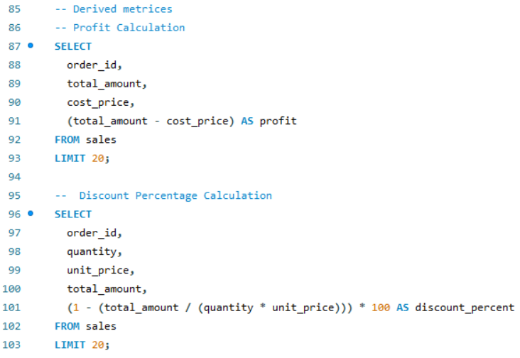
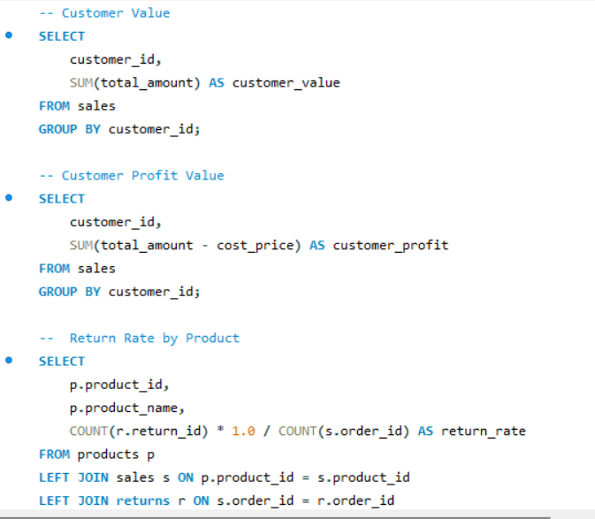
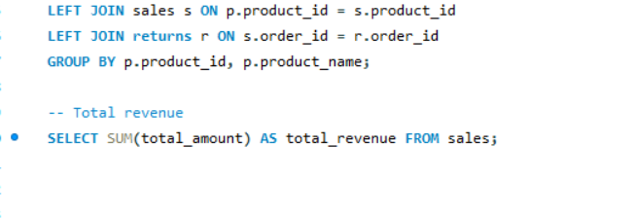

- Business Questions
1.
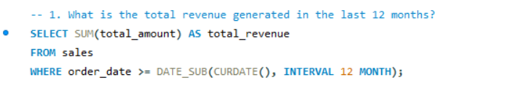
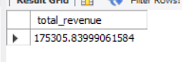

2.
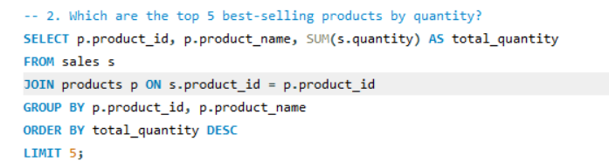
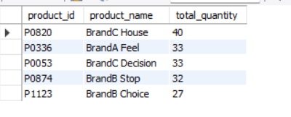
3.
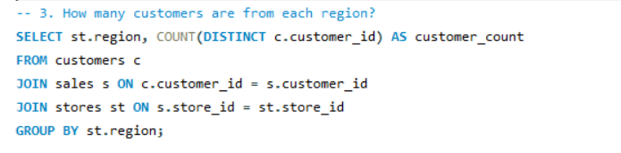
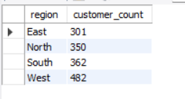
4.
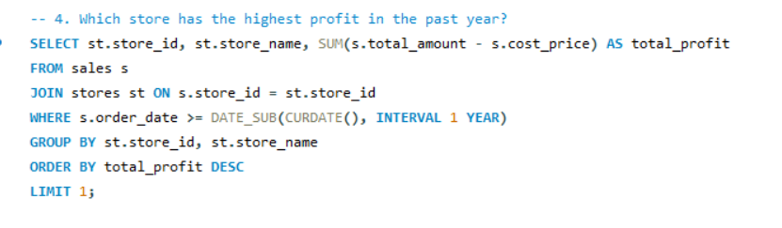
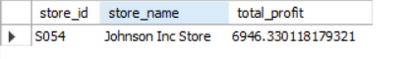

5.
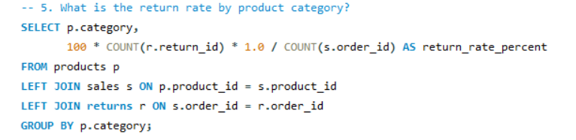
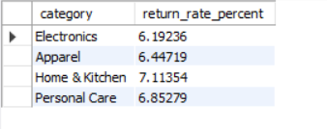

6.
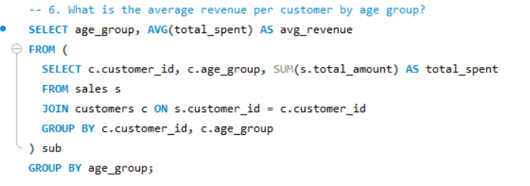
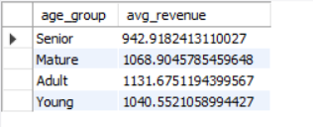

7.
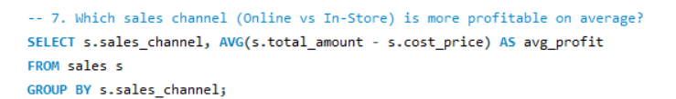
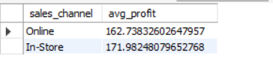
8.
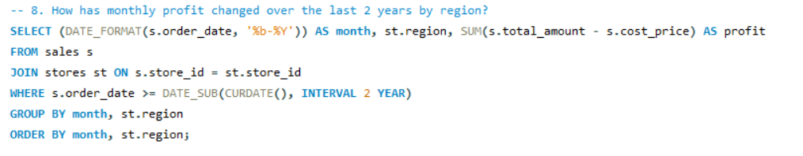
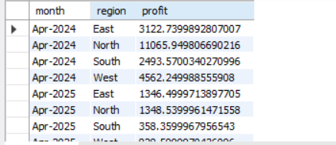

9.
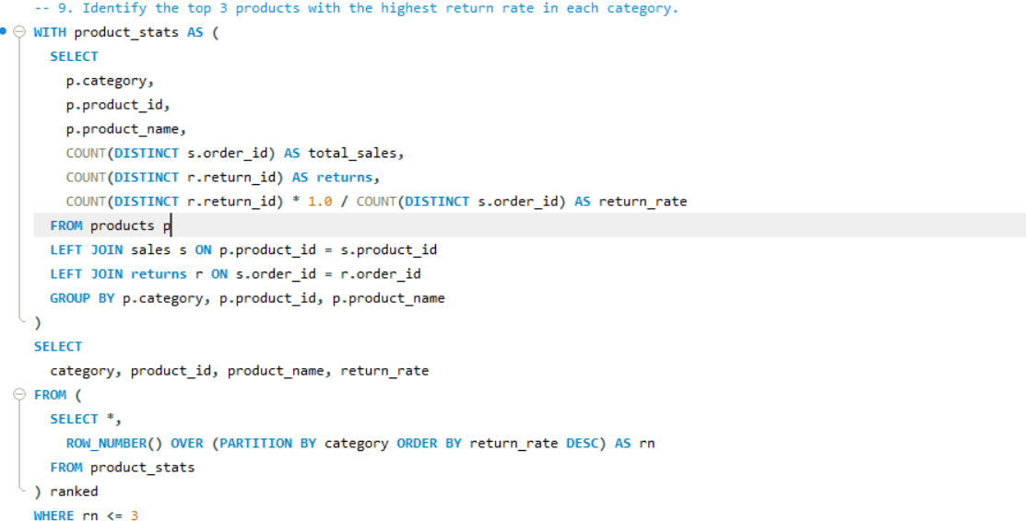
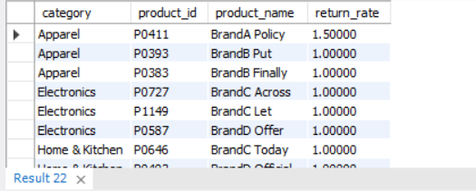

10. 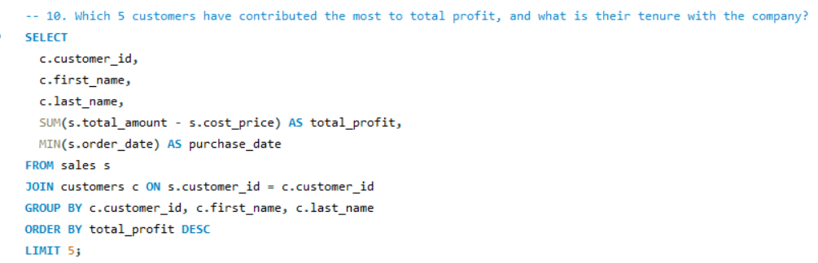
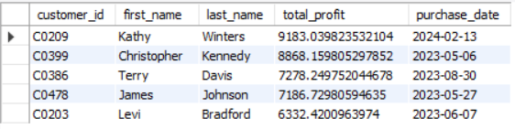

7. Visualization Overview

- Sales Overview report
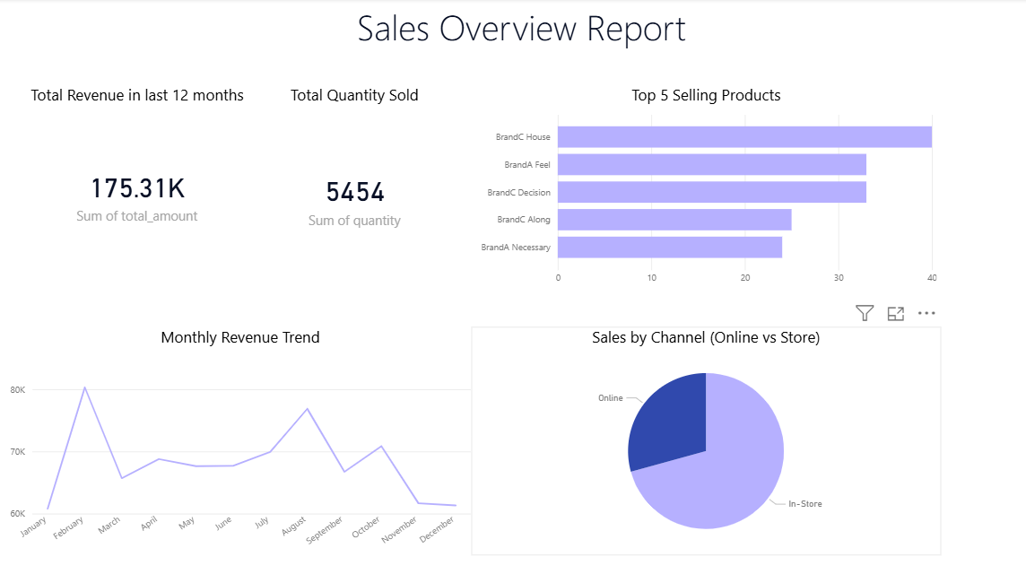

- Visualization for Customer Insights
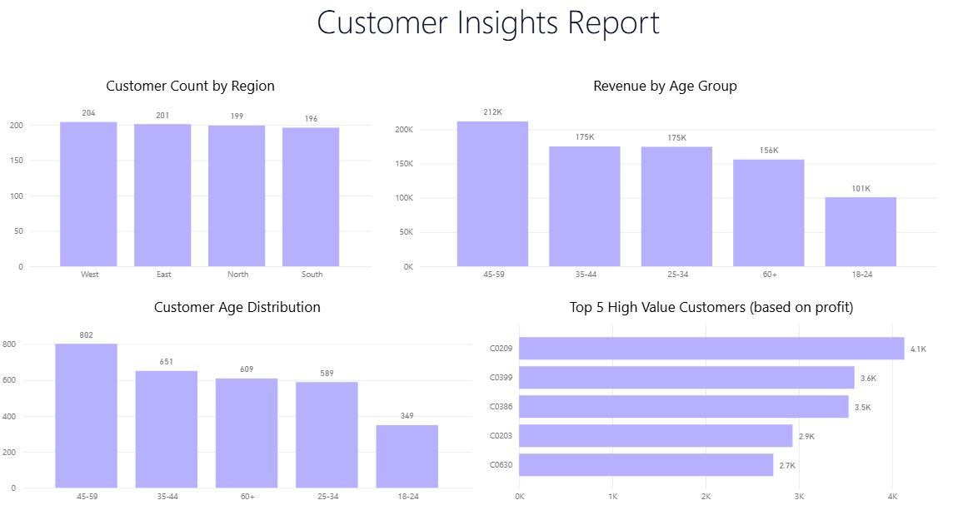

- Visualizations on Product performance
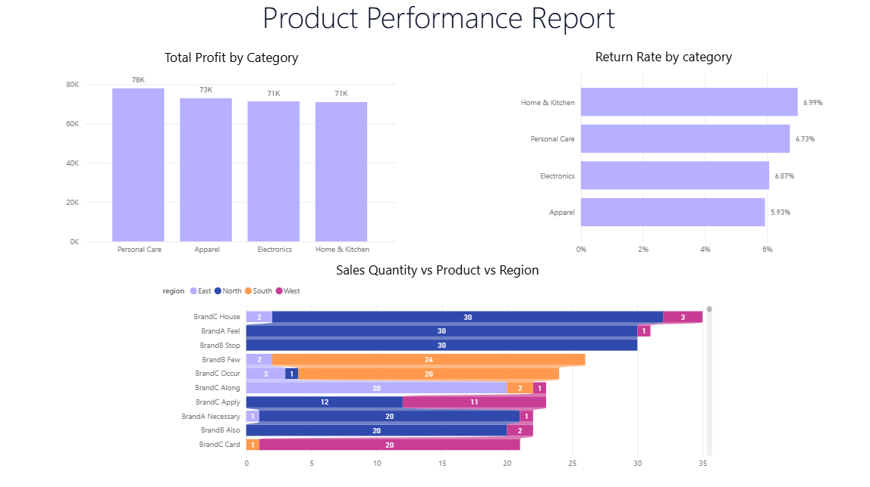

- Store Analysis Visualization
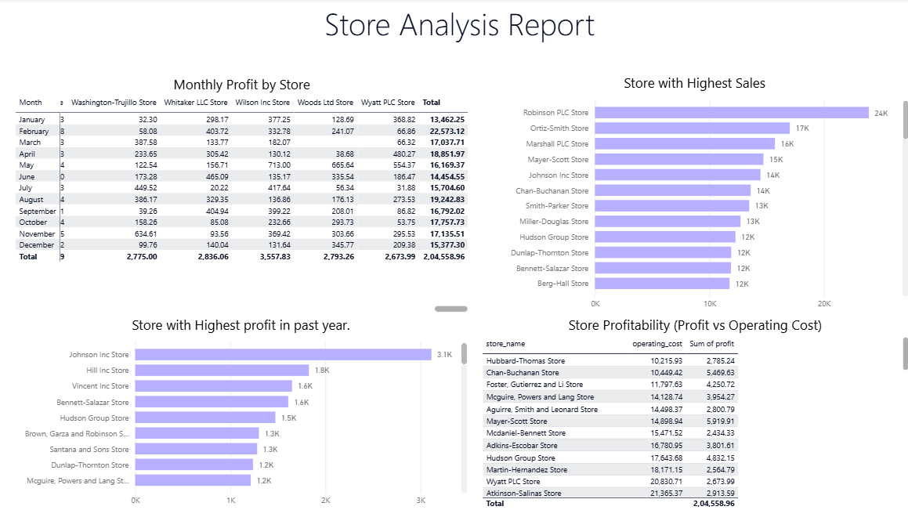

- Returns Analysis Visualization
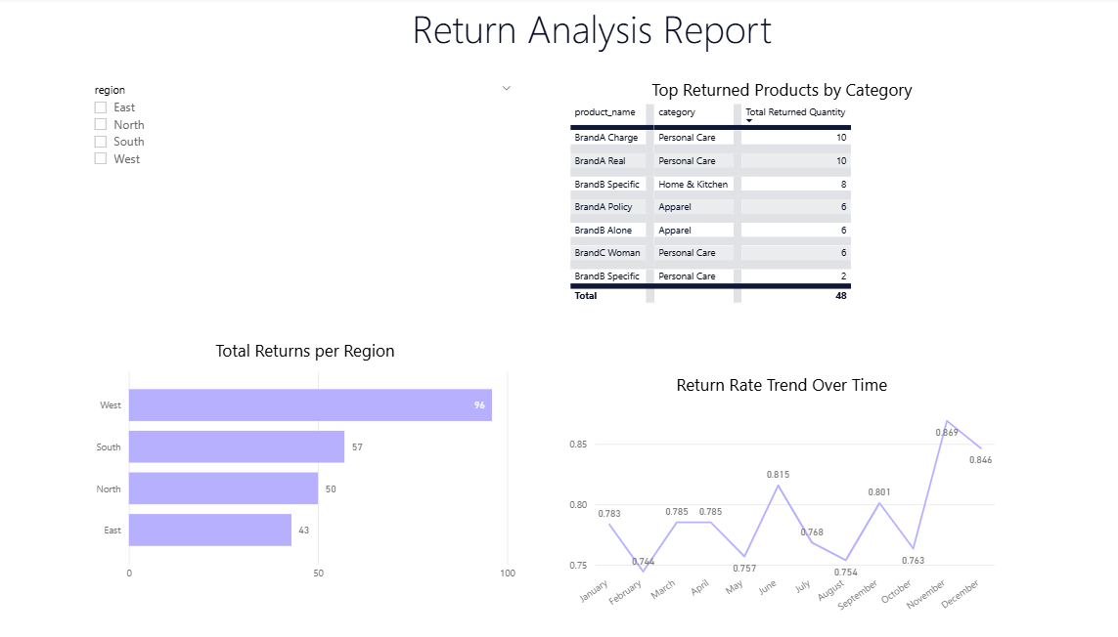

8. Key Findings
- Sales Channels: Online sales account for a significant share of total revenue, but in-store purchases remain strong.
- Profit Drivers: Store and region differences impact overall profitability.
- Returns Analysis: Specific products and categories show higher return rates, indicating quality or fit issues.

9. Summary
This project focused on end-to-end retail data analysis, with final dashboards in Power BI. First, data from multiple files—sales, customers, products, stores, and returns—was cleaned and validated. Necessary columns were formatted (e.g., dates, numeric types), missing values were addressed, and new derived columns for profit and customer segments were created.
A relational data model was established, linking orders, returns, products, and regional information. Using SQL and Power BI, the analysis explored sales and return trends, regional and product-wise performance, and customer value distribution. Visualizations highlighted top selling and most returned products, return rate patterns, sales channel proportions, and profit distribution across regions.
10. Conclusion

This project demonstrated a comprehensive approach to retail analytics, combining data cleaning, integration, and advanced analysis using Python, SQL, and Power BI. Sales, returns, and customer data were successfully modeled to reveal key business trends and actionable insights. The findings provide a strong foundation for data-driven decisions targeting product quality, customer value, and regional performance. Overall, the project highlights the impact of robust data management and visualization in improving business strategy and operational efficiency.

