**DAA ASSIGNMENT-3**



**SUBMITTED TO:**

**PROF. SUBHASH TATALE**

**VISHWAKARMA INSTITUTE OF INFORMATION TECHNOLOGY, PUNE**

**COMPUTER ENGINEERING DEPARTMENT**

**BY:**

**NAME: ABHISHEK MORE**

**G.R NO.: 21810033**

**ROLL NO.: 323036**

**CLASS: T.Y COMP**

**BATCH: COMP C2**

**Assignment-3**

**Aim:**

Implement Dynamic programming approach to find the cost of OBST.

**Objective:**

Our objective is to find the cost of OBST using Dynamic approach.

**Source code:**

**package** assignment3_OBST;

**import** java.util.Scanner;

**public** **class** OBST

{

**static** **int** optimalSearchTree(**int** keys[], **int** freq[], **int** n)

{

**int** cost[][] = **new** **int**[n + 1][n + 1];

**for** (**int** i = 0; i < n; i++)

{

cost[i][i] = freq[i];

}

**for** (**int** L = 2; L <= n; L++)

{

**for** (**int** i = 0; i <= n - L + 1; i++)

{

**int** j = i + L - 1;

cost[i][j] = Integer.***MAX_VALUE***;

**for** (**int** r = i; r <= j; r++)

{

**int** c = ((r > i) ? cost[i][r - 1] : 0) + ((r < j) ? cost[r + 1][j] : 0) + *sum*(freq, i, j);

**if** (c < cost[i][j])

{

cost[i][j] = c;

}

}

}

}

**return** cost[0][n - 1];

}

**static** **int** sum(**int** freq[], **int** i, **int** j)

{

**int** s = 0;

**for** (**int** k = i; k <= j; k++)

{

**if** (k >= freq.length)

**continue**;

s += freq[k];

}

**return** s;

}

**public** **static** **void** main(String[] args)

{

Scanner sc=**new** Scanner(System.***in***);

**int** size = sc.nextInt();

**int** key=0, fre=0;

**int** keys[] = **new** **int**[size];

**int** freq[] = **new** **int**[size];

**for**(**int** i=0; i<size; i++)

{

key=sc.nextInt();

fre=sc.nextInt();

keys[i]=key;

freq[i]=fre;

}

System.***out***.println("Cost of Optimal BST is " + *optimalSearchTree*(keys, freq, size));

}

}

**Output:**

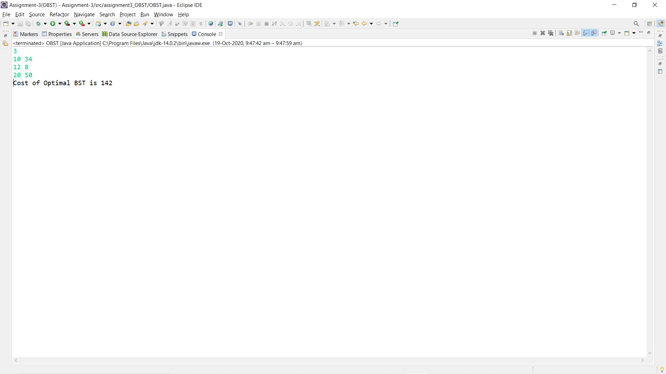

**Conclusion:**

Successfully found the cost of optimal cost of BST using dynamic programming approach.