PL/SQL Programming

Exercise 1: Control Structures – Bank Scenarios
This document contains PL/SQL scripts to simulate three real-world banking operations using control structures like loops and conditionals.
Note: The following programs are written and executed using Oracle Live SQL for demonstration and practice purposes.

🔧 Step 1: Create Tables
Create customers table
CREATE TABLE customers (
customer_id NUMBER PRIMARY KEY,
name VARCHAR2(50),
age NUMBER,
balance NUMBER(10,2),
isVIP VARCHAR2(5) DEFAULT 'FALSE'
);
OUTPUT:
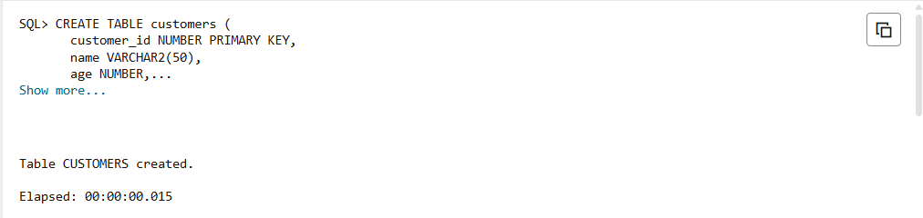

Create loans table
CREATE TABLE loans (
loan_id NUMBER PRIMARY KEY,
customer_id NUMBER,
interest_rate NUMBER(5,2),
due_date DATE,
FOREIGN KEY (customer_id) REFERENCES customers(customer_id)
);

📅 Step 2: Insert Sample Data
-- Insert customers
INSERT INTO customers VALUES (1, 'Abhiram', 65, 12000, 'FALSE');
INSERT INTO customers VALUES (2, 'Jaya', 45, 8000, 'FALSE');
INSERT INTO customers VALUES (3, 'Ravi', 70, 5000, 'FALSE');
INSERT INTO customers VALUES (4, 'Meena', 30, 15000, 'FALSE');
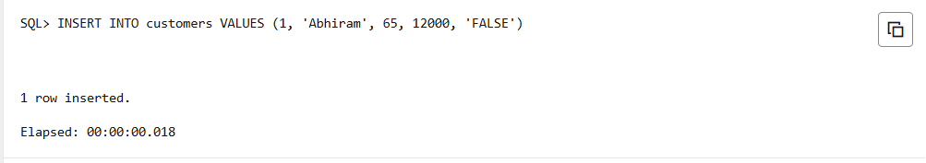
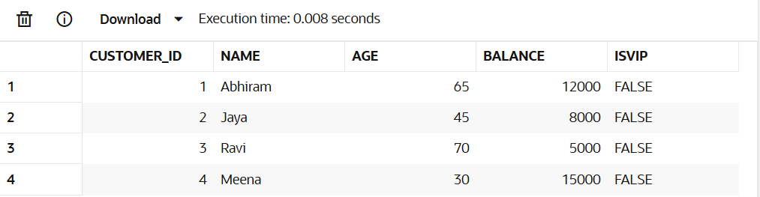
-- Insert loans
INSERT INTO loans VALUES (101, 1, 10.5, SYSDATE + 10);
INSERT INTO loans VALUES (102, 2, 9.5, SYSDATE + 40);
INSERT INTO loans VALUES (103, 3, 11.0, SYSDATE + 20);
INSERT INTO loans VALUES (104, 4, 8.0, SYSDATE + 5);

Scenario 1 – Apply 1% Discount for Customers > 60 Years Old
BEGIN
FOR cust IN (
SELECT c.customer_id, l.loan_id
FROM customers c
JOIN loans l ON c.customer_id = l.customer_id
WHERE c.age > 60
)
LOOP
UPDATE loans
SET interest_rate = interest_rate - 1
WHERE loan_id = cust.loan_id;
END LOOP;

COMMIT;
END;
/
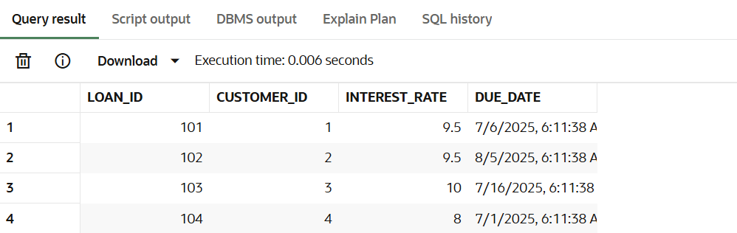

Scenario 2 – Mark Customers with Balance > $10,000 as VIP
BEGIN
FOR cust IN (
SELECT customer_id FROM customers WHERE balance > 10000
)
LOOP
UPDATE customers
SET isVIP = 'TRUE'
WHERE customer_id = cust.customer_id;
END LOOP;

COMMIT;
END;
/
OUTPUT:
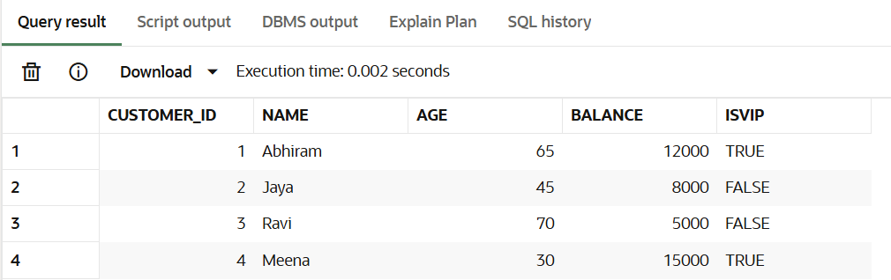

Scenario 3 – Print Reminders for Loans Due in Next 30 Days
BEGIN
FOR rec IN (
SELECT c.name, l.due_date
FROM loans l
JOIN customers c ON l.customer_id = c.customer_id
WHERE l.due_date BETWEEN SYSDATE AND SYSDATE + 30
)
LOOP
DBMS_OUTPUT.PUT_LINE('Reminder: Loan due for ' || rec.name || ' on ' || TO_CHAR(rec.due_date, 'DD-Mon-YYYY'));
END LOOP;
END;
/

OUTPUT:
