PL/SQL Programming
________________________________________________________
Exercise 3: Stored Procedures – Bank Scenarios
This document contains PL/SQL scripts to simulate real-world banking operations using stored procedures like interest calculation, bonus updates, and fund transfers.
Note: The following programs are written and executed using Oracle Live SQL for demonstration and practice purposes.
Step 1: Create Tables:
Create accounts table
CREATE TABLE accounts (
account_id NUMBER PRIMARY KEY,
customer_name VARCHAR2(50),
account_type VARCHAR2(20),
balance NUMBER
);
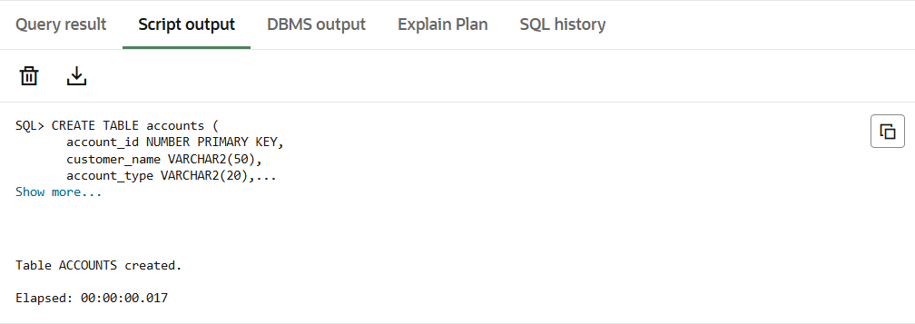
Create employees table
CREATE TABLE employees (
employee_id NUMBER PRIMARY KEY,
name VARCHAR2(50),
department_id NUMBER,
salary NUMBER
);
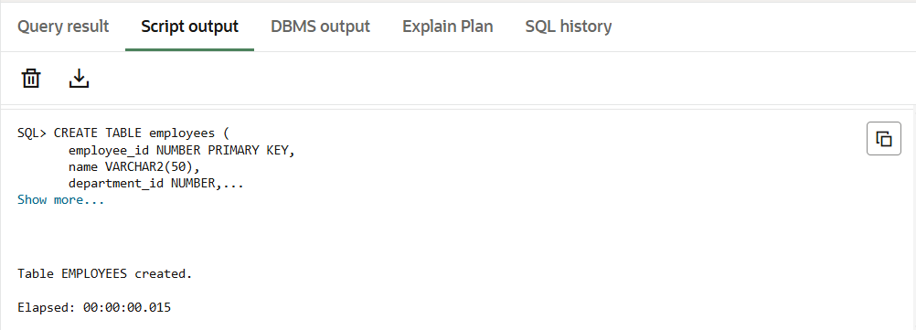
___________________________________________________________________________ Step 2: Insert Sample Data:
Insert into accounts
INSERT INTO accounts VALUES (101, 'Alice', 'Savings', 10000);
INSERT INTO accounts VALUES (102, 'Bob', 'Current', 15000);
INSERT INTO accounts VALUES (103, 'Charlie', 'Savings', 20000);
INSERT INTO accounts VALUES (104, 'David', 'Savings', 5000);
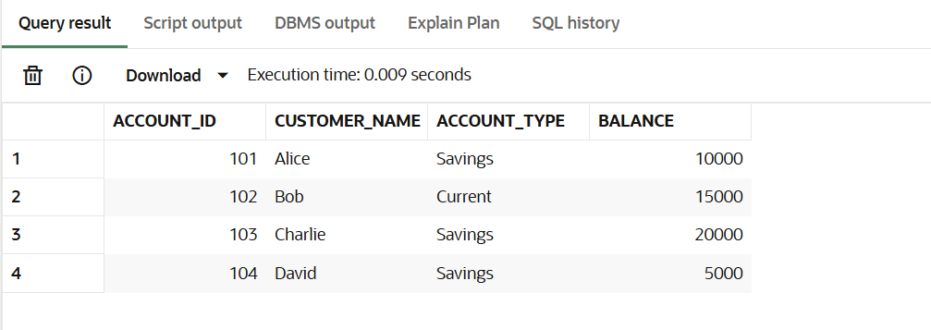
Insert into employees
INSERT INTO employees VALUES (1, 'John', 10, 30000);
INSERT INTO employees VALUES (2, 'Ravi', 10, 35000);
INSERT INTO employees VALUES (3, 'Priya', 20, 40000);
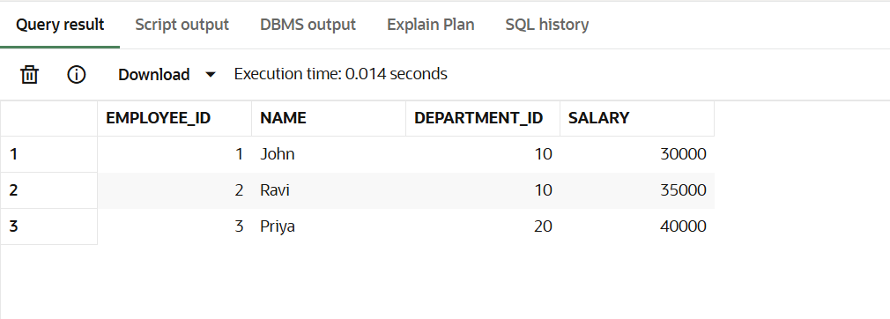
Scenario 1 – Process Monthly Interest for Savings Accounts:
CREATE OR REPLACE PROCEDURE ProcessMonthlyInterest IS
BEGIN
UPDATE accounts
SET balance = balance + (balance * 0.01)
WHERE account_type = 'Savings';

COMMIT;
END;
/
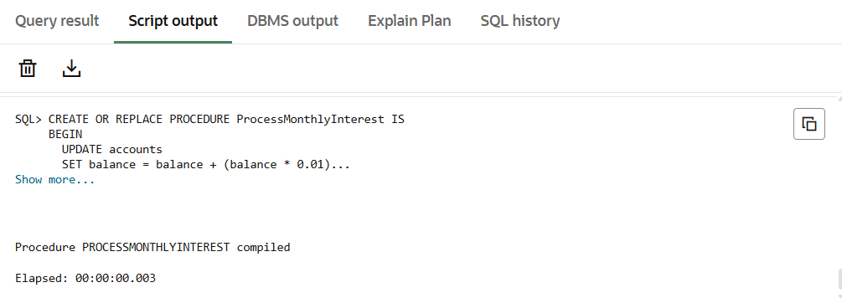
Scenario 2 – Update Employee Bonus by Department
CREATE OR REPLACE PROCEDURE UpdateEmployeeBonus (
dept_id IN NUMBER,
bonus_percent IN NUMBER
) IS
BEGIN
UPDATE employees
SET salary = salary + (salary * bonus_percent / 100)
WHERE department_id = dept_id;

COMMIT;
END;
/
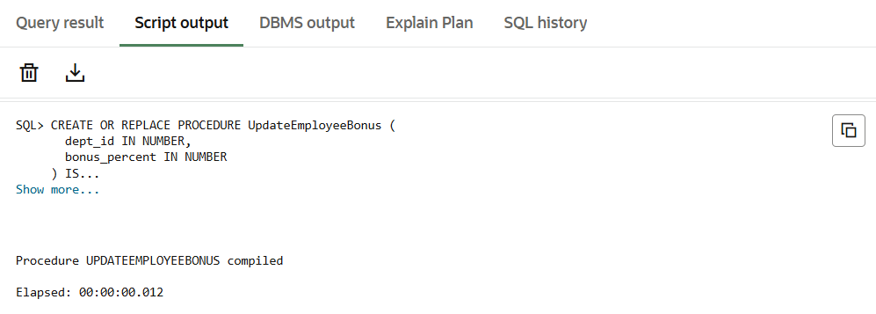
Scenario 3 – Transfer Funds Between Accounts
CREATE OR REPLACE PROCEDURE TransferFunds (
from_account IN NUMBER,
to_account IN NUMBER,
amount IN NUMBER
) IS
insufficient_balance EXCEPTION;
BEGIN
-- Check balance first
DECLARE
available_balance NUMBER;
BEGIN
SELECT balance INTO available_balance
FROM accounts
WHERE account_id = from_account;

IF available_balance < amount THEN
RAISE insufficient_balance;
END IF;

UPDATE accounts
SET balance = balance - amount
WHERE account_id = from_account;

UPDATE accounts
SET balance = balance + amount
WHERE account_id = to_account;

COMMIT;
END;

EXCEPTION
WHEN insufficient_balance THEN
DBMS_OUTPUT.PUT_LINE('Transfer failed: Insufficient balance.');
ROLLBACK;
WHEN OTHERS THEN
DBMS_OUTPUT.PUT_LINE('Transfer failed: ' || SQLERRM);
ROLLBACK;
END;
/
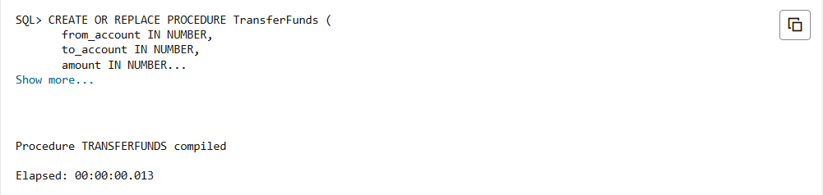

>>>EXEC ProcessMonthlyInterest;
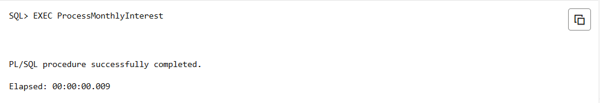
>>> EXEC UpdateEmployeeBonus(10, 10);
>>> EXEC TransferFunds(103, 102, 3000);
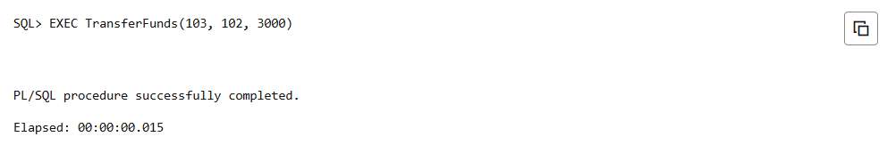
Accounts Table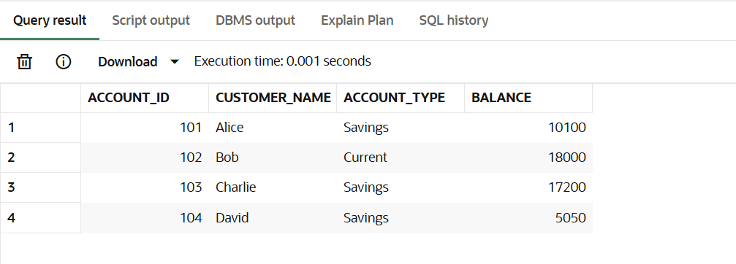
Employees Table
