1.Git-HOL OUTPUT
Git Commands with Outputs:
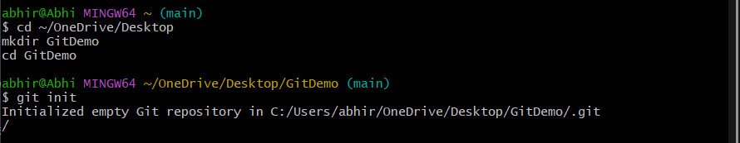
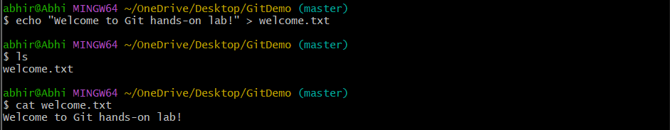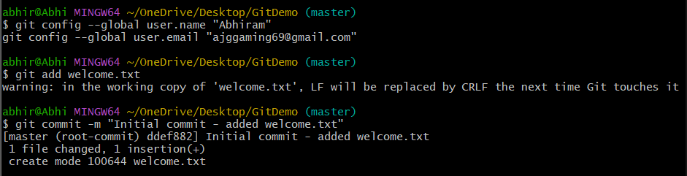
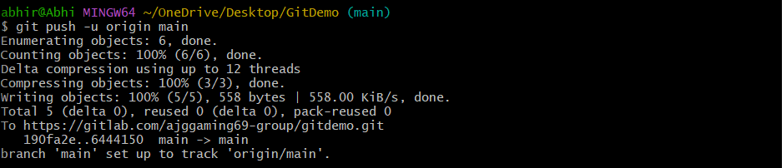

Final Output in GitLab:
