1. Understanding Asymptotic Notation
Big O Notation is a mathematical way to describe the performance of an algorithm as the input size grows. It helps us understand the worst-case time or space an algorithm might take, especially as the input becomes large. Instead of measuring actual time, it focuses on how the number of operations increases.
For example:
- O(1): Constant time – the algorithm takes the same time regardless of input size.
- O(n): Linear time – the time increases proportionally with input size.
- O(log n): Logarithmic time – the time grows slowly as the input size increases.
Best, Average, and Worst Case Scenarios:
- Best case: The minimum time an algorithm takes (e.g., first element match in a search).
- Average case: The expected time for a typical input.
- Worst case: The maximum time taken, often used in Big O to ensure performance under all conditions.

2. Linear and Binary Search in Our Program
We implemented two search methods:
- Linear Search: Goes through the array one element at a time until it finds the target. It works on unsorted data and is simple to implement.
- Binary Search: Works on sorted arrays. It divides the array in half each time, checking if the target is in the left or right half, and continues this until the element is found.

3. Results and Analysis
In our test case, we searched for "Product9999" in an array of 10,000 products.
- Linear Search Result: Product9999
Time Taken: 2,335,000 ns
Time complexity: O(n)
- Binary Search Result: Product9999
Time Taken: 32,000 ns
Time complexity: O(log n)

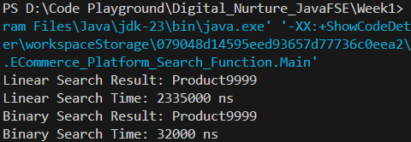
Comment on Results:
Binary search was significantly faster than linear search for a large dataset. While linear search took over 2 million nanoseconds, binary search completed in just 32,000. This confirms that for large, sorted data, binary search is more suitable. However, binary search requires the data to be sorted, whereas linear search does not. Therefore, for small or unsorted datasets, linear search may be acceptable, but for fast performance on larger datasets, binary search is the better choice.

