A Project Report
on
Detection of Alphanumeric Handwritten Values using Fuzzy Logic
carried out as part of the Soft Computing Techniques (INT3141) Submitted
by
Abhijay Shrivastava
2430030333
Aarush Dayal
2430030303
Section: Soft Computing D
in partial fulfilment for the award of the degree of
Bachelor of Technology
in
Information Technology

Department of Information Technology
MANIPAL UNIVERSITY JAIPUR
RAJASTHAN, INDIA
Oct 2026
Code repository: https://github.com/Abhijay09/Softcomputing-project

1. Introduction
Handwritten character recognition is one of the application areas named in the course hand-out. Handwriting is imprecise: the same letter written twice never looks identical, and different letters (O/0, S/5, I/1) can look alike. Such imprecision cannot be handled well by crisp yes/no rules, which is exactly the situation fuzzy logic was designed for (CO2). In this project we build a system that watches a live camera feed (laptop or USB camera), finds handwritten characters, and recognises each of them with a fuzzy rule base. For every character the system also reports how reliable the reading is, computed by a second small fuzzy controller.
Course outcomes addressed: INT3141.2 (apply fuzzy logic and reasoning) and INT3141.5 (develop and test a soft computing technique on a real-life problem).

2. Formal Problem Description

2.1 Input
A video frame is a colour image of H × W pixels (480 × 640 for the laptop camera), each pixel having a red, green and blue value from 0 to 255.
The frame contains n ≥ 0 handwritten characters written in dark ink on a light background. For training we use a labelled set of N grey-scale character images g of size 28 × 28, each with a label y from the alphabet A.
Alphabet: A is the set of 47 EMNIST-balanced classes – the digits 0–9, the upper-case letters A–Z (some letters that look the same in both cases, e.g. C/c, O/o, S/s, are one class) and the lower-case letters a, b, d, e, f, g, h, n, q, r, t.

2.2 Output
An ordered sequence of n pairs, where c is the recognised character at position k (reading order: left to right, top to bottom) and ρ is its fuzzy reliability in percent:
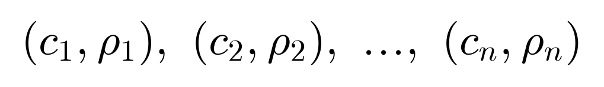
The text output is the recognised characters joined into one string, with a space inserted where the horizontal gap between two characters is more than 1.2 × the median character width.

2.3 Mathematical formulation
Step 1 – Segmentation. The frame is converted to grey, blurred, and thresholded with a local (adaptive) threshold, giving a binary ink mask. Each 8-connected component of the mask whose area and height are within limits is a character candidate with a bounding box. Each candidate is resized to fit a 20×20 box (aspect ratio kept) and centred in a 28×28 image g – the same format as the training data.
Step 2 – Feature vector. A feature map φ turns the 28×28 image into 177 numbers. The first 49 are the average ink in each 4×4 block (ink-density zones); the other 128 are stroke-direction values: the image is cut into 4×4 cells and in each cell the gradient strength is added up in 8 orientation bins (0°–180°), then the whole vector is scaled to unit length. Written as x = φ(g): 28×28 image in, 177 numbers out.
Step 3 – Fuzzy rule base. For every class k there are 4 fuzzy rules R(k, r) (188 rules in total):
Each antecedent “x is ~c” is a Gaussian membership function, where c is the typical value of that feature and σ says how much it varies (every rule has its own c and σ for each of the 177 features):
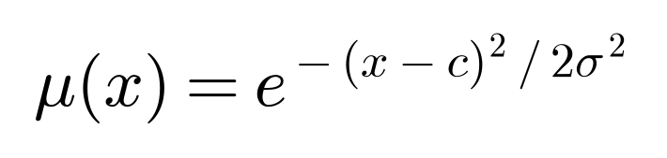
The centres c and widths σ of the rules come from fuzzy c-means clustering (Section 3.2). AND is implemented as the geometric mean of the memberships, so the firing strength of a rule is
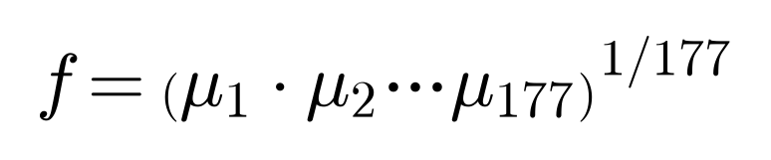
Rules of the same class are combined with OR = max, giving the membership of the character in class k. Defuzzification is by maximum membership: the class with the largest membership is the answer ĉ.
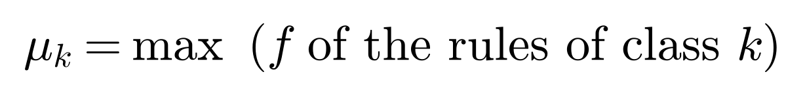
The strength s is the winning membership, and the gap γ = s − (runner-up membership) shows how far ahead it is.
Step 4 – Reliability controller (Mamdani). Inputs s and γ (both in [0,1]) are fuzzified with triangular sets (Figure 4), nine IF-THEN rules (e.g. IF strength is HIGH AND gap is LARGE THEN reliability is HIGH) are evaluated with AND = min, clipped outputs are joined with max, and the centroid of the aggregated output set gives the reliability ρ between 0 and 100:
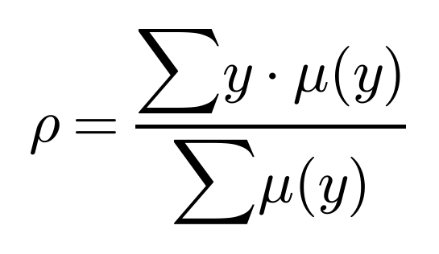

2.4 Objective and performance measures
Find the rule parameters that maximise the top-1 accuracy (correct readings ÷ number of test images) on a held-out test set, and make ρ meaningful: samples with higher ρ should be recognised correctly more often. Secondary measure: top-3 accuracy (true class among the three largest class memberships).

2.5 Assumptions and scope
- Dark ink on light paper, one or more lines of separate (non-cursive) characters, reasonably large and well lit.
- Only the 47 classes above; no punctuation. Touching characters are not split.
- Recognition is character-by-character; there is no dictionary or language model.

3. Methodology
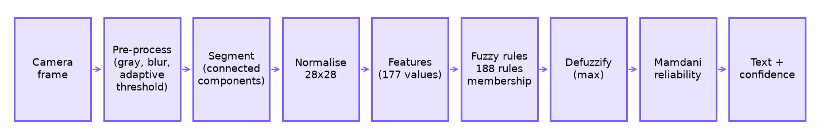
Figure 1: System block diagram

3.1 Dataset
EMNIST-balanced (Cohen et al., 2017): 112,800 training and 18,800 test images, 28×28, 47 classes with equal numbers of samples. It is derived from NIST handwriting and is the letters-and-digits extension of MNIST.
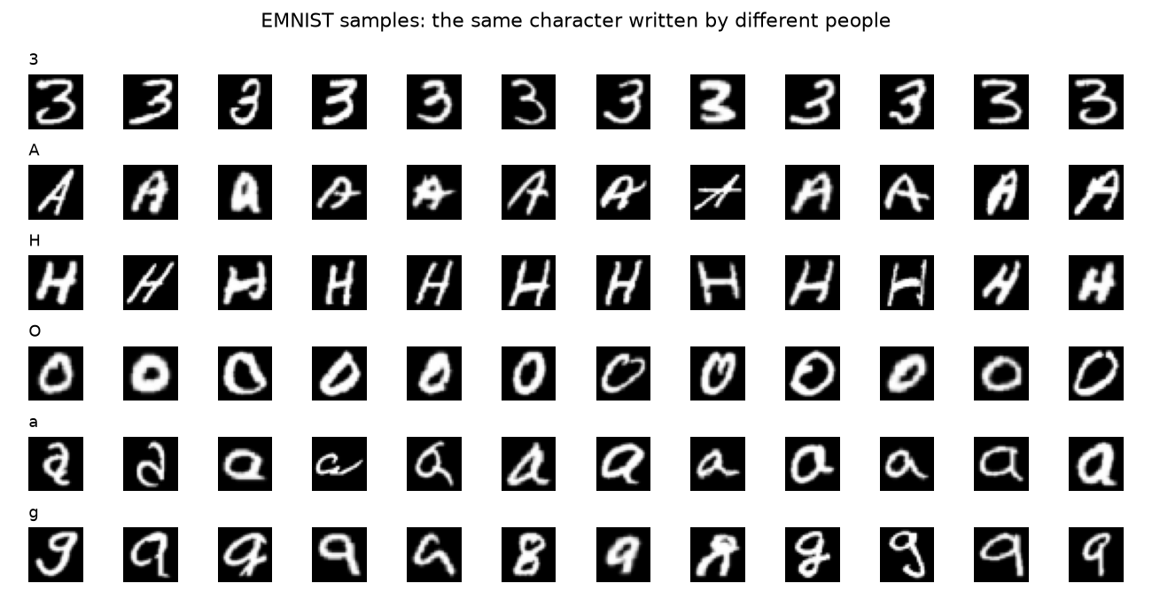
Figure 2: EMNIST samples. Each row is one character class written by different people, so the same character varies a lot in shape and thickness.

3.2 Learning the fuzzy rules with fuzzy c-means
For each class, its training feature vectors are clustered by fuzzy c-means (FCM, fuzzifier 2, 4 clusters). Unlike k-means, every sample belongs to every cluster with a degree u between 0 and 1, and the degrees of one sample add up to 1. FCM repeats two steps until it settles: (a) each cluster centre is the average of the samples weighted by u², (b) each membership u is recomputed from the distances d of the sample to the cluster centres.
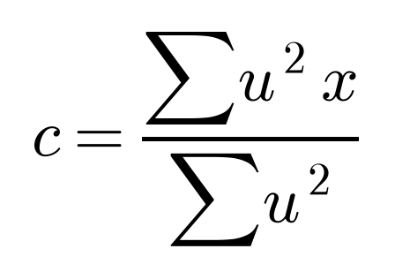
Each cluster becomes one rule: its centre gives c and the membership-weighted standard deviation gives σ. A floor of 0.3 × the overall standard deviation of that feature is applied, so a rule is never unrealistically narrow. The idea behind several rules per class is that one letter has several writing styles (e.g. 4 vs. open-top 4, 7 with or without a bar). Section 4.2 measures how much this actually helps.
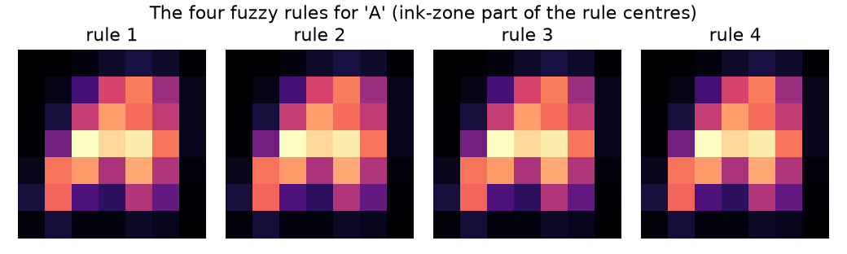
Figure 3: the four fuzzy rules learned for the letter A (ink-zone part of each rule centre). The four rules turn out to be very similar to each other, which matches the experiment in Section 4.2 where extra rules help only a little.

3.3 Reliability fuzzy controller
Strength \ Gap | SMALL | MEDIUM | LARGE
LOW | LOW | LOW | MEDIUM
MEDIUM | LOW | MEDIUM | HIGH
HIGH | MEDIUM | HIGH | HIGH

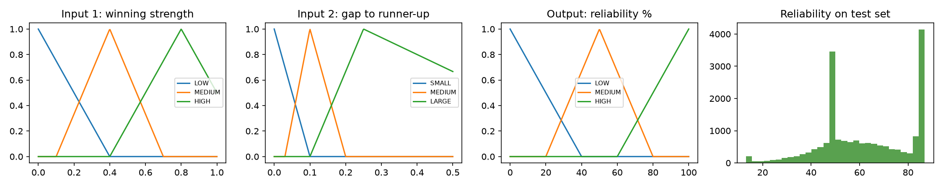
Figure 4: membership functions of the reliability controller and the distribution of ρ on the test set

3.4 Camera application
A Tkinter desktop application reads frames with OpenCV, runs the pipeline of Figure 1 about 6 times per second, and draws a box around each character, coloured green/amber/red by reliability level (≥65 / 35–65 / <35 %). The side panel shows the detected text, the average reliability bar, and for each character the three best classes with their membership values. Buttons: Freeze/Resume, Save snapshot, Open image…, Switch camera.
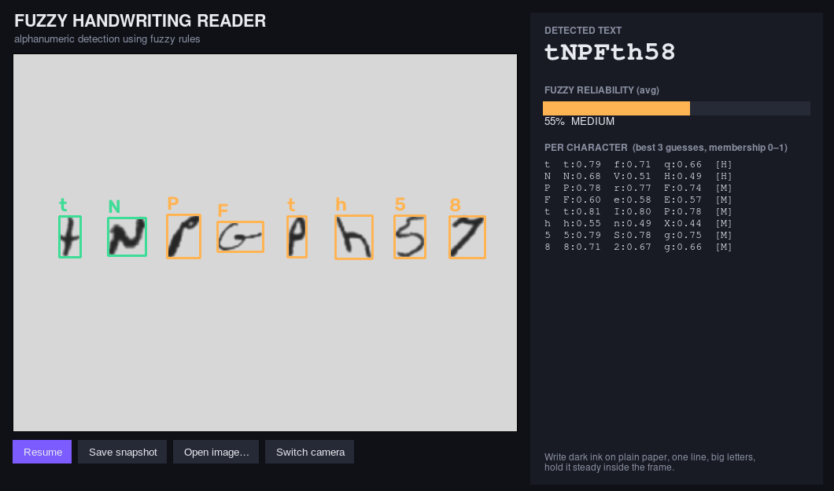
Figure 5: the Tkinter application reading a still image (Open image… mode). In camera mode the left panel shows the live feed instead. Box colour = reliability level; the panel on the right lists the three best classes and their membership for each character.
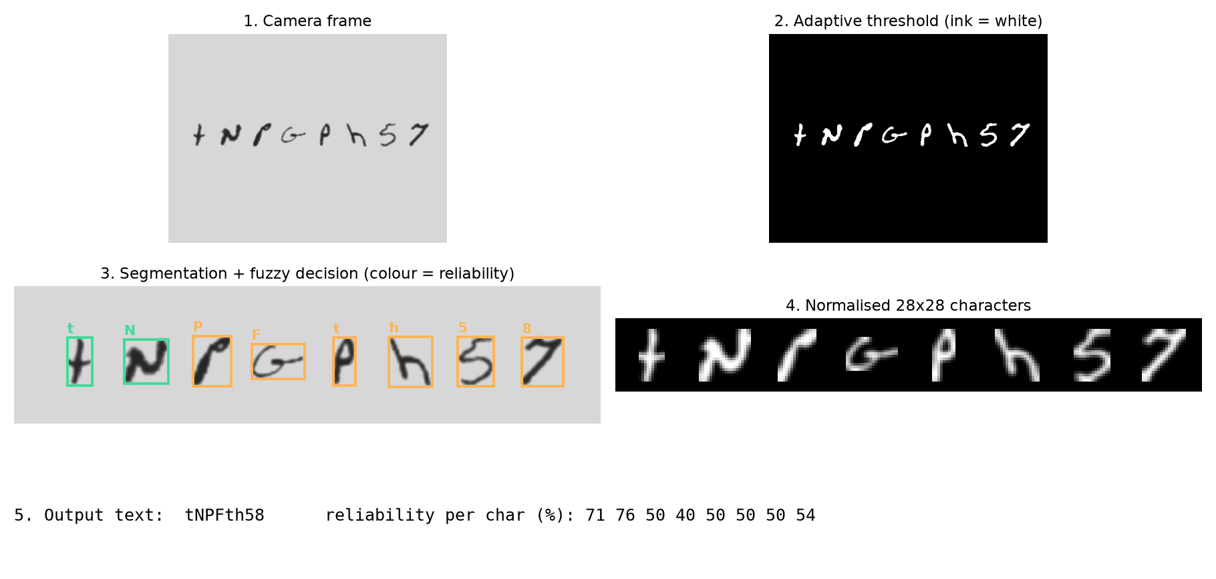
Figure 6: pipeline on a sample image (characters taken from the EMNIST test set and placed on a paper-like background)

4. Results (progress till date)

4.1 Accuracy and reliability
Measure | Value
Top-1 accuracy (18,800 test images, 47 classes) | 66.3%
Top-3 accuracy | 86.8%
Number of fuzzy rules | 188
Random-guess baseline | 2.1 %

Does the reliability value mean anything? Test samples grouped by the reliability the controller assigned:
Reliability group | Samples | Accuracy in group
LOW (<35) | 1096 | 28.6%
MEDIUM (35-65) | 9661 | 51.5%
HIGH (>=65) | 8043 | 89.2%

Accuracy rises from the LOW to the HIGH group, so ρ is a useful warning: when the fuzzy controller says HIGH the reading is right about nine times out of ten.
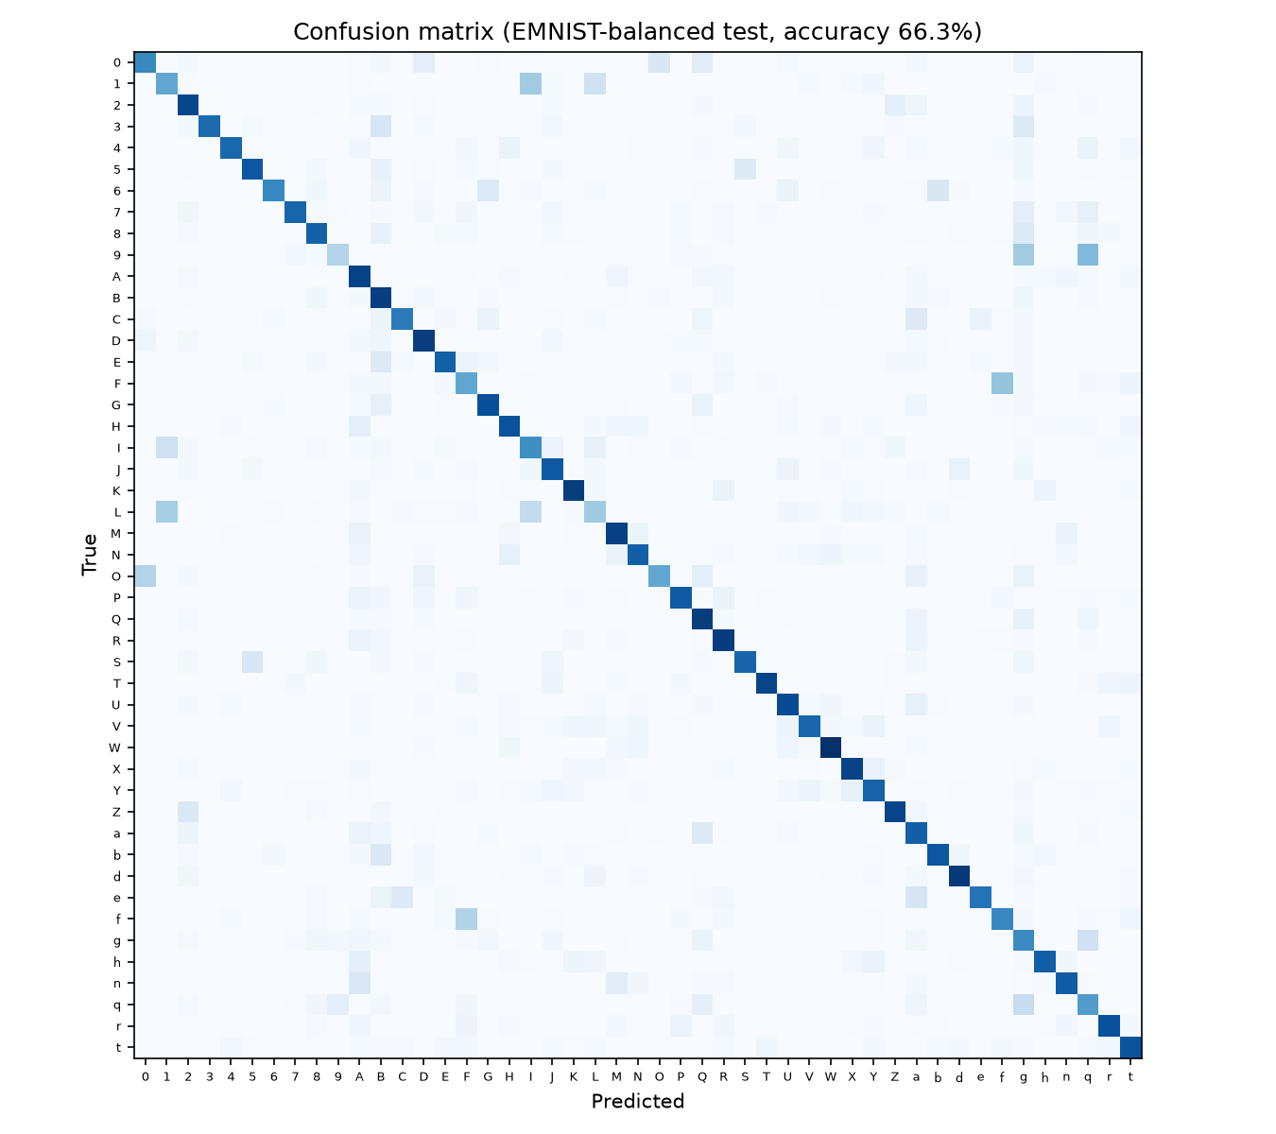
Figure 7: confusion matrix
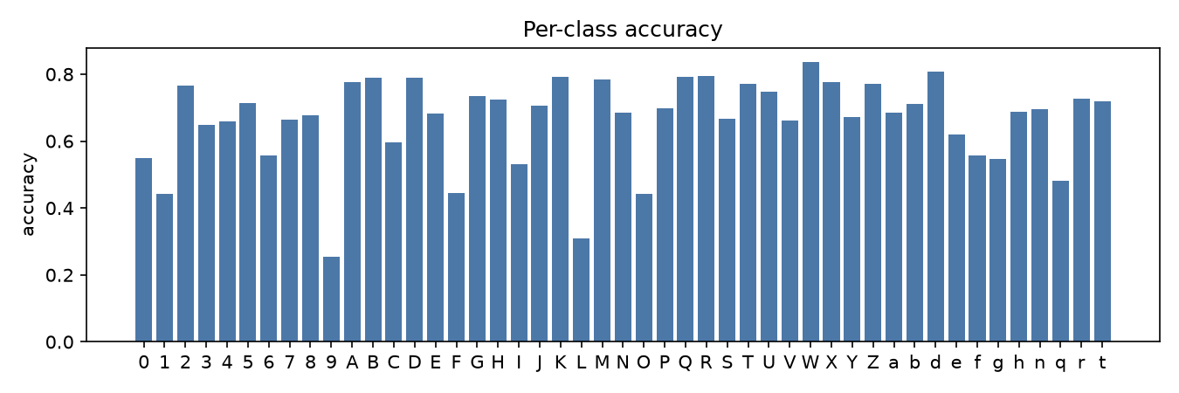
Figure 8: accuracy per class
Observations. Most errors are between look-alike shapes: 9/q/g, F/f, 1/I/L, O/0, e/a and 3/B (the most frequent confusions in our test run). This is the inherent imprecision that motivated the fuzzy approach; the top-3 accuracy shows that the correct character is almost always among the top candidates.

4.2 Experiments: what actually matters?
To understand which design choices matter, we changed one thing at a time and measured test accuracy.
Rules per class | Test accuracy
1 | 65.9%
2 | 66.2%
4 | 66.3%
8 | 66.5%

Features used (4 rules per class) | Test accuracy
ink zones only (49) | 50.2%
stroke directions only (128) | 65.5%
both (177) | 66.3%

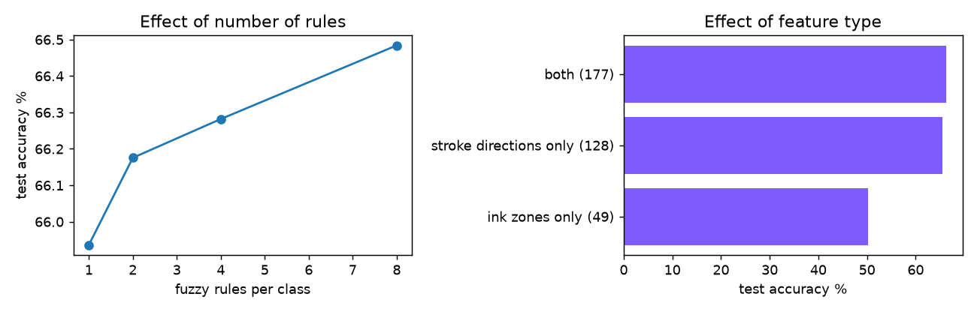
Figure 9: effect of the number of rules and of the feature type
Findings. (1) The stroke-direction features carry most of the information: using them alone gives 65.5%, while the ink zones alone give only 50.2%. Adding the ink zones to the directions improves the result slightly. (2) More rules per class helps only a little (65.9% with one rule, 66.5% with eight), so the limit is the feature description and the simple Gaussian membership form, not the number of writing styles. We kept 4 rules per class as a compromise between accuracy and the size of the rule base. These findings point to where improvement should come from next (better features, tuned membership widths).

5. Limitations and future work
- Accuracy (about 66 %) is lower than a trained neural network would reach (CO3). The fuzzy rules are deliberately simple and explainable: every decision can be traced back to rules and membership values.
- Future: tune the rule widths and number of rules per class with a genetic algorithm (CO4); add a perceptron / neural network and compare; use context (dictionary) to resolve O/0 and I/1; split touching characters.
- Camera robustness: strong shadows, thin pen strokes and tilted paper reduce quality.

6. Tools and how to run
Python 3, NumPy (fuzzy c-means and fuzzy rules written from scratch), OpenCV (image processing), Tkinter + Pillow (GUI), Matplotlib (figures). Commands: python src/train.py | python src/evaluate.py | python src/app.py [camera index or image file]

7. References
- L. A. Zadeh, “Fuzzy sets”, Information and Control, 8(3), 1965.
- J. C. Bezdek, Pattern Recognition with Fuzzy Objective Function Algorithms, Plenum, 1981 (fuzzy c-means).
- E. H. Mamdani and S. Assilian, “An experiment in linguistic synthesis with a fuzzy logic controller”, 1975.
- G. Cohen, S. Afshar, J. Tapson, A. van Schaik, “EMNIST: an extension of MNIST to handwritten letters”, 2017.
- S. Rajasekaran and G. A. Vijayalakshmi Pai, Neural Networks, Fuzzy Logic and Genetic Algorithms, PHI.
- N. Dalal and B. Triggs, “Histograms of oriented gradients for human detection”, CVPR 2005 (idea behind direction features).

