FLATKART
Shipping and Delivery Policy Dispatch timelines, delivery estimates, tracking, and delivery exceptions

Document control

1. Service area and delivery estimates
This policy explains how Flatkart communicates dispatch and delivery expectations. 1.1 Serviceable locations Delivery availability is checked using the address and serviceability information available at checkout. Remote locations, restricted areas, or temporary carrier limits may affect availability. 1.2 Standard dispatch Standard dispatch is targeted within 1–2 business days after order confirmation after order confirmation, subject to payment confirmation, stock availability, and verification checks. 1.3 Standard delivery For serviceable locations, standard delivery is estimated at 3–7 business days after dispatch for serviceable locations after dispatch. The estimate is not a guarantee and may change when the carrier reports a delay.

2. Shipping charges and order preparation
2.1 Charges Any shipping charge or free-shipping condition should be displayed before the customer submits the order. Support should refer to the checkout summary and order invoice. 2.2 Preparation Order preparation may include stock allocation, packing, invoice generation, and carrier handover. An order may remain in processing while these steps are completed. 2.3 Multiple parcels Items from one order may ship separately when stock location, package size, or fulfilment timing differs. Each parcel should have its own tracking details where the carrier provides them.

3. Tracking and shipment status
3.1 Tracking availability A tracking link or shipment reference becomes available after carrier data is received. It may take time for the carrier's first scan to appear. 3.2 Status meanings Processing means the order is being prepared; Shipped means the parcel has been handed to or registered with the carrier; Out for delivery means the carrier plans a delivery attempt; Delivered means the carrier has recorded delivery. 3.3 Status mismatch If the carrier status conflicts with what the customer observes, support should compare the latest scan, address, delivery notes, and proof-of-delivery information where available.

4. Delivery attempts and customer availability
4.1 Accurate delivery details Customers should provide a complete address, reachable phone number, landmark where useful, and any delivery instructions supported at checkout. 4.2 Failed attempt A failed delivery may result from an unavailable recipient, incomplete address, access restrictions, or carrier capacity. Check the carrier's stated reason and whether another attempt is scheduled. 4.3 Delivery verification If a parcel is marked delivered but was not received, contact support promptly with the order ID and confirm whether another household member, reception desk, or authorised recipient accepted it.

5. Delay, loss, damage, and address changes
5.1 Delay Delivery estimates can be affected by weather, operational disruption, carrier delays, high-volume periods, or address verification. Support should provide the latest known event and avoid inventing an arrival date. 5.2 Lost or damaged parcel Support may open a carrier investigation when tracking is stalled or delivery evidence is inconsistent. For damaged contents, preserve the packaging and follow the Return and Replacement Policy. 5.3 Address changes An address change may be possible before dispatch but is not guaranteed after carrier handover. If the order is already shipped, support should check the carrier's available options instead of promising a reroute.

6. Delivery milestones and customer actions
6.1 Delivery checklist Check the tracking link, keep the delivery address reachable, and retain the package until the item is confirmed. For a damaged or incorrect item, photograph the parcel and product where safe. 6.2 Contacting support Include the order ID, tracking number, latest status, and a short description of the issue. Do not publish private delivery details in a public review. Milestone What it means Customer action Confirmed Order request received Check order summary Processing Preparation and checks underway Wait for dispatch update Shipped Carrier handover recorded Use tracking reference Delivered Carrier records completion Report non-receipt promptly if applicable

7. Shipping — illustrative delivery-stage chart and FAQ
This illustration uses hypothetical counts to explain shipment stages; it is not live carrier data or a promise of delivery volume. 7.1 Quick answers Dispatch target is 1–2 business days after confirmation. Delivery estimate is 3–7 business days after dispatch for serviceable locations. Tracking may take time to show its first scan. 7.2 Delayed delivery If the estimate has passed, contact support with the order ID and tracking reference. Flatkart will check the latest carrier information and explain the available next step.

Illustrative parcel status distribution
Processing In transit Out today Delivered 0 12 24 36 48

Illustrative parcel count
Chart description: The example shows four possible status groups at a hypothetical point in time. It cannot be used to infer an actual delivery rate
or a specific parcel's arrival date.

Quick reference and customer support
Use the policy sections above to identify the applicable rule and next action. When a case does not fit a listed example, the support team reviews the order record and the facts provided by the customer. Topic Quick rule
Effective date 1 October 2026
Policy version Version 1.0
Support email support@flatkart.example
Support hours Monday to Saturday, 9:00 AM–6:00 PM IST, excluding published holidays When contacting support, include the order ID, registered email or phone number, product name, relevant dates, and a short description of the issue. Do not send passwords, full card numbers, CVV codes, or one-time passwords.

Policy interpretation
This document is part of the Flatkart sample policy corpus. Where an order-specific message gives a more specific operational instruction, retain that message and contact support if the two appear inconsistent. No customer should be asked to share payment authentication secrets.

Existing reference table
Details | Policy version
Version 1.0 | Effective date
1 October 2026 | Applies to
Orders placed through Flatkart's online shopping platform | Policy owner
Customer Experience & Operations | Purpose. This policy explains the customer-facing rules, process steps, responsibilities, and support route for the subject shown
above. | Important corpus note. Sample policy corpus for RAG testing. Business-specific details and legal terms require review before publication.
Shipping timeline reference
Milestone | Typical estimate
Dispatch | 1–2 business days
Delivery after dispatch | 3–7 business days
Tracking | Available after shipment processing
Exceptions | Location, holidays, or carrier delays may affect timing

Illustrative chart — Illustrative shipping timeline
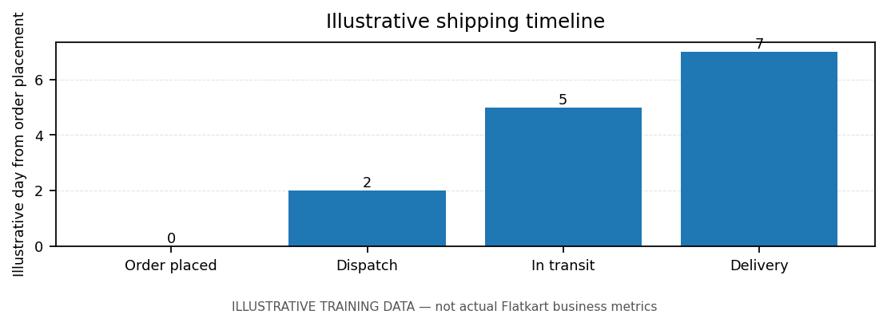
Note: chart values are illustrative training data, not actual Flatkart business metrics.
Sample policy corpus for RAG testing. Business-specific details and legal terms require review before publication.

