FLATKART
Return and Replacement Policy Eligibility, evidence, inspection, replacement, and return shipping

Document control

1. Purpose and return window
This policy explains how customers request a return or replacement for an eligible Flatkart order. 1.1 Standard request window Customers should submit a return or replacement request within the 10 calendar days from delivery from delivery, unless the product listing or order-specific terms show a different approved rule. 1.2 Eligible reasons Requests may be considered for an incorrect item, transit damage, a missing component, a product that does not match its listing in a material way, or a verified functional defect, subject to product-specific eligibility. 1.3 Product-specific limits Some categories may have hygiene, activation, customisation, or safety restrictions. The product page should state any special restriction before checkout; support must not invent a restriction after a complaint is raised.

2. Eligibility and condition requirements
2.1 Item condition Where applicable, the item should be returned with its accessories, manuals, tags, and original packaging. Necessary inspection should distinguish normal opening for inspection from damage caused after delivery. 2.2 Non-eligible cases A request may be declined where the product is outside the stated window, the issue is not covered, required parts are missing due to customer use, or inspection evidence contradicts the claim. The decision should explain the reason.  Damage caused after delivery through misuse or unauthorised repair.
 A request submitted after the applicable window without an approved exception.
 A serial number or product identity that does not match the order.
 A change-of-mind request for a product explicitly marked non-returnable before purchase.
2.3 Evidence Photos or a short video can help document damage, wrong-item delivery, or a functional issue. Customers should not share unrelated personal documents or payment authentication details.

3. How to submit a request
3.1 Request steps Open the order history, select the relevant item, choose the closest reason, describe the issue, and attach clear evidence where helpful. If the self-service option is unavailable, contact support with the order ID. 3.2 Review Support checks the order date, product eligibility, reason, evidence, and delivery record. Some cases require inspection after collection or return receipt. 3.3 Decision communication The customer should receive a status update identifying whether the request is approved, needs more information, requires pickup, or cannot be accepted. A request submission alone is not approval.

4. Replacement workflow
4.1 Replacement window Replacement requests should normally be submitted within the 10 calendar days from delivery from delivery. 4.2 Stock availability A replacement depends on stock and product eligibility. If the same item is unavailable, support may explain the available alternatives under the applicable order policy; it should not promise a dispatch date before stock is confirmed. 4.3 Inspection and dispatch A replacement may be dispatched after the original item is collected or received and the stated checks are completed. Where advance replacement is authorised, the order record should show the approval and any conditions.

5. Return pickup, packaging, and responsibility
5.1 Packaging Use secure packaging that protects the item in transit. Include the accessories and components specified in the approved request. Do not attach labels directly to the retail product where doing so could damage it. 5.2 Pickup Pickup availability depends on the delivery partner and serviceable location. The customer should keep the parcel ready and provide the approved return reference to the pickup agent. 5.3 Failed pickup If a pickup fails, check the reason in the request status and contact support. A failed attempt should not automatically be treated as a rejected return without review.

6. Return decision table and customer checklist
6.1 Before sending an item Customers should confirm that the request is approved, the correct item is packed, accessories are included, and the return reference is available. 6.2 After handover Keep the pickup receipt or tracking details until the return is marked received. If tracking stops updating, contact support with the return reference. Case Typical review Possible outcome Wrong item Compare item and order details Return or replacement review Transit damage Review photos and delivery record Replacement or refund review Missing accessory Check listing and package contents Accessory resolution or return review Functional defect Troubleshooting and/or inspection Repair, replacement, or refund review

7. Returns — illustrative request chart and FAQ
The chart uses fictional counts to demonstrate request categories and must not be interpreted as actual Flatkart performance data. 7.1 Common questions The standard request window is 10 calendar days from delivery. Eligibility depends on product terms, request reason, evidence, and inspection where applicable. 7.2 Decision fairness Support should explain the evidence reviewed and the reason for the outcome. If the customer believes an order detail was missed, they may reply to the existing case with the relevant information.

Illustrative return-request reasons
Wrong item Damage Defect Missing part 0 5 10 15 20

Illustrative request count
Chart description: In this hypothetical example, wrong-item requests are the most frequent category. A real operational report should use verified
request records and a clearly defined time period.

Quick reference and customer support
Use the policy sections above to identify the applicable rule and next action. When a case does not fit a listed example, the support team reviews the order record and the facts provided by the customer. Topic Quick rule
Effective date 1 October 2026
Policy version Version 1.0
Support email support@flatkart.example
Support hours Monday to Saturday, 9:00 AM–6:00 PM IST, excluding published holidays When contacting support, include the order ID, registered email or phone number, product name, relevant dates, and a short description of the issue. Do not send passwords, full card numbers, CVV codes, or one-time passwords.

Policy interpretation
This document is part of the Flatkart sample policy corpus. Where an order-specific message gives a more specific operational instruction, retain that message and contact support if the two appear inconsistent. No customer should be asked to share payment authentication secrets.

Existing reference table
Details | Policy version
Version 1.0 | Effective date
1 October 2026 | Applies to
Orders placed through Flatkart's online shopping platform | Policy owner
Customer Experience & Operations | Purpose. This policy explains the customer-facing rules, process steps, responsibilities, and support route for the subject shown
above. | Important corpus note. Sample policy corpus for RAG testing. Business-specific details and legal terms require review before publication.
Return and replacement quick reference
Item | Policy reference
Request window | Within 10 calendar days from delivery
Condition | Item and packaging checks may apply
Evidence | Order details and relevant photos may be requested
Outcome | Return, replacement, or another resolution after review

Illustrative chart — Illustrative return-window reference
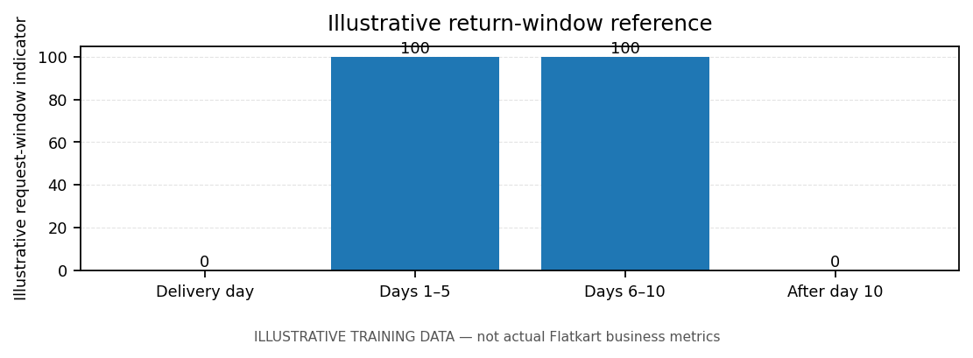
Note: chart values are illustrative training data, not actual Flatkart business metrics.
Sample policy corpus for RAG testing. Business-specific details and legal terms require review before publication.

