FLATKART
Terms and Conditions Rules for browsing, account use, orders, payments, and platform conduct

Document control

1. Agreement and platform scope
These sample terms describe the rules for using Flatkart's online shopping platform. By browsing or placing an order, a customer is expected to read the applicable terms and product information. 1.1 Platform role Flatkart presents product listings, checkout, order information, and customer-support channels. Availability of a product, delivery service, or payment method may depend on stock, location, service-provider status, and verification. 1.2 Policy set These terms operate alongside the Privacy Policy, Return and Replacement Policy, Refund Policy, Shipping and Delivery Policy, Cancellation Policy, and Payment Policy. Topic-specific rules should be read with the relevant policy. 1.3 Updates A revised version should show its effective date and version. For an existing order, the order confirmation and the policy version applicable when the order was placed should be retained for review.

2. Accounts and acceptable use
2.1 Account accuracy Customers should provide accurate contact and delivery details and update them when they change. An incorrect phone number or address can delay delivery or prevent successful service. 2.2 Account security Customers are responsible for protecting their password and devices. Flatkart support will not ask for a password, CVV, or one-time password to resolve an ordinary order issue.  Do not impersonate another person or create accounts to evade a restriction.
 Do not attempt to access another customer's account or data.
 Report suspicious account activity promptly.
2.3 Platform misuse Automated abuse, fraudulent orders, payment manipulation, harassment, or attempts to disrupt the platform may lead to order review or access restriction, subject to appropriate review.

3. Product listings and availability
3.1 Product information Product pages should provide the available description, price, variant, key specifications, and relevant limitations. Images are intended to illustrate the item; minor differences in colour rendering may occur across screens. 3.2 Price and stock checks The checkout summary is the customer's final review point before submitting an order. If a listing contains an obvious error or stock becomes unavailable, Flatkart may contact the customer, cancel the affected order, and initiate an eligible refund. 3.3 Third-party fulfilment Where a product or service partner participates in fulfilment, Flatkart may coordinate relevant order information with that partner to complete the transaction.

4. Order formation and customer responsibilities
4.1 Order submission An order request is submitted when the customer completes checkout. A confirmation message records that the order was received; it does not guarantee that every order has passed payment, fraud, stock, or address checks. 4.2 Verification and changes Flatkart may hold an order for additional verification where payment details, address information, unusual activity, or stock records require review. Customers should respond through official support channels if more information is requested. 4.3 Customer review Before confirming checkout, customers should verify item, quantity, selected variant, delivery address, contact details, applied discount, shipping charge, and total payable amount.

5. Payments, cancellations, returns, and refunds
5.1 Payments Available payment methods and payment-state definitions are described in the Payment Policy. An order is not treated as successfully paid merely because a payment screen was opened. 5.2 Cancellation A cancellation request is generally available before the order is marked Shipped. The order status and operational stage determine whether cancellation can be completed. 5.3 Returns and refunds Return eligibility, replacement review, refund initiation, and delivery exceptions are governed by their respective policies. A refund may take additional time to appear after initiation because banks and payment providers control posting times.

6. Responsibilities, limitations, and dispute handling
6.1 Service interruptions Temporary interruptions may occur due to maintenance, network issues, payment-provider outages, or delivery-partner events. Support should provide available status information rather than promise an outcome that has not been confirmed. 6.2 Disputes Customers should first contact support with the order ID and a clear description of the issue. Flatkart should review available records and explain the decision or escalation path. Applicable consumer rights are not intended to be removed by this sample document. Area Flatkart responsibility Customer responsibility Order details Show available order status and confirmation Review item, address, and total before checkout Delivery Coordinate dispatch and provide tracking when available Provide accurate address and receive parcel Account safety Apply reasonable access and monitoring controls Protect credentials and report suspicious use Support Review the facts and explain next steps Provide order ID and relevant evidence

7. Terms — illustrative order status chart and FAQ
The chart is illustrative and explains a typical order-state mix for training only. It is not actual Flatkart transaction data. 7.1 Key customer questions A confirmation means the order was received; payment, stock, and verification checks may still apply. Cancellation is generally available before the order is marked Shipped. Return and refund decisions follow their topic-specific policies. 7.2 Contact and records Keep the order confirmation, invoice, shipment updates, and support ticket reference until the transaction is fully resolved.

Illustrative order-status mix
Confirmed Processing Shipped Delivered 0 10 20 30 40

Illustrative order count
Chart description: The hypothetical values demonstrate that an order may move through several statuses. A status label should be interpreted
with the order's latest event and the applicable policy.

Quick reference and customer support
Use the policy sections above to identify the applicable rule and next action. When a case does not fit a listed example, the support team reviews the order record and the facts provided by the customer. Topic Quick rule
Effective date 1 October 2026
Policy version Version 1.0
Support email support@flatkart.example
Support hours Monday to Saturday, 9:00 AM–6:00 PM IST, excluding published holidays When contacting support, include the order ID, registered email or phone number, product name, relevant dates, and a short description of the issue. Do not send passwords, full card numbers, CVV codes, or one-time passwords.

Policy interpretation
This document is part of the Flatkart sample policy corpus. Where an order-specific message gives a more specific operational instruction, retain that message and contact support if the two appear inconsistent. No customer should be asked to share payment authentication secrets.

Existing reference table
Details | Policy version
Version 1.0 | Effective date
1 October 2026 | Applies to
Orders placed through Flatkart's online shopping platform | Policy owner
Customer Experience & Operations | Purpose. This policy explains the customer-facing rules, process steps, responsibilities, and support route for the subject shown
above. | Important corpus note. Sample policy corpus for RAG testing. Business-specific details and legal terms require review before publication.
Terms quick reference
Topic | Summary
Account | Customer is responsible for accurate account information
Orders | Orders may be subject to availability and confirmation
Pricing | Displayed prices and charges are shown during checkout
Support | Contact support for order-related concerns

Illustrative chart — Illustrative order journey
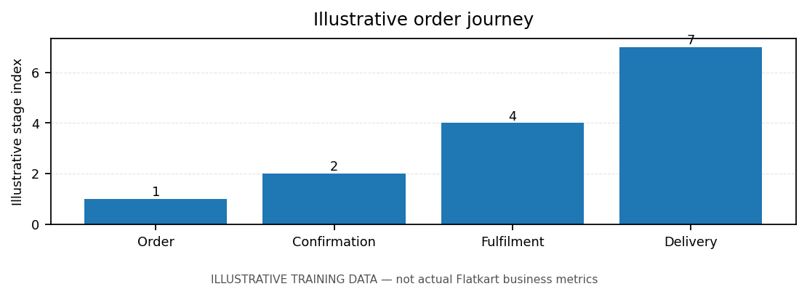
Note: chart values are illustrative training data, not actual Flatkart business metrics.
Sample policy corpus for RAG testing. Business-specific details and legal terms require review before publication.

