finalReport.md 8/7/2018

Introduction

Different Types Of Dataset

- Cross-sectional data : Cross sectional data can obtained when there is multiple observations is taken from multiple individuals at same point time. In case of cross sectional data Time does not play any important role in analysis. Analysis of cross sectional data starts with visualization of basic statistical properties i.e. central tendency, dispersion, skewness, kurtosis.

- Time series data : Timeseries data can obtained when there is multiple observations is taken form same source at different points of time. Time series data can be describe by trend, seasonality, stationarity, autocorrelation, and so on.

- Panel data : Panel data is collection of multiple entities over multiple points in time. Panel data also known as longitudinal data.

Here we have Nifty50 data from Apr-2010 to Mar-2018

https://www.nseindia.com/products/content/equities/indices/historical_index_data.htm

This is time series data with the frequency of business days.

First we need to explore the data to check the presence of null values


import pandas as pd

Nifty_data=pd.read_csv("E:/summer/NIFTY50.csv",parse_dates=['Date'],index_col= ['Date'])
Nifty_data.info()
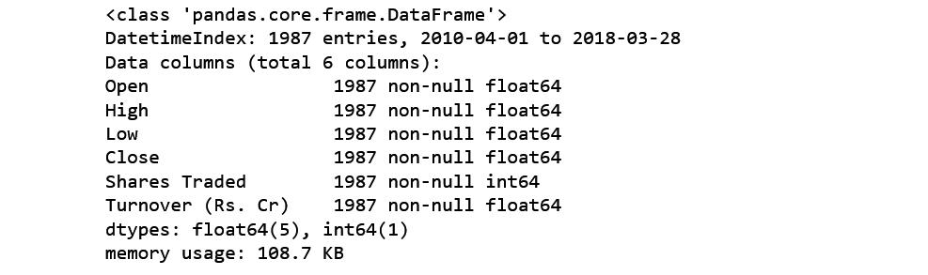

Let’s understand the arguments one by one :

parse_dates : This specifies the column which contains the date-time information. As we say above, the column name is 'date'.

index_col : This argument tells pandas to use the ‘date’ column as index.

1 / 26

finalReport.md 8/7/2018

In this dataset we have DateTime series as index and 6 columns, 1987 entries for each. 5 of them are float and one is integer type also we don't have any Null values.

Internal structure of Timeseries

A time series is combination of trend, seasonal, cyclical, and irregular components

General trend : A general trend can be identify by it's upward or downward movement in a long run. General trend can be seen with plotting the data, here we are using matplotlib library to plot Close prices.

import matplotlib.pyplot as plt

plt.plot(Nifty_data.Close)

plt.title('Nifty50 data for Close prices')

plt.show()
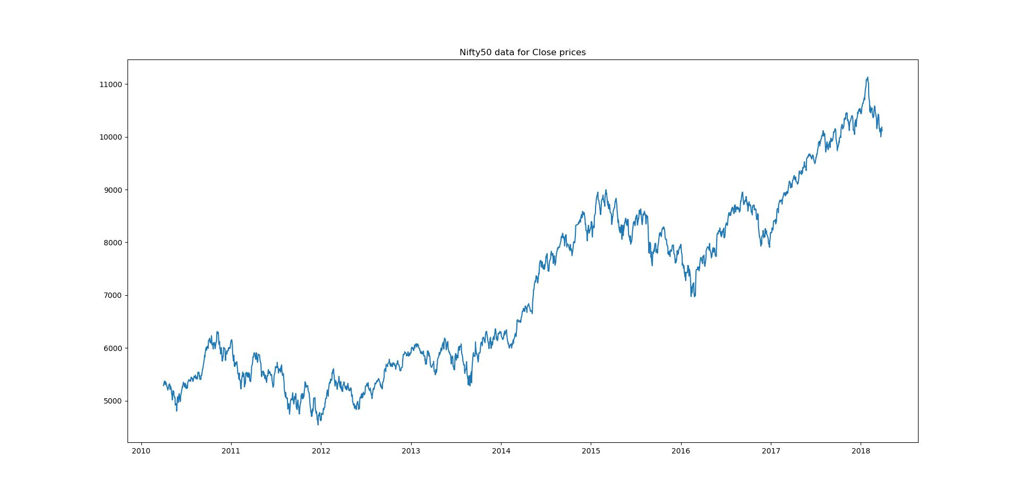

The graph is showing movement in upward direction, this is clear sign of presence of trend component.

General trend might not capable of being noticed during short run of time series .

Seasonality : If in time series data, there are patterns that repeat over known periods of time. For example the consumption of ice-cream during summer is more than winter and hence an ice-cream dealer's sales would be higher in summer months. Mostly, presence of seasonality can be reveals by exploratory data analysis.

Cyclical movements : If there are movements observe after every few units of time, but they are not as frequent as seasonal components, are known as Cyclic components. cyclic components do not have fixed periods of variations.

Unexpected variations : These are sudden changes occurring in a time series which are unlikely to be repeated. They are components of a time series which cannot be explained by trends, seasonal or cyclic

2 / 26

finalReport.md 8/7/2018

movements. These variations are sometimes called residual or random components. These variations, though accidental in nature, can cause a continual change in the trends, seasonal and cyclical oscillations during the forthcoming period.

The objective of time series analysis is to decompose timeseries into it's elements and develop mathematical models to predict future values.

Stationary time series

When a time series free from general trend and seasonality, it become stationary. Statistical properties like mean, variance, autocorrelation etc. of an stationary time series remains constant over time. It is important to gain stationarity before forecasting because most statistical forecasting methods are applicable on stationary time series.

we can check stationarity using the following:

- Plotting rolling statistics : we can plot moving mean and moving variance and see if these terms are varying with time. let's plot the moving average for business week days, business month days , Quarterly and yearly. we have .rolling() method in pyhon to calculate rolling statistics.

weekly


plt.plot(Nifty_data.Close,label='Close Prices',color='green')

plt.plot(Nifty_data['Close'].rolling(window=5).mean(),label='moving

avg',color='orange')

plt.legend()

plt.title('Weekly rolling statistics')

plt.show()
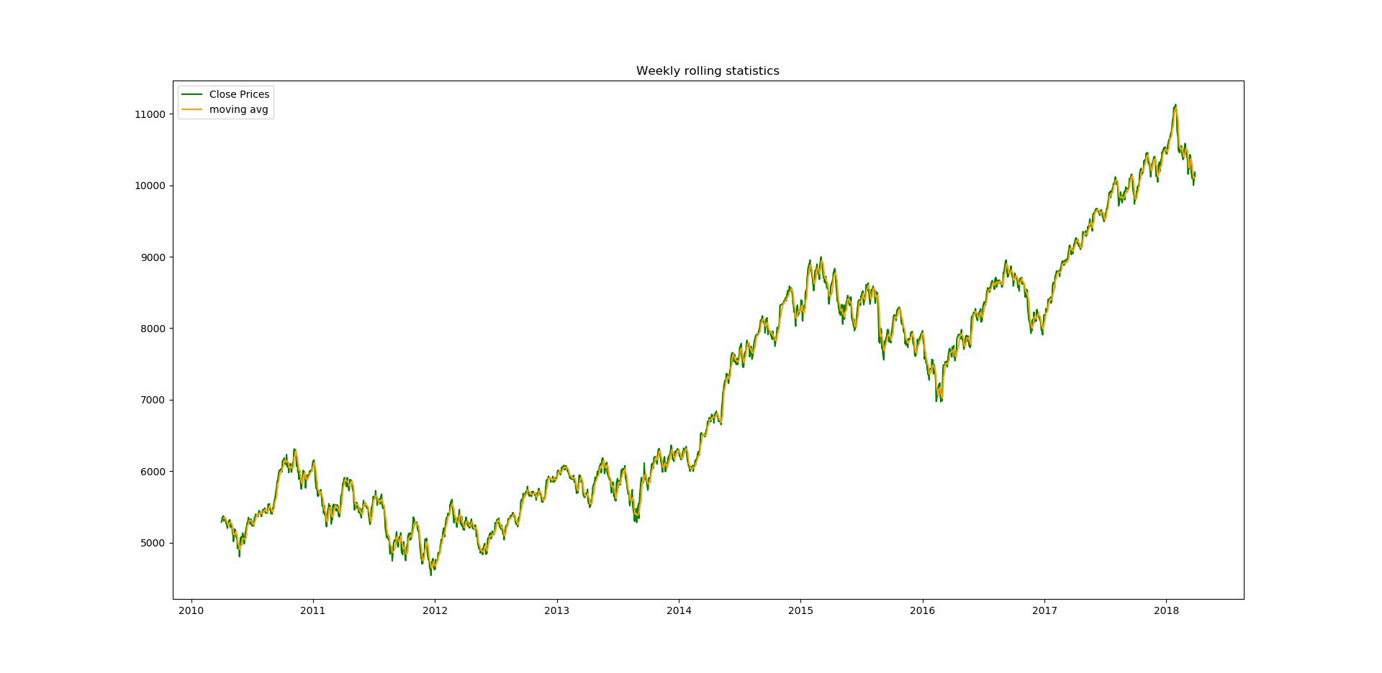

Monthly

3 / 26

finalReport.md 8/7/2018


plt.plot(Nifty_data.Close,label='Close Prices',color='green')

plt.plot(Nifty_data['Close'].rolling(window=21).mean(),label='moving

avg',color='orange')

plt.legend()

plt.title('Monthly rolling statistics')

plt.show()
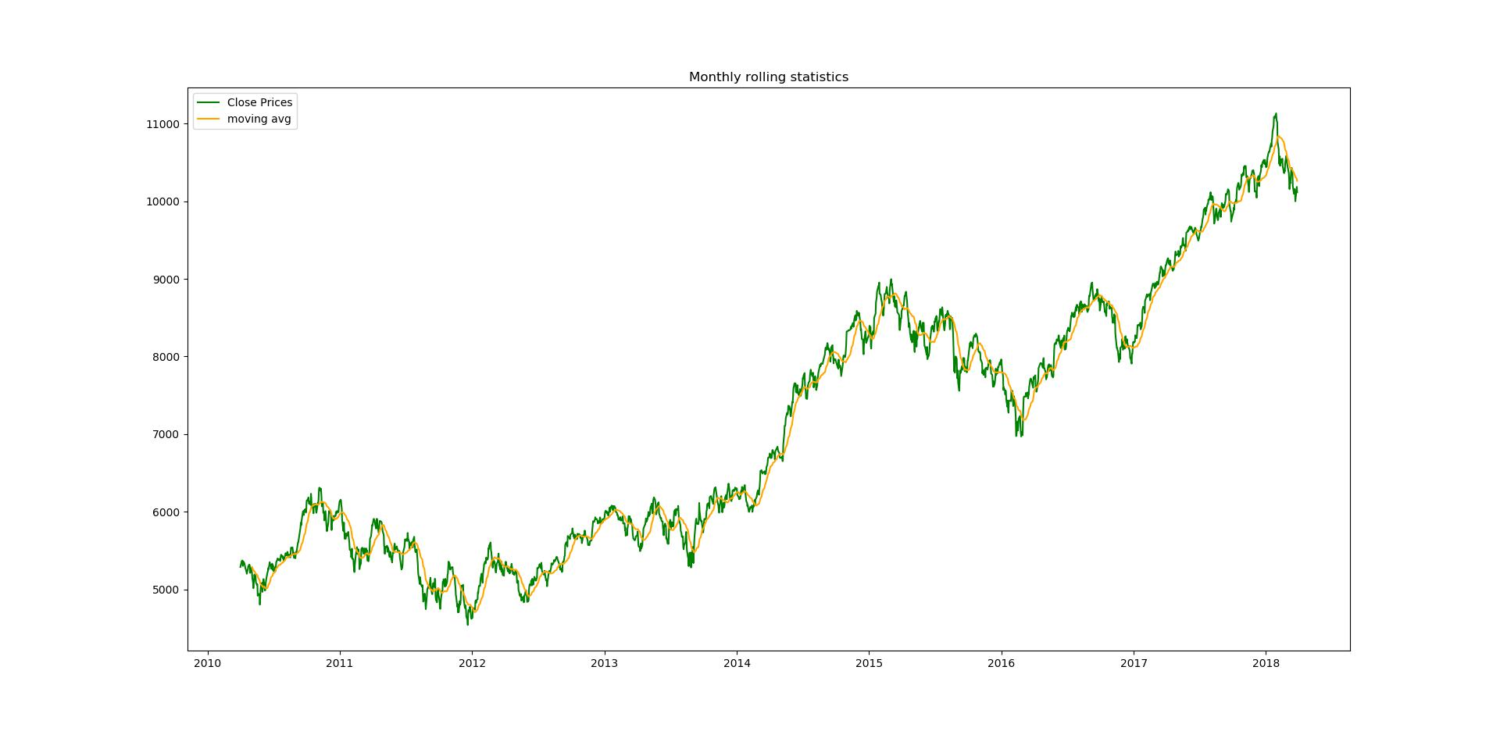

Quarterly

plt.plot(Nifty_data.Close,label='Close Prices',color='green')

plt.plot(Nifty_data['Close'].rolling(window=63).mean(),label='moving

avg',color='orange')

plt.legend()

plt.title('Quarterly rolling statistics')

plt.show()

4 / 26

finalReport.md 8/7/2018
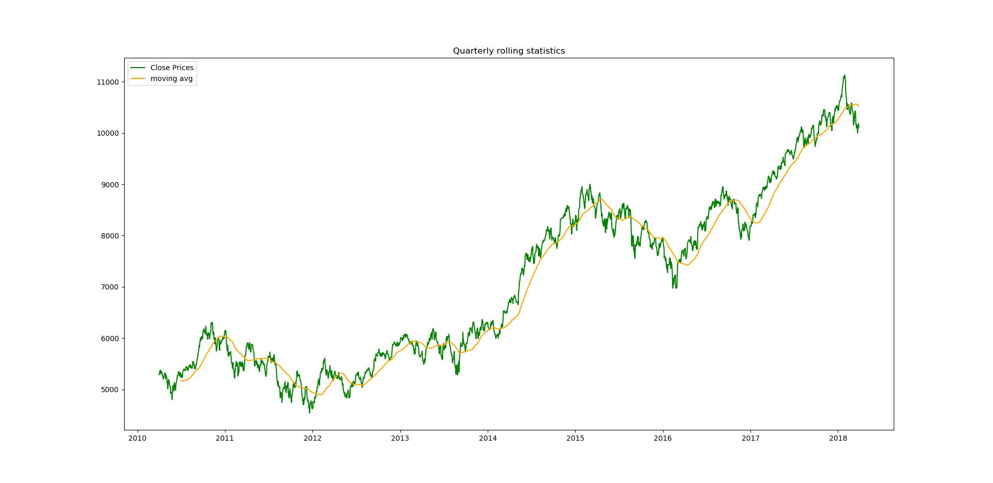

yearly

plt.plot(Nifty_data.Close,label='Close Prices',color='green')

plt.plot(Nifty_data['Close'].rolling(window=252).mean(),label='moving

avg',color='orange')

plt.legend()

plt.title('Yearly rolling statistics')

plt.show()
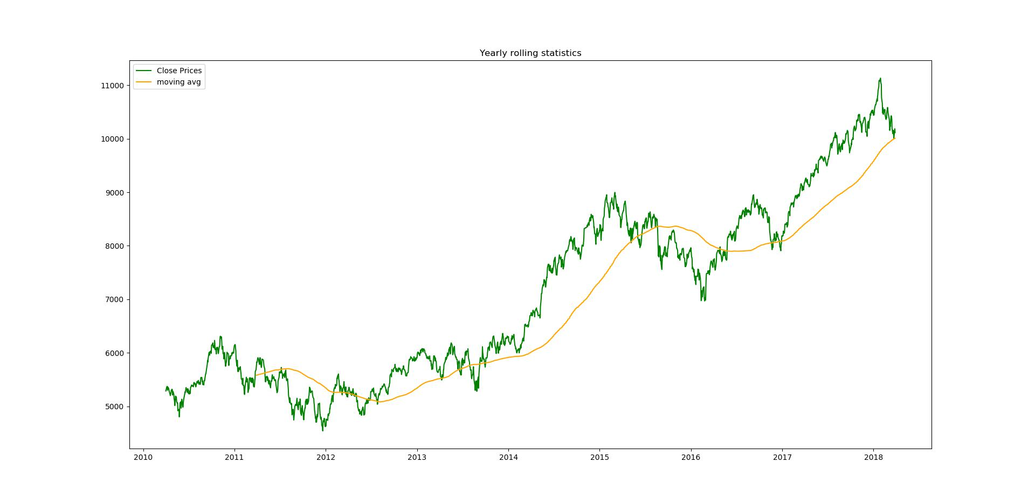

As we can see moving average is changing with time so, Time series is not stationary.

- Augmented Dickey Fuller test : This is one of the unit root tests for checking stationarity. In this this test we check for null hypothiesis, where H₀ stats that time series is stationary whereas H_{A} stats that

5 / 26

finalReport.md 8/7/2018

time series is not Stationary. In python we have stattools.adfuller function to check the stationarity of time series.


from statsmodels.tsa.stattools import adfuller

stnry_test=adfuller(Nifty_data['Close'],autolag='AIC')

stnry_rslt = pd.Series(stnry_test[0:4], index=['Test Statistic','p-value','#Lags Used','Number of Observations Used'])
for key,value in stnry_test[4].items():

stnry_rslt['Critical Value (%s)'%key] = value

print(stnry_rslt)

if(stnry_test[1]>0.05):

print("Time Series is not stationary")

else:

print("Time series is stationary")
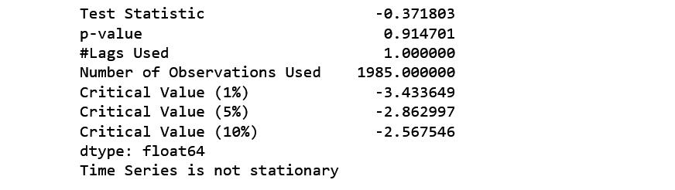

**Note - ** if p-value is greater than 0.05 reject null hypothesis.

Here, p-value is 0.914701 which is greater than 0.05. Hence it is confirmed that our time series is not stationary.

To get stationary time series we need to remove trend and seasonality.

Methods to detrending data

A time series can be detrended using following methods -

Differencing

Regression

using functions

- Method to detrending timeseries using Differencing : Differencing is the process of taking difference between successive occurrence of time series Δx_{t} = x_{t} - x_{t-1}.

Where, Δx_{t} is stationary time series.

x_{t} is original time series.

x_{t-1} is time series with lag 1.

In python we have .shift() method to create a series with lag.

6 / 26

finalReport.md 8/7/2018

diff=Nifty_data['Close']-Nifty_data['Close'].shift(1)

There will be null values because of lag. It is important to remove null values otherwise adfuller test function will show an error i.e. "SVD did not converge"


diff.dropna(inplace=True)

lets plot rolling statistics

plt.plot(diff,label='differenced timeseries',color='grey')

plt.plot(diff.rolling(window=252).mean(),label='Moving average',color='red')

plt.title('Yearly rolling statistics on diffrenced time series')

plt.axhline(y=0,color='green')

plt.legend()

plt.show()
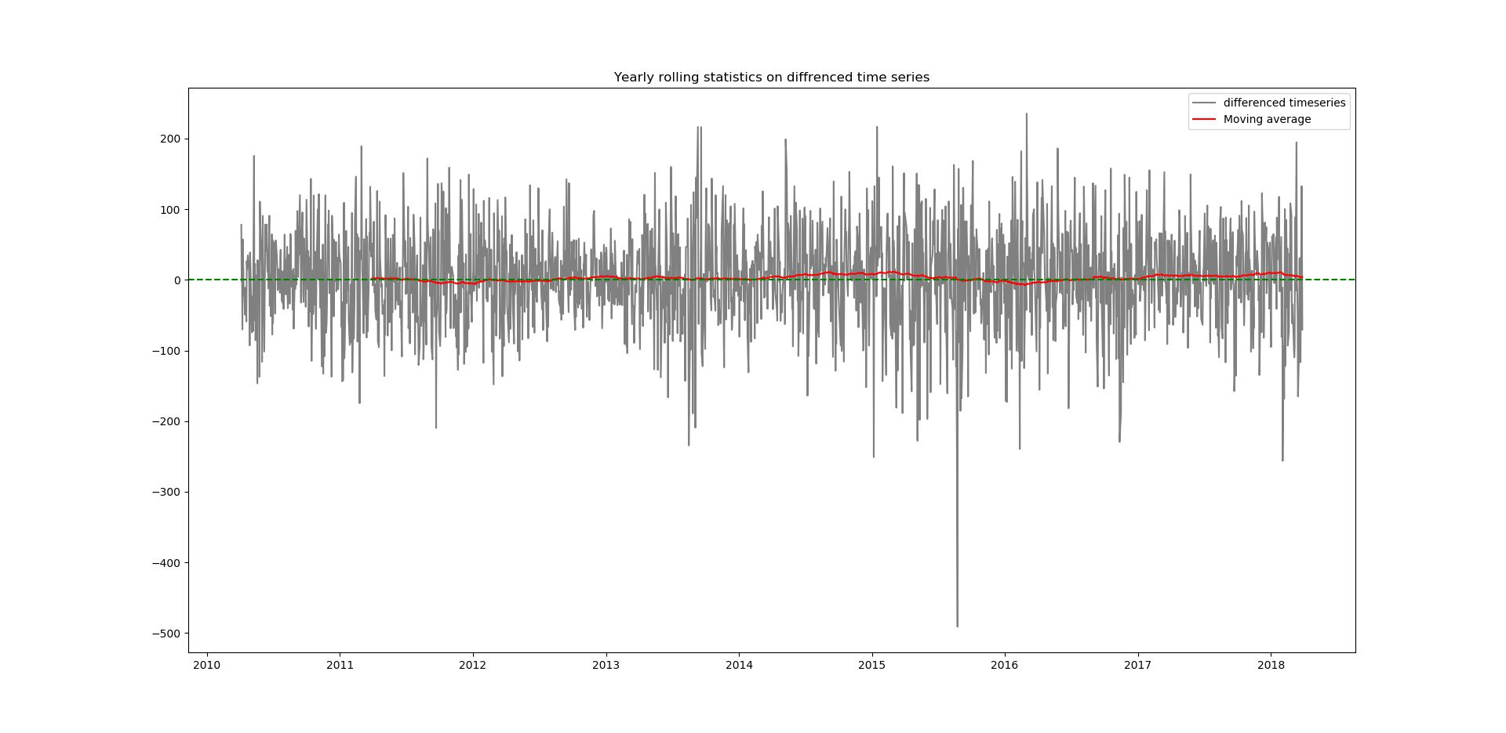

Now, the moving average is constant.

We can confirm the stationarity by apply Augmented DickeyFullerTest on diff time series -


stnry_test_diff=adfuller(diff,autolag='AIC')

stnry_rslt_diff = pd.Series(stnry_test_diff[0:4], index=['Test Statistic','p-value','#Lags Used','Number of Observations Used'])
for key,value in stnry_test[4].items():

stnry_rslt_diff['Critical Value (%s)'%key] = value

print(stnry_rslt_diff)

if(stnry_test_diff[1]>0.05):

7 / 26

finalReport.md 8/7/2018

print("Time Series is not stationary")


else:

print("Time series is stationary")
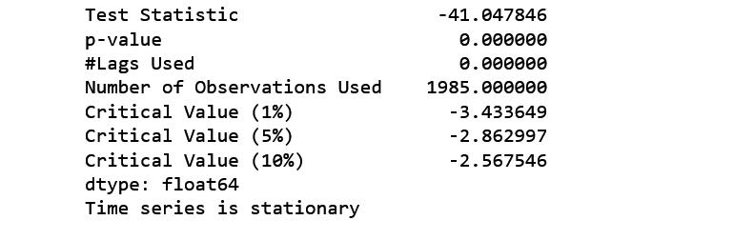

p-value is 0.000000 which is less than 0.05.

So, the time series is now stationary.

The method of differencing discussed above is first order differencing. After applying first order differencing It is possible that the time series may not become stationary then we have to perform second order differencing. To perform second order differencing, take difference another time.

x′_{t} - x′_{t-1} = (x_{t} - x_{t-1}) - (x_{t-1} - x_{t-2}) = x_{t} - 2x_{t-1} - x_{t-2}

This was the first method of making a time series stationary.

- Method to detrening timeseries using Regression : Regression is another way to detrending timeseries data. Objective of choosing regression over differencing is to get trend line. Trend line can later be used as prediction of long run movement of time series.

Regression analysis is a form of predictive modeling technique which looks into the relationship between a target and predictor variables. Regression analysis is used for forecasting, time series modeling.

Here we fit a trend line to the training data, in such a manner that the distance between data points and trend line is minimum.

lets perform linear regression, but first we have to separate training data and testing data


- separating training and testing data train = Nifty_data['Close'].iloc[:1750] test = Nifty_data['Close'].iloc[1751:]
- building linear model

import numpy as np

from sklearn import linear_model

lm = linear_model.LinearRegression(normalize=True, fit_intercept=True)

Details of parameters :

8 / 26

finalReport.md 8/7/2018

- Normalize : This parameter is ignored when fit_intercept is set to False. If True, the regressors X will be normalized before regression. By default this is set to False.

- fit_intercept : whether to calculate the intercept for this model. If set to False, no intercept will be used in calculations. By default this is set to True.

For more information about parameters you can see LinearRegression documentation.

http://scikit-

learn.org/stable/modules/generated/sklearn.linear_model.LinearRegression.html#sklearn.linear_model.LinearR egression

Now we have to fit linear_model to Nifty_data timeseries

lm.fit(np.arange(np.array(len(train.index))).reshape((-1,1)), train)

Now lets check the accuracy of fitted model

lm.score(np.arange(np.array(len(train.index))).reshape((-1,1)), train)

Now, we are going to plot close prices with trend line

plt.plot(Nifty_data['Close'],label='Original data') plt.plot(pd.Series(lm.predict(np.arange(np.array(len(Nifty_data.index))).reshape(( -1,1))),index=Nifty_data.index),label='Trend line') plt.title('Close prices with trend line')
plt.legend()

plt.show()

9 / 26

finalReport.md 8/7/2018

Output will be -
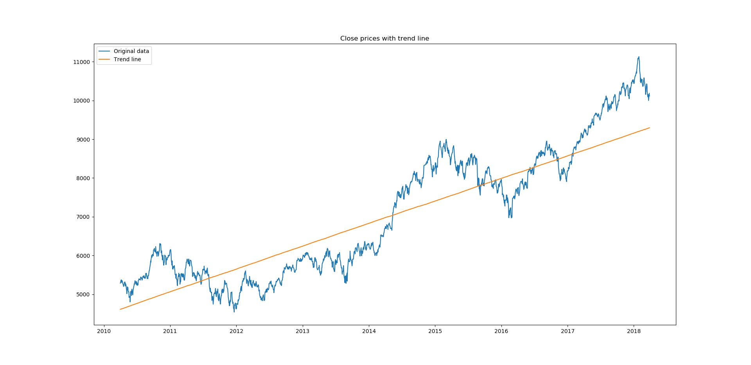

Now we are going to calculate residuals which will be used later in forecasting


Residuals=Nifty_data['Close']-

lm.predict(np.arange(np.array(len(Nifty_data.index))).reshape((-1,1)))

plt.plot(pd.Series(Residuals,index=Nifty_data.index),label=Residuals)

plt.title('Residuals for Close prices')

plt.show()
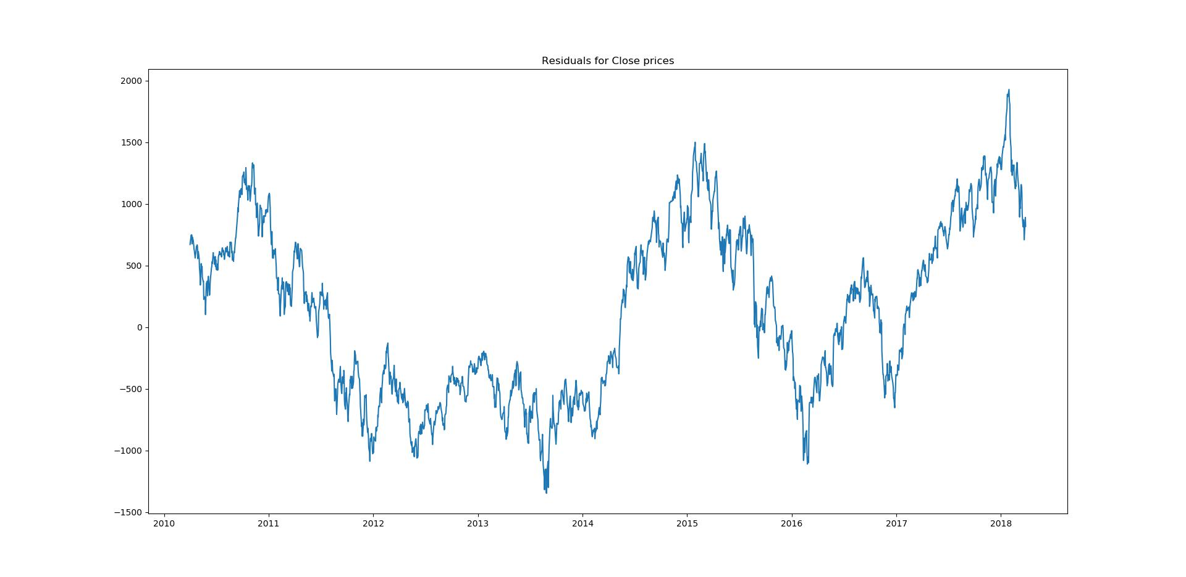

- Method to detrending timeseries using Functions : There are many libraries in python which are specially made to perform Statistical operations, one of them is statsmodels.

10 / 26

finalReport.md 8/7/2018


from statsmodels.tsa import seasonal

decompose = seasonal.seasonal_decompose(Nifty_data['Close'],freq=252)

seasonal_decompose() method returns,

Observed data (i.e. Close prices from Nifty_data dataset)

Trend components

Seasonal components

Residuals

We can access Trend, seasonal components and Residuals by decompose.trend, decompose.seasonal, decompose.resid respectively.

Note : Because we use 252 as frequency so we will have 252 null values in trend component and in residuals


decompose.trend.dropna(inplace=True)

decompose.resid.dropna(inplace=True)

Now, we are going to plot trend component.


decompose.trend.plot()

plt.title('Trend Component')

plt.show()
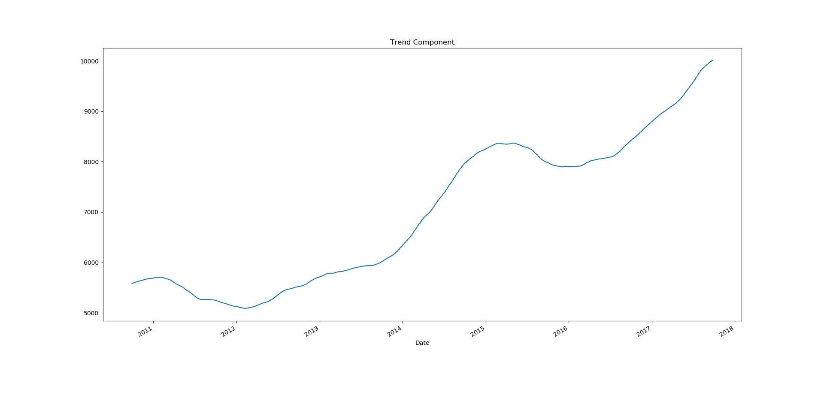

We detrended our time series now it's time to do work on seasonality.

Estimating seasonality

11 / 26

finalReport.md 8/7/2018

while removing trend by using differencing, seasonality was also removed so if we perform differencing method trend and seasonality both will removed

while applying seasonal_decompose method we already get the seasonal component.

so there is no need to perform any other operation to remove seasonality if we follow differencing or use statsmodels package. If we use regression then we don't get anything related to seasonality. So we have to perform exploratory data analysis through following plots :

Run sequence plot

Seasonal subseries plot

Multiple box plot

To remove Seasonality, simply take average of detrended data for specific season. In these plot we will use Residuals -

Residuals = Nifty_data['Close'] -

lm.predict(np.arange(np.array(len(Nifty_data.index))).reshape((-1,1)))

Run sequence plot :

A simple time series plot wit time on x-axis itself reveals following properties :

- Movement in mean of series

- Shifts in variance

- presence of outliers

lets viusualize :

Monthly


plt.plot(Residuals.rolling(window=21).mean(),label='residual mean')

plt.plot(Residuals.rolling(window=21).std(),label='residual std')

plt.plot(Residuals,label='Residuals')

plt.xlabel('year')

plt.ylabel('Residuals')

plt.title('Residuals,Monthly mean and Monthly Std ')

plt.legend()

plt.show()

12 / 26

finalReport.md 8/7/2018
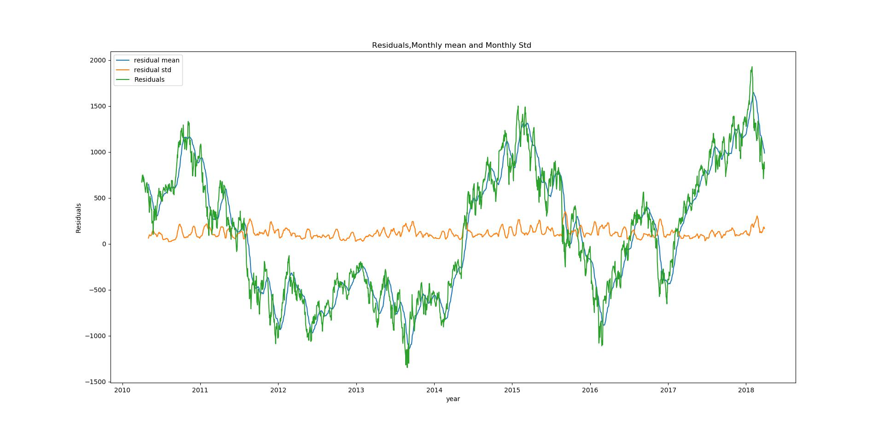

Quarterly

plt.plot(Residuals.rolling(window=63).mean(),label='residual mean')

plt.plot(Residuals.rolling(window=63).std(),label='residual std')

plt.plot(Residuals,label='Residuals')

plt.xlabel('year')

plt.ylabel('Residuals')

plt.title('Residuals,Quarterly mean and Quarterly Std ')

plt.legend()

plt.show()
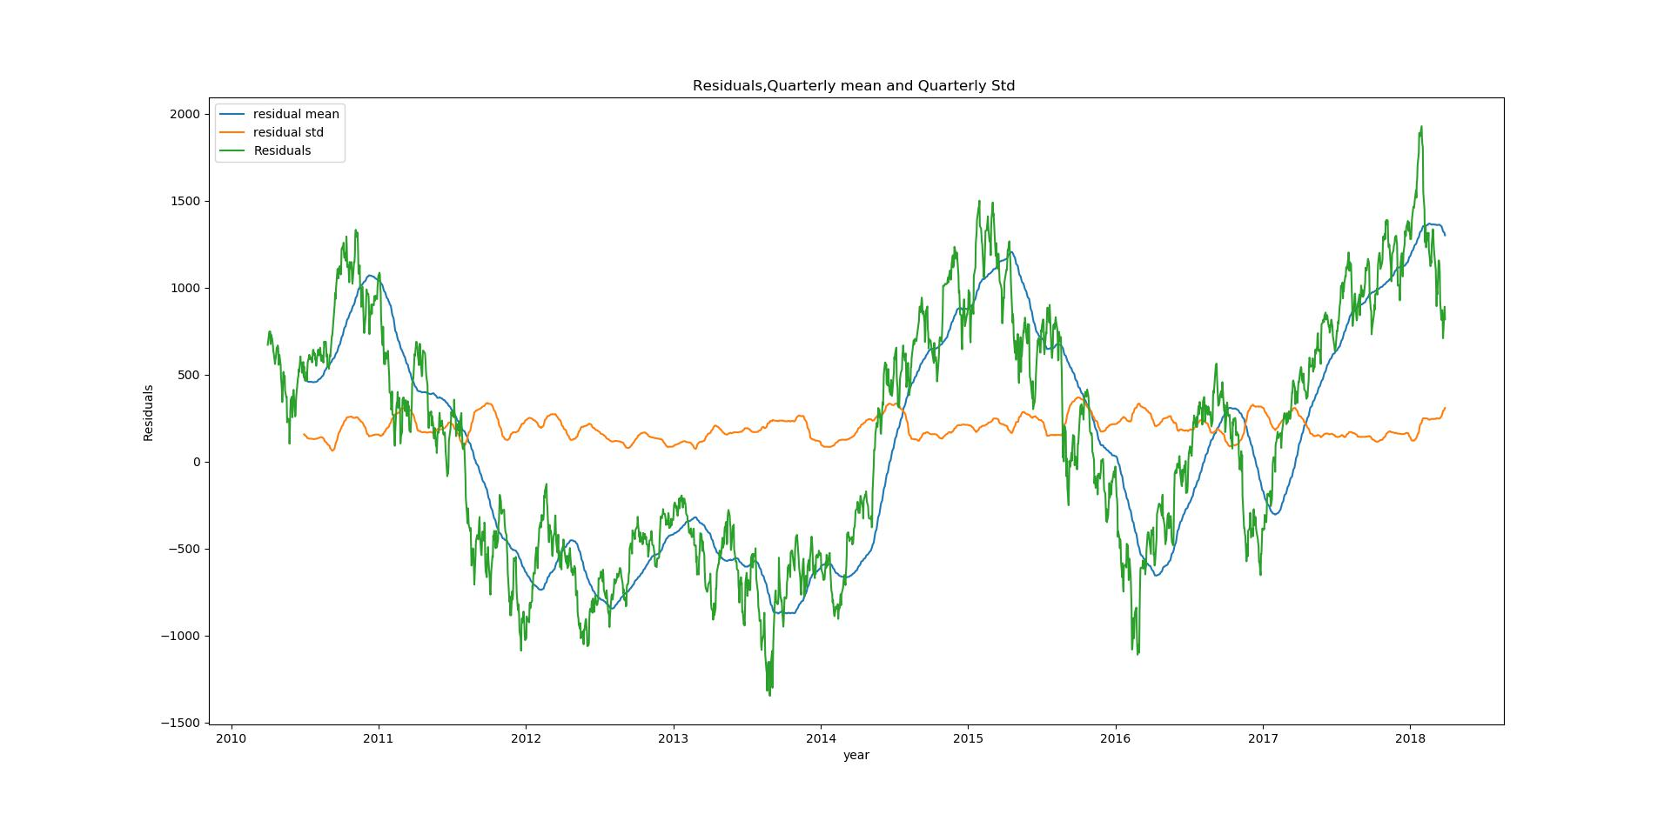

yearly

13 / 26

finalReport.md 8/7/2018


plt.plot(Residuals.rolling(window=252).mean(),label='residual mean')

plt.plot(Residuals.rolling(window=252).std(),label='residual std')

plt.plot(Residuals,label='Residuals')

plt.xlabel('year')

plt.ylabel('Residuals')

plt.title('Residuals,Yearly mean and Yearly Std ')

plt.legend()

plt.show()
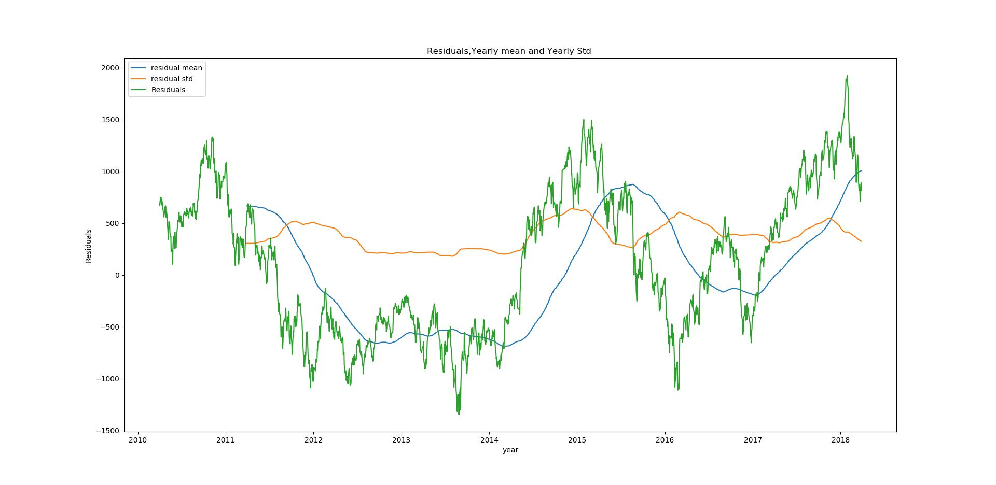

Seasonal sub series plot :

We can identify seasonality by groping time periods like month, quarter or year. this method is only useful when time period of seasonality is known.

before plotting lets add columns for Residuals, months, quarter and years.

Adding column "Residuals"

Nifty_data['Residuals']=Residuals

Adding column "month"

Nifty_data['month']=Nifty_data.index.map(lambda x:x.month)

Adding column "year"

14 / 26

finalReport.md 8/7/2018

Nifty_data['year']=Nifty_data.index.map(lambda x:x.year)

Adding column "quarter"

month_quarter_map = {1: 'Q1', 2: 'Q1', 3: 'Q1',

4: 'Q2', 5: 'Q2', 6: 'Q2',

7: 'Q3', 8: 'Q3', 9: 'Q3',

10: 'Q4', 11: 'Q4', 12: 'Q4'

}

Nifty_data['quarter'] = Nifty_data['month'].map(lambda m:

month_quarter_map.get(m))

Now we are going to calculate mean and standard deviation for residuals and making a new subseries. we already calculated residuals while detrending data using regression.

quarterly


# Creating new subseries

sub_series_quarterly = Nifty_data.groupby(by=['year', 'quarter'])

['Residuals'].aggregate([np.mean, np.std])

sub_series_quarterly.columns = ['Quarterly Mean Close', 'Quarterly Standard

Deviation Close']

#Create row indices of seasonal_sub_series_data using Year & Quarter

sub_series_quarterly.reset_index(inplace=True)

sub_series_quarterly.index = sub_series_quarterly['year'].astype(str) + '-' +

sub_series_quarterly['quarter']

Lets have a look to our sub series :

sub_series_quarterly.head()
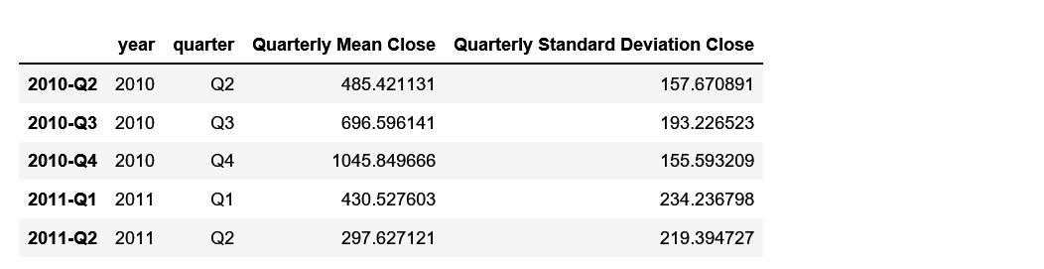

Now we are going to plot it -

15 / 26

finalReport.md 8/7/2018


sub_series_quarterly['Quarterly Mean Close'].plot(color='b')

plt.title('Quarterly Mean of Residuals')

plt.ylabel('Residuals')

plt.show()

sub_series_quarterly['Quarterly Mean Close'].plot()

plt.title('Quarterly standard Deviation of Residuals')

plt.show()
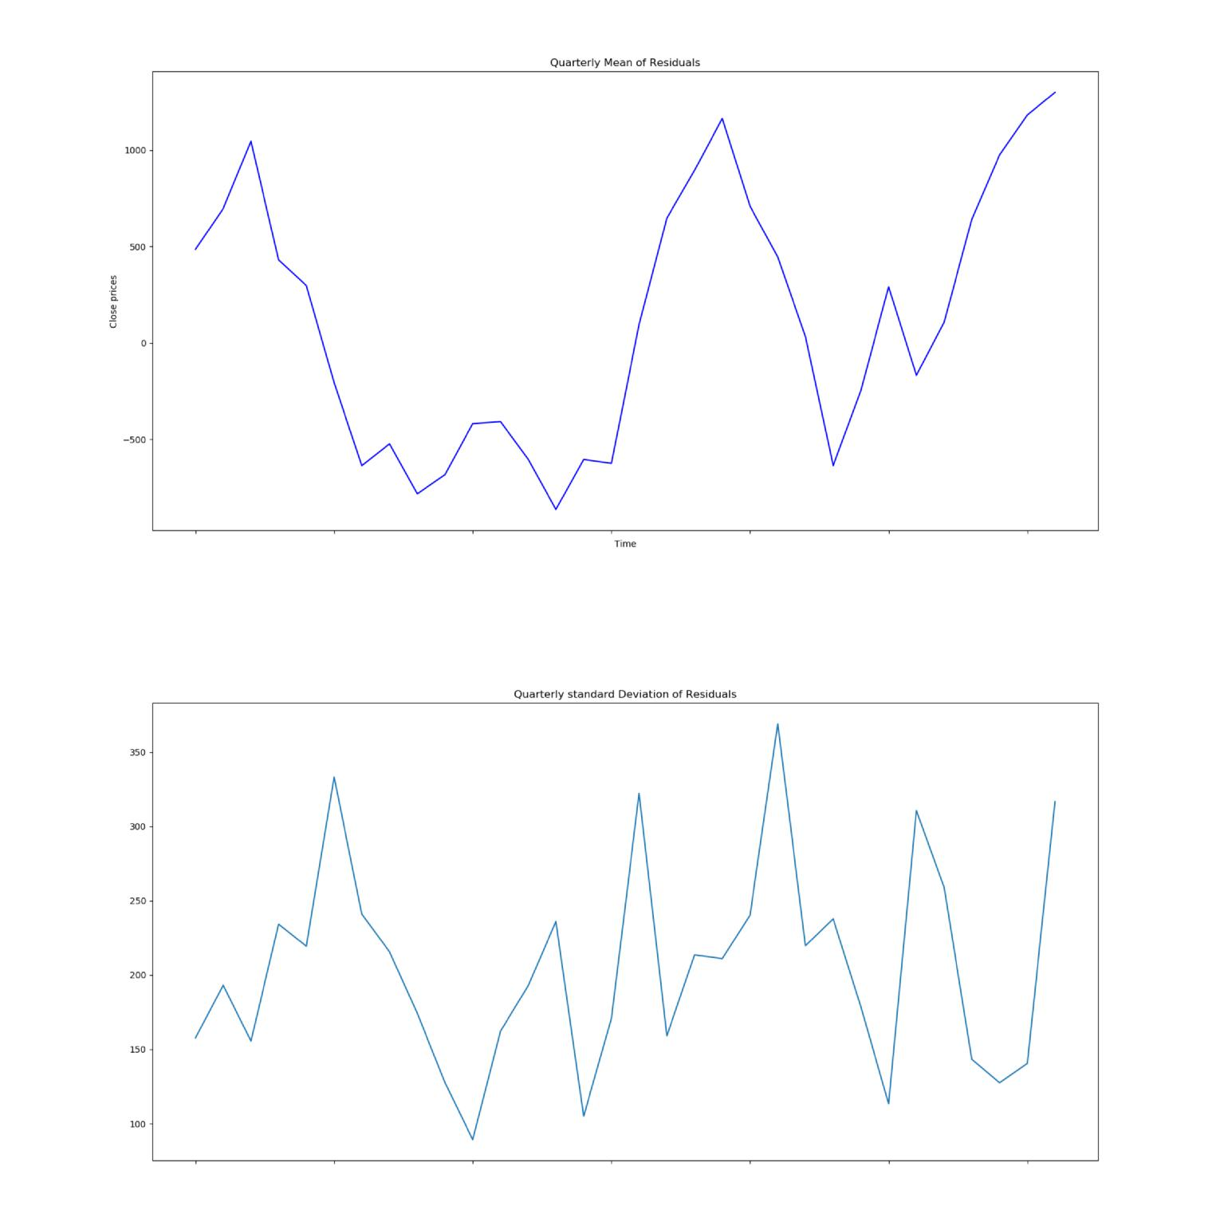

Monthly


# Creating new subseries

sub_series_Monthly = Nifty_data.groupby(by=['month'])

['Residuals'].aggregate([np.mean, np.std])

sub_series_Monthly.columns = ['monthly Mean', 'monthly Standard Deviation']

16 / 26

finalReport.md 8/7/2018

# plotting sub series


sub_series_Monthly['monthly Mean'].plot()

plt.title('Monthly mean of residuals')

plt.show()

sub_series_Monthly['monthly Standard Deviation'].plot()

plt.title('Monthly Standard Deviation of residuals')

plt.show()
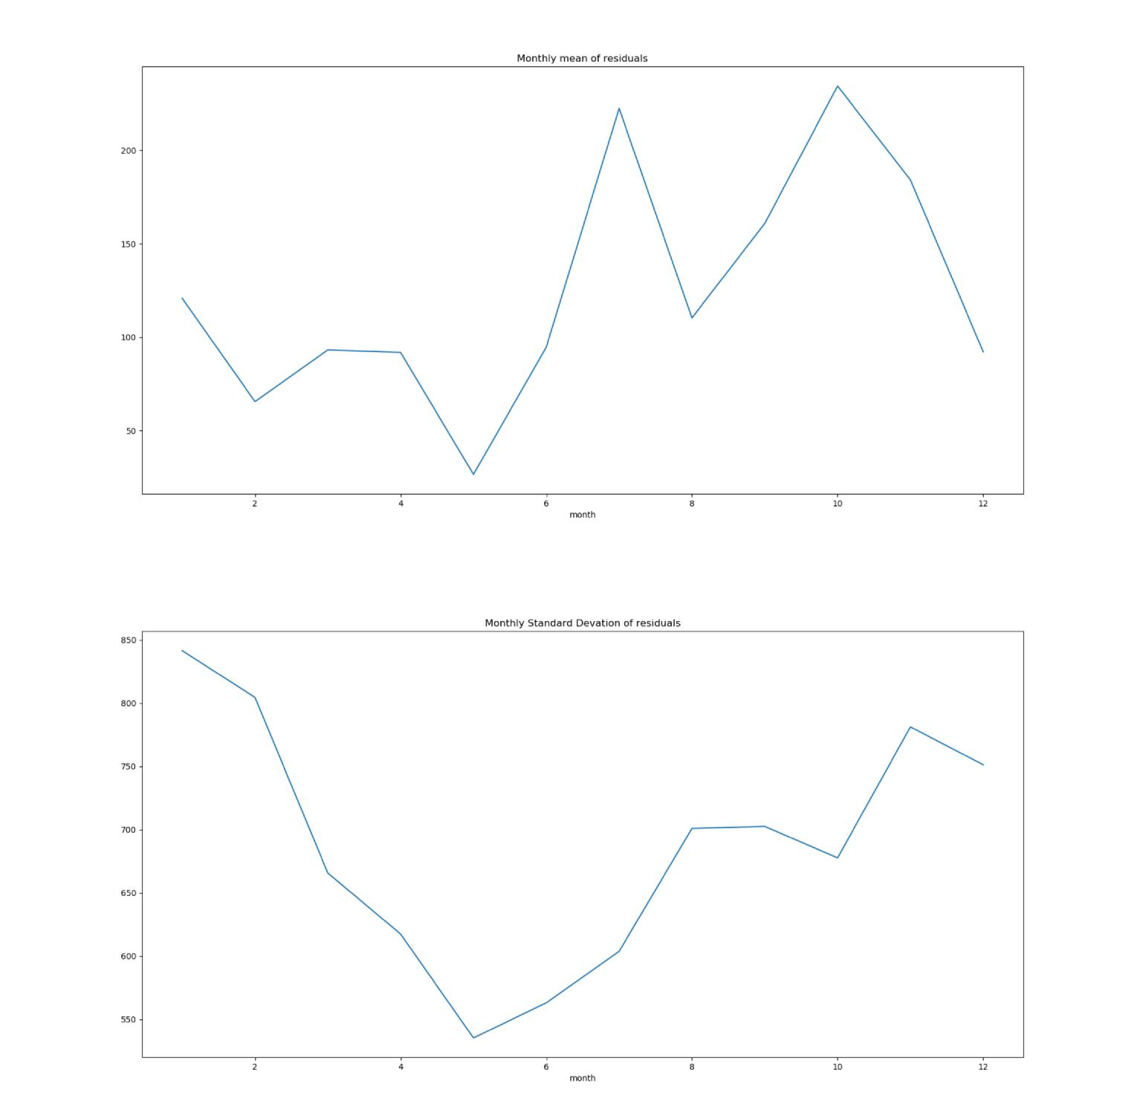

Yearly


# Creating new subseries

sub_series_yearly = Nifty_data.groupby(by=['year'])

['Residuals'].aggregate([np.mean, np.std])

sub_series_yearly.columns = ['yearly Mean', 'yearly Standard Deviation']

# plotting sub series

17 / 26

finalReport.md 8/7/2018

sub_series_yearly['yearly Mean'].plot()


plt.title('yearly mean of residuals')

plt.show()

sub_series_yearly['yearly Standard Deviation'].plot()

plt.title('Yearly Standard Devation of residuals')

plt.show()
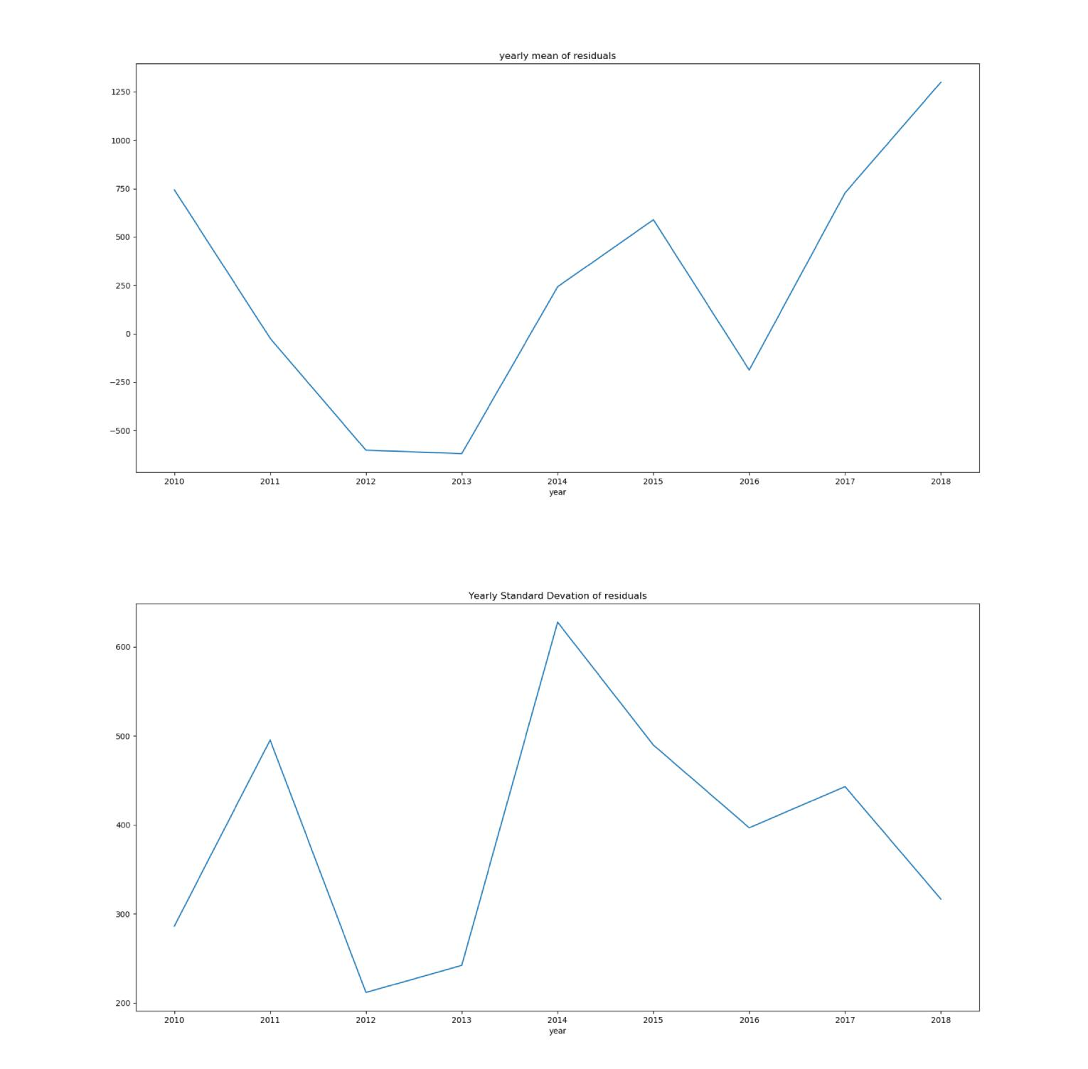

Multiple box plots :

Multiple box plots are basically the boxplots of seasonal subseries plots. Box plots are more informative than any simple plot. Box plot revels information like mean, inter quartile range, minimum and maximum value and outliers, central tendency and dispersion.

For box plots we are going to use seaborn.

18 / 26

finalReport.md 8/7/2018

Quarterly

- Multiple Boxplot(Quarterly) import seaborn as sns plt.figure(figsize=(5.5, 5.5))
g = sns.boxplot(data=Nifty_data[['Residuals','quarter']], y=Nifty_data['Residuals'], x=Nifty_data['quarter']) g.set_title('Quarterly box plot of Residuals') g.set_xlabel('Time')
g.set_ylabel('Residuals') plt.show()
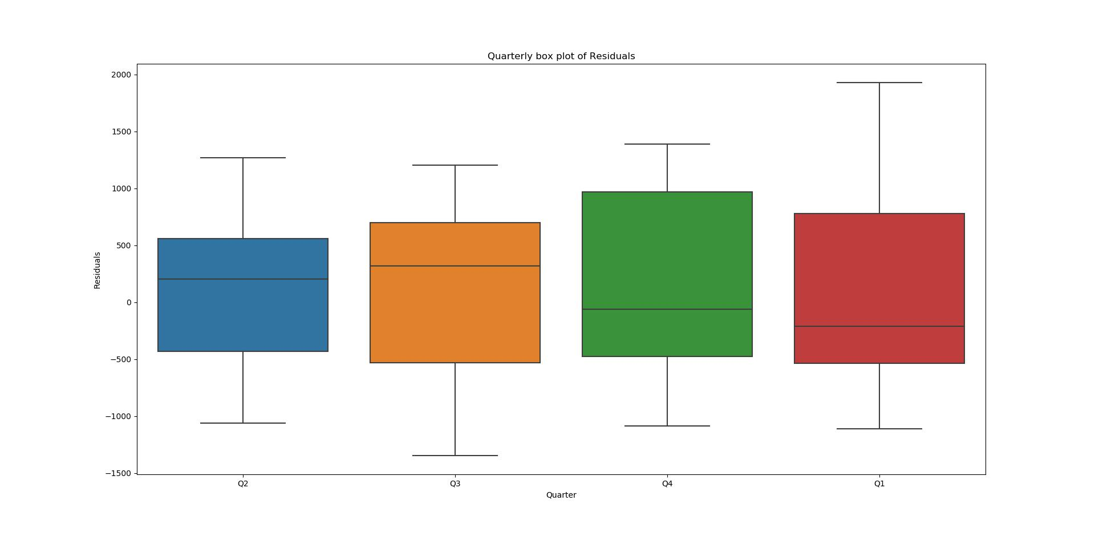

Monthly

- Multiple Boxplot(Monthly) import seaborn as sns plt.figure(figsize=(5.5, 5.5))
g = sns.boxplot(data=Nifty_data[['Residuals','month']], y=Nifty_data['Residuals'], x=Nifty_data['month'])
g.set_title('Monthly box plot of Residuals') g.set_xlabel('Time') g.set_ylabel('Residuals')
plt.show()

19 / 26

finalReport.md 8/7/2018
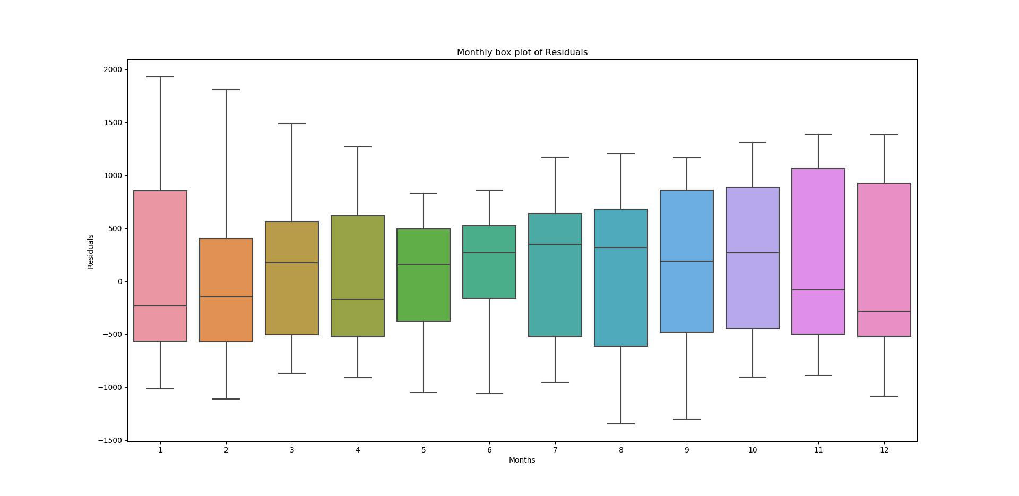

Yearly

- Multiple Boxplot(Yearly) import seaborn as sns plt.figure(figsize=(5.5, 5.5))
g = sns.boxplot(data=Nifty_data[['Residuals','year']], y=Nifty_data['Residuals'], x=Nifty_data['year'])
g.set_title('Yearly box plot of Residuals') g.set_xlabel('Time') g.set_ylabel('Residuals')
plt.show()
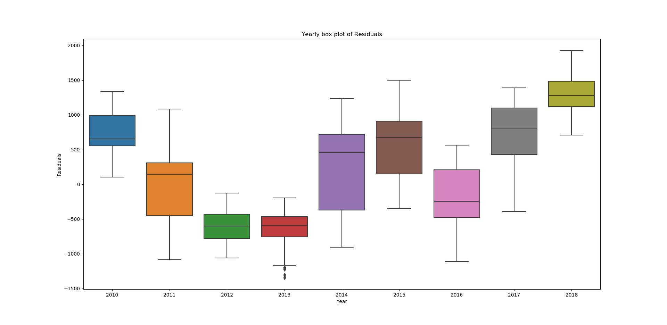

These are the methods to estimating seasonality.

20 / 26

finalReport.md 8/7/2018

Forecasting

For Time series forecasting ARIMA model is popular and widely used statistical method. ARIMA is an acronym of AutoRegressive Integrated Moving Average. It is generalization of AutoRegressive Moving Average and differencing.

AR (AutoRegression): This technique can be used on time series where output variable depends on its own previous values.

I (integrated) : This is order of differencing to make time series stationary.

MA (Moving Average) : A model that analyze data points by creating series of averages of subsets of data.

The ARIMA(p,d,q) represents the order of AR term, Differencing order and MA term respectively To find the value of p and q we will plot autocorrelation and partial autocorrelation functions.


from statsmodels.tsa.stattools import acf, pacf

# ACF plot

lag_acf=acf(diff,nlags=20)

lag_pacf=pacf(diff,nlags=20,method='ols')

- plot ACF plt.plot(lag_acf)
plt.axhline(y=0,linestyle='--',color='gray') plt.axhline(y=-1.96/np.sqrt(len(diff)),linestyle='--',color='gray') plt.axhline(y=1.96/np.sqrt(len(diff)),linestyle='--',color='gray') plt.title('Autocorrelation Function')
plt.show()

- plot PACF

plt.plot(lag_pacf)

plt.axhline(y=0,linestyle='--',color='gray')

plt.axhline(y=-1.96/np.sqrt(len(diff)),linestyle='--',color='gray')

plt.axhline(y=1.96/np.sqrt(len(diff)),linestyle='--',color='gray')

plt.title('Partial Autocorrelation Function')

plt.show()

21 / 26

finalReport.md 8/7/2018
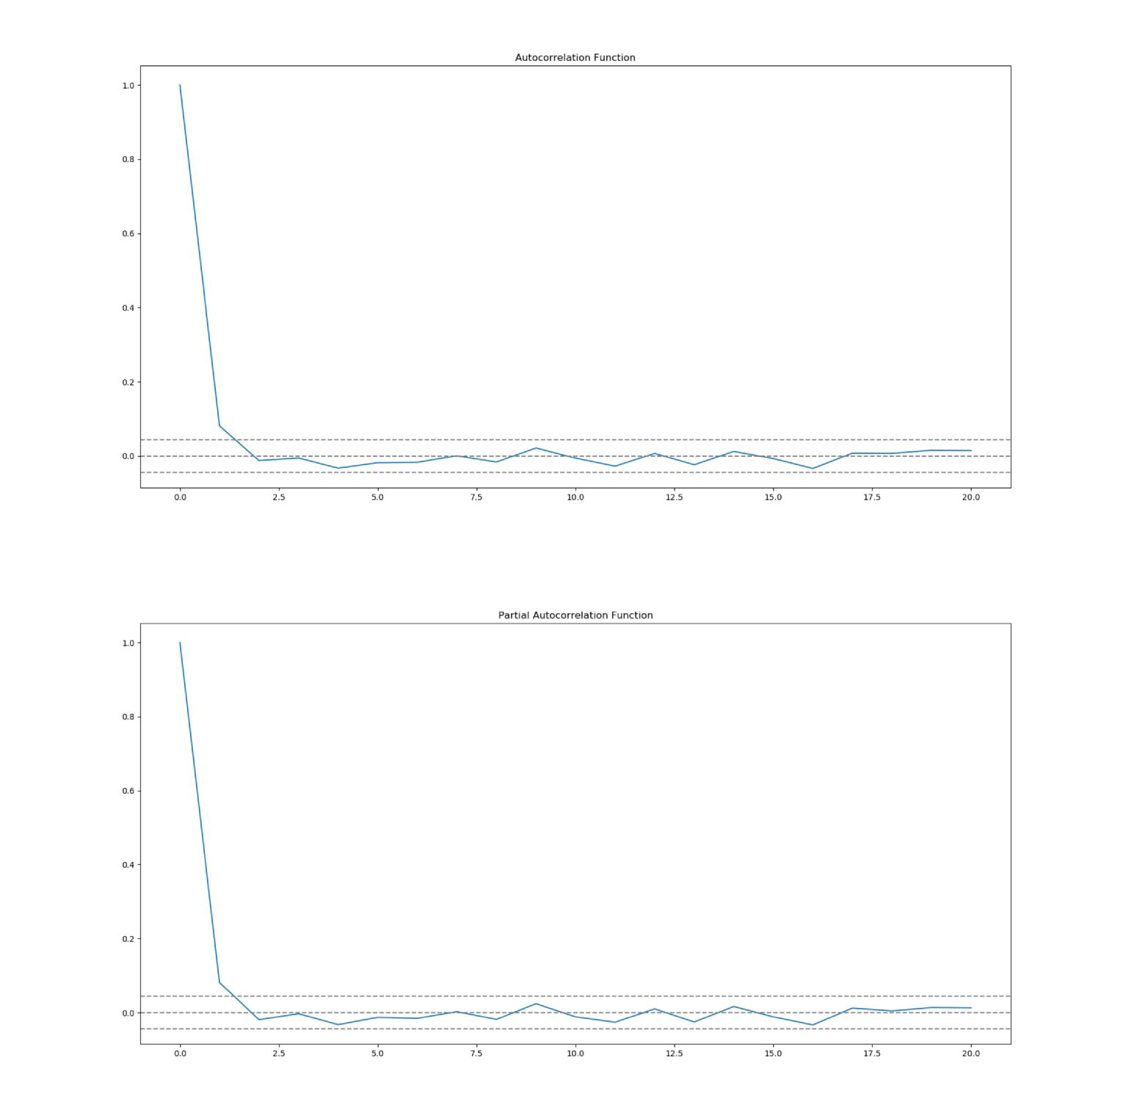

In these plots we draw the dotted line at y=0 and confidence intervals (dotted lines).

- The value of p will be the lag value where the PACF chart crosses the upper confidence interval for the first time. In our plot it is 2.

- The value of q will be the lag value where the ACF chart crosses the upper confidence interval for the first time. In our plot it is also 2.

Time series forecasting can be done in two ways :

- We can calculate fitted values from model and take it back to original time series scale

- Use .forecast() function on ARIMAresults, which performs one step forcast using the model.

Forecasting without using .forecast() function

from statsmodels.tsa.arima_model import ARIMA

# seperating training and testing data

22 / 26

finalReport.md 8/7/2018

train=Nifty_data['Close'].iloc[:1750]


test=Nifty_data['Close'].iloc[1751:]

# Building ARIMA model

model = ARIMA(Nifty_data['Close'], order=(2, 1, 2))

results_ARIMA = model.fit()

# taking it back to original scale

predict_Arima=pd.Series(results_ARIMA.fittedvalues, copy=True)

predict_Arima.head()
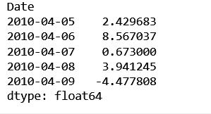

The first element of our original time series is lost because we took a lag by 1. to convert the differencing to log scale we will first determine the cumulative sum at index and then add it to the base number.

predict_Arima_cumsum=predict_Arima.cumsum()

predict_Arima_data=pd.Series(Nifty_data['Close'].iloc[0], index=Nifty_data.index)

predict_Arima_data=predict_Arima_data.add(predict_Arima_cumsum,fill_value=0)

predict_Arima_data.head()
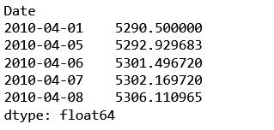

Now the series is on its original scale.

plt.plot(Nifty_data['Close'],label='Close prices')

plt.plot(predict_Arima_data,label='predicted values')

plt.legend()

plt.show()

23 / 26

finalReport.md 8/7/2018
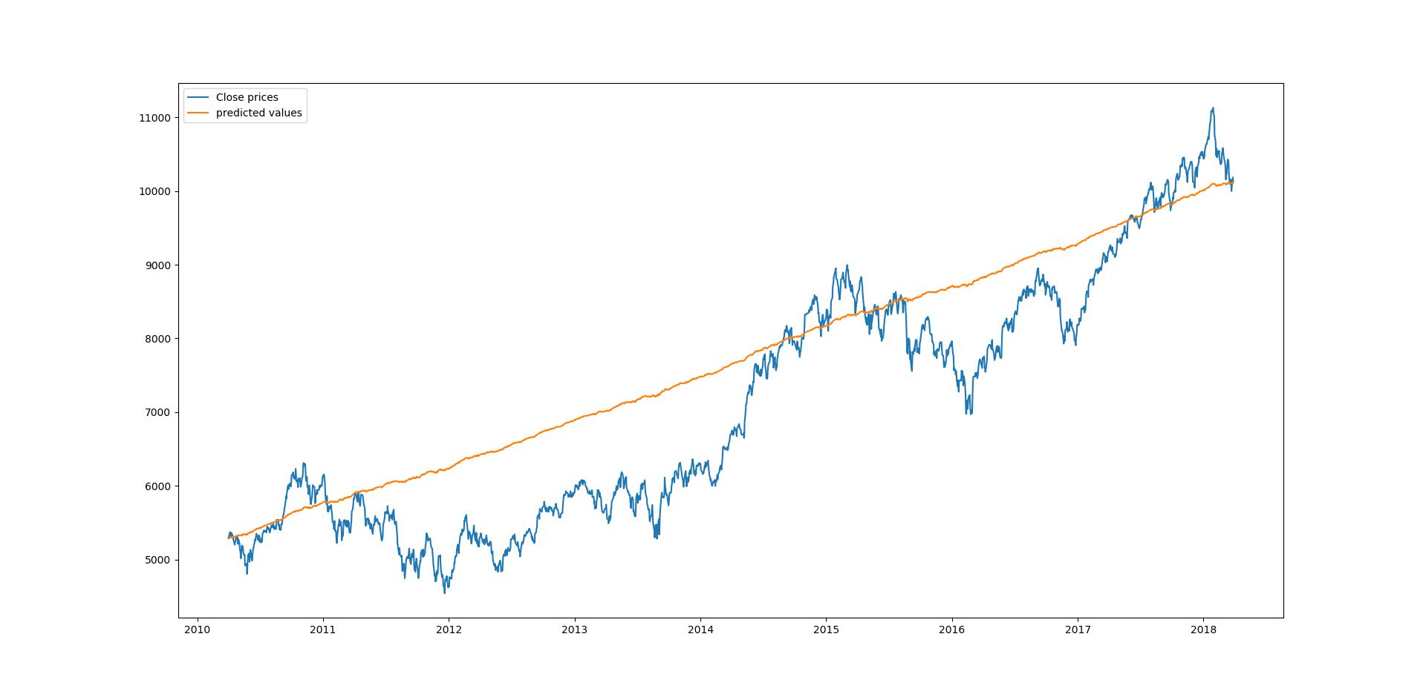

code to calculate score -

import sklearn.metrics

sklearn.metrics.r2_score(Nifty_data['Close'],predict_Arima_data)

The score is : 0.7398187397952602

Forecasting using .forecast() function


training_set = [x for x in train]

predictions = []

for i in range(len(test)):

model = ARIMA(training_set, order=(2,1,2))

model_fit = model.fit()

output = model_fit.forecast()

predictions.append(output[0])

obs = test[i]

training_set.append(obs)

print('predicted=%f, expected=%f' % (output[0], obs))

Sample of output is :

24 / 26

finalReport.md 8/7/2018
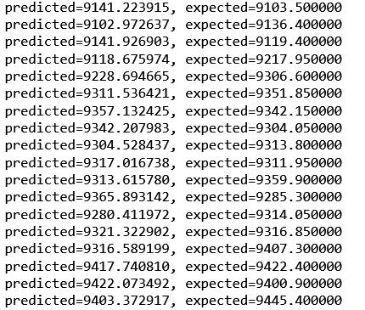

Plot of predicted values with test data :

pred=pd.Series(predictions,index=test.index)

plt.plot(test,label='Test data')

plt.plot(pred, color='red',label='Predicted values')

plt.title('Test data VS. Predicted values')

plt.legend()

plt.show()
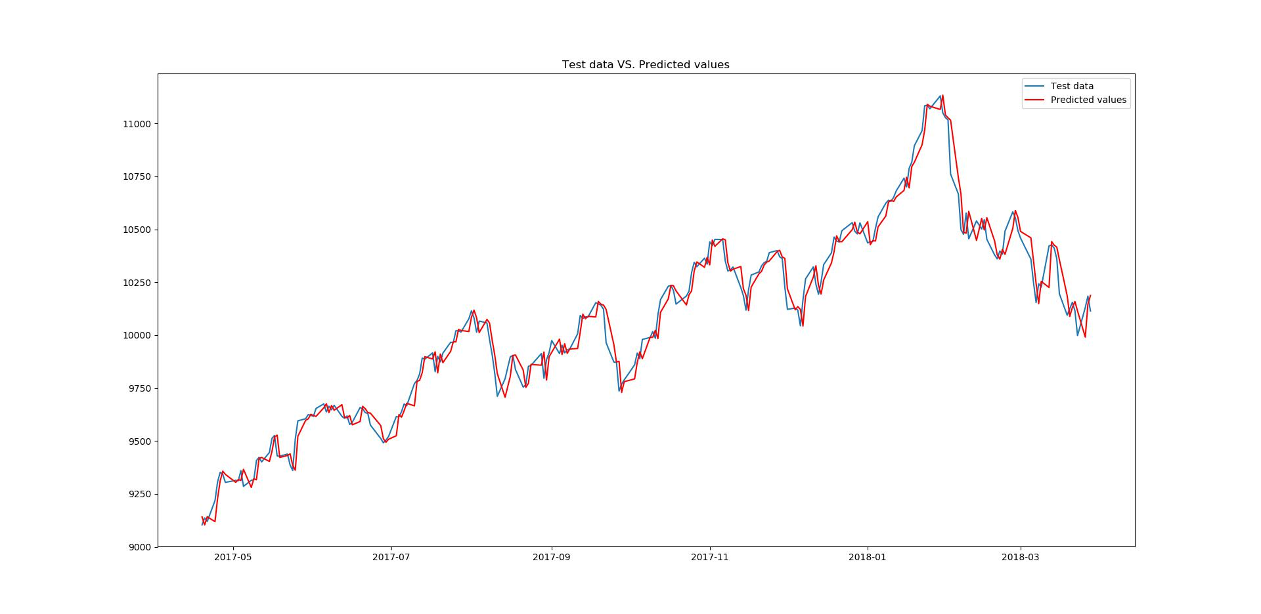

R2 Score -

sklearn.metrics.r2_score(test,pred)

25 / 26

finalReport.md 8/7/2018

The Score is : 0.9777090172770078

26 / 26

