CS 5392 Reinforcement Learning
Project Report: Proximal Policy Optimization on Pendulum-v1
Implementation, Analysis, and Extensions
Team 15
Abhijeet Pandey
Ganesh Adhikari
Vishal Thapa
May 8, 2026

1. Introduction
This report documents our implementation and analysis of Proximal Policy Optimization (PPO) applied to the Pendulum-v1 swing-up control task. The project covers the full PPO algorithm as introduced by Schulman et al. (2017), built incrementally through five tasks: an experience replay buffer with environment interaction, vanilla policy gradient (REINFORCE), Generalized Advantage Estimation (GAE) with a learned value function, the PPO clipped surrogate objective, and the complete PPO algorithm with multiple SGD epochs over collected data.
Beyond the required tasks, we explored four extensions chosen to test different aspects of the algorithm: state-dependent action variance, ensemble value estimation, parallel data collection, and recurrent policies for partial observability. Each extension was implemented as a toggleable flag in our training pipeline so that any combination of extensions can be compared against the baseline. The work was distributed across the team in pair-programming style, with all members contributing to coding, debugging, and analysis.

1.1 Environment
Pendulum-v1 (Gymnasium) is a classic continuous-control benchmark. The agent observes a 3-dimensional state [cos θ, sin θ, θ̇] and produces a single torque action in the range [-2, 2]. The reward is r = -(θ² + 0.1·θ̇² + 0.001·torque²), penalising deviation from upright, angular velocity, and control effort. Each episode lasts 200 steps. A perfect policy would achieve close to 0; random behaviour scores around -1500.

1.2 Codebase Structure
Our implementation is organised into the following files:
- buffer.py — Buffer class, sequential and parallel data collection, action sampling
- vpg.py — REINFORCE training loop and policy/log-prob helpers
- gae.py — Critic network and GAE advantage computation
- ppo.py — PPO surrogate loss, total loss, ensemble loss, training loops
- lstm.py — RecurrentActor for partial-observability extension
- Modules.py — NormalModule head with optional state-dependent variance
A unified train_ppo function accepts use_parallel and use_ensemble flags, which select between sequential vs. parallel rollouts and single-critic vs. ensemble training. A separate train_ppo_recurrent function handles the LSTM-based recurrent variant.

2. Core Algorithm Implementation (Tasks 1–5)

2.1 Task 1: Buffer and Environment Interaction
The Buffer class stores per-step transitions (state, action, reward, done, next_state) in preallocated NumPy arrays of fixed size, with a circular write index. We added next_states as a dedicated array (rather than reconstructing it via state[i+1]) so that GAE could later fetch correct next-state values even when transitions from multiple environments are interleaved. This becomes important for the parallel-collection extension.
The act helper samples actions from a Gaussian policy: a ~ N(μ(s), σ), with the mean tanh-squashed into (-1, 1) and then linearly rescaled to the environment's action range [-2, 2]. The clamp before rescaling prevents extreme samples in the tails of the distribution from producing invalid actions.
calc_reward_to_go fills R(s_t) = Σ γ^k · r_{t+k} with a single backward pass that resets the accumulator at episode boundaries (done flags). collect_data runs the standard rollout loop, storing transitions and resetting the environment when an episode terminates.

2.2 Task 2: Vanilla Policy Gradient
Vanilla PG implements the REINFORCE objective L = -E[(R_t - b)·log π(a|s)], where R_t is the reward-to-go and b is an optional baseline. We compared two learning rates (1e-4 and 3e-4); both produced flat learning curves around -1200 within 200 epochs, confirming that naive policy gradient is too high-variance to make meaningful progress on Pendulum in this budget. Adding the average-reward baseline gave a small reduction in variance but did not change the qualitative result — Pendulum's reward is always negative, so a constant baseline recentres the signal but does not provide state-dependent information.

2.3 Task 3: GAE with a Learned Critic
We added a feedforward critic V_φ(s) trained against reward-to-go targets, then computed GAE advantages:
δ_t = r_t + γ · V(s_{t+1}) · (1 - done) - V(s_t)
A_t = δ_t + γ · λ · (1 - done) · A_{t+1}
GAE's λ parameter interpolates between TD(0) (low variance, high bias) at λ=0 and Monte Carlo (low bias, high variance) at λ=1. We use λ=0.95 throughout. With GAE the policy gradient becomes much cleaner and we observe a steady upward trend (~-1600 → ~-900 over 200 epochs), in contrast to the flat curve from rewards-to-go alone. The early advantage of rewards-to-go training is then reversed because GAE's critic needs a few epochs to stabilise.

2.4 Task 4: PPO Surrogate Objective
The clipped PPO surrogate replaces the policy gradient signal log π(a|s) · A_t with a ratio-based importance-weighted version:
r_t(θ) = exp(log π_θ(a|s) - log π_old(a|s))
L_clip = E[ min(r_t·A_t, clip(r_t, 1-ε, 1+ε)·A_t) ]
The clipping range ε=0.2 prevents any single update from moving the policy too far from the one that produced the data. The min operator provides a pessimistic bound that stops the objective from rewarding excessive policy change in the favourable direction.
We compared clipped vs. unclipped over 50 iterations. As expected, the difference is small in this short window — divergence between π_θ and π_old does not yet exceed the clip range. The benefit of clipping shows up later, in the full PPO experiments, where it prevents the catastrophic late-training collapses that we observed when ε was effectively disabled.
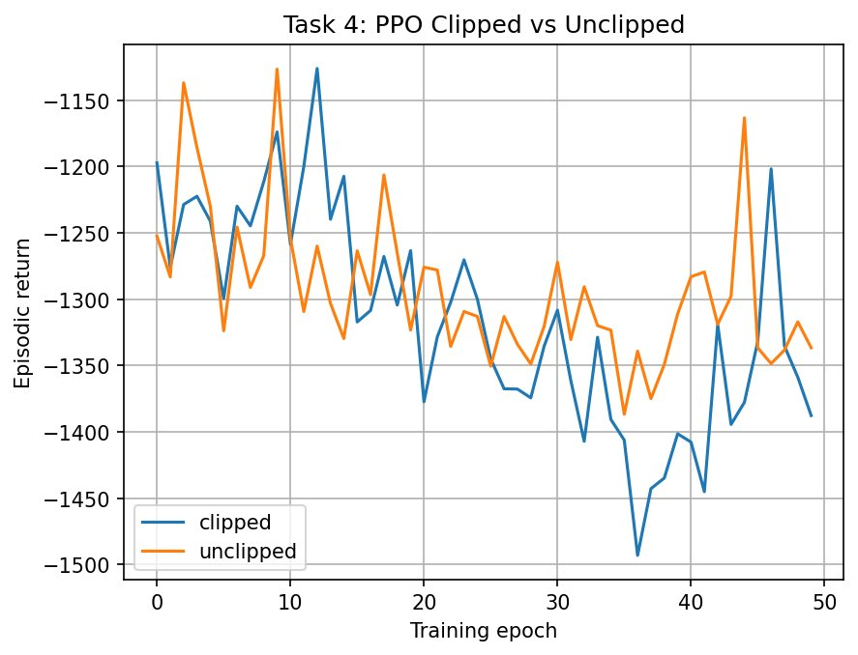
Figure 2.1 — Task 4: Clipped vs. unclipped PPO surrogate, 50 iterations. The two curves track each other because the policy has not yet drifted enough to trigger clipping.
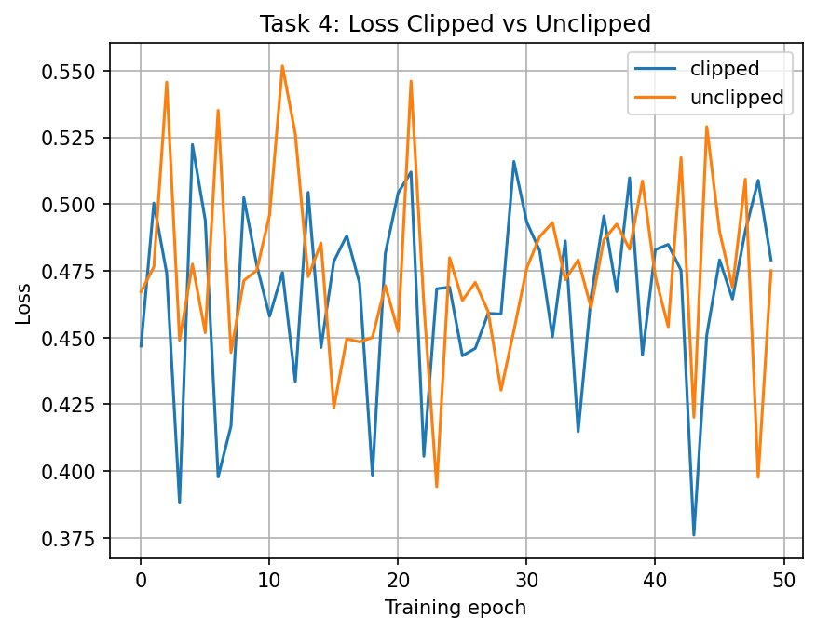
Figure 2.2 — Task 4: Corresponding loss curves. Loss magnitude is similar in both regimes early in training.

2.5 Task 5: Full PPO
The full PPO loop adds two pieces on top of Task 4: multiple SGD epochs over each batch of collected data (sample efficiency), and a combined loss that includes the value-function loss and an entropy bonus:
L_total = L_surr + c1 · L_VF - c2 · S[π], c1=0.5, c2=0.01
The entropy bonus prevents the policy from collapsing to a deterministic mapping prematurely, which would shut down exploration. The value-function term shares parameters with the policy only insofar as both share the optimizer step — the gradient of L_VF flows only through the critic's parameters because the policy's mean and variance are not arguments of the critic.
We trained for 500 iterations with steps_per_iter=2048 and 10 SGD epochs per iteration, minibatch size 64, learning rate 3e-4, hidden size 64. Gradient clipping with max_norm=0.5 was added on the policy and the critic to prevent occasional gradient spikes that we observed in early experiments.
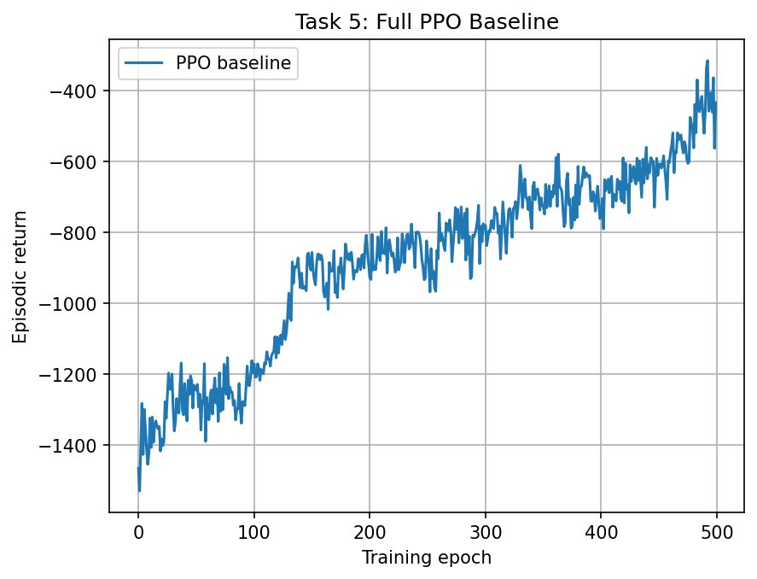
Figure 2.3 — Task 5: Full PPO baseline learning curve (500 iterations). Steady improvement from -1500 to roughly -400.
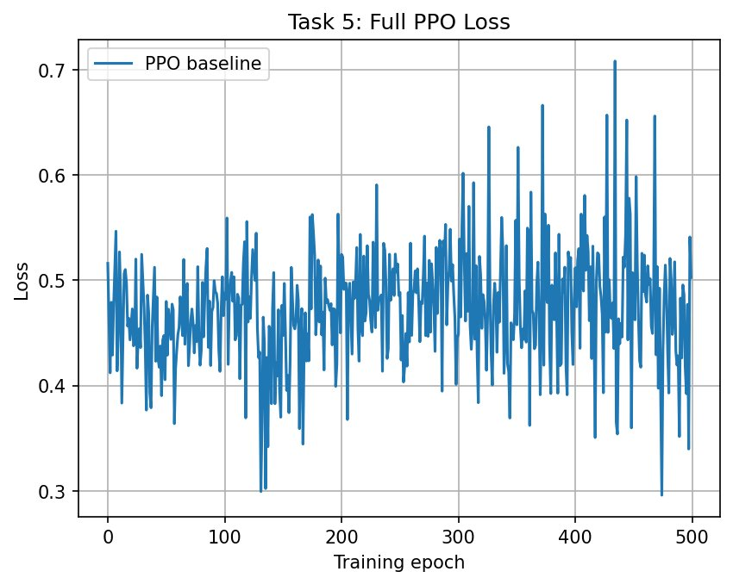
Figure 2.4 — Task 5: PPO total loss. Note that the loss is non-stationary and contains components that partially cancel; the loss curve is much less informative than the return curve.
The episodic return curve shows clear, monotonic improvement to about -400, well past the point at which the agent has learned a competent swing-up strategy. The loss curve is noisy and does not trend down — this is expected for actor-critic algorithms because the surrogate, value, and entropy components have different signs and the targets (advantages, returns) change every iteration. Reward is the meaningful learning signal, not loss.

3. Extensions
We chose four extensions to probe different aspects of PPO. Each was implemented as a toggleable flag (where possible) in the unified train_ppo function so that combinations and ablations would be easy to run. The summary is:
Extension | Idea | Result on Pendulum
1. State-dependent σ | Predict per-state action variance | Worse — high instability, requires aggressive stabilization
2. Ensemble critics (B=3) | Average B independent value estimators | Comparable final reward, smoother early learning
3. Parallel collection | Collect rollouts from N envs in parallel | Same returns, ~3.5× faster wall-clock
4. Recurrent policy (LSTM) | Replace feedforward actor with LSTM | Worse — extra capacity hurts on this task

3.1 Extension 1 — State-Dependent Action Variance

3.1.1 Motivation
The default Gaussian policy uses a single state-independent σ parameter learned globally. A natural improvement is to let σ depend on the observation: σ(s) = exp(clamp(W·s + b, -20, 2)). Intuitively, the agent should explore more aggressively in unfamiliar states and commit to actions in well-known ones. This is a standard component in many continuous-control PPO implementations.

3.1.2 Implementation
We extended NormalModule with a separate Linear(hidden_size, action_dim) layer producing log σ(s), with weights initialized to zero and bias initialized to -1 (sigma ≈ 0.37 initially, similar to the fixed case). The forward pass clamps log σ to (-20, 2) and exponentiates to get σ. Training initially used the same learning rate for the mean and variance heads.

3.1.3 Stabilization Steps
A naive run produced NaN explosions within a few hundred iterations. Investigation showed large gradients on the σ-head when r_t (the importance ratio) became large — small changes in σ produce large changes in log-probability, which are amplified by exp(·). We applied three stabilizers progressively:
- Reduced learning rate from 1e-3 to 1e-4. Without this the σ-head diverges in a few hundred iterations.
- Added gradient clipping with max_norm=0.5/0.3 on the policy. This caught occasional spikes that would otherwise produce invalid Gaussian parameters.
- Optionally: separate parameter groups with σ-head learning rate set to 0.1× the mean-head learning rate, plus a frozen-σ warmup of the first 200 iterations. We tested this configuration but it did not produce better results than the simpler reduced-lr setup, so the final reported run uses only the reduced learning rate and gradient clipping.

3.1.4 Results
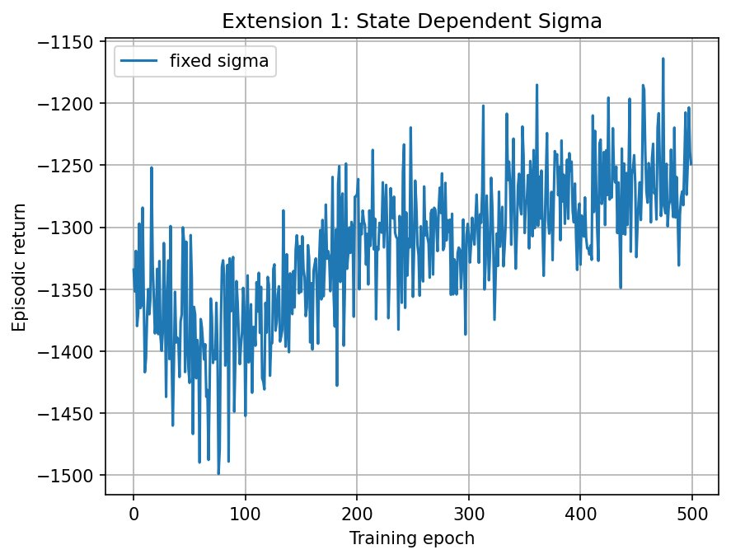
Figure 3.1 — Extension 1: State-dependent σ at lr=1e-4. Slow learning with high variance, ending around -1250.
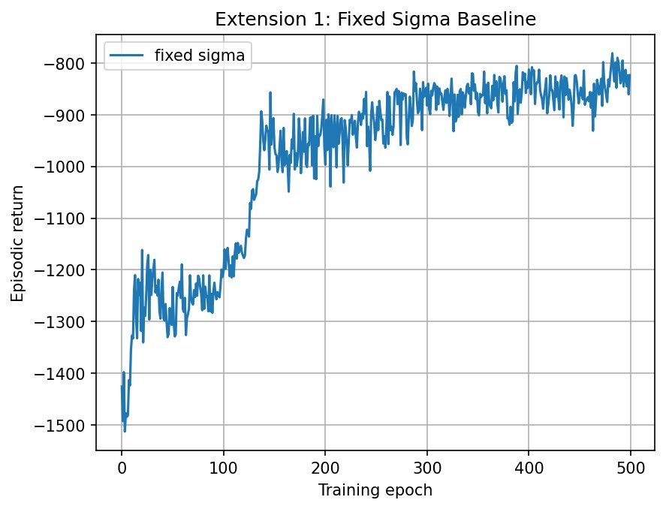
Figure 3.2 — Comparison: fixed σ baseline at the same hyperparameters reaches -800 in the same 500 iterations.
The state-dependent σ run trains, but slowly — it ends at approximately -1250, while the fixed-σ baseline at otherwise identical hyperparameters reaches approximately -800 in the same number of iterations. Two factors explain this:
- The σ-head adds a separate learning problem on top of the mean head. The policy must simultaneously discover good actions and how confidently to take them. On a 3-dimensional state, optimal exploration does not vary much across states, so the additional capacity provides little benefit while doubling the gradient flow.
- Gradient interactions between μ and σ are unstable. Even with clipping, the tail of the gradient distribution is heavy because of the exp(·) in σ — occasional large updates push σ to small values that then make r_t explode in subsequent updates, causing the agent to backtrack.
For this reason we treat state-dependent σ as a single standalone experiment and use fixed σ in all subsequent extensions. The result is a useful negative finding: state-dependent variance is theoretically motivated but practically counterproductive on simple environments where the optimisation difficulty outweighs the small modelling benefit.

3.2 Extension 2 — Ensemble Critics

3.2.1 Motivation
PPO's policy gradient is weighted by GAE advantages, which depend on the critic's value estimates. A noisy critic produces noisy advantages and noisy gradient updates. One way to reduce critic variance is to train B independent critics on the same data and average their predictions for inference: V_ens(s) = (1/B) Σ V_b(s).
Mathematically, if each critic's error is V_b(s) = V*(s) + ε_b with E[ε_b]=0 and independent across b, the ensemble error has variance σ²/B, B times smaller than a single critic. Independence is the key assumption; in practice it holds only partially — the critics share data and architecture, but different random initializations produce partially independent error patterns and the ensemble average is empirically less noisy than a single estimator (analogous to averaging multiple polls with overlapping methodology).

3.2.2 Implementation
B critic networks are constructed independently with separate optimizers. For inference, we average their outputs to compute V(s) and V(s'). For training, each critic is updated independently against the same target — we never average the loss, only the predictions. We also created a dedicated ppo_ensemble_loss function that omits the value term L_VF (since it would otherwise require coupling all B critics through a single backward pass) and instead trains each critic with a separate MSE loss in the inner loop.

3.2.3 Results
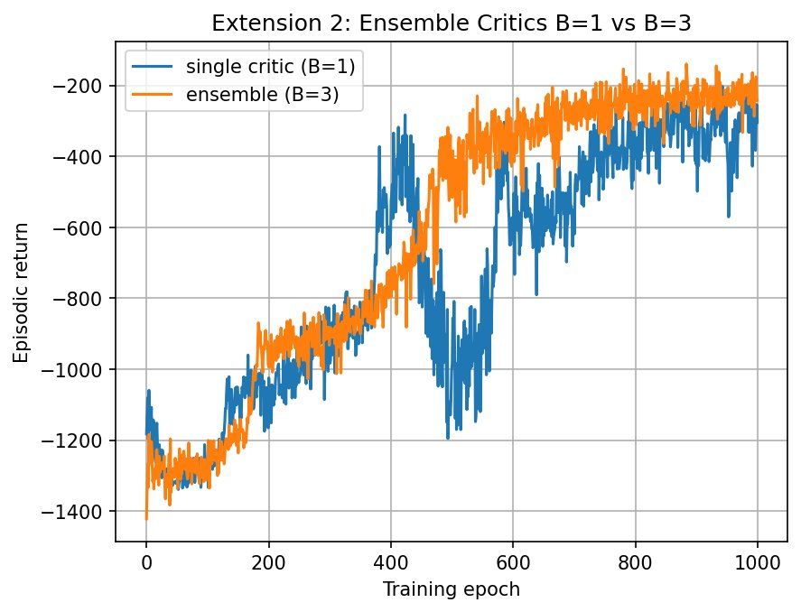
Figure 3.3 — Extension 2: Ensemble (B=3) vs. single critic (B=1) over 1000 iterations. Both reach ~-200; B=3 is consistently smoother but reaches the plateau at a similar iteration count.
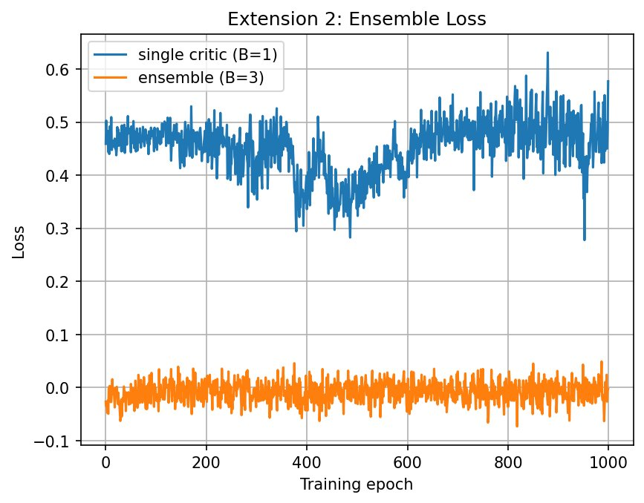
Figure 3.4 — Extension 2: Loss curves. The B=1 case uses ppo_total_loss (including L_VF), while the B=3 case uses ppo_ensemble_loss (without L_VF, critics trained separately). The magnitude difference is purely a definitional artifact and not a sign of better/worse performance.

3.2.4 Note on the Loss Curve Difference
The B=1 and B=3 loss curves in Figure 3.4 sit at very different magnitudes (~0.45 vs. ~0.0). This is not a learning result — it is a definition difference. The B=1 case uses ppo_total_loss, which adds c1·L_VF to the surrogate loss. The MSE term dominates the magnitude. The B=3 case uses ppo_ensemble_loss, which omits L_VF entirely (the critics are trained in a separate optimization step) and only contains the surrogate plus the small entropy bonus. The two losses are not comparable as numerical quantities; only the return curves provide a fair comparison.

3.2.5 Discussion
Both runs converge to similar final returns (~-200) and on Pendulum the ensemble does not provide a clear sample-efficiency advantage. This is consistent with the idea that variance reduction from averaging matters most when the value function is hard to estimate. Pendulum's state space is only 3-dimensional and the reward is dense and smooth, so a single critic already produces low-variance estimates. The 3× compute overhead of training B critics is visible in wall-clock time but the per-iteration progress is similar.
We expect the ensemble approach to show clearer benefits on higher-dimensional or sparse-reward tasks, where critic estimates are intrinsically noisier and the variance-reduction argument carries more weight.

3.3 Extension 3 — Parallel Data Collection

3.3.1 Motivation
Sequential rollouts are the wall-clock bottleneck of PPO at our scale: each iteration's optimisation work takes a fraction of a second on the GPU/CPU, but generating ~4000 transitions sequentially against the environment takes most of the per-iteration time. Running multiple environments in parallel removes this bottleneck without changing the algorithm.

3.3.2 Implementation
We use gymnasium.vector.SyncVectorEnv to run num_envs=8 Pendulum instances simultaneously. A new collect_data_parallel function steps all 8 environments at each iteration of its inner loop, producing num_envs transitions per step and a buffer with the same total size in steps_per_iter // num_envs outer iterations. SyncVectorEnv handles automatic resets when individual environments terminate, returning the new starting state in the corresponding next_states slot. We added an act_parallel helper that processes a (num_envs, state_dim) batch in a single forward pass and returns (num_envs, action_dim) actions, eliminating the unsqueeze(0) hack from the single-environment act.
A subtle correctness issue arises in GAE computation: with parallel collection, transitions from different environments are interleaved in the buffer. The shortcut next_values[:-1] = values[1:] is then wrong, because index i+1 may belong to a different environment's trajectory. Our fix is to store next_states explicitly in the buffer (this also required fixing an off-by-one in Buffer.add) and to compute next_values by running the critic on buffer.next_states directly. The same _critic_values function then works for both sequential and parallel collection.

3.3.3 Wall-Clock Timing
Average per-iteration data-collection times (steps_per_iter=4096, hidden_size=128):
Configuration | Total collection time (800 iters) | Avg. per-iter time
Sequential (1 env) | 597.73 s | 0.747 s
Parallel (8 envs, SyncVectorEnv) | 170.16 s | 0.213 s
Speedup | 3.51× | 3.51×

The 3.5× speedup is below the theoretical 8× because SyncVectorEnv runs the environments sequentially within a single Python process — its main benefit is amortising the per-step overhead (action sampling, advantage bookkeeping) across 8 environments per call rather than truly parallel execution. AsyncVectorEnv would launch a separate process per environment and approach the 8× ceiling, at the cost of inter-process communication overhead. We chose SyncVectorEnv because its determinism made debugging the next_state alignment issue much easier.

3.3.4 Results
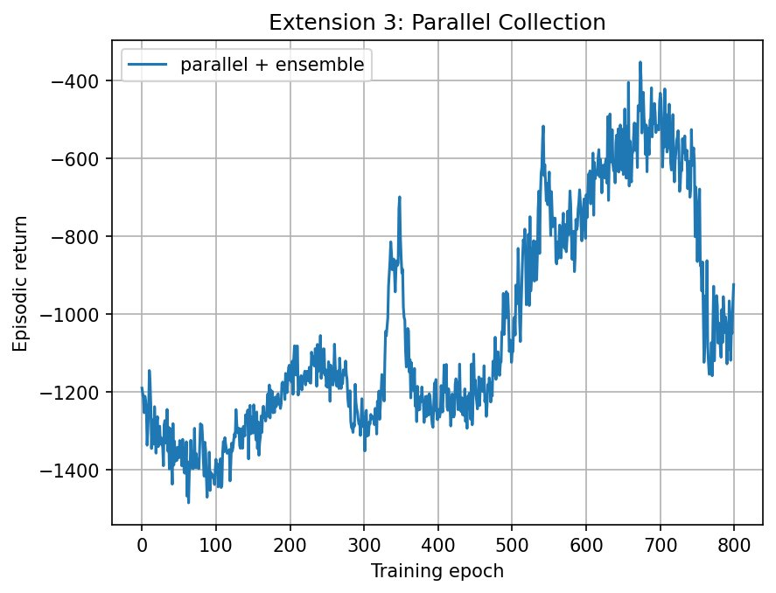
Figure 3.5 — Extension 3: Parallel + ensemble run, 800 iterations. Reaches a peak around -400 before partial collapse around iteration 750. Same hyperparameters as Extension 2 except for parallel collection.
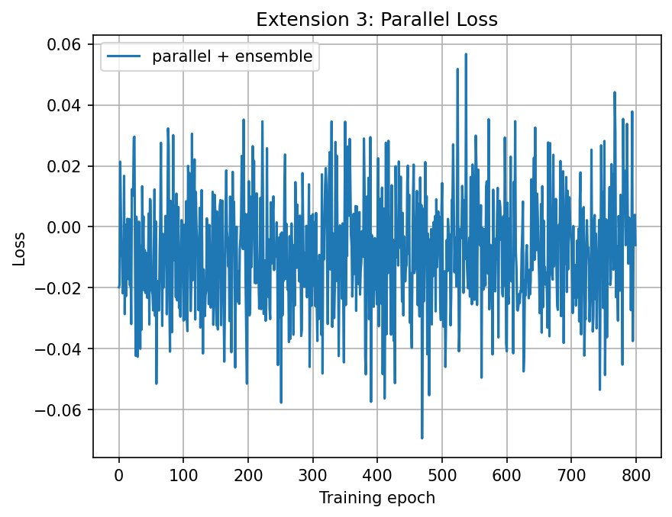
Figure 3.6 — Extension 3: Loss curve for the parallel + ensemble run.
The learning trajectory is similar to the sequential ensemble run (Figure 3.3) — same algorithm, same data, just collected faster. The late dip near iteration 750 is the same kind of distribution-shift collapse that PPO occasionally suffers when the policy drifts too far during the SGD epochs; reducing sgd_epochs from 10 to 4 would mitigate it but also slow sample-level progress. The important conclusion is that parallel collection is purely a wall-clock improvement: it does not change the algorithm or the asymptotic policy, only how fast the same iterations complete.

3.4 Extension 4 — Recurrent Policy and Partial Observability

3.4.1 Motivation
The default Pendulum observation [cos θ, sin θ, θ̇] is fully Markovian — the agent has access to position and velocity, so a feedforward policy is in principle sufficient. To study the effect of recurrence we created a partial-observability variant that strips θ̇ from the observation, leaving the agent with [cos θ, sin θ] only. With position alone the agent cannot tell whether the pendulum is moving fast or slow from a single observation; an LSTM should in principle be able to integrate consecutive position observations to recover this information.

3.4.2 Implementation
A new RecurrentActor module wraps an nn.LSTM(state_dim, hidden_size, batch_first=True) feeding into the existing NormalModule head. forward(state, hidden) returns (μ, σ, new_hidden); the mean of the action distribution is taken from the last timestep's output. A new act_recurrent helper carries hidden state across steps during rollouts, and collect_data_recurrent resets the hidden state to zeros at episode boundaries.
The biggest practical difficulty is that during the SGD inner loop we sample random transitions, not contiguous trajectories — so naively passing zero hidden state to the LSTM destroys the temporal context the policy was trained to use during rollouts. We addressed this by switching to sequence minibatches: each minibatch element is a contiguous chunk of seq_len=32 transitions sampled at random start points. The LSTM is run forward through the sequence (starting from zero hidden state) and the loss uses only the last step's output. This makes the training-time forward pass much closer to the rollout-time forward pass, at the cost of using seq_len transitions per gradient evaluation. For the partial-state experiment we used learning_rate=3e-4, hidden_size=128, sgd_epochs=5, minibatch_size=32 — smaller minibatches because each one now contains seq_len times more transitions.

3.4.3 Results
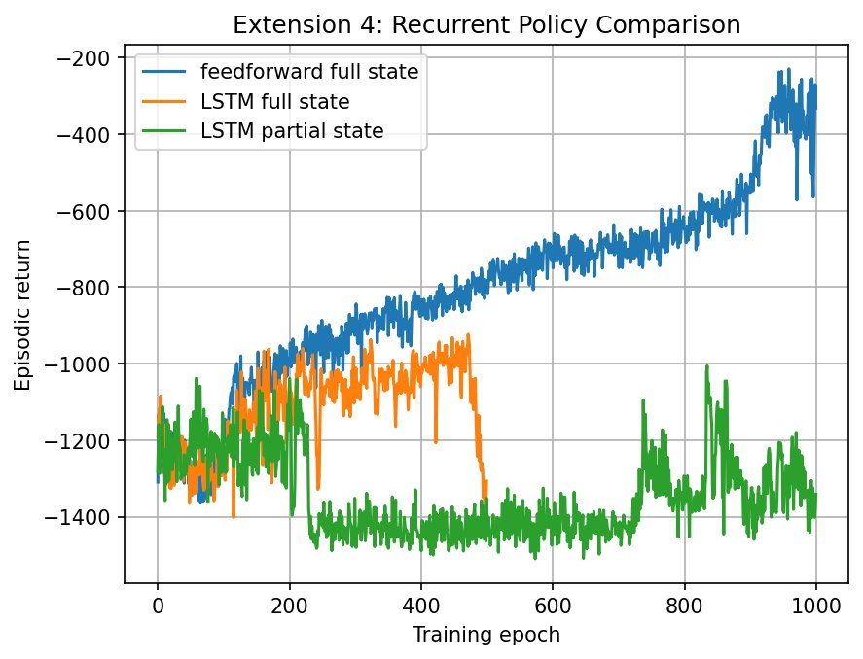
Figure 3.7 — Extension 4: Three-way comparison. Feedforward + full state (B=1 result reused as the FF baseline) reaches -300; LSTM + full state plateaus around -1000 with a late collapse; LSTM + partial state stays near -1400 throughout.
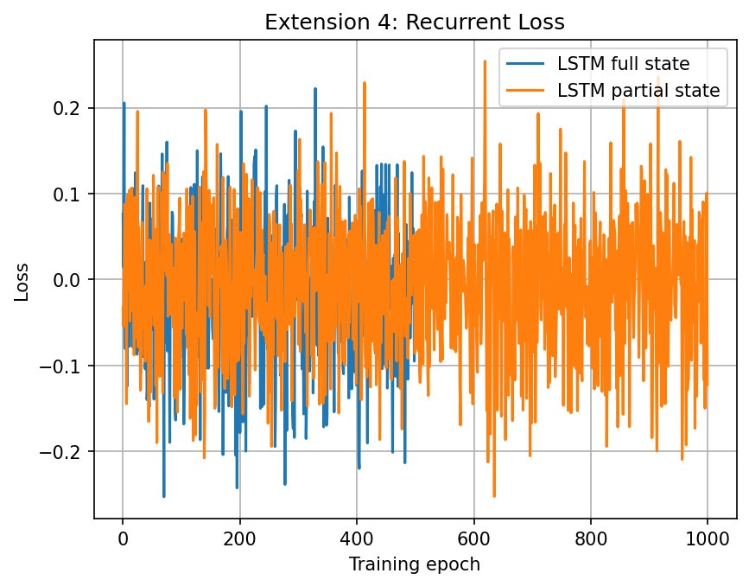
Figure 3.8 — Extension 4: Loss curves for the LSTM full-state and partial-state runs.

3.4.4 Discussion
Three observations stand out:
- The LSTM does not match the feedforward baseline even with full state. We expected the LSTM to be at worst equivalent (it has strictly more capacity), but it is in fact slower and noisier. The most likely cause is the zero-hidden approximation in SGD: even with sequence minibatches of length 32, the LSTM's warmup over the first ~10 steps of each sequence is dominated by an artificial cold start, biasing the gradient. Stateful BPTT (carrying hidden state across consecutive minibatches) would help but requires a more invasive buffer redesign.
- The LSTM full-state run shows a sharp late-training collapse around iteration 470, similar to but more severe than the parallel-ensemble collapse. This is consistent with sequence minibatching being noisy — the policy gradient can drift sharply when sequences happen to land in correlated regions of state space.
- Partial observability is severely damaging. With θ̇ removed, the LSTM-partial run barely improves above the random baseline. In principle the LSTM could integrate position observations to recover velocity, but in practice the variance of the gradient signal is too high to learn reliably within 1000 iterations. A larger hidden state, longer sequences, or stateful BPTT would all be reasonable next steps.
The honest conclusion is that recurrent policies are not "free": they introduce a significant optimisation difficulty (BPTT, sequence sampling, hidden-state mismatch) that is hard to justify on a fully observable, low-dimensional task. They are most useful when the environment is genuinely partially observable and the missing information is recoverable from short-term history — a regime where Pendulum's 200-step episodes and 1-dimensional hidden state (just θ̇) are simultaneously too short and too easy to compensate for the overhead.

4. Conclusion
We implemented PPO from the ground up, validating each algorithmic component (rewards-to-go, GAE, clipped surrogate, full PPO) against learning-curve evidence before moving on. The baseline Task-5 implementation reaches approximately -400 episodic return after 500 iterations, and the strongest extension configurations reach approximately -200, corresponding to a near-solved swing-up task.
From the four extensions we draw the following conclusions:
- State-dependent σ is theoretically appealing but practically destabilising on Pendulum. The added optimisation difficulty outweighs the modelling benefit on a 3-dimensional environment, and it requires non-trivial gradient clipping and a 10× learning-rate reduction to remain stable. The technique's payoff likely scales with state dimensionality.
- Ensemble critics (B=3) produce smoother early learning and arrive at the same final policy as B=1. The 3× compute cost of training three critics is real, and on Pendulum it does not buy a measurable improvement in final return. Variance reduction in V(s) matters more in high-dimensional or sparse-reward tasks.
- Parallel data collection is a pure wall-clock win — 3.5× faster collection with no algorithmic effect. Implementation requires storing next_states explicitly to keep GAE correct under interleaved trajectories. We recommend this as the first extension anyone working on PPO should add.
- Recurrent policies underperform feedforward on Pendulum, both on the full state (where they should be at least equivalent) and on the partial-state variant (where they should be the right tool). The mismatch between rollout-time hidden state and SGD-time zero-hidden state is the main culprit, and addressing it requires either stateful BPTT or much longer sequence minibatches than we used.
The most striking unifying observation is that several extensions sound theoretically beneficial yet hurt empirically on a simple environment. PPO's strong baseline on Pendulum leaves little room for variance reduction or additional capacity to help, while the optimisation costs of those additions are real. This is consistent with the broader RL-literature observation that algorithmic improvements often only pay off on tasks at the edge of the baseline's capability.

4.1 Hyperparameters Used
For reproducibility, the hyperparameters of every reported run are listed below.
Run | iterations | steps/iter | sgd_epochs | minibatch | lr | hidden | other
Task 4 (clipped/unclipped) | 50 | 2048 | 10 | 64 | 3e-4 | 64 | —
Task 5 baseline | 500 | 2048 | 10 | 64 | 3e-4 | 64 | —
Ext. 1 fixed σ | 500 | 4096 | 10 | 256 | 1e-4 | 128 | —
Ext. 1 state σ | 500 | 4096 | 10 | 256 | 1e-4 | 128 | grad clip 0.5
Ext. 2 B=1 | 1000 | 4096 | 10 | 256 | 1e-4 | 128 | —
Ext. 2 B=3 | 1000 | 4096 | 10 | 256 | 1e-4 | 128 | B=3
Ext. 3 sequential | 800 | 4096 | 10 | 256 | 1e-4 | 128 | B=3
Ext. 3 parallel | 800 | 4096 | 10 | 256 | 1e-4 | 128 | B=3, num_envs=8
Ext. 4 LSTM full | 500 | 4096 | 5 | 32 | 3e-4 | 128 | seq_len=32
Ext. 4 LSTM partial | 1000 | 4096 | 5 | 32 | 3e-4 | 128 | seq_len=32, state[:2]

Common settings unless otherwise noted: γ=0.99, λ=0.95, ε_clip=0.2, c1=0.5, c2=0.01, gradient clipping with max_norm=0.5 on the policy and on each critic.

4.2 Team Contributions
Work was distributed in pair-programming style across the team. All members contributed to the implementation, debugging, and analysis phases.

